Manual for dry mouth measurement

Purpose of measurement

Among the many types of frailty, there is the concept of oral frailty, which occurs as the oral cavity becomes more fragile with age, leading to eating disorders and even a decline in physical and mental functions (Japan Dental Association, 2019, p.13) .

The concept of oral frailty includes the disease of oral hypofunction, which is diagnosed based on seven test items: poor oral hygiene, dry mouth, decreased bite force, decreased lingual and labial motor function, low tongue pressure, decreased chewing function, and decreased swallowing function ( Japan Dental Association , 2019, p. 37 ) . If three or more of the seven items show a decline, the patient is diagnosed with oral hypofunction (Japan Dental Association, 2019, p. 4 1) . In this study, we aimed to investigate the dry mouth condition of elderly people at Suginami Seikyo Clinic and measure the degree of mucosal moisture in the mouth. We also aimed to diagnose oral hypofunction by combining the dry mouth condition with other items.

② Measurement procedure and precautions

For the dry mouth section, the testing device used is the Mucus oral moisture meter (Japan Dental Association , 2019, p. 37) .

*Before measurement

1. Attach a sensor cover to the device (Life Co., Ltd., 2020) . Since using a sensor cover other than the dedicated one will make accurate measurements impossible, be sure to attach a dedicated sensor cover and replace it for each subject to prevent infection (Life Co., Ltd., 2020) .

2. The sensor cover is made up of two pieces of film, a transparent film and a milky film, and the transparent film is placed over the sensor until it lightly touches the sensor (Life Co., Ltd., 2020) .

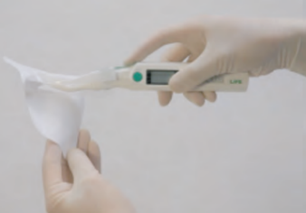

出典：株式会社ライフ(2020)

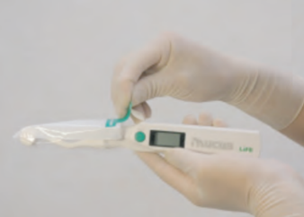

3. Because there is a switch at the tip of the device, open the tip of the cover about 1 cm to avoid hitting the switch (Life Co., Ltd., 2020) . When you turn on the device and the LCD screen displays 0 0.0 , it is ready (Life Co., Ltd., 2020) .

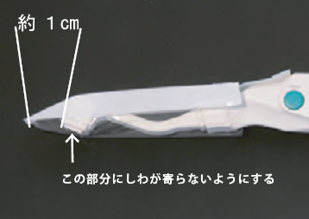

出典：株式会社ライフ(2020)

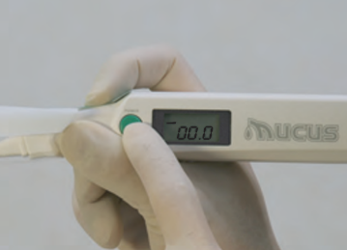

4. Before the measurement , the subject should close their mouth and relax their mind and body for about five minutes. After five minutes, the effects of eating, drinking, talking, excitement, and tension will disappear (Life Co., Ltd., 2020).

*measurement

200g or more to the front of the sensor on a flat area on the left or right side of the tongue, about 1cm from the tip , avoiding the grooves, and continue to press for 2 seconds until the buzzer sounds (Life Co., Ltd., 2020) . However, if the tongue moves or the sensor is released before the measurement is complete, an error will occur, so in that case, release the sensor once and apply pressure again (Life Co., Ltd., 2020) . This is repeated three times in a row with no time in between, and the median value is used as the measurement point (Life Co., Ltd., 2020) .

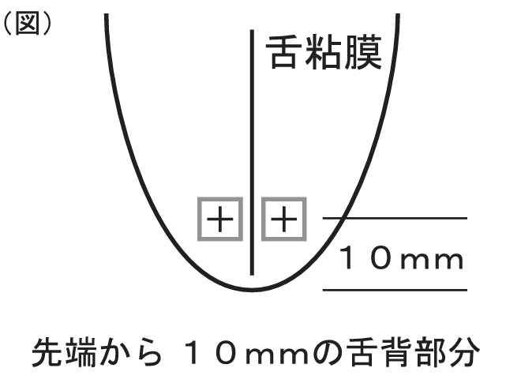

出典：株式会社ライフ(2020)

*Measurement precautions

When taking the measurement, place your index finger on the green sticker and apply pressure to stabilize it. You can also place your finger under your tongue for a more stable measurement (Life Co., Ltd., 2020) .

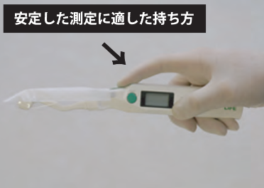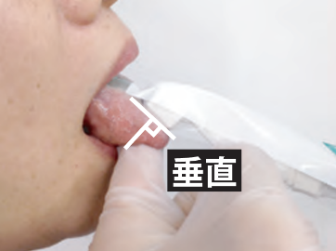

出典：株式会社ライフ(2020)

How to evaluate and interpret the measurement results

The standard measurement values are 29.6 or above for normal, 28.0 to 29.5 for borderline , and 27.9 or below for dryness (Life Co., Ltd., 2020) . A diagnosis of oral hypofunction is 27 or below, and a borderline reading of less than 28 is suspected to indicate dryness in the oral cavity (Life Co., Ltd., 2020) . For example, if the first measurement is 28.9 , the second is 29.2 , and the third is 28.7 , the median is 28.9 , so this case is in the borderline range (Life Co., Ltd., 2020) . The values displayed are relative values and therefore have no units ( Life Co., Ltd. webpage ) .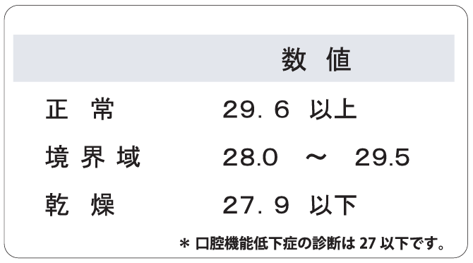

出典：株式会社ライフ(2020)

References

・Life Corporation ( 2020). "Oral Moisture Meter Mucus Measurement Method Guide."

・Life Co., Ltd. website. Accessed July 7, 2023 from [https://www.life-qol.net/mucus .](https://www.life-qol.net/mucus)

・Japan Dental Association ( 2019) "Oral Frailty Management Manual for Dental Clinics 2019 Edition"