Manual for tongue pressure measurement

Purpose of measurement

Among the many types of frailty, there is a concept called oral frailty, which is characterized by the progression of oral frailty with age, leading to eating disorders and even mental and physical decline (Japan Dental Association, 2019, p.13). The concept of oral frailty includes a disease called oral hypofunction, which is diagnosed based on seven test items: poor oral hygiene, dry mouth, decreased bite force, decreased lingual and labial motor function, low tongue pressure, decreased chewing function, and decreased swallowing function (Japan Dental Association, 2019, p.37). If a decline is observed in three or more of the seven items, it is considered oral hypofunction (Japan Dental Association, 2019, p.41). The purpose of this study is to measure whether elderly people have low tongue pressure at Suginami Seikyo Clinic. The purpose is also to diagnose oral hypofunction by combining not only tongue pressure but also other items.

② Measurement procedure and precautions

For the low tongue pressure item, a JMS tongue pressure meter is used to measure maximum tongue pressure (Japan Dental Association, 2019, p. 37) .

1. First , connect the digital tongue pressure gauge, connecting tube, and tongue pressure probe, turn on the power, and adjust the internal pressure (JMS Co., Ltd., 2022) . When doing this, be sure to connect them so that there are no gaps (JMS Co., Ltd., 20 2 2) .

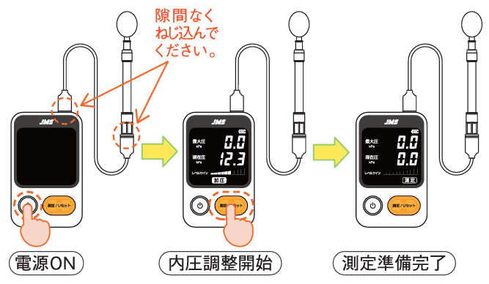

　　　　　　　　　　　　　　　　　 Source: JMS Co., Ltd., 2022

2. Place the tongue pressure probe in the mouth (JMS Co., Ltd., 2022) . Instruct the patient not to bite the balloon, but to lightly grasp the lower part of the balloon with the front teeth (JMS Co., Ltd., 2022) . Also, be careful not to bite too hard on the shaded area in the figure (JMS Co., Ltd., 2022) .

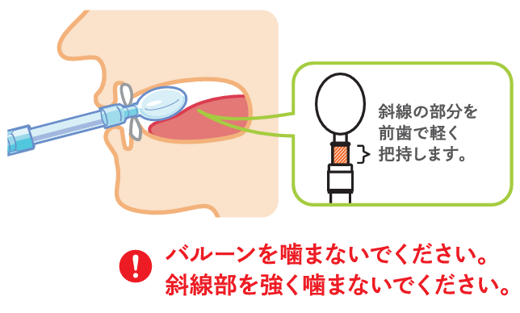

Source: JMS Co., Ltd. , 2022

3. Press the balloon with your tongue for approximately 7 seconds (JMS Co., Ltd., 2022) . Tongue pressure probes must not be reused (JMS Co., Ltd., 2022) .

出典：株式会社ジェイ・エム・エス,2022

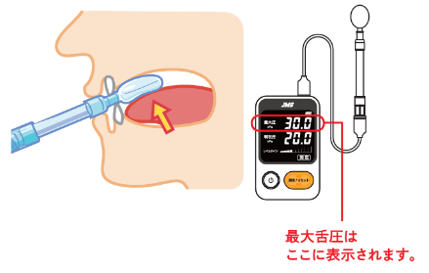

3) How to evaluate and interpret the measurement results

Tongue pressure is measured in kilopascals (kPa), and the recommended maximum tongue pressure is 35 or more for adult men ( ages 20-59 ), 30 or more for adult women (ages 20-59 ) , 30 for those in their 60s ( ages 60-69 ) , and 20 is required for people aged 70 or older ( JMS Co. , Ltd., 2022 ) . In the low tongue pressure section of the oral hypofunction test, a maximum tongue pressure of less than 30 kPa is diagnosed as low tongue pressure (Japan Dental Association, 2019, p. 37) .

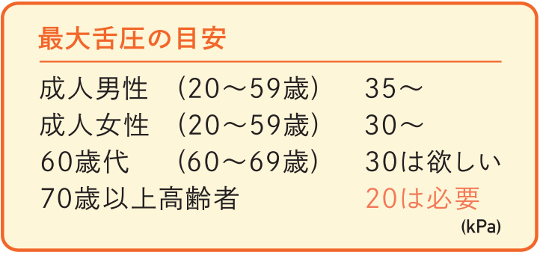

Source: JMS Co., Ltd. , 2022

References

・JMS Co., Ltd. (2022) " JMS Tongue Pressure Measuring Device TPM-02 ".

・Japan Dental Association (2019) "Manual for dealing with oral frailty in dental clinics, 2019 edition."