Vehicle Theft Trends in New Zealand
  - An Exploratory Analysis

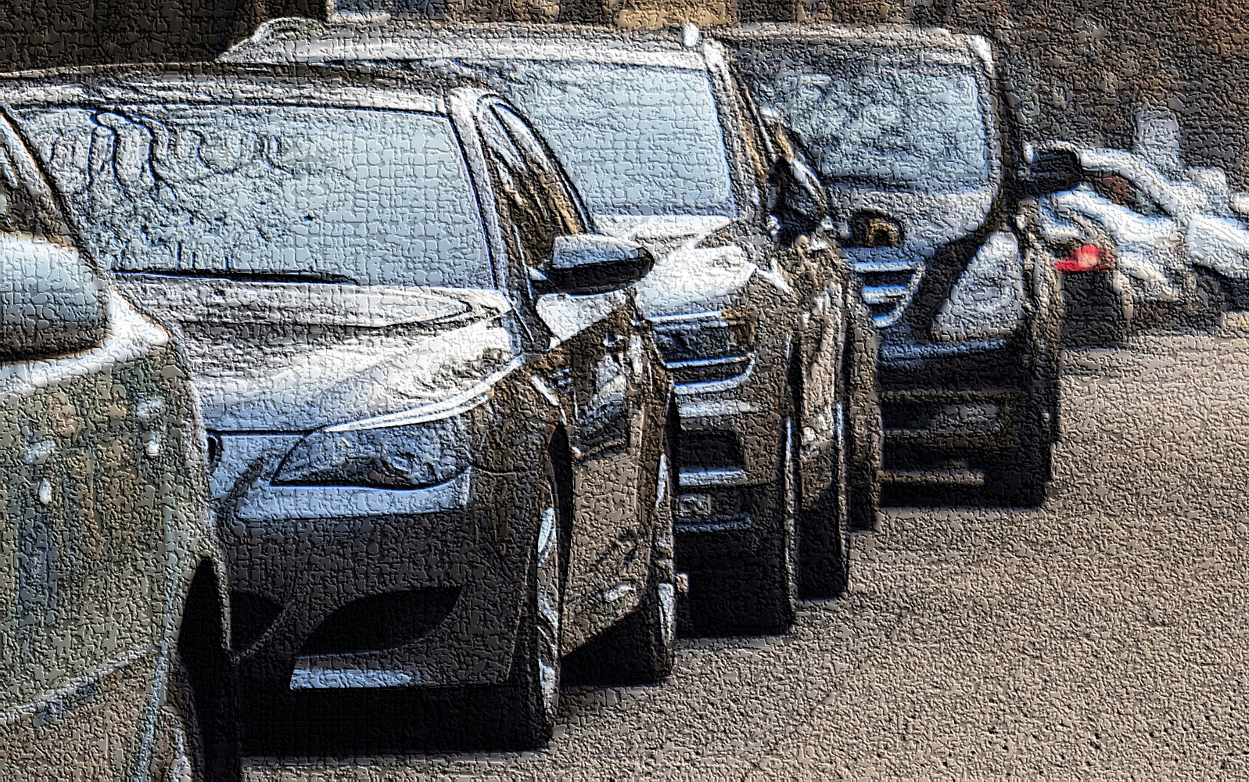

Created By | Muhammad Hameez Aqeel
Data Source | Maven Analytics
Tech Stack | 

Introduction
Motor vehicle theft is a significant concern in New Zealand, with thousands of vehicles stolen every year. Understanding the patterns and trends of vehicle thefts can help law enforcement agencies and policymakers develop effective strategies to prevent and investigate these crimes. This project aims to analyse the when, where, and which vehicles are stolen across New Zealand, providing valuable insights into the dynamics of motor vehicle theft in the country.

Objectives
- To identify the temporal patterns of motor vehicle thefts in New Zealand
- To determine the spatial distribution of motor vehicle thefts in New Zealand
- To investigate the types of vehicles most commonly stolen in New Zealand

Dataset Used

The dataset used for this analysis was created by executing a SQL query file obtained from Maven Analytics. The query file extracted a comprehensive dataset of motor vehicle thefts in New Zealand from a proprietary database.

Dataset Characteristics
- Data Period: 2021-2022
- Data Source: Proprietary database via Maven Analytics SQL query file
- Variables: Unique ID, Type, Colour, Date Stolen and others.

Dataset Limitations
While the dataset provides a comprehensive overview of motor vehicle thefts in New Zealand, it is essential to acknowledge the following limitations:
- Data Coverage: The dataset only includes records from 2021-2022 and may not reflect the current trend.
- Data Quality: The accuracy and completeness of the data rely on the proprietary database and Maven Analytics' query file.

Motor Vehicle Thefts in New Zealand: A Growing Concern
Motor vehicle theft is a significant problem in New Zealand, with thousands of vehicles stolen every year. According to the New Zealand Police, motor vehicle theft is one of the most common types of property crime in the country.
Significance of Motor Vehicle Thefts
The significance of motor vehicle thefts in New Zealand can be understood from several perspectives:
- Economic Impact: Motor vehicle thefts result in significant economic losses for individuals, businesses, and the broader community. The cost of replacing stolen vehicles, repairing damaged property, and paying insurance premiums can be substantial.
- Social Impact: Motor vehicle thefts can also have a significant social impact, particularly for victims who rely on their vehicles for transportation, work, or other essential activities. The emotional distress and inconvenience caused by motor vehicle theft can be considerable.
- Crime and Safety: Motor vehicle thefts are often linked to other crimes, such as burglary, robbery, and organized crime. Addressing motor vehicle thefts is essential to maintaining community safety and reducing the overall crime rate.

Data Analysis

Data Description
The dataset consists of three tables that provide comprehensive information about stolen vehicles, vehicle make and types, and regional data about New Zealand.

Table 1: Stolen Vehicles
- Table Name: stolen_vehicles
- Description: This table contains details about stolen vehicles, including:
  - Unique ID of Vehicle
  - Type of Vehicle
  - Make_ID
  - Location_ID
  - Colour of Vehicle
  - Date the vehicle was stolen

Table 2: Vehicle Make
- Table Name: make_details
- Description: This table provides information about vehicle makes, including:
  - Make_ID
  - Name of Make
  - Type of Make

Table 3: Locations
- Table Name: locations
- Description: This table contains regional data about New Zealand, including:
  - Location_ID
  - Region
  - Population
  - Density

Findings and Observations
This section presents the key findings and observations from the analysis of motor vehicle thefts data in New Zealand. The findings are organized into three categories:

When are vehicles stolen
Number of vehicles stolen each year
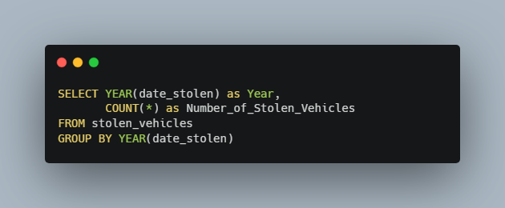

Year | Number of Vehicles Stolen
2021 | 1668
2022 | 2885

Number of Vehicles Stolen by Month
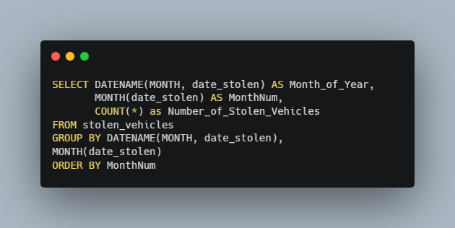

Month_of_Year | MonthNum | Number_of_Stolen_Vehicles
January | 1 | 740
February | 2 | 763
March | 3 | 1053
April | 4 | 329
October | 10 | 464
November | 11 | 560
December | 12 | 644

Number of vehicles stolen each day of the week
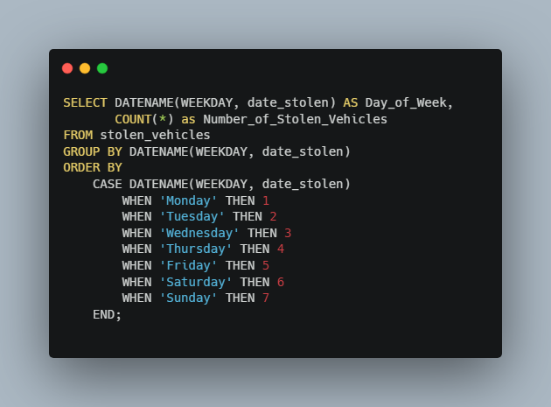

Day_of_Week | Number_of_Vehicles_Stolen
Monday | 767
Tuesday | 711
Wednesday | 629
Thursday | 619
Friday | 655
Saturday | 577
Sunday | 595

Which vehicles are stolen?

Vehicle types stolen most often
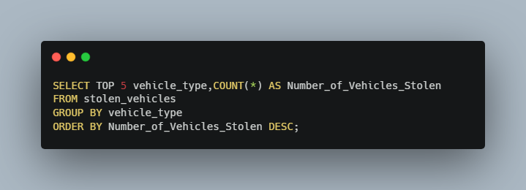

vehicle_type | Number_of_Stolen_Vehicles
Stationwagon | 945
Saloon | 851
Hatchback | 644
Trailer | 582
Utility | 466

Vehicles stolen by Type and Colour

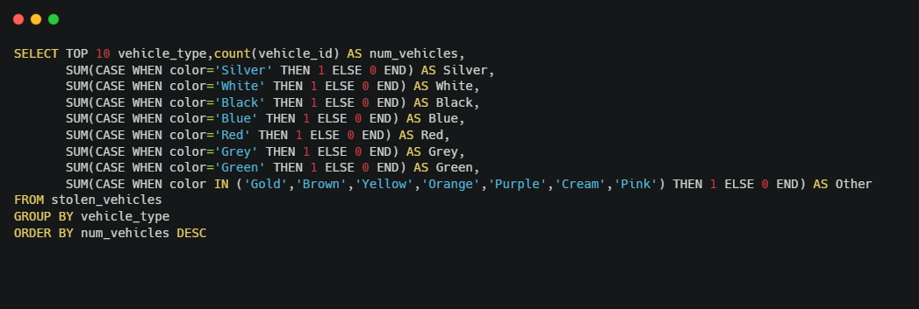

Where are vehicles stolen from?

Population and Density Statistics for each Region

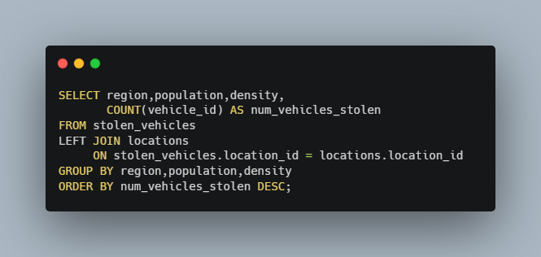\

Region | Population | Density | Vehicles_Stolen
Auckland | 1695200 | 343.09 | 1638
Canterbury | 655000 | 14.72 | 660
Bay of Plenty | 347700 | 28.8 | 446
Wellington | 543500 | 67.52 | 420
Waikato | 513800 | 21.5 | 371
Northland | 201500 | 16.11 | 234
Gisborne | 52100 | 6.21 | 176
Manawatu-Whanganui | 258200 | 11.62 | 139
Otago | 246000 | 7.89 | 139
Taranaki | 127300 | 17.55 | 112
Hawke's Bay | 182700 | 12.92 | 100
Nelson | 54500 | 129.15 | 92
Southland | 102400 | 3.28 | 26

Conclusion and Recommendations

Summary of Key Insights

- Vehicle Stealing rose by a whopping 73% from 2021 to 2022
- Weekdays saw more vehicles stolen on average than Weekends.
- Stationwagon and Saloon were the most stolen cars out of all types that were reported.
- Auckland, Canterbury and Wellington unsurprisingly saw the highest numbers of stolen cars due to their population. However, it was Nelson that witnessed the highest number of cars stolen per capita despite having a very small population, roughly thrice than those of the regions mentioned above.

Recommendations

For Law Enforcement Agencies

- Focus on Nelson: Despite having a small population, Nelson witnessed the highest number of cars stolen per capita. Increase patrols and surveillance in this region to address this anomaly.
- Target weekdays: With a 73% increase in vehicle thefts from 2021 to 2022, and more thefts occurring on weekdays, prioritize weekday patrols and investigations.
- Prioritize station wagons and saloons: As these vehicle types are most stolen, allocate resources to monitor and protect these vehicles.

For Vehicle Owners

- Secure your vehicle in Auckland, Canterbury, and Wellington: As these regions have the highest numbers of stolen cars, take extra precautions to secure your vehicle, such as parking in secure locations and installing anti-theft devices.

For Policy Makers

- Develop targeted prevention programs for Nelson: Address the disproportionately high rate of vehicle thefts in Nelson by creating specialized programs and allocating resources to this region.
- Invest in weekday policing initiatives: Given the increase in vehicle thefts on weekdays, consider investing in initiatives that increase policing presence and effectiveness during these days.

Appendix

- SQL Queries Code
- Data Dictionary (Metadata)

