**BAHRIA UNIVERSITY, ISLAMABAD**

**Department of Computer Science**

**CEN 444**

**Digital Image Processing**

**Lab Journal 8**

**Student Name: ____________________________**

**Enrolment No.: __________________________________**

**Title: Spatial Filtering**

**Objectives:** to introduce to the process of Filtering. To understand functions for Smoothing and Sharpening filters.

**Tools Used:** Python

**Procedure:** Open IDLE and perform the following tasks

|  |
| --- |
| import cv2  import numpy as np  img = cv2.imread("Your_image.jpg")  img = cv2.resize(img, (0, 0), None, .25, .25)  gaussianBlurKernel = np.array(([[1, 2, 1], [2, 4, 2], [1, 2, 1]]), np.float32)/9  sharpenKernel = np.array(([[0, -1, 0], [-1, 9, -1], [0, -1, 0]]), np.float32)/9  meanBlurKernel = np.ones((3, 3), np.float32)/9  gaussianBlur = cv2.filter2D(src=img, kernel=gaussianBlurKernel, ddepth=-1)  meanBlur = cv2.filter2D(src=img, kernel=meanBlurKernel, ddepth=-1)  sharpen = cv2.filter2D(src=img, kernel=sharpenKernel, ddepth=-1)  horizontalStack = np.concatenate((img, gaussianBlur, meanBlur, sharpen), axis=1)  cv2.imwrite("Output.jpg", horizontalStack)  cv2.imshow("2D Convolution Example", horizontalStack)  cv2.waitKey(0)  cv2.destroyAllWindows() |

The Filter2D operation convolves an image with the kernel. You can perform this operation on an image using the Filter2D() method of the imgproc class. Following is the documentation of this method −

**filter2D(src, dst, ddepth, kernel)**

This method accepts the following parameters −

* **src** − A Mat object representing the source (input image) for this operation.
* **dst** − A Mat object representing the destination (output image) for this operation.
* **ddepth** − A variable of the type integer representing the depth of the output image.
* **kernel −** A Mat object representing the convolution kernel.

|  |
| --- |
| **Average Filtering with 5x5 kernel**  import cv2  import numpy as np  from matplotlib import pyplot as plt  img = cv2.imread('/content/sample_data/images/cameraman.png')  kernel = np.ones((5,5),np.float32)/25  dst = cv2.filter2D(img,-1,kernel)  plt.figure(figsize=(10,10))  plt.subplot(121),plt.imshow(img),plt.title('Original')  plt.subplot(122),plt.imshow(dst),plt.title('Averaging')  plt.show()  **Using blur Function**  import cv2  import numpy as np  from matplotlib import pyplot as plt  img = cv2.imread('/content/sample_data/images/cameraman.png')  blur = cv2.blur(img,(5,5))  plt.figure(figsize=(10,10))  plt.subplot(121),plt.imshow(img),plt.title('Original')  plt.xticks([]), plt.yticks([])  plt.subplot(122),plt.imshow(blur),plt.title('Blurred')  plt.xticks([]), plt.yticks([])  plt.show() |

**Some other functions:**

**cv2.GaussianBlur()**.

**cv2.getGaussianKernel()**.

**cv2.medianBlur()**

median = cv2.medianBlur(img,5)

**Task 1**

Read an image of your choice. Apply average and gaussian filters of size 5x5 individually and identify the differences b/w their results.

**Task 2**

Read an image of your choice which has salt and pepper noise. Apply rank filter of size 5x5 using rank = 13. What is the other name of this filtering? If you use rank = 1 or 25, will the noise increase or decrease?

**Task 3**

Read the image. Write a function named ‘mylaplacian’ to MANUALLY code/implement 2nd order derivate of above read image in order to extract horizontal and vertical edges, collectively. Also, compare your results with ‘Sobel’ filter and state your findings.

[Code Hint]: You need to perform filtering with the following masks.  
**Vertical Edges:**g(x, y) = f(x + 1, y) + f(x – 1, y) – 2f(x, y)  
**Horizontal Edges:**g(x, y) = f(x , y + 1) + f(x, y - 1) – 2f(x, y)

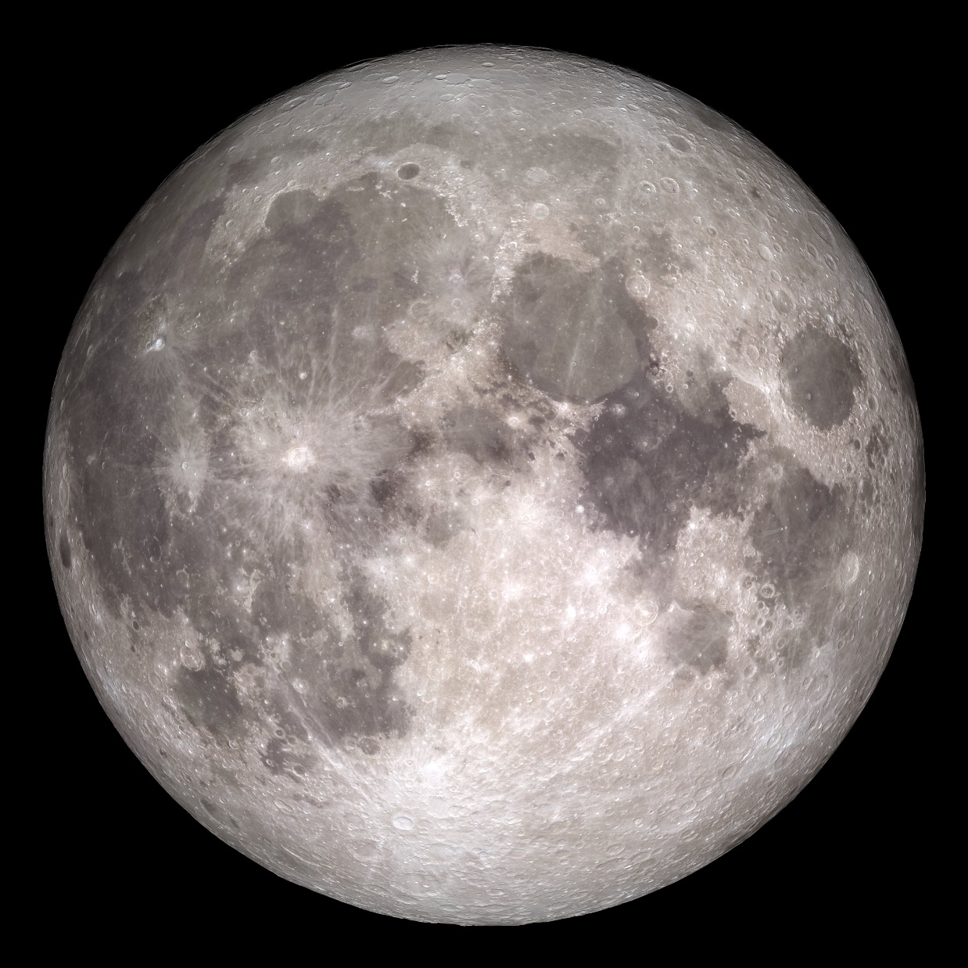

**Submission Date:**