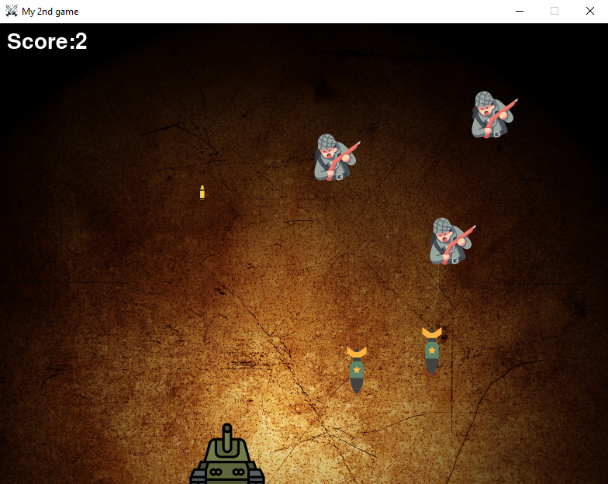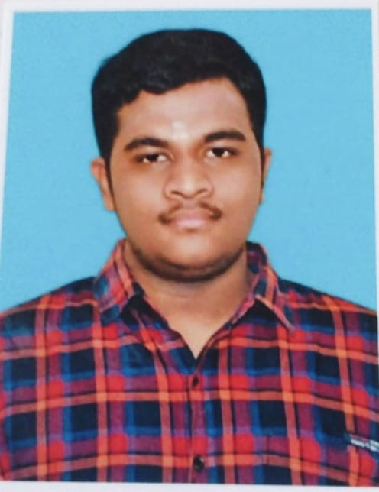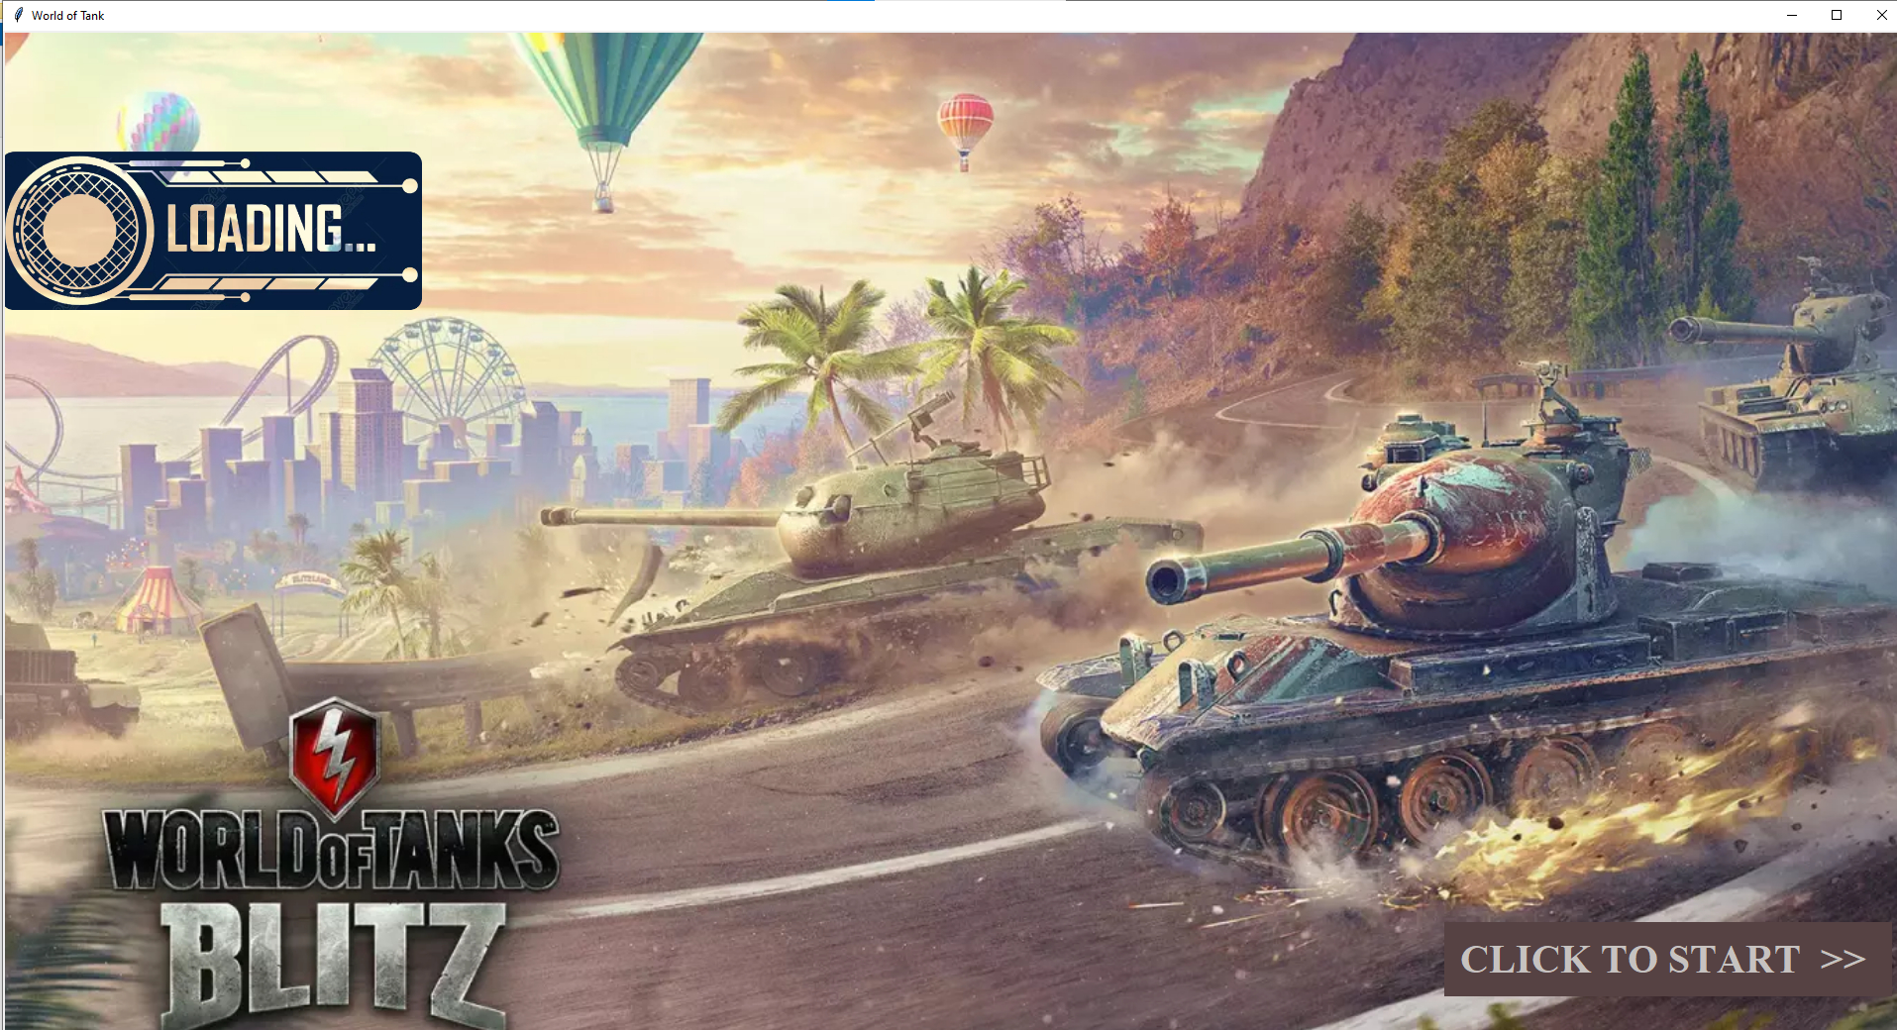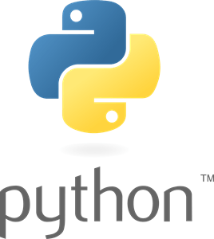

**TANK SHOOTERS GAME USING PYTHON**

**( Solo tank siege )**

|  |  |  |  |
| --- | --- | --- | --- |
| **DEVELOPED BY** | **LANGUAGE** | **GUIDED BY** | **LOCATION** |
| HARIHARASUDHAN.M | PYTHON | LOGANATHAN.K. | HOSUR |