PROJECT BLUEPRINT
Autonomous Event Planning Team
A Stateful, Reflective, Manager-Led Multi-Agent System for End-to-End Event Execution Planning
Course 4 — Build Autonomous Multi-Agent Systems
Selected Scenario: Autonomous Event Planning Team
Architecture, API, Workflow & Codeflow Design Document
Document Version 1.0
July 2026

Table of Contents
1. Executive Summary
2. Problem Statement & Context
3. Goals & Objectives
4. System Architecture
5. Agent Roster & Responsibilities
6. Workflow & State Machine Design
7. API Design
8. Core Data Models
9. Reflection & Self-Correction Mechanism
10. Hierarchical Delegation Model
11. Optimization Strategy
12. Error Handling & Production Considerations
13. Security & Data Validation
14. Technology Stack
15. Sprint & Deliverable Mapping
16. Evaluation Criteria Alignment
17. Project & Repository Structure
18. Implementation Roadmap

1. Executive Summary
This document is the complete design blueprint for the Autonomous Event Planning Team — a manager-led, multi-agent system that turns a short event brief into a fully coordinated event execution plan. The system is built as a stateful LangGraph workflow in which five specialist agents (Logistics, Budget, Marketing, Schedule, Risk) work under an Event Manager Agent, with a dedicated Reflection Agent acting as a quality gate before any plan is finalized.
The design deliberately minimizes the public API surface to four endpoints — create, retrieve, refine, and health — while pushing all coordination complexity into the orchestration and agent layers, where it belongs. This keeps the system easy to integrate, easy to test, and easy to reason about, while still satisfying every functional requirement in the course brief: state-machine workflows, structured reasoning loops, reflection and self-correction, hierarchical delegation, multi-agent orchestration, and cost/latency/quality optimization.
Sections 4–6 cover architecture and workflow with full diagrams; Section 7 specifies the API; Sections 8–12 cover data models, reflection, delegation, optimization, and error handling; Sections 13–15 map the design back to the sprint timeline and evaluation rubric supplied in the course README; Section 17 gives the complete, file-by-file repository structure; and Section 18 closes with an implementation roadmap.

2. Problem Statement & Context
Planning events such as workshops, conferences, college fests, or meetups requires coordination across logistics, budgeting, scheduling, promotion, and risk management. Decisions made in one area routinely affect the others — a venue change shifts logistics costs, which forces a budget rebalance, which can affect marketing spend, which in turn changes expected attendance and therefore risk exposure.
Traditional single-purpose tools handle isolated tasks well but cannot represent or resolve these cross-cutting dependencies. The Autonomous Event Planning Team addresses this by simulating an organizing committee: specialized agents produce their own sub-plans in parallel, an Event Manager Agent synthesizes those sub-plans into one coherent blueprint, and a Reflection Agent checks the result for feasibility, budget fit, risk coverage, and internal coherence before it is released.

2.1 Key Real-World Challenges Addressed
- Interdependent tasks: budget, logistics, and promotion decisions influence one another and cannot be planned in isolation.
- Iterative refinement: a first draft is rarely final; the plan must be revisable against new constraints (e.g., “adjust the plan within a reduced budget”).
- Coordination failure: miscommunication between planning tracks leads to scheduling conflicts or resource shortfalls.
- Decision synthesis: execution requires one unified plan, not five disconnected documents.

2.2 Example Prompts the System Must Handle
- “Plan a one-day AI workshop for 200 participants.”
- “Adjust the event plan within a reduced budget.”
- “Review risks and improve execution readiness.”

3. Goals & Objectives
The system is designed to meet the following objectives, drawn directly from the course-end project mandate:
- Stateful workflow modeling — represent the entire planning process as an explicit LangGraph state machine rather than a single monolithic prompt.
- Structured reasoning — each specialist agent runs a bounded ReAct-style loop; the Manager Agent runs an explicit Plan → Act → Check cycle across the whole workflow.
- Reflection-driven quality — a dedicated Reflection Agent scores every draft blueprint and triggers targeted revision rather than blind acceptance.
- Hierarchical delegation — an Event Manager Agent owns task decomposition, assignment, and synthesis; specialist agents never talk to each other directly.
- Multi-agent coordination — five specialist roles execute in parallel and their outputs are reconciled deterministically by the manager.
- Optimization — the design minimizes redundant LLM calls, bounds iteration counts, and tiers models by task complexity to control cost and latency.
- Production-oriented architecture — typed error handling, checkpointed state, idempotent creation, and a minimal, well-documented API surface.

4. System Architecture
The system is organized into five layers. Each layer has a single, narrow responsibility, which keeps the agent logic testable independently of the web framework and keeps the API layer free of any orchestration logic.
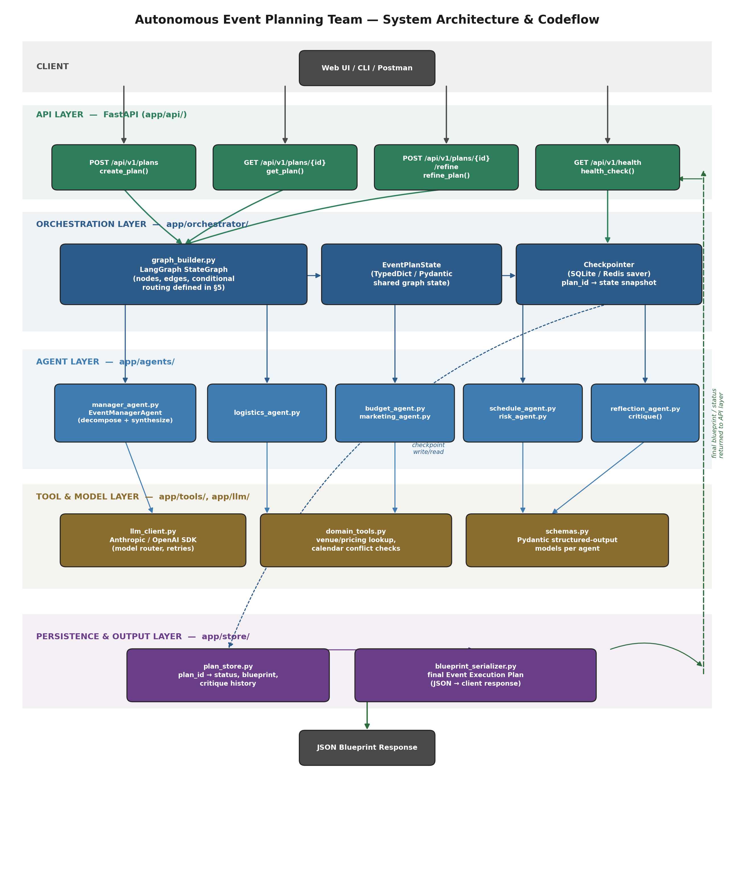
Figure 1. System architecture and codeflow — request enters through the API layer, is handed to the LangGraph orchestrator, fans out across the agent layer, uses the tool/model layer for LLM and domain-tool calls, and persists through the store layer before the final blueprint is returned.

4.1 Layer Responsibilities
- API Layer (app/api/) — FastAPI routers only. Validates requests with Pydantic, translates them into orchestrator calls, and shapes responses. Contains zero planning logic.
- Orchestration Layer (app/orchestrator/) — Owns the LangGraph StateGraph: node registration, edges, the conditional revision-routing function, and the checkpointer that persists EventPlanState after every node.
- Agent Layer (app/agents/) — One module per agent (manager, five specialists, reflection). Each agent is a pure function of state in → state out, which makes unit testing straightforward.
- Tool & Model Layer (app/tools/, app/llm/) — Wraps LLM calling through LiteLLM (unified Azure OpenAI / Gemini / Ollama interface, retries, and fallback routing), any domain tools (venue/pricing lookups, calendar checks), and the Pydantic schemas used for structured output.
- Persistence & Output Layer (app/store/) — Maps plan_id to status, blueprint, and critique history, and serializes the final blueprint for the API response.

4.2 Why a Minimal API Surface
Every cross-agent interaction — delegation, synthesis, critique, revision — happens inside the LangGraph run, not across HTTP calls. This means the number of public endpoints does not grow with the number of agents: adding a sixth specialist agent later requires a new node and edge in the orchestrator, not a new endpoint. Section 7 details the four endpoints this yields.

5. Agent Roster & Responsibilities
Seven agents participate in every planning run: one manager, five domain specialists, and one reflection agent. No specialist agent communicates with another specialist directly — all coordination is mediated by the Event Manager Agent, which keeps the delegation model strictly hierarchical (Section 10).
Agent | Role Type | Core Responsibility | Key Inputs | Key Outputs
Event Manager Agent | Orchestrator | Decomposes the brief into sub-tasks, delegates to specialists, synthesizes the draft blueprint, and re-delegates targeted revisions. | Brief, specialist outputs, critique notes | Task assignments, draft/final blueprint
Logistics Planning Agent | Specialist | Venue selection, room layout, equipment, catering and vendor logistics. | Brief, budget ceiling, audience size | LogisticsPlan
Budget & Finance Agent | Specialist | Cost estimation and budget allocation across categories; enforces the stated budget constraint. | Brief, draft costs from other specialists | BudgetPlan
Marketing & Promotion Agent | Specialist | Promotion channel strategy, content calendar, and outreach timeline. | Brief, audience size, schedule draft | MarketingPlan
Schedule Coordination Agent | Specialist | Builds the master timeline, sequences tasks, and flags cross-track dependency conflicts. | All specialist outputs | ScheduleTimeline
Risk & Operations Agent | Specialist | Identifies risks (weather, no-shows, vendor failure) and defines contingency and on-day operations plans. | All specialist outputs | RiskRegister
Reflection / Critique Agent | Quality Gate | Scores the draft blueprint against a fixed rubric and emits actionable, targeted critique notes. | Draft blueprint | CritiqueReport + revision targets

6. Workflow & State Machine Design
The planning process is modeled as a LangGraph StateGraph. Every node reads and writes a single shared state object, EventPlanState (Section 8), which is checkpointed after each node so that a run can be inspected, resumed, or refined later without replaying earlier work.
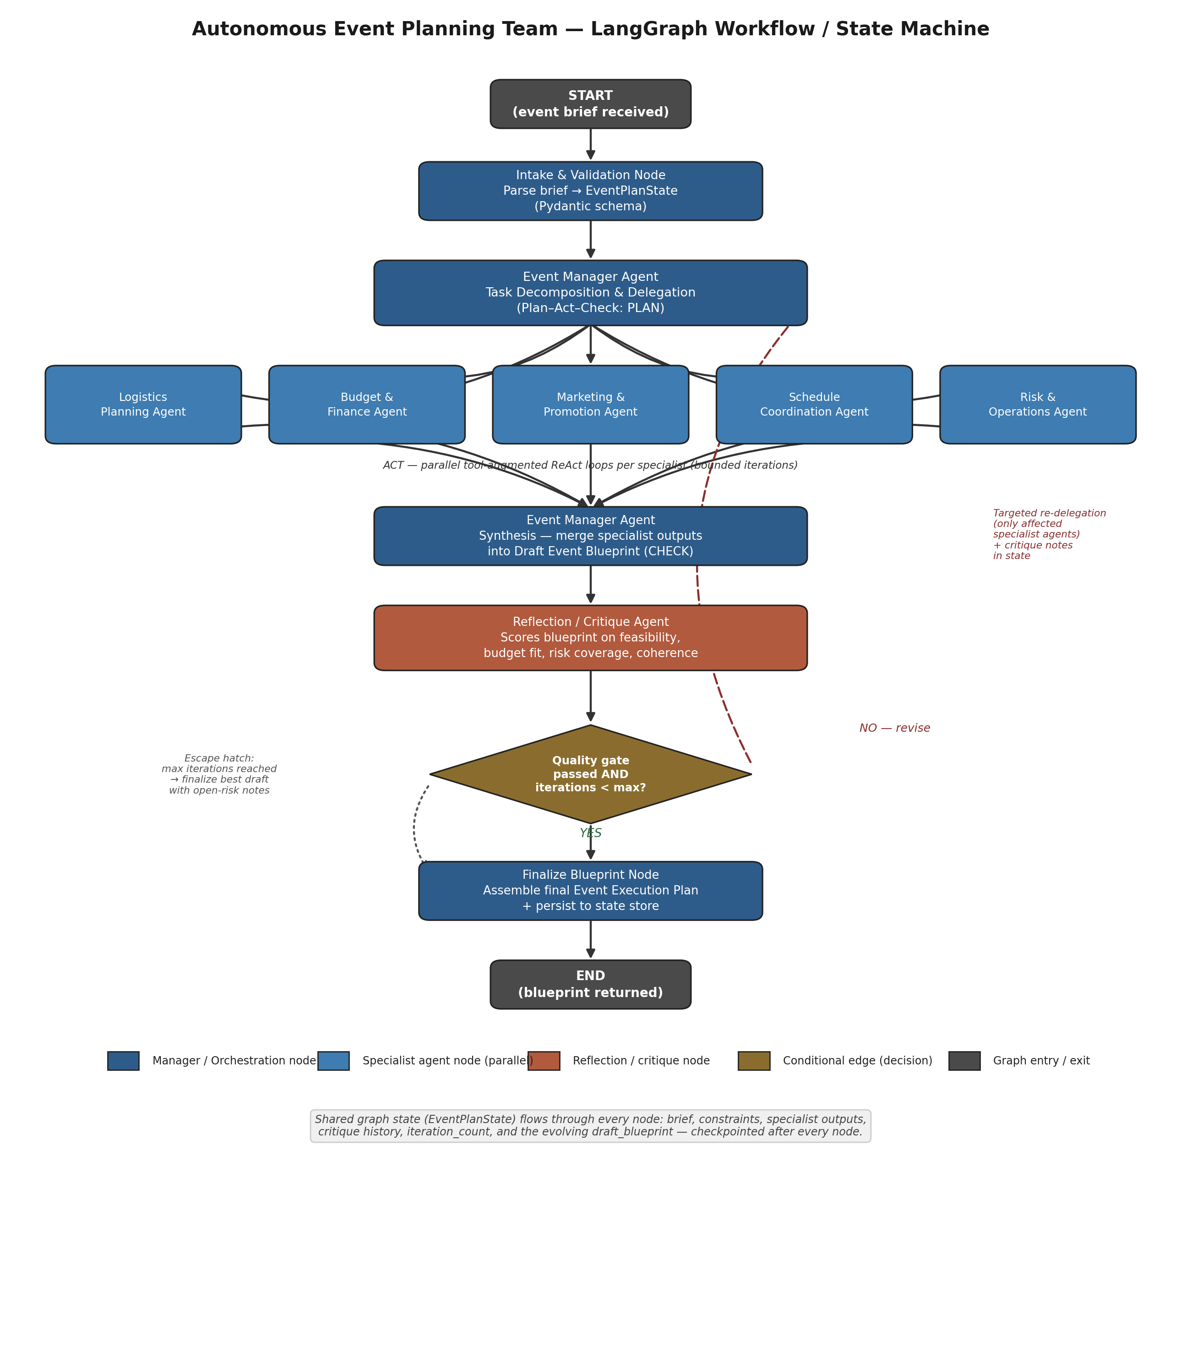
Figure 2. LangGraph workflow — intake, manager-led decomposition, five parallel specialist nodes, manager synthesis, a reflection quality gate, and a bounded revision loop before finalization.

6.1 Node-by-Node Description
- Intake & Validation — parses the incoming brief into EventPlanState using the EventBrief Pydantic schema; rejects malformed requests before any LLM call is made.
- Event Manager: Task Decomposition (PLAN) — the manager reads the brief and constraints and produces five task assignments, one per specialist, each scoped to that specialist's domain.
- Specialist Nodes (ACT) — the five specialist agents run in parallel, each executing a bounded ReAct loop (reason → call domain tool if needed → observe → finalize output) capped at a small fixed number of tool calls.
- Event Manager: Synthesis (CHECK) — the manager merges the five specialist outputs into a single draft_blueprint, resolving obvious conflicts (e.g., a schedule clash) itself before handing off to reflection.
- Reflection / Critique Agent — scores the draft on feasibility, budget fit, risk coverage, and coherence (Section 9) and writes a CritiqueReport, including which specialist areas need revision if the score is below threshold.
- Conditional Edge: Quality Gate — if the critique passes and iteration_count is below max_iterations, the graph proceeds to Finalize. Otherwise it routes back to Task Decomposition, but only re-assigns the specialists named in the critique's revision targets.
- Finalize Blueprint — assembles the final Event Execution Plan, marks status as completed, and persists the result.
- Escape Hatch — if max_iterations is reached without a passing score, the graph finalizes the best available draft with the outstanding critique notes attached as open-risk items, rather than looping indefinitely.

6.2 Why Targeted Re-Delegation, Not Full Restart
On a failed quality gate, the manager only re-invokes the specialist agents named in the critique's revision_targets, carrying forward the untouched outputs from the other specialists. This bounds the cost of each revision cycle to roughly one-fifth of a full replanning pass and is the single largest cost/latency optimization in the design (Section 11).

7. API Design
The API surface is kept to four endpoints on purpose. Creation, status/result retrieval, iterative refinement, and health are the only operations a client ever needs — everything else (delegation, synthesis, reflection, revision routing) is an internal graph transition, not an HTTP-visible action.
Method | Path | Purpose
POST | /api/v1/plans | Create a new event plan and start the multi-agent workflow.
GET | /api/v1/plans/{plan_id} | Retrieve the current status, draft/final blueprint, and critique history of a plan.
POST | /api/v1/plans/{plan_id}/refine | Submit a refinement instruction; re-enters the graph for a new, targeted revision cycle.
GET | /api/v1/health | Liveness/readiness check for the API, LLM provider, and state store.

7.1 POST /api/v1/plans
Creates a new plan and starts the LangGraph run asynchronously (the run typically involves multiple parallel LLM calls and may take longer than a typical HTTP timeout). Returns immediately with a plan_id for polling.

Request Body
{
"event_type": "AI Workshop",
"objective": "Educate 200 students on generative AI fundamentals",
"audience_size": 200,
"budget": { "currency": "INR", "max_amount": 500000 },
"timeline": { "preferred_date": "2026-09-15", "duration_days": 1 },
"venue_preference": "on-campus auditorium",
"constraints": ["must include a hands-on lab", "vegetarian catering only"]
}

Response — 202 Accepted
{
"plan_id": "plan_8f3ac2",
"status": "in_progress",
"created_at": "2026-07-01T10:15:00Z",
"poll_url": "/api/v1/plans/plan_8f3ac2"
}

7.2 GET /api/v1/plans/{plan_id}
Returns the current snapshot of the plan's state. Clients poll this endpoint until status is completed (or failed).

Response — 200 OK
{
"plan_id": "plan_8f3ac2",
"status": "completed",
"iteration_count": 2,
"blueprint": {
"overview": { "...": "..." },
"logistics": { "...": "..." },
"budget": { "...": "..." },
"marketing": { "...": "..." },
"schedule": { "...": "..." },
"risks": { "...": "..." }
},
"critique_summary": [
{ "iteration": 1, "score": 0.62, "revised_areas": ["budget", "schedule"] },
{ "iteration": 2, "score": 0.88, "revised_areas": [] }
],
"updated_at": "2026-07-01T10:16:40Z"
}
status is one of: in_progress, needs_review, completed, failed. needs_review is used only in the rare case the escape hatch in Section 6.1 is triggered.

7.3 POST /api/v1/plans/{plan_id}/refine
Re-opens a completed (or needs_review) plan with a new instruction, e.g. a budget cut or a request to strengthen risk coverage. The manager agent decides which specialists actually need to re-run; target_agents is an optional hint, not a hard override.

Request Body
{
"instruction": "Reduce total budget by 20% without cancelling the keynote speaker",
"target_agents": ["budget", "logistics"]
}

Response — 202 Accepted
{
"plan_id": "plan_8f3ac2",
"status": "in_progress",
"iteration_count": 3
}

7.4 GET /api/v1/health

Response — 200 OK
{
"status": "ok",
"llm_provider_reachable": true,
"state_store_reachable": true,
"version": "1.0.0"
}

8. Core Data Models
All inter-agent data exchange uses typed Pydantic models rather than free-form text, both to reduce hallucinated fields and to give the reflection agent something structured to score against.

8.1 EventPlanState — the shared LangGraph state
class EventPlanState(TypedDict):
plan_id: str
brief: EventBrief
constraints: list[str]
specialist_outputs: dict[str, SpecialistOutput]
draft_blueprint: EventBlueprint | None
critique_history: list[CritiqueNote]
iteration_count: int
max_iterations: int # default 3
active_revision_targets: list[str]
status: Literal[
"in_progress", "needs_review", "completed", "failed"
]

8.2 EventBrief — the validated request
class EventBrief(BaseModel):
event_type: str
objective: str
audience_size: int
budget: BudgetConstraint
timeline: TimelinePreference
venue_preference: str | None = None
constraints: list[str] = []

8.3 CritiqueNote — reflection agent output
class CritiqueNote(BaseModel):
iteration: int
score: float # 0.0 - 1.0, weighted rubric (Sec. 9)
passed: bool
revision_targets: list[str] # e.g. ["budget", "schedule"]
notes: dict[str, str] # per-dimension rationale

9. Reflection & Self-Correction Mechanism
The Reflection Agent is a distinct node, not a self-critique prompt appended to the manager's synthesis step. Separating it out means the critique is generated by a fresh reasoning pass over the finished draft, which produces more reliable revision targets than asking the same agent that wrote the plan to also grade it.

9.1 Scoring Rubric
Dimension | Weight | What It Checks
Feasibility | 35% | Can the plan realistically be executed given the stated timeline and audience size?
Budget Fit | 25% | Does the aggregated cost stay within the stated budget constraint?
Risk Coverage | 20% | Does the risk register address the most likely failure modes for this event type?
Coherence | 20% | Are the five specialist outputs mutually consistent (no date/venue/headcount conflicts)?
A draft passes the quality gate when the weighted score is at or above 0.80 and iteration_count is below max_iterations (default 3). Below threshold, the critique's revision_targets list determines exactly which specialist nodes are re-invoked — see Section 6.2.

9.2 Bounded Iteration
max_iterations defaults to 3. This bound, combined with the escape hatch in Section 6.1, guarantees the workflow always terminates: either with a passing blueprint or with the best available draft plus explicit open-risk notes, never with an unbounded loop.

10. Hierarchical Delegation Model
Delegation is strictly two-level: the Event Manager Agent is the only node that assigns work and the only node that reads all five specialist outputs at once. Specialist agents never call each other, which keeps the coordination graph simple to reason about and simple to test in isolation.

10.1 Decomposition
On task decomposition, the manager converts the EventBrief into five scoped task assignments, one per specialist, each containing only the fields that specialist needs (e.g., the Marketing agent never sees raw budget line items, only the marketing allocation ceiling).

10.2 Synthesis
On synthesis, the manager merges the five SpecialistOutput objects into one EventBlueprint with fixed sections — Overview, Logistics, Budget, Marketing, Schedule, Risks — and performs first-pass conflict resolution itself (for example, if the Schedule agent flags a date conflict with the Logistics agent's venue booking window, the manager decides how to resolve it before handing the draft to reflection).

10.3 Targeted Re-Delegation
When the Reflection Agent fails a draft, the manager re-issues task assignments only to the specialists named in revision_targets, passing them the relevant critique notes as additional context. Untouched specialist outputs from the prior iteration are carried forward unchanged.

11. Optimization Strategy

11.1 Cost
- Single decomposition call: the manager issues all five task assignments in one call rather than one call per specialist.
- Targeted re-delegation: revision cycles re-run only the flagged specialists (Section 6.2), typically 1-2 of 5 agents.
- Model routing, not tiering: all seven agent-reasoning nodes (manager, five specialists, reflection) call Azure OpenAI gpt-4o-mini as the single primary model, avoiding the quality inconsistency of a strong/weak split. On Azure errors, timeouts, or rate limits, calls automatically fall back to Google Gemini (gemini-flash-lite-latest). Non-reasoning helper tasks (input normalization, preliminary revision-target tagging) route to a local Ollama phi3:mini model, which costs nothing per call and keeps that traffic off both paid APIs entirely. LiteLLM provides the underlying Router — all three deployments and the fallback rule are declared once, not hand-coded per call site.
- Response caching: identical sub-queries within a run (e.g., repeated venue lookups) are memoized for the lifetime of the graph run.

11.2 Latency
- Parallel specialist execution: the five specialist nodes run concurrently via LangGraph's parallel fan-out, not sequentially.
- Checkpointed resume: if a node fails, the run resumes from the last successful checkpoint instead of restarting the whole graph.
- Bounded tool loops: each specialist's ReAct loop is capped at a small fixed number of tool calls to prevent runaway latency on a single node.

11.3 Quality
- Structured outputs: every agent returns a typed Pydantic object, eliminating a large class of parsing and hallucination errors.
- Independent reflection pass: as covered in Section 9, critique is generated by a separate reasoning pass rather than self-grading.
- Bounded iteration with escape hatch: guarantees termination while still allowing up to three genuine improvement cycles.

12. Error Handling & Production Considerations

12.1 Typed Exception Hierarchy
class EventPlanningError(Exception): ...
class ValidationError(EventPlanningError): ...
class LLMProviderError(EventPlanningError): ...
class AgentExecutionError(EventPlanningError): ...
class MaxIterationsExceededError(EventPlanningError): ...

12.2 Resilience Practices
- Retries with backoff — LLM calls retry on transient provider errors with exponential backoff and a small retry ceiling.
- Idempotent creation — POST /api/v1/plans accepts an optional client-supplied idempotency key to prevent duplicate runs on client retry.
- Graceful degradation — Langfuse tracing is a mandatory dependency of the system (Section 14), not optional — but if the Langfuse endpoint is briefly unreachable, the run logs locally and continues rather than failing the plan; missed spans are not a reason to fail a planning run.
- Checkpointed state — every node write is checkpointed, so a mid-run failure loses at most one node's work, not the whole plan.
- Fail-safe finalize — the escape hatch (Section 6.1) means a plan is always returned to the client, even if it never reaches a passing critique score.

13. Security & Data Validation
Event briefs and refinement instructions routinely carry personal data — attendee contacts, vendor emails, phone numbers for on-day coordination. This section defines how that data is detected, redacted, and validated before it ever reaches an LLM provider, and how agent outputs are validated on the way back out.

13.1 PII Detection & Redaction
- Redaction point — PII redaction runs inside Intake & Validation (Section 6.1, step 1) before EventPlanState is constructed and before any LLM call is made — raw PII never reaches Azure OpenAI, Gemini, or the local Ollama model.
- Engine strategy — Guardrails AI is the documented primary engine, since its validators cover both PII detection and general output validation in one framework. Microsoft Presidio is the required fallback and is used wherever Guardrails is not installed or not available — this is expected to vary by teammate/environment, so the PII_ENGINE config flag (not a code branch) decides which one runs.
- Token substitution — detected spans are replaced with stable placeholder tokens (e.g., [PERSON_1], [EMAIL_1]) rather than deleted outright, so downstream agents can still reason about “the point of contact” without ever seeing the underlying value.

13.2 Input/Output Validation
- Schema validation — Guardrails (where available) or direct Pydantic validation enforces the EventBrief and all inter-agent schemas from Section 8, rejecting malformed requests before they enter the graph.
- Structured-output checks — each agent’s typed output (LogisticsPlan, BudgetPlan, etc.) is validated against its schema immediately after generation, catching hallucinated or missing fields before they reach EventPlanState.
- Rejection handling — a failed validation raises ValidationError from the exception hierarchy in Section 12.1, which the API layer maps to a 422 response rather than silently passing bad data downstream.

13.3 Secrets & Tracing Hygiene
- All provider credentials (Azure OpenAI, Gemini, Langfuse) live in .env only, per the variable list in Section 17.1 — never in code, prompts, or logs.
- Redaction happens before tracing, not after: Langfuse spans (Section 17.10) receive already-redacted payloads, so PII cannot leak into trace history either.

14. Technology Stack
Category | Choice | Purpose
Language | Python 3.11+ | Core implementation language.
Orchestration | LangGraph | Stateful workflow graph, checkpointing, conditional routing.
Agent Abstractions | LangChain | Prompt templates, structured-output parsing, tool binding.
Primary / Fallback LLM | Azure OpenAI (gpt-4o-mini) + Gemini fallback + Ollama phi3-mini, via LiteLLM | Primary: Azure OpenAI gpt-4o-mini for all agent reasoning (manager, specialists, reflection). Fallback: Google Gemini (gemini-flash-lite-latest) on Azure errors or rate limits. Local: Ollama phi3-mini for non-reasoning helper tasks only. LiteLLM provides the single calling interface and automatic fallback across all three.
Validation | Pydantic v2 | EventBrief, EventPlanState, and all inter-agent schemas.
Security & PII | Guardrails AI (primary) / Microsoft Presidio (fallback) | Structured-output validation and PII detection/redaction; swappable via the PII_ENGINE config flag (Section 13).
API Framework | FastAPI + Uvicorn | The four endpoints described in Section 7.
Checkpoint Store | SQLite | LangGraph checkpointer backing store.
Config | python-dotenv | Environment variable management.
Observability (mandatory) | Langfuse | Per-node tracing for debugging and demo walkthroughs.
Testing | pytest | Unit tests per agent node plus end-to-end graph tests.
Deployment | uvicorn (bare-metal / venv) | Local process (uvicorn); no container runtime required for this project’s scope.

15. Sprint & Deliverable Mapping
This blueprint is organized so that each course sprint deliverable maps directly onto a set of sections, allowing it to be submitted incrementally as the sprint schedule requires.
Sprint | Deliverable | Blueprint Sections
Sprint 11 | Project Architecture & System Design | Sections 2–6 (problem, goals, architecture, agents, workflow)
Sprint 11 | Implementation Setup | Section 14 (tech stack) + Section 17 (full repository structure)
Sprint 12 | Core Multi-Agent Implementation | Sections 5–10 (agents, workflow, API, data models, reflection, delegation)
Sprint 12 | Refactoring & Optimization | Sections 11–13 (optimization, error handling, security & validation)
Sprint 14/15 | Final Presentation & Demonstration | Full document as architecture reference; Figures 1–2 as presentation diagrams

16. Evaluation Criteria Alignment
Evaluation Parameter | Weight | Addressed In
Architecture & Workflow Design | 20% | Sections 4, 6, Figures 1–2
Multi-Agent Coordination | 25% | Sections 5, 6.1, 10
Reflection & Self-Correction | 15% | Section 9
Hierarchical Delegation | 15% | Section 10
Optimization & Code Quality | 15% | Sections 11, 12, 13
Demo & Documentation | 10% | This document; Section 17 repo layout; Section 18 roadmap

17. Project & Repository Structure
This section is the literal, file-by-file scaffold for the repository. It mirrors the five architecture layers from Section 4 one-to-one, so there is no ambiguity about where any given piece of logic belongs. Create the folders and empty files in this order, then fill them in following the roadmap in Section 18.
autonomous-event-planning-team/
|-- app/
| |-- __init__.py
| |-- main.py
| |-- config.py
| |-- api/
| | |-- __init__.py
| | |-- routers/
| | | |-- __init__.py
| | | |-- plans.py
| | | `-- health.py
| | |-- schemas/
| | | |-- __init__.py
| | | |-- requests.py
| | | `-- responses.py
| | `-- dependencies.py
| |-- orchestrator/
| | |-- __init__.py
| | |-- graph_builder.py
| | |-- nodes.py
| | |-- edges.py
| | |-- state.py
| | `-- checkpointer.py
| |-- agents/
| | |-- __init__.py
| | |-- base.py
| | |-- manager_agent.py
| | |-- logistics_agent.py
| | |-- budget_agent.py
| | |-- marketing_agent.py
| | |-- schedule_agent.py
| | |-- risk_agent.py
| | |-- reflection_agent.py
| | `-- prompts/
| | |-- __init__.py
| | |-- manager_prompts.py
| | |-- specialist_prompts.py
| | `-- reflection_prompts.py
| |-- llm/
| | |-- __init__.py
| | |-- client.py
| | `-- model_router.py
| |-- tools/
| | |-- __init__.py
| | |-- venue_tool.py
| | |-- pricing_tool.py
| | `-- calendar_tool.py
| |-- store/
| | |-- __init__.py
| | |-- plan_store.py
| | `-- blueprint_serializer.py
| `-- errors/
| |-- __init__.py
| `-- exceptions.py
| |-- security/
| | |-- __init__.py
| | |-- pii_validator.py
| | |-- guardrails_engine.py
| | `-- presidio_engine.py
| |-- observability/
| | |-- __init__.py
| | `-- langfuse_tracer.py
|-- tests/
| |-- __init__.py
| |-- conftest.py
| |-- test_agents/
| | |-- test_manager_agent.py
| | |-- test_specialist_agents.py
| | `-- test_reflection_agent.py
| |-- test_orchestrator/
| | |-- test_graph_builder.py
| | `-- test_edges.py
| `-- test_api/
| |-- test_plans_endpoint.py
| `-- test_health_endpoint.py
|-- scripts/
| `-- run_local.py
|-- docs/
| |-- architecture_diagram.png
| `-- workflow_diagram.png
|-- .env.example
|-- pyproject.toml
|-- .gitignore
`-- README.md
Figure 3. Full repository layout for the Autonomous Event Planning Team.

17.1 Root-Level Files
- app/ — the entire application package; everything importable lives under this single top-level package.
- .env.example — documents every environment variable the system needs: AZURE_OPENAI_API_KEY, AZURE_OPENAI_ENDPOINT, AZURE_OPENAI_DEPLOYMENT_NAME, AZURE_OPENAI_API_VERSION (primary LLM), GEMINI_API_KEY, GEMINI_MODEL_NAME (fallback LLM, defaults to gemini-flash-lite-latest), OLLAMA_BASE_URL, OLLAMA_MODEL_NAME (local helper-task LLM, defaults to phi3:mini), PII_ENGINE, PRESIDIO_ENABLED, GUARDRAILS_API_KEY (Section 13 security stack), LANGFUSE_PUBLIC_KEY, LANGFUSE_SECRET_KEY, LANGFUSE_HOST (mandatory tracing), DEBUG_MODE, DATABASE_URL, MAX_ITERATIONS. Copied to .env locally; never committed with real values — model names are always read from here, never hardcoded in agent or router code.
- pyproject.toml — pins fastapi, uvicorn, langgraph, langchain, pydantic, python-dotenv, litellm (unified Azure/Gemini/Ollama calling + fallback routing), guardrails-ai, presidio-analyzer / presidio-anonymizer, and langfuse. A single dependency file, chosen since this is a packaged application, not a script collection.
- .gitignore — excludes .env, __pycache__/, *.db (local SQLite checkpoint files), and any local venv directory.
- README.md — quick-start instructions: install, set environment variables, run uvicorn, and call the four endpoints from Section 7.

17.2 app/ — Root Application Files
- app/main.py — creates the FastAPI() app instance, registers the plans and health routers, and wires startup/shutdown events (e.g., opening and closing the checkpoint store connection).
- app/config.py — a Pydantic BaseSettings class (Settings) that reads every value from .env: model names per tier, MAX_ITERATIONS, the quality-gate score threshold (0.80 per Section 9.1), and the checkpoint backend URL. Imported everywhere else via a single get_settings() dependency.

17.3 app/api/ — API Layer (Section 4.1)
- api/routers/plans.py — implements create_plan(), get_plan(), and refine_plan() — the three plan-related endpoints from Section 7. Each function only validates input, calls the orchestrator, and shapes the response; no planning logic lives here.
- api/routers/health.py — implements health_check(), pinging the configured LLM provider and the checkpoint store and returning the HealthResponse shape from Section 7.4.
- api/schemas/requests.py — CreatePlanRequest and RefinePlanRequest Pydantic models, matching the request bodies documented in Sections 7.1 and 7.3.
- api/schemas/responses.py — PlanCreatedResponse, PlanStatusResponse, and HealthResponse Pydantic models, matching Sections 7.1, 7.2, and 7.4.
- api/dependencies.py — FastAPI dependency-injection functions such as get_orchestrator() and get_plan_store(), so routers never import orchestrator/store internals directly.

17.4 app/orchestrator/ — Orchestration Layer (Section 4.1)
- orchestrator/state.py — defines EventPlanState exactly as specified in Section 8.1; this is the single object every node reads and writes.
- orchestrator/graph_builder.py — builds the LangGraph StateGraph: registers every node from Section 6.1, wires the edges (including the parallel fan-out to the five specialists), attaches the conditional quality-gate edge, and compiles the graph with the checkpointer attached. Exposes a single build_graph() used by the API layer.
- orchestrator/nodes.py — thin wrapper functions that adapt each agent's run() method to the (state) -> state node signature LangGraph expects; keeps agent classes themselves framework-agnostic.
- orchestrator/edges.py — the conditional routing function implementing the quality gate from Section 6.1, step 6 (route to Finalize on pass, back to targeted Task Decomposition on fail, or to the escape hatch when max_iterations is reached).
- orchestrator/checkpointer.py — instantiates the LangGraph SQLite checkpoint saver. A single backend keeps local dev and grading/demo runs identical; swapping in a different backend later is a one-file change if the project ever needs it.

17.5 app/agents/ — Agent Layer (Section 4.1, Section 5)
- agents/base.py — a BaseAgent abstract class providing the shared bounded ReAct loop (reason -> optionally call a tool -> observe -> finalize) that every specialist agent inherits, per Section 6.1 step 3.
- agents/manager_agent.py — EventManagerAgent with two entry points: decompose() (Section 6.1 step 2 / Section 10.1) and synthesize() (Section 6.1 step 4 / Section 10.2), plus the targeted re-delegation logic from Section 10.3.
- agents/logistics_agent.py, budget_agent.py, marketing_agent.py, schedule_agent.py, risk_agent.py — one file per specialist from Section 5's agent roster table; each subclasses BaseAgent and returns its typed SpecialistOutput (LogisticsPlan, BudgetPlan, MarketingPlan, ScheduleTimeline, or RiskRegister).
- agents/reflection_agent.py — implements critique(), scoring the draft blueprint against the weighted rubric in Section 9.1 and returning a CritiqueNote.
- agents/prompts/ — one prompt-template module per agent family (manager_prompts.py, specialist_prompts.py, reflection_prompts.py), kept separate from agent logic so prompts can be iterated on without touching control flow.

17.6 app/llm/ — Tool & Model Layer, LLM Half (Section 4.1)
- llm/client.py — wraps litellm.completion() calls (Azure OpenAI, Gemini, and local Ollama all speak the same interface here) with timeouts and the retry/backoff policy from Section 12.2 layered on top of LiteLLM’s own retry handling.
- llm/model_router.py — implements the model-routing strategy from Section 11.1 as a LiteLLM Router model_list: the seven agent-reasoning nodes target Azure OpenAI gpt-4o-mini with a declared fallback to Gemini (gemini-flash-lite-latest), and non-reasoning helper tasks target the local Ollama phi3-mini model — three deployments, one Router config, no hand-rolled provider-switching logic.

17.7 app/tools/ — Tool & Model Layer, Domain-Tools Half (Section 4.1)
- tools/venue_tool.py — venue availability/lookup used by the Logistics agent.
- tools/pricing_tool.py — cost/pricing lookups used by the Budget and Logistics agents; results are memoized per run per the caching optimization in Section 11.1.
- tools/calendar_tool.py — calendar conflict checks used by the Schedule agent.

17.8 app/store/ — Persistence & Output Layer (Section 4.1)
- store/plan_store.py — maps plan_id to status, the latest draft/final blueprint, and critique_history; backs GET /api/v1/plans/{plan_id} (Section 7.2).
- store/blueprint_serializer.py — converts the final EventBlueprint object into the JSON shape returned to the client, matching the response example in Section 7.2.

17.9 app/security/ — Security & Validation Layer (Section 13)
- security/pii_validator.py — a single swappable interface (redact(text) -> RedactedText) that the Intake node and the blueprint serializer call; which engine actually runs is a config choice, not a code branch.
- security/guardrails_engine.py — the primary implementation, using Guardrails AI validators for both structured-output schema conformance and PII detection where Guardrails is available.
- security/presidio_engine.py — the required fallback implementation using Microsoft Presidio for PII detection/redaction; this is the default engine in local/teammate environments where Guardrails is not installed.

17.10 app/observability/ — Tracing Layer (Section 12.2, Section 13)
- observability/langfuse_tracer.py — wraps every orchestrator node execution in a Langfuse trace span (mandatory, not optional); redaction from security/pii_validator.py runs before any payload is sent to Langfuse, so raw PII never leaves the process.

17.11 app/errors/ — Typed Exceptions (Section 12.1)
- errors/exceptions.py — the full exception hierarchy from Section 12.1 (EventPlanningError, ValidationError, LLMProviderError, AgentExecutionError, MaxIterationsExceededError), imported by both the agent layer and the API layer for consistent error responses.

17.12 tests/, scripts/, docs/
- tests/test_agents/ — unit tests per agent, exercising each one as a pure state-in/state-out function without running the full graph.
- tests/test_orchestrator/ — tests for graph_builder.py (correct nodes/edges registered) and edges.py (the quality-gate routing logic, including the escape hatch).
- tests/test_api/ — end-to-end tests hitting the four endpoints from Section 7 against a running test client.
- scripts/run_local.py — a convenience CLI script that posts one of the three example prompts from Section 2.2 straight to a locally running instance, for quick manual demos.
- docs/ — stores the exported architecture_diagram.png and workflow_diagram.png (Figures 1–2 of this document) for reuse in the Sprint 14/15 final presentation.

18. Implementation Roadmap
- Scaffold the repository exactly as laid out in Section 17 (every folder and file, with its purpose).
- Define EventBrief, EventPlanState, and all specialist/critique schemas from Section 8 first — every agent depends on them.
- Implement the Intake, Manager (decomposition + synthesis), and one specialist agent end-to-end; get a single-agent path working before adding the rest.
- Add the remaining four specialist agents and wire the parallel fan-out in the orchestrator.
- Implement the Reflection Agent and the conditional quality-gate edge, including the bounded iteration counter and escape hatch.
- Wire the checkpointer (SQLite locally) and implement the four API endpoints from Section 7 as thin wrappers over the graph.
- Add the typed exception hierarchy and retry/backoff logic from Section 12.
- Wire PII redaction (Section 13) into the Intake node and Langfuse tracing (Section 17.10) into every orchestrator node, before layering in optimization passes.
- Apply the optimization passes from Section 11 (model routing, targeted re-delegation, caching) and measure latency/cost before and after.
- Test with the three example prompts from Section 2.2, including at least one refinement cycle via POST /refine.
- Prepare the final demo using Figures 1–2 as the architecture and workflow walkthrough slides.

