FinDoc Analyzer
Financial Report Intelligence System
Production-Grade RAG System Blueprint

LlamaIndex | Python | PostgreSQL + pgvector | FastAPI | MCP Integration

Project  FinDoc Analyzer | Scenario  Course-3 RAG Capstone
Framework  LlamaIndex (Python) | Database  PostgreSQL + pgvector

Sample Dataset: TechVision Corporation Annual Report 2024 | Revenue: $1.83B | YoY Growth: 23%

- Executive Overview

FinDoc Analyzer is a production-grade AI-powered Financial Report Intelligence System built as the capstone project for the Production-Grade RAG Systems course. The system enables financial analysts, auditors, investors, and compliance teams to query dense financial documents using natural language — combining unstructured RAG retrieval with structured SQL lookups for accurate, explainable results.
Core Mission

Objective | Description
Intelligent Querying | Allow natural language questions over financial reports like TechVision's 2024 Annual Report
Hybrid Retrieval | Route queries dynamically between RAG (narrative), SQL (numeric), and Hybrid
Source Traceability | Every numeric answer must cite its exact source document and table
Safety & Guardrails | Prevent hallucinated financial figures; flag uncertain or ambiguous answers
Human Escalation | Route complex/ambiguous decisions to human financial experts with full context
Why TechVision Corporation Annual Report 2024?
This report provides an ideal real-world dataset: dense financial tables (revenue $1.83B, +23% YoY), narrative risk disclosures, quarterly trend charts (Q1 2022 to Q4 2024), and forward-looking guidance — spanning all three retrieval modes the system must support.

- System Architecture

The system is built as a layered, modular backend with clear separation between ingestion, retrieval, routing, and response generation. All components communicate through well-defined APIs.

  - High-Level Architecture Layers

Layer | Components | Responsibility
Ingestion Layer | PDF Parser, Table Extractor, Chunker, Embedder | Parse financial documents, extract structured tables, create semantic chunks, generate embeddings
Storage Layer | pgvector (vectors), PostgreSQL (structured), File Store (raw docs) | Persist all data forms: embeddings, financial time-series, raw PDFs
Routing Layer | Query Classifier, Intent Detector, Router | Determine whether each query needs RAG, SQL, or Hybrid retrieval
Retrieval Layer | LlamaIndex RAG Pipeline, SQLAlchemy Query Engine, Hybrid Combiner | Execute the appropriate retrieval strategy and return relevant context
Generation Layer | Claude / OpenAI LLM, Prompt Templates, Context Assembler | Generate grounded, cited responses with source attribution
Safety Layer | guardrails-ai, Numeric Validator, Uncertainty Handler | Validate financial figures, detect hallucinations, flag ambiguous outputs
API Layer | FastAPI, Uvicorn, REST endpoints | Expose query and management APIs for frontend and external integrations
Evaluation Layer | RAGAS, Langfuse, SLO Monitor | Continuously measure retrieval quality, latency, and correctness
MCP Layer | MCP Server, External Financial APIs | Integrate real-time financial data sources via Model Context Protocol

  - Query Flow Diagram
Each user query follows this deterministic path through the system:

1. User Query (Natural Language)
2. Safety Pre-check → Guardrails Input Validation
3. Query Classification → Intent Detection (RAG / SQL / Hybrid / Escalate)
4a. RAG Path: LlamaIndex retrieves relevant document chunks from pgvector

4b. SQL Path: SQLAlchemy executes deterministic financial queries on PostgreSQL
4c. Hybrid Path: Both paths execute; Combiner merges results
4d. Escalation Path: Full context packaged and routed to human expert
5. Context Assembly → Prompt Engineering → LLM Generation
6. Safety Post-check → Numeric Validation → Source Attribution
7. Response + Citations returned to User
8. Evaluation logged to Langfuse (latency, correctness, routing accuracy)

- Technology Stack

  - Core Technologies

Category | Technology | Purpose
Language | Python 3.11+ | Primary development language
RAG Framework | LlamaIndex | Document ingestion, indexing, retrieval pipelines
API Framework | FastAPI + Uvicorn | REST API backend and async server
Vector DB | PostgreSQL + pgvector | Semantic similarity search for document chunks
Structured DB | PostgreSQL + SQLAlchemy | Financial statements, ratios, time-series data
LLM Provider | Anthropic Claude (primary) / OpenAI (fallback) | Response generation
PDF Parsing | PyMuPDF / pypdf | Financial document ingestion
Table Extraction | pandas + camelot / pdfplumber | Extract financial tables from PDFs
Guardrails | guardrails-ai | Financial accuracy validation
Evaluation | RAGAS + Langfuse | RAG pipeline evaluation and observability
MCP Integration | Model Context Protocol (MCP) | External financial data source access
Environment | python-dotenv | Secrets and config management
Containerization | Docker + docker-compose | Reproducible deployment

  - Environment Variables

Variable | Purpose
ANTHROPIC_API_KEY | Claude API authentication for LLM generation
OPENAI_API_KEY | OpenAI fallback API authentication
DATABASE_URL | PostgreSQL connection string (with pgvector extension)
MCP_SERVER_URL | MCP server endpoint for external financial data

LANGFUSE_PUBLIC_KEY | Langfuse observability platform public key
LANGFUSE_SECRET_KEY | Langfuse observability platform secret key
EMBEDDING_MODEL | Embedding model name (e.g. text-embedding-3-small)
VECTOR_DIMENSION | Embedding vector dimensions (e.g. 1536)

- Project Structure

The project follows a clean, modular layout that maps each system component to a dedicated Python module. Every component is independently testable.

findoc-analyzer/
├── app/
│ ├── main.py # FastAPI application entry point
│ ├── config.py # Settings, env vars, constants
│ ├── ingestion/
│ │ ├── pdf_parser.py # PyMuPDF / pypdf document loader
│ │ ├── table_extractor.py # Financial table extraction (camelot/pdfplumber)
│ │ ├── chunker.py # Semantic text chunking strategy
│ │ └── embedder.py # Embedding generation + pgvector upsert
│ ├── retrieval/
│ │ ├── rag_pipeline.py # LlamaIndex RAG query engine
│ │ ├── sql_engine.py # SQLAlchemy structured query engine
│ │ └── hybrid.py # Hybrid result combiner & re-ranker
│ ├── routing/
│ │ ├── classifier.py # Query intent classifier (RAG/SQL/Hybrid/Escalate)
│ │ └── router.py # Dispatch logic to retrieval engines
│ ├── generation/
│ │ ├── prompt_templates.py # Financial analysis prompt library
│ │ └── llm_client.py # Claude / OpenAI client wrapper
│ ├── safety/
│ │ ├── guardrails.py # guardrails-ai validators
│ │ ├── numeric_validator.py # Cross-check numeric claims vs SQL
│ │ └── uncertainty.py # Confidence scoring & hedging
│ ├── human_handoff/
│ │ ├── escalation.py # Escalation trigger logic
│ │ └── context_packager.py # Full context bundler for human review
│ ├── mcp/
│ │ ├── client.py # MCP client connector
│ │ └── tools.py # Available external financial tools
│ ├── evaluation/
│ │ ├── ragas_eval.py # RAGAS metric runners
│ │ ├── slo_monitor.py # SLO tracking and alerting
│ │ └── langfuse_logger.py # Observability event logging

│ └── api/
│ ├── query.py # /query endpoint
│ ├── ingest.py # /ingest endpoint
│ └── health.py # /health endpoint
├── data/
│ ├── raw/ # Raw uploaded PDFs
│ └── processed/ # Parsed tables and text chunks
├── tests/ # Unit and integration tests
├── scripts/ # DB migration, seeding scripts
├── docker-compose.yml # PostgreSQL + API container config
├── requirements.txt
├── .env.example
└── README.md

- SQL Data Model

All structured financial data extracted from the TechVision Annual Report is stored in PostgreSQL. This enables deterministic numeric lookups without relying on LLM memory.

  - Tables

Table | Columns | Data from TechVision Report
financial_metrics | id, company, fiscal_year, metric_name, value, unit, source_page | Revenue $1.83B, Gross Profit $1.25B, Net Income $328.7M, EPS $3.28, Gross Margin 68.4%
quarterly_revenue | id, company, year, quarter, revenue_m, source_chart | Q1–Q4 2022/2023/2024 revenue from Quarterly Revenue Trend chart
business_segments | id, company, fiscal_year, segment_name, revenue_m, growth_pct | Cloud Services $892M +31%, Enterprise Software $654M +18%, AI Solutions  $286M +27%
yoy_comparisons | id, company, metric_name, year_current, year_prior, value_current, value_prior, change_pct | All YoY comparisons from Financial Highlights table
risk_factors | id, company, fiscal_year, risk_category, description, severity | Market Competition, Economic Uncertainty, Cybersecurity, Regulatory Compliance
document_chunks | id, doc_id, chunk_text, chunk_type, page_num, embedding vector(1536) | pgvector-stored semantic chunks of full annual report

  - Sample SQL Queries

-- Revenue growth 2023 → 2024
SELECT metric_name, value_prior, value_current, change_pct
FROM yoy_comparisons
WHERE company = 'TechVision' AND metric_name = 'Total Revenue';
-- Segment breakdown for FY2024
SELECT segment_name, revenue_m, growth_pct
FROM business_segments
WHERE company = 'TechVision' AND fiscal_year = 2024
ORDER BY revenue_m DESC;

- Intelligent Query Routing

The query router is the brain of the system. It classifies every incoming query and dispatches it to the most appropriate retrieval engine, ensuring accuracy and efficiency.

  - Routing Decision Matrix

Route | Trigger Keywords / Patterns | Engine Used | Example Query
RAG | explain, describe, what are, risk, strategy, why, how, overview, summary | LlamaIndex VectorStoreIndex over pgvector | Explain the key risks mentioned in the 2024 annual report
SQL | what was, how much, revenue, income, EPS, margin, growth %, specific year/quarter | SQLAlchemy NL-to-SQL query engine | What was TechVision's net income in 2024?
Hybrid | compare, trend, analyze performance, combine, context + numbers | RAG + SQL parallel, then LLM combiner | What drove the 31% growth in Cloud Services in 2024?
Escalate | advise, should I, invest, recommend, legal, compliance decision | Human handoff with full context bundle | Should I invest in TechVision given these results?

  - Classifier Implementation
The classifier uses a zero-shot LLM prompt with structured output. Implementation approach:
    - System prompt defines the 4 route categories with examples and disambiguation rules
    - Input: raw user query + conversation history
    - Output: JSON with { route: 'rag'|'sql'|'hybrid'|'escalate', confidence: float, reasoning: str }
    - Fallback: if confidence < 0.7, default to Hybrid to maximize recall
    - Override rules: any query mentioning specific dollar values or percentages → SQL or Hybrid
Routing Accuracy SLO
Target: ≥ 90% routing accuracy on evaluation set. Measure using annotated query dataset with ground-truth route labels. Log all routing decisions in Langfuse for continuous monitoring and improvement.

- Safety & Guardrails

Financial systems demand extremely high accuracy. A single hallucinated revenue figure can mislead investment decisions. The safety layer enforces correctness at both input and output stages.

  - Input Guardrails

Guardrail | Action
Topic Relevance Check | Reject queries unrelated to financial analysis; return helpful redirect message
PII Detection | Detect and redact any personally identifiable information before LLM processing
Prompt Injection Detection | Identify and block adversarial prompt patterns attempting to override system behavior
Query Length Limit | Cap input at 1000 tokens; return error with guidance for overly long queries

  - Output Guardrails

Guardrail | Action
Numeric Cross-Validation | Every numeric value in LLM response is cross-checked against SQL ground truth; flag mismatches
Source Attribution Enforcer | Responses must cite document + page or SQL table for every claim; reject unsourced assertions
Confidence Thresholding | If retrieval similarity score < 0.7, prepend uncertainty disclaimer to response
Investment Advice Filter | Detect and block responses that constitute investment advice; redirect to human expert
Hallucination Detector | Use RAGAS faithfulness score in real-time; flag responses scoring < 0.8 for review

  - Human Escalation Trigger Conditions
    - Query classified as 'escalate' by the router
    - Guardrail violations that cannot be auto-corrected
    - LLM confidence score below threshold (< 0.65)

    - Contradictory information between RAG and SQL results
    - Query involves forward-looking predictions or investment recommendations
    - Compliance or regulatory interpretation questions
Escalation Context Package
When escalating, the system bundles: original query, routing decision + confidence, all retrieved chunks with similarity scores, SQL query results, LLM draft response (if any), guardrail violation reason, and full conversation history. This gives the human expert everything needed for immediate review.

- Evaluation & Service Level Objectives

Evaluation is built into every stage of the system — not a one-time afterthought. RAGAS provides retrieval quality metrics; Langfuse provides operational observability; SLO monitors enforce production standards.

  - SLO Definitions

SLO Metric | Target | Measurement Method
End-to-End Latency (p95) | < 3 seconds | Langfuse trace duration from query receipt to response
RAG Faithfulness | > 0.85 | RAGAS faithfulness score on evaluation dataset
Answer Relevancy | > 0.80 | RAGAS answer relevancy metric
Context Recall | > 0.75 | RAGAS context recall against ground-truth contexts
Query Routing Accuracy | > 90% | Annotated test set with ground-truth route labels
Numeric Correctness | 100% | All figures validated against SQL ground truth
Guardrail Pass Rate | > 99% | Ratio of clean outputs to total (no hallucinated numbers)
Human Escalation Rate | < 5% | Ratio of escalated queries to total (proxy for system confidence)
Availability | > 99.5% | FastAPI /health endpoint uptime monitoring

  - Evaluation Dataset (TechVision Queries)

Query | Expected Route
What was TechVision's total revenue in FY2024? | SQL
How did revenue change compared to 2023? | SQL
What were the quarterly revenue figures for 2024? | SQL
What is the gross margin for FY2024? | SQL
Explain the key risk factors in the 2024 annual report | RAG

Summarize the management discussion and analysis section | RAG
What drove the growth in Cloud Services? | Hybrid
Compare 2024 vs 2023 gross profit with context on why it improved | Hybrid
Should I invest in TechVision based on these results? | Escalate
What regulatory risks does TechVision face? | RAG

- Quick Reference: TechVision Data Points

These are all the specific data points from the TechVision 2024 Annual Report available for SQL seeding and RAG ground-truth evaluation.

  - Financial Highlights (FY2024 vs FY2023)

Metric | FY2024 | FY2023 / Change
Total Revenue | $1,831.5M | $1,489.3M / +23.0%
Gross Profit | $1,251.8M | $983.6M / +27.3%
Operating Income | $456.3M | $341.7M / +33.5%
Net Income | $328.7M | $245.2M / +34.1%
Earnings Per Share | $3.28 | $2.45 / +33.9%
Gross Margin | 68.4% | 66.0% / +2.4pp
Cash & Equivalents | $823M | — (balance sheet)

  - Business Segment Breakdown (FY2024)

Segment | Revenue (FY2024) | YoY Growth
Cloud Services | $892M | +31%
Enterprise Software | $654M | +18%
AI Solutions | $286M | +27%

  - Quarterly Revenue Trend

Quarter | Revenue | Notes
Q1 2022 | $245.5M | Earliest data point in chart
Q2 2022 | $289.7M
Q3 2022 / Q4 2022 | (interpolated from chart) | Extract exact values from PDF chart
Q1 2023 | $328.4M
Q2 2023 | $378.9M

Q3 2023 | $421.3M
Q4 2023 | $468.2M (approx) | Verify from PDF
Q1 2024 – Q4 2024 | Sum = $1,831.5M | Extract individual quarters from PDF

  - Key Risk Factors (RAG Content)

Risk Category | Summary
Market Competition | Highly competitive sector with rapid innovation; pricing pressure risk from established and new entrants
Economic Uncertainty | Global macro conditions (inflation, interest rates, recession) may impact customer tech spending
Cybersecurity Threats | Data breach or security incident risk: financial losses, reputational damage, regulatory penalties
Regulatory Compliance | Evolving data privacy, AI governance frameworks may increase costs and restrict certain deployments

  - Forward Guidance (FY2025 Outlook)
    - Revenue growth guidance: 18–22% for FY2025
    - Capital expenditure projected: $180–200M (data center + R&D infrastructure)
    - Focus areas: AI infrastructure, expanded cloud capabilities, customer success programs
    - Balance sheet: $823M cash, minimal long-term debt
Important Note on Data Extraction
The quarterly revenue values for individual quarters of 2024 and exact Q4 2022/2023 figures must be extracted directly from the bar chart on page 2 of the TechVision PDF. Use pdfplumber or manual annotation to get precise values for SQL seeding.

- System Workflow Diagram

The workflow diagram below shows the end-to-end journey of every request — from the user's natural language query through the API layer, query routing, retrieval engines, LLM generation, safety validation, and back to the user with cited financial insights. The storage and observability layers run continuously in the background.

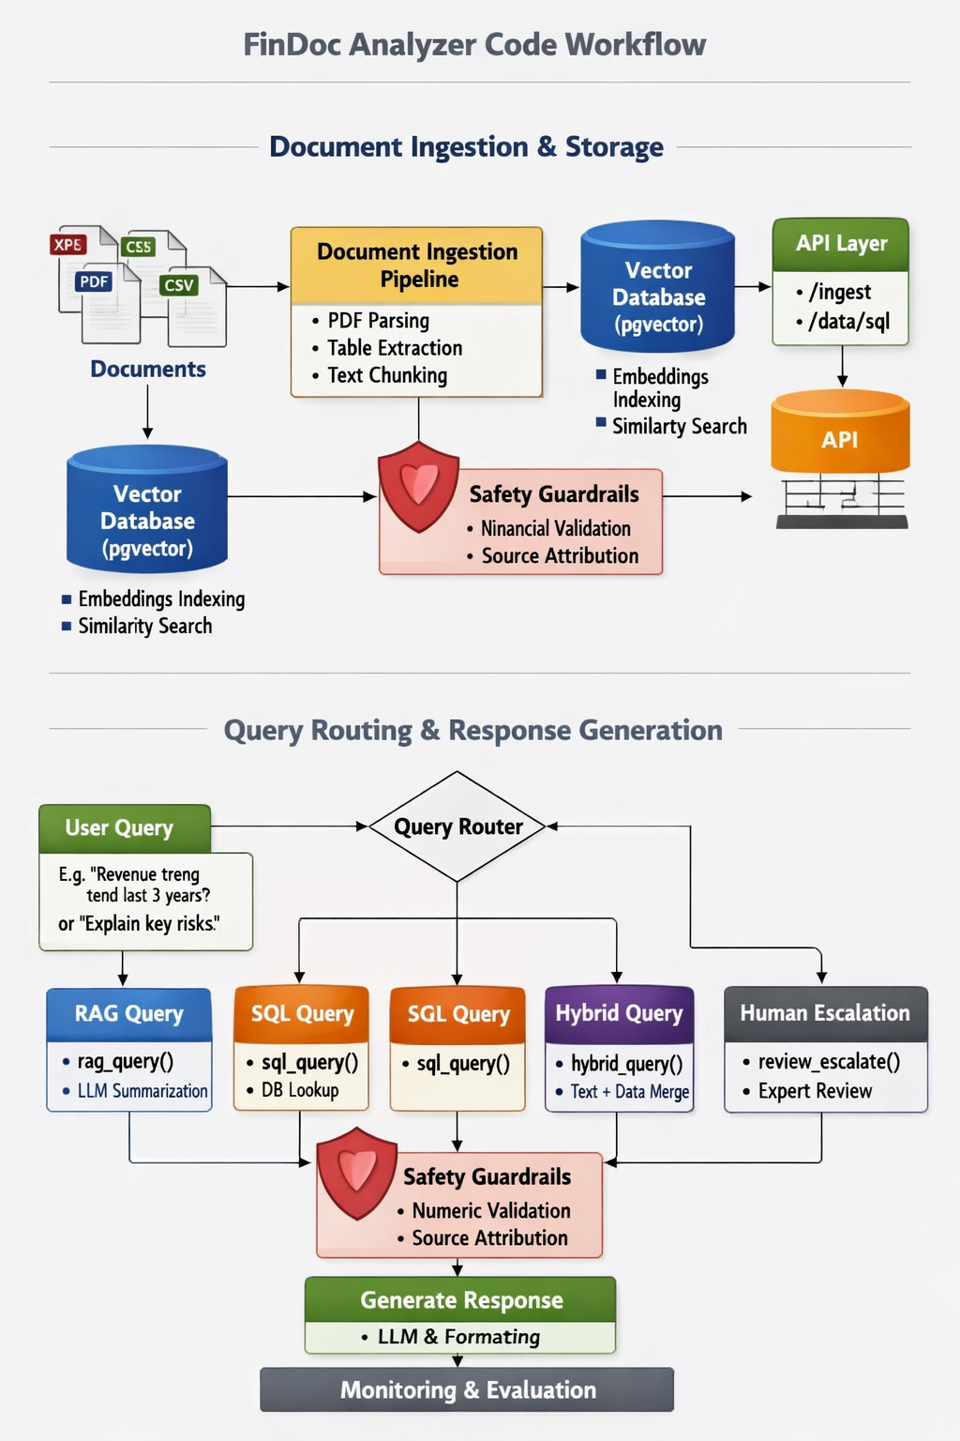

11. Code Flow Diagram

The code flow diagram maps each logical step directly to its Python module and function. Every box shows the module path (header strip) and the primary function call. Follow the arrows to trace exactly which file handles each stage of a query, from ingestion through evaluation.

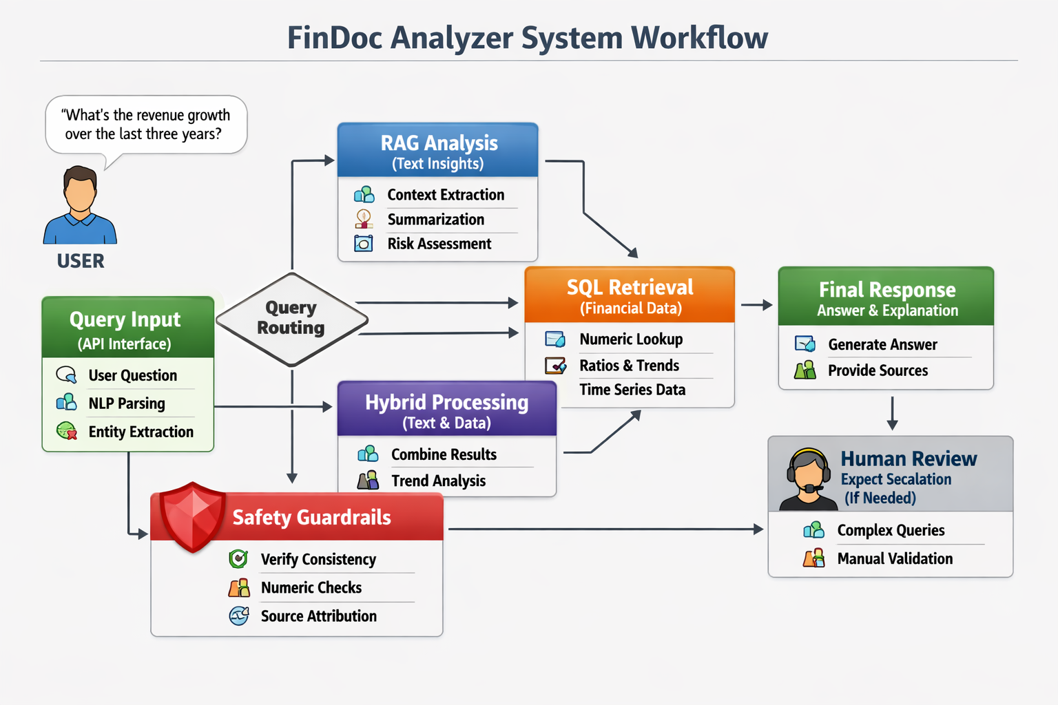

- API Endpoints Reference
Field | Type | Description
query | string (req) | The natural language financial question (max 1000 chars)
session_id | string (opt) | Conversation session ID for multi-turn context continuity
route_override | string (opt) | Force route: 'rag' | 'sql' | 'hybrid'. Skips classifier if set
top_k | integer (opt) | Number of RAG chunks to retrieve. Default: 5, max: 20
include_sources | boolean (opt) | Return source chunk metadata with response. Default: true

Field | Type | Description
answer | string | The LLM-generated financial answer with inline source markers
route_used | string | Which engine handled the query: 'rag' | 'sql' | 'hybrid' | 'escalated'
confidence | float | Confidence score 0.0–1.0 from the uncertainty module
sources | array | List of source objects: { doc_name, page, chunk_text, score }
sql_query | string|null | The SQL query executed (if route was sql or hybrid)
latency_ms | integer | Total end-to-end latency in milliseconds
trace_id | string | Langfuse trace ID for observability lookup
escalated | boolean | True if query was routed to human handoff

All endpoints are implemented in FastAPI and served via Uvicorn. The base URL is http://localhost:8000. Full interactive docs are auto-generated at /docs (Swagger UI) and /redoc.

  - Core Query Endpoints

POST /query — Main financial query endpoint
Purpose
Accepts a natural language financial question, routes it to the correct retrieval engine (RAG / SQL / Hybrid / Escalate), generates a grounded LLM response with source citations, applies safety guardrails, logs the trace to Langfuse, and returns the validated answer.
Request Body

Response (200 OK)

Error codes: 400 invalid input / guardrail block • 422 validation error • 429 rate limited • 500 LLM/retrieval failure

POST /query/stream — Streaming query endpoint (SSE)
Purpose
Same as POST /query but streams the LLM response token-by-token using Server-Sent Events (SSE). Reduces

perceived latency for long financial summaries. Returns a stream of JSON delta objects followed by a final metadata event containing route, sources, confidence, and trace ID.
Same request body as /query. Stream format: data: {delta: '...'} per token, then data: {done: true, metadata: {...}}
Field | Type | Description
file | File (req) | PDF / CSV / XLSX upload. Max size: 50MB
company_name | string (req) | Company identifier (e.g. 'TechVision')
fiscal_year | integer (opt) | Fiscal year for structured data tagging (e.g. 2024)
doc_type | string (opt) | 'annual_report' | 'quarterly' | 'balance_sheet' | 'other'
chunk_strategy | string (opt) | 'financial' (default) | 'sentence' | 'fixed_size'

POST /query/batch — Batch query for evaluation runs
Purpose
Accepts an array of up to 50 queries in a single request. Processes them concurrently using asyncio and returns an array of responses in the same order. Primarily used for RAGAS evaluation runs and regression testing. Each item in the request array follows the same schema as /query.

  - Document Ingestion Endpoints

POST /ingest/document — Upload and ingest a financial document
Purpose
Accepts a PDF, CSV, or XLSX financial document via multipart form upload. Triggers the full ingestion pipeline: PDF parsing → table extraction → financial-aware chunking → embedding generation → pgvector upsert → SQL seeding (for structured tables). Returns a job ID for async status tracking.

Endpoint | Description
GET /ingest/status/{job_id} | Poll ingestion job status. Returns: { job_id, status: 'pending'|'processing'|'complete'|'failed', chunks_created, tables_extracted, error_msg }
GET /ingest/documents | List all ingested documents with metadata: doc_id, company, fiscal_year, doc_type, chunk_count, ingested_at
DELETE /ingest/document/{doc_id} | Remove a document and all its associated chunks from pgvector and file store. Does not remove SQL-seeded structured data.

  - Structured Data Endpoints

Endpoint | Description
POST /data/sql | Execute a direct NL-to-SQL query against the financial database. Body: { nl_query: string, company?: string, fiscal_year?: integer }. Returns: { sql_generated, results: [...], columns: [...] }
GET /data/metrics/{company}/{year} | Retrieve all financial metrics for a company and fiscal year. Returns the full financial_metrics table row set including revenue, profit, EPS, margins.
GET /data/segments/{company}/{year} | Return business segment breakdown: segment name, revenue, YoY growth. Used for segment analysis queries.
GET /data/quarterly/{company} | Return full quarterly revenue series for a company across all available years. Powers time-series and trend queries.
GET /data/risks/{company}/{year} | Return all risk factors for a company/year from the risk_factors table with category and severity fields.
POST /data/compare | Compare metrics between two years or two companies. Body:  { metric, company, year_a, year_b }. Returns: { value_a, value_b, delta, delta_pct }

  - Safety & Escalation Endpoints

Endpoint | Description
POST /safety/validate | Run input and output guardrails on arbitrary text without triggering a full query. Used for testing guardrail behaviour. Body: { text, check_type: 'input'|'output' }
GET /escalations | List all escalated queries pending human review. Returns:  [ { escalation_id, query, reason, context_bundle_url, created_at, status } ]
GET /escalations/{id} | Retrieve the full context bundle for a specific escalation: original query, routing decision, retrieved chunks, SQL results, LLM draft, guardrail violations, and conversation history.
PATCH /escalations/{id}/resolve | Mark an escalation as resolved. Body: { resolution: string, reviewed_by: string }. Logs the human expert's response and closes the escalation.

  - Evaluation & Observability Endpoints

Endpoint | Description
POST /eval/run | Trigger a RAGAS evaluation run against the annotated test dataset. Body: { dataset: 'default'|'custom', questions?: [...] }. Returns:  { run_id, faithfulness, answer_relevancy, context_recall, routing_accuracy }
GET /eval/results | List historical evaluation run results with timestamps and metric scores. Useful for tracking improvement over sprints.
GET /eval/slos | Return current SLO compliance status: each SLO metric, its target, current value, and pass/fail status. Powers the SLO dashboard.
GET /eval/traces | Retrieve recent Langfuse traces: trace_id, query_snippet, route_used, latency_ms, faithfulness_score, timestamp. Supports pagination.
GET /eval/traces/{trace_id} | Get full trace detail for a single query: all spans, retrieval scores, routing decision, token usage, guardrail events.

  - Health & Admin Endpoints

Endpoint | Description
GET /health | Liveness probe. Returns { status: 'ok', version, timestamp }. Always returns 200 unless the server is down.
GET /health/ready | Readiness probe. Checks pgvector connection, PostgreSQL connection, and LLM API reachability. Returns 200 only when all dependencies are healthy.
GET /health/deps | Detailed dependency status: { pgvector: ok|fail, postgresql: ok| fail, llm_api: ok|fail, mcp_server: ok|fail, langfuse: ok|fail }
GET /admin/index/stats | Return vector index statistics: total chunks, document count, embedding model, index size, last updated timestamp.
POST /admin/index/rebuild | Trigger a full re-indexing of all documents from the file store. Useful after embedding model changes. Long-running — returns job_id for polling.
DELETE /admin/index/clear | Wipe all vectors from pgvector. Requires admin API key header. Irreversible — intended for development resets only.

  - Full Endpoint Summary

Metho d | Path | Auth | Module | One-Line Purpose
POST | /query | API Key | api/ query.py | Main NL financial query → routed response + citations
POST | /query/stream | API Key | api/ query.py | Streaming SSE version of /query
POST | /query/batch | API Key | api/ query.py | Batch up to 50 queries for eval runs
POST | /ingest/document | API Key | api/ ingest.py | Upload PDF/CSV/XLSX → full ingestion pipeline
GET | /ingest/status/{job_id} | API Key | api/ ingest.py | Poll async ingestion job status
GET | /ingest/documents | API Key | api/ ingest.py | List all ingested documents
DELETE | /ingest/document/  {doc_id} | Admin | api/ ingest.py | Remove document + vectors
POST | /data/sql | API Key | api/data.py | NL-to-SQL query on financial DB
GET | /data/metrics/{co}/{yr} | API Key | api/data.py | All financial metrics for company/year
GET | /data/segments/{co}/{yr} | API Key | api/data.py | Business segment revenue breakdown
GET | /data/quarterly/  {company} | API Key | api/data.py | Quarterly revenue time series
GET | /data/risks/{co}/{yr} | API Key | api/data.py | Risk factors list
POST | /data/compare | API Key | api/data.py | Compare metrics across years/companies
POST | /safety/validate | API Key | api/ safety.py | Test guardrails on arbitrary text
GET | /escalations | Admin | api/ escalations  .py | List pending human review queue
GET | /escalations/{id} | Admin | api/ escalations  .py | Full context bundle for one escalation
PATCH | /escalations/{id}/ resolve | Admin | api/ escalations  .py | Close escalation with human resolution
POST | /eval/run | Admin | api/eval.py | Trigger RAGAS evaluation run
GET | /eval/results | Admin | api/eval.py | Historical eval scores
GET | /eval/slos | API Key | api/eval.py | Live SLO compliance dashboard data
GET | /eval/traces | Admin | api/eval.py | Recent Langfuse traces paginated
GET | /eval/traces/{trace_id} | Admin | api/eval.py | Full span detail for one trace
GET | /health | None | api/ health.py | Liveness probe
GET | /health/ready | None | api/ health.py | Readiness probe (checks all deps)
GET | /health/deps | None | api/ health.py | Detailed dependency health map
GET | /admin/index/stats | Admin | api/ admin.py | Vector index statistics

POST | /admin/index/rebuild | Admin | api/ admin.py | Full re-index from file store
DELETE | /admin/index/clear | Admin | api/ admin.py | Wipe pgvector (dev only)

