Our web application would be a platform for selling books. The application would be designed in a very antique manner to attract the user’s attention. Its main functionality would be to sell books, keep a track of sold books and unsold books, and to collect feedback from the user about the book. Our application will basically have the application name at the top left corner, a Search bar beside it, a My Books (history of the user’s books) drop down menu, a Browse option to search the book according to its category, and the add to cart logo near the user’s account id logo. Below all this there will be a list of books for the user to choose, and as soon as the book is chosen, a new page will open, which will give all the information about the book such as its author, its price, its description, etc. There will be a list of related books at the bottom of this page to attract the user for purchasing more books. After the user a has clicked the buy option, a new page will open, which will ask him for some of his personal details to purchase the book/books. Our web application will also consist of a news section, which will provide the user with the information about the upcoming books and some more similar content. All the information about the user and the books will be stored in our database. Our ER diagram will consist of 6 entities: news, books, category, user, order, and cart. The book and user will have a relationship with category and order respectively. The user will see:

* Title, description, and date for news
* Price, author, description, and quantity for books
* Name of the category
* Login and address for the user
* Order date and delivery date for order
* 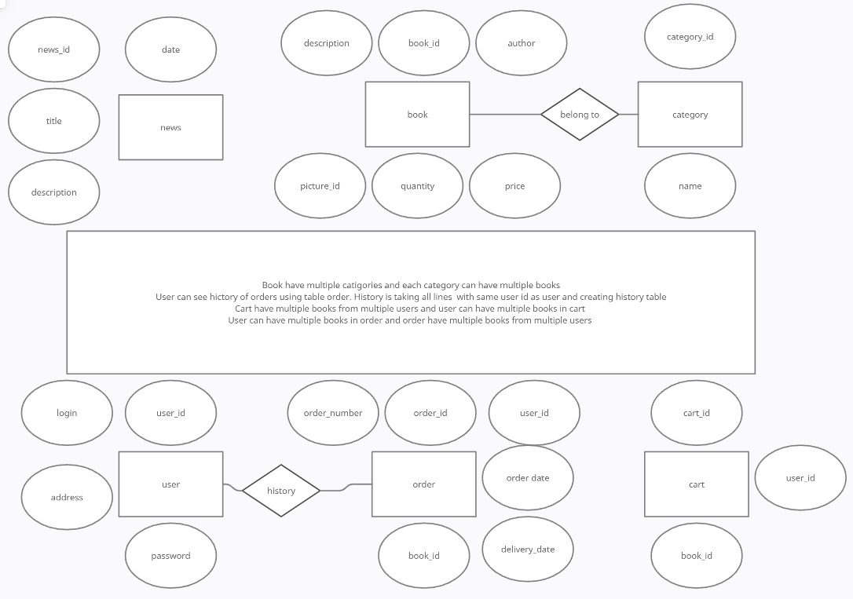Book in the cart

The user can do the following on the main page:

* Search for a book
* See his purchase history
* Read the news
* Look for different books from the list
* See his profile

The user can do the following on the Book page:

* See the book cover
* See all the information about the book
* Read the feedbacks about the book
* See the list of related books

The user can do the following on the order page:

* See the list of all the books he is ordering
* See his own personal details, for example: Address, phone number, etc. (All data will be checked if it is valid, if not the user will get an error message to check his details)
* Make order