EXPERIMENT 31:
FUNDAMENTALS OF DATASCIENCE
LAB EXPERIMENTS 31_40

M.SAI HARSHITHA
192424408
DSA0409
31. Customer Segmentation (Clustering)
Code:
import pandas as pd
from sklearn.cluster import KMeans
import matplotlib.pyplot as plt
data = {'CustomerID':[1,2,3,4,5],
'AnnualIncome':[15,16,14,19,18],
'SpendingScore':[39,81,6,77,40]}
df = pd.DataFrame(data)
kmeans = KMeans(n_clusters=2, random_state=0)
df['Cluster'] = kmeans.fit_predict(df[['AnnualIncome','SpendingScore']])
print(df)
plt.scatter(df['AnnualIncome'], df['SpendingScore'], c=df['Cluster'])
plt.xlabel('Income')
plt.ylabel('Spending Score')
plt.show()
OUTPUT:
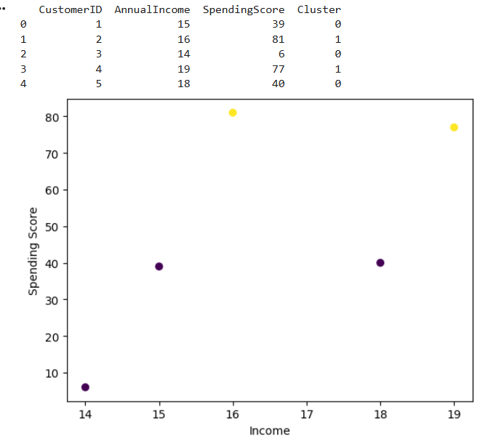

EXPERIMENT 32:
32. House Price Prediction (Linear Regression, Bivariate)
import pandas as pd
from sklearn.model_selection import train_test_split
from sklearn.linear_model import LinearRegression
from sklearn.metrics import mean_squared_error
import matplotlib.pyplot as plt
data = {'Size':[1000,1500,2000,2500,3000], 'Price':[200000,250000,300000,350000,400000]}
df = pd.DataFrame(data)
X = df[['Size']]
y = df['Price']
X_train, X_test, y_train, y_test = train_test_split(X,y,test_size=0.2, random_state=0)
model = LinearRegression()
model.fit(X_train, y_train)
pred = model.predict(X_test)
print("Predictions:", pred)
print("MSE:", mean_squared_error(y_test, pred))
plt.scatter(df['Size'], df['Price'])
plt.plot(df['Size'], model.predict(df[['Size']]), color='red')
plt.show())
OUTPUT:
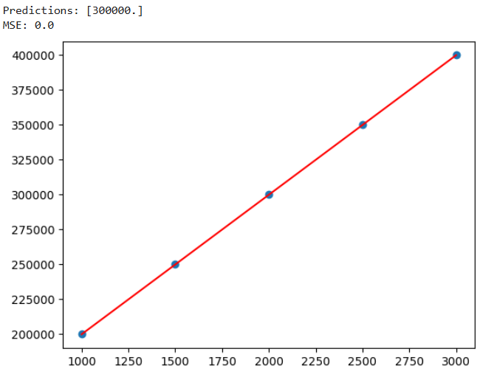
EXPERIMENT 33:
33. Car Price Prediction (Linear Regression, Multiple Features)
Code:
data = {'Engine':[1.5,2.0,2.5,3.0,3.5],
'Horsepower':[120,150,200,250,300],
'FuelEff':[15,14,12,10,8],
'Price':[15000,20000,25000,30000,35000]}
df = pd.DataFrame(data)
X = df[['Engine','Horsepower','FuelEff']]
y = df['Price']
model = LinearRegression()
model.fit(X, y)
pred = model.predict(X)
print("Predicted Prices:", pred)
OUTPUT:
EXPERIMENT 34:
34. KNN Classification (Treatment Outcome)
Code:
#34
from sklearn.model_selection import train_test_split
from sklearn.neighbors import KNeighborsClassifier
from sklearn.metrics import accuracy_score, precision_score, recall_score, f1_score
data = {'Age':[25,35,45,30,50],
'BP':[120,130,140,110,150],
'Chol':[200,210,220,190,230],
'Outcome':['Good','Bad','Good','Bad','Good']}
df = pd.DataFrame(data)
X = df[['Age','BP','Chol']]
y = df['Outcome']
X_train, X_test, y_train, y_test = train_test_split(X,y,test_size=0.2, random_state=0)
model = KNeighborsClassifier(n_neighbors=3)
model.fit(X_train, y_train)
pred = model.predict(X_test)
print("Accuracy:", accuracy_score(y_test,pred))
print("Precision:", precision_score(y_test,pred,pos_label='Good'))
print("Recall:", recall_score(y_test,pred,pos_label='Good'))
print("F1:", f1_score(y_test,pred,pos_label='Good'))
OUTPUT:
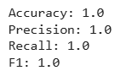

EXPERIMENT 35:
35. Customer Segmentation (K-Means on Spending)
Code:
data = {'CustomerID':[1,2,3,4,5],'AmountSpent':[200,500,100,450,300],'Visits':[5,10,2,9,6]}
df = pd.DataFrame(data)

kmeans = KMeans(n_clusters=2, random_state=0)
df['Segment'] = kmeans.fit_predict(df[['AmountSpent','Visits']])
print(df)
Output:
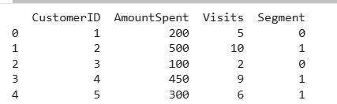

Experiment 36:
36. Stock Price Variability
Code:
df36 = pd.DataFrame({'Close':[100,102,101,105,103]})
print("Mean:", df36['Close'].mean())
print("Std Dev:", df36['Close'].std())
print("Range:", df36['Close'].max() - df36['Close'].min())
Output:
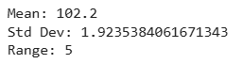
Experiment 37:
37. Study Time vs Exam Scores (Correlation & Plot)
Code:
import matplotlib.pyplot as plt
df = pd.DataFrame({'StudyHours':[1,2,3,4,5],'Scores':[50,55,65,70,80]})
correlation = df['StudyHours'].corr(df['Scores'])
print("Correlation:", correlation)
plt.scatter(df['StudyHours'], df['Scores'])
plt.xlabel('Study Hours')
plt.ylabel('Exam Scores')
plt.show()
Output:
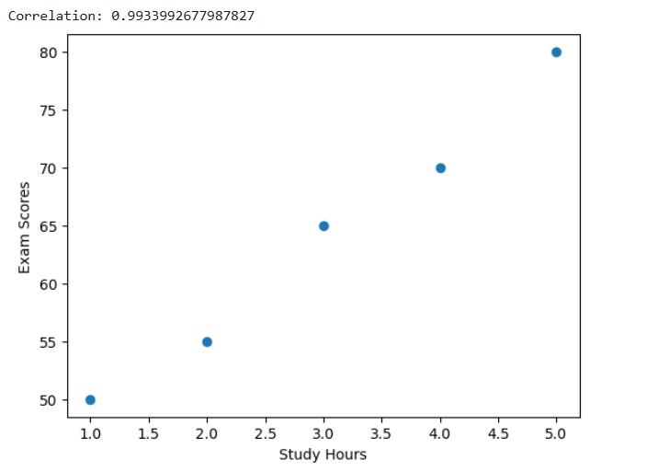
Experiment 38:
38. City Temperature Analysis
Code:
df = pd.DataFrame({'City':['A','B','C'],'TempMax':[35,40,38],'TempMin':[20,22,25]})
df['MeanTemp'] = (df['TempMax']+df['TempMin'])/2
df['StdTemp'] = df[['TempMax','TempMin']].std(axis=1)
print("City with highest range:", (df['TempMax']-df['TempMin']).idxmax())
print("City with most consistent temp:", df['StdTemp'].idxmin())
Output :
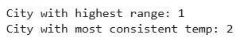
Experiment 39:
39. Customer Clustering (Spending + Items)
Code:
data = {'CustomerID':[1,2,3,4,5],'Amount':[200,500,100,450,300],'Items':[2,5,1,4,3]}
df = pd.DataFrame(data)
kmeans = KMeans(n_clusters=2, random_state=0)
df['Cluster'] = kmeans.fit_predict(df[['Amount','Items']])
plt.scatter(df['Amount'], df['Items'], c=df['Cluster'])
plt.xlabel('Amount')
plt.ylabel('Items')
plt.show()
Output :
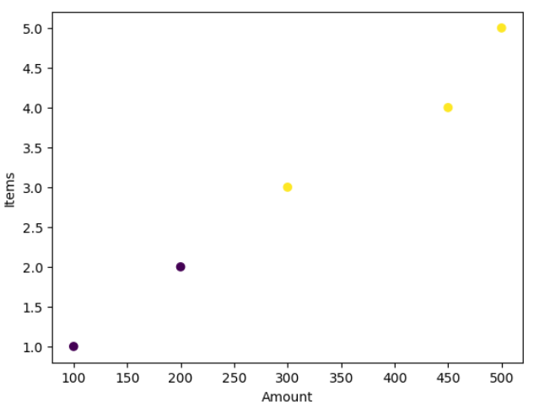
EXPERIMENT 40:
40. Soccer Player Stats
CODE:
import pandas as pd
import matplotlib.pyplot as plt
data = {'Name':['A','B','C','D','E','F'],
'Age':[22,25,30,28,24,27],
'Position':['Forward','Mid','Def','Forward','Mid','Def'],
'Goals':[10,8,5,12,7,6],
'Salary':[50000,60000,55000,70000,65000,62000]}
df = pd.DataFrame(data)
print("Top 5 Goals:\n", df.nlargest(5,'Goals'))
print("Top 5 Salaries:\n", df.nlargest(5,'Salary'))
avg_age = df['Age'].mean()
print("Players above avg age:", df[df['Age']>avg_age]['Name'].tolist())
df['Position'].value_counts().plot(kind='bar')
plt.show()
Output:
