EXPERIMENT 1:
FUNDAMENTALS OF DATASCIENCE
LAB EXPERIMENTS 1_30

M.SAI HARSHITHA
192424408
DSA0409
1. Average score for each subject + highest-average subject (4×4 matrix)
Code:
import numpy as np
student_scores = np.array([
[85, 90, 78, 88],
[76, 80, 92, 85],
[90, 88, 84, 91],
[70, 75, 80, 79]
])
avg_scores = student_scores.mean(axis=0)
subjects = ['Math', 'Science', 'English', 'History']
highest_subject = subjects[np.argmax(avg_scores)]
print("Average scores:", avg_scores)
print("Highest average subject:", highest_subject)
OUTPUT:
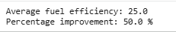
EXPERIMENT 2:
2. Average price of all products sold (3×3 matrix)
import numpy as np
sales = np.array([
[120, 130, 140],
[150, 160, 170],
[110, 115, 125]
])
avg_price = sales.mean()
print("Average price:", avg_price)

OUTPUT:
EXPERIMENT 3:
3. Average sale price of houses with more than 4 bedrooms
import numpy as np
house_data = np.array([
[3, 1200, 150000],
[5, 2000, 320000],
[4, 1800, 250000],
[6, 2400, 410000]
])
filtered = house_data[house_data[:,0] > 4]
avg_price = filtered[:,2].mean()
print("Average sale price:", avg_price)
OUTPUT:
EXPERIMENT 4:
4. Total yearly sales
import numpy as np
sales_data = np.array([25000, 30000, 35000, 40000])
total_sales = sales_data.sum()
percent_increase = ((sales_data[3] - sales_data[0]) / sales_data[0]) * 100
print("Total sales:", total_sales)
print("Percent increase:", percent_increase)
OUTPUT:
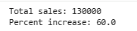

EXPERIMENT 5:
5. Average fuel efficiency AND improvement between two car models
Code:
import numpy as np
fuel_efficiency = np.array([20, 25, 30, 35, 40])
avg_eff = fuel_efficiency.mean()
model1 = fuel_efficiency[0]
model3 = fuel_efficiency[2]
percent_improvement = ((model3 - model1) / model1) * 100
print("Average fuel efficiency:", avg_eff)
print("Percent improvement:", percent_improvement)
Output:
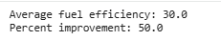
Experiment 6:
6. Total cost with discount and tax
Code:
prices = [100, 50, 80]
quantities = [2, 1, 3]
discount_rate = 10
tax_rate = 5
subtotal = sum(p*q for p, q in zip(prices, quantities))
discount_amount = subtotal * (discount_rate / 100)
after_discount = subtotal - discount_amount
tax_amount = after_discount * (tax_rate / 100)
total_cost = after_discount + tax_amount
print("Total cost:", total_cost)

Output:
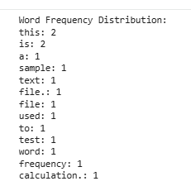
Experiment 7:
7. Pandas: orders per customer, avg quantity per product, earliest & latest dates
Code:
import pandas as pd
order_data = pd.DataFrame({
'customer_id': [101, 102, 101, 103, 102, 101],
'order_date': pd.to_datetime([
"2024-01-05", "2024-01-06", "2024-01-10",
"2024-01-12", "2024-01-15", "2024-01-20"
]),
'product_name': ["Mobile", "Laptop", "Mobile", "TV", "Laptop", "Headphones"],
'order_quantity': [1, 2, 1, 1, 3, 2]
})
orders_per_customer = order_data.groupby('customer_id').size()
avg_quantity_product = order_data.groupby('product_name')['order_quantity'].mean()
earliest_date = order_data['order_date'].min()
latest_date = order_data['order_date'].max()
print("Total orders per customer:\n", orders_per_customer)
print("\nAverage order quantity per product:\n", avg_quantity_product)
print("\nEarliest order date:", earliest_date)
print("Latest order date:", latest_date)
Output:
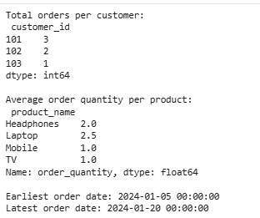
Experiment 8:
8. Top 5 most-sold products (Pandas)
Code:
import numpy as np
import pandas as pd
sales_data = np.array([
["Mobile", 10],
["Laptop", 5],
["Mobile", 20],
["TV", 8],
["Laptop", 22],
["Headphones", 15],
["Charger", 9],
["Mobile", 5],
["TV", 7],
["Laptop", 13]
])

df = pd.DataFrame(sales_data, columns=['product_name', 'quantity'])
df['quantity'] = df['quantity'].astype(int)
top5 = (
df.groupby('product_name')['quantity']
.sum()
.sort_values(ascending=False)
.head(5)
)
print("Top 5 Most Sold Products:")
print(top5)
Output :
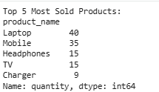
Experiment 9:
9.Property Data Analysis Using Pandas
Code:
import pandas as pd
property_data = pd.DataFrame({
'property_id': [101, 102, 103, 104, 105],
'location': ['CityA', 'CityB', 'CityA', 'CityC', 'CityB'],
'bedrooms': [3, 5, 4, 6, 2],
'area_sqft': [1500, 2200, 1800, 3000, 1200],
'listing_price': [250000, 400000, 320000, 550000, 200000]
})
avg_price_location = property_data.groupby('location')['listing_price'].mean()
print("Average listing price per location:\n", avg_price_location)
count_big_houses = property_data[property_data['bedrooms'] > 4].shape[0]
print("\nNumber of properties with more than 4 bedrooms:", count_big_houses)
largest_area_property = property_data.loc[property_data['area_sqft'].idxmax()]
print("\nProperty with the largest area:\n", largest_area_property)
Output :
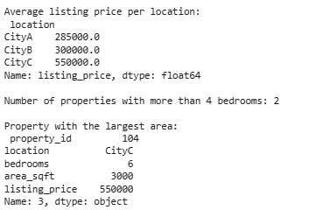
EXPERIMENT 10:
10.Line Plot and Bar Plot Using Matplotlib
CODE:
import matplotlib.pyplot as plt
months = ["Jan", "Feb", "Mar", "Apr", "May", "Jun"]
sales = [1200, 1500, 1700, 1600, 1800, 2000]
plt.figure(figsize=(8,5))
plt.plot(months, sales, marker='o')
plt.xlabel("Month")
plt.ylabel("Sales")
plt.title("Monthly Sales - Line Plot")
plt.grid(True)
plt.show()

plt.figure(figsize=(8,5))
plt.bar(months, sales)
plt.xlabel("Month")
plt.ylabel("Sales")
plt.title("Monthly Sales - Bar Plot")
plt.show()
Output:
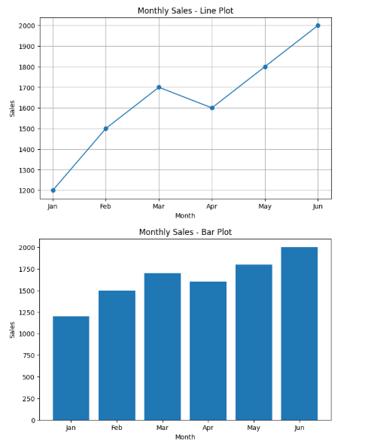
EXPERIMENT 11:
11. Sales Over Time (Line, Scatter, Bar Plots)
CODE:
import matplotlib.pyplot as plt
months = ["Jan", "Feb", "Mar", "Apr", "May", "Jun"]
sales = [120, 150, 170, 160, 200, 220]
plt.plot(months, sales, marker='o')
plt.xlabel("Month")
plt.ylabel("Sales")
plt.title("Monthly Sales - Line Plot")
plt.show()
plt.scatter(months, sales)
plt.xlabel("Month")
plt.ylabel("Sales")
plt.title("Monthly Sales - Scatter Plot")
plt.show()

plt.bar(months, sales)
plt.xlabel("Month")
plt.ylabel("Sales")
plt.title("Monthly Sales - Bar Plot")
plt.show()
OUTPUT:
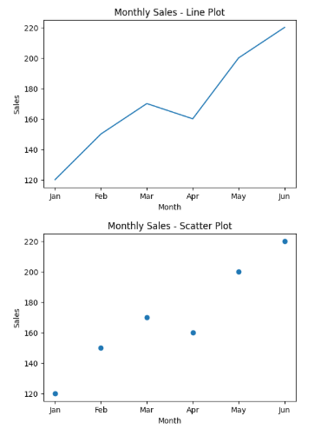
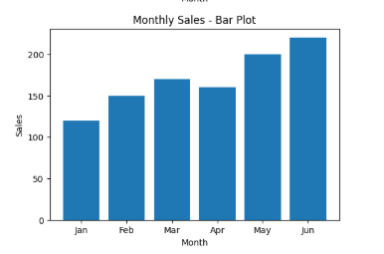

EXPERIMENT 12:
12. Temperature & Rainfall Visualization
CODE:
import matplotlib.pyplot as plt
months = ["Jan", "Feb", "Mar", "Apr", "May", "Jun"]
temperature = [22, 25, 28, 30, 33, 35]
rainfall = [50, 40, 70, 60, 80, 90]
plt.plot(months, temperature, marker='o')
plt.xlabel("Month")
plt.ylabel("Temperature (°C)")
plt.title("Monthly Temperature - Line Plot")
plt.show()
plt.scatter(months, rainfall)
plt.xlabel("Month")
plt.ylabel("Rainfall (mm)")
plt.title("Monthly Rainfall - Scatter Plot")
plt.show()
OUTPUT:
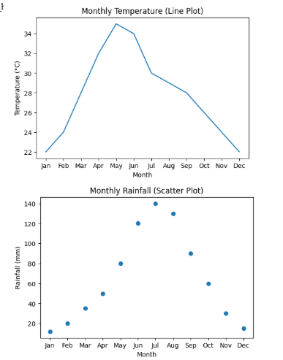
EXPERIMENT 13:
13. Frequency Distribution of Words in a Text File
CODE:
from collections import Counter
with open("sample_text.txt", "r") as f:
text = f.read()
words = text.lower().split()
freq = Counter(words)
print("Word Frequency Distribution:")
for word, count in freq.items():
print(word, ":", count)
OUTPUT:
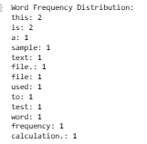
EXPERIMENT 14:
14. Frequency Distribution of Customer Ages (Pandas)
CODE:
import pandas as pd
sales_data = pd.DataFrame({
'customer_id': [1, 2, 3, 4, 5, 6],
'age': [25, 30, 25, 40, 30, 25],
'amount': [200, 150, 300, 220, 180, 100]
})
age_distribution = sales_data['age'].value_counts()

print("Frequency Distribution of Customer Ages:")
print(age_distribution)
OUTPUT:
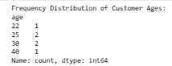
EXPERIMENT 15:
15. Frequency Distribution of Likes per Post
CODE:
from collections import Counter
likes = [10, 20, 10, 50, 20, 20, 5, 10]
freq = Counter(likes)
print("Frequency Distribution of Likes:")
for like, count in freq.items():
print(like, ":", count)
OUTPUT:
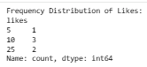
EXPERIMENT 16:
16. Frequency Distribution of Words (Simple Customer Reviews Dataset)
CODE:
import re
from collections import Counter
reviews = [
"The product is great and works very well",
"I love this product, it is amazing",
"Not satisfied, the product stopped working",
]
text = " ".join(reviews).lower()
text = re.sub(r"[^a-z\s]", "", text)
words = text.split()
freq = Counter(words)
print("Word Frequency Distribution:")
for word, count in freq.items():
print(word, ":", count)
OUTPUT:
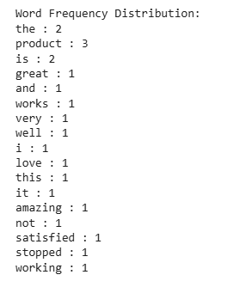
EXPERIMENT 17:
17.CSV Loading , Cleaning , Stopwords ,Frequency , Top N AND Bar Plot
CODE:
import pandas as pd
import matplotlib.pyplot as plt
import re
from collections import Counter
from nltk.corpus import stopwords
import nltk
nltk.download("stopwords")
df = pd.read_csv("data.csv")
text = " ".join(df["feedback"].astype(str)).lower()
text = re.sub(r"[^a-z\s]", " ", text)
stop_words = set(stopwords.words("english"))
words = [w for w in text.split() if w not in stop_words]
freq = Counter(words)
N = int(input("Enter N: "))
top_words = freq.most_common(N)
print(top_words)
words_list = [w for w, c in top_words]
count_list = [c for w, c in top_words]
plt.bar(words_list, count_list)
plt.xticks(rotation=45)
plt.xlabel("Words")
plt.ylabel("Frequency")
plt.title(f"Top {N} Most Frequent Words")
plt.tight_layout()
plt.show()
OUTPUT:
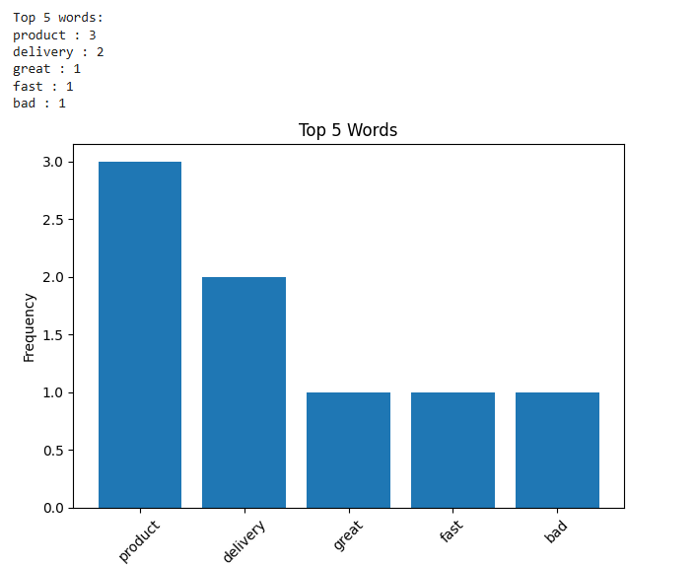
EXPERIMENT 18:
18. Mean, Median, Std + Boxplots + Scatter + Q-Q Plot
CODE:
import pandas as pd
import matplotlib.pyplot as plt
import scipy.stats as stats
data = {
"age": [23, 45, 34, 50, 29, 40, 32, 47, 38, 55, 31, 44, 36, 52, 27, 48, 33, 41],
"%fat": [12.5, 22.1, 18.3, 25.7, 14.8, 21.2, 17.5, 24.9,
19.0, 26.4, 16.3, 23.5, 18.7, 25.9, 13.4, 24.1, 17.9, 22.8]
}
df = pd.DataFrame(data)
print("Mean:\n", df.mean())
print("Median:\n", df.median())
print("Std Dev:\n", df.std())
df.boxplot(column=["age", "%fat"])
plt.show()
plt.scatter(df["age"], df["%fat"])
plt.xlabel("Age")
plt.ylabel("% Fat")
plt.title("Age vs Body Fat")
plt.show()
stats.probplot(df["age"], dist="norm", plot=plt)
plt.title("Q-Q Plot for Age")
plt.show()
stats.probplot(df["%fat"], dist="norm", plot=plt)
plt.title("Q-Q Plot for %Fat")
plt.show()
OUTPUT:
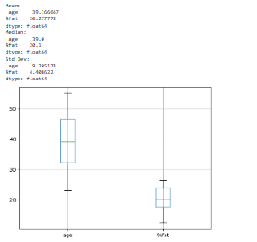
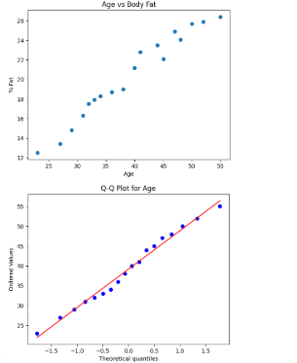
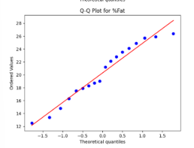

EXPERIMENT 19:
19.95% Confidence Interval for Mean Reduction (Drug vs Placebo)
CODE:
import numpy as np
from scipy import stats
drug = np.array([12, 15, 17, 14, 10, 18, 16, 11, 19, 13])
placebo = np.array([5, 7, 6, 4, 8, 5, 6, 7, 3, 4])
def confidence_interval(data):
mean = np.mean(data)
se = stats.sem(data)
ci = stats.t.interval(0.95, len(data)-1, loc=mean, scale=se)
return mean, ci
drug_mean, drug_ci = confidence_interval(drug)
placebo_mean, placebo_ci = confidence_interval(placebo)
print("Drug group:")
print("Mean reduction:", drug_mean)
print("95% CI:", drug_ci)
print("\nPlacebo group:")
print("Mean reduction:", placebo_mean)
print("95% CI:", placebo_ci)
OUTPUT:
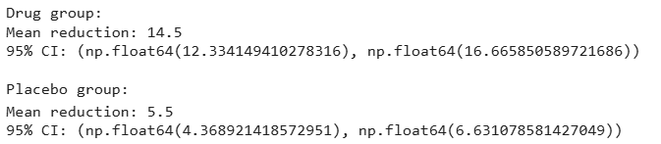

EXPERIMENT 20:
20. A/B Test: Is There a Significant Difference in Conversion Rates? (Two-sample t-test)
CODE:
import numpy as np
from scipy import stats
design_A = np.array([1,0,1,1,0,0,1,0,1,1])
design_B = np.array([0,0,1,0,0,1,0,0,0,1])
t_stat, p_value = stats.ttest_ind(design_A, design_B)
print("T-statistic:", t_stat)
print("P-value:", p_value)
if p_value < 0.05:
print("Result: Significant difference between Design A and Design B")
else:
print("Result: No significant difference between the two designs")
OUTPUT:
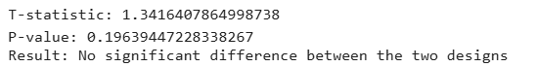
EXPERIMENT 21:
21. Point Estimation and Confidence Interval for Rare Elements
Code:
import numpy as np
from scipy import stats
n = int(input("Enter sample size: "))
conf = float(input("Enter confidence level (0.90 / 0.95 / 0.99): "))
data = []
for i in range(n):
data.append(float(input(f"Enter value {i+1}: ")))
data = np.array(data)
mean = data.mean()
std = data.std(ddof=1)
z = stats.norm.ppf((1 + conf) / 2)
lower = mean - z * std / np.sqrt(n)
upper = mean + z * std / np.sqrt(n)
print("Mean:", mean)
print("Confidence Interval:", (lower, upper))
Output:
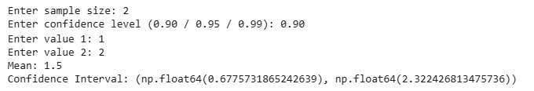
EXPERIMENT 22:
22. Confidence Interval for Customer Ratings
CODE:
import numpy as np
from scipy import stats
ratings = list(map(float, input("Enter ratings separated by space: ").split()))
ratings = np.array(ratings)
mean = ratings.mean()
std = ratings.std(ddof=1)
n = len(ratings)
conf = 0.95
z = stats.norm.ppf((1 + conf) / 2)
lower = mean - z * std / np.sqrt(n)
upper = mean + z * std / np.sqrt(n)
print("Average Rating:", mean)
print("95% Confidence Interval:", (lower, upper))
OUTPUT:
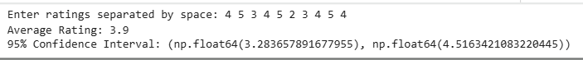
EXPERIMENT 23:
23. Hypothesis Testing and P-Value Analysis for Clinical Trial Data
CODE:
import numpy as np
from scipy import stats
import matplotlib.pyplot as plt
control = list(map(float, input("Enter control group values: ").split()))
treatment = list(map(float, input("Enter treatment group values: ").split()))
control = np.array(control)
treatment = np.array(treatment)
t_stat, p_value = stats.ttest_ind(treatment, control)
print("T-statistic:", t_stat)
print("P-value:", p_value)
plt.boxplot([control, treatment], labels=["Control", "Treatment"])
plt.title("Control vs Treatment")
plt.show()
plt.bar(["p-value"], [p_value])
plt.title("P-value Visualization")
plt.show()

OUTPUT:
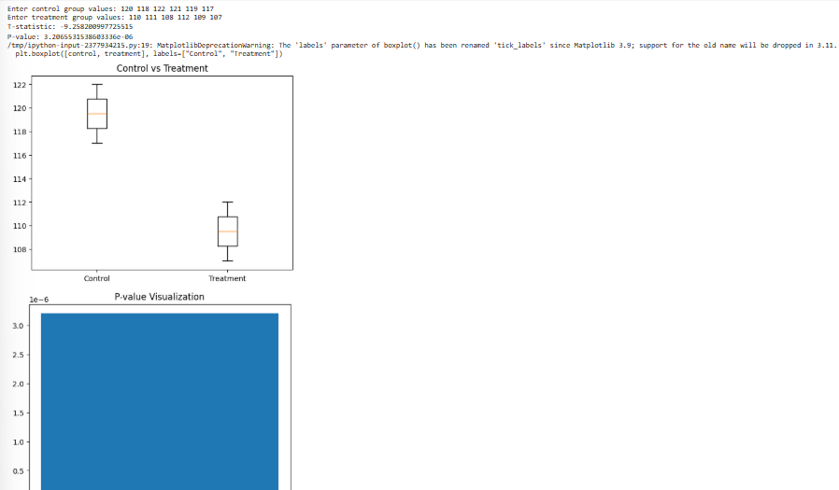
EXPERIMENT 24:
24. K-Nearest Neighbors (KNN) Classifier for Medical Condition Prediction
CODE:
from sklearn.neighbors import KNeighborsClassifier
X = [
[101, 1, 1],
[98, 0, 0],
[103, 1, 1],
[97, 0, 0],
[100, 1, 0]
]
y = [1, 0, 1, 0, 1]
k = int(input("Enter value of k: "))
fever = float(input("Enter fever value: "))
cough = int(input("Cough? (0/1): "))
headache = int(input("Headache? (0/1): "))
new_patient = [[fever, cough, headache]]
model = KNeighborsClassifier(n_neighbors=k)
model.fit(X, y)
prediction = model.predict(new_patient)[0]
print("Prediction:", "Has disease" if prediction == 1 else "No disease")
OUTPUT:
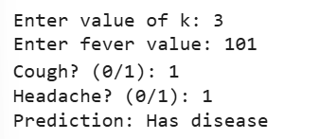
EXPERIMENT 25:
25. Decision Tree Classifier for Iris Flower Species Prediction
CODE:
from sklearn.datasets import load_iris
from sklearn.tree import DecisionTreeClassifier
iris = load_iris()
X, y = iris.data, iris.target
model = DecisionTreeClassifier()
model.fit(X, y)
vals = list(map(float, input("Enter 4 values (SL SW PL PW): ").split()))
pred = model.predict([vals])
print("Predicted Species:", iris.target_names[pred][0])
OUTPUT:
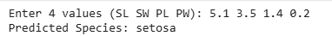

EXPERIMENT 26:
26. Linear Regression for Housing Price Prediction
CODE:
from sklearn.linear_model import LinearRegression
X = [
[1000, 2],
[1500, 3],
[2000, 3],
[2500, 4],
[3000, 5]
]
y = [50, 75, 100, 130, 160] # prices in lakhs
model = LinearRegression()
model.fit(X, y)
area = float(input("Enter area: "))
bed = int(input("Enter bedrooms: "))
pred = model.predict([[area, bed]])[0]
print("Predicted Price (lakhs):", round(pred, 2))
OUTPUT:
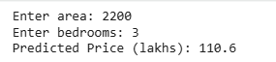
EXPERIMENT 27:
27. Logistic Regression for Customer Churn Prediction
CODE:
from sklearn.linear_model import LogisticRegression
X = [
[200, 12],
[50, 1],
[300, 24],
[80, 3],
[400, 36]
]
y = [0, 1, 0, 1, 0] # churn labels
model = LogisticRegression()
model.fit(X, y)
u = float(input("Enter usage minutes: "))
c = int(input("Enter contract months: "))
pred = model.predict([[u, c]])[0]
print("Churn Prediction:", "Will Churn" if pred == 1 else "Will NOT Churn")
OUTPUT:
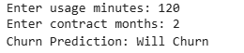
EXPERIMENT 28:
28. K-Means Clustering for Customer Segmentation
CODE:
from sklearn.cluster import KMeans
X = [
[5000, 2],
[15000, 5],
[25000, 10],
[4000, 1],
[18000, 6]
]
model = KMeans(n_clusters=3, random_state=0)
model.fit(X)
spend = float(input("Enter annual spending: "))
visits = int(input("Enter monthly visits: "))
cluster = model.predict([[spend, visits]])[0]
print("Customer Segment:", cluster)
OUTPUT:
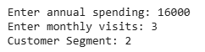
EXPERIMENT 28:
29. Evaluation Metrics for Model Performance (Accuracy, Precision, Recall, F1-Score)
CODE:
from sklearn.datasets import load_iris
from sklearn.model_selection import train_test_split
from sklearn.metrics import accuracy_score, precision_score, recall_score, f1_score
from sklearn.tree import DecisionTreeClassifier
data = load_iris()
X = data.data
y = data.target
Xtrain, Xtest, ytrain, ytest = train_test_split(X, y, test_size=0.3, random_state=0)
model = DecisionTreeClassifier()
model.fit(Xtrain, ytrain)
pred = model.predict(Xtest)
print("Accuracy:", accuracy_score(ytest, pred))
print("Precision:", precision_score(ytest, pred, average='macro'))
print("Recall:", recall_score(ytest, pred, average='macro'))
print("F1 Score:", f1_score(ytest, pred, average='macro'))
OUTPUT:
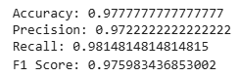
EXPERIMRNT 30:
30. Classification and Regression Tree (CART) for Car Price Prediction
CODE:
from sklearn.tree import DecisionTreeRegressor, export_text
X = [
[50000, 5, 120],
[30000, 3, 150],
[80000, 8, 100],
[20000, 2, 160],
[70000, 7, 110]
]
y = [5, 8, 3, 10, 4]
model = DecisionTreeRegressor()
model.fit(X, y)
m = float(input("Enter mileage: "))
a = int(input("Enter age: "))
e = int(input("Enter engine power: "))
pred = model.predict([[m, a, e]])[0]
print("Predicted Price (lakhs):", round(pred, 2))
tree_rules = export_text(model, feature_names=["mileage","age","engine_power"])
print("\nDecision Path:\n")
print(tree_rules)
OUTPUT:
