TRAFFIC AND TRANSPORTATION DATA ANALYSIS FOR URBAN CONGESTION MANAGEMENT AND SIGNAL OPTIMIZATION
COMMON COURSE ASSIGNMENT FORMAT
A. Assignment Information
Department: | Artificial Intelligence & Data Science (AI & DS)
Programme: | B.E., B.TECH
Course Code & Course Name: | DSA0606 - Data Handling and Visualization
Academic Year / Batch: | 2026
Faculty Name: | Dr L Karthikeyan
Assignment Title: | Traffic and Transportation Data Analysis for Urban Congestion Management and Signal Optimization
Date of Issue: | 31-08-2026
Date of Submission: | 01-09-2026
Maximum Marks: | 100
Course Outcome(s) - CO: | CO1, CO2 and CO4
Bloom's Taxonomy Level: | L3, L4, L5, L6
SDG Mapping (SDG 1-17): | SDG 9 (Industry, Innovation and Infrastructure), SDG 11 (Sustainable Cities and Communities)
Industry / Societal Relevance: | Smart-city traffic management, public-transport planning and signal optimization using civic sensor data

Traffic and Transportation Data Analysis for Urban Congestion Management and Signal Optimization

1. Abstract
The project involves the analysis of one month of raw, unformatted traffic-sensor data collected from twelve road junctions across the city. The unformatted dataset suffers from practical data-quality problems including missing readings, duplicate log entries, and inconsistent timestamp formats. The goal of the project is to cleanse, transform, and organize this unformatted dataset into a clean, analysis-ready one. After cleansing the data, an interactive web-based analytics dashboard, TRAFFIC OS, was built to provide traffic-management insights such as hourly traffic volume trends, the most congested junctions, and daily traffic patterns. The dashboard enables the city transport authority to monitor congestion, identify peak traffic hours, and make evidence-based decisions related to signal timing and bus-route planning.

2. Problem Statement
City transport authorities operate roadside sensor networks that record vehicle counts, timestamps, and junction identifiers across the city. This data is frequently unorganized and unstructured, containing missing readings, duplicate log entries, and inconsistent timestamp formats generated from sensor downtime and network retransmission. It is assumed that after structuring the data, analysis will be carried out in order to identify peak congestion hours, high-traffic junctions, and daily traffic patterns that can guide signal-timing and bus-route planning decisions.

3. Objectives
- To understand the structure and quality of the raw traffic-sensor dataset.
- To identify missing, duplicate, inconsistent, and invalid records.
- To clean and preprocess the raw sensor data.
- To standardize timestamps, junction identifiers, and vehicle-count fields.
- To perform data wrangling and create analysis-ready data.
- To calculate important traffic metrics and KPIs.
- To analyze hourly and daily traffic volume trends.
- To identify the most congested junctions.
- To compare traffic performance across junctions.
- To design an interactive dashboard (TRAFFIC OS) for transport-authority users.
- To provide insights that support signal-timing and bus-route decisions.

4. Scope of the Project
Data Preparation
- Data loading
- Data inspection
- Missing-value handling
- Duplicate removal
- Timestamp standardization
- Data type conversion
- Data validation
Data Analysis
- Hourly traffic-volume analysis
- Junction-wise congestion analysis
- Peak-hour identification
- Daily-trend analysis
- Identification of high-congestion junctions
Visualization
- KPI cards
- Hourly traffic-volume trend chart
- Top-congested-junctions chart
- Vehicle-count-by-area histogram
- Daily-trend chart
- Interactive filters
- User-access and reporting module

5. Dataset Description
The dataset consists of vehicle-count records generated from roadside sensors installed at twelve junctions across the city, collected over a period of one month.
Column | Description
Junction_ID | Unique identifier for each road junction (e.g., J01_Kathipara)
Timestamp | Date and time at which the vehicle count was recorded
Vehicle_Count | Number of vehicles recorded in that time interval
Hour | Hour of day derived from the timestamp
Day_of_Week | Day of week derived from the timestamp
Status | Data-quality flag (OK / Missing / Duplicate / Inconsistent format)

A. Requirements and Constraints
Functional Requirements
- Load, inspect, clean, and validate one month of multi-junction traffic-sensor data.
- Standardize inconsistent timestamp formats and junction identifiers.
- Compute key traffic metrics: Total Vehicle Count, Peak Traffic Hour, Junction-wise Volume, and Daily Trend.
- Provide an interactive dashboard with KPI cards, an hourly trend chart, a junction-congestion chart, and a daily-trend chart.
Data / Technical Constraints
- Multiple timestamp formats appear in the raw data and must be reconciled to a single ISO 8601 standard format.
- Exact duplicate sensor log entries must be detected and removed using a combination of Junction ID, Timestamp, and Vehicle Count.
- Missing values in Vehicle_Count and Timestamp fields must be identified and treated (short gaps interpolated, long gaps flagged).

Tool Constraints
- Data cleaning and wrangling must use Python with Pandas and NumPy.
- Exploratory visualization must use Matplotlib and Seaborn.
- The final interactive dashboard (TRAFFIC OS) must be built using Streamlit / Power BI.
User Requirements
- The dashboard must be usable by non-technical transport-authority staff to interpret congestion trends and junction performance without requiring programming knowledge.
Scope Constraints
- The analysis is limited to the fields present in the dataset (junction, timestamp, vehicle count); signal-controller hardware, real-time streaming, and field validation of bus routes are outside the available data and therefore outside scope.

6. Data Quality Issues
6.1 Missing Data Identification and Treatment
Some sensor readings may contain missing values in the Vehicle_Count or Timestamp fields.
Handling Method:
- Short, isolated gaps (a single missing hour) are treated as recoverable sensor issues and interpolated.
- Longer gaps are treated as genuine sensor outages and are flagged rather than estimated.
- Missing critical fields such as Junction ID or Timestamp are investigated and removed if the record cannot be reliably used.
6.2 Duplicate Record Detection and Removal
The dataset may contain repeated sensor-log records caused by network retransmission. Duplicate records can inflate vehicle-count totals and therefore must be identified and removed.
Duplicate detection uses Junction ID, Timestamp, and Vehicle Count. Exact duplicate records are removed to prevent inflated traffic-volume figures.

7. Inconsistent Timestamp Formats
The raw dataset may contain formats such as 03/08/2026 08:00, 2026-08-03 08:00, and 03/08/2026 10.00 AM. After standardization to ISO 8601 (YYYY-MM-DDTHH:MM), Hour and Day-of-Week fields can be generated for trend analysis.

8. Sensor Downtime and Data Gaps
Roadside sensors occasionally go offline, producing gaps in the record. Distinguishing genuine low-traffic periods from sensor downtime is addressed by cross-checking gaps against neighbouring junctions, and only interpolating short, isolated gaps rather than longer ones.

9. Data Cleaning Process
The following workflow is used for data cleaning:
Raw Sensor Dataset → Data Loading → Data Inspection → Identify Missing Values → Handle Missing Values → Remove Duplicates → Standardize Timestamps → Derive Hour / Day-of-Week Fields → Convert Data Types → Validate Data → Clean Dataset

10. Data Wrangling
Data wrangling involves transforming the cleaned dataset into a format suitable for analysis.
- Filtering unnecessary records
- Selecting relevant columns
- Renaming columns
- Creating calculated fields (Hour, Day of Week)
- Grouping data by junction and hour
- Aggregating vehicle counts
- Sorting records
- Creating hourly and daily summaries
Total Vehicles (Junction) = Sum of Vehicle_Count per Junction_ID
Hourly Average = Mean of Vehicle_Count grouped by Hour
Daily Total = Sum of Vehicle_Count grouped by Date

11. Exploratory Data Analysis
- Hourly traffic volumes are aggregated to identify rising traffic, peak hours, and low-traffic periods. A line chart is suitable for this analysis.
- Vehicle counts are grouped by junction to determine which junctions experience the highest congestion. A bar chart is used to compare junctions.
- Total vehicles are calculated for each day of the month. A line chart clearly shows the daily trend.
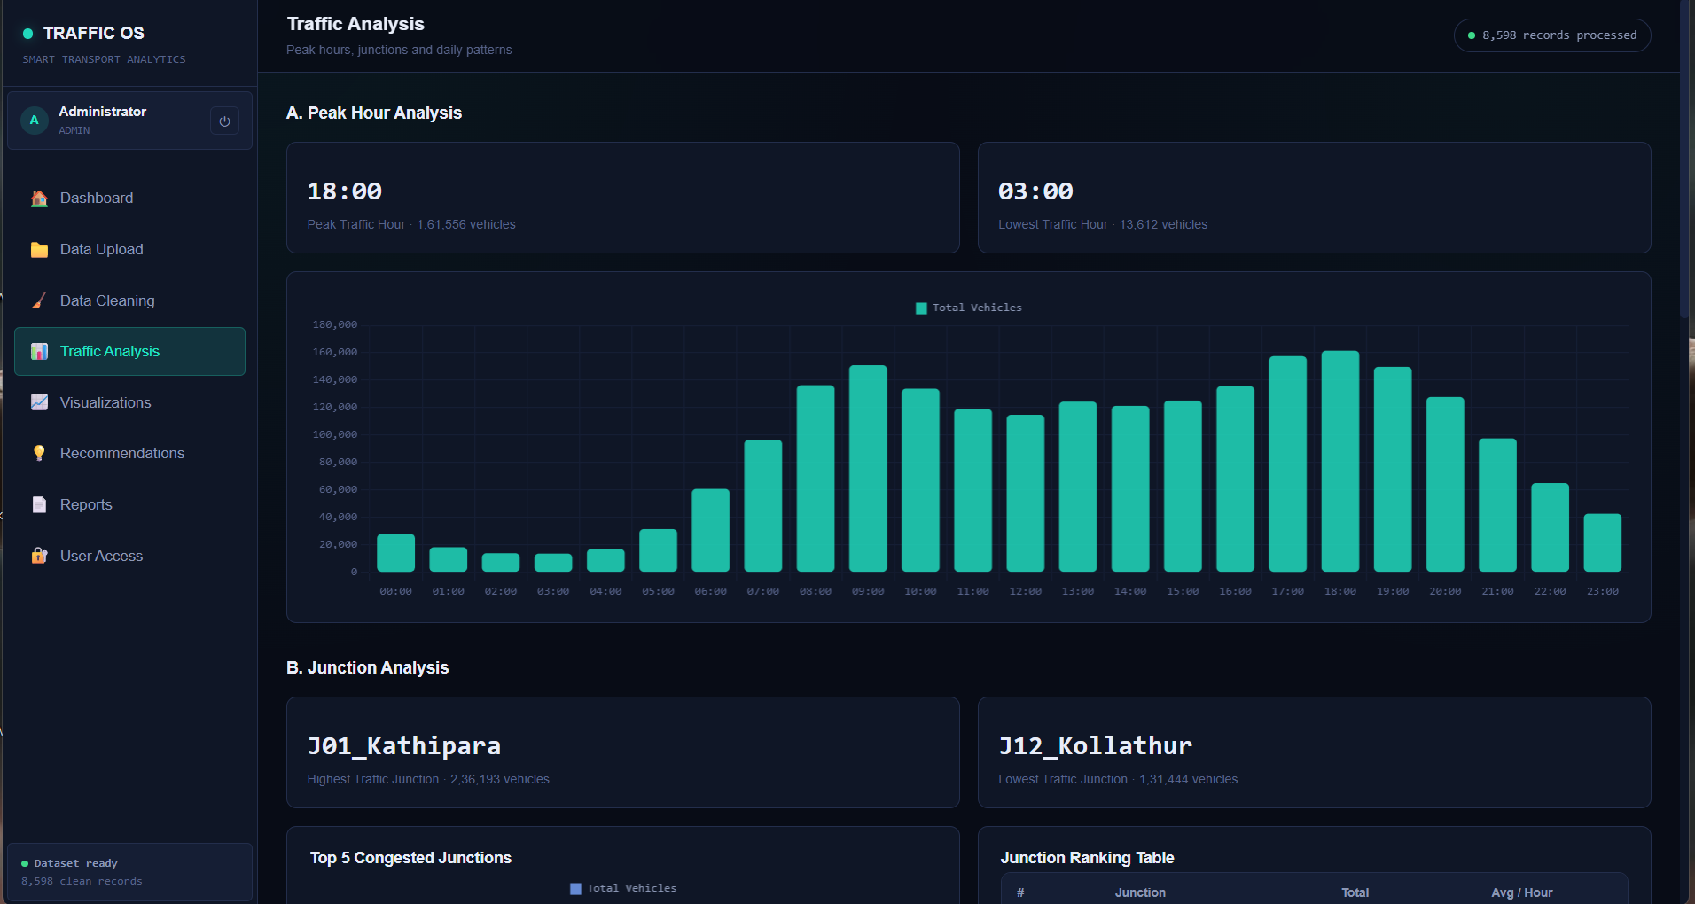
Figure 11.1: Traffic Analysis screen - Peak Hour Analysis, Junction Analysis, and Top-5 Congested Junctions

12. Dashboard Design
The final dashboard, TRAFFIC OS, is designed to provide the transport authority with a quick overview of citywide junction traffic.
- Total Traffic Records
- Total Vehicle Count
- Number of Junctions
- Peak Traffic Hour
- Highest Traffic Junction
- Data Quality Score
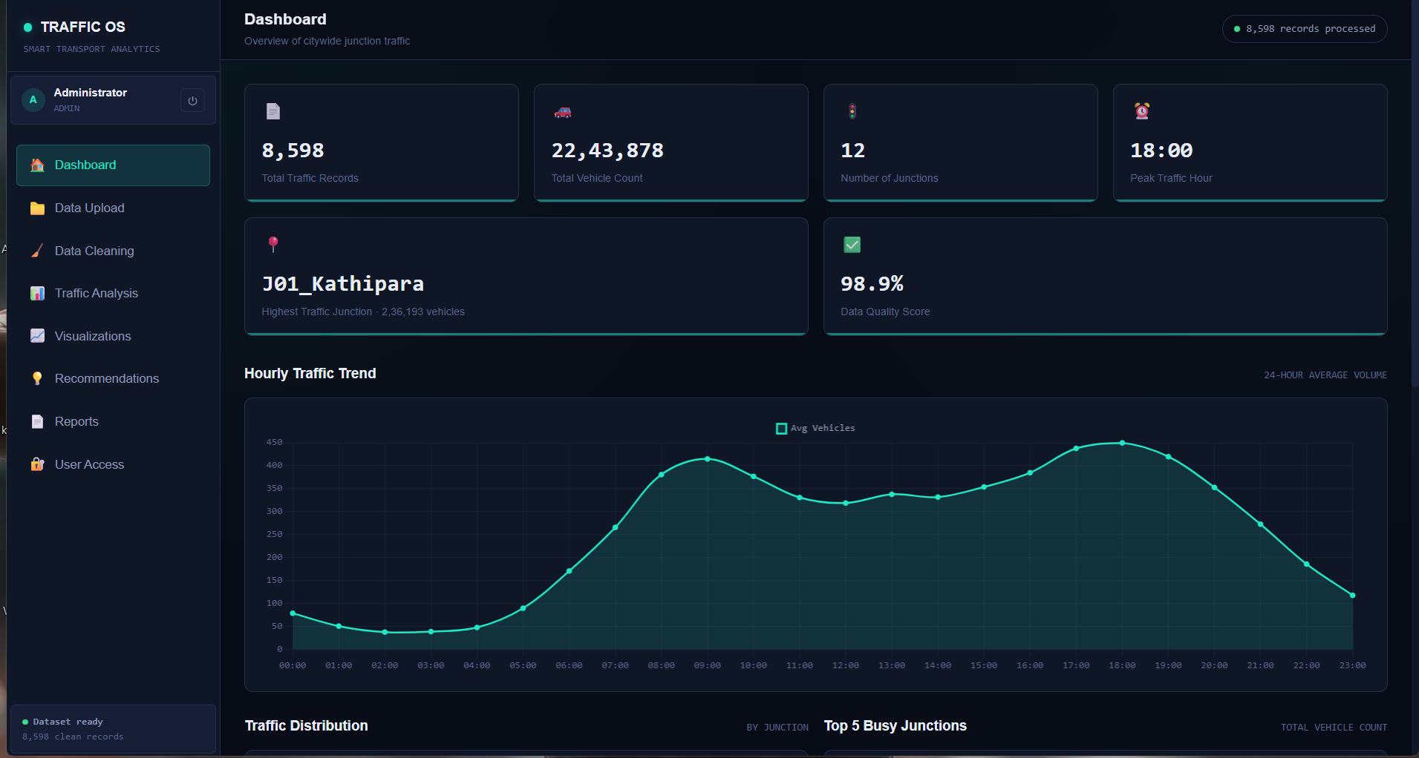
Figure 12.1: TRAFFIC OS Dashboard - KPI cards and 24-hour average traffic trend

13. Traffic Volume Trend Visualization
A line chart displays traffic volume over time. The X-axis represents Hour of Day and the Y-axis represents Total Vehicles. This helps the transport authority identify the morning peak, evening peak, and low-traffic overnight periods.

14. Top Congested Junctions
A bar chart ranks junctions based on total vehicle count. High-congestion junctions can be prioritized for signal re-timing and bus-route adjustments.

15. Junction-Wise Performance Comparison
A bar chart compares junctions based on total vehicles passed. It helps identify the highest- and lowest-congested junctions and supports signal-timing and sensor-maintenance prioritization decisions.
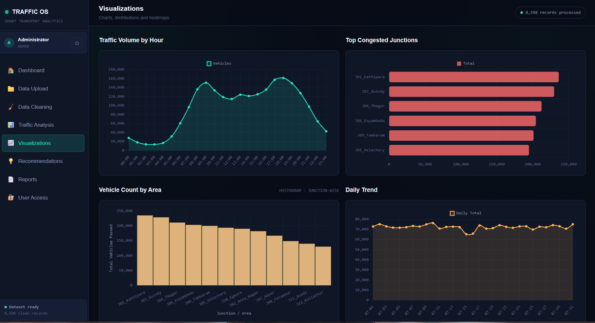
Figure 15.1: Visualizations screen - Traffic Volume by Hour, Top Congested Junctions, Vehicle Count by Area, and Daily Trend

16. Interactive Features
- Secure login with User ID and password
- Role-based access approval (User Access module)
- Data Upload module
- Data Cleaning module
- Junction filter
- Date / hour filter
- Report generation and export
For example, an administrator can approve or reject pending access requests from the User Access screen, and uploading a new month of sensor data automatically re-runs the cleaning pipeline and refreshes every chart on the dashboard.
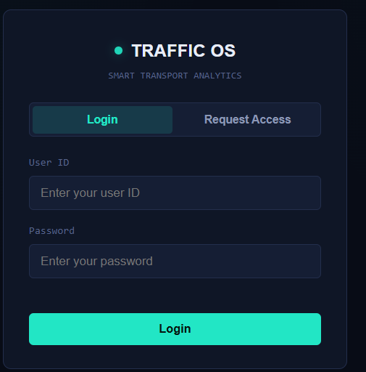
Figure 16.1: TRAFFIC OS login screen
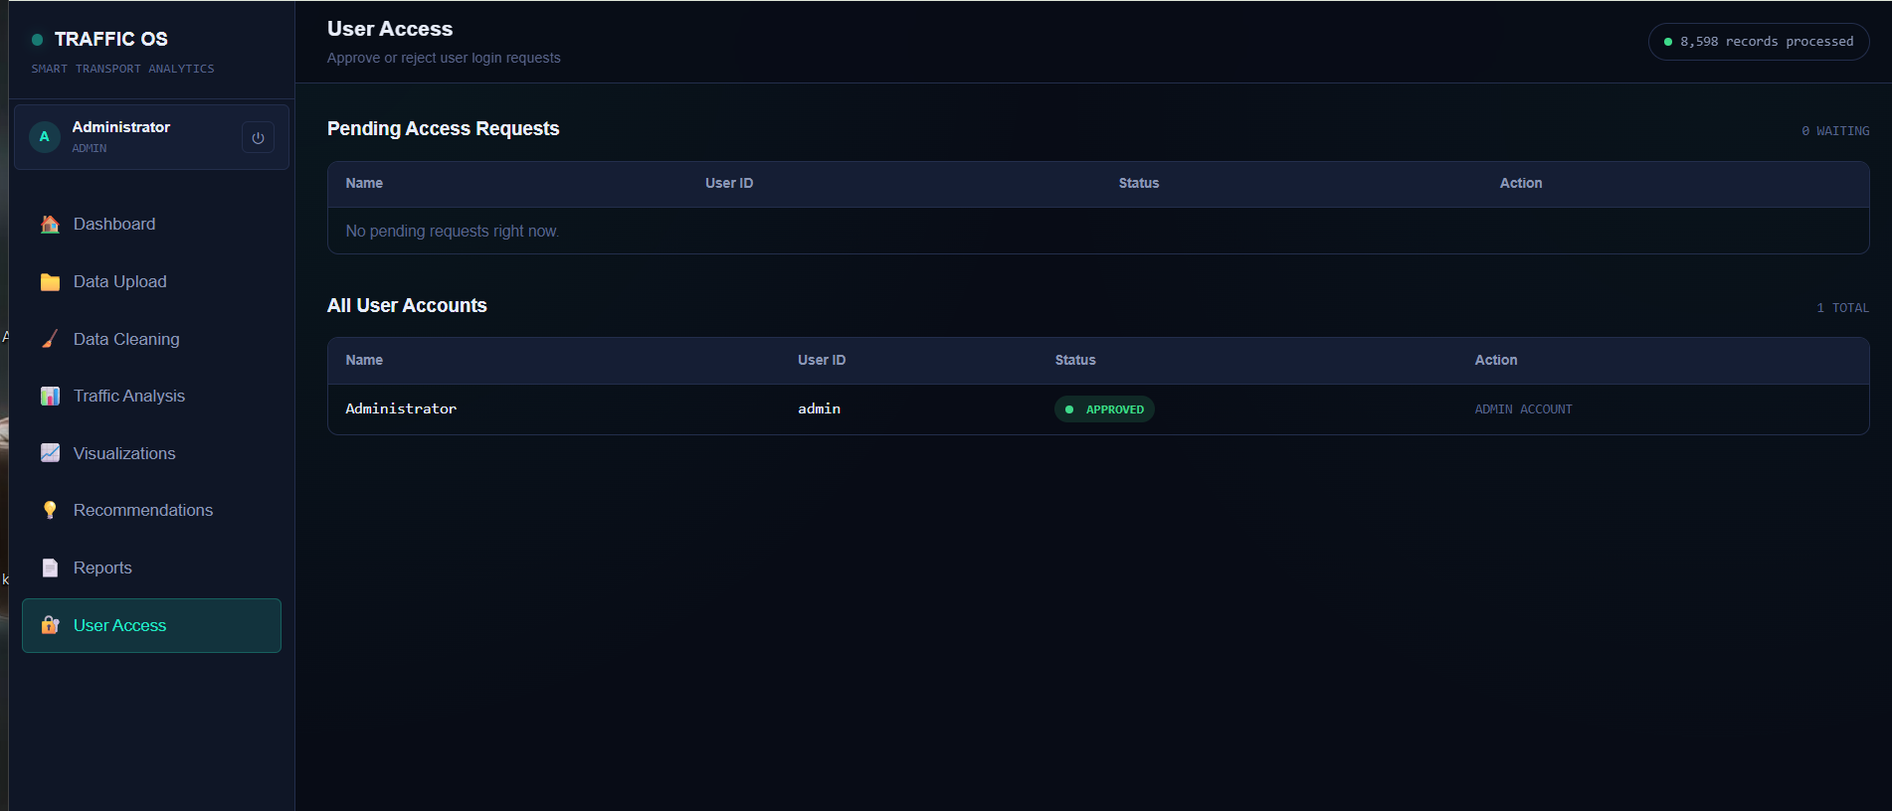
Figure 16.2: User Access screen - approve or reject login requests

17. Tools and Technologies
Tool | Purpose
Python | Data cleaning and analysis
Pandas | Data manipulation
NumPy | Numerical operations
Matplotlib / Seaborn | Exploratory data visualization
Streamlit | Interactive TRAFFIC OS web dashboard
Plotly | Interactive charts within the dashboard
Excel / CSV | Dataset storage
Power BI | Supplementary interactive reporting
Git | Version control for scripts and the dashboard app

18. Implementation Methodology
- Data Collection - Collect and load one month of multi-junction sensor data.
- Data Understanding - Examine records, columns, data types, missing values, and duplicates.
- Data Cleaning - Identify and correct data-quality issues.
- Data Wrangling - Transform and aggregate the cleaned data.
- Exploratory Analysis - Analyze traffic patterns using summaries and visualizations.
- Dashboard Development - Combine KPIs, charts, and filters into TRAFFIC OS.
- Business Insights - Interpret results to support signal-timing and staffing decisions.

Pseudo code:
BEGIN
SET page title = "TRAFFIC OS"
SET page icon = "🚦"
SET dashboard layout = "Wide"
IF CSS file exists THEN
LOAD and APPLY dark-theme CSS
END IF

FUNCTION main()
DISPLAY login screen (User ID, Password)
IF credentials valid THEN
DISPLAY sidebar title "TRAFFIC OS - Smart Transport Analytics"
LOAD raw sensor dataset
STORE dataset in RAW_DATA
CLEAN RAW_DATA
STORE CLEANED_DATA, CLEANING_SUMMARY
DISPLAY navigation: Dashboard, Data Upload, Data Cleaning,
Traffic Analysis, Visualizations,
Recommendations, Reports, User Access
GET selected page
GET junction / date filters from CLEANED_DATA
FILTER CLEANED_DATA based on selections
STORE result in FILTERED_DATA
IF selected page = "Dashboard" THEN
CALCULATE KPIs from FILTERED_DATA
DISPLAY Total Records, Total Vehicles, Junctions, Peak Hour
CREATE hourly traffic trend chart
CREATE top-5 busy junctions chart
ELSE IF selected page = "Traffic Analysis" THEN
CALCULATE peak / lowest traffic hour
DISPLAY junction ranking table
ELSE IF selected page = "Visualizations" THEN
DISPLAY volume-by-hour, congestion, area and daily charts
ELSE IF selected page = "User Access" THEN
DISPLAY pending and approved user accounts
END IF
END IF
END FUNCTION
CALL main()
END

Sample implementation (Python / Streamlit):
import streamlit as st
import pandas as pd
import plotly.express as px

st.set_page_config(page_title="TRAFFIC OS", page_icon="🚦", layout="wide")

# ---------- Data cleaning ----------
@st.cache_data
def load_and_clean(path):
df = pd.read_csv(path)
df.drop_duplicates(subset=["Junction_ID", "Timestamp",
"Vehicle_Count"], inplace=True)
df["Timestamp"] = pd.to_datetime(df["Timestamp"], errors="coerce")
df["Hour"] = df["Timestamp"].dt.hour
df["Day_of_Week"] = df["Timestamp"].dt.day_name()
df["Vehicle_Count"] = (
df.groupby("Junction_ID")["Vehicle_Count"]
.transform(lambda s: s.interpolate(limit=1))
)
df.dropna(subset=["Junction_ID", "Timestamp"], inplace=True)
return df

# ---------- Authentication ----------
def login():
st.title("🟢 TRAFFIC OS")
st.caption("SMART TRANSPORT ANALYTICS")
user_id = st.text_input("User ID")
password = st.text_input("Password", type="password")
if st.button("Login"):
if authenticate(user_id, password):
st.session_state["logged_in"] = True
else:
st.error("Invalid credentials")

# ---------- Dashboard ----------
def dashboard(df):
st.header("Dashboard")
col1, col2, col3, col4 = st.columns(4)
col1.metric("Total Traffic Records", f"{len(df):,}")
col2.metric("Total Vehicle Count", f"{df['Vehicle_Count'].sum():,}")
col3.metric("Number of Junctions", df["Junction_ID"].nunique())
peak_hour = df.groupby("Hour")["Vehicle_Count"].mean().idxmax()
col4.metric("Peak Traffic Hour", f"{peak_hour:02d}:00")

hourly = df.groupby("Hour")["Vehicle_Count"].mean().reset_index()
fig = px.area(hourly, x="Hour", y="Vehicle_Count",
title="Hourly Traffic Trend")
st.plotly_chart(fig, use_container_width=True)

top5 = (df.groupby("Junction_ID")["Vehicle_Count"].sum()
.nlargest(5).reset_index())
fig2 = px.bar(top5, x="Vehicle_Count", y="Junction_ID",
orientation="h", title="Top 5 Busy Junctions")
st.plotly_chart(fig2, use_container_width=True)

def traffic_analysis(df):
st.header("Traffic Analysis")
hourly = df.groupby("Hour")["Vehicle_Count"].sum().reset_index()
peak = hourly.loc[hourly["Vehicle_Count"].idxmax()]
low = hourly.loc[hourly["Vehicle_Count"].idxmin()]
c1, c2 = st.columns(2)
c1.metric("Peak Traffic Hour", f"{int(peak.Hour):02d}:00",
f"{int(peak.Vehicle_Count):,} vehicles")
c2.metric("Lowest Traffic Hour", f"{int(low.Hour):02d}:00",
f"{int(low.Vehicle_Count):,} vehicles")
fig = px.bar(hourly, x="Hour", y="Vehicle_Count",
title="Total Vehicles by Hour")
st.plotly_chart(fig, use_container_width=True)

ranking = (df.groupby("Junction_ID")
.agg(Total=("Vehicle_Count", "sum"),
Avg_per_Hour=("Vehicle_Count", "mean"))
.sort_values("Total", ascending=False)
.reset_index())
st.dataframe(ranking, use_container_width=True)

# ---------- Main ----------
def main():
if not st.session_state.get("logged_in"):
login()
return
df = load_and_clean("traffic_sensor_data.csv")
page = st.sidebar.radio(
"Navigate",
["Dashboard", "Data Upload", "Data Cleaning",
"Traffic Analysis", "Visualizations",
"Recommendations", "Reports", "User Access"]
)
junctions = st.sidebar.multiselect(
"Junction", df["Junction_ID"].unique(),
default=list(df["Junction_ID"].unique())
)
filtered = df[df["Junction_ID"].isin(junctions)]
if page == "Dashboard":
dashboard(filtered)
elif page == "Traffic Analysis":
traffic_analysis(filtered)

if __name__ == "__main__":
main()

GITHUB LINK: https://github.com/<your-username>/traffic-os-assignment

19. Business Insights
Signal Timing
If a junction consistently records high traffic during specific hours, the transport authority can increase green-signal duration during those windows.
Bus-Route Planning
Junctions with consistently high vehicle counts may require re-timed or additional bus services during peak periods.
Seasonal / Weekly Planning
Daily trends can reveal weekday-versus-weekend demand differences, allowing the authority to prepare weekday-specific signal-timing plans.
Junction Performance
Low-traffic junctions can be investigated to determine whether the cause is sensor downtime, genuinely low demand, or another operational factor.
Sensor Maintenance
Junctions with recurring data gaps can be identified and prioritized for sensor maintenance.

20. Analysis and Engineering Decision
Static exploratory libraries (Matplotlib, Seaborn) were used during analysis, while an interactive web dashboard (Streamlit / Power BI) was chosen for the final deliverable because dynamic, authority-driven filtering was a core functional requirement that static charts alone could not satisfy. The cleaned data was then interpreted to support the following engineering and business decisions:
Signal Timing
Increase green-signal duration during the identified morning and evening peak windows at the top-ranked junctions, with a corresponding reduction during confirmed low-traffic overnight hours.
Bus-Route Planning
Introduce or re-time bus services along the corridor connecting the highest-ranked junctions to better match capacity with observed demand.
Weekday vs Weekend Plans
Apply weekday-specific signal-timing plans distinct from weekend plans, given the clear difference in observed traffic volumes.
Sensor Maintenance
Prioritise sensor maintenance at junctions showing recurring data gaps, to improve the reliability of future analyses.

21. Broader Considerations
- Economic: more accurate signal-timing and bus-route decisions can reduce fuel wastage and lost productivity caused by congestion.
- Professional responsibility: the dashboard gives non-technical transport-authority staff a reliable, evidence-based basis for operational decisions rather than intuition alone.
- Data privacy: the dataset used (Junction_ID, Timestamp, Vehicle_Count) does not include personally identifiable information, which limits privacy risk.
- Sustainability: smoother traffic flow reduces idling, fuel consumption, and emissions, supporting more efficient use of city infrastructure.

22. Expected Outcome
The expected outcome is a clean, structured, and analysis-ready traffic-sensor dataset along with an interactive dashboard, TRAFFIC OS. The dashboard enables the transport authority to monitor traffic trends, identify the most congested junctions, compare junction performance, detect peak-demand periods, and make better signal-timing and bus-route decisions.
The dashboard output produced the following headline results:
KPI | Value
Total Traffic Records | 8,598
Total Vehicle Count | 22,43,878
Number of Junctions | 12
Peak Traffic Hour | 18:00 (1,61,556 vehicles)
Lowest Traffic Hour | 03:00 (13,612 vehicles)
Highest Traffic Junction | J01_Kathipara - 2,36,193 vehicles
Lowest Traffic Junction | J12_Kollathur - 1,31,444 vehicles
Data Quality Score | 98.9%

23. Advantages
- Improves data quality.
- Reduces errors caused by duplicate and inconsistent records.
- Provides a centralized view of citywide junction traffic.
- Makes congestion patterns easier to understand.
- Supports faster decision-making.
- Helps optimize signal timing.
- Helps plan bus routes based on demand.
- Enables junction performance comparison.
- Provides interactive data exploration.
- Converts raw sensor data into actionable insights.

24. Limitations
- The quality of insights depends on the quality of the original sensor data.
- Missing information may reduce analytical accuracy.
- Sensor downtime can introduce gaps that limit visibility into true traffic conditions.
- Historical, one-month data alone may not accurately predict future congestion.
- The dashboard focuses primarily on vehicle-count information and does not include weather, incident, or road-work data.

25. Future Enhancements
- Real-time / near-real-time sensor data streaming.
- Time-series forecasting of congestion.
- Expanded sensor coverage to reduce data gaps.
- Automated anomaly detection for sudden congestion spikes.
- Integration with weather and incident data.
- Dynamic, demand-responsive signal control.
- Alerts for chronically under-monitored junctions.
- Junction-wise emissions estimation.

26. Conclusion
This project involves the transformation of unclean, unstructured traffic-sensor data into usable, analysis-ready data. The first step involves the cleaning of the data, including issues such as missing readings, duplicate logs, and inconsistent timestamps. The second step involves wrangling and aggregating the data to identify hourly and daily traffic patterns. The third step involves the creation of TRAFFIC OS, an interactive dashboard that visualizes traffic trends on an hourly basis and the performance of various junctions.
This dashboard will help the transport authority assess congestion and make business decisions such as signal-timing adjustments and bus-route planning. In conclusion, the above project represents the application of data cleaning, data wrangling, data exploration, and data visualization in the solution of real-world urban-transport problems.

27. References
• Roess, R. P., Prassas, E. S., & McShane, W. R. Traffic Engineering (5th ed.). Pearson Education.
• Institute of Transportation Engineers. Manual of Transportation Engineering Studies (2nd ed.). ITE.
• McKinney, W. Python for Data Analysis: Data Wrangling with Pandas, NumPy, and Jupyter. O'Reilly Media.
• International Organization for Standardization. ISO 8000: Data Quality - An Overview. ISO.
• International Organization for Standardization. ISO 8601: Date and Time - Representations for Information Interchange. ISO.
• Institute of Electrical and Electronics Engineers. IEEE 1512: Standard for Common Incident Management Message Sets. IEEE.
• Ministry of Road Transport and Highways, Government of India. Urban Traffic Management Guidelines. MoRTH.
• Pandas Development Team. Pandas Documentation - User Guide and API Reference.
• Streamlit Inc. Streamlit Documentation - Build Data Applications in Python.
• Plotly Technologies Inc. Plotly Python Graphing Library Documentation.
F. Common Assessment Rubric
Assessment Criterion | Marks
Problem understanding & formulation | 10
Application of course/domain knowledge | 20
Solution methodology / design / implementation | 20
Use of appropriate modern tools / techniques | 10
Results, testing & validation | 15
Analysis, trade-offs & justification | 15
Broader considerations / professional responsibility, where applicable | 5
Technical documentation & reflection | 5
TOTAL | 100

G. CO-PO-Assessment Mapping
Assessment Component | CO | PO(s) | Bloom's Level | Marks
Problem formulation |  |  | L3/L4 | 10
Application of knowledge |  |  | L3/L4 | 20
Solution / Design / Implementation |  |  | L4/L5/L6 | 20
Modern tool usage |  |  | L3/L4 | 10
Validation |  |  | L4/L5 | 15
Analysis & justification |  |  | L4/L5 | 15
Broader considerations |  |  | L4/L5 | 5
Documentation & reflection |  |  | L3/L4 | 5

H. Faculty Evaluation & Continuous Improvement
CO Attainment
Performance Level | Criterion
Level 3 | ≥ 70%
Level 2 | 60-69%
Level 1 | 50-59%
Level 0 | < 50%

Target CO Attainment: __________ Actual CO Attainment: __________
Faculty Analysis
Areas in which students performed well:
Areas requiring improvement:
Corrective / Improvement Action:
Action to be implemented in the next offering:

