CO2-AT1 — CHART CONSTRUCTION TEST
Chart Type Answer Key

NAME: M.SAI HARSHITHA
REG.NO: 192424408
COURSE CODE: DSA0606
COURSE NAME: DATA HANDLING AND VISUALIZATION
DATE: 30.07.2026

Problem 6 — Multi-Line Chart — Comparison
Scenario: Two continuous series (rainfall for two cities) need to be compared across the same ordered time axis; overlaid lines make it easy to see where the two trends diverge or align.

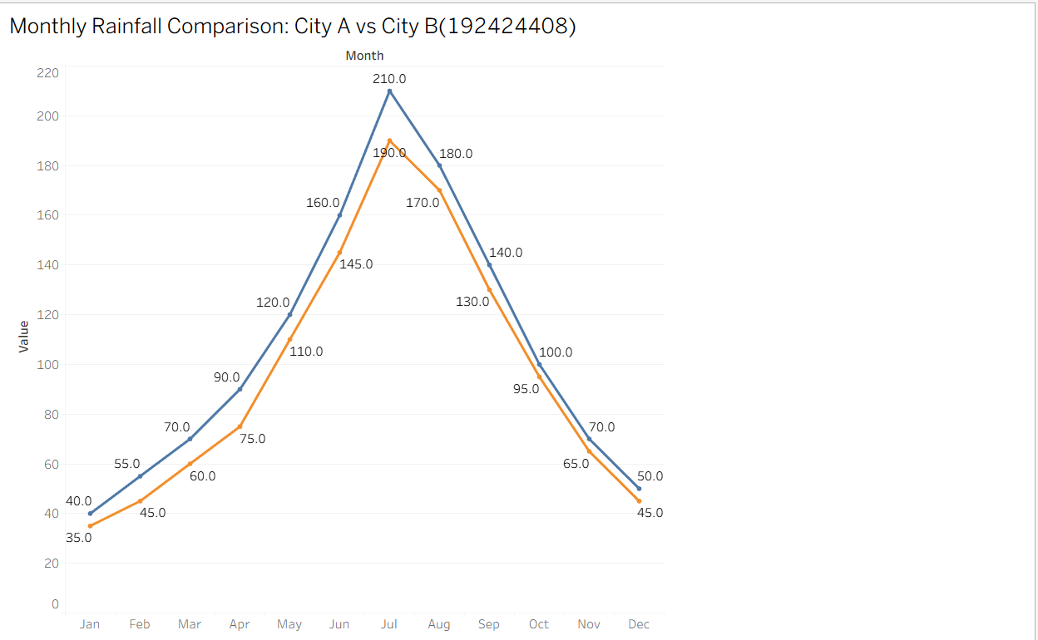
Explanation of the Multi-Line Chart
The multi-line chart compares the monthly rainfall of City A and City B over a period of one year (January to December).
- The X-axis represents the months (January–December).

- The Y-axis represents the rainfall measured in millimetres (mm).
- The blue line represents the rainfall in City A.
- The green line represents the rainfall in City B.
Observation
- Rainfall in both cities gradually increases from January to July.
- July records the highest rainfall, with 210 mm in City A and 190 mm in City B.
- After July, the rainfall decreases steadily from August to December.
- Throughout the year, City A receives slightly more rainfall than City B.
- Both cities show a similar seasonal rainfall pattern, indicating that rainfall trends are nearly the same, although City A consistently experiences higher rainfall.
Conclusion
The multi-line chart makes it easy to compare rainfall trends between the two cities over time. It clearly shows the increase, peak, and decrease in rainfall, helping identify similarities and differences in the rainfall patterns of City A and City B.

Problem 7 – Pie Chart – Angle Calculation
Scenario: Only 4 categories that sum to a meaningful whole (100% market share); pie slices directly encode each company's proportion of that whole via angle
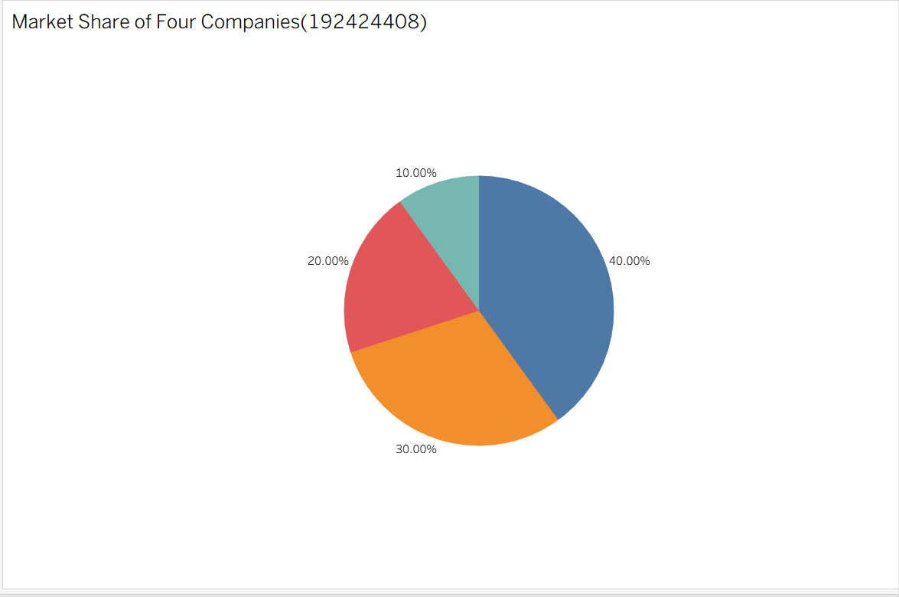

Explanation
- The pie chart represents the market share of four companies.
- Each slice corresponds to a company's percentage of the total market.
- Company A has the largest market share (40%, 144°).
- Company B accounts for 30% (108°).
- Company C contributes 20% (72°).
- Company D has the smallest market share (10%, 36°).
Observation
- Company A dominates the market.
- Company B is the second-largest contributor.
- Company C holds a moderate share.
- Company D has the smallest market share.

Conclusion
The pie chart is the most suitable visualization because it shows how each company's market share contributes to the total market (100%). Each slice represents a company's percentage and corresponding angle, making it easy to compare their proportions. Company A has the largest market share, while Company D has the smallest.
Problem: Pie Chart — From Raw Counts
Scenario:
Three response categories are collected from 200 respondents. A pie chart is used to show how the total respondents are divided among these categories.
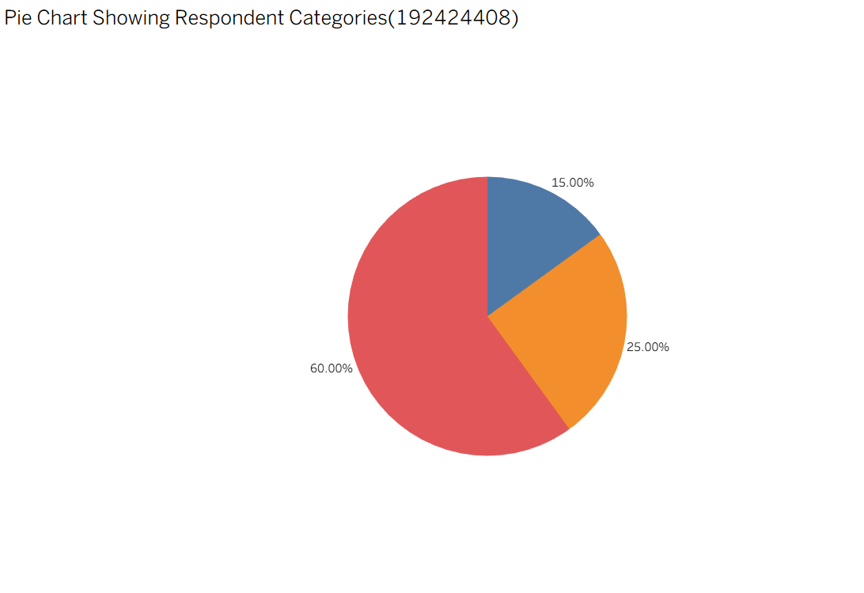

Graph Explanation
The pie chart divides the 200 respondents into three groups:
- Satisfied respondents occupy the largest portion of the circle because they represent 60% of total responses.
- Neutral respondents form a smaller portion with 25%.

- Dissatisfied respondents represent the smallest section with only 15%.
The size of each slice directly represents the contribution of that category to the total responses.
Observation
- The majority of respondents are Satisfied (60%), indicating positive feedback.
- A quarter of respondents are Neutral (25%), meaning they have no strong opinion.
- Only 15% respondents are Dissatisfied, showing a smaller group with negative feedback.
- The response distribution is dominated by satisfied customers.
Conclusion
The pie chart shows that most respondents have a positive response, with 60% satisfaction among the 200 participants. The low dissatisfaction percentage (15%) indicates that overall user/customer experience is favorable. However, the neutral group (25%) suggests there is still an opportunity to improve satisfaction and convert neutral respondents into satisfied users.
Problem 9 — Histogram — Binning
Scenario: The three response counts sum to a fixed total (200 respondents); once converted to percentages, a pie chart is appropriate because there are few categories (3) representing parts of one whole.
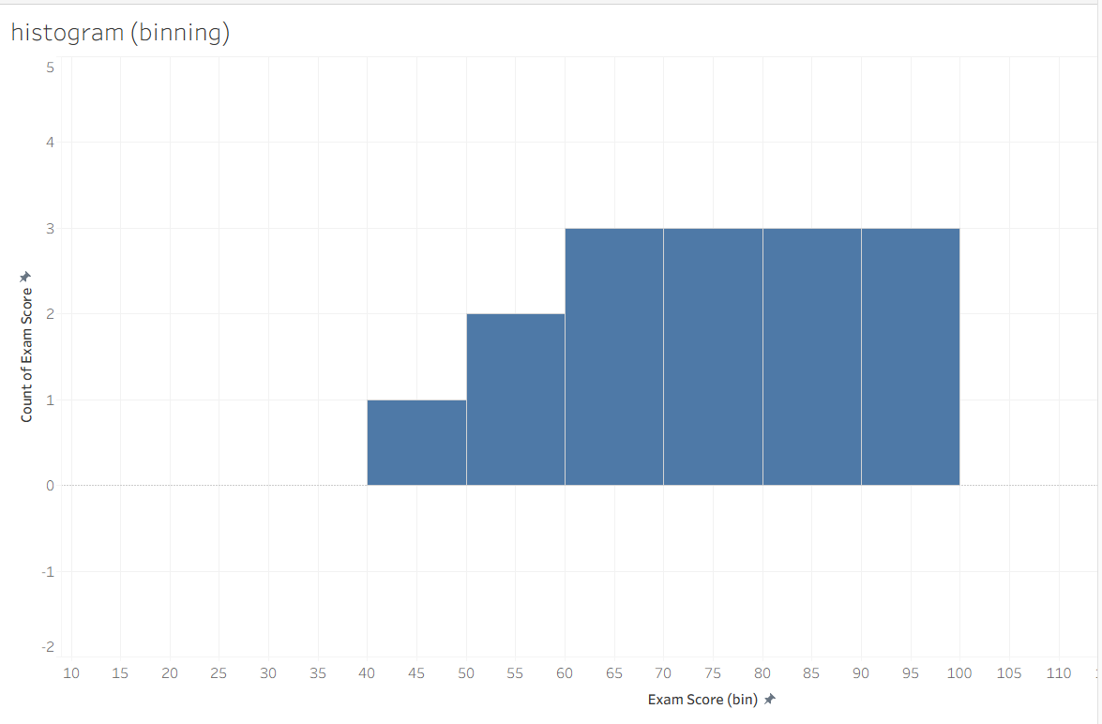
Observation:
- The histogram shows how exam scores are distributed across different score ranges.
- The highest bar represents the score range where most students are concentrated.
- It helps identify whether scores are normally distributed, highly spread, or concentrated.
Conclusion:
The histogram provides a clear view of the distribution and variation of exam scores. Since exam scores are continuous numerical data, binning helps understand performance patterns instead of comparing individual values.

Problem 10 — Scatter Plot — Basic Construction
Scenario: Two continuous numeric variables (study hours, exam score) need their relationship examined; a scatter plot's point positions reveal correlation without any implied ordering or connection between points.
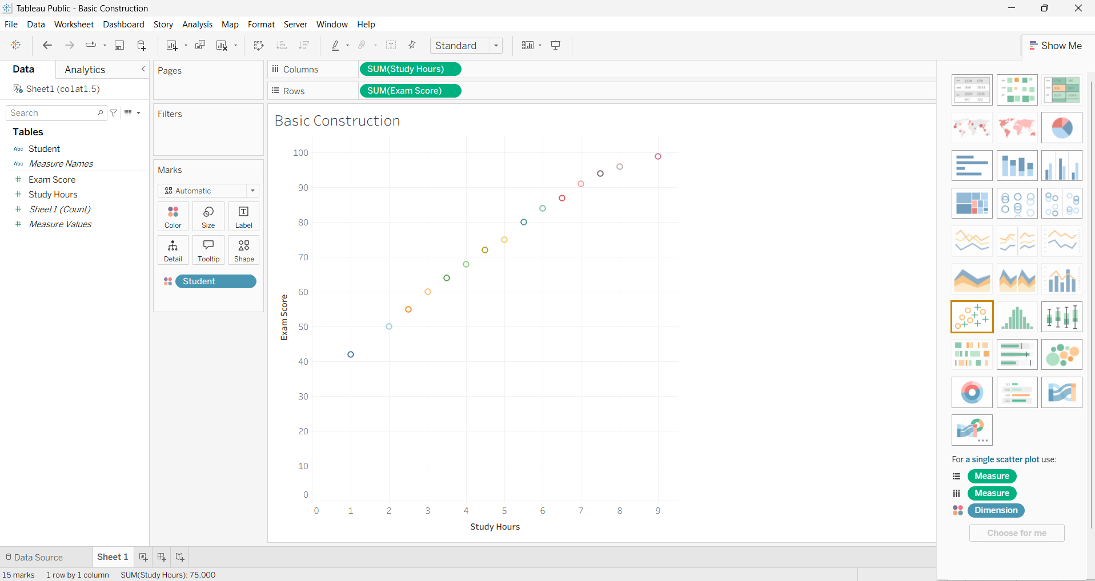
Observation:
- Each point represents one student's study hours and exam score.
- If points move upward from left to right, study hours and marks have a positive relationship.
- If points are randomly scattered, there is little or no relationship.
Conclusion:
The scatter plot helps analyze the relationship between study hours and exam scores. It shows whether increased study time improves exam performance and identifies possible patterns or correlations between the two variables.

