M. Sai Harshitha
192424408
CSA0701
SET-2 : Customer Feedback Analysis
Procedure to Create a Histogram
- Open Tableau Desktop/Public.
- Connect to the Customer Satisfaction dataset.
- Drag the Age field into the worksheet.
- Right-click Age and select Create → Bins (accept the default bin size or specify one).
- Drag AGE (bin) to the Columns shelf.
- Drag AGE to the Rows shelf.
- Right-click AGE on the Rows shelf and select Measure → Count (CNT).
- Tableau displays the histogram.
- Rename the chart title as "Customer Age Distribution".
- Label the X-axis as Age Group and the Y-axis as Number of Customers.
- Save the worksheet
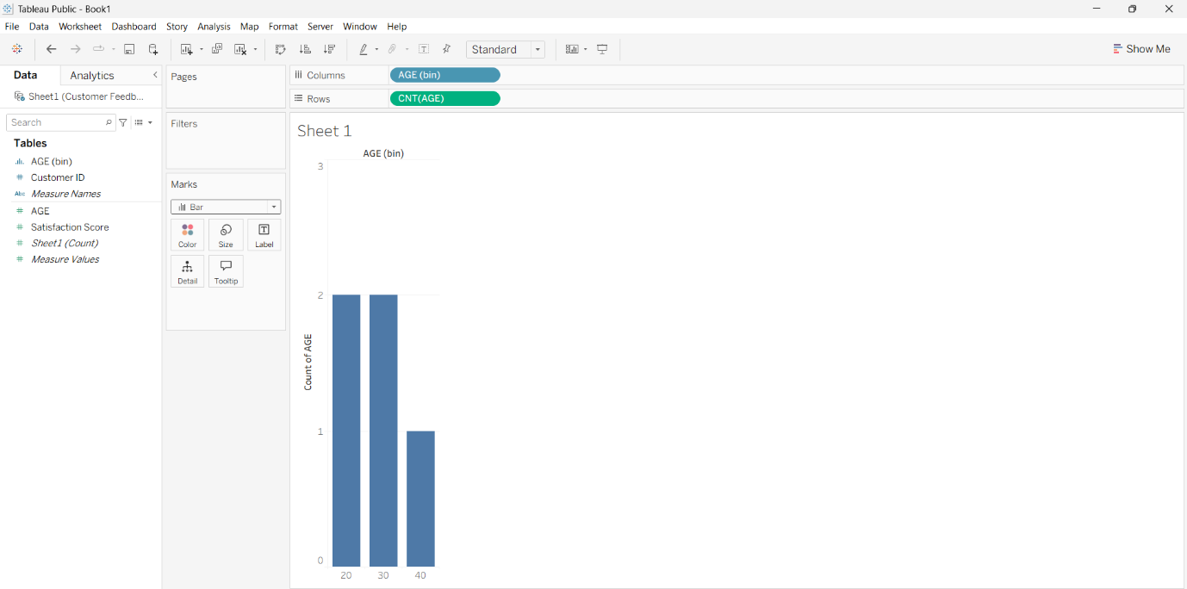

2. Procedure to Create a Pie Chart
- Create a New Worksheet.
- Change the Marks type to Pie.

- Drag Satisfaction Score to the Color shelf.
- Drag Satisfaction Score again to the Label shelf.
- Drag Customer ID to the Angle shelf.
- Right-click Customer ID and select Measure → Count (CNT).
- Click Show Mark Labels.
- Rename the chart title as "Customer Satisfaction Score Distribution".
- Save the worksheet.
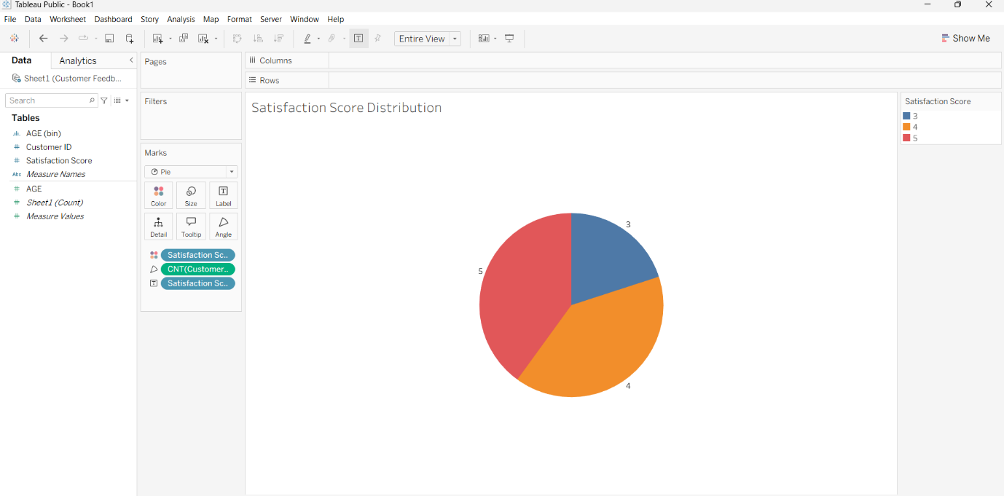
3. Procedure to Create a Stacked Bar Chart
- Create a New Worksheet.
- Drag AGE (bin) to the Columns shelf.
- Drag Customer ID to the Rows shelf.
- Right-click Customer ID and select Measure → Count (CNT).
- Change the Marks type to Bar.
- Drag Satisfaction Score to the Color shelf.
- Ensure Analysis → Stack Marks → On.
- Rename the chart title as "Customer Satisfaction by Age Group".
- Label the X-axis as Age Group and the Y-axis as Number of Customers.
- Save the worksheet.

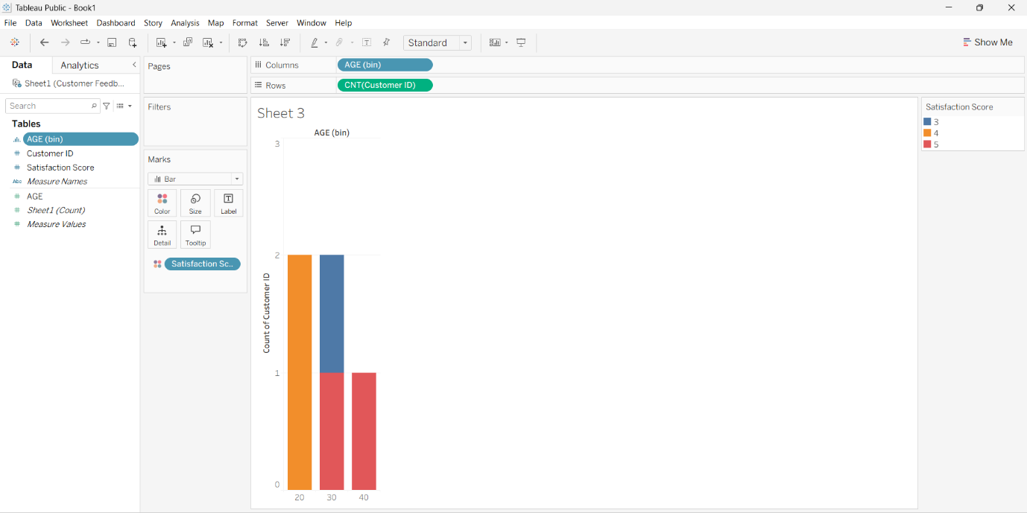
4. Procedure to Create a Word Cloud
- Create a New Worksheet.
- Drag the Feedback field to the Text shelf.
- Change the Marks type to Text.
- Drag Feedback to the Size shelf.
- Apply Word Cloud from Show Me.
- Adjust the font size and colors.
- Rename the chart title as "Customer Feedback Word Cloud".
- Save the worksheet.
