M. Sai Harshitha
192424408
CSA0701
SET-3: Employee Performance Evaluation

1.Procedure to Create a Line Chart
1. Open Tableau Desktop/Public.
2. Connect to the Employee Performance dataset.
3. Drag Years of Service to the Columns shelf.
4. Drag Performance Score to the Rows shelf.
5. From the Marks card, select Line.
6. Drag Employee ID to the Label shelf (optional).
7. Rename the chart title as "Employee Performance Trend".
8. Label the X-axis as Years of Service and the Y-axis as Performance Score.
9. Save the worksheet.
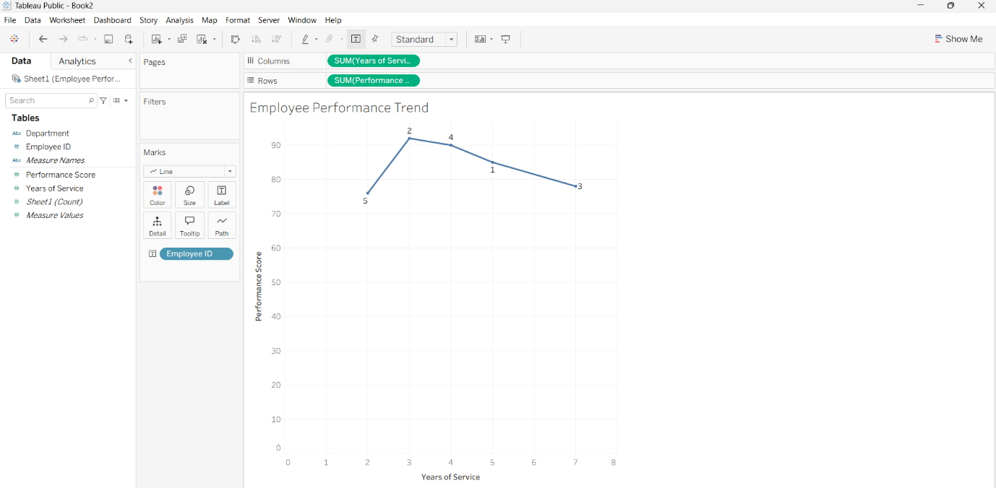

2. Procedure to Create a bar Chart
1. Create a New Worksheet.
2. Drag Department to the Columns shelf.
3. Drag Employee ID to the Rows shelf.
4. Right-click Employee ID and select Measure → Count (CNT).
5. Select Bar from the Marks card.
6. Click Show Mark Labels.
7. Rename the chart title as "Employees by Department".
8. Label the X-axis as Department and the Y-axis as Number of Employees
9. Save the worksheet. 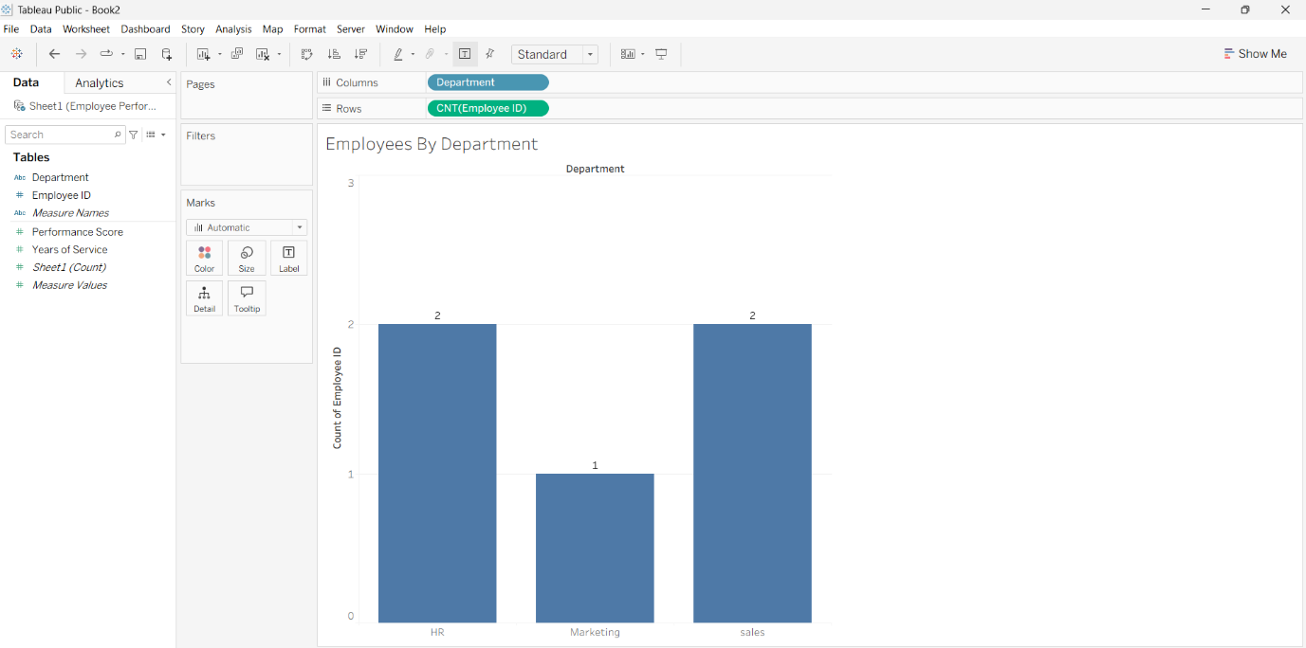

3. Procedure to Create a scattered chart
1. Create a New Worksheet.
2. Drag Years of Service to the Columns shelf.
3. Drag Performance Score to the Rows shelf.
4. Select Circle from the Marks card.
5. Drag Employee ID to the Label shelf.
6. Rename the chart title as "Years of Service vs Performance Score".
7. Label the X-axis as Years of Service and the Y-axis as Performance Score.
8. Save the worksheet.
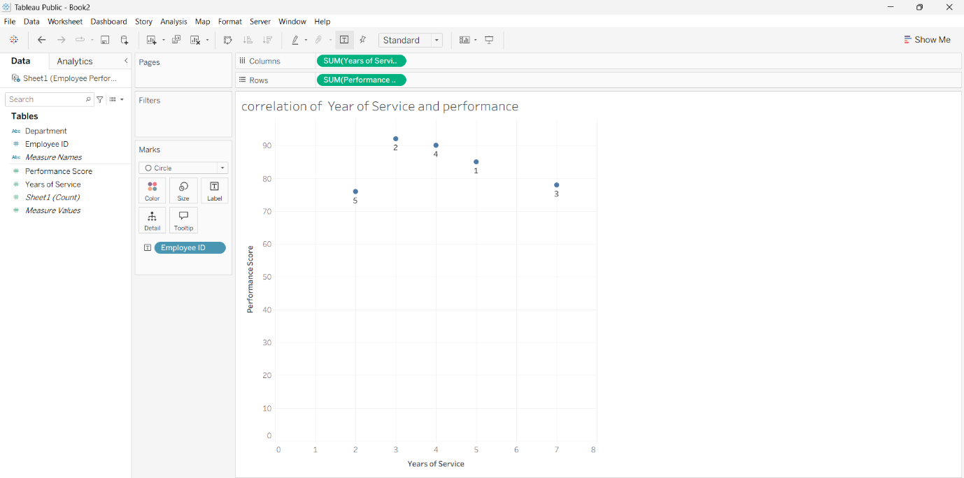

4. Procedure to Create a Word Cloud
1. Click the New Dashboard icon.
2. Set the dashboard size to Automatic.
3. Drag the Line Chart worksheet to the dashboard.
4. Drag the Bar Chart worksheet to the dashboard.
5. Arrange the charts neatly.
6. Rename the dashboard title as "Employee Performance Dashboard".
7.Save the dashboard.
