M. Sai Harshitha
192424408
CSA0701
SET- 5: Website Traffic

1. Procedure to Create a Line Chart

- Open Tableau Desktop.
- Connect to the Website Traffic dataset by selecting Microsoft Excel under the Connect pane.
- Load the dataset into Tableau.
- Open a new worksheet.
- Drag the Date field to the Columns shelf.
- Drag the Page Views field to the Rows shelf.
- Ensure that the Marks card is set to Line.
- Edit the worksheet title to Daily Page Views Trend.
- Rename the X-axis as Date and the Y-axis as Page Views.
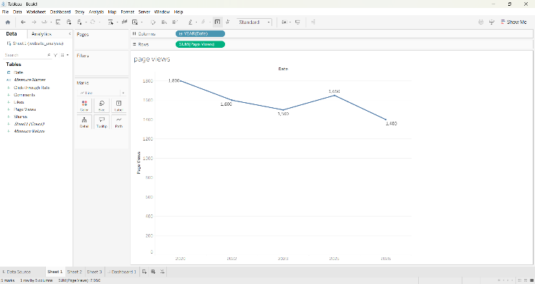

2. Procedure to Create a Stacked Bar Chart
- Open a new worksheet.
- Drag the Date field to the Rows shelf.
- Drag the Click-through Rate field to the Columns shelf.
- Change the Marks type to Bar.
- Sort the bars in Descending Order based on Click-through Rate.
- Apply a Top N Filter on the Date field by selecting the required number of top records.
- Drag the Click-through Rate field to the Label option on the Marks card.
- Edit the worksheet title to Top N Days by Click-through Rate.
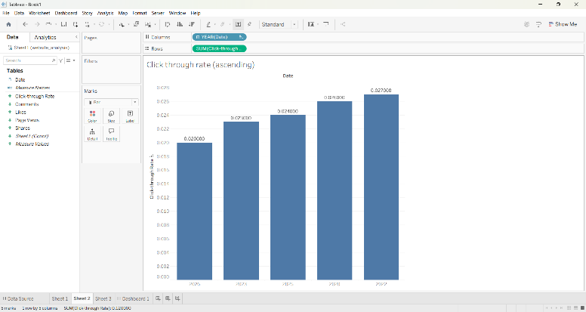
3. Procedure to Create a Bar Graph
- Refresh the modified dataset in Tableau.
- Open a new worksheet.
- Drag the Date field to the Columns shelf.
- Drag Measure Values to the Rows shelf.
- Drag Measure Names to the Color option on the Marks card.
- In the Measure Values shelf, retain only Likes, Shares, and Comments.
- Change the Marks type to Area.
- Select Analysis → Stack Marks → On.
- Rename the worksheet title as Distribution of User Interactions.

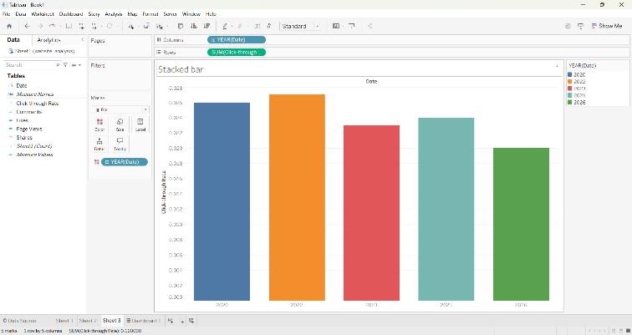

4. Procedure to Create a Dash Board
1. Click the New Dashboard icon.
2. Set the dashboard size to Automatic.
3. Drag the Bar Chart worksheet to the dashboard.
4. Drag the Stacked Bar Chart worksheet to the dashboard.
5. Arrange the charts neatly.
6. Rename the dashboard title as "Product Inventory Dashboard".
7.Save the Dashboard
. 