Week 2 Report: Data Preparation for Machine Learning (arXiv Papers)
Muhammad Hassan | 17 October 2026
GitHub repository: https://github.com/MHassanEjaz/rag-project

1. Dataset
Source: arXiv abstracts (Hugging Face mirror of the Kaggle arXiv dataset by Cornell University), the first 20,000 papers. The sample has 20,000 rows and 11 columns; 19,979 rows remain after removing 21 duplicate abstracts.
Target: field (main subject area of the paper, built from its first arXiv category). Classes: astro-ph, cond-mat, cs, gr-qc, hep, math, nucl, other, physics, quant-ph. Problem type: multi-class classification. Numeric columns (abstract length, number of authors, pages, ...) and text/categorical columns (journal, DOI publisher) are both used, and real missing values exist in comments, journal-ref, doi and report-no.

2. EDA
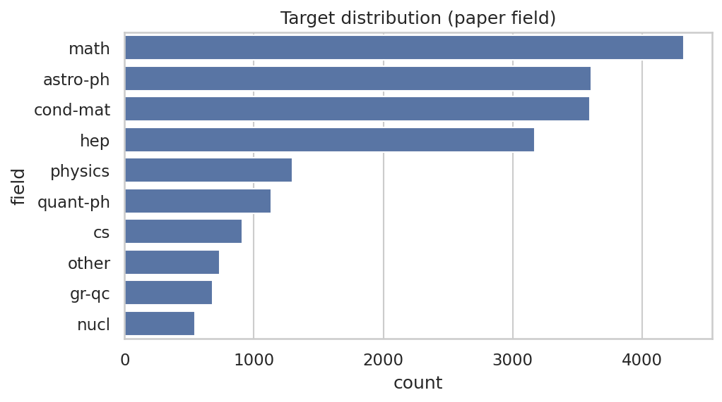 | 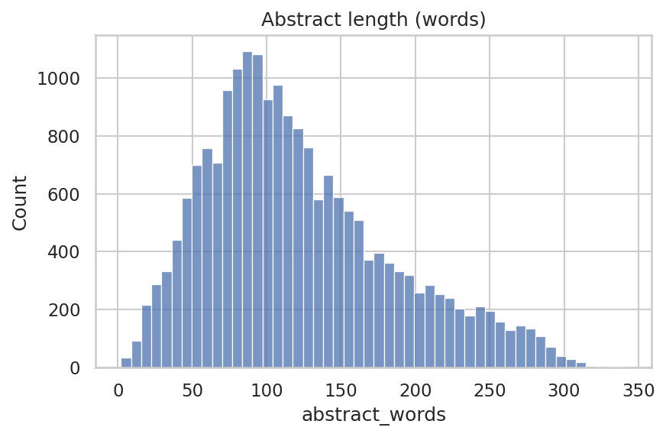 | 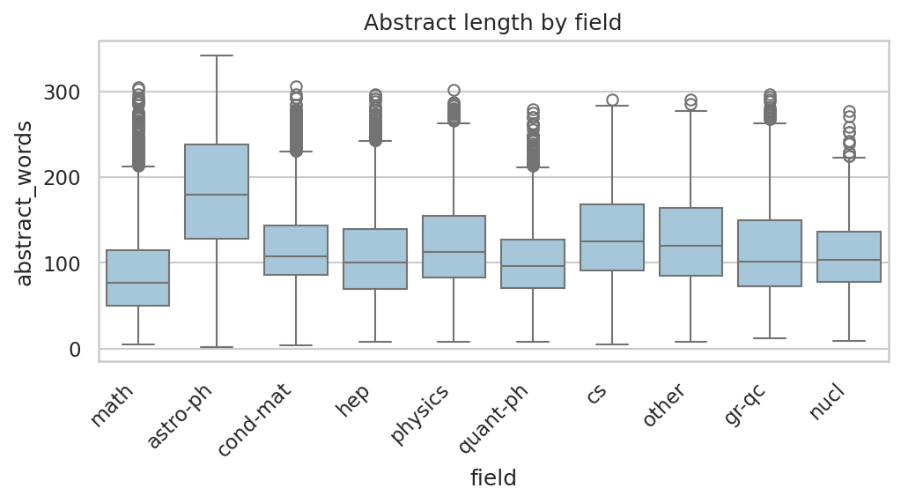
- The largest class is 'math' with 21.6% of the papers; the smallest is 'nucl' with 2.7%, so the classes are imbalanced.
- Abstracts have a median of 109 words (max 342); 'math' papers have the shortest median abstract (77) and 'astro-ph' the longest (180).
- The largest absolute correlation between two numeric columns is 0.23, so they are only weakly related and none looks redundant.

3. Cleaning decisions
Column | Problem | Action | Reason
abstract | 21 duplicate abstracts | Dropped the duplicate rows | The same text in train and test would make the test score look better than it is
id | Identifier, no meaning for the model | Dropped | A paper id is just a label; it also encodes the submission date
submitter | Free-text name with thousands of different values | Dropped | Too many unique values to encode, and not related to the subject
report-no | 91% missing | Dropped the column | Almost always empty, so there is nothing to learn from and filling it would be guessing
categories | This column is where the target comes from | Dropped from X | Keeping it would leak the answer into the inputs
comments | 12% missing | Extracted pages and figures (Step 3); numbers that are not mentioned stay missing and get the median later | A missing value here means the author did not say, so the median is a neutral guess
journal-ref | 47% missing | Made has_journal_ref and journal_family; missing journal becomes 'unpublished' | Here a missing value carries real meaning (not published yet), so a label is better than guessing
doi | 37% missing | Made has_doi and doi_prefix; missing prefix stays missing and gets the most frequent value later | The has_doi flag already keeps the information, so filling the prefix cannot hide anything
authors, title, versions | Raw text / lists, not usable directly | Replaced by counts (n_authors, title_words, n_versions) | Counts are simple numbers a model can use

4. New features and why
Feature | What it is | Why it can help
pages | number of pages mentioned by the authors | Experimental and astronomy papers tend to be longer than theory or math papers.
figures | number of figures mentioned by the authors | The number of figures differs between data-heavy fields and theory fields.
math_symbols | count of '$' (LaTeX math) in the abstract | Math-heavy fields write more LaTeX in the abstract.
has_journal_ref | yes/no: paper has a journal reference | Published papers have more metadata, and unpublished ones look different.
has_doi | yes/no: paper has a DOI | Same idea: a DOI shows the paper went through a publisher.
journal_family | journal name without volume and year | Each journal serves a few fields (for example Phys.Rev.D is mostly particle physics).
doi_prefix | publisher part of the DOI | The DOI prefix identifies the publisher, and publishers specialise in fields.

5. Train/test split
80/20 split with random_state=42 and stratify=y (the target is a category). Train: 15,983 rows, test: 3,996 rows. Class proportions (train vs test):
Class | Train | Test
math | 21.6% | 21.6%
astro-ph | 18.0% | 18.0%
cond-mat | 18.0% | 18.0%
hep | 15.9% | 15.9%
physics | 6.5% | 6.5%
quant-ph | 5.7% | 5.7%
cs | 4.5% | 4.6%
other | 3.6% | 3.6%
gr-qc | 3.4% | 3.4%
nucl | 2.7% | 2.7%

6. Preprocessing
- Numeric columns: missing values filled with the median, then StandardScaler. Scaling puts columns on the same range so no column dominates only because of its units.
- Categorical columns: missing values filled with the most frequent value, then OneHotEncoder (rare categories grouped together). Models need numbers, and one-hot avoids a fake order between categories.
- Data leakage: everything is wrapped in a ColumnTransformer that is fitted with fit_transform on the training set only; the test set only gets transform. The target source column (categories) is not in X, and duplicate abstracts were removed before splitting. The notebook checks that the imputer medians match the train medians and the scaler saw only the training rows.

7. Final result
Array | Shape
X_train | [15983, 78]
X_test | [3996, 78]
y_train | [15983]
y_test | [3996]
7 numeric columns and 4 categorical columns became 78 model-ready features. Missing values after preprocessing: 0 in train and 0 in test.

8. Problems faced and what I learned
- Kaggle's search page crashed in my browser, so I loaded the same arXiv data from Hugging Face instead.
- The first 20,000 papers are mostly physics and have few computer-science papers, so I built a subject-field target instead of an AI/ML one.
- The target is made from categories, so I had to remove that column from X, otherwise the model would simply read the answer.
- Missing values do not always mean the same thing: a missing journal means 'not published', so I filled it with a label, while a missing page count is truly unknown, so I used the median.
- I learned to fit the imputer, scaler and encoder only on the training data and to check this with simple assertions.

