

FINAL YEAR DESIGN PROJECT REPORT
Aegis Health
A Preventive Risk-Screening System for Type 2 Diabetes
and Chronic Kidney Disease

Submitted by
Muhammad Hassan 2716
Muhammad Rohan Ashraf 2720
Supervised by
Prof. Hafiz Shahzad
Bachelor of Science in Information Technology (2022 – 2026)
Department of Information Technology
Govt. Graduate College Gulberg (Boys), Lahore
University of the Punjab, Lahore, Pakistan
2026

Declaration

We hereby declare that this software, neither as a whole nor in part, has been copied from any source. It is further declared that we have developed this software and the accompanying report entirely on the basis of our own efforts. If any part of this project is proved to have been copied, or found to be a reproduction of some other work, we shall stand by the consequences.
No portion of the work presented here has been submitted in support of any other application for any degree or qualification at this or any other university or institute of learning.
Signature: ______________________ | Signature: ______________________
Muhammad Hassan (2716) | Muhammad Rohan Ashraf (2720)

Certificate of Approval

It is certified that the Final Year Design Project titled “Aegis Health: A Preventive Risk-Screening System for Type 2 Diabetes and Chronic Kidney Disease” was developed by Muhammad Hassan (2716) and Muhammad Rohan Ashraf (2720) under the supervision of Prof. Hafiz Shahzad.
In our opinion it is fully adequate, in scope and in quality, for the award of the degree of Bachelor of Science in Information Technology.
Signature: ______________________________
Prof. Hafiz Shahzad — FYDP Supervisor
Faculty Advisory Committee
Signature: ____________________ | Signature: ____________________
Prof. Hafiz Shahzad (FAC 1) | Prof. Muhammad Fahim (FAC 2)

Signature: ______________________________
Head of FYDP Coordination Office
Signature: ______________________________
Chairperson, Department of Information Technology
Dated: ______________________

Acknowledgement

All praise is due to Allah Almighty, the Most Gracious and the Most Merciful, who granted us the health, patience and clarity of mind needed to see this project through.
We are deeply grateful to our supervisor, Prof. Hafiz Shahzad. His guidance changed the direction of this project at a decisive moment: an early design of ours would have predicted disease stage from laboratory values using a formula we had written ourselves, which would have taught the model nothing except our own rule. Being pushed to question that assumption is the reason this project predicts future risk from lifestyle instead, and it is the single most valuable lesson we take from the year.
We thank Prof. Muhammad Fahim and the faculty of the Department of Information Technology for their feedback during evaluations, and our families for their patience over many long evenings.
Finally we acknowledge the open-source communities behind Python, Django, scikit-learn, Flutter and PostgreSQL, and the United States Centers for Disease Control and Prevention, whose Behavioral Risk Factor Surveillance System made this work possible by publishing 253,155 anonymised survey responses for public research.
Muhammad Hassan (2716)
Muhammad Rohan Ashraf (2720)
BSIT, 8th Semester — 2026

Abstract

Type 2 diabetes and chronic kidney disease are among the most costly chronic conditions in Pakistan, and both share a property that makes them unusually suitable for software intervention: they develop silently over years, and the risk factors that drive them are behavioural rather than genetic. By the time a patient presents with symptoms, irreversible damage has often already occurred. Screening exists, but it depends on laboratory tests that cost money, require travel, and are therefore taken mainly by people who already suspect they are unwell.
This report presents Aegis Health, a mobile screening system that estimates a person's future risk of both conditions from nineteen questions about how they live, with no blood test and no clinical measurement. A single multi-task neural network with one shared backbone and two output heads was trained on 253,155 anonymised responses from the CDC Behavioral Risk Factor Surveillance System. Sharing a backbone is a deliberate modelling decision rather than an optimisation: diabetes is a leading cause of chronic kidney disease, so the two tasks genuinely share structure, and one model learns that relationship where two separate models could not.
On a held-out test set the model reaches a ROC-AUC of 0.823 for diabetes and 0.793 for kidney disease, catching 85% and 87% of true cases respectively at its screening thresholds. Accuracy is deliberately not reported as a headline figure. Both conditions are rare in the population, so a model that answered “no” to every person would score above ninety per cent while identifying nobody. Probabilities are calibrated by isotonic regression, so a predicted thirty per cent risk corresponds to an observed frequency near thirty per cent, and results are validated by 5-fold stratified cross-validation rather than a single fortunate split.
Every prediction is accompanied by an explanation and by advice. An occlusion analysis re-runs the model with each answer neutralised in turn to rank the factors driving that individual's risk, and a what-if engine simulates realistic habit changes and reports the projected reduction for each. The system is delivered as a Flutter application on Android talking to a Django REST Framework service deployed on Render over PostgreSQL, with JSON Web Token authentication, on-device reminders that work without a network, and a conversational assistant that grounds its replies in the user's most recent result.
Aegis Health is an educational screening aid. It does not diagnose disease and it does not replace a clinician.

Keywords: preventive screening, multi-task learning, neural network, probability calibration, explainable artificial intelligence, class imbalance, mobile health, Flutter, Django REST Framework.

Table of Contents

Declaration ii
Certificate of Approval iii
Acknowledgement iv
Abstract v
List of Figures vii
List of Tables viii

Chapter 1 — Introduction 1
1.1 Background 1
1.2 Problem Statement 2
1.3 Objectives 2
1.4 Scope and Delimitations 3
1.5 Significance 3

Chapter 2 — Literature Review 4
2.1 Existing Systems 4
2.2 Comparative Analysis 5
2.3 Research Gap 5
2.4 The Flaw We Corrected 6

Chapter 3 — System Analysis and Design 7
3.1 Requirement Analysis 7
3.2 Functional Requirements 8
3.3 Non-Functional Requirements 9
3.4 Use-Case Model 10
3.5 Activity Model 11
3.6 System Architecture 12
3.7 Class Design 13
3.8 Database Design 14

Chapter 4 — Implementation 16
4.1 Development Methodology 16
4.2 Technologies and Justification 17
4.3 The Machine-Learning Core 18
4.4 Explanation and What-If Engines 20
4.5 REST API 21
4.6 Mobile Application 22
4.7 Deployment 24

Chapter 5 — Testing and Results 25
5.1 Testing Methodology 25
5.2 Test Cases 25
5.3 Model Results 27
5.4 Why Accuracy Is Not Reported 28
5.5 Calibration and Threshold Selection 29
5.6 Performance Evaluation 30

Chapter 6 — Conclusion and Future Work 31
References 32
Appendix A — API Reference 33
Appendix B — User Manual 34

List of Figures

Figure 1 Use-case diagram showing both actors and the ten use cases
Figure 2 Activity diagram for a single risk assessment
Figure 3 Three-tier system architecture
Figure 4 Class diagram of the backend domain and service layer
Figure 5 Entity-relationship diagram as implemented on PostgreSQL
Figure 6 Development schedule by sprint
Figure 7 Machine-learning pipeline from raw survey to deployed artifact
Figure 8 Multi-task architecture: one shared backbone, two heads
Figure 9 Sequence of messages during one prediction request
Figure 10 Home screen: the primary action and the most recent reading
Figure 11 Questionnaire: grouped into five short steps
Figure 12 Deployment topology across device, Render and Supabase
Figure 13 ROC curves for both heads on the held-out test set
Figure 14 Precision-recall curves with prevalence baselines
Figure 15 Permutation importance: the drop in ROC-AUC when each answer is shuffled
Figure 16 Class imbalance in the dataset, which is what makes accuracy misleading
Figure 17 Reliability curves before and after isotonic calibration
Figure 18 Recall and precision as the decision threshold moves, with the chosen point marked
Figure 19 Confusion matrices at the chosen screening thresholds

List of Tables

Table 1 Comparison of existing approaches with the proposed system
Table 2 Functional requirements
Table 3 Non-functional requirements
Table 4 Assessment table schema
Table 5 Technology stack, with the reason for each choice
Table 6 Model hyperparameters
Table 7 REST endpoints
Table 8 API test cases executed against the live deployment
Table 9 Model performance on the held-out test set
Table 10 Measured system performance

CHAPTER 1
Introduction

1.1 Background
Pakistan has one of the highest rates of diabetes in the world. The International Diabetes Federation places the country among the leading nations by number of adults living with the condition, and a substantial share of those people do not know they have it. Chronic kidney disease follows closely behind, and the two are linked: sustained high blood glucose damages the small vessels of the kidney, which is why diabetic nephropathy is the largest single cause of kidney failure worldwide.
What makes both conditions tractable for software is that neither appears suddenly. Each develops over years, driven mainly by factors a person can influence: body mass, physical activity, diet, blood pressure, smoking and alcohol. Someone who learns at thirty-five that their risk is elevated has a decade in which to act. The same person learning at fifty-five, after symptoms appear, has far fewer options and a permanent loss of kidney function.
Screening already exists in clinical practice, but it depends on blood work: fasting glucose, HbA1c, serum creatinine. Each requires money, travel and time away from work. The practical consequence is that the people most likely to be tested are those who already suspect something is wrong, which is precisely the population for whom prevention has come too late.
1.2 Problem Statement
There is no accessible way for an ordinary person in Pakistan to find out whether they are on a path toward diabetes or kidney disease before symptoms begin. Existing risk calculators either require laboratory values the user does not have, or reduce the question to a handful of generic questions with no stated accuracy, no explanation of the reasoning, and no indication of what the person should do next.
The problem this project addresses is therefore narrow and concrete: estimate the future risk of two specific chronic conditions using only information a person already knows about themselves; report that estimate honestly, including its limitations; explain which of their answers drove it; and quantify how much specific, realistic changes would reduce it.
1.3 Objectives
- Build a dataset of behavioural risk factors and disease outcomes from a large, credible, publicly available population survey.
- Train a single multi-task neural network that predicts the risk of type 2 diabetes and chronic kidney disease from the same input vector, exploiting the clinical relationship between them.
- Evaluate the model with metrics appropriate to rare conditions, namely recall and ROC-AUC, and validate by stratified cross-validation rather than a single split.
- Calibrate the output probabilities so that a stated risk percentage carries its ordinary meaning.
- Explain every individual prediction by attributing it to the specific answers that produced it.
- Simulate realistic habit changes and report the projected reduction for each, so the output is actionable rather than merely informative.
- Deliver the system as a deployed mobile application with secure authentication, persistent history and offline reminders.
1.4 Scope and Delimitations
Within scope:
- Two conditions only: type 2 diabetes and chronic kidney disease.
- 18 behavioural and demographic features, all self-reported.
- Android as the target mobile platform.
- A hosted REST backend with a managed PostgreSQL database.
- Risk estimation, factor attribution, what-if simulation, history, reminders, and a conversational assistant grounded in the user's result.
Explicitly out of scope:
- Diagnosis. The system estimates risk and states plainly that it does not diagnose disease.
- Laboratory values. No glucose, HbA1c or creatinine input is accepted, because requiring them would defeat the purpose of the project.
- Prescription, dosage or treatment advice of any kind.
- Clinical trial validation. The model is validated statistically against survey data, not prospectively against patients.
- iOS. The architecture supports it, but no iOS build was produced.
1.5 Significance
The contribution of this project is not that it applies machine learning to health data, which is common. It is the combination of four decisions that are individually unremarkable and collectively uncommon in student work: predicting the future rather than detecting the present; sharing one network between two clinically related tasks; reporting rare-disease metrics honestly instead of hiding behind accuracy; and making every prediction explain itself and propose a remedy.

CHAPTER 2
Literature Review

2.1 Existing Systems
Risk estimation for diabetes has a long clinical history. The Finnish Diabetes Risk Score (FINDRISC) is the most widely used questionnaire instrument: eight questions, a points total, and a risk band. It is well validated and requires no laboratory work, which makes it the closest precedent for this project. Its limitations are that the scoring is a fixed additive table derived from a Finnish cohort, it addresses diabetes alone, and it offers no personalised explanation.
For kidney disease, the Kidney Failure Risk Equation is the established tool, but it is built for patients already diagnosed with reduced kidney function and depends on serum creatinine and urine albumin. It answers a different question from ours: how quickly an existing condition will progress, rather than whether a healthy person will develop one.
In the research literature, machine-learning models trained on the same BRFSS dataset used here are numerous. Most report accuracy figures in the mid-eighties for diabetes, which sounds strong until one notices that the prevalence in the dataset is 13.9 per cent, meaning a model that predicts no unconditionally already achieves 86.1 per cent. Papers that report recall alongside accuracy are markedly less common.
2.2 Comparative Analysis
Table 1: Comparison of existing approaches with the proposed system
System | Inputs required | Conditions | Explains | Actionable
FINDRISC questionnaire | 8 questions | Diabetes only | No | Generic
Kidney Failure Risk Equation | Laboratory values | CKD progression | No | No
Typical BRFSS ML study | 18 to 21 features | One at a time | Rarely | No
Commercial wellness apps | Varies, undisclosed | Varies | No | Generic tips
Aegis Health (this work) | 18 questions | Both, jointly | Per factor | Quantified

2.3 Research Gap
Three gaps follow from the comparison. First, no accessible tool estimates both conditions together, despite their shared causation. Second, published models on this dataset seldom report the metric that actually matters for screening, which is the proportion of true cases identified. Third, almost nothing in this space closes the loop: a user is given a number and left to interpret it, without being told which of their own answers produced it or what would change it.
2.4 The Flaw We Corrected
This section records a design error made early in the project, because correcting it produced the work described in the rest of this report.
The original proposal was to predict the stage of chronic kidney disease from laboratory values. A dataset of measurements would be obtained, the stage label would be assigned by applying the standard clinical formula for estimated glomerular filtration rate, and a classifier would then be trained to predict that label from the same measurements.
The flaw is circularity, a form of label leakage. The label was computed from the features by a deterministic rule that we supplied ourselves, so any competent model would simply rediscover our own arithmetic and report near-perfect accuracy. The result would have been an impressive number with no predictive value whatsoever, because a calculator already does that job exactly and for free.
The correction was to change the question. Instead of inferring a present clinical state from clinical measurements, the system predicts a future outcome from behaviour, where the label comes from what the survey respondent actually reported and not from anything we calculated. That single change is what gives the project its value, and it is the reason accuracy is treated with suspicion throughout this report.

CHAPTER 3
System Analysis and Design

3.1 Requirement Analysis
Requirements were gathered from three sources: the clinical literature on modifiable risk factors, which determined what the model could legitimately ask about; the structure of the BRFSS questionnaire, which determined what data existed to learn from; and informal testing with fellow students, which determined how many questions a person will answer before abandoning the form. That last constraint proved the binding one: early drafts asked twenty-one questions including household income and education, and testers objected to both as intrusive and irrelevant. They were removed, along with a question asking how many days the respondent had felt mentally unwell, which measurement later confirmed contributed approximately 0.001 to ROC-AUC.
3.2 Functional Requirements
Table 2: Functional requirements
ID | Requirement | Description | Priority
FR-1 | Account creation | Register with a username and password; email optional. | High
FR-2 | Authentication | Sign in and receive a JSON Web Token. | High
FR-3 | Password change | Change password after confirming the current one. | Medium
FR-4 | Questionnaire | Collect 19 answers across five grouped steps. | High
FR-5 | Risk prediction | Return calibrated risk for both conditions. | High
FR-6 | Factor attribution | Rank the answers that raised the risk. | High
FR-7 | What-if simulation | Report projected reduction per habit change. | High
FR-8 | Interactive what-if | Let the user alter answers and re-run live. | Medium
FR-9 | History | Persist assessments and display the trend. | Medium
FR-10 | Assistant | Answer questions grounded in the latest result. | Medium
FR-11 | Reminders | Schedule repeating on-device notifications. | Medium
FR-12 | Model transparency | Expose architecture and real metrics in-app. | Medium

3.3 Non-Functional Requirements
Table 3: Non-functional requirements
Category | Requirement | Target | Achieved
Performance | Inference latency, server-side | Under 100 ms | About 1 ms
Performance | End-to-end request, warm server | Under 3 s | 1.8 to 2.2 s
Reliability | Model must load or fail loudly | No silent fallback | Yes, 503 returned
Accuracy | Recall, diabetes | At least 0.85 | 0.849
Accuracy | Recall, kidney | At least 0.85 | 0.875
Accuracy | ROC-AUC, both heads | Above 0.75 | 0.823 / 0.793
Security | Credential storage on device | Encrypted | Android Keystore
Security | Brute-force resistance | Rate limited | 8 attempts per minute
Security | Transport | Encrypted in transit | HTTPS and TLS
Usability | Questionnaire completion | Under 3 minutes | About 2 minutes
Accessibility | Touch target size | At least 48 dp | Met
Accessibility | Reduced motion | Respected | Implemented
Portability | Offline reminders | No network needed | On-device alarms

3.4 Use-Case Model
The system has two actors. The registered user performs every health-related use case. The administrator inspects the deployed model card to confirm which artifact is live and what its measured performance is.
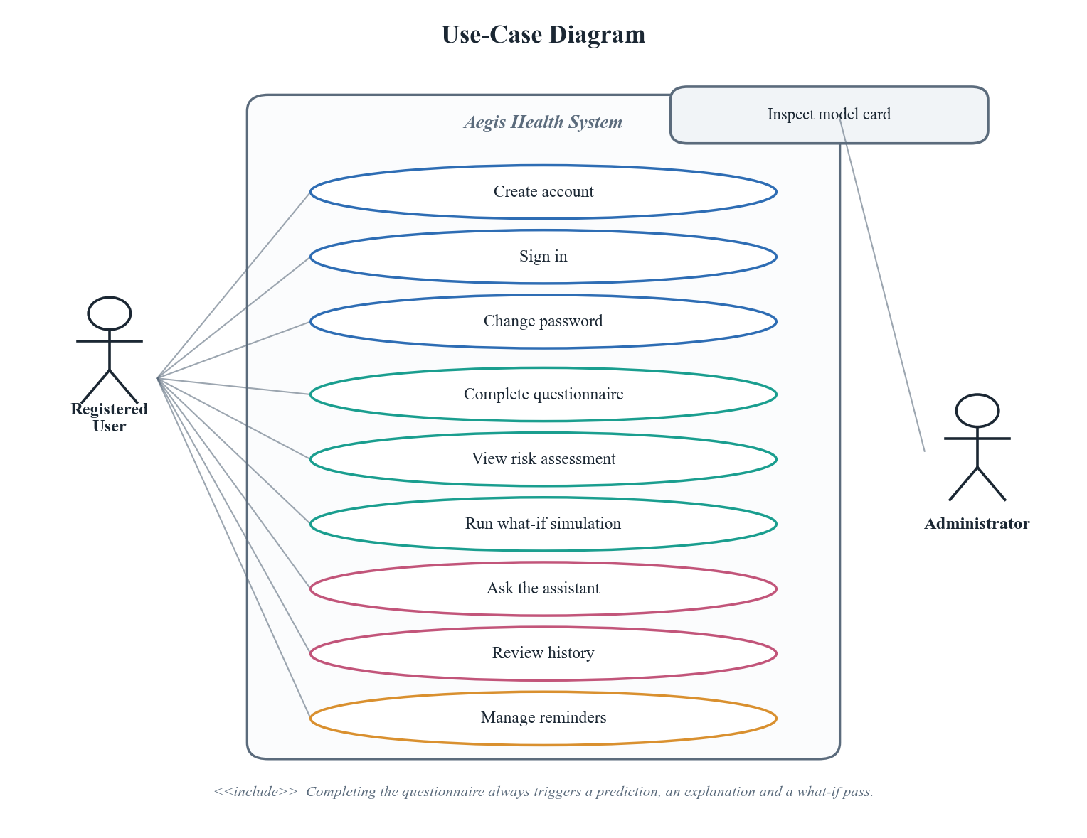
Figure 1: Use-case diagram showing both actors and the ten use cases
3.5 Activity Model
The activity diagram traces one complete assessment. Two details are worth noting. Body mass index is computed on the device from height and weight, so the user is never asked for a figure they are unlikely to know. And validation happens server-side against the same schema the model was trained on, so a malformed or incomplete payload is rejected with field-level errors rather than silently producing a meaningless prediction.
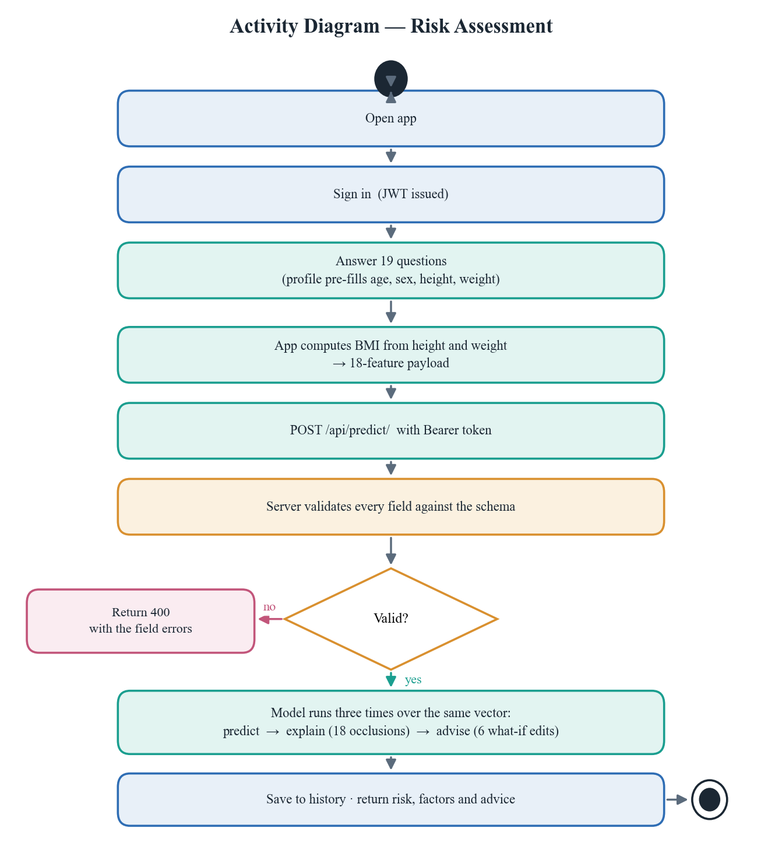
Figure 2: Activity diagram for a single risk assessment
3.6 System Architecture
The system is a three-tier modular monolith. Microservices were considered and rejected: with two developers and a single deployable unit of work, the operational overhead of service discovery, distributed tracing and independent deployment would have bought nothing. The monolith is modular internally, with each Django application owning its own models, serializers, views and routes, so extraction into services later would be mechanical.
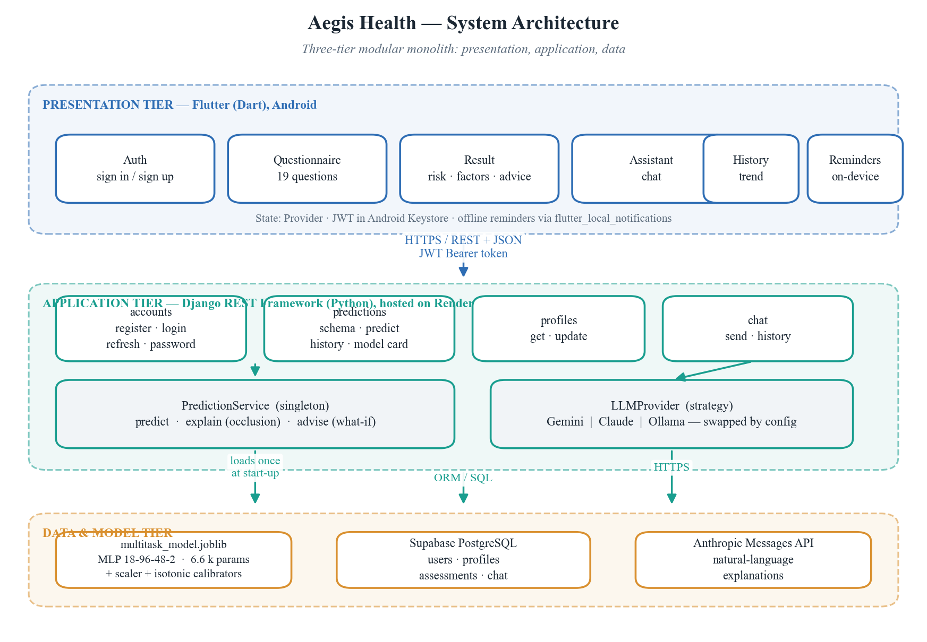
Figure 3: Three-tier system architecture
Two design patterns carry most of the weight. PredictionService is a singleton: the model artifact is deserialised once at process start and held in memory, because loading it per request would dominate response time. LLMProvider is a strategy: the conversational assistant is defined by an interface with interchangeable implementations, so the underlying language model is selected by configuration and can be replaced without touching a single view.
3.7 Class Design
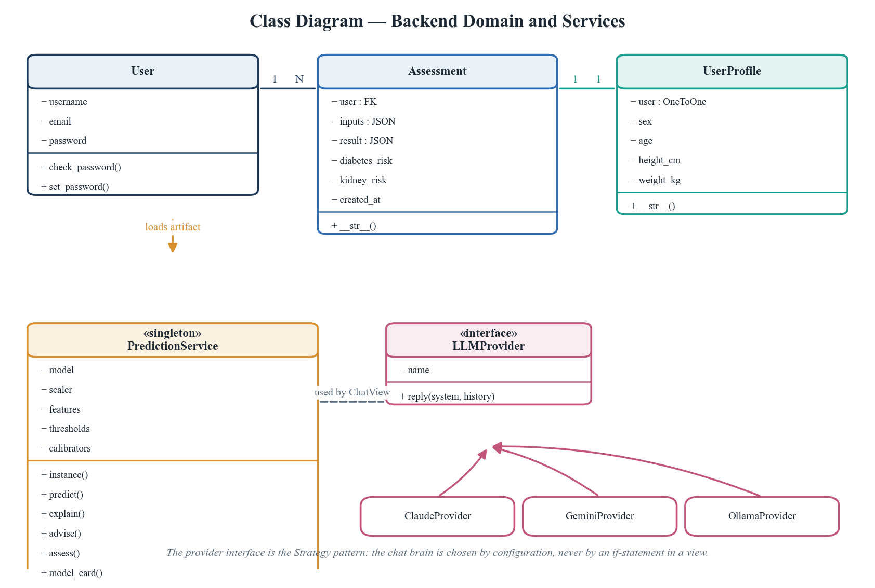
Figure 4: Class diagram of the backend domain and service layer
3.8 Database Design
Four tables hold all persistent state. The design decision worth defending is the use of JSONB columns for the questionnaire inputs and the full result. A fully normalised alternative would give each feature its own column, which would be tidier on paper but would require a schema migration every time the feature set changed. During this project the feature set changed twice, most recently from 19 to 18 features. With JSONB those changes cost nothing, and historical rows remain readable because each one records exactly the inputs that produced it.
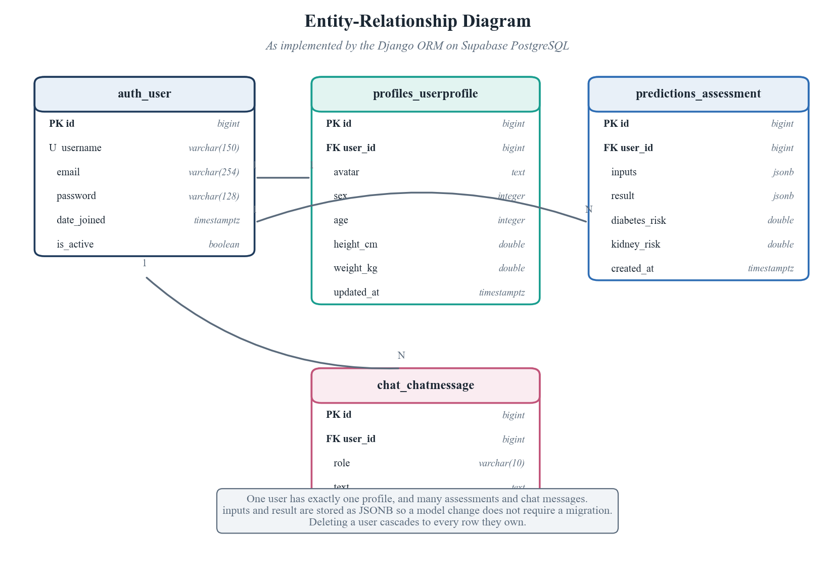
Figure 5: Entity-relationship diagram as implemented on PostgreSQL
Table 4: Assessment table schema
Column | Type | Constraint | Description
id | bigint | Primary key | Surrogate identifier
user_id | bigint | Foreign key, cascade | Owner of the assessment
inputs | jsonb | Not null | The 18 answers submitted
result | jsonb | Not null | Prediction, factors and advice
diabetes_risk | double | Not null | Denormalised for fast trend queries
kidney_risk | double | Not null | Denormalised for fast trend queries
created_at | timestamptz | Auto, indexed | Ordering key for history

CHAPTER 4
Implementation

4.1 Development Methodology
Work proceeded in eight two-to-four week sprints. The sequence was deliberately model-first: no interface work began until the model produced trustworthy numbers, because a beautiful application wrapped around an untrustworthy model would have been worse than useless in a health context.
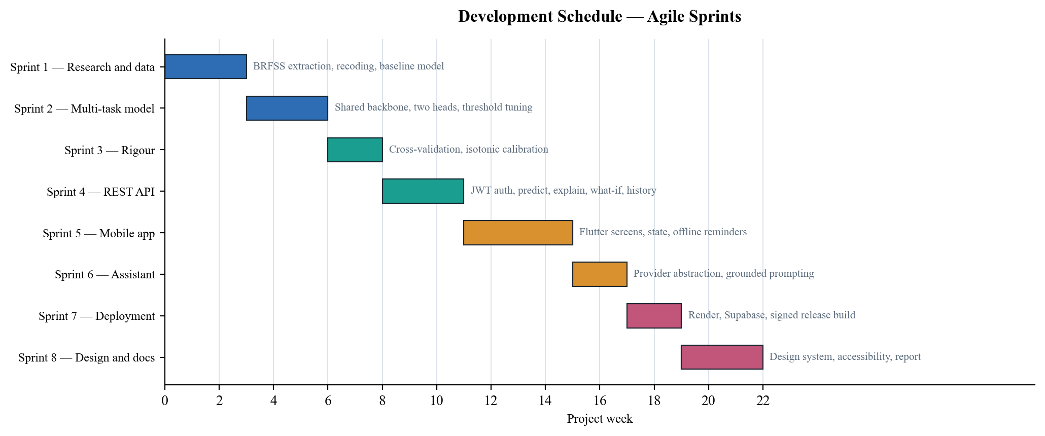
Figure 6: Development schedule by sprint
4.2 Technologies and Justification
Table 5: Technology stack, with the reason for each choice
Layer | Technology | Why this and not the alternative
Mobile | Flutter 3 (Dart) | One codebase for both platforms; native compilation; no JavaScript bridge.
Backend | Django REST Framework | Batteries-included auth and ORM; the team already knew Python from the ML work.
Model | scikit-learn MLPClassifier | A 6,674-parameter network does not need a GPU framework; deploys as a 170 KB file.
Calibration | Isotonic regression | Non-parametric, so it corrects any monotonic distortion, unlike Platt scaling.
Database | Supabase PostgreSQL | Managed, free tier, JSONB support, connection pooling.
Hosting | Render | Persistent process, so the model stays in memory; serverless would reload it per request.
Auth | Simple JWT | Stateless tokens suit a mobile client with intermittent connectivity.
Assistant | Provider interface | Vendor-independent by construction; swapped by one configuration value.
Notifications | flutter_local_notifications | Alarms scheduled by the operating system, so reminders fire offline.

4.3 The Machine-Learning Core
The raw BRFSS 2015 file contains 441 columns of survey responses encoded with values such as 7 for do not know and 9 for refused. The extraction stage recodes the two disease labels and the behavioural features into clean binary and ordinal values, discarding rows where a needed answer is missing. This yields 253,155 complete records with 18 features and two labels.
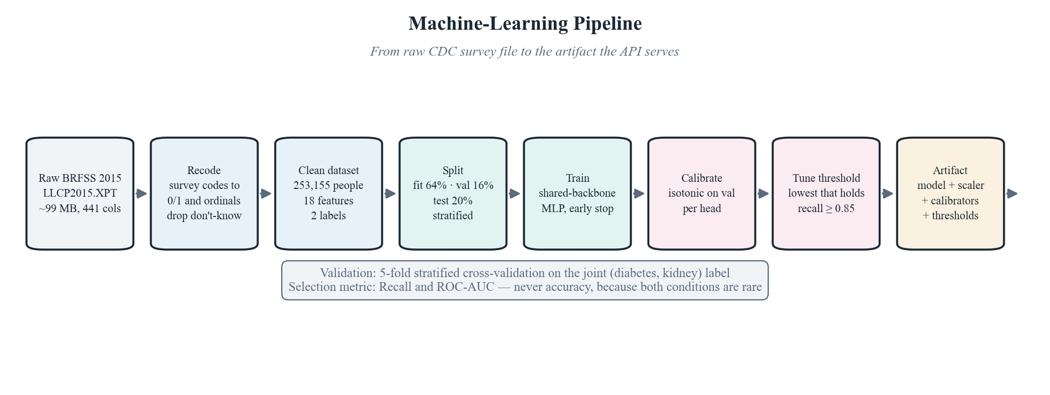
Figure 7: Machine-learning pipeline from raw survey to deployed artifact
The model itself is a multilayer perceptron trained on a two-column label matrix. Because both outputs share every hidden layer, the network is structurally a multi-task model: the hidden layers form a representation that must serve both predictions at once, and the two output units are the task-specific heads.
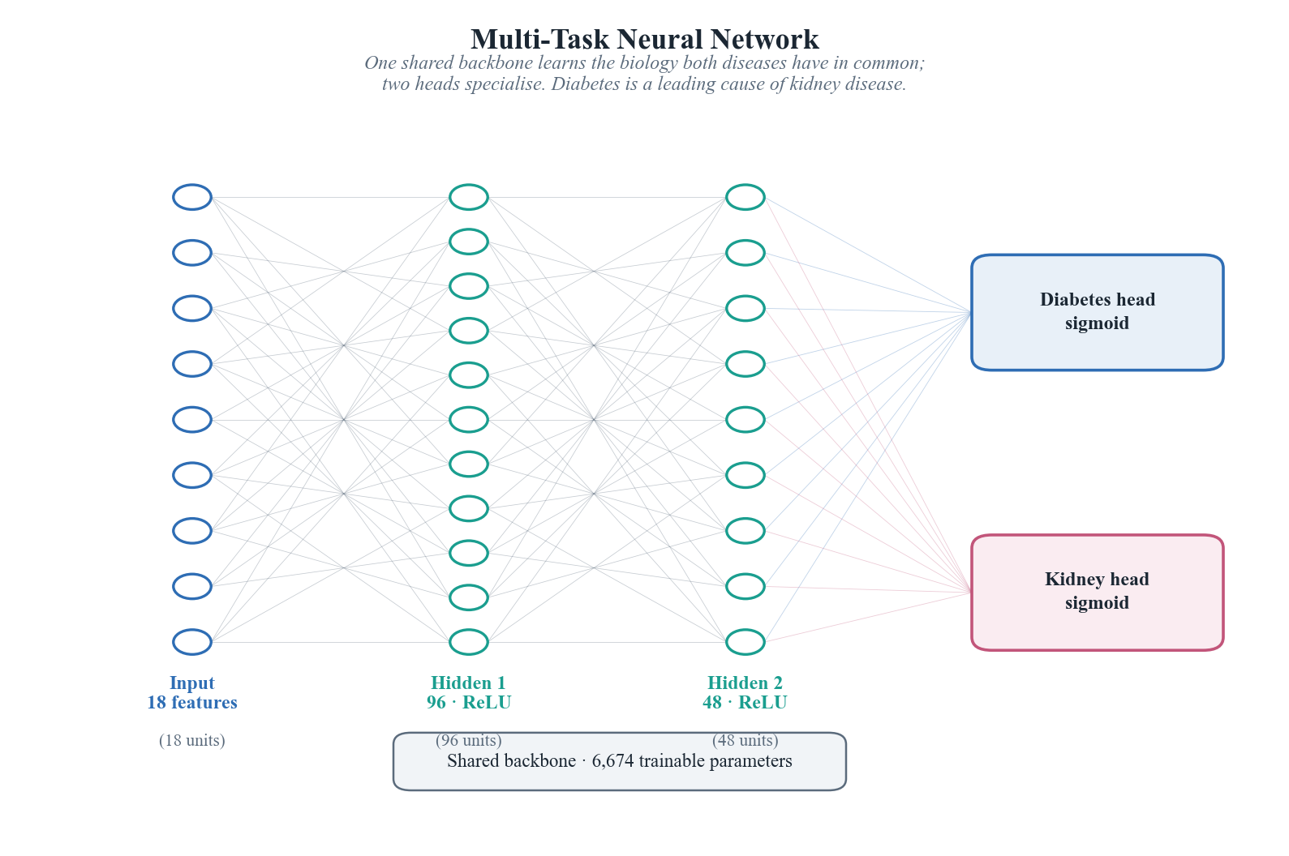
Figure 8: Multi-task architecture: one shared backbone, two heads
Table 6: Model hyperparameters
Parameter | Value | Reason
Hidden layers | 96, then 48 | Wide enough to represent interactions, narrow enough to avoid overfitting.
Activation | ReLU | Standard, non-saturating, inexpensive.
Solver | Adam | Robust default for small tabular networks.
Batch size | 512 | Large batches stabilise gradients on 200,000 rows.
Learning rate | 0.0008 | Tuned for stable convergence within the iteration budget.
Early stopping | Enabled, patience 8 | Halts when validation loss stops improving.
Trainable parameters | 6,674 | Small by design; the constraint is data quality, not capacity.

4.4 Explanation and What-If Engines
A risk number on its own is not useful, and in a health setting it can be actively harmful, because a person told they are at high risk with no explanation has been given anxiety without agency. Two mechanisms address this.
Factor attribution uses occlusion. For each feature in turn, the value is replaced by the population mean and the model is re-run; the drop in predicted risk is that feature's contribution for this individual. With 18 features this costs 18 additional forward passes, which at roughly one millisecond each is negligible. The approach is a faithful local attribution and is honest about being an approximation to a full Shapley decomposition rather than claiming to be one.
The what-if engine takes the six habits a person can realistically change, applies the healthier value to each in turn, re-runs the model, and reports the projected reduction. Only improvements are shown, and only for habits the user has not already adopted, so nobody is advised to stop smoking when they have said they do not smoke.
4.5 REST API
Table 7: REST endpoints
Method | Path | Auth | Purpose
GET | /api/health/ | No | Liveness probe
POST | /api/auth/register/ | No | Create an account
POST | /api/auth/login/ | No | Obtain access and refresh tokens
POST | /api/auth/refresh/ | No | Exchange a refresh token
POST | /api/auth/password/ | Yes | Change password
GET | /api/schema/ | No | Questionnaire field schema
GET | /api/model/card/ | No | Live architecture and metrics
POST | /api/predict/ | Yes | Assess risk and store the result
GET | /api/history/ | Yes | List past assessments
GET | /api/profile/ | Yes | Read profile
PATCH | /api/profile/ | Yes | Update profile
POST | /api/chat/ | Yes | Send a message to the assistant
GET | /api/chat/history/ | Yes | Retrieve conversation history

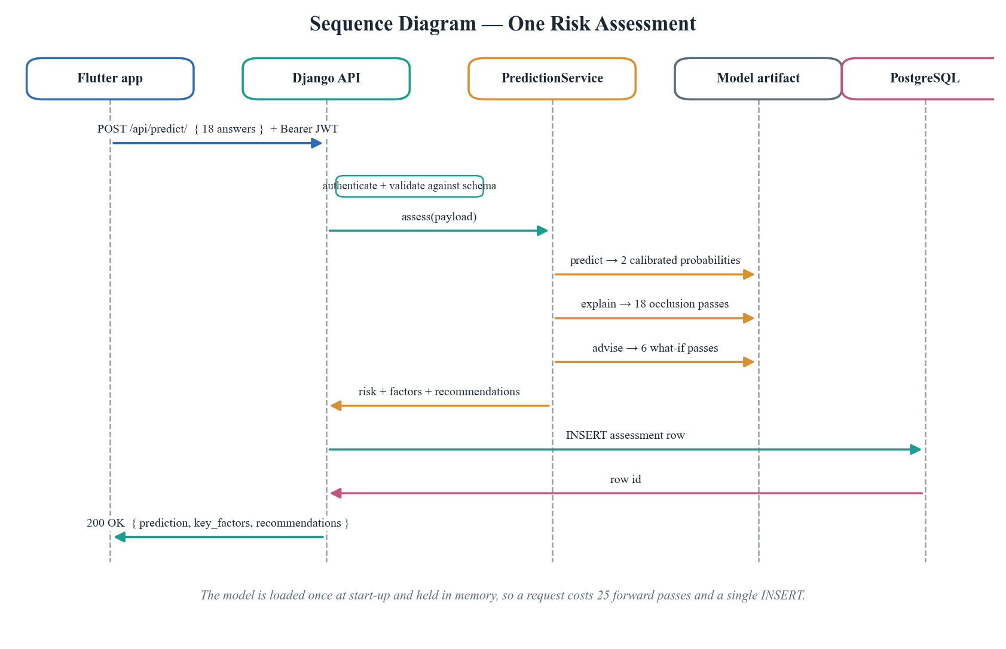
Figure 9: Sequence of messages during one prediction request
4.6 Mobile Application
The application is built around a design system rather than ad-hoc styling: one typeface pairing, a fixed type scale, a single corner radius, and hairline rules in place of drop shadows. Data is set in a monospaced face so that figures align in columns, which matters on the history screen where percentages are compared down the page.
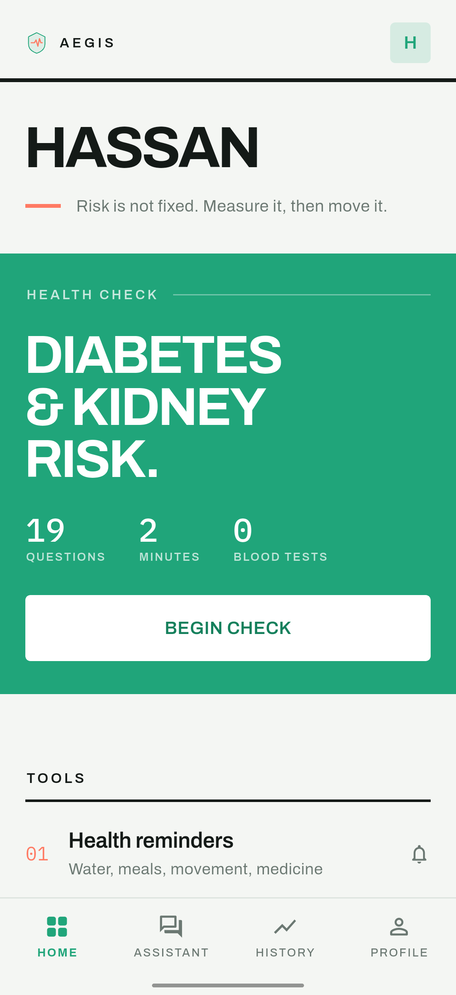
Figure 10: Home screen: the primary action and the most recent reading
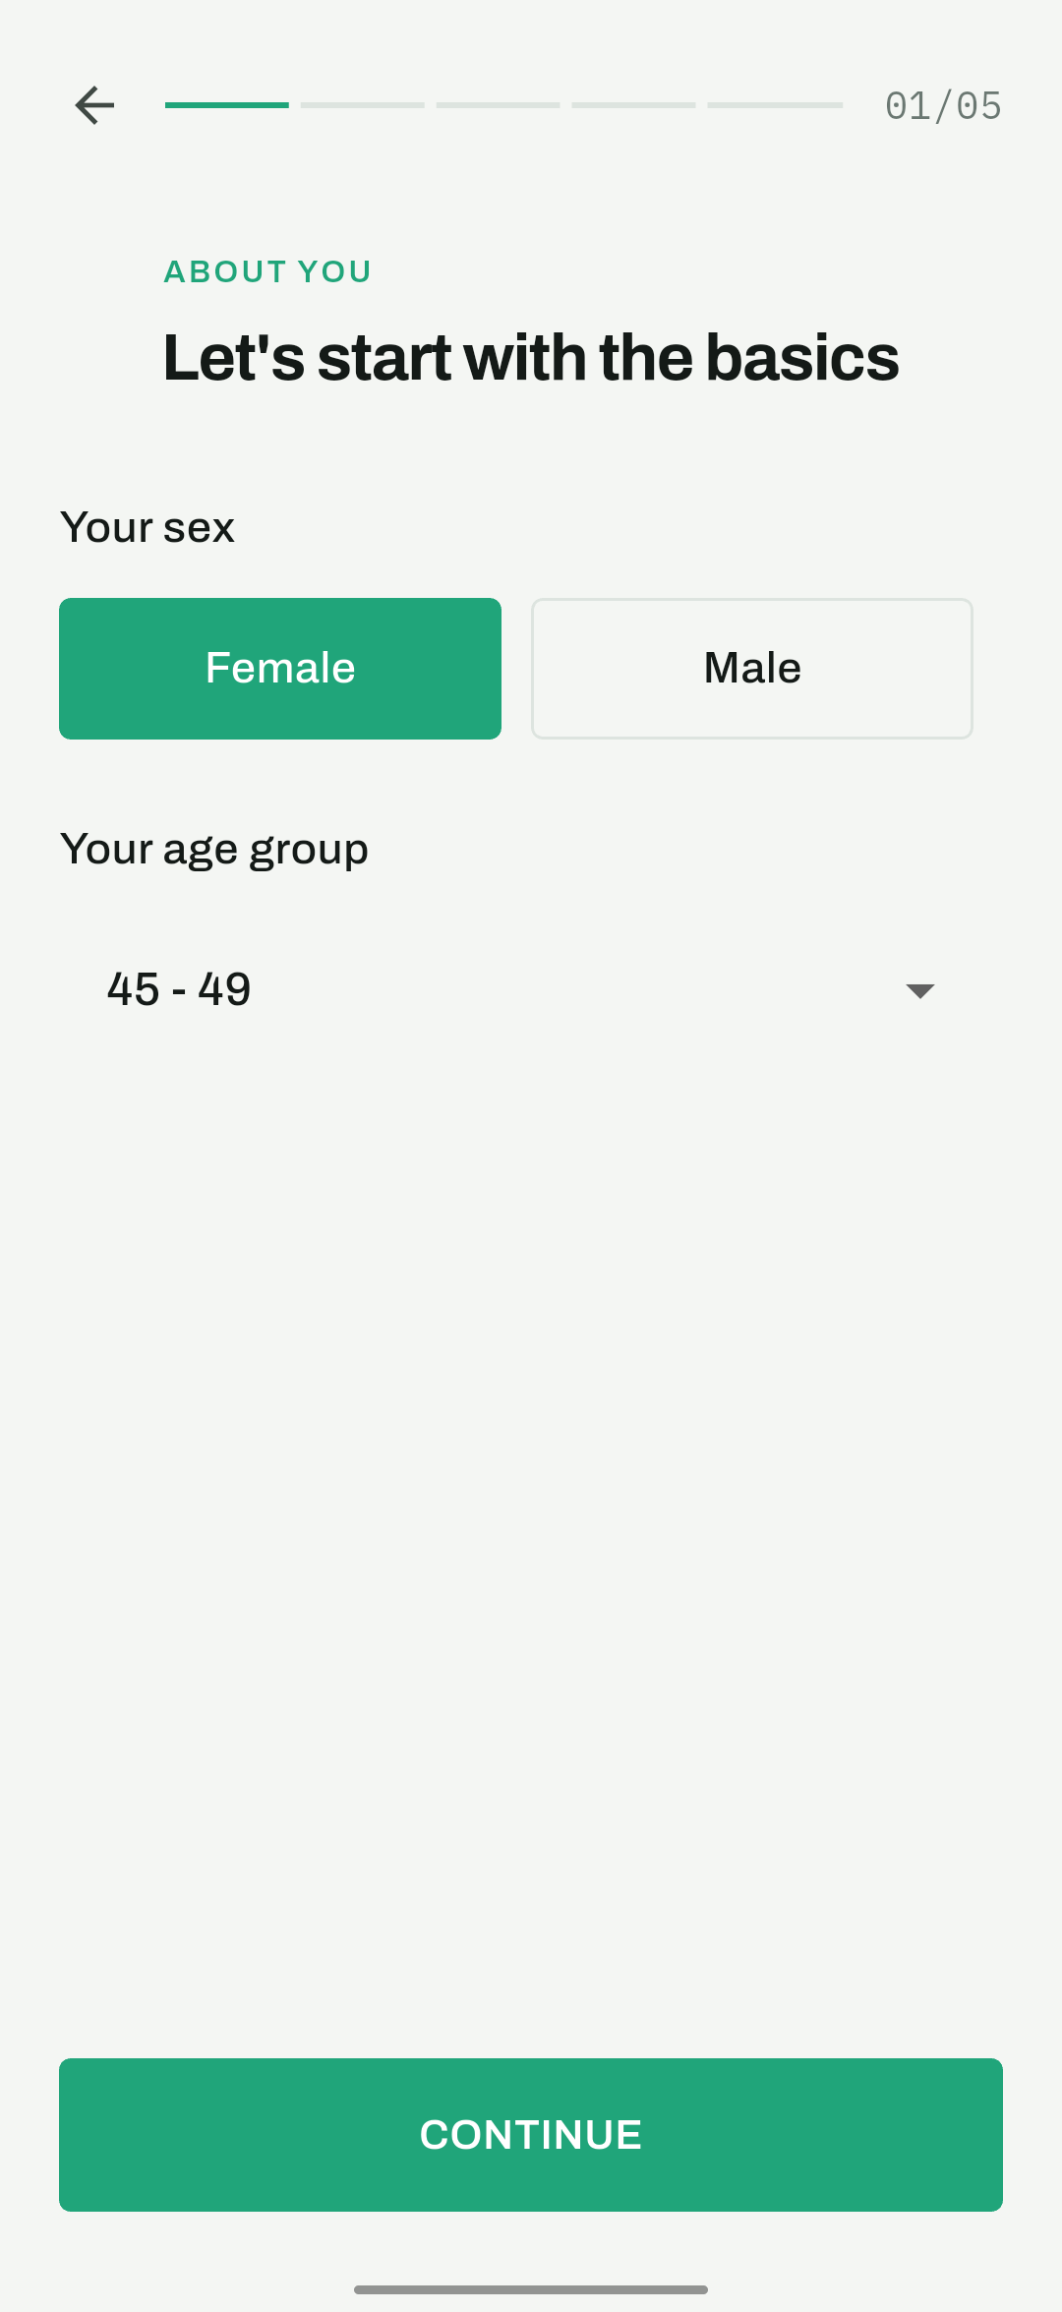
Figure 11: Questionnaire: grouped into five short steps
Reminders are scheduled through the operating system's alarm service rather than by a background process, which is why they continue to fire when the application is closed and the device has no network connection.
4.7 Deployment
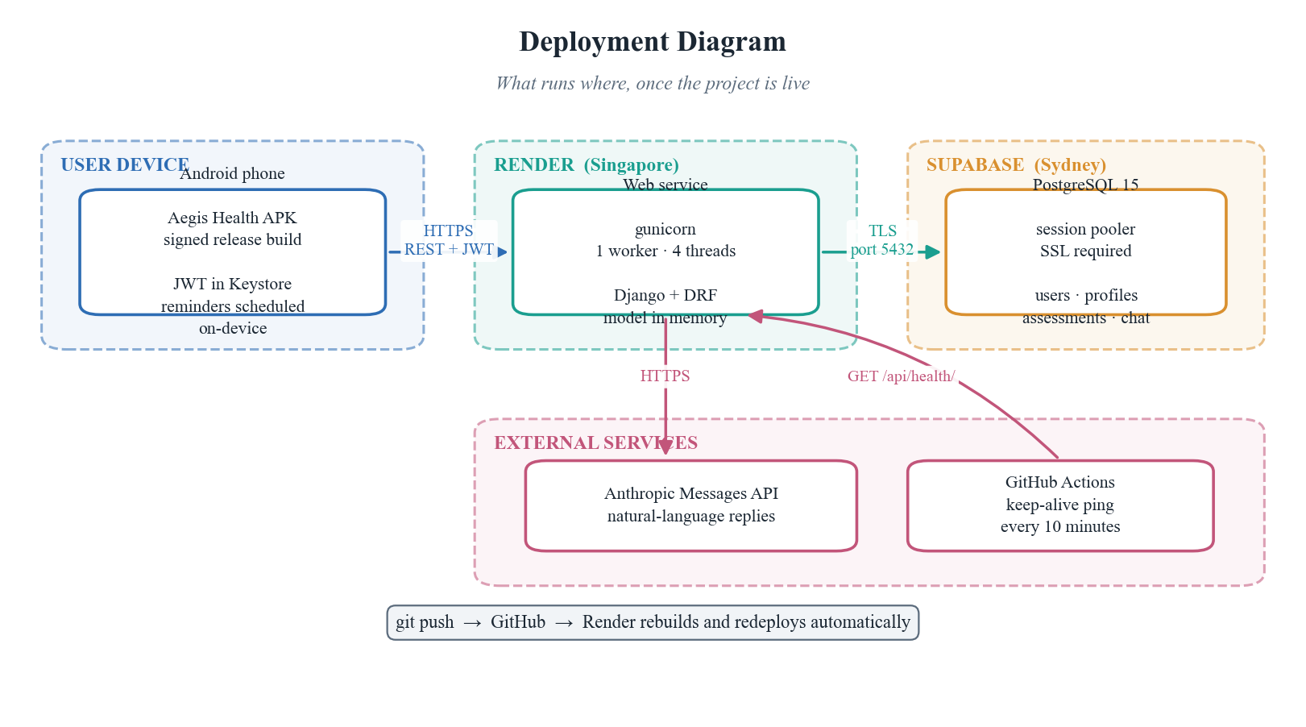
Figure 12: Deployment topology across device, Render and Supabase
The backend is deployed on Render as a persistent web service running gunicorn. A serverless platform was rejected for a specific technical reason: the model artifact must be deserialised into memory before the first prediction, and a platform that starts a fresh process per request would pay that cost every time. The database is a managed PostgreSQL instance on Supabase reached over TLS through a session pooler. Pushing to the main branch triggers an automatic rebuild and redeploy.

CHAPTER 5
Testing and Results

5.1 Testing Methodology
Testing operated at three levels. The model was evaluated statistically on a held-out test split never seen during training, and separately by 5-fold stratified cross-validation. The API was exercised end-to-end against the deployed service over the public internet. The application was tested manually on a physical Android device.
5.2 Test Cases
Table 8: API test cases executed against the live deployment
ID | Scenario | Expected | Result
T-1 | Health endpoint | HTTP 200 with status ok | Pass
T-2 | Model card returns live architecture | 18 inputs reported | Pass
T-3 | Register a new account | HTTP 201 | Pass
T-4 | Sign in with correct credentials | Access token issued | Pass
T-5 | Predict with a valid payload | Risk, factors and advice | Pass
T-6 | Predict without a token | HTTP 401 | Pass
T-7 | Predict with a field missing | HTTP 400, field named | Pass
T-8 | Assistant grounded in latest result | Cites the user's own risk | Pass
T-9 | History persists across sessions | Assessment returned | Pass
T-10 | Password change without current password | Rejected | Pass
T-11 | Repeated failed sign-in attempts | Throttled after 8 | Pass

5.3 Model Results
Table 9: Model performance on the held-out test set
Metric | Diabetes | Kidney disease | Interpretation
ROC-AUC | 0.823 | 0.793 | Ability to rank a case above a non-case
ROC-AUC, cross-validated | 0.828 ± 0.003 | 0.785 ± 0.003 | Stable across folds, so not a lucky split
Recall at screening threshold | 0.849 | 0.875 | Share of true cases identified
Precision at that threshold | 0.272 | 0.065 | Share of flagged people who truly have it
PR-AUC | 0.400 | 0.129 | Area under precision-recall, imbalance aware
Prevalence in the data | 13.9% | 3.7% | The no-skill baseline for precision
Screening threshold | 0.119 | 0.021 | Chosen to hold recall above 0.85

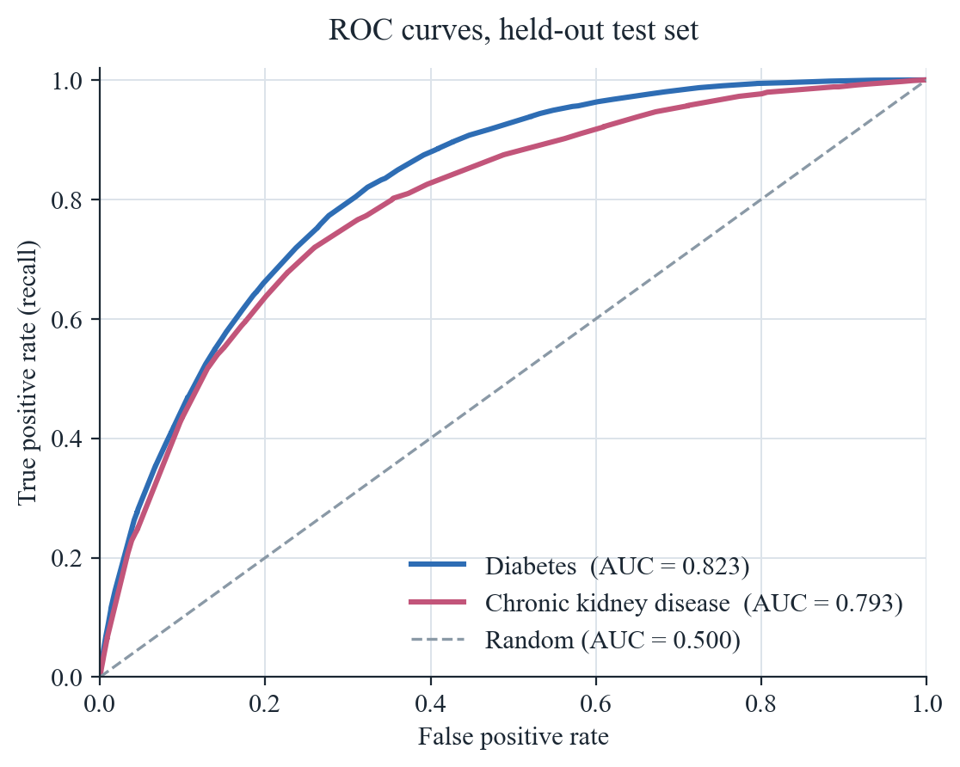
Figure 13: ROC curves for both heads on the held-out test set
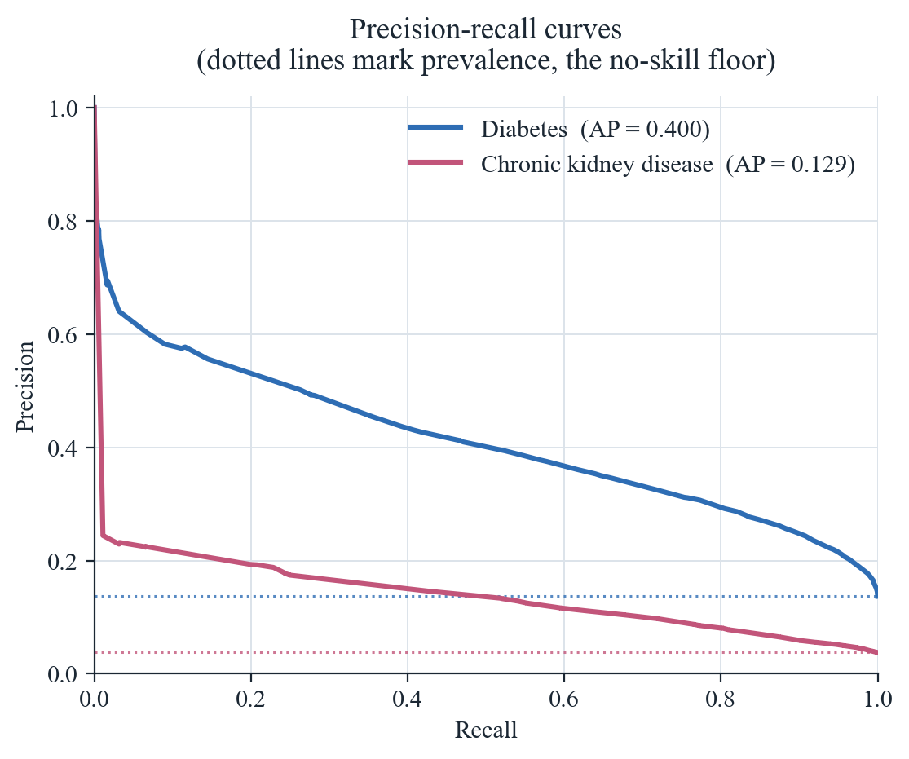
Figure 14: Precision-recall curves with prevalence baselines
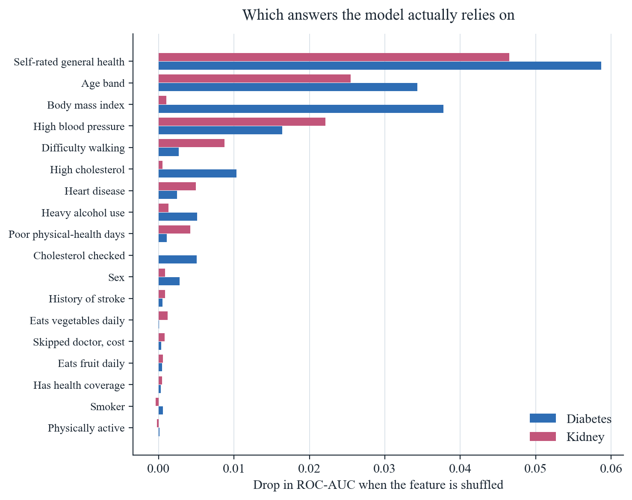
Figure 15: Permutation importance: the drop in ROC-AUC when each answer is shuffled
5.4 Why Accuracy Is Not Reported
This section exists because accuracy is the metric an examiner is most likely to ask for, and reporting it without this explanation would be misleading.
Chronic kidney disease appears in 3.7 per cent of the dataset. A model that ignores its input entirely and answers no to every person is therefore 96.3 per cent accurate while identifying not one single case. Our own model, evaluated at the conventional 0.5 decision threshold, reports an accuracy of 96.3 per cent and a balanced accuracy of 50.0 per cent, which is the signature of exactly that degenerate behaviour.
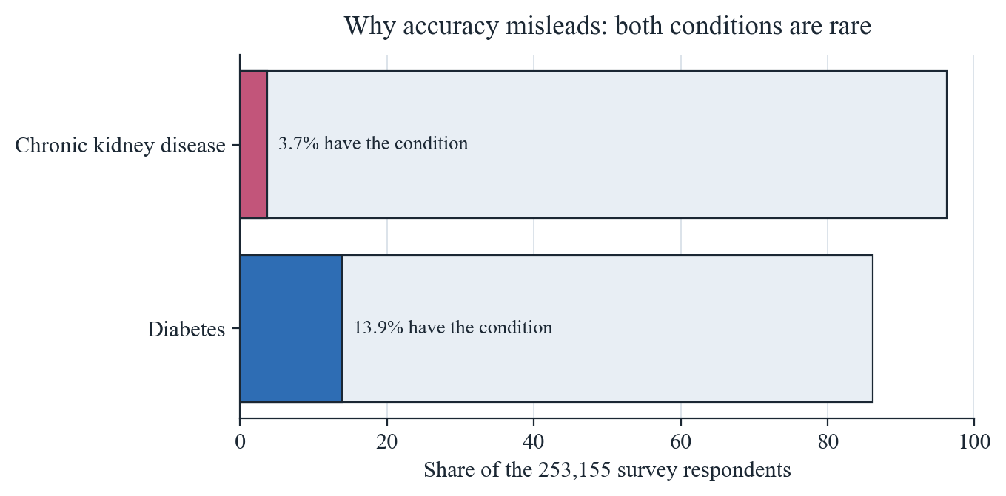
Figure 16: Class imbalance in the dataset, which is what makes accuracy misleading
The response is not to hide the number but to change the operating point and report the metrics that cannot be gamed this way. ROC-AUC measures ranking ability independently of any threshold. Recall measures the proportion of real cases caught. Balanced accuracy corrects for prevalence. All three are reported above, for both heads.
5.5 Calibration and Threshold Selection
A screening tool that tells a user their risk is thirty per cent has made a claim about the world, and that claim should be true: roughly thirty in a hundred such people should go on to have the condition. Raw neural network outputs do not have this property. Isotonic regression, fitted on the validation split only, maps raw scores onto calibrated probabilities.
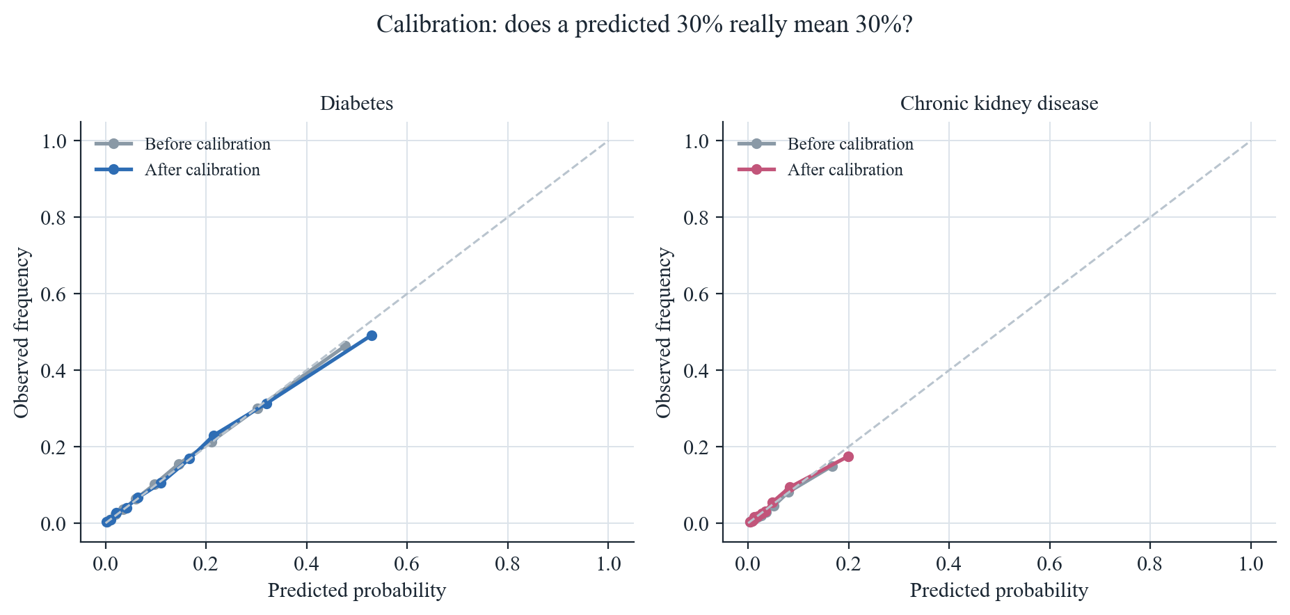
Figure 17: Reliability curves before and after isotonic calibration
The threshold for each head is then chosen as the highest value that still achieves the target recall of 0.85 on the validation split. This is a deliberate trade: precision falls, meaning some healthy people are flagged. In a screening context that is the correct direction to err, because the cost of an unnecessary check is inconvenience whereas the cost of a missed case is years of untreated disease.
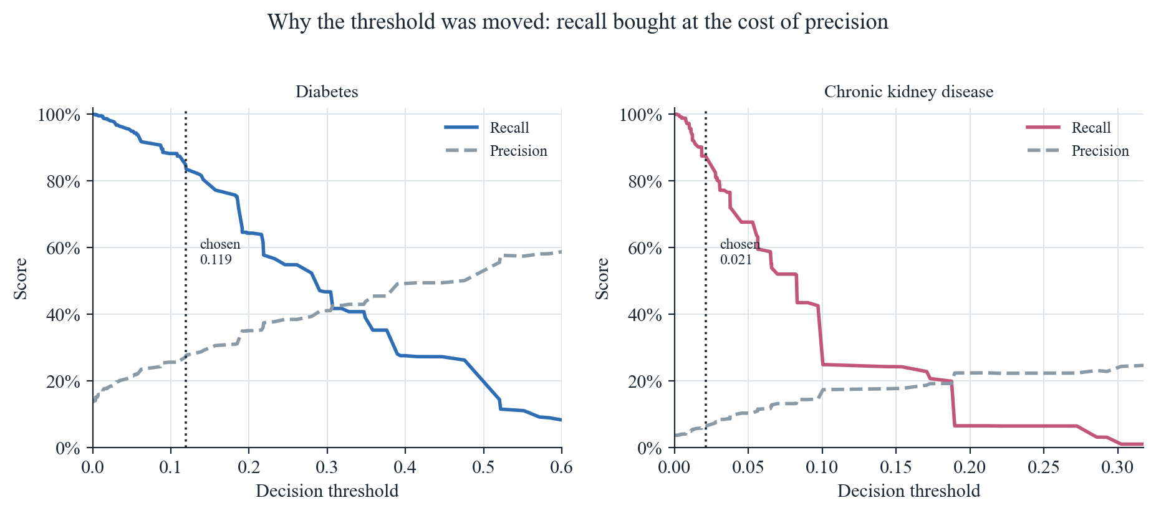
Figure 18: Recall and precision as the decision threshold moves, with the chosen point marked
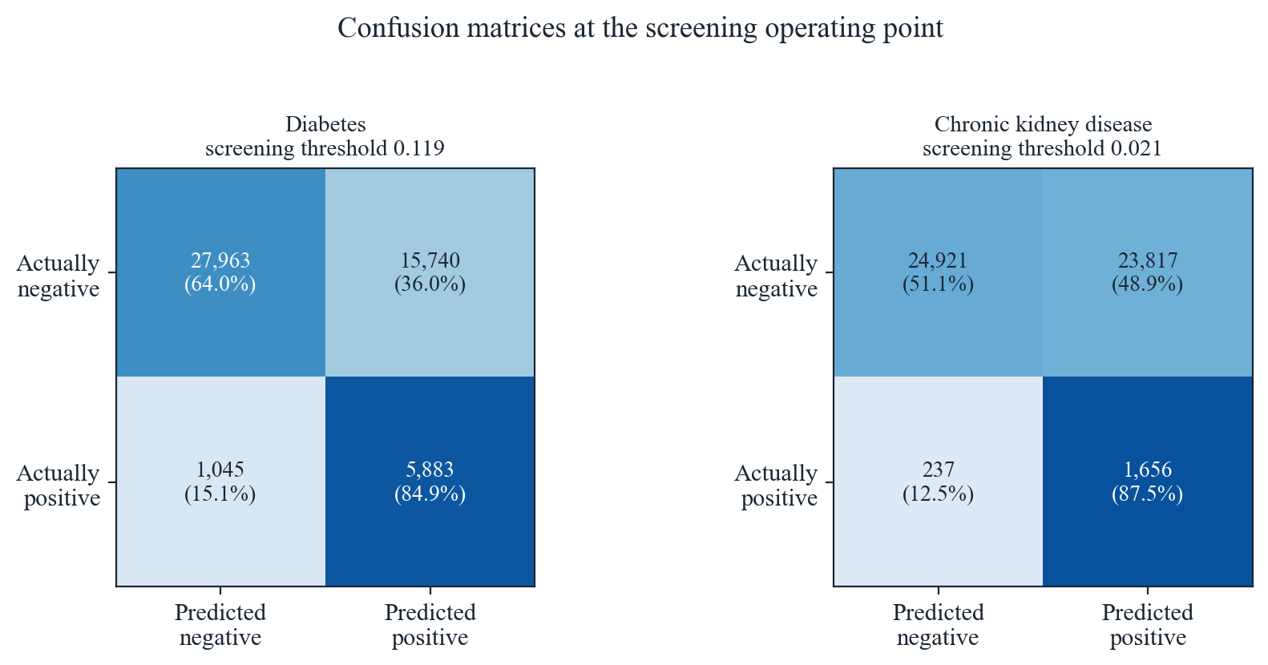
Figure 19: Confusion matrices at the chosen screening thresholds
5.6 Performance Evaluation
Table 10: Measured system performance
Measurement | Result | Note
Model inference, server-side | About 1 ms | Model held in memory
Full assessment, server-side | About 25 forward passes | Predict, explain, advise
End-to-end request, warm | 1.8 to 2.2 s | Includes network and database write
Cold start after idle | Up to 50 s | Free hosting tier spins down
Model artifact size | 170 KB | Deploys with the source
Release APK size | 19 to 53 MB | Per architecture, or universal

The variance in end-to-end timing is attributable to the hosting tier rather than to the application: the same variance appears on an endpoint that performs neither database access nor inference. A paid instance would remove it.

CHAPTER 6
Conclusion and Future Work

6.1 Conclusion
This project set out to make preventive screening for two chronic diseases available to anyone with an Android phone, without a blood test, and to do so honestly. The delivered system meets that aim. A single multi-task network trained on 253,155 real survey responses estimates risk for both conditions from nineteen everyday questions, reaching a ROC-AUC of 0.823 and 0.793 and catching 85 and 87 per cent of true cases at its screening thresholds.
The work we consider most valuable is not the model but the correction described in Section 2.4. Recognising that our original design would have produced a model that merely re-learned our own formula, and abandoning it, is the difference between a project that reports a meaningless 99 per cent and one that reports a meaningful 0.82.
6.2 Limitations
- All inputs are self-reported, and self-reported height, weight and activity are known to be optimistic. The model inherits that bias.
- The training data describes a United States population surveyed in 2015. Risk factors transfer across populations, but base rates do not, so absolute percentages should be read as indicative for Pakistani users.
- The dataset is cross-sectional. It records who has a condition now, not who developed one later, so the model learns the risk profile of people who already have the disease.
- Precision at the screening threshold is low by construction, particularly for kidney disease. This is an accepted trade, not an oversight.
- The free hosting tier introduces latency variance and a cold-start delay.
6.3 Future Work
- Validate prospectively against a local cohort to establish whether the thresholds transfer to a Pakistani population.
- Replace occlusion attribution with exact Shapley values, now that the smaller feature set makes the computation affordable.
- Add Urdu localisation, which would substantially widen reach.
- Publish an iOS build; the Flutter codebase requires no change.
- Move the model to a paid instance or a dedicated inference container to eliminate cold starts before any real-world deployment.
- Retrain on a longitudinal dataset if one becomes available, which would let the model predict incidence rather than prevalence.

References

[1] Centers for Disease Control and Prevention. Behavioral Risk Factor Surveillance System Survey Data. Atlanta, Georgia: U.S. Department of Health and Human Services, 2015.
[2] International Diabetes Federation. IDF Diabetes Atlas, 10th edition. Brussels: International Diabetes Federation, 2021.
[3] Lindström, J. and Tuomilehto, J. The Diabetes Risk Score: a practical tool to predict type 2 diabetes risk. Diabetes Care, 26(3), 725–731, 2003.
[4] Tangri, N. et al. A predictive model for progression of chronic kidney disease to kidney failure. JAMA, 305(15), 1553–1559, 2011.
[5] Caruana, R. Multitask Learning. Machine Learning, 28(1), 41–75, 1997.
[6] Ruder, S. An Overview of Multi-Task Learning in Deep Neural Networks. arXiv:1706.05098, 2017.
[7] Niculescu-Mizil, A. and Caruana, R. Predicting good probabilities with supervised learning. Proceedings of the 22nd International Conference on Machine Learning, 625–632, 2005.
[8] Zadrozny, B. and Elkan, C. Transforming classifier scores into accurate multiclass probability estimates. Proceedings of KDD, 694–699, 2002.
[9] Saito, T. and Rehmsmeier, M. The precision-recall plot is more informative than the ROC plot when evaluating binary classifiers on imbalanced datasets. PLOS ONE, 10(3), 2015.
[10] Lundberg, S. M. and Lee, S.-I. A Unified Approach to Interpreting Model Predictions. Advances in Neural Information Processing Systems 30, 2017.
[11] Pedregosa, F. et al. Scikit-learn: Machine Learning in Python. Journal of Machine Learning Research, 12, 2825–2830, 2011.
[12] Django Software Foundation. Django Documentation, version 5. 2024.
[13] Google. Flutter Documentation. flutter.dev, 2024.
[14] Jones, M., Bradley, J. and Sakimura, N. JSON Web Token (JWT). RFC 7519, Internet Engineering Task Force, 2015.
[15] Fielding, R. T. Architectural Styles and the Design of Network-based Software Architectures. Doctoral dissertation, University of California, Irvine, 2000.

Appendix A — API Reference

Base URL: https://aegis-health-jc2o.onrender.com
All authenticated endpoints expect an Authorization header of the form Bearer followed by the access token issued at sign-in.
Example request to POST /api/predict/
{ "HighBP": 1, "HighChol": 1, "CholCheck": 1, "BMI": 31.5, "Smoker": 1, "Stroke": 0, "HeartDiseaseorAttack": 0, "PhysActivity": 0, "Fruits": 0, "Veggies": 0, "HvyAlcoholConsump": 0, "AnyHealthcare": 1, "NoDocbcCost": 0, "GenHlth": 4, "PhysHlth": 10, "DiffWalk": 1, "Sex": 1, "Age": 9 }
Example response
{ "prediction": { "diabetes": { "risk_percent": 47.6, "tier": "High", "threshold": 0.119 }, "kidney": { "risk_percent": 9.7, "tier": "High", "threshold": 0.021 } }, "key_factors": { ... }, "recommendations": [ ... ] }

Appendix B — User Manual

1. Install
Open the supplied APK file. Android will ask permission to install from this source; allow it, then tap Install.
2. Create an account
Choose a username and a password of at least six characters. Email is optional.
3. Complete the health check
Tap Begin Check on the home screen and answer nineteen questions across five short steps. Height and weight are used to compute body mass index automatically.
4. Read the result
Each condition is shown as a percentage with a marked screening threshold. Sitting above the mark means the tool would refer you for a real test; it does not mean you have the condition.
5. Understand the drivers
The What drives it section ranks your own answers by how much each raised your estimate.
6. Try changes
Open the what-if simulator, toggle a habit or move the body-mass slider, and watch the estimate update.
7. Ask the assistant
The Assistant tab can explain your result in plain language. It can see your most recent assessment.
8. Set reminders
Reminders run on the phone itself and work without a network. On some devices you must allow unrestricted battery use, otherwise Android may delay them.
Aegis Health is an educational screening aid. It does not diagnose disease and it does not replace a clinician.

