Punjab University College of Information Technology
University of the Punjab, Lahore

Final Year Design Project

AI Medical Assist
A Predictive Lifestyle Health-Risk Assessment System for Diabetes and Chronic Kidney Disease

Session: BSIT (2022 - 2026)

Project Advisor
Prof. Hafiz Shahzad
Head of Department
Prof. Muhammad Fahim
Submitted By
Muhammad Hassan Roll No. 2716
Muhammad Rohan Ashraf Roll No. 2720

Punjab University College of Information Technology
University of the Punjab, Lahore.

Statement of Submission
This is to certify that Mr. Muhammad Hassan, Roll No. 2716, and Mr. Muhammad Rohan Ashraf, Roll No. 2720, have successfully completed the final year design project titled “AI Medical Assist – A Predictive Lifestyle Health-Risk Assessment System for Diabetes and Chronic Kidney Disease” at the Punjab University College of Information Technology, University of the Punjab, Lahore, in the partial fulfilment of the requirements for the degree of Bachelor of Science in Information Technology (BSIT).

______________________________
Project Advisor
Prof. Hafiz Shahzad
Punjab University College of Information Technology, Lahore

______________________________
Head of Department
Prof. Muhammad Fahim
Punjab University College of Information Technology, Lahore

Proofreading Certificate
It is to certify that I have read this document meticulously and circumspectly. I am convinced that the resultant document does not contain any spelling, punctuation or grammatical mistakes. Overall, I find this document well organised, and I am in no doubt that its objectives have been successfully met.

______________________________
Business Communication and Technical Writing
Lecturer, PUCIT

Acknowledgement
All praise and gratitude are due to Almighty Allah, whose blessings enabled us to undertake and complete this project. We owe our sincere appreciation to our supervisors, Prof. Hafiz Shahzad and Prof. Muhammad Fahim, whose guidance, patience and constructive feedback shaped this work at every stage. Their insistence that we question our own assumptions – particularly around the design of the machine learning core – pushed the project towards a genuinely meaningful and defensible solution.
We are equally thankful to the faculty of the Punjab University College of Information Technology for providing the academic foundation that made this work possible. Finally, we thank our families and friends, whose quiet and unwavering support carried us through the demanding months of this project.

Muhammad Hassan
Muhammad Rohan Ashraf

Abstract
Diabetes Mellitus and Chronic Kidney Disease are among the most widespread and costly chronic illnesses in the world, yet most existing health applications only react after a person is already ill – typically by reading a laboratory blood report. By that point, the opportunity for prevention has often passed. AI Medical Assist takes the opposite approach. Instead of confirming disease from clinical lab values, it predicts a person’s future risk of developing diabetes and kidney disease from their everyday lifestyle – factors such as physical activity, diet, body-mass index, sleep, smoking, blood-pressure history and family history – without requiring any blood test.
At the heart of the system is a multi-task machine learning model that predicts both diseases at once. Because diabetes is a leading cause of kidney disease, a single model with a shared representation learns the physiological link between the two conditions, rather than treating them as unrelated problems. The model is trained on the CDC Behavioural Risk Factor Surveillance System (BRFSS) dataset, which contains the lifestyle and health records of roughly 250,000 real individuals. To ensure the predictions are trustworthy, the system explains every result using SHAP feature attribution and goes one step further with a “what-if” counterfactual engine that tells the user exactly which habits to change to lower their risk.
The platform is delivered as a mobile-first application built with Flutter and served by a Django REST Framework backend, with a Gemini conversational interface for plain-language health guidance and Google Maps integration for locating nearby medical facilities. The system is positioned strictly as a preventive screening and educational tool, not a diagnostic authority.
Keywords: Preventive Healthcare, Lifestyle Risk Prediction, Multi-Task Learning, Explainable AI, Counterfactual Recommendations.

Table of Contents
1 Project Title 1
2 Project Overview Statement 1
2.1 The Problem 1
2.2 The Proposed Solution 1
2.3 The Machine Learning Innovation 1
2.4 Project Objectives 2
3 High Level System Components 2
3.1 Mobile Application (Flutter) 3
3.2 Backend and API Layer (Django REST Framework) 3
3.3 Predictive ML Engine 3
3.4 Explainability and Advisory 4
3.5 Data and Geolocation Services 5
4 List of Optional Functional Units 5
5 Application Architecture 5
6 Gantt Chart 7

List of Figures
Figure 1: High-level layered architecture of AI Medical Assist. 3
Figure 2: Predictive machine learning pipeline (lifestyle input to actionable advice). 4
Figure 3: Multi-task model: a shared backbone with two disease-specific risk heads. 4
Figure 4: Application architecture and request flow across major components. 6
Figure 5: Project schedule across the sixteen-week timeline. 7

List of Tables
Table 1: Project objectives and their success measures. 2
Table 2: Optional functional units and their descriptions. 5
Table 3: Technology stack mapped to system concerns. 6
Table 4: Project phases, timeline and milestones. 7

1 Project Title
AI Medical Assist – A Predictive Lifestyle Health-Risk Assessment System for Diabetes and Chronic Kidney Disease.
The project delivers an intelligent, mobile-first health companion that estimates a person’s future risk of developing Diabetes Mellitus (DM) and Chronic Kidney Disease (CKD) from their daily lifestyle, explains the reasoning behind every prediction, and recommends concrete, personalised actions to reduce that risk.

2 Project Overview Statement

2.1 The Problem
Chronic diseases such as diabetes and kidney disease develop silently over many years. In developing regions in particular, people rarely undergo regular laboratory screening, so the condition is usually discovered only once symptoms or complications appear. The vast majority of existing health applications reinforce this reactive pattern: they require a blood test or clinical lab value and then simply confirm what an already-present report indicates. This is of limited value, because by the time a lab result is abnormal, the disease is frequently already established. The genuine, unmet need is for a tool that warns people earlier – before the disease takes hold – using information they already have about their own lifestyle.

2.2 The Proposed Solution
AI Medical Assist reframes the goal from detection to prevention. A user answers a short, approachable questionnaire about their everyday routine – activity level, diet, body-mass index, sleep, smoking and alcohol habits, blood-pressure history and family history. From these lifestyle signals alone, and with no blood test required, the system predicts the user’s future risk of both diabetes and kidney disease, presents the result as an easy-to-understand risk tier, explains which factors are driving that risk, and recommends specific changes that would measurably lower it.
The platform is deliberately designed as a two-tier engine. The first tier performs lifestyle-only screening that anyone can use immediately. The optional second tier allows a user who already has laboratory values to enter them and receive a sharper, refined estimate. This keeps the product widely accessible while still rewarding clinical data when it is available.

2.3 The Machine Learning Innovation
The intelligence of the system is a multi-task learning model that predicts both diseases simultaneously. Because diabetes is one of the leading causes of kidney disease, the two conditions are physiologically connected. Rather than building two isolated models, AI Medical Assist uses a single model with a shared representation that learns this connection directly from the data, with two dedicated output “heads” – one for diabetes risk and one for kidney risk. This design is both medically faithful and technically stronger, as knowledge learned for one disease improves the prediction of the other.
Crucially, the model is trained to predict outcomes that cannot be trivially derived from a fixed formula. It learns genuine, non-linear risk patterns from the CDC Behavioural Risk Factor Surveillance System (BRFSS) dataset – a national health survey covering approximately 250,000 real individuals – rather than re-encoding a clinical threshold rule. Because serious disease is comparatively rare in the population, the data is deliberately rebalanced, and the model is judged on recall (sensitivity), AUC-ROC and F1 score rather than on raw accuracy, which would otherwise hide missed high-risk cases.
Finally, the system does not stop at a risk number. Using SHAP it identifies the factors most responsible for each individual’s risk, and a counterfactual “what-if” engine translates those factors into actionable advice – for example, indicating how much a user’s risk could fall if they increased weekly physical activity or reduced their body-mass index. This turns a passive warning into a practical, motivating plan.

2.4 Project Objectives
Table 1: Project objectives and their success measures.
ID | Objective | Success Measure
OBJ-1 | Build a multi-task model predicting future diabetes and kidney risk from lifestyle data | Strong recall and AUC-ROC on held-out data
OBJ-2 | Train and validate on the large, real-world BRFSS dataset with class balancing | Robust performance on rare positive cases
OBJ-3 | Explain every prediction with SHAP feature attribution | Top contributing factors shown per result
OBJ-4 | Provide what-if counterfactual recommendations | Actionable risk-reduction guidance generated
OBJ-5 | Deliver a secure Flutter mobile app with JWT authentication | Working login, questionnaire and dashboard
OBJ-6 | Integrate Gemini chat and Google Maps doctor lookup | Plain-language guidance and nearby facilities

3 High Level System Components
AI Medical Assist is organised as a layered, modular system in which each component has a single clear responsibility. The presentation layer collects input and displays results; the application layer orchestrates business logic and security; the intelligence layer performs prediction, explanation and advice; and the data and external-service layers provide persistence and third-party capabilities. Figure 1 presents the high-level architecture.
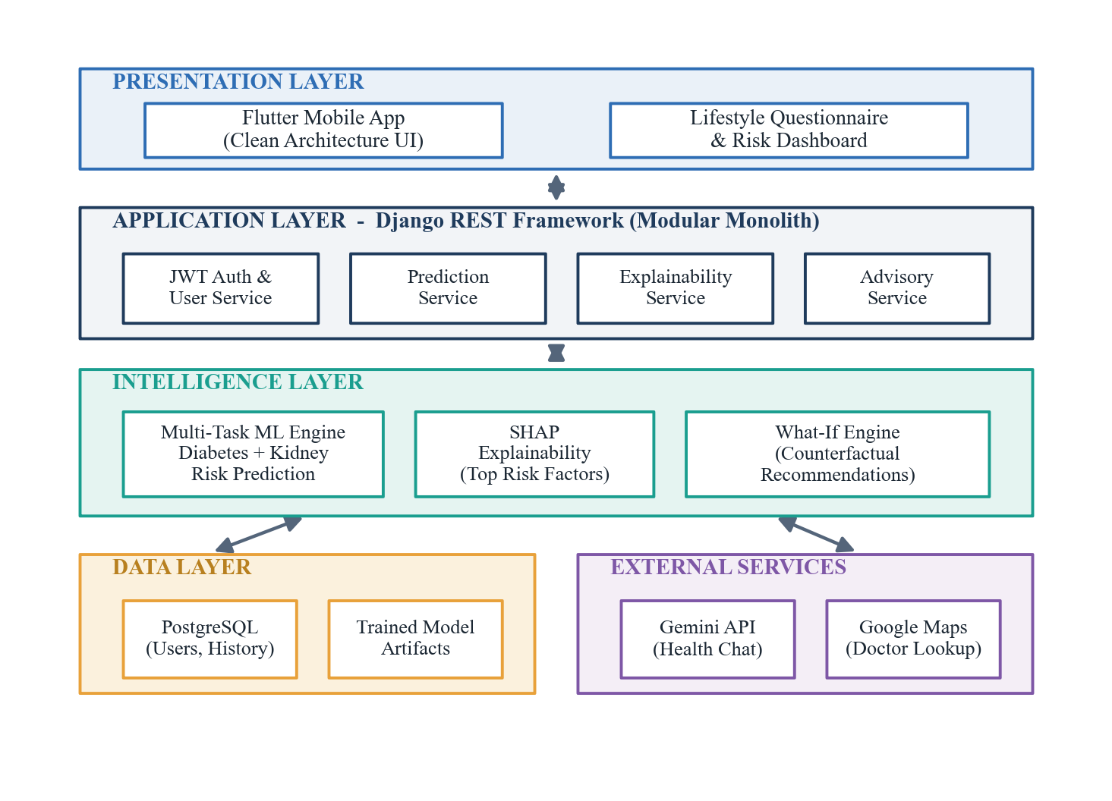
Figure 1: High-level layered architecture of AI Medical Assist.

3.1 Mobile Application (Flutter)
The user-facing application is built with Flutter using a clean, layered structure that separates presentation, domain and data concerns. It guides the user through the lifestyle questionnaire, presents risk tiers and explanations in an uncluttered dashboard, and hosts the conversational chat experience. The interface emphasises ample whitespace, consistent typography and thumb-friendly navigation suitable for everyday, non-specialist users.

3.2 Backend and API Layer (Django REST Framework)
The backend is a modular monolith built on the Django REST Framework. It exposes secure REST endpoints protected by JWT authentication and is internally divided into well-defined services – user and authentication, prediction, explainability and advisory – each following the single-responsibility principle. This layered organisation keeps the system maintainable and easy to defend, while avoiding the operational overhead of a premature microservices design.

3.3 Predictive ML Engine
The predictive engine is the core of the system. It loads the trained multi-task model once at start-up and serves real-time risk predictions for both diabetes and kidney disease. Figure 2 shows the end-to-end machine learning pipeline, from lifestyle input through to explained, actionable output, and Figure 3 illustrates the multi-task model architecture in which a shared backbone feeds two disease-specific risk heads.
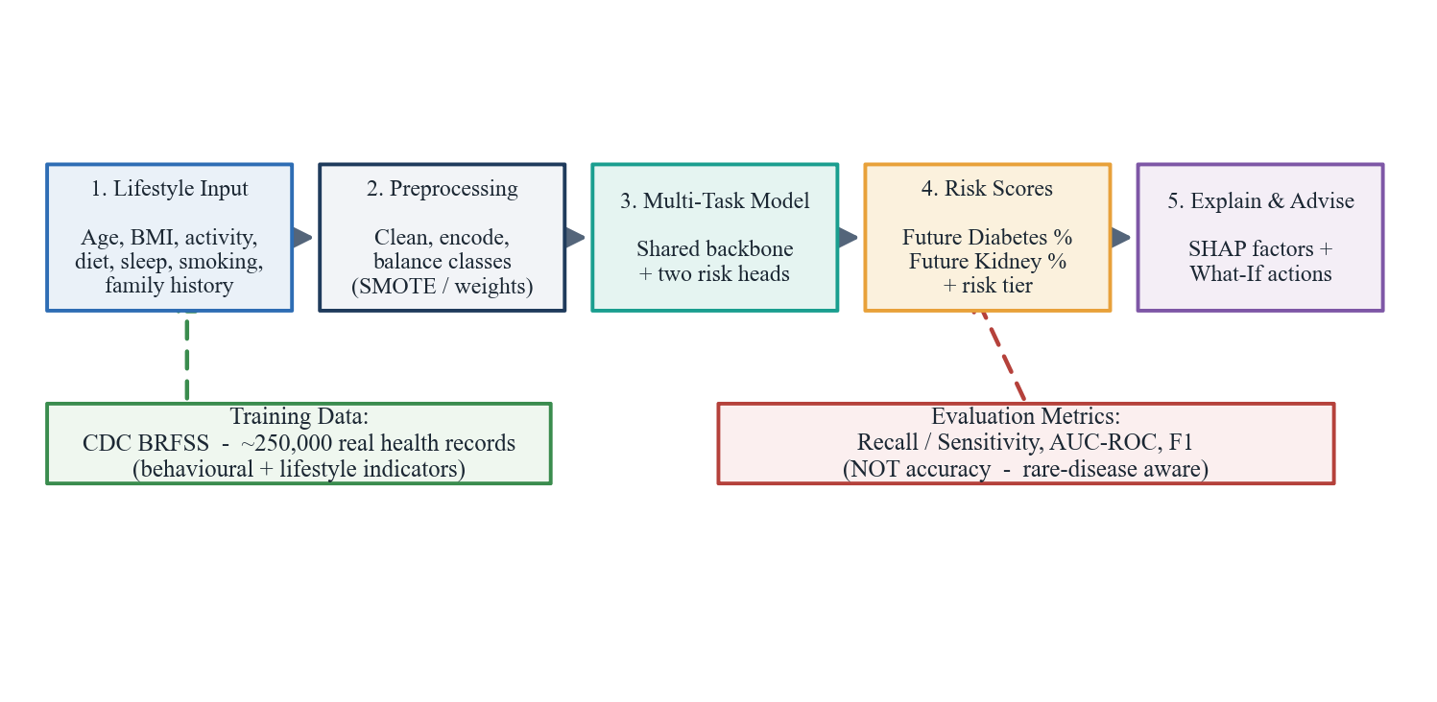
Figure 2: Predictive machine learning pipeline (lifestyle input to actionable advice).
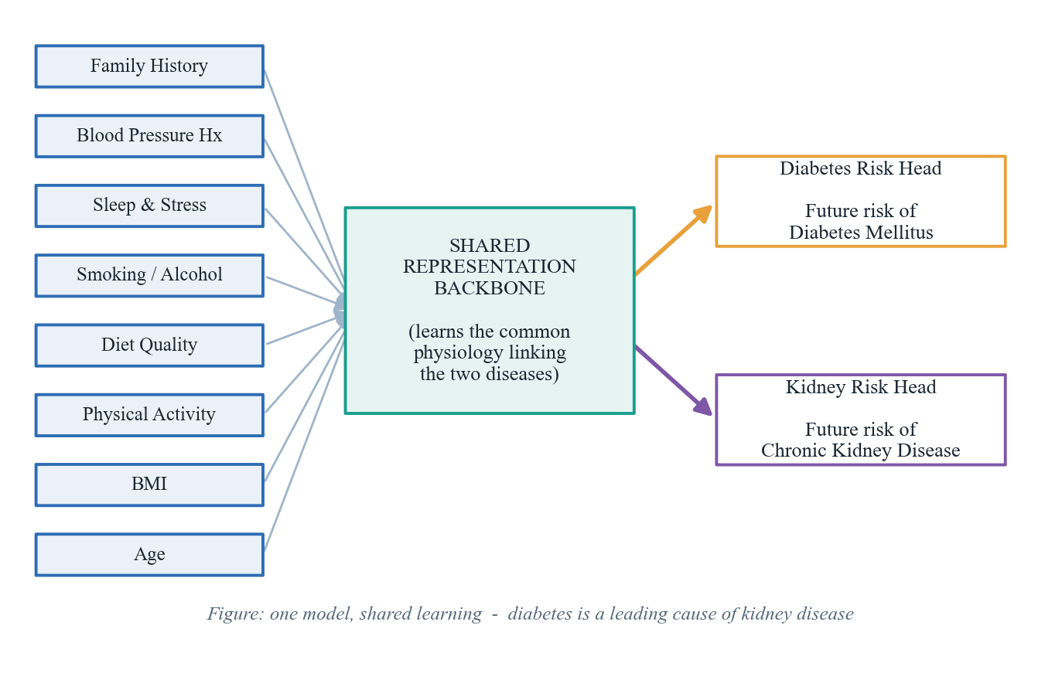
Figure 3: Multi-task model: a shared backbone with two disease-specific risk heads.

3.4 Explainability and Advisory
Trust is essential in any health-facing system, so no prediction is presented as an unexplained black box. The explainability service applies SHAP to reveal the factors most responsible for each user’s risk, while the advisory service uses a counterfactual what-if engine to recommend the specific lifestyle changes that would most reduce that risk. A Gemini-powered conversational interface then communicates these insights in clear, supportive, plain language.

3.5 Data and Geolocation Services
A PostgreSQL database securely stores user accounts, questionnaire history and prediction records, enabling users to track how their risk evolves over time. The Google Maps service helps users who are flagged as high-risk locate nearby clinics or doctors, closing the loop between awareness and action.

4 List of Optional Functional Units
The following units enhance the system but are not essential to its core preventive function. They are scoped as optional so that the central prediction-and-advice experience can be delivered and validated first.
Table 2: Optional functional units and their descriptions.
Optional Unit | Description
Clinical (Tier-2) Refinement | Lets users who have lab values enter them to sharpen the lifestyle-based risk estimate.
Risk History and Trends | Visualises how a user’s predicted risk changes over repeated assessments.
PDF Health Report Export | Generates a shareable summary of risk, contributing factors and recommendations.
Reminders and Notifications | Encourages periodic reassessment and adherence to recommended habit changes.
Multi-Language Support | Provides the questionnaire and guidance in local languages for wider accessibility.
Doctor Lookup via Maps | Surfaces nearby medical facilities for users flagged as high-risk.

5 Application Architecture
The application follows a modular-monolith architecture with a clean, layered internal structure, applying SOLID and DRY principles throughout. The Flutter client communicates with the Django REST backend exclusively over secure HTTPS using JWT-authenticated requests. The backend routes each request to the appropriate service, invokes the ML engine for prediction and the explainability and advisory components for interpretation, and persists results to PostgreSQL. External capabilities – Gemini for conversation and Google Maps for geolocation – are integrated as cleanly isolated services. Figure 4 shows the request flow across these components.
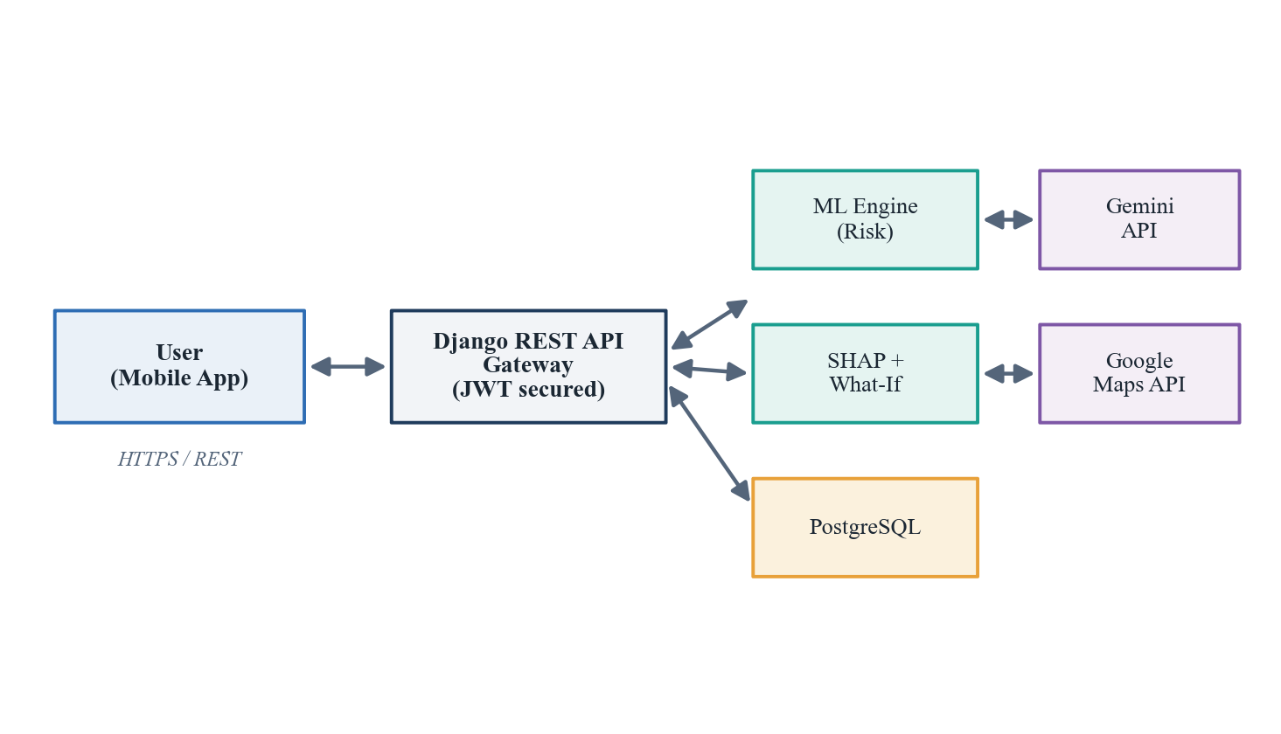
Figure 4: Application architecture and request flow across major components.
This architecture was chosen deliberately. For a two-person team delivering within a single academic timeline, a modular monolith provides the clarity, testability and clean separation of a well-structured system without the deployment and coordination cost of microservices. The ML engine is isolated behind a clean interface so that the underlying model can be improved or replaced without disturbing the rest of the system. Table 3 summarises the technology stack.
Table 3: Technology stack mapped to system concerns.
Layer / Concern | Technology | Rationale
Mobile Frontend | Flutter, Dart | Cross-platform, clean and responsive UI
Backend and API | Django REST Framework, JWT | Secure, modular, maintainable API layer
ML Engine | scikit-learn / gradient boosting, multi-task model | Lifestyle-based dual-disease risk prediction
Explainability | SHAP, counterfactual what-if engine | Transparent, actionable results
Database | PostgreSQL | Secure relational storage of users and history
Conversational AI | Gemini API | Plain-language health guidance
Geolocation | Google Maps API | Nearby doctor and facility lookup

6 Gantt Chart
The project is planned across a sixteen-week timeline. Development is deliberately front-loaded onto the machine learning core – the component carrying the greatest technical risk and the greatest academic value – before backend, mobile and integration work proceed. Figure 5 presents the schedule.
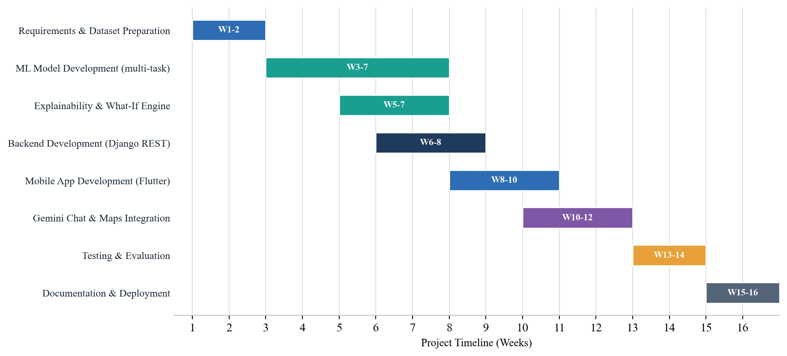
Figure 5: Project schedule across the sixteen-week timeline.
Table 4: Project phases, timeline and milestones.
Phase | Weeks | Milestone
Requirements & Dataset Preparation | 1 - 2 | Problem framing and dataset finalised
ML Model Development (multi-task) | 3 - 7 | Trained and validated risk model
Explainability & What-If Engine | 5 - 7 | SHAP and counterfactual advice working
Backend Development (Django REST) | 6 - 8 | Secure REST APIs ready
Mobile App Development (Flutter) | 8 - 10 | Questionnaire and dashboard integrated
Gemini Chat & Maps Integration | 10 - 12 | Conversational guidance and doctor lookup
Testing & Evaluation | 13 - 14 | All modules validated
Documentation & Deployment | 15 - 16 | Project finalised and submitted

