**Homework 2 Problems**

Due: Wednesday, 17 Apr 19

1. (Problem 2.31.a from Robertazzi, *Computer Networks and Systems*, 3rd edition.) A packet buffer *and* a single communications server can hold at most five packets. The arrival rate to the system is 20 packets per millisecond (ms). The communications server can serve 40 packets per ms. Calculate the blocking probability of the system under Markovian statistics (i.e., arrivals are Poisson and service times are exponentially distributed). [Hint: The final answer is 0.0159.]
2. (Problem 2.31.b from Robertazzi, *Computer Networks and Systems*, 3rd edition.) A large company has hundreds of phones, but only three international phone lines. The international call arrival rate is 10 calls/hour. Each call lasts, on average, 12 minutes. Calculate the probability that all three lines are busy using Markovian statistics. [Hint: The final answer is 0.21.]
3. A local exchange carrier (LEC) is trying to convince a state public utilities commission that it must increase local telephone switching capacity and inter-switch trunk capacity due to use of traditional voice telephone lines for Internet access. You are asked to conduct an analytical study to help them build their case.

(a) What is the key performance measure for the study.

Blocking probability because traditional telephone lines do not have call waiting

(b) What queuing model result should be used in the study?

M/M/m/m 🡪 no queueing

(c) What data are required to conduct the analysis?

To conduct the analysis, you need mean arrival and service rates As well as the current capacity *m*

1. A message switching system supports messages of two lengths. Short messages are 32 bytes. Long messages are 128 bytes. 75% of the messages are short messages and the remainder are long. Arrivals to a particular link in the network are Poisson distributed with a mean arrival rate of 50 messages per second. The capacity of the link is 128 Kbps.

(a) What is the expected number of messages in the queue?

(b) What is the expected time spent by a message in the queue?

(c) What is the expected time that a message spends at the link, including queuing delay and transmission time?

, as calculated above.

1. A remote campus location connects to an ATM network using a T1 line. Assume that the effective capacity of the T1 line is 1.536 Mbps. The location has two “low-end” (type 1) video conferencing systems that each require a 384-Kbps constant bit rate (CBR) connection and one “high-end” (type 2) video conferencing system that requires a 768-Kbps CBR connection.[1]* The ATM edge switch servicing the site is configured to allocate at most 768 Kbps to CBR applications. Any capacity not used by CBR connections is available for Internet access as unspecified bit rate (UBR) traffic.

Assume that the two type 1 systems each make connection requests at a rate of λ1 and that the type 2 system makes connection requests at a rate of λ2. Connection requests from an idle source arrive according to a Poisson distribution. Connection times are exponentially distributed with mean 1/μ for both types of systems.

1. Draw the Markov chain for this system. [Hint: It is a two-dimensional chain with four states.]

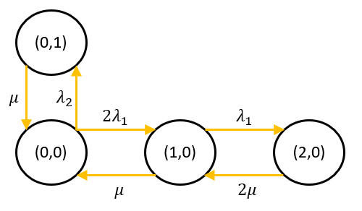

(b) Let *C* be the probability of no CBR connections being active. Find πi,j, the steady-state probability of being in each state (*i*,*j*) as a function of *C*, λ1, λ2, and μ. [Hint: The probability of there being one type 1 connection and no type 2 connection is π1,0 = (2λ1/μ)*C*.]

Balance Equations: State Probabilities:

(c) Determine an expression for *C* = π0,0, the probability that no connections are active, as a function of λ1, λ2, and μ.

(d) Capacity of 768 Kbps is always available for UBR (generic Internet) traffic. Additional capacity is available for UBR traffic if the capacity allocated for CBR traffic is not fully utilized. Determine an expression for *B*UBR, the average capacity available for UBR traffic as a function of the steady‑state probabilities πi,j.

(e) If we are interested in the performance of this system for Internet access, why is it *not* a good idea to use the capacity BUBR determined in part (d)? Be brief. [Hint: imagine the impact when many are using the UBR bandwidth, and a video conferencing session begins.]

* Any new CBR connection decreases the available internet bandwidth by a sizeable amount, i.e. If **n** users are using the internet, and one user opens a video conference, the bandwidth available to the **n** users is halved.
  + The average capacity for UBR traffic inherently has periods where it is very large, and others where it is small in comparison.
* The UBR bandwidth available is shared by all users connected to the internet, so a more valuable metric for performance of internet access would need to include the expected number of users on the internet system.

1. A remote campus location connects to an ATM network using a T1 line. Assume that the effective capacity of the T1 line is 1.536 Mbps. The location has three “low-end” (type 1) video conferencing systems that each require a 384-Kbps constant bit rate (CBR) connection and two “high-end” (type 2) video conferencing system that requires a 768-Kbps CBR connection. Any capacity not used by CBR connections is available for Internet access as unspecified bit rate (UBR) traffic.

Assume that the three type 1 systems each make connection requests at a rate of λ1 and that the two type 2 system makes connection requests at a rate of λ2. Connection requests from an idle source arrive according to a Poisson distribution. Connection times are exponentially distributed with mean 1/μ for both types of systems.

Draw the Markov chain for this system.

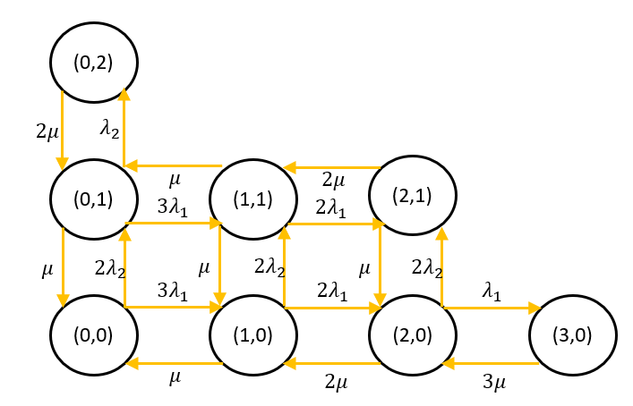

1. (Problem 2.39 from Robertazzi, *Computer Networks and Systems*, 3rd edition.)
2. An M/D/1 queue has an arrival rate of 10 customers per second and a service rate of 20 customers per second. Calculate the mean number of customers in the queue.

(b) Prove for an M/D/1 queuing system with ρ close to 1 that the mean number of customers in the *system* is half of that for an M/M/1 queuing system.

The number in the system for an M/D/1 and M/M/1 queue are shown below:

Calculate the ratio :

Compute the limit as approaches 1:

Thus, as approaches 1, the mean number of customers in the system for an M/D/1 queue is half that of an M/M/1 queue.

1. Using the graphs provided on slides 94 and 95 of presentation 05_qt_2.ppt, solve the following problem. As a telephone system developer, you have been asked to determine how many PSTN lines are needed to service 200 employees in a particular business office. Calls arriving to find all lines busy are blocked, not queued. You have determined that the average call length is 5 minutes (with an exponential distribution), and that calls follow a Poisson arrival rate with a mean of 4 times per hour per employee. Each call has the potential to generate much money, so the customer would like a good GOS, you choose 0.2%. How many lines are required?

Use Erlang B because there is blocking

Calculate traffic intensity:

To achieve a probability of loss of 0.2%, with an intensity of 66.667 Erlangs, 90 lines are required.

1. A student requests some time to chat with a professor. Student appointment durations are exponentially distributed with mean of 20 minutes. The professor is unavailable until 1:00pm. He also has a high-priority meeting at 1:30, which will end precisely at 1:40. Understanding that there is a chance he will have to interrupt the chat (exponential appointment durations), the professor explains that he has this meeting at 1:30pm that he must attend, but that if the student can tolerate a potential interruption, he can meet at 1:00pm. Otherwise, he isn’t free until 1:40pm. The student wishes to get home as early as possible, and agrees to come at 1:00pm. (It is understood that if the chat exceeds 30 minutes, the student will wait for the professor and the chat will resume when he returns.) What is the expected time of departure of the student?

Using the exponential distribution, one achieves the following probabilities for chat lengths:

The expected length of a call is 20 minutes for conversations less than 30 minutes, and 30 minutes for conversations greater than 30 minutes.

Thus, the following determines the expected chat length:

This equates to an expected departure time of 1:22pm.

1. * In reality, distance learning videoconferencing systems may use real-time variable bit rate (rt-VBR) connections. However, there is almost no variation in the capacity utilization of such connections so a CBR assumption is reasonable for this problem.