**Capt Alamri, 2Lt Hayden, 2Lt Mireles**

**Lab 2 – Scanning**

**Dr. Mullins**

**1/16/2019**

**Network Mapping**:

1. What is the IP address and host name of your machine? What is the IP address and host name of your partner’s machine?

* My IP address is 10.204.0.68, with a hostname kali

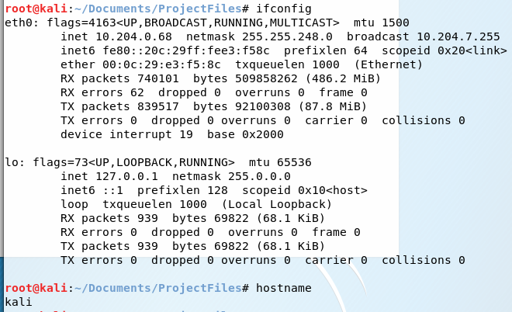

* My partner’s IP address is 10.204.0.51, with a hostname of kali

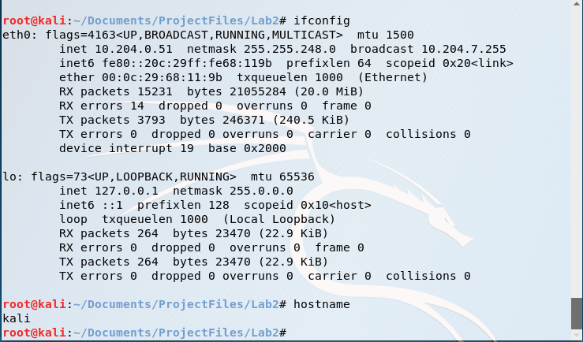

1. Using ping, determine if your partner’s workstation is up. Is your partner’s workstation up?

* My partner’s workstation is working because I received responses back from 10.204.0.51  
  because all packets sent were received.

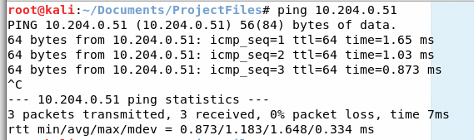

1. Using tracert, determine the number of hops between your two machines. How many hops are there between the two computers?

* 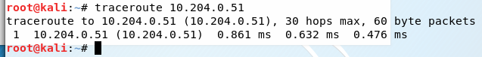There is one hop between the two computers.

1. Perform a network sweep using arp-scan to identify potential targets/IPs quickly.

What type of packet is the tool sending? Provide a Wireshark screenshot showing some of the captured packets.

How many IPs did the tool discover?

Did the tool scan sequentially? What does the third column represent, and how is that information learned?

* The packets sent are link-layer ARP broadcasts, sent from my machine at 10.204.0.68.

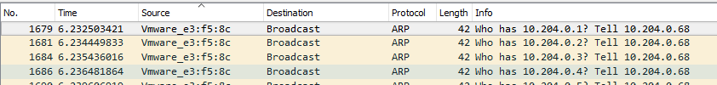

* The tool discovered 56 hosts (it received 56 responses) out of 2048 hosts scanned.



* The tool scanned sequentially, incrementing the target IP by one each iteration. As shown above boxed in yellow, the first packet was to 10.204.0.1, followed by 10.204.0.2, etc.
* The third column of the arp-scan contains the manufacturer(s) details, shown in the arp-scan result below. This information is learned by analyzing the first 3 bytes of the MAC address shown in column 2.

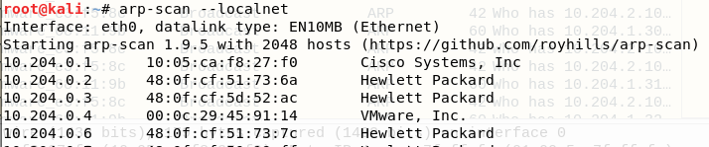

**Nmap**

1. Blackhat: Start Wireshark and perform a SYN scan using nmap or zenmap. Use aggressive timing and turn on verbose output. You may add other options as needed to provide the following information about the target. Using just the nmap results, answer the following questions; in other words, you cannot ask your partner for the name of his/her machine.
   1. What nmap command did you use? Describe all options used and how they affect the scan.

* The nmap command is shown below, boxed in red.
* -sS is a SYN scan
* -T4 indicates aggressive timing
* -A enables all advanced/aggressive options
* -v -v sets the verbosity level to 2
* 10.204.0.26 is the target’s IP address.
  1. Which ports are open? Provide a screenshot.  
     There are 6 open ports:
  2. What services are being offered? Spell out all acronyms.
* msrpc – Microsoft remote procedure call
* netbios-ssn – NETBIOS session service
* Microsoft-ds – Microsoft directory services
* ssl/vmware-auth – secure sockets layer, vmware-authorization
* vmware-auth – vmware authorization
* postgresql - PostgreSQL is a open source object-relational database system  
  1. What is the MAC address?
* The MAC address is 48:0F:CF:5D:52:C4
  1. What is the operating system?
* The operating system is Windows 10 Education 17134
  1. What is the hostname of the target (e.g., LISXP33LG)?
* The hostname is 2UA6241YKQ
  1. Look at the Wireshark data. During the scans, what type of packets did your workstation send to the target (i.e., which flags are set in the packets)?
* The packets are TCP packets with the SYN flag set.
  1. Select a port listed as open by nmap. How did the target respond for the open port? How did the Blackhat computer respond to the target’s response? Provide a screenshot of your filtered results. Useful filter: **tcp.port == <port #>**
* The target responded with a TCP SYN-ACK packet
* The Blackhat computer responded with an TCP ACK packet, completing the 3-way handshake  
  1. Select a port listed as closed by nmap. How did the target respond for the closed port? Provide a screenshot of your filtered results.
* The target responded with a TCP RST-ACK packet, indicating the target was not expecting the packet.
  1. Were the ports scanned sequentially?
* No, the ports were not scanned sequentially.

1. Now try nmap’s decoy feature.  
   Blackhat: Start Wireshark and run a SYN scan against ports 1-500 with decoy addresses of **2.2.2.2, 3.3.3.3, <<your real IP>>, 4.4.4.4**. Note there is no space between those addresses, just a comma. Also set your source port number to 999.
   1. Provide a screenshot of the Wireshark screen demonstrating the decoy and real IP addresses along with the 999 port number.
   2. Describe how the use of decoys is different than nmap’s idle scanning.
   3. Inspect the Wireshark output of your decoy scan. Describe when and how many decoys are sent per real packet.
2. Scan the IP addresses 10.1.0.1 through 10.1.0.20 looking just for FTP, SSH, or web servers. In the interest of time, I suggest running a simple SYN scan using aggressive timing without OS or version detection. Provide a screenshot showing the topology map generated by nmap. Ensure the text is readable. You may want to uncheck the hostname option in the controls panel to remove the clutter; displaying just IP addresses is fine.

**Shares**

Both team members perform the following, but only provide answers from one member. Provide a screenshot of your results.

Using a command shell, answer the following:

1. List all (including hidden) shares offered on your local machine.
2. List the users on your local machine.
3. List the account settings on your local machine.
4. Using Server Message Block (SMB) and Windows Explorer, connect to the machine called SMB#.m4i.local where # is your team number. Provide screenshots of the windows/commands used. Which folders are being shared? What transport protocol and port is the SMB server using? Provide a Wireshark screenshot of your computer using the protocol and port listed; filter your Wireshark capture to only include frames involved. What is the secret message found on the target?

**Extended Reconnaissance and Scanning:**

1. The Air Force has developed a new cyber attack tool. Your assignment is to find the phrase used to activate the tool. This phrase is contained in a file with a name starting with “flag”. In answering each step, provide detailed instructions or commands used as well as screenshots for each step. In order to actually view the file, you are only authorized to use a command shell; you may not use any other Windows utilities like Windows Explorer. At this point in the course, I do not expect you to crack passwords; therefore, I provide the following hints:

* This computer is on the same subnet as SMB#.m4i.local computers.
* Users are lazy and often use a password that is the same as their username or one of the top 10 worst passwords.
* The cyber attack tool installation process created a listening socket on TCP/33333.
* The following accounts are typical for Windows systems are not of interest for this lab: Administrator, Guest, HelpAssistant, and any account with “Support” in the name.
  1. What is the name, IP address, and operating system (and version) of this mysterious computer?
  2. Identify shares on this machine. Provide a screenshot of your results.
  3. Find the secret phrase contained in the file located in the shared folder. List the exact instructions you used to find your answer. Provide a screenshot showing the phrase.

**General Observations:**

How long did it take you to complete the lab?

Was it an appropriate length lab?

What corrections and or improvements do you suggest for this lab? Please be very specific, and if you add new material, provide the exact wording and instructions you would give to future students in the new lab handout. You may cross out and edit the text of the lab on previous pages to make minor corrections/suggestions.