**Software Requirement Specification (SRS)**

**Business Area:**

**Recruitment Information System (RIS)**

**Creation/ Modification History Record Card**

|  |  |  |  |  |  |
| --- | --- | --- | --- | --- | --- |
| **Sl.** | **Date** | **Version** | **Description** | **Changed by** | **Approved/Reviewed by** |
| 1 | 25 Aug. 2015 | 1 | Release 1 | Bibi Zoynob Tumpa |  |
| 2 | 19 Sept. 2015 | 2 | Release 2 | Bibi Zoynob Tumpa |  |
| 3 | 2nd Oct. 2015 | 3 | Modified | Bibi Zoynob Tumpa | Reviewed By: Mozammel Bin Motalab |
| 4 | 6th Dec. 2015 | 4 | Modified  Activity Added and Marge. | Taukir Hasan |  |



**COPYRIGHT NOTICE**

Copyright **©** LEADS Corporation Limited. All rights reserved.

This document is confidential and proprietary to LEADS Corporation Limited. Without limiting the rights under copyright, no part of this document may be reproduced, stored in or introduced into a retrieval system, or transmitted in any form or by any means (electronic, mechanical, photocopying, recording, or otherwise), or be used to make a derivative work (such as translation or adaptation), or be disclosed to third parties, or for any purpose, without the express written permission of LEADS Corporation Limited.

Complying with all applicable copyright laws is the responsibility of the user.

The names of companies and products mentioned herein may be the trademarks of their respective owners.

**Table of Contents**

1 Introduction 4

1.1 Purpose 4

1.2 Business Activity List 4

2 Business Activity Description 4

2.1 Create New Vacancy Notice 4

2.1.1 Description 4

2.1.3 Business Flow 4

2.1.4 Solution of Activity 5

2.2 Job View 7

2.2.1 Description 7

2.2.2 Actor List 7

2.2.3 Business Flow 8

2.2.4 Solution of Activity 8

2.3 Online Application 9

2.3.1 Description 9

2.3.2 Actors 9

2.3.3 Business flow: 9

2.3.4 Solution of activity 9

2.4 Select for written exam -> SMS & Mail to beneficiary 17

2.4.1 Description 17

2.4.2 Actor List 17

2.4.3 Business Flow: 17

2.4.4 Solution of Activity 17

2.5 Select for the VIVA-> SMS & Mail 19

2.5.1 Description 19

2.5.2 Actor List 19

2.5.3 Business Flow: 19

2.5.4 Solution of Activity 19

2.6 Appointment Latter (issue) 21

2.6.1 Description 21

2.6.2 Actor List 21

2.6.3 Business Flow: 21

2.6.4 Solution of Activity 21

2.7 Customize Recruitment Report 24

2.7.1 Description 24

2.7.2 Actor List 24

2.7.3 Business Flow: 24

2.7.4 Solution of Activity 24

# Introduction

## Purpose

The purpose of Recruitment Information System is to have Create New Vacancy Notice, Online Application, Select for the Exam -> SMS & Mail to beneficiary, Exam Information, Select for the VIVA -> SMS & Mail to beneficiary, Appointment Letter Print & SMS & Mail notification, Final Recruitment, Customize Recruitment Log/Report to maintain online recruitment activities & connect each other through a communication interface. BMET will have access to maintain recruitment information system through BMET MIS.

## Business Activity List

|  |  |  |
| --- | --- | --- |
| **SL#** | **Activity Code** | **Activity Name** |
| 1 | RIS-001-01 | Create New Vacancy |
| 2 | RIS-001-02 | Job Details View |
| 3 | RIS-001-03 | Online Application |
| 4 | RIS-001-04 | Applicant List |
| 5 | RIS-001-05 | Selection for Written Exam > SMS & Mail Notification |
| 6 | RIS-001-06 | Selection for VIVA > SMS & Mail Notification |
| 7 | RIS-001-06 | Appointment Letter (Issue) |
| 8 | RIS-001-08 | Report |

# Business Activity Description

## Create New Vacancy

### Description

Create new vacancy will be captured in Recruitment Information System from BMET Premises. It will contain each recruitment data like vacancy name, department name, designation name etc. System will allow only Authorized User and BMET Admin to access.

**2.1.2 Actor List**

* Authorized User
* BMET Admin

### 2.1.3 Business Flow



Figure: Business Flow Diagram

### Solution of Activity

#### Business Rules

|  |  |  |  |  |
| --- | --- | --- | --- | --- |
| **Rule Id** | **Rule Definition** | **Type of Rule**  <<Constraint, Computation, Fact, Action Enablers, Inferences >> | **Static / Dynamic** | **Source**  <<Corporate , Regulation>> |
| RIS-001-01-BR01 | Vacancy ID will follow its Unique convention that will be auto generated by the system. | Fact | Static | Corporate |
| RIS-001-01-BR02 | Job Nature will be fixed as ‘Full Time’. But sometimes it can be part time. | Fact | Static | Corporate |
| RIS-001-01-BR03 | Department name should be chosen from drop down list. | Fact | Static | Corporate |
| RIS-001-01-BR04 | Description will provide all information about the vacancy post. | Fact | Static | Corporate |
| RIS-001-01-BR05 | Any notice related to Vacancy can be uploaded and file size MAX 100KB. | Fact | Static | Corporate |

#### Prototype & Functional Requirement

RIS-001-01-PT1: Create New Vacancy

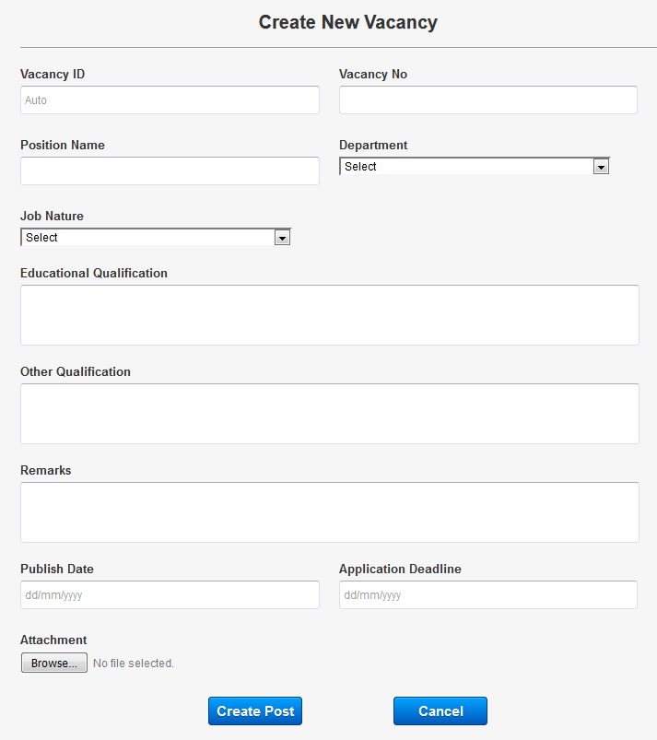

|  |  |  |
| --- | --- | --- |
| Business Activity Ref. | Business Activity Name | Business Rules Ref. |
| RIS -001-01 | Create New Vacancy |  |
|  |  |  |
| RIS -001-01-FR-01 | CNV.VAcancyId | System will generate the vacancy id automatically. |
| RIS -001-01-FR-02 | CNV.VacancyNo | User will input the vacancy number. |
| RIS -001-01-FR-03 | CNV.PositionName | User will input the position name. |
| RIS -001-01-FR-04 | CNV.Department | System will fetch the Department name from dropdown menu. |
| RIS -001-01-FR-05 | CNV.JobNature | System will fetch the Job Nature from dropdown menu. |
| RIS -001-01-FR-06 | CNV.EducationalQualification | User will Manually insert the educational qualification. |
| RIS -001-01-FR-07 | CNV.OtherQualification | User will Manually insert the other qualification. |
| RIS -001-01-FR-08 | CNV.Remarks | User will Manually insert the Remarks. |
| RIS -001-01-FR-09 | CNV.PublishDate | System will fetch the publish date automatically. |
| RIS -001-01-FR-10 | CNV.ApplicationDeadline | User will input the Deadline date in dd/mm/yyyy format. |
| RIS -001-01-FR-11 | CNV.Attachment | User will attach pdf or doc file MAX SIZE 100KB. |
| RIS -001-01-FR-12 | CNV.CreatePost | If user click this button, system will check all the mandatory fields are filled with necessary data. If all the information is correct then system will save all the information and notify user through a confirmation message otherwise notify user to enter the valid data. |
| RIS -001-01-FR-13 | CNV.Cancel | System can cancel any data if it’s approved by BMET Admin.  But if any dependencies exist, system will notify user. Say if user want to cancel information, then at first user has to cancel that information. |

## Job Details View

### Description

This section will View the Posted Job Details. BMET Admin, RIS Employee, Candidate and Others Stakeholder Can view The Job details.

### Actor List

* BMET Admin
* RIS Employee
* Candidate/Public
* Other Stakeholders

### Business Flow

Figure: Business Flow Diagram

### Solution of Activity

#### Business Rules

|  |  |  |  |  |
| --- | --- | --- | --- | --- |
| **Rule Id** | **Rule Definition** | **Type of Rule**  <<Constraint, Computation, Fact, Action Enablers, Inferences >> | **Static / Dynamic** | **Source**  <<Corporate , Regulation>> |
| RIS -001-02-BR01 | For BMET this Job Post will be visible to Job Portal and Candidate can apply by clicking apply button then he/she will redirect to Recruitment Registration Page. | Fact | Dynamic | Corporate |

#### Prototype & Functional Requirement

RIS-001-02**: Job View**

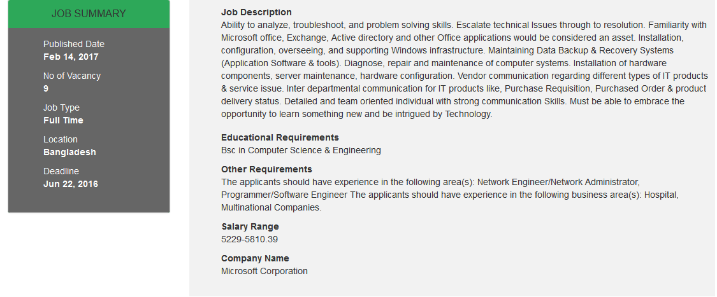

|  |  |  |
| --- | --- | --- |
| Business Activity Ref. | Business Activity Name | Business Rules Ref. |
| RIS -001-02 | Job Details View |  |
|  |  |  |
| RIS -001-02-FR-01 | JDV.Apply | If user click this button, System Allow user to apply for the job and redirect to the online application page. |

## Online Application

### Description

Applicants will be able to apply in online and must be inputted some information like name, father’s name, date of birth, educational qualification etc. System will allow to access authorized personnel only and some stakeholders.

### Actors

* Applicant/Candidate/Public
* Other Stakeholders

### Business flow:

Figure: Business Flow Diagram

### Solution of activity

#### Business Rules

|  |  |  |  |  |
| --- | --- | --- | --- | --- |
| **Rule Id** | **Rule Definition** | **Type of Rule**  <<Constraint, Computation, Fact, Action Enablers, Inferences >> | **Static / Dynamic** | **Source**  <<Corporate , Regulation>> |
| RIS -001-02-BR01 | National id number will follow its Unique convention. | Fact | Static | Corporate |
| RIS -001-02-BR02 | Online application will allow for all types of users who will qualify for the respected post. | Fact | Static | Corporate |
| RIS -001-02-BR03 | Quota should be 4 types like,   1. Children/grand-children of freedom fighters. 2. Tribal 3. Departmental 4. Others | Fact | Static | Corporate |
| RIS -001-02-BR04 | Photograph would be the passport size. | Fact | Static | Corporate |
| RIS -001-02-BR05 | Email address should follow unique key conventions. | Fact | Static | Corporate |
| RIS -001-02-BR06 | National id will be numeric field. If other character, then system will show a message. | Fact | Static | Corporate |
| RIS -001-02-BR07 | Applicants Registration No should be auto generate by the system. | Fact | Static | Corporate |

#### Prototype & Functional Requirements

RIS-001-03-PT-1: Online Application

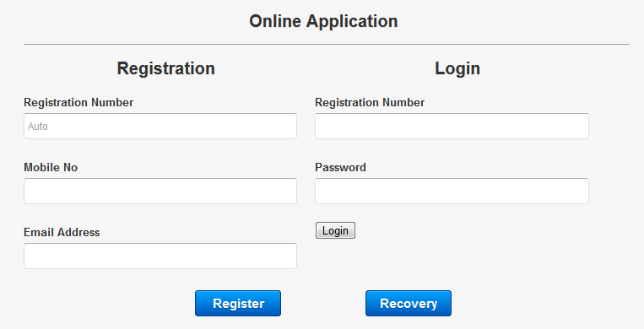

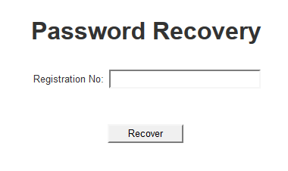

|  |  |  |
| --- | --- | --- |
| Business Activity Ref. | Business Activity Name | Business Rules Ref. |
| RIS -001-03 | Online Application > Registration > Login |  |
|  |  |  |
| Registration | | |
| RIS-001-03-FR-01 | OR.RegistrationNo | System will generate Registration No automatically after registration. |
| RIS-001-03-FR-02 | OR.MobileNo | Candidate will input his/her mobile no. |
| RIS-001-03-FR-03 | OR.Email | Candidate will input his/her email address with validation. |
| RIS-001-03-FR-04 | OR.Register | By Clicking this button System will generate a registration no and password for login automatically and send a notification to candidates mobile and email address. |
| Login | | |
| RIS-001-03-FR-05 | OL.RegistrationNo | Candidate will input his/her Registration No he/she has been provided after Registration. |
| RIS-001-03-FR-06 | OL.Password | Candidate will input his/her Password he/she has been provided after Registration. |
| RIS-001-03-FR-07 | OL.Login | By Clicking this button system will allow Candidate to access the Online Application Section if the Registration No & Password is correct. |
| RIS-001-03-FR-08 | OL.Recovery | By clicking this button Candidate will redirect to password recovery page. |
| Password Recovery | | |
| RIS-001-03-FR-09 | PR.RegistrationNo | Candidate will input his/her Registration No. |
| RIS-001-03-FR-10 | PR.Recover | If any Candidate forgot his/her password he/she can recover his/her password by providing Registration No. |

RIS-001-03-PT2: General Information

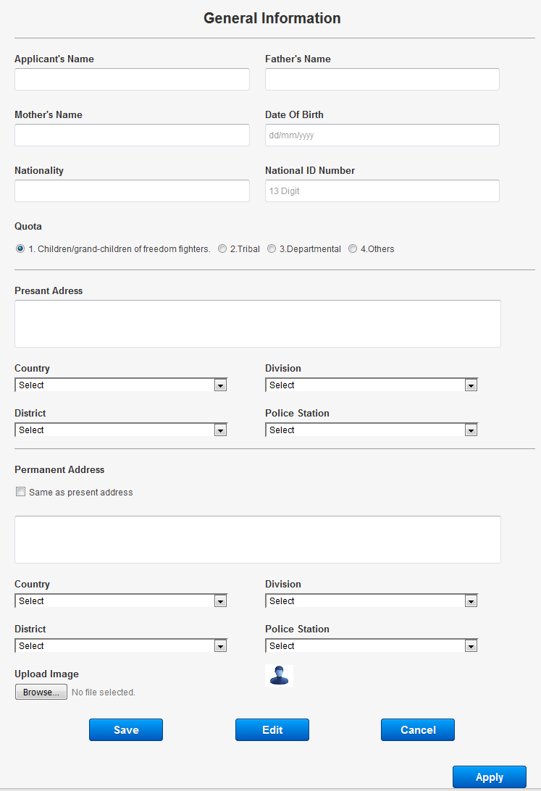

|  |  |  |
| --- | --- | --- |
| Business Activity Ref. | Business Activity Name | Business Rules Ref. |
| RIS -001-03 | Online Application |  |
|  |  |  |
| General Information | | |
| RIS -001-03-FR-01 | GI .ApplicantsName | User will input the applicant name. |
| RIS -001-03-FR-02 | GI .Father’sName | User will input the applicant father’s name. |
| RIS -001-03-FR-03 | GI .Mother’sName | User will input the applicant mother’s name. |
| RIS -001-03-FR-04 | GI .DateOfBirth | User will Input the date of birth with the given format. |
| RIS -001-03-FR-05 | GI .Nationality | System will fetch the nationality. |
| RIS -001-03-FR-06 | GI.NationalIdNo | User will input the national id number. NID must be 13>NID<17 |
| RIS -001-03-FR-07 | GI .PresentAddress | User will input the present address. |
| RIS -001-03-FR-08 | GI.Country | System will fetch the country from dropdown menu. |
| RIS -001-03-FR-09 | GI.Division | System will fetch the division from dropdown menu Respective to Country |
| RIS -001-03-FR-10 | GI.District | System will fetch the district from dropdown menu respective to division |
| RIS -001-03-FR-11 | GI.PoliceStation | System will fetch the police station from dropdown menu respective to district |
| RIS -001-03-FR-12 | GI.PermanentAddress | User will input the permanent address. |
| RIS -001-03-FR-13 | GI.SameAsPresentAddress | If User will check this checkbox Permanent Address will be same as present Address. |
| RIS -001-03-FR-14 | GI.Country | System will fetch the country from dropdown menu. |
| RIS -001-03-FR-15 | GI.Division | System will fetch the division from dropdown menu Respective to Country |
| RIS -001-03-FR-16 | GI.District | System will fetch the district from dropdown menu. Respective to division |
| RIS -001-03-FR-17 | GI.PoliceStation | System will fetch the police station from dropdown menu Respective to district |
| RIS -001-03-FR-18 | GI.UploadImage | Image size cannot be more than 50kb. |
| RIS -001-03-FR-19 | GI.Save | If user click this button, system will check all the mandatory fields are filled with necessary data. If all the information is correct then system will save all the information and notify user through a confirmation message otherwise notify user to enter the valid data. |
| RIS -001-03-FR-20 | GI.Edit | System will allow user to Update information by pressing Edit button.  During Edit operation required field to edit will be enabled and user can then edit the data. |
| RIS -001-03-FR-21 | GI.Cancel | System can cancel any data if it’s approved by BMET Admin.  But if any dependencies exist, system will notify user. Say if user want to cancel information, then at first user has to cancel that information. |
| RIS -001-03-FR-22 | GI.Apply | By click this button system allow user to apply this job if he/she inputted all required fields and tabs. |

RIS-001-03-PT3: Education Information

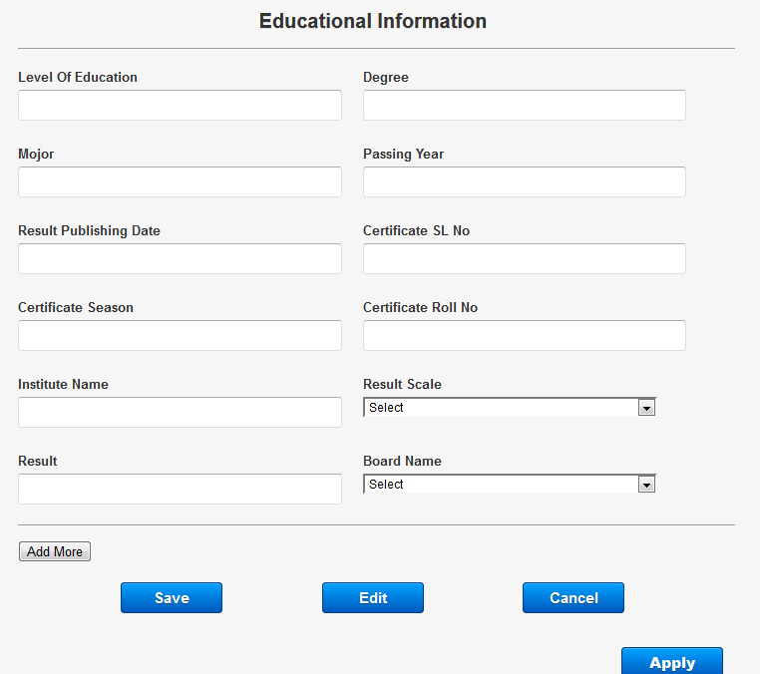

|  |  |  |
| --- | --- | --- |
| Educational Information | | |
| RIS -001-03-FR-23 | EI.LavelOfEducation | User will input name of level of education like S.S.C / H.S.C / Bachelor/Honors etc. |
| RIS -001-03-FR-24 | EI.Degree | User will input the degree |
| RIS -001-03-FR-25 | EI.Major | User will input the major subject |
| RIS -001-03-FR-24 | EI.PassYear | User will input the passing year of S.S.C / H.S.C / Bachelor/Honors. |
| RIS -001-03-FR-25 | EI.ResultPublishingDate | User will input the result date of S.S.C / H.S.C / Bachelor/Honors. |
| RIS -001-03-FR-26 | EI.Certificate.SlNo | User will input the serial no. along with achieved certification. |
| RIS -001-03-FR-27 | EI.Certificate.Session | User will input the certificate session. |
| RIS -001-03-FR-28 | EI.Certificate.RollNumber | User will input the roll number from the certificate. |
| RIS -001-03-FR-29 | EI.InstituteName | User will input the institution name. |
| RIS -001-03-FR-29 | EI.ResulScale | System will fetch the result scale from dropdown menu |
| RIS -001-03-FR-30 | EI.Result | User will input the Result. |
| RIS -001-03-FR-31 | EI.BoardName | System will fetch the board name from dropdown menu. |
| RIS -001-03-FR-32 | EI.AddMoreButton | By Clicking this Button user can add more educational information. |
| RIS -001-03-FR-33 | EI.Save | If user click this button, system will check all the mandatory fields are filled with necessary data. If all the information is correct then system will save all the information and notify user through a confirmation message otherwise notify user to enter the valid data. |
| RIS -001-03-FR-34 | EI.Edit | System will allow user to Update information by pressing Edit button.  During Edit operation required field to edit will be enabled and user can then edit the data. |
| RIS -001-03-FR-35 | EI.Cancel | System will allow BMET Admin user to refresh the form in case of consecutive information check.  Or in case of refreshing the page, user can press Cancel button. |
| RIS -001-03-FR-29 | EI.Apply | By click this button system allow user to apply this job if he/she inputted all required fields and tabs. |

RIS-001-03-PT3: Experience Information

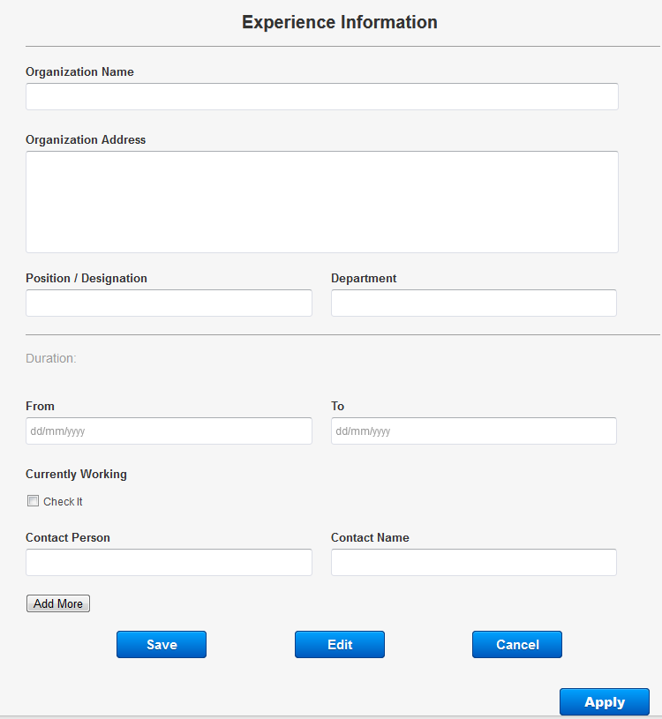

|  |  |  |
| --- | --- | --- |
| Experience Information | | |
| RIS -001-03-FR-36 | ExInfo.OrganizationName | User will input the organization name. |
| RIS -001-03-FR-37 | ExInfo.OrganizationAddress | User will input the organization address. |
| RIS -001-03-FR-38 | ExInfo.Designation | User will input the designation. |
| RIS -001-03-FR-29 | ExInfo.Department | User will input the Department. |
| RIS -001-03-FR-39 | ExInfo.Duration | User will input the duration. |
| RIS -001-03-FR-40 | ExInfo.Duration.From | User will input the duration start date. |
| RIS -001-03-FR-41 | ExInfo.Duration.To | User will input the duration ending date. |
| RIS -001-03-FR-42 | ExInfo.CurrentlyWorking | If user click this option then no need to feel up ending date. |
| RIS -001-03-FR-43 | ExInfo.ContactPerson | User will input the contact person |
| RIS -001-03-FR-44 | ExInfo.ContactName | User will input the contact name |
| RIS -001-03-FR-45 | ExInfo.AddMoreButton | By Clicking this Button user can add more educational information. |
| RIS -001-03-FR-46 | ExInfo.Save | If user click this button, system will check all the mandatory fields are filled with necessary data. If all the information is correct then system will save all the information and notify user through a confirmation message otherwise notify user to enter the valid data. |
| RIS -001-03-FR-47 | ExInfo.Edit | System will allow BMET Admin user to refresh the form in case of consecutive information check.  Or in case of refreshing the page, user can press Cancel button. |
| RIS -001-03-FR-48 | ExInfo.Cancel | System can cancel any data if it’s approved by BMET Admin.  But if any dependencies exist, system will notify user. Say if user want to cancel information, then he/she will able to cancel information. |
| RIS-001-03-FR-49 | ExInfo.Apply | By click this button system allow user to apply this job if he/she inputted all required fields and tabs. |

RIS-001-03-PT4: Training Information

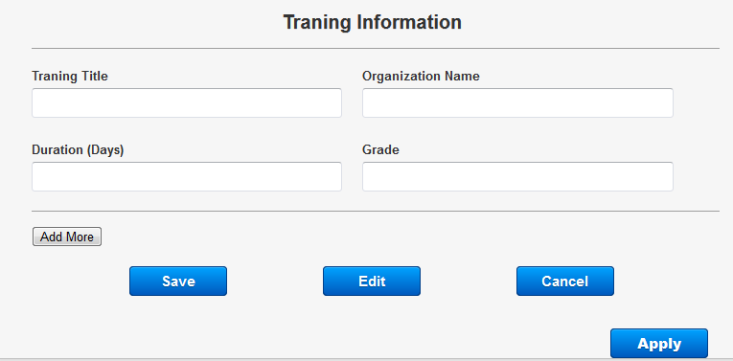

|  |  |  |
| --- | --- | --- |
| Training Information | | |
| RIS -001-03-FR-49 | TI.TraningTitle | User will input the name of the training. |
| RIS -001-03-FR-50 | TI.TrainingOrganizationName | User will input the name of the training organization. |
| RIS -001-03-FR-51 | TI.Duration | User will input the duration of training in days. |
| RIS -001-03-FR-52 | TI.Grade | User will input the grade or result of the training. |
| RIS -001-03-FR-53 | TI.AddMoreButton | By Clicking this Button user can add more educational information. |
| RIS -001-03-FR-54 | TI.Save | If user click this button, system will check all the mandatory fields are filled with necessary data. If all the information is correct then system will save all the information and notify user through a confirmation message otherwise notify user to enter the valid data. |
| RIS -001-03-FR-55 | TI.Edit | System will allow user to Update information by pressing Edit button.  During Edit operation required field to edit will be enabled and user can then edit the data. |
| RIS -001-03-FR-56 | TI.Cancel | System will allow BMET Admin user to refresh the form in case of consecutive information check.  Or in case of refreshing the page, user can press Cancel button. |
| RIS-001-03-FR-57 | TI.Apply | By click this button system allow user to apply this job if he/she inputted all required fields and tabs. |

## Applicant List

### Description

In this section Only BMET Admin and Authorized user will see the Applicant/Candidate List by posted Vacancy wise. System will allow only the BMET Admin and some stakeholders to access this information.

### Actor List

* Authorized User
* BMET Admin

### Business Flow:

Figure: Business Flow Diagram

### Solution of Activity

#### Business Rules

|  |  |  |  |  |
| --- | --- | --- | --- | --- |
| **Rule Id** | **Rule Definition** | **Type of Rule**  <<Constraint, Computation, Fact, Action Enablers, Inferences >> | **Static / Dynamic** | **Source**  <<Corporate , Regulation>> |
| RIS-001-04-BR01 | BMET Admin can view job wise candidate list with their details view. | Fact | Static | Corporate |
| RIS-001-04-BR02 | Authorized User will able to reject an application. | Fact | Static | Corporate |

#### Prototype & Functional Requirement

RIS-04: Applicant List

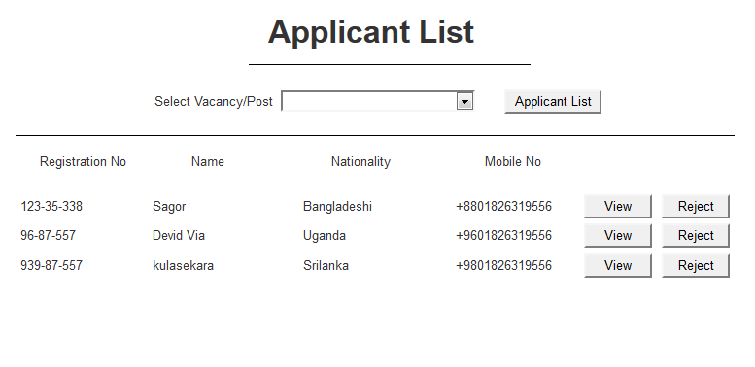

|  |  |  |
| --- | --- | --- |
| Business Activity Ref. | Business Activity Name | Business Rules Ref. |
| RIS-001-04 | Applicant List |  |
|  |  |  |
| RIS -001-04-FR-01 | AL.VacancyPost | User will select Vacancy/Post from dropdown. |
| RIS -001-04-FR-02 | AL.ApplicantList | By Clicking this button System will generate all the candidate list respected to selected Vacancy/Post. |
| RIS -001-04-FR-03 | AL.View | By clicking this button user will able to view the details of the candidate. |
| RIS -001-04-FR-04 | AL.Reject | By clicking this button user will able to reject any candidate from that specific post. |

## Selection for written exam -> SMS & Mail

### Description

This section will send sms/mail to an applicant as confirmation for written exam. System will allow only the BMET Admin and some stakeholders to access this information.

### Actor List

* Authorized User
* BMET Admin

### Business Flow:

Figure: Business Flow Diagram

### Solution of Activity

#### Business Rules

|  |  |  |  |  |
| --- | --- | --- | --- | --- |
| **Rule Id** | **Rule Definition** | **Type of Rule**  <<Constraint, Computation, Fact, Action Enablers, Inferences >> | **Static / Dynamic** | **Source**  <<Corporate , Regulation>> |
| RIS-001-05-BR01 | When an applicants will be selected for the written exam, then he/she will be notified by SMS/email. Only BMET Admin can access this. | Fact | Static | Corporate |
| RIS-001-05-BR02 | Authorized User will able to approve/reject an application. | Fact | Static | Corporate |

#### Prototype & Functional Requirement

**RIS-05:** Selection for written exam -> SMS/Mail

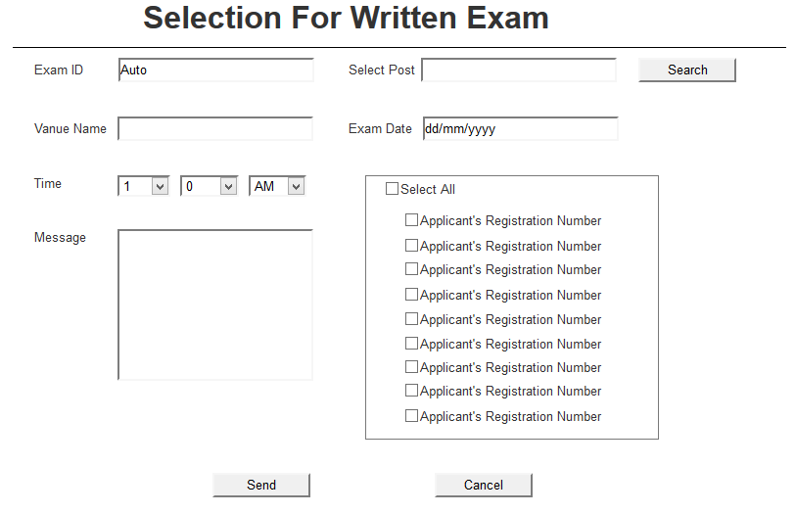

|  |  |  |
| --- | --- | --- |
| Business Activity Ref. | Business Activity Name | Business Rules Ref. |
| RIS-001-05 | Selection for Written exam > SMS/Mail |  |
|  |  |  |
| RIS -001-05-FR-01 | SFE.ExamID | System will fetch the Exam ID automatically. |
| RIS -001-05-FR-02 | SFE.SelectPost | User will select the post name from dropdown and search. |
| RIS -001-05-FR-03 | SFE.VenueName | User will input the venue name. |
| RIS -001-05-FR-04 | SFE.ExamDate | User will input the date with the given format. |
| RIS -001-05-FR-05 | SFE.Time | System will fetch the time from dropdown menu |
| RIS -001-05-FR-06 | SFE.Message | System will input the message regarding to exam. |
| RIS -001-05-FR-07 | SFE.SelectButton | This section will fill-up by respected post selection. User can select one/more or all by click this option |
| RIS -001-05-FR-08 | SFE.Send | System will send the confirmation message to the applicants. |
| RIS -001-05-FR-09 | SFE.Cancel | System will allow BMET Admin user to refresh the form in case of consecutive information check.  Or in case of refreshing the page, user can press Cancel button. |

## Selection for VIVA-> SMS & Mail

### Description

Selected applicants for VIVA will be informed by SMS & Mail from the system. System will allow only BMET Admin and Authorized User to access it.

### Actor List

* BMET Admin
* Authorized User

### Business Flow:

### Solution of Activity

#### Business Rules

|  |  |  |  |  |
| --- | --- | --- | --- | --- |
| **Rule Id** | **Rule Definition** | **Type of Rule**  <<Constraint, Computation, Fact, Action Enablers, Inferences >> | **Static / Dynamic** | **Source**  <<Corporate , Regulation>> |
| RIS -001-06-BR01 | An applicants will receive a confirmation SMS and email if he/she will selected for the VIVA. | Fact | Static | Corporate |
| RIS -001-06-BR02 | Selection for the viva will be allowed for only BMET Admin. | Fact | Static | Corporate |
| RIS -001-06-BR03 | Message will provide the date, time and venue of VIVA. | Fact | Static | Corporate |

#### Prototype & Functional Requirements

**RIS-05: Selection for Viva**

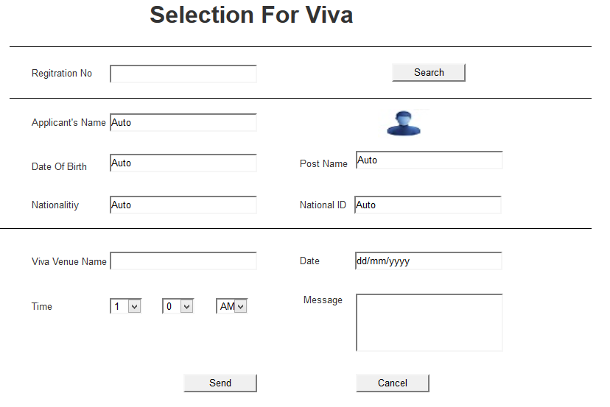

|  |  |  |
| --- | --- | --- |
| Business Activity Ref. | Business Activity Name | Business Rules Ref. |
| RIS-001-06 | Selection for VIVA -> SMS/Mail |  |
|  |  |  |
| RIS -001-06-FR-01 | SFV.RegistrationNo | User will input registration number and search. |
| RIS -001-06-FR-02 | SFV.ApplicantsName | System will fetch the applicant’s name automatically. |
| RIS -001-06-FR-03 | SFV. ApplicantsImage | System will fetch the Applicants image automatically. |
| RIS -001-06-FR-04 | SFV.DateOfBirth | System will fetch the Applicants date of birth automatically. |
| RIS -001-06-FR-05 | SFV.PostName | System will fetch the post name automatically. |
| RIS -001-06-FR-06 | SFV.Nationality | System will fetch the nationality automatically. |
| RIS -001-06-FR-07 | SFV.NationalID | System will fetch the national id No automatically. |
| RIS -001-05-FR-08 | SFV.VivaVenueName | User will input viva venue name |
| RIS -001-05-FR-08 | SFV.Date | User will input viva date with the given format |
| RIS -001-05-FR-08 | SFV.Time | User will input viva time with the given format |
| RIS -001-05-FR-09 | SFE.Message | System will input the message regarding to viva. |
| RIS -001-05-FR-10 | SFV.Send | System will send the confirmation message to the applicants. |
| RIS -001-05-FR-11 | SFV.Cancel | System will allow BMET Admin user to refresh the form in case of consecutive information check.  Or in case of refreshing the page, user can press Cancel button. |

## Appointment Latter (issue)

### Description

Selected applicants will be informed by receiving an appointment letter and also informed by SMS & Mail from the system. System will allow only BMET Admin and specific Authorized User to access it.

### Actor List

* Authorized User
* BMET Admin

### Business Flow:

### Solution of Activity

#### Business Rules

|  |  |  |  |  |
| --- | --- | --- | --- | --- |
| **Rule Id** | **Rule Definition** | **Type of Rule**  <<Constraint, Computation, Fact, Action Enablers, Inferences >> | **Static / Dynamic** | **Source**  <<Corporate , Regulation>> |
| RIS -001-07-BR01 | An ID for appointment letter will be auto-generated by its unique conventions. | Fact | Static | Corporate |
| RIS -001-07-BR02 | Appointment letter must be controlled by the BMET Admin. | Fact | Static | Corporate |
| RIS -001-07-BR03 | A notification will be send to candidate automatically when an appointment letter issued. | Fact | Static | Corporate |

#### Prototype & Functional Requirements

RIS-07: Appointment Latter Issue

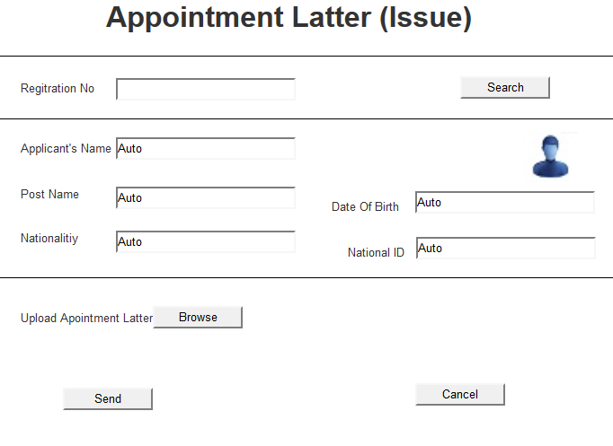

Figure: Appointment notification confirmed by mail.

|  |  |  |
| --- | --- | --- |
| Business Activity Ref. | Business Activity Name | Business Rules Ref. |
| RIS -001-07 | Appointment letter print- Mail |  |
|  |  |  |
| RIS -001-07-FR-01 | ALP.RegistrationNo | User will input the registration no and search. |
| RIS -001-07-FR-02 | ALP.ApplicantsName | System will fetch the applicant’s name automatically. |
| RIS -001-07-FR-03 | ALP.Image | System will fetch the applicant’s image automatically. |
| RIS -001-07-FR-04 | ALP.PostName | System will fetch the applicant’s post name automatically. |
| RIS -001-07-FR-05 | APL.DateOfBirth | System will fetch the applicant’s date of birth automatically. |
| RIS -001-07-FR-06 | APL.Nationality | System will fetch the applicant’s nationality automatically. |
| RIS -001-07-FR-07 | APL.NationalID | System will fetch the applicant’s national Id No automatically. |
| RIS -001-07-FR-08 | APL.UploadApointmentLatter | User will upload Appointment latter. |
| RIS -001-07-FR-09 | ALP. Send | If BMET Admin clicks the ‘Send Mail’ button, then a confirmation email will be sent to the applicants. |
| RIS -001-07-FR-10 | SFV.Cancel | System will allow BMET Admin user to refresh the form in case of consecutive information check.  Or in case of refreshing the page, user can press Cancel button. |

## Report

### Description

Customize recruitment report will contain the applicants list report, selected applicants report for exam, VIVA etc. System will allow only the BMET Admin and Authorized User to access this report.

### Actor List

* BMET Admin
* Authorized User

### Business Flow:

### Solution of Activity

#### Business Rules

|  |  |  |  |  |
| --- | --- | --- | --- | --- |
| **Rule Id** | **Rule Definition** | **Type of Rule**  <<Constraint, Computation, Fact, Action Enablers, Inferences >> | **Static / Dynamic** | **Source**  <<Corporate , Regulation>> |
| RIS -001-08-BR01 | BMET Admin can be searched by the keyword ‘Designation’, then he/she will be able to see all information about any recruitment. | Fact | Static | Corporate |
| RIS -001-08-BR02 | BMET Admin can be searched by the keyword ‘Date of Join’ and also will able to see the recruitment information as by the serial of date. | Fact | Static | Corporate |
| RIS -001-08-BR03 | BMET Admin can able to see the applicants list, selected applicants list for exam, selected applicants list for VIVA. | Fact | Static | Corporate |

#### Prototype & Functional Requirements

RIS-08: Report

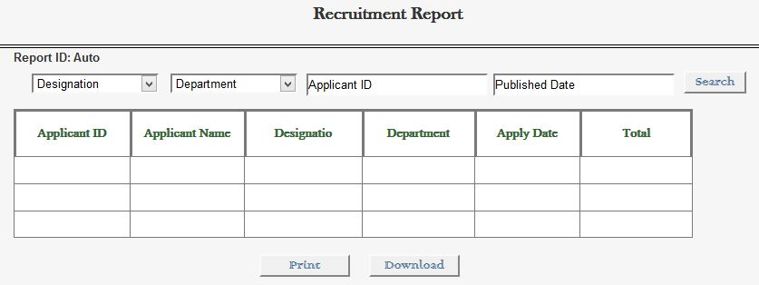

|  |  |  |
| --- | --- | --- |
| Business Activity Ref. | Business Activity Name | Business Rules Ref. |
| RIS -001-07 | Customize Recruitment Report |  |
|  |  |  |
| RIS -001-07-FR-01 | CRR..Download | System can delete any data if it’s approved by BMET Admin. |
| RIS -001-07-FR-02 | CRR..Print | System can print the final recruitment paper. |

**Report List:**

1. Vacancy Report
2. Post Report
3. Written Exam Report
4. Viva Report
5. Appointment Report
6. Applicant Report

**Document Sign Off**

|  |  |  |
| --- | --- | --- |
| Responsible Person of Client | *Name:* | *Signature* |
| *Designation:* | *Date* |
| Project Manager | *Name :* | *Signature* |
| *Designation:* | *Date* |