Validation and replication results report exercise
Minheng Chen, for Genan’s code
- Exercise instructions:
The goal of this exercise is to introduce you to the process of replication check, which some journals are already requiring. In addition, this should serve as a good reminder of what you should consider including in your own papers going forward! (at least in an appendix).
Based on your paired replication exercise, use this template to produce a (partial) replication report of your fellow trainee’s code. For the purposes of this training module, you may focus only on the highlighted sections, as you did not have to work through a paper to replicate the analyses.
This is an individual, self-paced exercise to be completed within a week. You can submit your work on Canvas and Dr. Gibson will provide feedback.

- Report template outline:
- Summary
- Data Description
  - Data sources
  - Analysis data files
- Data deposit
  - Requirements
  - Deposit metadata
- Data checks
  - Using 2016 Public Use Micro Files in Canada
  - Checking variables for the first 5 rows
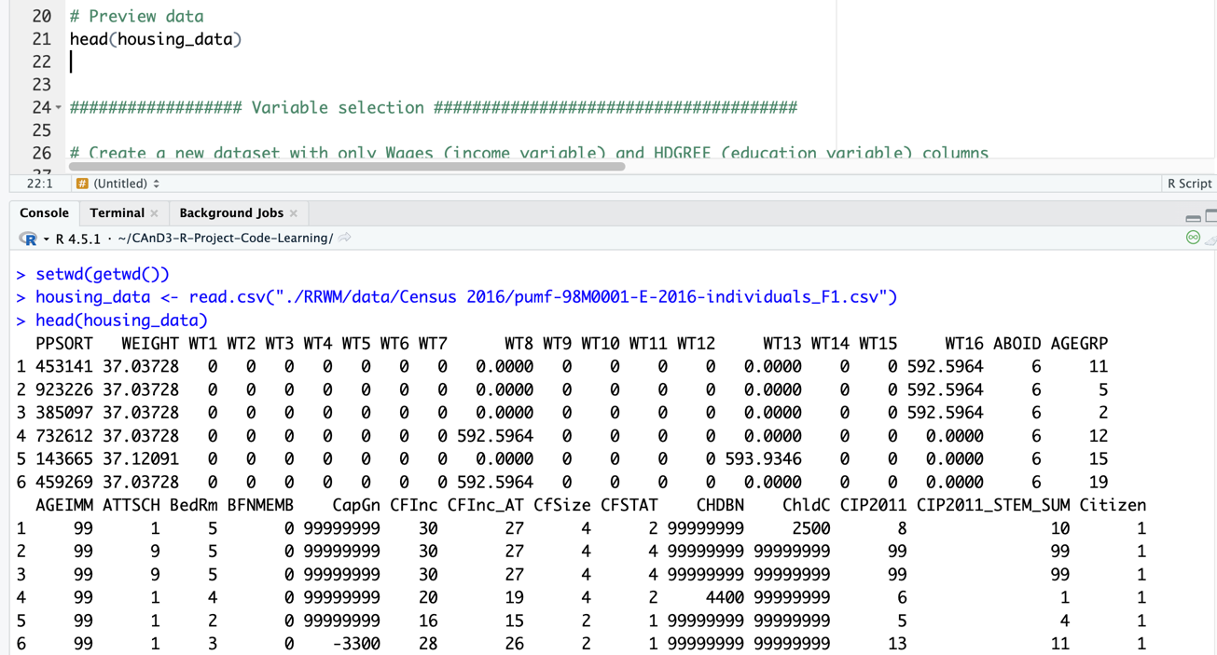
- Code description
- Stated requirements
- Missing requirements
  - Need to indicate the file path by relative path. The current code of loading data only indicate the file name.
- Computing environment of the replicator
- Replication steps
  - Download data
- Findings
  - Data Preparation Code
  - Tables
  - Figures
  - In-text numbers
- Classification
  - Reason for incomplete reproducibility
- Detailed template & instructions

SUMMARY
Replicator’s Computing Environment:
Software:
Edition: R version 4.5.1 (2025-06-13)
RStudio: 2025.8.0.357
R Package installed & used:
dplyr 1.1.4
summarytools 1.1.4
officer 0.7.0

Code testing summary:
Figure or table | Relevant program | Replicated (comments)
Descriptive statistics table | Genan Code_RRWM Data Activity_Housing,R.R | Yes
Regression summary table | Genan Code_RRWM Data Activity_Housing,R.R | Yes

Discrepancies: None

Data description
Data Sources
- Example data from https://onedrive.live.com/?redeem=aHR0cHM6Ly8xZHJ2Lm1zL3UvcyFBdVpHV1Z4bS02VzhnYUFfV3cwUWJjNTNQUkl3S0E%5FZT1FQVYwbHI&cid=BCA5FB665C5946E6&id=BCA5FB665C5946E6%2120543&parId=BCA5FB665C5946E6%2119719&o=OneUp, shared by CAnD3 program

Analysis Data Files
- No analysis data file mentioned
- Analysis data files mentioned, not provided (explain reasons below)
- Analysis data files mentioned, provided. File names listed below.

- Fully accessible through the link provided. https://github.com/genan-h/RRWM-Activity_CAnD-3-training.

  - Data file: pumf-98M0001-E-2016-individuals_F1.csv
- The file name could be simpler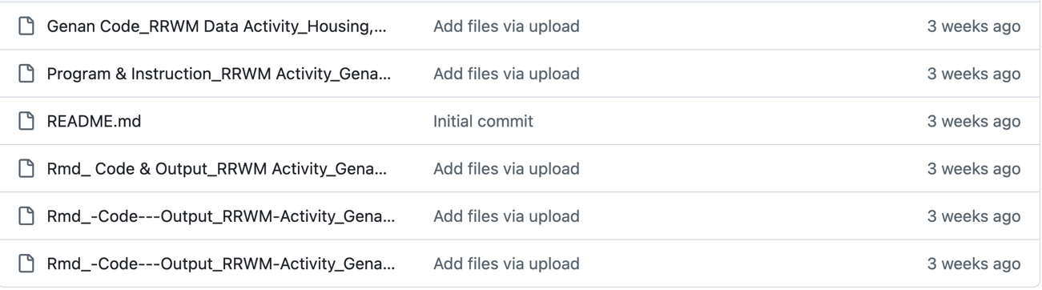
  - Output files are also available in RMarkdown file and html files. It seems that the author use two language two compile but I think one of them should be enough.
    - Rmd_ Code & Output_RRWM Activity_Genan.Rmd
    - Rmd_-Code---Output_RRWM-Activity_Genan (1).html
    - Rmd_-Code---Output_RRWM-Activity_Genan.html

Data deposit
- The author has clearly indicated that the data being used should be downloaded and save to the local path.Requirements
INSTRUCTIONS: Check that these requirements are met.
- README is in TXT, MD, PDF format
- openICPSR deposit has no ZIP files
- Title conforms to guidance (starts with "Data and Code for:" or "Code for:", is properly capitalized)
- Authors (with affiliations) are listed in the same order as on the paper

Deposit Metadata
- JEL Classification (required)
- Manuscript Number (required)
- Subject Terms (highly recommended)
- Geographic coverage (highly recommended)
- Time period(s) (highly recommended)
- Collection date(s) (suggested)
- Universe (suggested)
- Data Type(s) (suggested)
- Data Source (suggested)
- Units of Observation (suggested)

- Not applicable, as data was provided through cloud storage

Data checks
INSTRUCTIONS: When data are present, run checks:
- The data can be readily readed.
- Datasets are in CSV format
- The dataset does not have labels for variables

Code description
There are one coding file, including data cleaning and data analysis, named “Genan Code_RRWM Data Activity_Housing,R.R”.
- A table for descriptive statistics 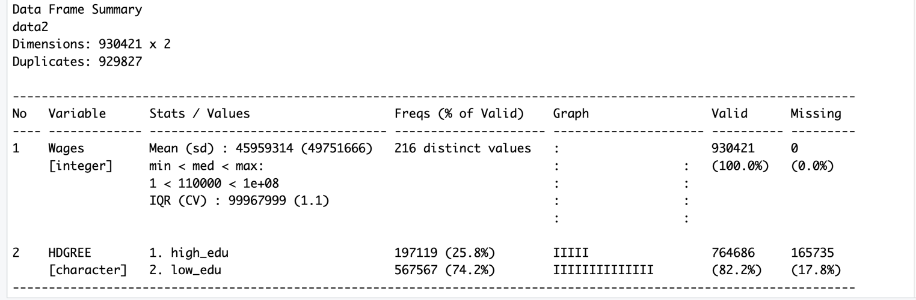
- A table for regression analysis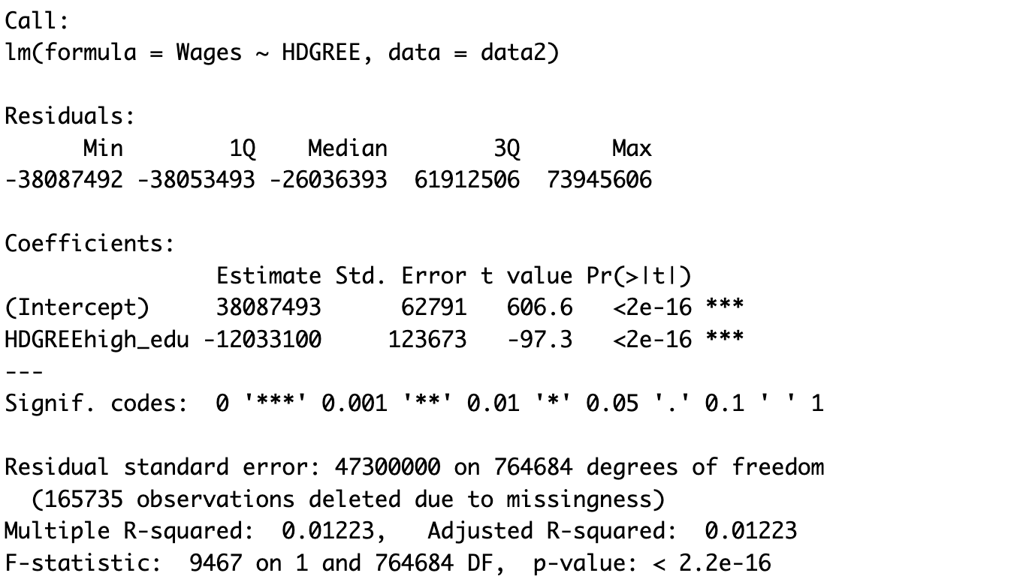
- Annotations in the code script clearly point out the production of descriptive table and the regression table

Stated Requirements
INSTRUCTIONS: The authors may have specified specific requirements in terms of software, computer hardware, etc. Please list them here. This is different from the Computing Environment of the Replicator. You have the option to amend these with unstated requirements later. If all requirements are listed, check the box "Requirements are complete".
- No requirements specified
- Software Requirements specified as follows:
  - Software 1
  - Software 2
- Computational Requirements specified as follows:
  - Cluster size, etc.
- Time Requirements specified as follows:
  - Length of necessary computation (hours, weeks, etc.)
- Requirements are complete.
- The author could include requirements for packages and versions of R/RStudio

Missing Requirements
- Software Requirements
  - Stata
    - Version
    - Packages go here
  - Matlab
    - Version
  - R
    - Version
    - R packages go here
  - Python
    - Version
    - Python package go here
  - REPLACE ME WITH OTHER
- Computational Requirements specified as follows:
  - Cluster size, disk size, memory size, etc.
- Time Requirements
  - Length of necessary computation (hours, weeks, etc.)
[REQUIRED] Please amend README to contain complete requirements.

Computing Environment of the Replicator
- Information of computing environment is missing

Replication steps
- Downloaded data per instructions from the readme.md file shown on the github page
- Downloaded auxiliary R code from the github repositories
- Changed directory setup inside “Genan Code_RRWM Data Activity_Housing,R.R” to match this system
- Ran the updated “Genan Code_RRWM Data Activity_Housing,R.R”
- Ran the descriptive analysis and the regression chunk in the R code

Findings
INSTRUCTIONS: Describe your findings both positive and negative in some detail, for each Data Preparation Code, Figure, Table, and any in-text numbers. You can re-use the Excel file created under Code Description. When errors happen, be as precise as possible. For differences in figures, provide both a screenshot of what the manuscript contains, as well as the figure produced by the code you ran. For differences in numbers, provide both the number as reported in the manuscript, as well as the number replicated. If too many numbers, contact your supervisor.

Data Preparation Code
- Variable selection chunk ran without error, output expected data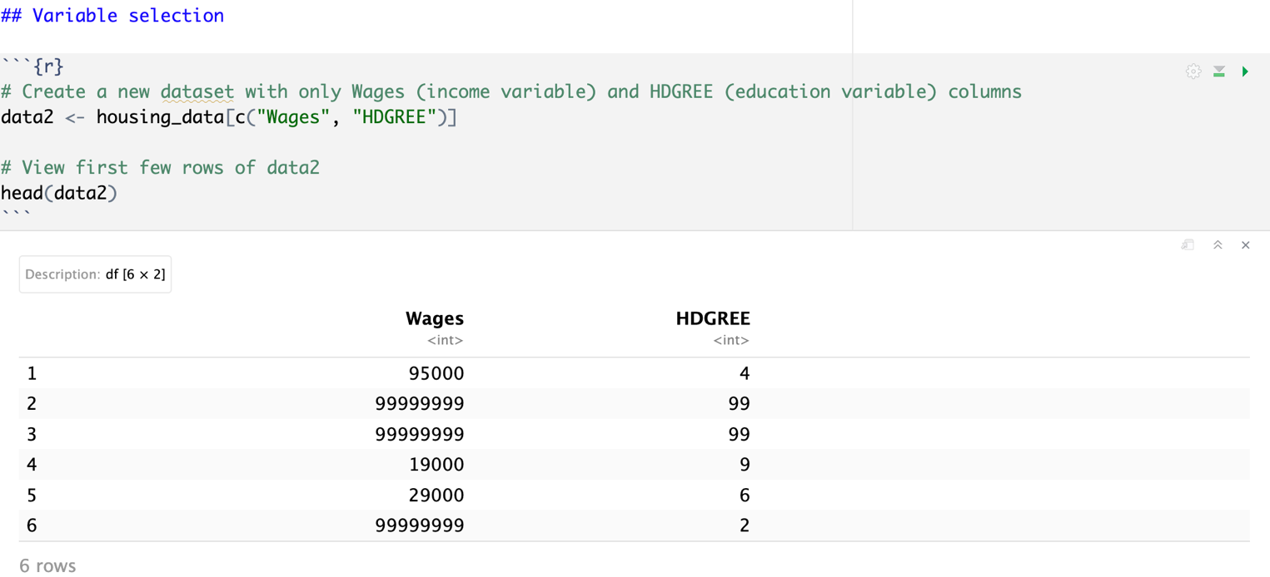
- Program 2-create-appendix-data.do failed to produce any output.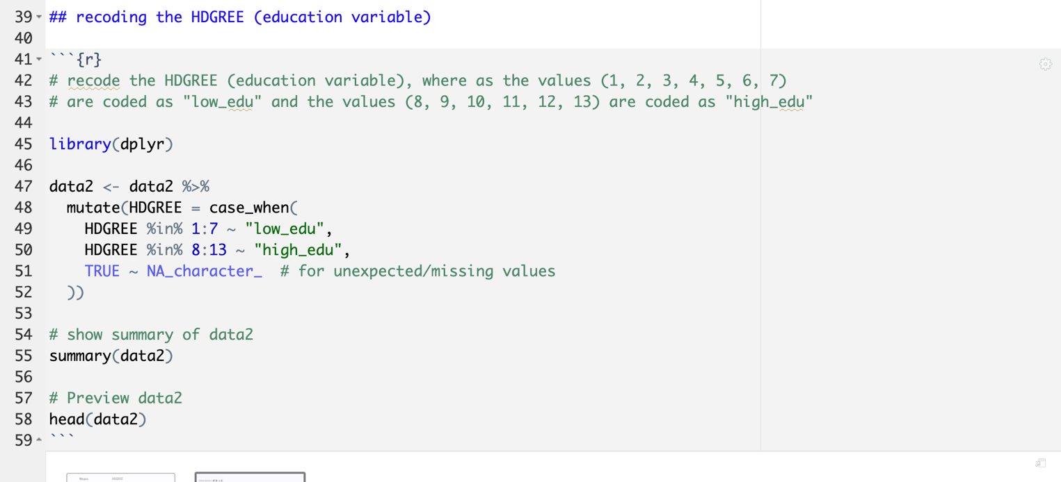

Tables
- Descriptive analysis chunk ran without error and return expected results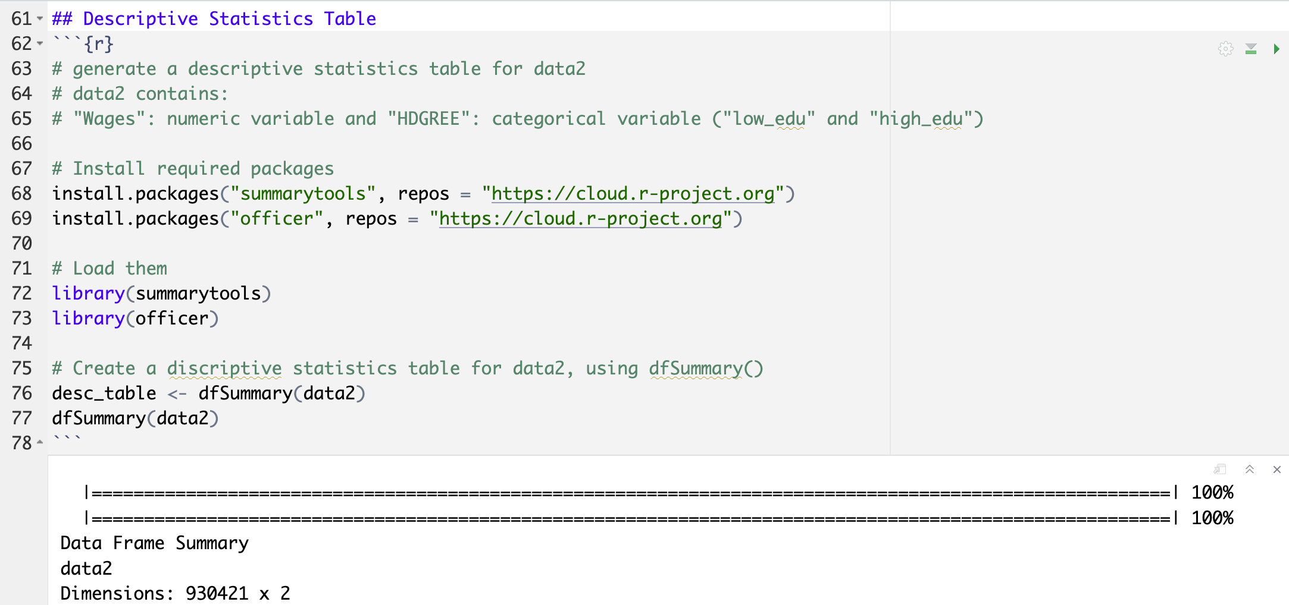
- Regression analysis chunk ran without error and return expected results, but the original markdown code missed ending mark “```” in the last line of the code chunk, which results in unexecuted chunk.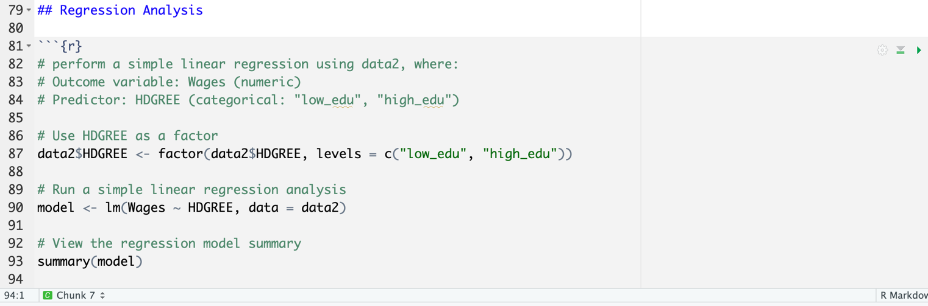
- After adding the ending mark
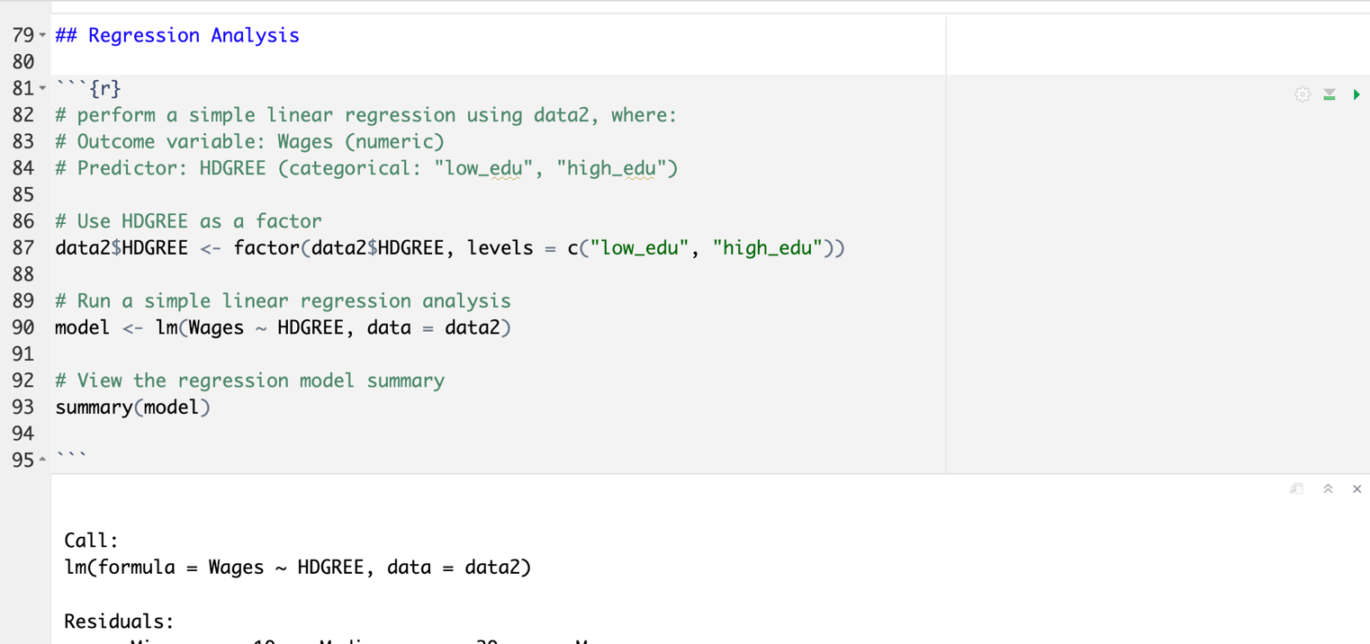
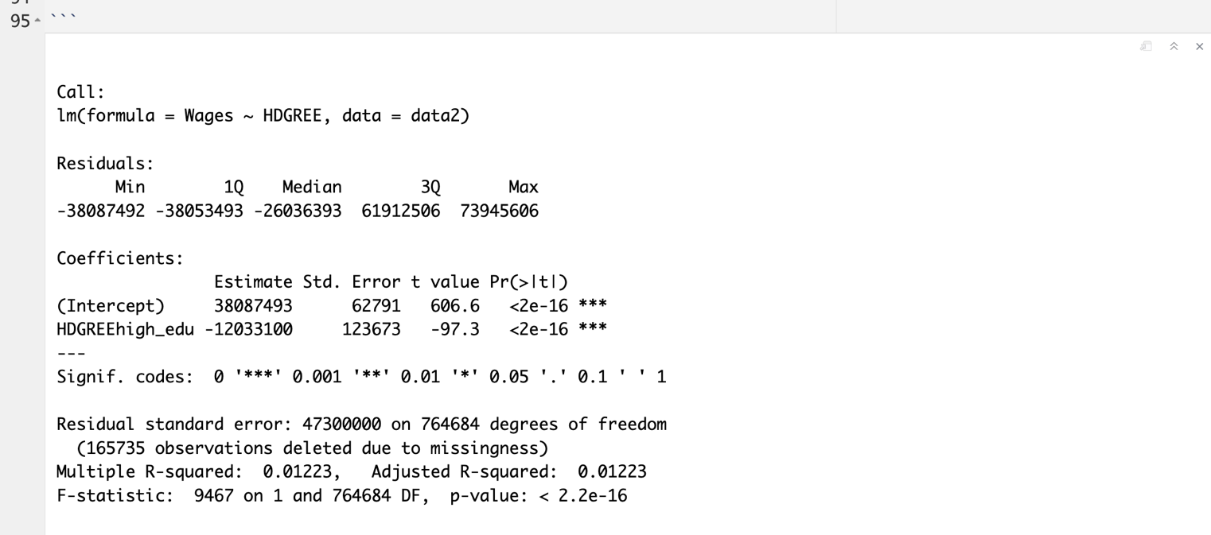

Classification
INSTRUCTIONS: Make an assessment here.
Full reproduction can include a small number of apparently insignificant changes in the numbers in the table. Full reproduction also applies when changes to the programs needed to be made, but were successfully implemented.
Partial reproduction means that a significant number (>25%) of programs and/or numbers are different.
Note that if any data is confidential and not available, then a partial reproduction applies. This should be noted in the Reasons
Note that when all data is confidential, it is unlikely that this exercise should have been attempted.
Failure to reproduce: only a small number of programs ran successfully, or only a small number of numbers were successfully generated (<25%)
- full reproduction
- full reproduction with minor issues
- partial reproduction (see above)
- not able to reproduce most or all of the results (reasons see above)

Reason for incomplete reproducibility
INSTRUCTIONS: mark the reasons here why full reproduciblity was not achieved, and enter this information in JIRA
- Discrepancy in output (either figures or numbers in tables or text differ)
- Bugs in code that were fixable by the replicator (but should be fixed in the final deposit)
- Code missing, in particular if it prevented the replicator from completing the reproducibility check
  - Data preparation code missing should be checked if the code missing seems to be data preparation code
- Code not functional is more severe than a simple bug: it prevented the replicator from completing the reproducibility check
- Software not available to replicator may happen for a variety of reasons, but in particular (a) when the software is commercial, and the replicator does not have access to a licensed copy, or (b) the software is open-source, but a specific version required to conduct the reproducibility check is not available.
- Insufficient time available to replicator is applicable when (a) running the code would take weeks or more (b) running the code might take less time if sufficient compute resources were to be brought to bear, but no such resources can be accessed in a timely fashion (c) the replication package is very complex, and following all (manual and scripted) steps would take too long.
- Data missing is marked when data should be available, but was erroneously not provided, or is not accessible via the procedures described in the replication package
- Data not available is marked when data requires additional access steps, for instance purchase or application procedure.

