TagVis survey results
Jul. 28 2021

Responses: 6 in total (4 full, 2 partial)

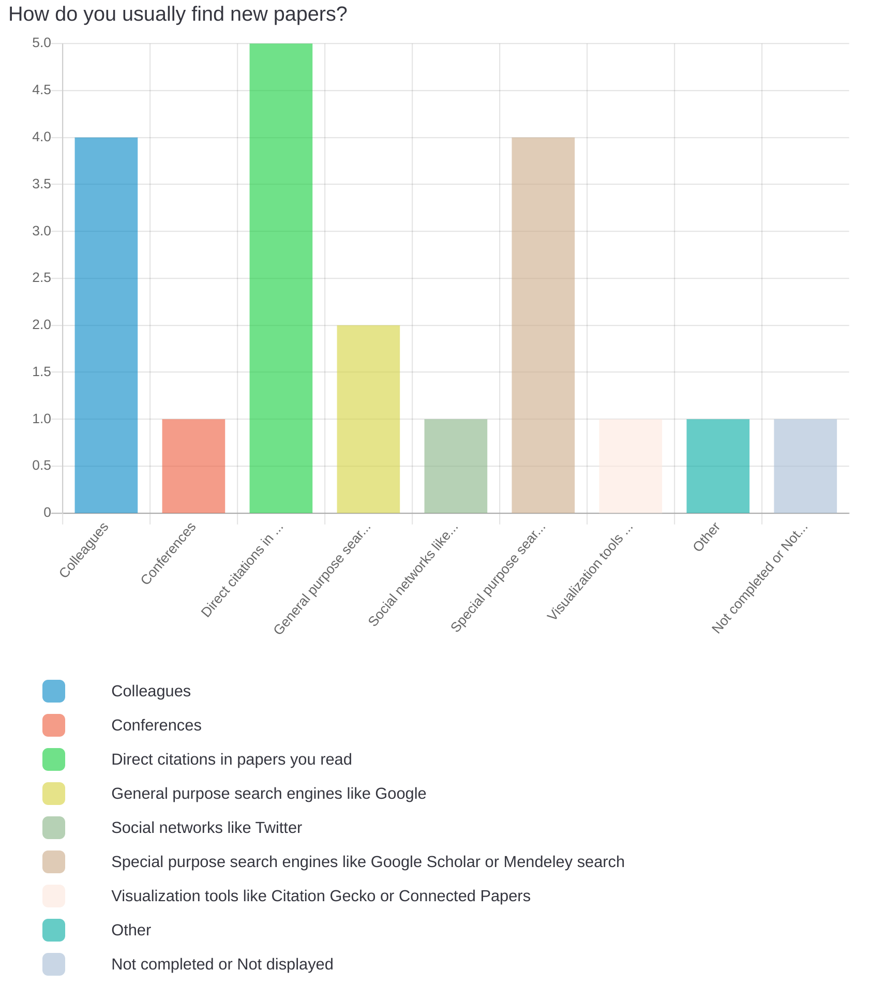
Other: Mailing list (1)

What could save you time when looking for new and interesting papers?
A big time-saver would be if the system "suggested" related/similar papers to a given one (or a set). I use the "cited by" feature on Google Scholar a lot but it is based on explicit citations - not on whether two papers are related in terms of content/theme/scope. With my current approach I potentially miss a whole bunch of closely related/relevant papers.
Another time saver would be to be able to "follow" / see the search results/papers of people who have done a similar search in the past. That is, to benefit from what other people have labelled as "relevant" or "important"
Suggestions and reader friendly summaries
proper full-text search
Being able to access them easily without going through five paywalls or authentication.
If relevant papers on the topic could be found easily, it saves time.

How do you decide whether a paper is worth reading or not?
Mainly from the abstract but also by looking at/skimming parts of the content, e.g. a method
overview figure if available
scanning the abstract for relevence, maybe the conclusion too.
- Reading abstract and conclusion
- looking at citations/connections to other relevant literature
I read the asbtract, then skim the paper. But I'm guilty of reading too much of a paper before deciding it's not interesting for me.
By reading the abstract, I decide whether a paper is worth reading or not.

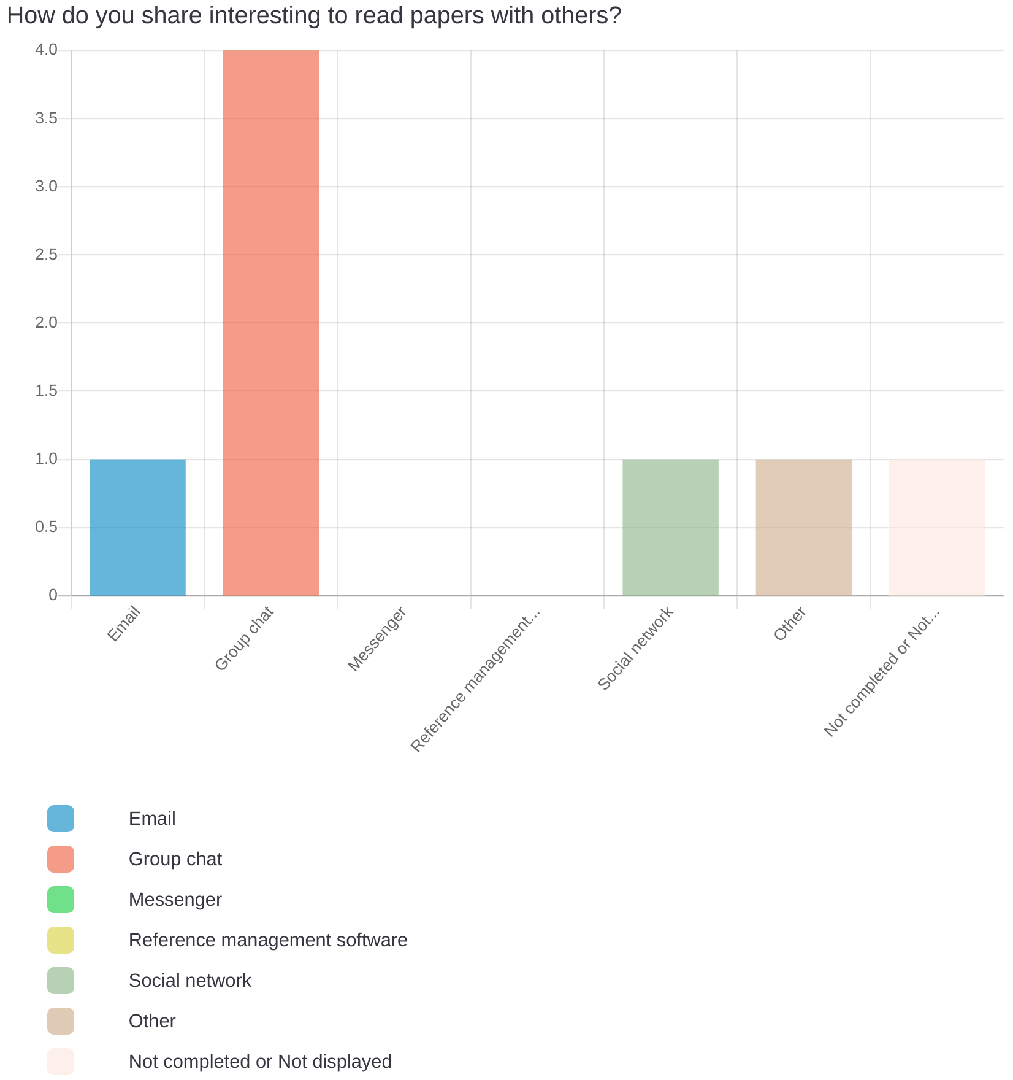
Other: Word of mouth (1)
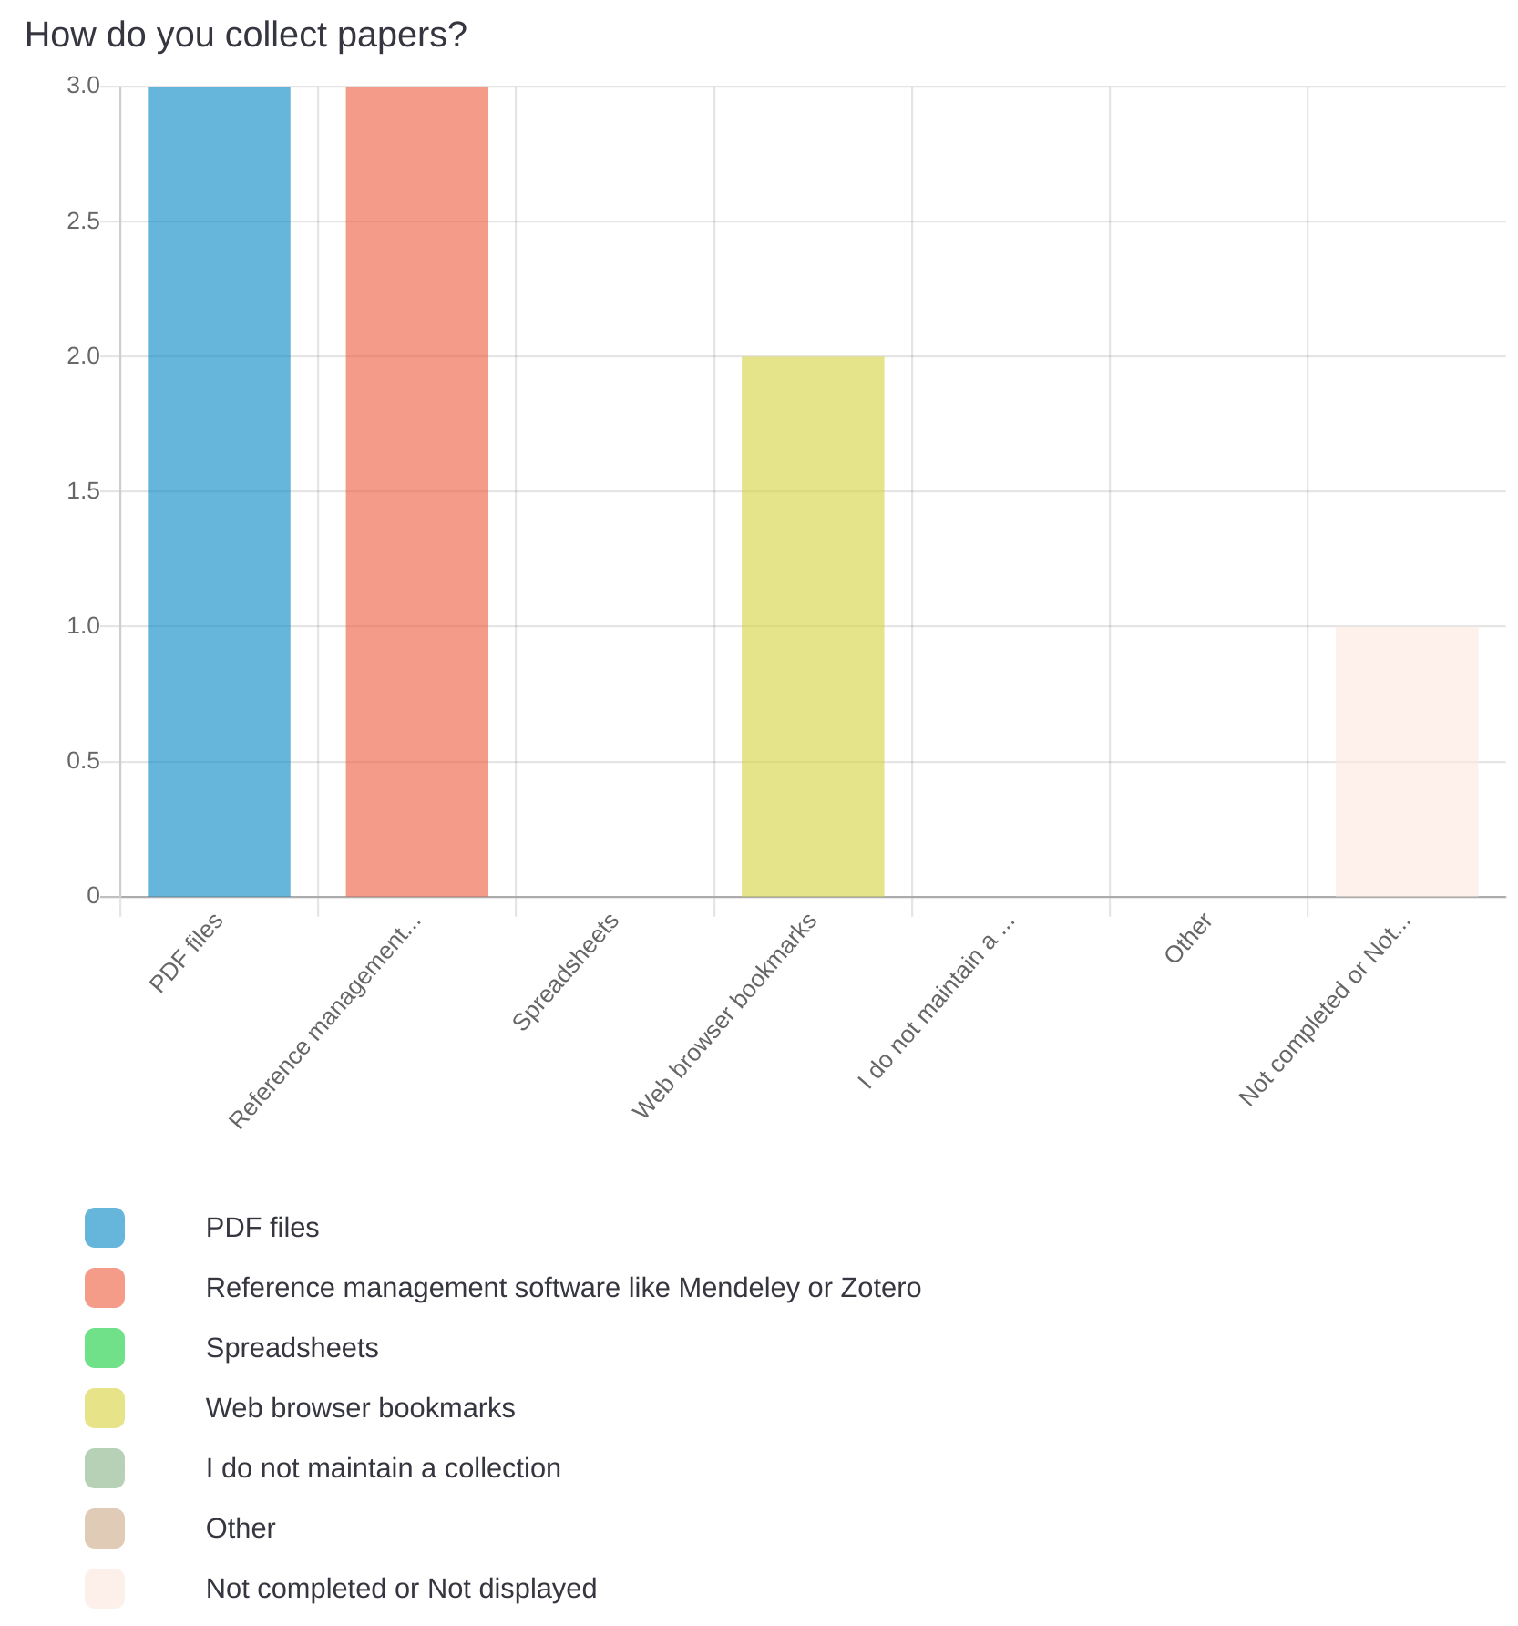
How do you organize your collection of papers?
not at all
mendeley tags, browser bookmarks
tagging
I have my papers saved through Zotero on my icloud, so that I can access them wherever I am (and also on my tablet, easily). They're renamed to LastnameYear using a Zotero plugin. So I have a large folder called "Literature" that has all the papers, and they're linked from Zotero. I search through Zotero to find an appropriate paper to read; I tag them there with "toread", "read", "useful" or with the name of a conference submission I'm working on.
By paper title or sometimes by the author names
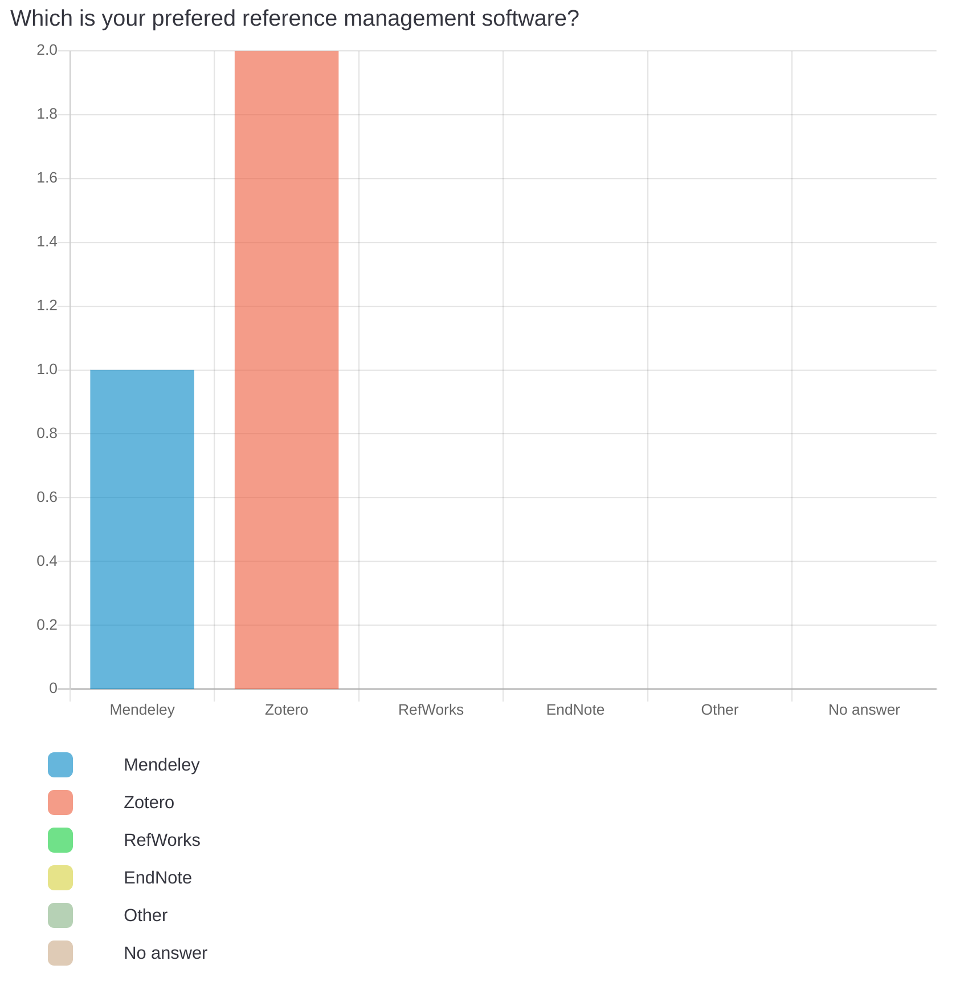

What would you like to change about the way you collect papers, if you could?
group papers by general topic and submission, maybe also keywords - the less I have to provide here manually the better, i.e. ideally a system would classify a document and suggest which group/category to put in
automatically adding broser bookmarks to reference managers
make more interconnections and direct links
I'm not a fan of Zotero's interface and the fact that it's not accessible offline on my tablet.
A different and effortless way to store the papers with a unique identification

Overall, what has your experience been with TagVis?
The graph interaction could be smoother. The details of a particular paper stay open even if I interact with the graph (change parameters for example) - this should probably auto-close for certain graph actions. overall good experience!
Good!
It looks nice, but in the current state it does not provide a benefit to my workflow.
It looks really nice!

If a service similar to TagVis was publicly available online, would you use it and why / why not?
What is not quite clear to me - if I add a new paper, does it already automatically associate it to existing papers in the library or is it entirely based on the tags I provide? I would love to use a tool like this if these kind of things were automated, i.e. if I didn't have to manually tag all of my papers. Papers these days do provide keywords, ACM CCS classes, IEEE also has a clasification system (although the ACM/IEEE ones are less useful to my experience because they are often not a great fit. Author provided keywords are usually better). Or directly extract this from the paper text/PDF. Also, if a PDF would automatically be found/downloaded for papers and added to the library - this typically takes time to find on GoogleScholar etc. and would be a time saver
Perhaps, depends on user benefit. If I could identify generally published papers that are closely linked to my library that would be really cool!
Yes, I use the similar "Connected Papers" because I prefer visual exploration over searching in google scholar.
I would try it, but I'm not sure if I would use it in the long term. I use the shortcuts to add papers to my library a lot, and adding papers to TagVis seems to be more complicated. However, maybe taking more time to add new papers would ensure that I add them correctly, and take less cleanup time later...

Which feature(s) did you miss the most while trying TagVis?
see above. In addition, it would be great if instead of authors the title of a paper could be shown in the graph. or in addition venue, e.g. CVPR'21
Perhaps a 'see similar papers' that are online generally, not just in other peoples libraries.
A way to see the direction of the connection and the temporal order in which they were published
Shortcut tool to add paper to the library (while browsing, etc.). Could be a bookmarklet.
While in visualisation mode, clicking on a paper doesn't show you the paper title and info, so for me that's not so helpful if you have 2000+ papers and don't remember which Smith et al. is in the graph...

Do you think TagVis is intuitive to navigate/use? What could be improved?
Adding group documents too me a moment, it wasnt immediately obvious that we were redirected to our own libraries and needed to select things from the bottm there.
There is quite a lot of navigation involved and the library, graph and paper information are not in one place. In the current form it does not really allow for proper exploration of the graph. Ideally the library entry would be shown on click on the node. The scaling factors for the tags do not seem to have much impact and their use is rather unintuitive. The whole tool is only geared towards my own library, but I only put stuff in there I already know and the only time I need to relate my already added papers is for writing. During writing I need access to the abstract, content and even citations.
Selecting all papers in the library requires setting the table to "show all" or traverse the pages. The button to visualize is at the bottom of the table, so I always have to scroll around.
When I am in a session, can I change the papers without creating a new session? I feel like the point of a session instead of just tagging a certain subset of papers is that the settings in the graph are retained, so I would like to add papers to the same set of graphs.
To me it looked quite intuitive, good job!

How does TagVis compare to similar visualization tools?
The whole exploration workflow is much better in connected papers, adding and analyzing my own library is also possible in Paperscape. The advantage of connecting your own library and filtering by tags is only really useful to me as an addition to this. Connected Papers and Paperscpae also each have a nice way of presenting the temporal order of papers, which is useful for writing related work sections and discovering the structure of the literature.

Were you pleased with the performance of TagVis? What could be improved?
seemed smooth, no long waiting times. A 'select all' button that spans across multiple pages would be good
The workflow is quite a bit slower than in connected papers due to the separation into different views and the necessity to go back to the library to add another paper. The different graphing methods (tag, citation, correlation) could be pre-loaded and locally cached while viewing the graph.
Yes it looks quick and was fun to use.

If you could change one thing about TagVis, what would it be? Why?
see related papers that have not been added by a user
Make it one interface where I can simultaneously add papers, view them, add tags etc. --> essentially use the connected papers interface plus your additional features.
The popup that gives you info about a paper when in visualisation mode.

Would you say the graph visualization is well readable, also when interacting with the graph?
yes, on a mouse pad the double click to see the paper content wasnt as smooth as it could have been?
Not really, especially when I hover over a node, I would like all nodes to be fixed so that I can drag one note around to better see the connections. Everything is bouncing around when dragging.
Yes.
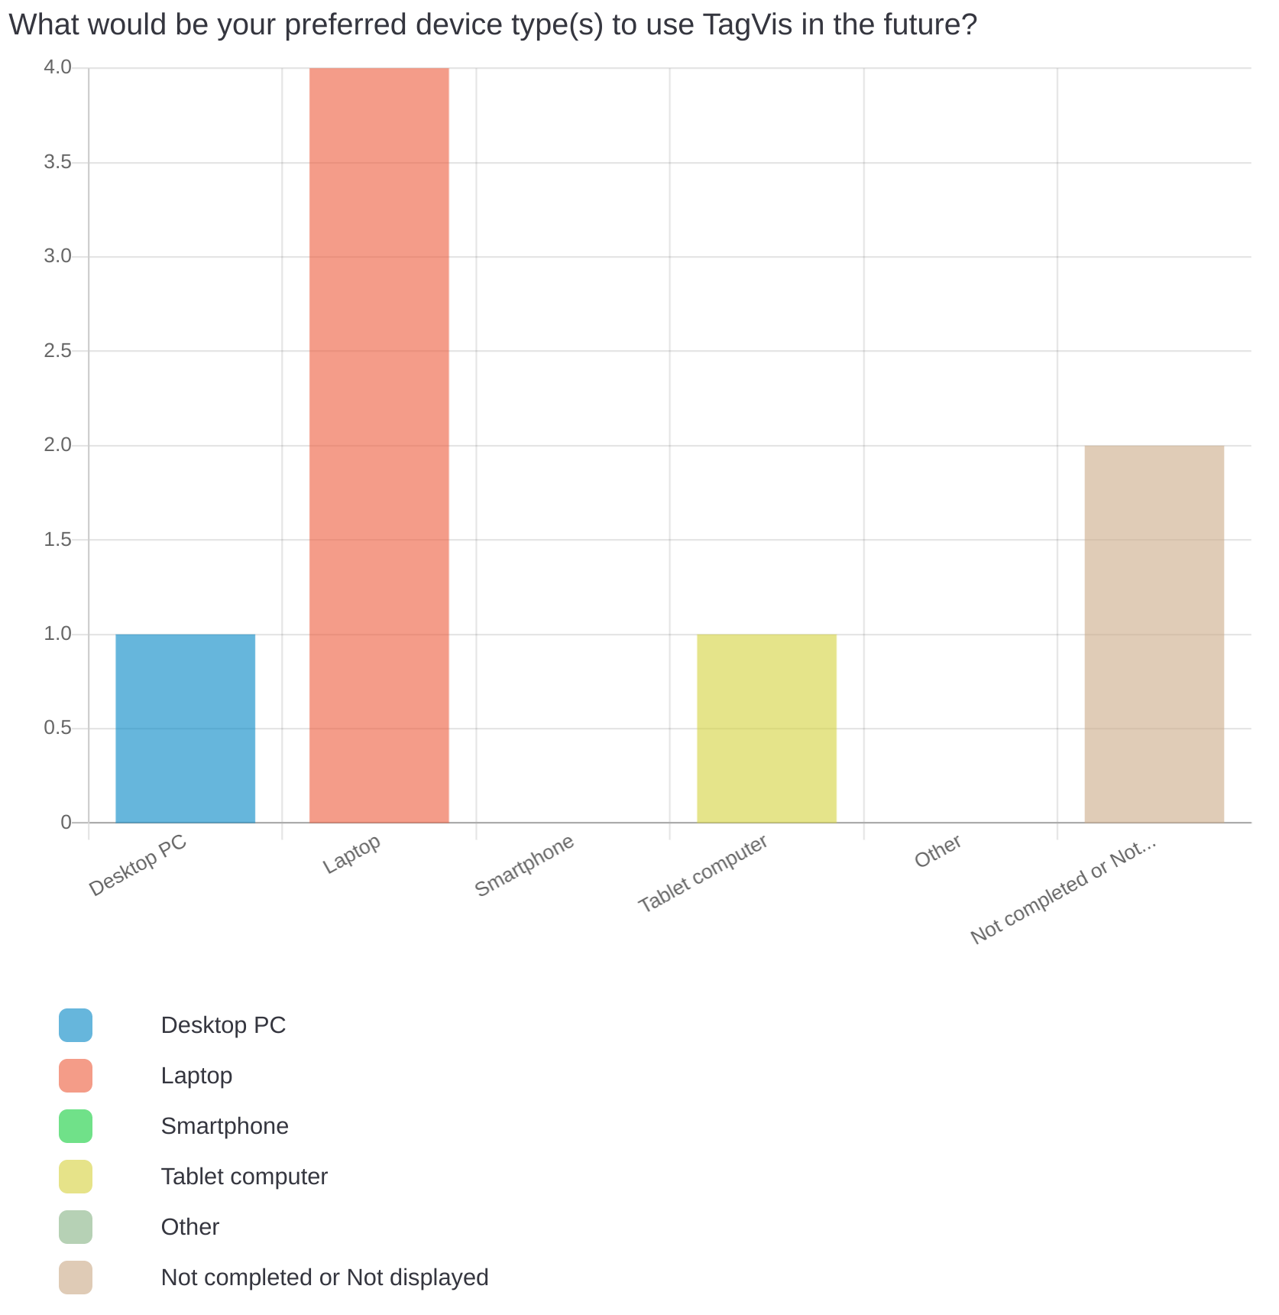

Please list any further comments or thoughts about TagVis.
I'm not sure I would use this tool personally because of the issues I mentioned, but I think it would be really cool to run it on our website so that people can interact with OUR papers and see how they related to each other and to some other main papers in the literature. It's a really cool visualisation :)

