**Emkan Finance**

**High Level Design Document**

CRM MIGRATION FLOW

**Solution Architect**

**V0.1**

**July 22, 2024**

Table of Contents

**Document Version History** 3

**Document Review & Approval History** 3

**Introduction** 4

**High Level Business Requirements** 4

**System Impact**  5

**Sequence Diagram** 6

**API Details** 7

**IRD Sheet** 8

**CRM Data Migraiton Sheet** 8

**Execution Flow:** **Error! Bookmark not defined.**

Appendix A - Architectural Decisions 10

Appendix B – Failing Retry Policy 11

Appendix C – Retention Policy 12

# **Document Version History**

|  |  |  |  |
| --- | --- | --- | --- |
| **Ver** | **Date** | **Author** | **Change Description** |
| 0.1 | 30/07/2024 | Mohammed Ishaq | Created |

Table 1 Document Version History

# **Document Review & Approval History**

|  |  |  |  |  |
| --- | --- | --- | --- | --- |
| **Version** | **Reviewer** | **Approver** | **Review Date** | **Approval Date** |
|  |  |  |  |  |
|  |  |  |  |  |

Table 2 Document Review & Approval History

# **Introduction**

Emkan Finance is a subsidiary of Al Rajhi Bank group, one of the largest banks in the world, based in the Kingdom of Saudi Arabia. Emkan is licensed by the Central Bank of Saudi Arabia (SAMA) and aims to deliver next generation financial technology enabled services focusing on the consumers, as per Saudi laws and regulatory compliances.

Being a leading multichannel fintech solution provider, Emkan currently offers digital financing solutions to its consumers in Saudi, by utilizing its digital finance platforms. The platform is powered by a smart credit and decision engine that allows for seamless decision-making without the need for manual intervention and covers end to end digital services from new customer registration to the loan disbursement.

## Document purpose

The purpose of this document is to depict migration of Customer Information data from Emkan Database to Dynamic CRM. Save Customer Information, Get Customer Information, Update Customer Information will be performed by calling Dynamic CRM.

# **High Level Business Requirements**

|  |  |  |
| --- | --- | --- |
| ID | JIRA Ref. | Statement of Requirement |
| 1 |  |  |

**System Roles**

List of all related systems and their roles as per the solution

|  |  |
| --- | --- |
| **System** | **Role** |
| **Mobile** | Customer Interface |
| **Emkan Services** | Integration , Business and Mobile BE Services |
| **Newgen** | Loan Origination System |
| **T24** | Loan Management System |
| **Middleware** | Integration Layer |
| **CRM** | Master Customer Data |

**System Impact**

List of all Impacted systems as per the solution

|  |  |
| --- | --- |
| **System** | **Role** |
| **CRM** | Provide API to perform below operations   * Save Customer Info * Get Customer Info * Update Customer Info * Publish Update Customer Info to Kafka |
| **Emkan-Services** | Consume below API’s from CRM   * Save Customer Info * Get Customer Info * Update Customer Info |
| **Ejada-MW** | Publish Update Request to Kafka topic through Ejada-Mw. |

# **Sequence Diagram**

## Diagram

The below diagram shows the landscape of Architecture:

**CRM FLOW**

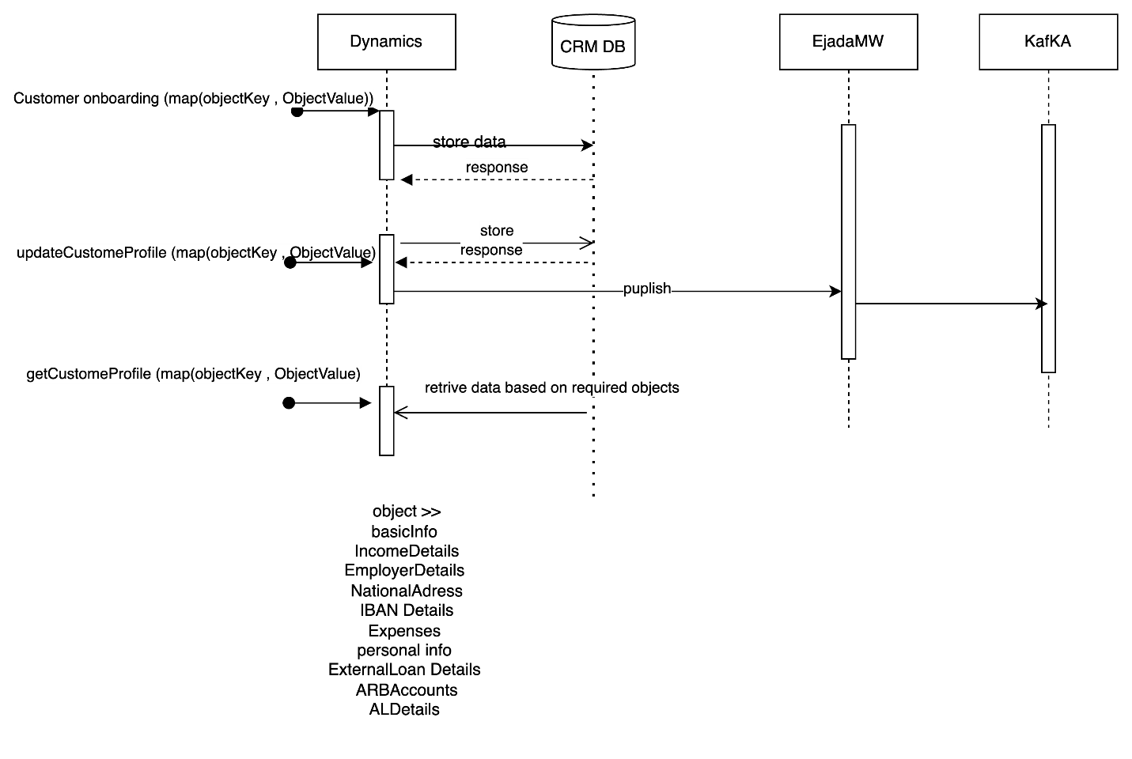

|  |  |  |  |  |  |
| --- | --- | --- | --- | --- | --- |
| **System Provider** | **Action** | **Request** | **Response** | **Type** | **Description** |
| **CRM** | /saveCustomerInfo |  |  |  | Refer IRD  CRM-EMK-DIG001  This api will be exposed by CRM to emkan. Emkan will call this api to save customer related information in Dynamic CRM.  Below objects will be passed as part of this request.  "basicCustInfo","addInfo","salInfo","expInfo","empInfo","autoLeaseCustomerInfo",ibanInfo","buyOutInfo","naInfo","companyInfo","loanDetails" |
| **CRM** | /getCustomerInfo |  |  |  | Refer IRD  CRM-EMK-DIG001  This api will be exposed by CRM to emkan. Emkan will call this api to get customer profile information from Dynamic CRM.  Below objects will be passed as part of this request to fetch customer profile.  "basicCustInfo","addInfo","salInfo","expInfo","empInfo","autoLeaseCustomerInfo","arbAccounts","ibanInfo","buyOutInfo","naInfo","companyInfo","loanDetails" |
| **CRM** | /saveCustomerInfo |  |  |  | Refer IRD  CRM-EMK-DIG001  This api will be exposed by CRM to emkan. Emkan will call this api to update customer profile information in Dynamic CRM.  Any object which need no update will be passed as null.  Below objects will be passed as part of this request to update customer information.  "basicCustInfo","addInfo","salInfo","expInfo","empInfo","autoLeaseCustomerInfo","arbAccounts","ibanInfo","buyOutInfo","naInfo","companyInfo","loanDetails" |
| **Kafka** | Kafka Topic | Request mentioned in  CRM-EMK-DIG003 |  | Kafka topic | When there is any update in CRM through api /updateCustomerInfo. CRM will push updated data to Kafka topic through Ejada Middleware.  Below objects will be passed as part of this update request to update customer profile. And this objects will be pushed to Kafka topic.  "basicCustInfo","addInfo","salInfo","expInfo","empInfo","autoLeaseCustomerInfo","arbAccounts","ibanInfo","buyOutInfo","naInfo","companyInfo","loanDetails" |



**IRD for reference**

Data Migration should be performed from EMKAN to CRM for tables attached in Excel sheet.



# Appendix A - Architectural Decisions

|  |  |  |  |
| --- | --- | --- | --- |
| Subject Area | Emkan Services |  |  |
| Derived requirements |  | | |
| Related Decisions |  | | |

# Appendix B – Failing Retry Policy

|  |  |  |  |  |
| --- | --- | --- | --- | --- |
| **System** | **Error Code** | **Retry Mechanism** | **Max Number of Retry** | **Alternative after Pass Max No of Retry** |
|  |  |  |  |  |

# Appendix C – Retention Policy

|  |  |  |  |
| --- | --- | --- | --- |
| **Environment** | **DB** | **Table Name** | **Retention period** |
|  |  |  |  |