**Differential Neural Correlates for Spatial Learning in Mice with Dorsal Hippocampal Lesions and Healthy Controls**

A scientific report for Statistics and Neural Modelling

Maxime Houtekamer and Marishka Mehta

**Université de bordeaux**

**Differential Neural Correlates for Spatial Learning in Mice with Dorsal Hippocampal Lesions and Healthy Controls**

Marishka Mehta and Maxime Houtekamer

**Introduction**

A large body of evidence indicates that the hippocampus plays a critical role in spatial learning and memory (Moser et al., 1993). More specifically, it has been shown that pyramidal cells in hippocampus of rats are activated for specific locations in their spatial environment, suggesting that these neurons maintain memory of spatial information (Quirk et al, 1990). Furthermore, it has been shown that rats with a lesioned hippocampus show impaired acquisition of behavioral tasks that depend on spatial strategies, such as the Morris water maze (Morris et al., 1982). Within the hippocampus, a distinction can be made between the dorsal and ventral hippocampus, as the dorsal hippocampus receives fibers from the entorhinal cortex, while the ventral hippocampus receives projections from more medial cells (Insausti et al. 1987). The ventral and dorsal hippocampus have also been shown to contribute to different subtypes of memory. In particular, dorsal hippocampal lesions have been shown to cause impairment in spatial learning tasks (Moser et al., 1993).

In the current study, we will investigate the effect of dorsal hippocampal lesions on the acquisition rate of a spatial learning task in mice. Since the acquisition rate is expected to decrease in lesioned mice, the duration of training will be varied in order to investigate whether lesioned mice are able to recruit alternative brain areas in order to compensate their performance. We hypothesize lesion influences learning negatively in the first days of the trial. Regarding the differential activation of structures after a variable training length, we hypothesize that there may be both, recruitment of different and the same areas of the brain. Lastly, we hypothesize that there may be a correlation between the activation of certain structures and performance.

**Methods**

*Subjects.* A total of 90 mice were housed in transparent cages with food and water available ad libitum. They were randomly assigned to a dorsal hippocampal lesion surgery (n=48) or sham surgery (n=42).

*Behavioral testing*. In each group, the mice were furthermore randomly assigned to a 3-or 5-day training in the Morris water maze (n=48 and n=42 respectively). Each day, the mice were given one trial in the Morris water maze, and the time needed to reach the platform was recorded.

*Histology.* On the last day of training, the mice were sacrificed immediately after the training session. The brains were removed and stored in formaldehyde. Frozen sections (50 µm) were cut coronally for 19 structures of interest and stained for zif immunopositive cells. The total number of zif immnopositive cells in each structure of interest was recorded.

*Statistical procedures.* All analysis was carried out in R Studio version 0.99.489 for windows.

In order to investigate whether lesion influenced learning, a repeated measures ANOVA was carried out. The assumptions of normality was considered to be met, as a majority of the cells were normally distributed (see figure 1). A post-hoc contrast was performed using one-way ANOVA's for each day. Significance levels were set at α=0.05 for the repeated measures ANOVA.

In order to investigate which structures were differentially activated depending on the duration of training, multiple student t tests were carried out in order to compare the activation of each structures in mice given a 3-day and a 5-day training. Lesioned and sham-operated animals were analyzed separately. The assumption of normality was checked using histograms and the Shapiro-Wilk test. For the structures that met the assumption of normality, a student t test for independent samples with Welch correction was used. For structures that did not meet the assumption of normality, a Wilcoxon test for independent samples was used. Significance levels were set at α=0.05 and corrected using the Bonferroni correction to compensate for the effect of multiple testing. For the control group, 19 t-tests were peformed and the significance level was adjusted to 0.00263 according to Bonferroni's correction. For the lesioned group, 16 t-tests were performed, and the significance level was adjusted to 0.00320 according to Bonferroni's correction.

To analyze whether activity in certain areas was correlated with performance, Pearson's correlation was used to create a correlation grid with significance levels. Performance was defined as the time needed to reach the platform in the Morris water maze on the last day of training. The correlation coefficients were calculated for both, all the groups pooled together, and for the four different groups separately. The assumptions of normality were considered to be met, as a majority of the cells were normally distributed. Significance levels were set at α=0.05.

**Results**

**Effect of Lesion on Learning**

A repeated measure ANOVA was carried out in order to study the effects the dorsal hippocampal lesion over time. The ANOVA revealed a significant effect of time (p=2e-16,F=169.998, df1=4, df2=12). This indicates that there is a significant change in the time needed to complete the task as the training progresses, i.e., the animals learn how to navigate the maze and are able to find the platform faster over time. The ANOVA furthermore indicates a significant effect of the group (p=1.95e-12, F=27.11, df1=3, df2=12). This indicates that that there is a significant difference in performance between the 4 groups, which have either a lesion or a sham lesion, and either a long training or a short training. Lastly, the ANOVA reveals a significant interaction between group and time (p=0.00462, F=2.861, df1=8, df2=252). Thus, the different groups have a different learning curve over time.

A visual representation of the effect of group and time and the interaction effect can be seen in Figure 3. As ANOVA indicated, there is a significant within subjects effect of time. in other words, all groups show learning, as the time needed to find the platform decreases in all groups over time. The between subjects effect, the grouping variable, was also found to be significant, and consequently the graph shows that the different groups do not show a parallel learning curve. Lastly, significant interaction of time and group indicates that over time, the mice in the different groups are learning at differing rates. In the graph, this can be seen as the groups have non-parallel lines that decrease over time and are growing progressively closer together.

**Differential activation of structures depending on training duration**

In the control group without lesion, the number of zif immunopositive cells in 19 structures was compared after a long or short training of 5 or 3 days respectively. (see figure 4) .The perirhinal cortex showed a significantly higher activation after a long training (p= 0.001358, W=93; two-sided Mann-Whitney test). Furthermore, the activation of the CA1 region of the hippocampus was also found to be significantly higher after long training (p=3.53e-05, t=-4.662, df=39.474; two sided Student t test for independent groups with Welch correction). Lastly, the CA3 region of the hippocampus showed a significantly higher activation after a long training (p=1.027e-05, t=-5.5277, df=24.487; two sided Student t test for independent groups with Welch correction). As hypothesized, there is a significantly different activation in certain brain structures depending on the training duration. More specifically, the perirhinal cortex and the CA1 and CA3 region of the hippocampus show an increased activation after a 5-day training as compared to a 3-day training.

In the lesioned animals, the cingular cortex, piriform cortex and retrosplenial cortex showed a trend towards significance (see figure 5). However, as the significance level was adjusted to 0.00320 using the Bonferroni correction, these were not considered to be significant.

**Structures that are correlated with performance**

In line with our hypothesis, the activity in several brain areas shows a significant correlation with performance on the task. Performance on the task was operationalized as the time needed to find the platform in the Morris Water Maze on the final trial. As a lower time indicates a better performance, brain areas that show a negative correlation with our variable "performance" can be interpreted as structures that positively correlate with performance. The correlation matrix can be found in figure 6.

In animals that underwent a sham surgery and were given a 3-day training, a moderate negative correlation (r=-0.44 and r=0.45 respectively) was found between activity in the entorhinal cortex and performance (p=0.030,t=-2.33, df=22), as well as, between the cingular cortex and performance (p=0.025, t=-2.40, df=22). On the other hand, a moderate positive correlation (r=0.42) was found between activation in the visual cortex and performance (p=0.043, t=-2.15, df=22). This indicates in healthy controls with a short training period, that increased activation in the entorhinal cortex and the cingular cortex are associated with improved performance on the task, whereas increased activation in the visual cortex is associated with poorer performance on the spatial navigation task.

A different pattern was found in animals that were lesioned in the dorsal hippocampus and given a 3-day training. A moderate negative correlation (r=-0.53) was found between activity in the perirhinal cortex and performance (p=0.007, t=-2.95, df=22). This indicates that in animals with a lesion of the dorsal hippocampus and a short training, increased activation in the perirhinal cortex is associated with improved performance on the spatial navigation task.

In the animals that underwent sham surgery and a 5-day training, a moderate positive correlation (r=0.52) was found between activity in the prelimbic cortex and performance on the task (p=0.026, t=2.46, df= 16). This indicates that in healthy mice that are given a long training, higher activity in the prelimbic area is associated with poorer performance on the task.

In the animals with a lesioned dorsal hippocampus and a 5-day training, a moderate positive correlation (r=0.42 and r=0.51 respectively) was found between the lateral dorsal striatum and performance (p=0.041, t=2.77, df=22), as well as between the medial dorsal striatum and performance (p=0.011,t=2.77, df=22). This indicates that in animals with a lesioned dorsal hippocampus and a long training, higher activity in both, the lateral dorsal striatum and in the medial dorsal striatum is associated with poorer spatial navigation performance.

**Discussion and Conclusion**

In the present study, we found that both mice with a lesion in the dorsal hippocampus and sham-operated mice show a learning process in a Morris water maze task. However, the rate of learning is different is depending on the duration of training and dorsal-hippocampal lesions, and changes differently over time in the different groups. Furthermore, it was found that over time, different brain regions become activated during the spatial learning task. In sham-operated animals, the perirhinal cortex and CA1 and CA3 region of the hippocampus showed increased activation in mice that had been trained longer, suggesting an increased involvement of the hippocampus as the task becomes consolidated. In the different groups, different structures have been found to correlate with performance. In healthy controls with a short training period, increased recruitment of the enorhinal and cingular cortex may improve performance on the task, whereas in lesioned animals, recruitment of the perirhinal cortex is associated with improved performance. After a long training however, lesioned animals that recruit the lateral and medial dorsal straitum are shown to perform better. Thus, the current study replicates the effect of dorsal hippocampal lesion on spatial learning and suggests that recruitment of different structures can be used to compensate their performance.

**Supporting Information**

The original datafile and the r Markdown script outlining the analysis can be found online, at [https://github.com/MHoutekamer/statsexamen](https://github.com/MHoutekamer/statsexamen%20) .

|  |  |
| --- | --- |
| **Abbreviation** | **Indicated Brain Region** |
| **STLD** | Lateral Dorsal Striatum |
| **STMD** | Medial Dorsal Striatum |
| **AMBASLAT** | Baso-lateral Amygdala |
| **AMLAT** | Lateral Amygdala |
| **ENTORH** | Entorhinal cortex |
| **PERIRH** | perirhinal cortex |
| **CA1** | CA1 of the dorsal hippocampus |
| **CA3** | CA3 of the dorsal hippocampus |
| **DG** | Dendate Gyrus, dorsal area |
| **CINGULAR** | Dcingular cortex |
| **PRELIMB** | Prelimbic cortex |
| **SOMSENS** | Somatosensorial cortex |
| **SUBICULUM** | Subiculum |
| **ACCCORE** | Corte of the Accumbens |
| **ACCSHELL** | Shell of the Accumbens |
| **VISUAL** | Visual Cortex |
| **PIRIFORM** | Piriform Cortex |
| **PARIETAL** | Parietal Cortex |
| **RETROSPLEN** | Retriospenial Cortex |

Figures

Table 1. Overview of studied brain areas and abbreviations.

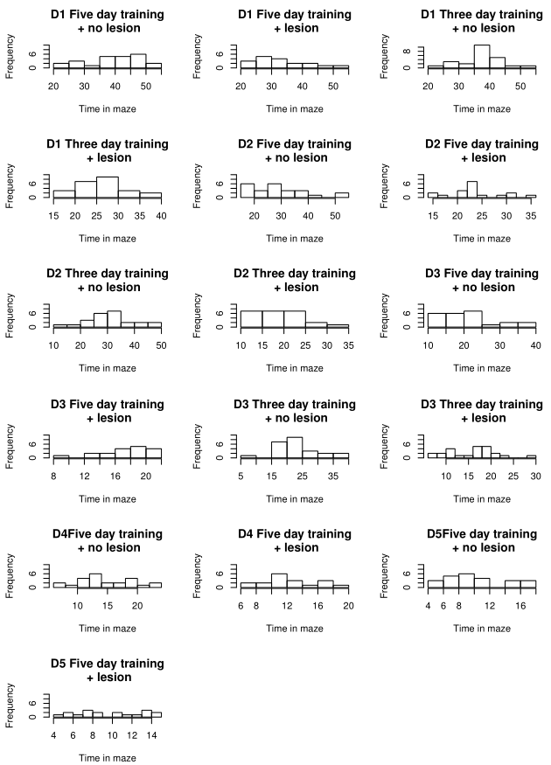

Figure 1: Histograms of time needed to find the platform in the Morris water maze, for each day of the trial. The data is shown separately for control and lesioned animals in the 3-day training and in the 5-day training.

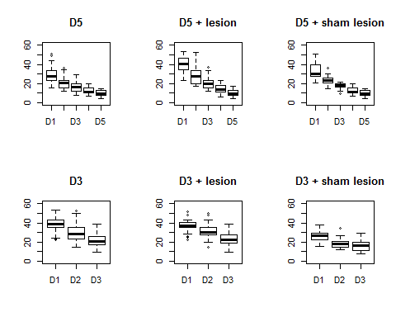

Figure 2. Box plots of task performance on each trial, for mice given a short or long training, and either a sham operation or a dorsal hippocampal lesion.

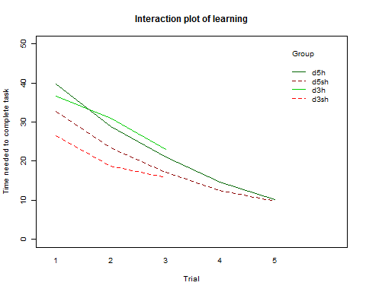

Figure 3. Interaction plot of the learning curve for a spatial navigation task. Animals with a lesion of the dorsal hippocampus are indicated in green lines, whereas control animals are indicated with a red, dotted line. The dark green and dark red lines indicate animals given a long, 5-day training. The bright red and bright green lines indicate animals given a short, 3-day training.

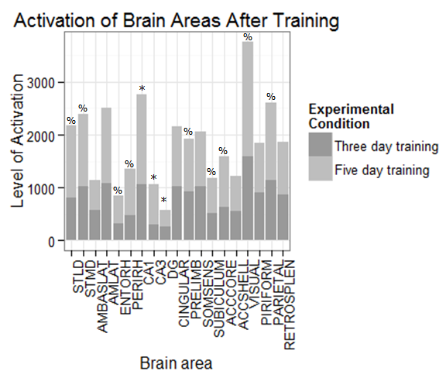

Figure 4 Differential activation of various brain in sham-operated mice. Significance at <0.05 is indicated by %s. After the bonferroni correction, the level of significance was adjusted to 0.0026. Areas that remained significant at p<0.0026 are indicated using *.

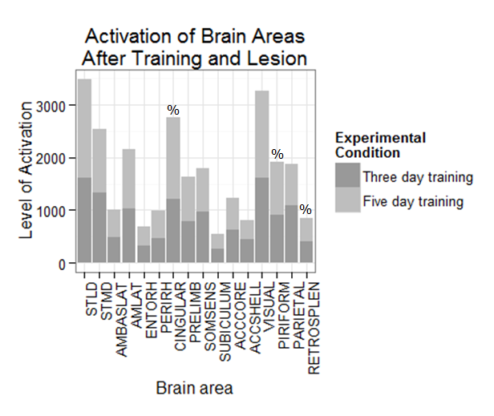

Figure 5 Differential activation of various brain structures in mice with lesioned dorsal hippocampus. Significance at <0.05 is indicated by %s. After the bonferroni correction, the level of significance was adjusted to 0.0026. Areas that remained significant at p<0.0026 are indicated using *.

Table 2 Correlation matrix of brain areas and performance on the last trial. Significant correlations are indicated using a yellow highlight. The correlations for CA1, CA3 and DG are missing in the lesioned group as these were damaged during the lesioning procedure.

|  |  |  |  |  |  |  |  |  |  |  |
| --- | --- | --- | --- | --- | --- | --- | --- | --- | --- | --- |
|  | **Pooled** |  | **5 days, no lesion** | | **5 days, lesion** | | **3 days, no lesion** | | **3 days, lesion** | |
| **Area of interest** | **Corr** | **P value** | **Corr** | **P value** | **Corr** | **P value** | **Corr** | **P value** | **Corr** | **P value** |
|  |  |  |  |  |  |  |  |  |  |  |
| **STLD** | -0,257 | 0,015 | 0,360 | 0,143 | 0,421 | 0,041 | -0,321 | 0,126 | -0,076 | 0,723 |
| **STMD** | -0,115 | 0,282 | 0,120 | 0,636 | 0,509 | 0,011 | -0,281 | 0,183 | -0,003 | 0,990 |
| **AMBASLAT** | 0,122 | 0,252 | 0,084 | 0,742 | 0,315 | 0,134 | -0,252 | 0,234 | 0,226 | 0,289 |
| **AMLAT** | 0,035 | 0,745 | 0,204 | 0,416 | 0,153 | 0,474 | -0,219 | 0,303 | 0,246 | 0,246 |
| **ENTORH** | -0,084 | 0,431 | -0,016 | 0,950 | 0,023 | 0,917 | -0,444 | 0,030 | -0,180 | 0,401 |
| **PERIRH** | -0,066 | 0,535 | 0,123 | 0,626 | -0,029 | 0,893 | -0,303 | 0,150 | -0,532 | 0,007 |
| **CA1** | -0,298 | 0,055 | -0,069 | 0,786 |  |  | -0,145 | 0,500 |  |  |
| **CA3** | -0,304 | 0,050 | 0,202 | 0,422 |  |  | -0,106 | 0,622 |  |  |
| **DG** | -0,159 | 0,316 | 0,122 | 0,629 |  |  | 0,064 | 0,767 |  |  |
| **CINGULAR** | -0,237 | 0,025 | 0,262 | 0,294 | 0,275 | 0,193 | -0,455 | 0,025 | -0,004 | 0,985 |
| **PRELIMB** | 0,068 | 0,525 | 0,524 | 0,026 | -0,273 | 0,196 | 0,060 | 0,780 | -0,236 | 0,267 |
| **SOMSENS** | 0,097 | 0,363 | 0,395 | 0,104 | -0,006 | 0,978 | -0,223 | 0,295 | 0,206 | 0,335 |
| **SUBICULUM** | 0,241 | 0,022 | 0,354 | 0,150 | -0,186 | 0,385 | -0,361 | 0,083 | -0,110 | 0,609 |
| **ACCCORE** | -0,081 | 0,449 | 0,183 | 0,468 | 0,351 | 0,093 | -0,354 | 0,090 | 0,076 | 0,726 |
| **ACCSHELL** | -0,068 | 0,524 | 0,131 | 0,606 | 0,088 | 0,682 | -0,063 | 0,769 | 0,178 | 0,407 |
| **VISUAL** | 0,060 | 0,576 | 0,271 | 0,278 | 0,062 | 0,773 | 0,416 | 0,043 | -0,022 | 0,920 |
| **PIRIFORM** | -0,057 | 0,591 | 0,257 | 0,304 | 0,175 | 0,413 | -0,364 | 0,081 | 0,150 | 0,483 |
| **PARIETAL** | 0,068 | 0,527 | 0,384 | 0,115 | 0,292 | 0,166 | -0,293 | 0,165 | 0,237 | 0,265 |
|  |  |  |  |  |  |  |  |  |  |  |
| **RETROSPLEN** | 0,235 | 0,026 | 0,359 | 0,144 | 0,004 | 0,987 | -0,179 | 0,402 | -0,022 | 0,920 |

.

**References**

Insausti R, Amaral DG, Cowan WM (1987) The entorhinal cortex of the monkey. II. Cortical afferents. *J Comp Neurol* 264:356-395.

Morris RGM, Garrud P, Rawlins JNP, Q’Keefe J (1982). Place navigation impaired in rats with hippocampal lesions. *Nature* 297:68 l-683

Moser, E., Moser, M. B., & Andersen, P. (1993). Spatial learning impairment parallels the magnitude of dorsal hippocampal lesions, but is hardly present following ventral lesions. *The Journal of Neuroscience : The Official Journal of the Society for Neuroscience*, *13*(9), 3916–3925.

Quirk GJ, Muller RV, Kubie JL (1990) The firing of hippocampal place cells in the dark depends on the rat’s recent experience. *The Journal of Neuroscience : The Official Journal of the Society for Neuroscience* 10:2008-20 17.