Statistics Examen_NeuroBIM

Maxime Houtekamer

16 november 2015

# Loading the data file into R

First of all, the data was loaded into R from the textfile. A summary of the data was obtained as an indication whether the data was correctly loaded into R.

# Let's add a collumn for the difference between time needed

# Creating seperate files for the 4 conditions

The mice were either trained in 3 sessions (D3) or in 5 sessions (D5). Within each of these two groups, the animals were either lesioned in the dorsal hippocampus (H) or they were given a sham lesion (SH). These groups were originally stored in the datafile, but will now be sorted in order to easily be able to display them seperately.

# Learning time

The mice were given a task, and the time they spent in the dark is a measure of how well they learnt it.

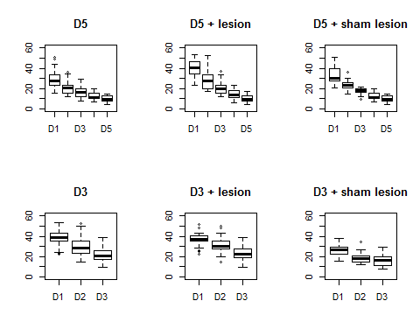

## [1] 29.5587

## [1] 22.88382

## [1] 13.70844

## [1] 10.73177

# Is the data normally distributed?

First, Let's look at histograms of each group.

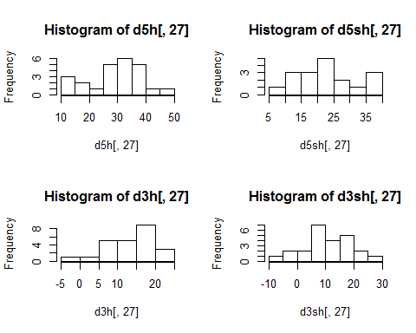

# NORMAL DISTIBUTION?

We will carry out the shapiro-Wilk test. If p>a (bigger than 0.05 generally), the data is normal.

##   
## Shapiro-Wilk normality test  
##   
## data: d5h[, 27]  
## W = 0.96506, p-value = 0.5482

##   
## Shapiro-Wilk normality test  
##   
## data: d5sh[, 27]  
## W = 0.94456, p-value = 0.3461

##   
## Shapiro-Wilk normality test  
##   
## data: d3h[, 27]  
## W = 0.95398, p-value = 0.3297

##   
## Shapiro-Wilk normality test  
##   
## data: d3sh[, 27]  
## W = 0.98565, p-value = 0.9735

All the values are higher than p=0.05, so the data is normally distributed.

# Making a new dataframe for ANOVA

We will make a list of the factors (d5h, d5sh, d3h, d3sh), and a list with the "learned" decrease in time needed to explore the matrix.

# Homogeneity of Variance

##   
## Bartlett test of homogeneity of variances  
##   
## data: d1$values by d1$exp  
## Bartlett's K-squared = 3.6572, df = 3, p-value = 0.3009

# ANOVA

Maybe we should instead to a repeated measures anova where we follow the animal over the different learning trials.

## Df Sum Sq Mean Sq F value Pr(>F)   
## d1$exp 3 5260 1753.3 24.6 1.38e-11 ***  
## Residuals 86 6129 71.3   
## ---  
## Signif. codes: 0 '***' 0.001 '**' 0.01 '*' 0.05 '.' 0.1 ' ' 1

The anova is highly significant at p<0.05. Let's do a post-hoc Tukey test to find where the differences are #Tukey posthoc

## Tukey multiple comparisons of means  
## 95% family-wise confidence level  
##   
## Fit: aov(formula = f1)  
##   
## $`d1$exp`  
## diff lwr upr p adj  
## d3sh-d3h -2.976667 -9.361469 3.4081355 0.6150204  
## d5h-d3h 15.850260 9.465458 22.2350626 0.0000000  
## d5sh-d3h 9.175382 2.279007 16.0717565 0.0042380  
## d5h-d3sh 18.826927 12.442125 25.2117293 0.0000000  
## d5sh-d3sh 12.152049 5.255674 19.0484232 0.0000790  
## d5sh-d5h -6.674878 -13.571253 0.2214961 0.0614873

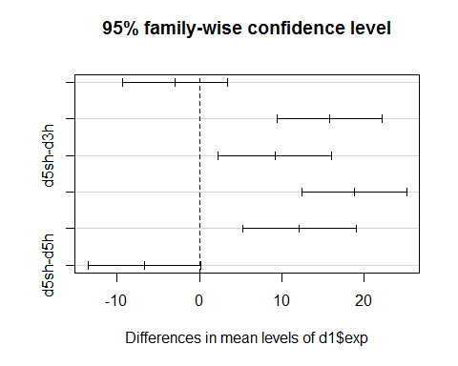 #Repeated measures ANOVA 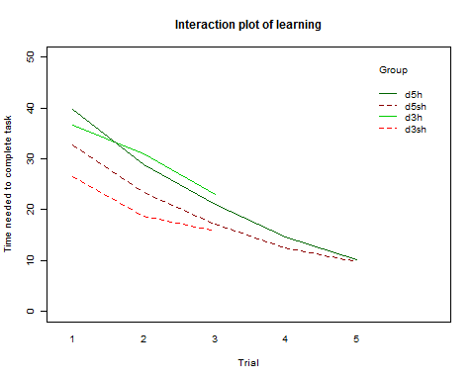

##   
## Error: id  
## Df Sum Sq Mean Sq F value Pr(>F)   
## group 3 5594 1864.7 27.11 1.95e-12 ***  
## Residuals 86 5914 68.8   
## ---  
## Signif. codes: 0 '***' 0.001 '**' 0.01 '*' 0.05 '.' 0.1 ' ' 1  
##   
## Error: Within  
## Df Sum Sq Mean Sq F value Pr(>F)   
## time 4 22320 5580 169.998 < 2e-16 ***  
## group:time 8 751 94 2.861 0.00462 **   
## Residuals 252 8272 33   
## ---  
## Signif. codes: 0 '***' 0.001 '**' 0.01 '*' 0.05 '.' 0.1 ' ' 1

## Loading required package: lme4  
## Loading required package: Matrix  
## Loading required package: reshape2  
## Loading required package: lsmeans  
## Loading required package: estimability  
##   
## Attaching package: 'lsmeans'  
##   
## The following object is masked from 'package:base':  
##   
## rbind  
##   
## ************  
## Welcome to afex. Important changes in the current version:  
## - Functions for ANOVAs have been renamed to: aov_car(), aov_ez(), and aov_4().  
## - ANOVA functions return an object of class 'afex_aov' as default, see: ?aov_car  
## - 'afex_aov' objects can be passed to lsmeans for contrasts and follow-up tests.  
## - Reset previous (faster) behavior via: afex_options(return_aov='nice')  
## - Many more arguments can now be set globally via options, see: afex_options()  
## ************  
## Loading required package: mvtnorm  
## Loading required package: survival  
## Loading required package: TH.data

model.cs <- gls(tasktime ~ group * time , data = d2, corr = corCompSymm(, form = ~ 1 | id) )

summary(model.cs)

The between group tests indicates that the variable group is significant. consequently, int he graph we see that the liens for the two groups are rather far apart. The within subject test indicates that there is a significant time effect, inother words, the groups do change other time, both groups are taking less time to complete the task over time. Morover, the interaction of time and group is significant which means that the groups are changing over time but are changing in different ways, which means that in the graph, the liens will not be parallel.

# DAY 1

## Df Sum Sq Mean Sq F value Pr(>F)   
## D1$exp 3 2324 774.7 13.5 2.68e-07 ***  
## Residuals 86 4934 57.4   
## ---  
## Signif. codes: 0 '***' 0.001 '**' 0.01 '*' 0.05 '.' 0.1 ' ' 1

## Tukey multiple comparisons of means  
## 95% family-wise confidence level  
##   
## Fit: aov(formula = fD1)  
##   
## $`D1$exp`  
## diff lwr upr p adj  
## d3sh-d3h -10.104688 -15.83327806 -4.3760969 0.0000775  
## d5h-d3h 3.086062 -2.64252806 8.8146531 0.4957580  
## d5sh-d3h -3.989444 -10.17702945 2.1981406 0.3356221  
## d5h-d3sh 13.190750 7.46215944 18.9193406 0.0000002  
## d5sh-d3sh 6.115243 -0.07234195 12.3028281 0.0539491  
## d5sh-d5h -7.075507 -13.26309195 -0.8879219 0.0184144

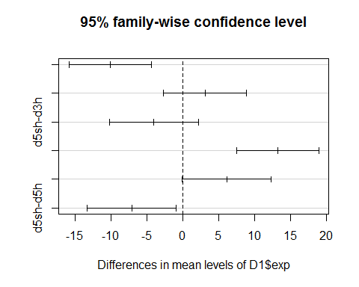

# DAY 2

## Df Sum Sq Mean Sq F value Pr(>F)   
## D2$exp 3 2191 730.4 12.73 5.84e-07 ***  
## Residuals 86 4935 57.4   
## ---  
## Signif. codes: 0 '***' 0.001 '**' 0.01 '*' 0.05 '.' 0.1 ' ' 1

## Tukey multiple comparisons of means  
## 95% family-wise confidence level  
##   
## Fit: aov(formula = fD2)  
##   
## $`D2$exp`  
## diff lwr upr p adj  
## d3sh-d3h -12.373333 -18.102674 -6.6439923 0.0000012  
## d5h-d3h -2.244844 -7.974185 3.4844973 0.7343947  
## d5sh-d3h -7.578073 -13.766469 -1.3896773 0.0099558  
## d5h-d3sh 10.128490 4.399149 15.8578307 0.0000745  
## d5sh-d3sh 4.795260 -1.393135 10.9836561 0.1850429  
## d5sh-d5h -5.333229 -11.521625 0.8551665 0.1161882

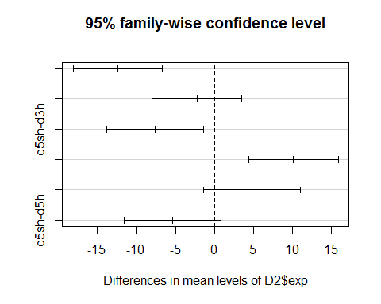 #DAY 3

## Df Sum Sq Mean Sq F value Pr(>F)   
## D3$exp 3 758.6 252.8 6.927 0.000313 ***  
## Residuals 86 3139.3 36.5   
## ---  
## Signif. codes: 0 '***' 0.001 '**' 0.01 '*' 0.05 '.' 0.1 ' ' 1

## Tukey multiple comparisons of means  
## 95% family-wise confidence level  
##   
## Fit: aov(formula = fD3)  
##   
## $`D3$exp`  
## diff lwr upr p adj  
## d3sh-d3h -7.128021 -11.697564 -2.5584780 0.0005588  
## d5h-d3h -1.903073 -6.472616 2.6664700 0.6958769  
## d5sh-d3h -5.706979 -10.642650 -0.7713088 0.0167529  
## d5h-d3sh 5.224948 0.655405 9.7944908 0.0184241  
## d5sh-d3sh 1.421042 -3.514629 6.3567121 0.8745762  
## d5sh-d5h -3.803906 -8.739577 1.1317642 0.1889809

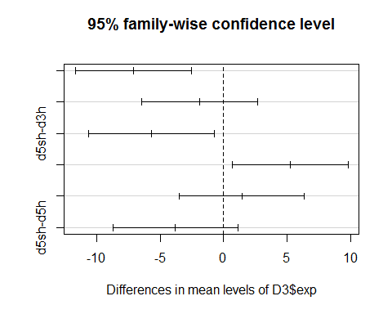 #DAY 4

## Df Sum Sq Mean Sq F value Pr(>F)  
## D4$exp 1 43.6 43.64 2.586 0.116  
## Residuals 40 675.1 16.88

## Tukey multiple comparisons of means  
## 95% family-wise confidence level  
##   
## Fit: aov(formula = fD4)  
##   
## $`D4$exp`  
## diff lwr upr p adj  
## d5sh-d5h -2.059722 -4.648644 0.5291991 0.1157122

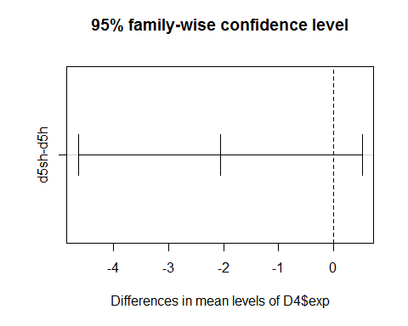 #DAY 5

## Df Sum Sq Mean Sq F value Pr(>F)  
## D5$exp 1 1.7 1.651 0.131 0.719  
## Residuals 40 502.8 12.571

## Tukey multiple comparisons of means  
## 95% family-wise confidence level  
##   
## Fit: aov(formula = fD5)  
##   
## $`D5$exp`  
## diff lwr upr p adj  
## d5sh-d5h -0.4006285 -2.634966 1.833709 0.7189687

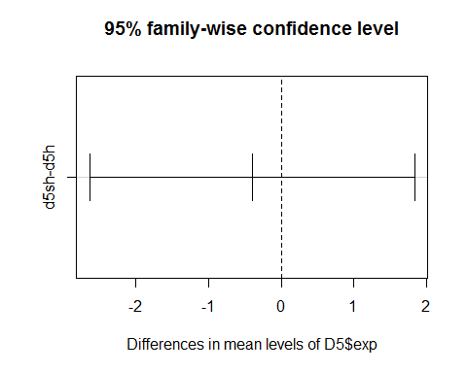

## Are there structures that are differentially activated depending on the duration of the training?

I think the best option here is MANOVA. I used this video first <https://www.youtube.com/watch?v=48cZ2cMBpio>

## Df Pillai approx F num Df den Df Pr(>F)   
## as.factor(TRAIN) 1 0.87467 8.0807 19 22 4.842e-06 ***  
## Residuals 40   
## ---  
## Signif. codes: 0 '***' 0.001 '**' 0.01 '*' 0.05 '.' 0.1 ' ' 1

I don't think these results are helpful at all. So there are areas that differ.. ok..

## What are the structure activities that are correlated with performance (in the last training session) ?

Ok. So we need a correlation. then we need a matrix.

## Loading required package: grid  
## Loading required package: Formula  
## Loading required package: ggplot2  
##   
## Attaching package: 'Hmisc'  
##   
## The following objects are masked from 'package:base':  
##   
## format.pval, round.POSIXt, trunc.POSIXt, units

## row column cor p  
## 172 STLD final -0.25688878 0.01451892  
## 173 STMD final -0.11459476 0.28215434  
## 174 AMBASLAT final 0.12201443 0.25194559  
## 175 AMLAT final 0.03474115 0.74512462  
## 176 ENTORH final -0.08409247 0.43068690  
## 177 PERIRH final -0.06621543 0.53520851  
## 178 CA1 final -0.29772902 0.05549844  
## 179 CA3 final -0.30402470 0.05029389  
## 180 DG final -0.15854518 0.31593655  
## 181 CINGULAR final -0.23694505 0.02454052  
## 182 PRELIMB final 0.06786582 0.52505980  
## 183 SOMSENS final 0.09701581 0.36300415  
## 184 SUBICULUM final 0.24090412 0.02218022  
## 185 ACCCORE final -0.08076198 0.44922795  
## 186 ACCSHELL final -0.06811436 0.52353991  
## 187 VISUAL final 0.05980199 0.57554592  
## 188 PIRIFORM final -0.05737391 0.59117707  
## 189 PARIETAL final 0.06761815 0.52657656  
## 190 RETROSPLEN final 0.23501243 0.02576832

## row column cor p  
## 121 STLD data1[, 26] 0.420943916 0.04052046  
## 122 STMD data1[, 26] 0.508609712 0.01115149  
## 123 AMBASLAT data1[, 26] 0.314945042 0.13387549  
## 124 AMLAT data1[, 26] 0.153313786 0.47446618  
## 125 ENTORH data1[, 26] 0.022545485 0.91671974  
## 126 PERIRH data1[, 26] -0.029052418 0.89280380  
## 127 CINGULAR data1[, 26] 0.275005847 0.19340416  
## 128 PRELIMB data1[, 26] -0.273405820 0.19611358  
## 129 SOMSENS data1[, 26] -0.005872661 0.97827284  
## 130 SUBICULUM data1[, 26] -0.185807616 0.38469403  
## 131 ACCCORE data1[, 26] 0.351101816 0.09251817  
## 132 ACCSHELL data1[, 26] 0.088317879 0.68153189  
## 133 VISUAL data1[, 26] 0.062166829 0.77290674  
## 134 PIRIFORM data1[, 26] 0.175138682 0.41304156  
## 135 PARIETAL data1[, 26] 0.292301059 0.16573976  
## 136 RETROSPLEN data1[, 26] 0.003533508 0.98692608

## Warning in sqrt(npair - 2): NaNs produced

## row column cor p  
## 172 STLD data1[, 24] -0.076227695 0.723325284  
## 173 STMD data1[, 24] -0.002770538 0.989748891  
## 174 AMBASLAT data1[, 24] 0.225778431 0.288775563  
## 175 AMLAT data1[, 24] 0.246296376 0.245979988  
## 176 ENTORH data1[, 24] -0.179720566 0.400729262  
## 177 PERIRH data1[, 24] -0.532149076 0.007435526  
## 178 CA1 data1[, 24] NA NA  
## 179 CA3 data1[, 24] NA NA  
## 180 DG data1[, 24] NA NA  
## 181 CINGULAR data1[, 24] -0.004120424 0.984754725  
## 182 PRELIMB data1[, 24] -0.236160472 0.266572650  
## 183 SOMSENS data1[, 24] 0.205784410 0.334698112  
## 184 SUBICULUM data1[, 24] -0.109996065 0.608889819  
## 185 ACCCORE data1[, 24] 0.075546660 0.725703792  
## 186 ACCSHELL data1[, 24] 0.177521572 0.406612533  
## 187 VISUAL data1[, 24] -0.021707390 0.919805660  
## 188 PIRIFORM data1[, 24] 0.150478333 0.482773527  
## 189 PARIETAL data1[, 24] 0.236988276 0.264850721  
## 190 RETROSPLEN data1[, 24] -0.021632330 0.920082088

## row column cor p  
## 172 STLD data1[, 24] -0.32145479 0.12559258  
## 173 STMD data1[, 24] -0.28133541 0.18293688  
## 174 AMBASLAT data1[, 24] -0.25245550 0.23398786  
## 175 AMLAT data1[, 24] -0.21934773 0.30309215  
## 176 ENTORH data1[, 24] -0.44434154 0.02960353  
## 177 PERIRH data1[, 24] -0.30310613 0.14993311  
## 178 CA1 data1[, 24] -0.14480291 0.49961947  
## 179 CA3 data1[, 24] -0.10614695 0.62155328  
## 180 DG data1[, 24] 0.06378335 0.76715843  
## 181 CINGULAR data1[, 24] -0.45524520 0.02539334  
## 182 PRELIMB data1[, 24] 0.06031009 0.77952358  
## 183 SOMSENS data1[, 24] -0.22309427 0.29469885  
## 184 SUBICULUM data1[, 24] -0.36111617 0.08296873  
## 185 ACCCORE data1[, 24] -0.35409132 0.08958555  
## 186 ACCSHELL data1[, 24] -0.06335748 0.76867166  
## 187 VISUAL data1[, 24] 0.41607288 0.04314844  
## 188 PIRIFORM data1[, 24] -0.36375323 0.08058232  
## 189 PARIETAL data1[, 24] -0.29271892 0.16510766  
## 190 RETROSPLEN data1[, 24] -0.17931114 0.40182103

## row column cor p  
## 172 STLD data1[, 26] 0.35961094 0.14272193  
## 173 STMD data1[, 26] 0.11980815 0.63584001  
## 174 AMBASLAT data1[, 26] 0.08361112 0.74151822  
## 175 AMLAT data1[, 26] 0.20436074 0.41597587  
## 176 ENTORH data1[, 26] -0.01583276 0.95028112  
## 177 PERIRH data1[, 26] 0.12335004 0.62581283  
## 178 CA1 data1[, 26] -0.06897060 0.78567310  
## 179 CA3 data1[, 26] 0.20157377 0.42249904  
## 180 DG data1[, 26] 0.12214736 0.62921076  
## 181 CINGULAR data1[, 26] 0.26162213 0.29432116  
## 182 PRELIMB data1[, 26] 0.52393258 0.02562968  
## 183 SOMSENS data1[, 26] 0.39525074 0.10449866  
## 184 SUBICULUM data1[, 26] 0.35399941 0.14951909  
## 185 ACCCORE data1[, 26] 0.18270271 0.46806182  
## 186 ACCSHELL data1[, 26] 0.13056333 0.60558531  
## 187 VISUAL data1[, 26] 0.27053288 0.27757543  
## 188 PIRIFORM data1[, 26] 0.25667286 0.30388027  
## 189 PARIETAL data1[, 26] 0.38416871 0.11549134  
## 190 RETROSPLEN data1[, 26] 0.35882717 0.14365820

First took all the data to see whether they are normally distributed or not: per brain area per group 4 groups, lesion vs. non lesion depending on normality: t test or wilcox

# NORMAL DISTIBUTION?

We will carry out the shapiro-Wilk test. If p>a (bigger than 0.05 generally), the data is normal.

d5h[,c(3,17,20,21)] are not normally distributed d5sh[,c(3)] is not normally distributed d3h[,c(15,21)] are not normally distributed d3sh[,c(3,8,2,14,16,18)] is not normally distributed. You have a small sample size but the population is actually normally distributed, so we will use a parametric test anyway

# ok fuck this shit let's do a t test for all these fuckers

t.test(collumn 1, collumn 2) skip collumns 9:11 for d3h vs d5h

for(i in c(3:8,12:21)){  
 print(t.test(d3h[,i],d5h[,i]))  
}

##   
## Welch Two Sample t-test  
##   
## data: d3h[, i] and d5h[, i]  
## t = -1.3064, df = 45.032, p-value = 0.1981  
## alternative hypothesis: true difference in means is not equal to 0  
## 95 percent confidence interval:  
## -675.4311 143.9513  
## sample estimates:  
## mean of x mean of y   
## 1612.441 1878.181   
##   
##   
## Welch Two Sample t-test  
##   
## data: d3h[, i] and d5h[, i]  
## t = 1.0996, df = 45.955, p-value = 0.2772  
## alternative hypothesis: true difference in means is not equal to 0  
## 95 percent confidence interval:  
## -115.6838 394.2305  
## sample estimates:  
## mean of x mean of y   
## 1339.385 1200.111   
##   
##   
## Welch Two Sample t-test  
##   
## data: d3h[, i] and d5h[, i]  
## t = -0.32978, df = 38.962, p-value = 0.7433  
## alternative hypothesis: true difference in means is not equal to 0  
## 95 percent confidence interval:  
## -139.8576 100.6467  
## sample estimates:  
## mean of x mean of y   
## 494.7242 514.3297   
##   
##   
## Welch Two Sample t-test  
##   
## data: d3h[, i] and d5h[, i]  
## t = -0.81178, df = 45.571, p-value = 0.4211  
## alternative hypothesis: true difference in means is not equal to 0  
## 95 percent confidence interval:  
## -323.4522 137.5726  
## sample estimates:  
## mean of x mean of y   
## 1027.418 1120.357   
##   
##   
## Welch Two Sample t-test  
##   
## data: d3h[, i] and d5h[, i]  
## t = -0.94103, df = 44.666, p-value = 0.3518  
## alternative hypothesis: true difference in means is not equal to 0  
## 95 percent confidence interval:  
## -138.88516 50.44491  
## sample estimates:  
## mean of x mean of y   
## 324.3175 368.5376   
##   
##   
## Welch Two Sample t-test  
##   
## data: d3h[, i] and d5h[, i]  
## t = -0.50866, df = 44.331, p-value = 0.6135  
## alternative hypothesis: true difference in means is not equal to 0  
## 95 percent confidence interval:  
## -182.7754 109.0943  
## sample estimates:  
## mean of x mean of y   
## 473.4962 510.3367   
##   
##   
## Welch Two Sample t-test  
##   
## data: d3h[, i] and d5h[, i]  
## t = -2.9969, df = 45.89, p-value = 0.004389  
## alternative hypothesis: true difference in means is not equal to 0  
## 95 percent confidence interval:  
## -544.3015 -106.8962  
## sample estimates:  
## mean of x mean of y   
## 1216.220 1541.819   
##   
##   
## Welch Two Sample t-test  
##   
## data: d3h[, i] and d5h[, i]  
## t = -0.70902, df = 45.997, p-value = 0.4819  
## alternative hypothesis: true difference in means is not equal to 0  
## 95 percent confidence interval:  
## -283.2634 135.6917  
## sample estimates:  
## mean of x mean of y   
## 781.9456 855.7315   
##   
##   
## Welch Two Sample t-test  
##   
## data: d3h[, i] and d5h[, i]  
## t = 1.6793, df = 45.154, p-value = 0.1  
## alternative hypothesis: true difference in means is not equal to 0  
## 95 percent confidence interval:  
## -31.6646 349.4785  
## sample estimates:  
## mean of x mean of y   
## 973.9191 815.0121   
##   
##   
## Welch Two Sample t-test  
##   
## data: d3h[, i] and d5h[, i]  
## t = -0.13494, df = 44.752, p-value = 0.8933  
## alternative hypothesis: true difference in means is not equal to 0  
## 95 percent confidence interval:  
## -136.0261 118.9459  
## sample estimates:  
## mean of x mean of y   
## 267.2530 275.7931   
##   
##   
## Welch Two Sample t-test  
##   
## data: d3h[, i] and d5h[, i]  
## t = 0.029937, df = 45.939, p-value = 0.9762  
## alternative hypothesis: true difference in means is not equal to 0  
## 95 percent confidence interval:  
## -202.1064 208.2086  
## sample estimates:  
## mean of x mean of y   
## 620.3324 617.2813   
##   
##   
## Welch Two Sample t-test  
##   
## data: d3h[, i] and d5h[, i]  
## t = 0.85777, df = 45.962, p-value = 0.3955  
## alternative hypothesis: true difference in means is not equal to 0  
## 95 percent confidence interval:  
## -98.57526 244.96806  
## sample estimates:  
## mean of x mean of y   
## 436.4552 363.2588   
##   
##   
## Welch Two Sample t-test  
##   
## data: d3h[, i] and d5h[, i]  
## t = -0.10222, df = 45.497, p-value = 0.919  
## alternative hypothesis: true difference in means is not equal to 0  
## 95 percent confidence interval:  
## -377.8926 341.3776  
## sample estimates:  
## mean of x mean of y   
## 1620.243 1638.500   
##   
##   
## Welch Two Sample t-test  
##   
## data: d3h[, i] and d5h[, i]  
## t = -0.77948, df = 42.538, p-value = 0.44  
## alternative hypothesis: true difference in means is not equal to 0  
## 95 percent confidence interval:  
## -325.3603 144.0024  
## sample estimates:  
## mean of x mean of y   
## 912.9051 1003.5840   
##   
##   
## Welch Two Sample t-test  
##   
## data: d3h[, i] and d5h[, i]  
## t = 2.282, df = 45.091, p-value = 0.02726  
## alternative hypothesis: true difference in means is not equal to 0  
## 95 percent confidence interval:  
## 34.44698 552.19530  
## sample estimates:  
## mean of x mean of y   
## 1086.926 793.605   
##   
##   
## Welch Two Sample t-test  
##   
## data: d3h[, i] and d5h[, i]  
## t = -0.54259, df = 45.789, p-value = 0.59  
## alternative hypothesis: true difference in means is not equal to 0  
## 95 percent confidence interval:  
## -246.8148 142.0159  
## sample estimates:  
## mean of x mean of y   
## 402.9082 455.3077

for(i in c(3:21)){  
 print(t.test(d3sh[,i],d5sh[,i]))  
}

##   
## Welch Two Sample t-test  
##   
## data: d3sh[, i] and d5sh[, i]  
## t = -2.8767, df = 27.78, p-value = 0.007635  
## alternative hypothesis: true difference in means is not equal to 0  
## 95 percent confidence interval:  
## -997.2579 -167.5475  
## sample estimates:  
## mean of x mean of y   
## 798.6822 1381.0849   
##   
##   
## Welch Two Sample t-test  
##   
## data: d3sh[, i] and d5sh[, i]  
## t = -2.1563, df = 31.541, p-value = 0.0388  
## alternative hypothesis: true difference in means is not equal to 0  
## 95 percent confidence interval:  
## -647.7289 -18.2504  
## sample estimates:  
## mean of x mean of y   
## 1031.708 1364.697   
##   
##   
## Welch Two Sample t-test  
##   
## data: d3sh[, i] and d5sh[, i]  
## t = 0.22244, df = 31.349, p-value = 0.8254  
## alternative hypothesis: true difference in means is not equal to 0  
## 95 percent confidence interval:  
## -119.5437 148.8271  
## sample estimates:  
## mean of x mean of y   
## 575.9308 561.2891   
##   
##   
## Welch Two Sample t-test  
##   
## data: d3sh[, i] and d5sh[, i]  
## t = -2.7633, df = 29.22, p-value = 0.0098  
## alternative hypothesis: true difference in means is not equal to 0  
## 95 percent confidence interval:  
## -602.5997 -90.0839  
## sample estimates:  
## mean of x mean of y   
## 1081.114 1427.455   
##   
##   
## Welch Two Sample t-test  
##   
## data: d3sh[, i] and d5sh[, i]  
## t = -2.8569, df = 21.807, p-value = 0.009218  
## alternative hypothesis: true difference in means is not equal to 0  
## 95 percent confidence interval:  
## -366.34520 -58.08466  
## sample estimates:  
## mean of x mean of y   
## 312.2207 524.4357   
##   
##   
## Welch Two Sample t-test  
##   
## data: d3sh[, i] and d5sh[, i]  
## t = -3.7813, df = 25.461, p-value = 0.0008469  
## alternative hypothesis: true difference in means is not equal to 0  
## 95 percent confidence interval:  
## -644.1981 -190.1669  
## sample estimates:  
## mean of x mean of y   
## 464.6539 881.8364   
##   
##   
## Welch Two Sample t-test  
##   
## data: d3sh[, i] and d5sh[, i]  
## t = -4.662, df = 39.474, p-value = 3.537e-05  
## alternative hypothesis: true difference in means is not equal to 0  
## 95 percent confidence interval:  
## -899.4325 -355.2715  
## sample estimates:  
## mean of x mean of y   
## 1065.894 1693.246   
##   
##   
## Welch Two Sample t-test  
##   
## data: d3sh[, i] and d5sh[, i]  
## t = -5.5277, df = 24.487, p-value = 1.027e-05  
## alternative hypothesis: true difference in means is not equal to 0  
## 95 percent confidence interval:  
## -608.6800 -277.9728  
## sample estimates:  
## mean of x mean of y   
## 304.2655 747.5919   
##   
##   
## Welch Two Sample t-test  
##   
## data: d3sh[, i] and d5sh[, i]  
## t = -1.1798, df = 38.161, p-value = 0.2454  
## alternative hypothesis: true difference in means is not equal to 0  
## 95 percent confidence interval:  
## -140.84168 37.11607  
## sample estimates:  
## mean of x mean of y   
## 256.5610 308.4238   
##   
##   
## Welch Two Sample t-test  
##   
## data: d3sh[, i] and d5sh[, i]  
## t = -0.59702, df = 23.292, p-value = 0.5563  
## alternative hypothesis: true difference in means is not equal to 0  
## 95 percent confidence interval:  
## -402.6953 222.2184  
## sample estimates:  
## mean of x mean of y   
## 1031.653 1121.892   
##   
##   
## Welch Two Sample t-test  
##   
## data: d3sh[, i] and d5sh[, i]  
## t = -0.44025, df = 31.991, p-value = 0.6627  
## alternative hypothesis: true difference in means is not equal to 0  
## 95 percent confidence interval:  
## -349.0704 224.9968  
## sample estimates:  
## mean of x mean of y   
## 929.2108 991.2476   
##   
##   
## Welch Two Sample t-test  
##   
## data: d3sh[, i] and d5sh[, i]  
## t = -0.10443, df = 26.241, p-value = 0.9176  
## alternative hypothesis: true difference in means is not equal to 0  
## 95 percent confidence interval:  
## -309.8448 279.8704  
## sample estimates:  
## mean of x mean of y   
## 1018.052 1033.039   
##   
##   
## Welch Two Sample t-test  
##   
## data: d3sh[, i] and d5sh[, i]  
## t = -1.7484, df = 32.93, p-value = 0.08971  
## alternative hypothesis: true difference in means is not equal to 0  
## 95 percent confidence interval:  
## -365.88103 27.68379  
## sample estimates:  
## mean of x mean of y   
## 505.7771 674.8757   
##   
##   
## Welch Two Sample t-test  
##   
## data: d3sh[, i] and d5sh[, i]  
## t = -1.9937, df = 29.799, p-value = 0.05541  
## alternative hypothesis: true difference in means is not equal to 0  
## 95 percent confidence interval:  
## -634.816975 7.733769  
## sample estimates:  
## mean of x mean of y   
## 633.9459 947.4875   
##   
##   
## Welch Two Sample t-test  
##   
## data: d3sh[, i] and d5sh[, i]  
## t = -0.91218, df = 28.386, p-value = 0.3694  
## alternative hypothesis: true difference in means is not equal to 0  
## 95 percent confidence interval:  
## -421.5918 161.6901  
## sample estimates:  
## mean of x mean of y   
## 547.3349 677.2858   
##   
##   
## Welch Two Sample t-test  
##   
## data: d3sh[, i] and d5sh[, i]  
## t = -2.482, df = 22.529, p-value = 0.02098  
## alternative hypothesis: true difference in means is not equal to 0  
## 95 percent confidence interval:  
## -1051.34862 -94.89004  
## sample estimates:  
## mean of x mean of y   
## 1594.843 2167.963   
##   
##   
## Welch Two Sample t-test  
##   
## data: d3sh[, i] and d5sh[, i]  
## t = -0.1828, df = 29.808, p-value = 0.8562  
## alternative hypothesis: true difference in means is not equal to 0  
## 95 percent confidence interval:  
## -301.8090 252.2322  
## sample estimates:  
## mean of x mean of y   
## 906.9945 931.7829   
##   
##   
## Welch Two Sample t-test  
##   
## data: d3sh[, i] and d5sh[, i]  
## t = -1.7383, df = 23.722, p-value = 0.09512  
## alternative hypothesis: true difference in means is not equal to 0  
## 95 percent confidence interval:  
## -744.10838 63.94894  
## sample estimates:  
## mean of x mean of y   
## 1136.431 1476.511   
##   
##   
## Welch Two Sample t-test  
##   
## data: d3sh[, i] and d5sh[, i]  
## t = -1.0525, df = 21.17, p-value = 0.3044  
## alternative hypothesis: true difference in means is not equal to 0  
## 95 percent confidence interval:  
## -383.0276 125.5168  
## sample estimates:  
## mean of x mean of y   
## 869.4037 998.1591

## FIGURETIME.

##   
## Attaching package: 'reshape'  
##   
## The following objects are masked from 'package:reshape2':  
##   
## colsplit, melt, recast  
##   
## The following object is masked from 'package:Matrix':  
##   
## expand

