Statistics Examen_NeuroBIM

Maxime Houtekamer

16 november 2015

# Loading the data file into R

First of all, the data was loaded into R from the textfile. A summary of the data was obtained as an indication whether the data was correctly loaded into R.

# Let's add a collumn for the difference between time needed

# Creating seperate files for the 4 conditions

The mice were either trained in 3 sessions (D3) or in 5 sessions (D5). Within each of these two groups, the animals were either lesioned in the dorsal hippocampus (H) or they were given a sham lesion (SH). These groups were originally stored in the datafile, but will now be sorted in order to easily be able to display them seperately.

# Learning time

The mice were given a task, and the time they spent in the dark is a measure of how well they learnt it.

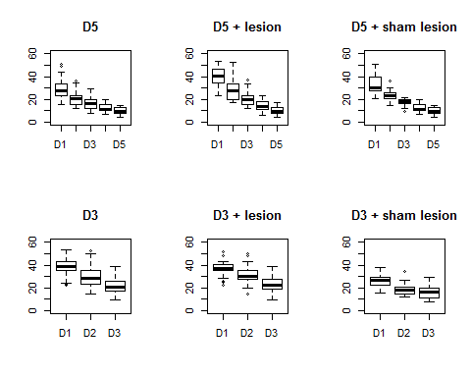

## [1] 29.5587

## [1] 22.88382

## [1] 13.70844

## [1] 10.73177

# Is the data normally distributed?

First, Let's look at histograms of each group.

# Day 1

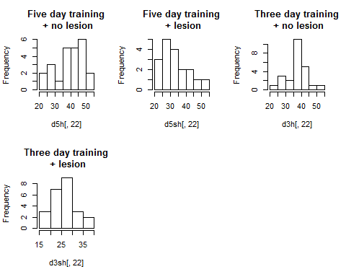

# Day 2

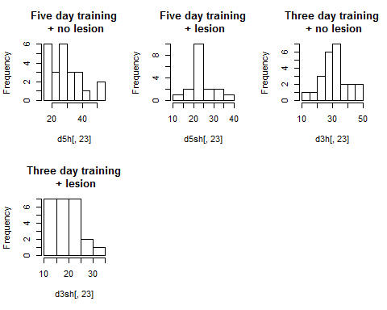

# Day 3

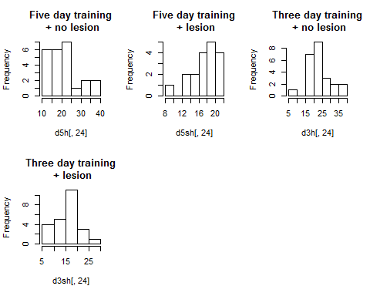

# Day 4

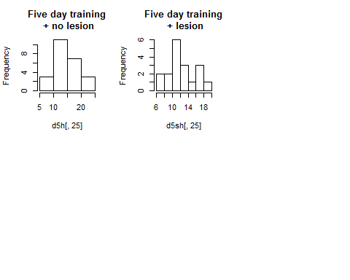

# Day 5

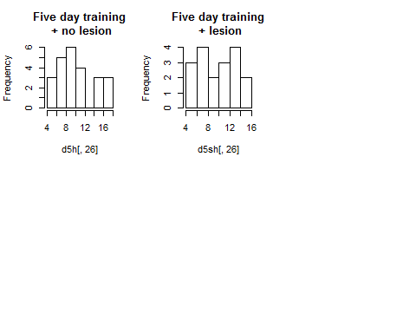

# Day 1

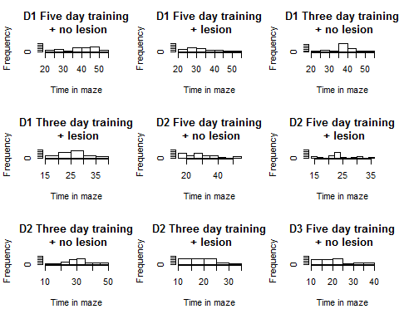 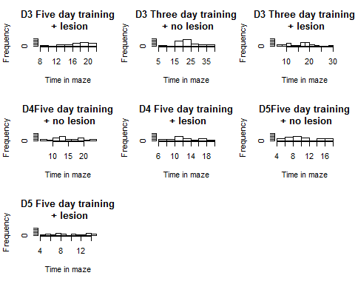

# NORMAL DISTIBUTION?

We will carry out the shapiro-Wilk test. If p>a (bigger than 0.05 generally), the data is normal.

##   
## Shapiro-Wilk normality test  
##   
## data: d5h[, 22]  
## W = 0.93728, p-value = 0.1418

##   
## Shapiro-Wilk normality test  
##   
## data: d5sh[, 22]  
## W = 0.91884, p-value = 0.1233

##   
## Shapiro-Wilk normality test  
##   
## data: d3h[, 22]  
## W = 0.95137, p-value = 0.29

##   
## Shapiro-Wilk normality test  
##   
## data: d3sh[, 22]  
## W = 0.97685, p-value = 0.8315

##   
## Shapiro-Wilk normality test  
##   
## data: d5h[, 23]  
## W = 0.89922, p-value = 0.02072

##   
## Shapiro-Wilk normality test  
##   
## data: d5sh[, 23]  
## W = 0.95189, p-value = 0.4555

##   
## Shapiro-Wilk normality test  
##   
## data: d3h[, 23]  
## W = 0.95015, p-value = 0.273

##   
## Shapiro-Wilk normality test  
##   
## data: d3sh[, 23]  
## W = 0.90132, p-value = 0.02296

##   
## Shapiro-Wilk normality test  
##   
## data: d5h[, 24]  
## W = 0.90804, p-value = 0.03198

##   
## Shapiro-Wilk normality test  
##   
## data: d5sh[, 24]  
## W = 0.93531, p-value = 0.2405

##   
## Shapiro-Wilk normality test  
##   
## data: d3h[, 24]  
## W = 0.97188, p-value = 0.7135

##   
## Shapiro-Wilk normality test  
##   
## data: d3sh[, 24]  
## W = 0.95286, p-value = 0.3121

##   
## Shapiro-Wilk normality test  
##   
## data: d5h[, 24]  
## W = 0.90804, p-value = 0.03198

##   
## Shapiro-Wilk normality test  
##   
## data: d5sh[, 24]  
## W = 0.93531, p-value = 0.2405

##   
## Shapiro-Wilk normality test  
##   
## data: d5h[, 25]  
## W = 0.97568, p-value = 0.805

##   
## Shapiro-Wilk normality test  
##   
## data: d5sh[, 25]  
## W = 0.93916, p-value = 0.2803

All the values are higher than p=0.05, so the data is normally distributed.

# Making a new dataframe for ANOVA

We will make a list of the factors (d5h, d5sh, d3h, d3sh), and a list with the "learned" decrease in time needed to explore the matrix.

# Homogeneity of Variance

##   
## Bartlett test of homogeneity of variances  
##   
## data: d1$values by d1$exp  
## Bartlett's K-squared = 3.6572, df = 3, p-value = 0.3009

# ANOVA

Maybe we should instead to a repeated measures anova where we follow the animal over the different learning trials.

## Df Sum Sq Mean Sq F value Pr(>F)   
## d1$exp 3 5260 1753.3 24.6 1.38e-11 ***  
## Residuals 86 6129 71.3   
## ---  
## Signif. codes: 0 '***' 0.001 '**' 0.01 '*' 0.05 '.' 0.1 ' ' 1

The anova is highly significant at p<0.05. Let's do a post-hoc Tukey test to find where the differences are #Tukey posthoc

## Tukey multiple comparisons of means  
## 95% family-wise confidence level  
##   
## Fit: aov(formula = f1)  
##   
## $`d1$exp`  
## diff lwr upr p adj  
## d3sh-d3h -2.976667 -9.361469 3.4081355 0.6150204  
## d5h-d3h 15.850260 9.465458 22.2350626 0.0000000  
## d5sh-d3h 9.175382 2.279007 16.0717565 0.0042380  
## d5h-d3sh 18.826927 12.442125 25.2117293 0.0000000  
## d5sh-d3sh 12.152049 5.255674 19.0484232 0.0000790  
## d5sh-d5h -6.674878 -13.571253 0.2214961 0.0614873

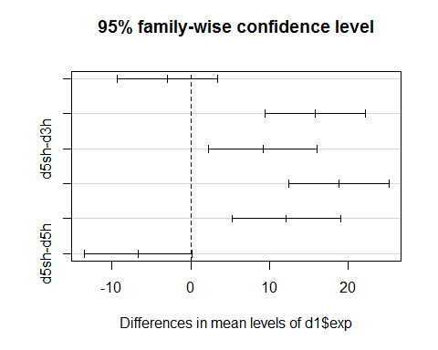 #Repeated measures ANOVA 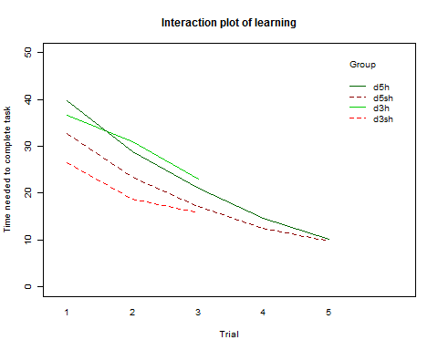

##   
## Error: id  
## Df Sum Sq Mean Sq F value Pr(>F)   
## group 3 5594 1864.7 27.11 1.95e-12 ***  
## Residuals 86 5914 68.8   
## ---  
## Signif. codes: 0 '***' 0.001 '**' 0.01 '*' 0.05 '.' 0.1 ' ' 1  
##   
## Error: Within  
## Df Sum Sq Mean Sq F value Pr(>F)   
## time 4 22320 5580 169.998 < 2e-16 ***  
## group:time 8 751 94 2.861 0.00462 **   
## Residuals 252 8272 33   
## ---  
## Signif. codes: 0 '***' 0.001 '**' 0.01 '*' 0.05 '.' 0.1 ' ' 1

Mauchly's test for sphericity was not met, so the degrees of freedom

## Loading required package: lme4  
## Loading required package: Matrix  
## Loading required package: reshape2  
## Loading required package: lsmeans  
## Loading required package: estimability  
##   
## Attaching package: 'lsmeans'  
##   
## The following object is masked from 'package:base':  
##   
## rbind  
##   
## ************  
## Welcome to afex. Important changes in the current version:  
## - Functions for ANOVAs have been renamed to: aov_car(), aov_ez(), and aov_4().  
## - ANOVA functions return an object of class 'afex_aov' as default, see: ?aov_car  
## - 'afex_aov' objects can be passed to lsmeans for contrasts and follow-up tests.  
## - Reset previous (faster) behavior via: afex_options(return_aov='nice')  
## - Many more arguments can now be set globally via options, see: afex_options()  
## ************  
## Loading required package: mvtnorm  
## Loading required package: survival  
## Loading required package: TH.data

model.cs <- gls(tasktime ~ group * time , data = d2, corr = corCompSymm(, form = ~ 1 | id) )

summary(model.cs)

The between group tests indicates that the variable group is significant. consequently, int he graph we see that the liens for the two groups are rather far apart. The within subject test indicates that there is a significant time effect, inother words, the groups do change other time, both groups are taking less time to complete the task over time. Morover, the interaction of time and group is significant which means that the groups are changing over time but are changing in different ways, which means that in the graph, the liens will not be parallel.

# DAY 1

## Df Sum Sq Mean Sq F value Pr(>F)   
## D1$exp 3 2324 774.7 13.5 2.68e-07 ***  
## Residuals 86 4934 57.4   
## ---  
## Signif. codes: 0 '***' 0.001 '**' 0.01 '*' 0.05 '.' 0.1 ' ' 1

## Tukey multiple comparisons of means  
## 95% family-wise confidence level  
##   
## Fit: aov(formula = fD1)  
##   
## $`D1$exp`  
## diff lwr upr p adj  
## d3sh-d3h -10.104688 -15.83327806 -4.3760969 0.0000775  
## d5h-d3h 3.086062 -2.64252806 8.8146531 0.4957580  
## d5sh-d3h -3.989444 -10.17702945 2.1981406 0.3356221  
## d5h-d3sh 13.190750 7.46215944 18.9193406 0.0000002  
## d5sh-d3sh 6.115243 -0.07234195 12.3028281 0.0539491  
## d5sh-d5h -7.075507 -13.26309195 -0.8879219 0.0184144

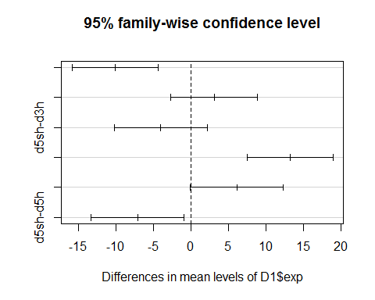

# DAY 2

## Df Sum Sq Mean Sq F value Pr(>F)   
## D2$exp 3 2191 730.4 12.73 5.84e-07 ***  
## Residuals 86 4935 57.4   
## ---  
## Signif. codes: 0 '***' 0.001 '**' 0.01 '*' 0.05 '.' 0.1 ' ' 1

## Tukey multiple comparisons of means  
## 95% family-wise confidence level  
##   
## Fit: aov(formula = fD2)  
##   
## $`D2$exp`  
## diff lwr upr p adj  
## d3sh-d3h -12.373333 -18.102674 -6.6439923 0.0000012  
## d5h-d3h -2.244844 -7.974185 3.4844973 0.7343947  
## d5sh-d3h -7.578073 -13.766469 -1.3896773 0.0099558  
## d5h-d3sh 10.128490 4.399149 15.8578307 0.0000745  
## d5sh-d3sh 4.795260 -1.393135 10.9836561 0.1850429  
## d5sh-d5h -5.333229 -11.521625 0.8551665 0.1161882

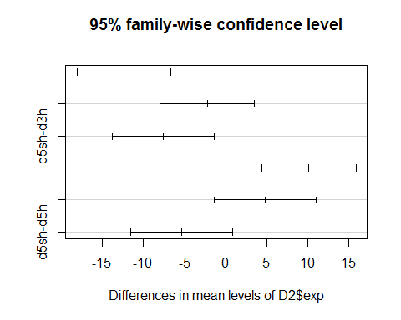 #DAY 3

## Df Sum Sq Mean Sq F value Pr(>F)   
## D3$exp 3 758.6 252.8 6.927 0.000313 ***  
## Residuals 86 3139.3 36.5   
## ---  
## Signif. codes: 0 '***' 0.001 '**' 0.01 '*' 0.05 '.' 0.1 ' ' 1

## Tukey multiple comparisons of means  
## 95% family-wise confidence level  
##   
## Fit: aov(formula = fD3)  
##   
## $`D3$exp`  
## diff lwr upr p adj  
## d3sh-d3h -7.128021 -11.697564 -2.5584780 0.0005588  
## d5h-d3h -1.903073 -6.472616 2.6664700 0.6958769  
## d5sh-d3h -5.706979 -10.642650 -0.7713088 0.0167529  
## d5h-d3sh 5.224948 0.655405 9.7944908 0.0184241  
## d5sh-d3sh 1.421042 -3.514629 6.3567121 0.8745762  
## d5sh-d5h -3.803906 -8.739577 1.1317642 0.1889809

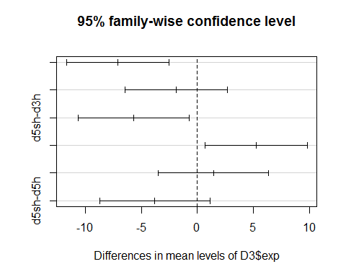 #DAY 4

## Df Sum Sq Mean Sq F value Pr(>F)  
## D4$exp 1 43.6 43.64 2.586 0.116  
## Residuals 40 675.1 16.88

## Tukey multiple comparisons of means  
## 95% family-wise confidence level  
##   
## Fit: aov(formula = fD4)  
##   
## $`D4$exp`  
## diff lwr upr p adj  
## d5sh-d5h -2.059722 -4.648644 0.5291991 0.1157122

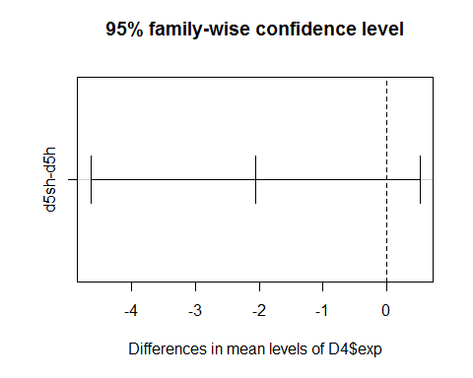 #DAY 5

## Df Sum Sq Mean Sq F value Pr(>F)  
## D5$exp 1 1.7 1.651 0.131 0.719  
## Residuals 40 502.8 12.571

## Tukey multiple comparisons of means  
## 95% family-wise confidence level  
##   
## Fit: aov(formula = fD5)  
##   
## $`D5$exp`  
## diff lwr upr p adj  
## d5sh-d5h -0.4006285 -2.634966 1.833709 0.7189687

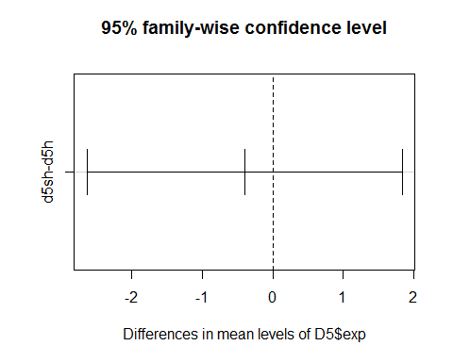

## Are there structures that are differentially activated depending on the duration of the training?

I think the best option here is MANOVA. I used this video first <https://www.youtube.com/watch?v=48cZ2cMBpio>

## Df Pillai approx F num Df den Df Pr(>F)   
## as.factor(TRAIN) 1 0.87467 8.0807 19 22 4.842e-06 ***  
## Residuals 40   
## ---  
## Signif. codes: 0 '***' 0.001 '**' 0.01 '*' 0.05 '.' 0.1 ' ' 1

I don't think these results are helpful at all. So there are areas that differ.. ok..

## What are the structure activities that are correlated with performance (in the last training session) ?

Ok. So we need a correlation. then we need a matrix.

## Loading required package: grid  
## Loading required package: Formula  
## Loading required package: ggplot2  
##   
## Attaching package: 'Hmisc'  
##   
## The following objects are masked from 'package:base':  
##   
## format.pval, round.POSIXt, trunc.POSIXt, units

## row column cor p  
## 172 STLD final -0.25688878 0.01451892  
## 173 STMD final -0.11459476 0.28215434  
## 174 AMBASLAT final 0.12201443 0.25194559  
## 175 AMLAT final 0.03474115 0.74512462  
## 176 ENTORH final -0.08409247 0.43068690  
## 177 PERIRH final -0.06621543 0.53520851  
## 178 CA1 final -0.29772902 0.05549844  
## 179 CA3 final -0.30402470 0.05029389  
## 180 DG final -0.15854518 0.31593655  
## 181 CINGULAR final -0.23694505 0.02454052  
## 182 PRELIMB final 0.06786582 0.52505980  
## 183 SOMSENS final 0.09701581 0.36300415  
## 184 SUBICULUM final 0.24090412 0.02218022  
## 185 ACCCORE final -0.08076198 0.44922795  
## 186 ACCSHELL final -0.06811436 0.52353991  
## 187 VISUAL final 0.05980199 0.57554592  
## 188 PIRIFORM final -0.05737391 0.59117707  
## 189 PARIETAL final 0.06761815 0.52657656  
## 190 RETROSPLEN final 0.23501243 0.02576832

## STLD STMD AMBASLAT AMLAT ENTORH PERIRH CINGULAR PRELIMB  
## STLD 1.00 0.68 0.53 0.57 0.09 0.05 0.56 -0.10  
## STMD 0.68 1.00 0.43 0.43 0.17 -0.14 0.52 -0.18  
## AMBASLAT 0.53 0.43 1.00 0.38 -0.01 -0.07 0.40 0.14  
## AMLAT 0.57 0.43 0.38 1.00 0.48 0.15 0.59 0.05  
## ENTORH 0.09 0.17 -0.01 0.48 1.00 0.62 0.32 -0.37  
## PERIRH 0.05 -0.14 -0.07 0.15 0.62 1.00 0.20 -0.30  
## CINGULAR 0.56 0.52 0.40 0.59 0.32 0.20 1.00 0.00  
## PRELIMB -0.10 -0.18 0.14 0.05 -0.37 -0.30 0.00 1.00  
## SOMSENS 0.14 0.30 0.21 0.12 0.24 0.20 0.02 0.23  
## SUBICULUM 0.01 0.12 0.29 0.02 -0.09 0.09 -0.09 0.24  
## ACCCORE 0.57 0.47 0.33 0.58 0.35 0.28 0.44 0.11  
## ACCSHELL 0.25 0.35 -0.04 0.06 0.23 0.30 0.03 -0.10  
## VISUAL -0.01 -0.05 0.25 0.10 0.00 -0.17 0.13 0.14  
## PIRIFORM 0.22 0.05 0.51 0.35 0.22 0.20 0.39 -0.01  
## PARIETAL 0.11 0.11 0.59 0.28 -0.05 0.07 0.06 0.38  
## RETROSPLEN 0.40 0.49 0.40 0.54 0.10 -0.12 0.33 0.08  
## performance 0.42 0.51 0.31 0.15 0.02 -0.03 0.28 -0.27  
## SOMSENS SUBICULUM ACCCORE ACCSHELL VISUAL PIRIFORM PARIETAL  
## STLD 0.14 0.01 0.57 0.25 -0.01 0.22 0.11  
## STMD 0.30 0.12 0.47 0.35 -0.05 0.05 0.11  
## AMBASLAT 0.21 0.29 0.33 -0.04 0.25 0.51 0.59  
## AMLAT 0.12 0.02 0.58 0.06 0.10 0.35 0.28  
## ENTORH 0.24 -0.09 0.35 0.23 0.00 0.22 -0.05  
## PERIRH 0.20 0.09 0.28 0.30 -0.17 0.20 0.07  
## CINGULAR 0.02 -0.09 0.44 0.03 0.13 0.39 0.06  
## PRELIMB 0.23 0.24 0.11 -0.10 0.14 -0.01 0.38  
## SOMSENS 1.00 0.36 0.49 0.60 -0.32 -0.11 0.32  
## SUBICULUM 0.36 1.00 -0.11 0.01 -0.05 0.05 0.43  
## ACCCORE 0.49 -0.11 1.00 0.58 0.05 0.26 0.33  
## ACCSHELL 0.60 0.01 0.58 1.00 -0.44 -0.30 0.00  
## VISUAL -0.32 -0.05 0.05 -0.44 1.00 0.60 0.13  
## PIRIFORM -0.11 0.05 0.26 -0.30 0.60 1.00 0.28  
## PARIETAL 0.32 0.43 0.33 0.00 0.13 0.28 1.00  
## RETROSPLEN 0.31 0.21 0.33 -0.10 0.05 0.26 0.31  
## performance -0.01 -0.19 0.35 0.09 0.06 0.18 0.29  
## RETROSPLEN performance  
## STLD 0.40 0.42  
## STMD 0.49 0.51  
## AMBASLAT 0.40 0.31  
## AMLAT 0.54 0.15  
## ENTORH 0.10 0.02  
## PERIRH -0.12 -0.03  
## CINGULAR 0.33 0.28  
## PRELIMB 0.08 -0.27  
## SOMSENS 0.31 -0.01  
## SUBICULUM 0.21 -0.19  
## ACCCORE 0.33 0.35  
## ACCSHELL -0.10 0.09  
## VISUAL 0.05 0.06  
## PIRIFORM 0.26 0.18  
## PARIETAL 0.31 0.29  
## RETROSPLEN 1.00 0.00  
## performance 0.00 1.00  
##   
## n= 24   
##   
##   
## P  
## STLD STMD AMBASLAT AMLAT ENTORH PERIRH CINGULAR PRELIMB  
## STLD 0.0002 0.0084 0.0037 0.6734 0.8234 0.0047 0.6552   
## STMD 0.0002 0.0362 0.0352 0.4311 0.5207 0.0092 0.4126   
## AMBASLAT 0.0084 0.0362 0.0675 0.9739 0.7422 0.0508 0.5030   
## AMLAT 0.0037 0.0352 0.0675 0.0165 0.4723 0.0025 0.8010   
## ENTORH 0.6734 0.4311 0.9739 0.0165 0.0012 0.1229 0.0756   
## PERIRH 0.8234 0.5207 0.7422 0.4723 0.0012 0.3559 0.1576   
## CINGULAR 0.0047 0.0092 0.0508 0.0025 0.1229 0.3559 0.9908   
## PRELIMB 0.6552 0.4126 0.5030 0.8010 0.0756 0.1576 0.9908   
## SOMSENS 0.5081 0.1476 0.3221 0.5828 0.2527 0.3571 0.9284 0.2898   
## SUBICULUM 0.9561 0.5760 0.1737 0.9427 0.6643 0.6914 0.6687 0.2568   
## ACCCORE 0.0037 0.0216 0.1211 0.0031 0.0938 0.1815 0.0301 0.5996   
## ACCSHELL 0.2328 0.0970 0.8566 0.7983 0.2696 0.1577 0.8963 0.6447   
## VISUAL 0.9721 0.8012 0.2366 0.6481 0.9999 0.4359 0.5481 0.5171   
## PIRIFORM 0.2926 0.8243 0.0116 0.0932 0.2954 0.3582 0.0626 0.9788   
## PARIETAL 0.6238 0.6129 0.0025 0.1841 0.8200 0.7453 0.7684 0.0651   
## RETROSPLEN 0.0539 0.0142 0.0545 0.0065 0.6361 0.5864 0.1148 0.7184   
## performance 0.0405 0.0112 0.1339 0.4745 0.9167 0.8928 0.1934 0.1961   
## SOMSENS SUBICULUM ACCCORE ACCSHELL VISUAL PIRIFORM PARIETAL  
## STLD 0.5081 0.9561 0.0037 0.2328 0.9721 0.2926 0.6238   
## STMD 0.1476 0.5760 0.0216 0.0970 0.8012 0.8243 0.6129   
## AMBASLAT 0.3221 0.1737 0.1211 0.8566 0.2366 0.0116 0.0025   
## AMLAT 0.5828 0.9427 0.0031 0.7983 0.6481 0.0932 0.1841   
## ENTORH 0.2527 0.6643 0.0938 0.2696 0.9999 0.2954 0.8200   
## PERIRH 0.3571 0.6914 0.1815 0.1577 0.4359 0.3582 0.7453   
## CINGULAR 0.9284 0.6687 0.0301 0.8963 0.5481 0.0626 0.7684   
## PRELIMB 0.2898 0.2568 0.5996 0.6447 0.5171 0.9788 0.0651   
## SOMSENS 0.0882 0.0157 0.0019 0.1325 0.6199 0.1262   
## SUBICULUM 0.0882 0.6189 0.9688 0.8341 0.8025 0.0358   
## ACCCORE 0.0157 0.6189 0.0029 0.8326 0.2180 0.1127   
## ACCSHELL 0.0019 0.9688 0.0029 0.0306 0.1583 0.9856   
## VISUAL 0.1325 0.8341 0.8326 0.0306 0.0020 0.5605   
## PIRIFORM 0.6199 0.8025 0.2180 0.1583 0.0020 0.1864   
## PARIETAL 0.1262 0.0358 0.1127 0.9856 0.5605 0.1864   
## RETROSPLEN 0.1368 0.3207 0.1205 0.6513 0.7989 0.2207 0.1465   
## performance 0.9783 0.3847 0.0925 0.6815 0.7729 0.4130 0.1657   
## RETROSPLEN performance  
## STLD 0.0539 0.0405   
## STMD 0.0142 0.0112   
## AMBASLAT 0.0545 0.1339   
## AMLAT 0.0065 0.4745   
## ENTORH 0.6361 0.9167   
## PERIRH 0.5864 0.8928   
## CINGULAR 0.1148 0.1934   
## PRELIMB 0.7184 0.1961   
## SOMSENS 0.1368 0.9783   
## SUBICULUM 0.3207 0.3847   
## ACCCORE 0.1205 0.0925   
## ACCSHELL 0.6513 0.6815   
## VISUAL 0.7989 0.7729   
## PIRIFORM 0.2207 0.4130   
## PARIETAL 0.1465 0.1657   
## RETROSPLEN 0.9869   
## performance 0.9869

## row column cor p  
## 121 STLD performance 0.420943916 0.04052046  
## 122 STMD performance 0.508609712 0.01115149  
## 123 AMBASLAT performance 0.314945042 0.13387549  
## 124 AMLAT performance 0.153313786 0.47446618  
## 125 ENTORH performance 0.022545485 0.91671974  
## 126 PERIRH performance -0.029052418 0.89280380  
## 127 CINGULAR performance 0.275005847 0.19340416  
## 128 PRELIMB performance -0.273405820 0.19611358  
## 129 SOMSENS performance -0.005872661 0.97827284  
## 130 SUBICULUM performance -0.185807616 0.38469403  
## 131 ACCCORE performance 0.351101816 0.09251817  
## 132 ACCSHELL performance 0.088317879 0.68153189  
## 133 VISUAL performance 0.062166829 0.77290674  
## 134 PIRIFORM performance 0.175138682 0.41304156  
## 135 PARIETAL performance 0.292301059 0.16573976  
## 136 RETROSPLEN performance 0.003533508 0.98692608

##   
## Pearson's product-moment correlation  
##   
## data: cordataD5H$STLD and cordataD5H$performance  
## t = 2.1766, df = 22, p-value = 0.04052  
## alternative hypothesis: true correlation is not equal to 0  
## 95 percent confidence interval:  
## 0.02113631 0.70468065  
## sample estimates:  
## cor   
## 0.4209439

##   
## Pearson's product-moment correlation  
##   
## data: cordataD5H$STMD and cordataD5H$performance  
## t = 2.7707, df = 22, p-value = 0.01115  
## alternative hypothesis: true correlation is not equal to 0  
## 95 percent confidence interval:  
## 0.1323719 0.7567441  
## sample estimates:  
## cor   
## 0.5086097

## row column cor p  
## 121 STLD performance -0.076227695 0.723325284  
## 122 STMD performance -0.002770538 0.989748891  
## 123 AMBASLAT performance 0.225778431 0.288775563  
## 124 AMLAT performance 0.246296376 0.245979988  
## 125 ENTORH performance -0.179720566 0.400729262  
## 126 PERIRH performance -0.532149076 0.007435526  
## 127 CINGULAR performance -0.004120424 0.984754725  
## 128 PRELIMB performance -0.236160472 0.266572650  
## 129 SOMSENS performance 0.205784410 0.334698112  
## 130 SUBICULUM performance -0.109996065 0.608889819  
## 131 ACCCORE performance 0.075546660 0.725703792  
## 132 ACCSHELL performance 0.177521572 0.406612533  
## 133 VISUAL performance -0.021707390 0.919805660  
## 134 PIRIFORM performance 0.150478333 0.482773527  
## 135 PARIETAL performance 0.236988276 0.264850721  
## 136 RETROSPLEN performance -0.021632330 0.920082088

##   
## Pearson's product-moment correlation  
##   
## data: cordataD3H$PERIRH and cordataD3H$performance  
## t = -2.9481, df = 22, p-value = 0.007436  
## alternative hypothesis: true correlation is not equal to 0  
## 95 percent confidence interval:  
## -0.7702075 -0.1639462  
## sample estimates:  
## cor   
## -0.5321491

## row column cor p  
## 172 STLD performance -0.32145479 0.12559258  
## 173 STMD performance -0.28133541 0.18293688  
## 174 AMBASLAT performance -0.25245550 0.23398786  
## 175 AMLAT performance -0.21934773 0.30309215  
## 176 ENTORH performance -0.44434154 0.02960353  
## 177 PERIRH performance -0.30310613 0.14993311  
## 178 CA1 performance -0.14480291 0.49961947  
## 179 CA3 performance -0.10614695 0.62155328  
## 180 DG performance 0.06378335 0.76715843  
## 181 CINGULAR performance -0.45524520 0.02539334  
## 182 PRELIMB performance 0.06031009 0.77952358  
## 183 SOMSENS performance -0.22309427 0.29469885  
## 184 SUBICULUM performance -0.36111617 0.08296873  
## 185 ACCCORE performance -0.35409132 0.08958555  
## 186 ACCSHELL performance -0.06335748 0.76867166  
## 187 VISUAL performance 0.41607288 0.04314844  
## 188 PIRIFORM performance -0.36375323 0.08058232  
## 189 PARIETAL performance -0.29271892 0.16510766  
## 190 RETROSPLEN performance -0.17931114 0.40182103

##   
## Pearson's product-moment correlation  
##   
## data: cordataD3SH$ENTORH and cordataD3SH$performance  
## t = -2.3264, df = 22, p-value = 0.0296  
## alternative hypothesis: true correlation is not equal to 0  
## 95 percent confidence interval:  
## -0.71888165 -0.04988684  
## sample estimates:  
## cor   
## -0.4443415

##   
## Pearson's product-moment correlation  
##   
## data: cordataD3SH$CINGULAR and cordataD3SH$performance  
## t = -2.3982, df = 22, p-value = 0.02539  
## alternative hypothesis: true correlation is not equal to 0  
## 95 percent confidence interval:  
## -0.72542218 -0.06351215  
## sample estimates:  
## cor   
## -0.4552452

##   
## Pearson's product-moment correlation  
##   
## data: cordataD3SH$VISUAL and cordataD3SH$performance  
## t = 2.1461, df = 22, p-value = 0.04315  
## alternative hypothesis: true correlation is not equal to 0  
## 95 percent confidence interval:  
## 0.01523293 0.70169535  
## sample estimates:  
## cor   
## 0.4160729

## row column cor p  
## 172 STLD performance 0.35961094 0.14272193  
## 173 STMD performance 0.11980815 0.63584001  
## 174 AMBASLAT performance 0.08361112 0.74151822  
## 175 AMLAT performance 0.20436074 0.41597587  
## 176 ENTORH performance -0.01583276 0.95028112  
## 177 PERIRH performance 0.12335004 0.62581283  
## 178 CA1 performance -0.06897060 0.78567310  
## 179 CA3 performance 0.20157377 0.42249904  
## 180 DG performance 0.12214736 0.62921076  
## 181 CINGULAR performance 0.26162213 0.29432116  
## 182 PRELIMB performance 0.52393258 0.02562968  
## 183 SOMSENS performance 0.39525074 0.10449866  
## 184 SUBICULUM performance 0.35399941 0.14951909  
## 185 ACCCORE performance 0.18270271 0.46806182  
## 186 ACCSHELL performance 0.13056333 0.60558531  
## 187 VISUAL performance 0.27053288 0.27757543  
## 188 PIRIFORM performance 0.25667286 0.30388027  
## 189 PARIETAL performance 0.38416871 0.11549134  
## 190 RETROSPLEN performance 0.35882717 0.14365820

##   
## Pearson's product-moment correlation  
##   
## data: cordataD5SH$PRELIMB and cordataD5SH$performance  
## t = 2.4605, df = 16, p-value = 0.02563  
## alternative hypothesis: true correlation is not equal to 0  
## 95 percent confidence interval:  
## 0.07554028 0.79607578  
## sample estimates:  
## cor   
## 0.5239326

First took all the data to see whether they are normally distributed or not: per brain area per group 4 groups, lesion vs. non lesion depending on normality: t test or wilcox

# NORMAL DISTIBUTION?

We will carry out the shapiro-Wilk test. If p>a (bigger than 0.05 generally), the data is normal.

d5h[,c(3,17,20,21)] are not normally distributed d5sh[,c(3)] is not normally distributed d3h[,c(15,21)] are not normally distributed d3sh[,c(3,8,2,14,16,18)] is not normally distributed. You have a small sample size but the population is actually normally distributed, so we will use a parametric test anyway

# T tests

t.test(collumn 1, collumn 2) skip collumns 9:11 for d3h vs d5h

datac<-colnames(data)  
for(i in c(3:8,12:21)){  
 print(i)  
 print(datac[i])  
 print(d3h[,i])  
 print(d5h[,i])  
 print(t.test(d3h[,i],d5h[,i]))  
}

## [1] 3  
## [1] "STLD"  
## [1] 19.63168 2236.07699 582.83527 1077.53831 1489.37467 1687.12486  
## [7] 1359.73386 1527.44955 1504.49669 1844.15789 1334.24550 956.44905  
## [13] 2145.38404 2038.74676 2098.16692 2168.44480 2051.68900 2080.87669  
## [19] 412.75920 1979.93478 1674.53727 2608.44735 2475.18341 1345.30369  
## [1] 2162.5189 2253.7244 2476.0565 2497.7111 2159.9612 1908.7014 1397.8837  
## [8] 1471.1390 2680.2471 2605.7150 220.3700 3033.4675 447.4333 2264.8033  
## [15] 1912.9299 2129.9374 1519.5065 127.0036 2575.5788 2063.8802 2078.9927  
## [22] 1492.2731 1466.8414 2129.6703  
##   
## Welch Two Sample t-test  
##   
## data: d3h[, i] and d5h[, i]  
## t = -1.3064, df = 45.032, p-value = 0.1981  
## alternative hypothesis: true difference in means is not equal to 0  
## 95 percent confidence interval:  
## -675.4311 143.9513  
## sample estimates:  
## mean of x mean of y   
## 1612.441 1878.181   
##   
## [1] 4  
## [1] "STMD"  
## [1] 613.4044 1268.1460 731.9615 737.6180 1068.3961 1850.6294 1081.5922  
## [8] 1553.5219 1628.5231 1411.1270 1173.7789 666.4401 1959.8445 1468.4872  
## [15] 1690.2822 1836.2487 1636.8039 1810.1890 999.8705 800.0622 1132.4764  
## [22] 1642.4100 2148.1133 1235.3099  
## [1] 1381.72319 942.41211 1718.07166 1850.48905 1752.27224 902.42175  
## [7] 977.93435 1073.60159 1277.29103 1658.16531 940.05475 1979.61404  
## [13] 1161.47194 1302.59044 661.15728 1464.25676 951.58813 76.97897  
## [19] 1343.72393 1554.99805 873.80158 796.80967 1145.40671 1015.84092  
##   
## Welch Two Sample t-test  
##   
## data: d3h[, i] and d5h[, i]  
## t = 1.0996, df = 45.955, p-value = 0.2772  
## alternative hypothesis: true difference in means is not equal to 0  
## 95 percent confidence interval:  
## -115.6838 394.2305  
## sample estimates:  
## mean of x mean of y   
## 1339.385 1200.111   
##   
## [1] 5  
## [1] "AMBASLAT"  
## [1] 12.73977 341.25103 229.40977 210.07327 233.19370 559.49423 242.27726  
## [8] 190.33886 481.87630 657.61089 623.26432 105.07088 904.33602 873.71290  
## [15] 611.48552 684.59717 771.89945 674.19626 652.45592 613.67106 427.14157  
## [22] 697.09527 550.03210 526.15830  
## [1] 733.2051 447.0207 435.1223 562.3705 439.4769 436.9660 450.6712  
## [8] 528.4098 540.3655 679.4420 433.8248 550.4839 200.0790 573.6337  
## [15] 530.6642 596.9028 470.2848 337.2469 780.3969 936.9758 491.3654  
## [22] 471.4619 411.0121 306.5309  
##   
## Welch Two Sample t-test  
##   
## data: d3h[, i] and d5h[, i]  
## t = -0.32978, df = 38.962, p-value = 0.7433  
## alternative hypothesis: true difference in means is not equal to 0  
## 95 percent confidence interval:  
## -139.8576 100.6467  
## sample estimates:  
## mean of x mean of y   
## 494.7242 514.3297   
##   
## [1] 6  
## [1] "AMLAT"  
## [1] 229.0571 729.0829 776.5962 537.3600 549.4386 964.7550 740.2038  
## [8] 951.5492 830.8318 728.7903 995.5701 370.9346 1412.5148 1747.0339  
## [15] 1637.1286 1361.3641 1105.8566 1431.9131 1183.0070 1504.2344 728.3111  
## [22] 1488.1785 1384.3927 1269.9198  
## [1] 1320.7379 1334.3172 1564.4870 1810.6113 1266.4851 1327.9889 1006.9825  
## [8] 1017.1517 1672.4449 1750.4069 848.8875 765.0776 388.9530 574.4337  
## [15] 721.8478 1085.2089 1120.3019 532.7377 1097.9460 1220.4230 1267.1138  
## [22] 1367.6256 921.9832 904.4263  
##   
## Welch Two Sample t-test  
##   
## data: d3h[, i] and d5h[, i]  
## t = -0.81178, df = 45.571, p-value = 0.4211  
## alternative hypothesis: true difference in means is not equal to 0  
## 95 percent confidence interval:  
## -323.4522 137.5726  
## sample estimates:  
## mean of x mean of y   
## 1027.418 1120.357   
##   
## [1] 7  
## [1] "ENTORH"  
## [1] 91.72464 415.76910 286.12744 194.47332 225.42337 382.03887 398.29572  
## [8] 103.89286 276.03488 537.51700 561.64069 216.27492 517.29182 313.07790  
## [15] 159.57977 401.06620 450.91545 495.52609 145.34975 107.30789 249.29914  
## [22] 512.72635 376.10235 366.16357  
## [1] 550.65938 479.10621 503.87191 601.20792 750.94900 658.14444 242.57817  
## [8] 361.57334 450.33673 190.88583 449.87827 52.68679 218.18128 114.38750  
## [15] 208.99339 317.66591 240.16797 271.25312 494.90884 319.91478 172.14224  
## [22] 342.24586 446.01656 407.14660  
##   
## Welch Two Sample t-test  
##   
## data: d3h[, i] and d5h[, i]  
## t = -0.94103, df = 44.666, p-value = 0.3518  
## alternative hypothesis: true difference in means is not equal to 0  
## 95 percent confidence interval:  
## -138.88516 50.44491  
## sample estimates:  
## mean of x mean of y   
## 324.3175 368.5376   
##   
## [1] 8  
## [1] "PERIRH"  
## [1] 453.8086 509.1763 709.5561 239.6807 568.3276 873.3179 780.9274  
## [8] 328.0283 594.2740 621.7334 763.9351 149.0912 739.9500 213.5823  
## [15] 141.1846 235.3600 439.7055 494.0332 102.3134 234.3406 432.6095  
## [22] 525.8464 574.6087 638.5184  
## [1] 438.67440 624.85969 505.00445 382.16027 928.66268 821.89627  
## [7] 248.06842 472.50871 465.06550 186.65085 271.35792 126.64439  
## [13] 90.65035 135.82274 259.34925 690.26515 622.09331 648.20365  
## [19] 872.22562 523.14645 414.69737 546.09091 1013.08656 960.89705  
##   
## Welch Two Sample t-test  
##   
## data: d3h[, i] and d5h[, i]  
## t = -0.50866, df = 44.331, p-value = 0.6135  
## alternative hypothesis: true difference in means is not equal to 0  
## 95 percent confidence interval:  
## -182.7754 109.0943  
## sample estimates:  
## mean of x mean of y   
## 473.4962 510.3367   
##   
## [1] 12  
## [1] "CINGULAR"  
## [1] 1189.0509 974.8326 890.9506 1469.8007 794.7879 1522.2636 1179.4122  
## [8] 1530.0271 1413.5438 1690.5018 1419.5049 161.7786 1932.0041 1522.1914  
## [15] 1291.7541 1593.1331 1001.5932 1072.3151 746.2974 1093.6215 1179.9426  
## [22] 1141.3207 1098.8717 1279.7912  
## [1] 1888.5034 1757.5289 1682.9119 1952.4770 1315.0218 1352.6516 930.1527  
## [8] 1540.9672 2121.3722 1905.8407 1328.7931 1576.5346 1341.7819 1303.0469  
## [15] 1035.5243 1246.9179 1181.2109 665.0386 2041.7037 1763.9257 1568.5532  
## [22] 1696.4146 2187.2375 1619.5530  
##   
## Welch Two Sample t-test  
##   
## data: d3h[, i] and d5h[, i]  
## t = -2.9969, df = 45.89, p-value = 0.004389  
## alternative hypothesis: true difference in means is not equal to 0  
## 95 percent confidence interval:  
## -544.3015 -106.8962  
## sample estimates:  
## mean of x mean of y   
## 1216.220 1541.819   
##   
## [1] 13  
## [1] "PRELIMB"  
## [1] 302.7055 510.9758 377.2699 519.5547 728.4430 583.4598 768.9257  
## [8] 393.2149 734.4360 934.1867 1221.3623 1113.9348 501.6878 1205.6599  
## [15] 839.9720 258.4478 1002.6615 710.3353 616.2404 580.7256 1671.4620  
## [22] 1432.4989 965.4515 793.0820  
## [1] 754.56712 460.18159 719.66811 51.35142 462.40428 1191.59963  
## [7] 701.06513 1088.87592 1212.39593 1644.27258 1356.05437 980.72552  
## [13] 660.13774 1054.32716 537.41924 466.02764 1087.43581 910.48197  
## [19] 787.38757 902.66389 1359.32608 990.89980 613.46461 544.82173  
##   
## Welch Two Sample t-test  
##   
## data: d3h[, i] and d5h[, i]  
## t = -0.70902, df = 45.997, p-value = 0.4819  
## alternative hypothesis: true difference in means is not equal to 0  
## 95 percent confidence interval:  
## -283.2634 135.6917  
## sample estimates:  
## mean of x mean of y   
## 781.9456 855.7315   
##   
## [1] 14  
## [1] "SOMSENS"  
## [1] 295.8071 763.2701 1248.5506 1093.7165 801.5070 1170.5920 1408.0629  
## [8] 468.3159 1061.0880 445.4522 1257.3004 267.2804 1657.4183 961.0371  
## [15] 1000.9821 1206.0895 1090.0306 1233.6414 1137.7227 868.6023 827.8960  
## [22] 1365.9371 875.9594 867.7981  
## [1] 419.7263 392.7557 526.9915 786.7337 1319.5633 1170.4086 760.6506  
## [8] 1444.4387 1032.8186 953.8275 1100.4718 1089.9629 501.7886 577.7349  
## [15] 491.5200 1133.7740 602.6142 675.9579 1122.4049 910.5111 669.7422  
## [22] 489.3859 580.4181 806.0902  
##   
## Welch Two Sample t-test  
##   
## data: d3h[, i] and d5h[, i]  
## t = 1.6793, df = 45.154, p-value = 0.1  
## alternative hypothesis: true difference in means is not equal to 0  
## 95 percent confidence interval:  
## -31.6646 349.4785  
## sample estimates:  
## mean of x mean of y   
## 973.9191 815.0121   
##   
## [1] 15  
## [1] "SUBICULUM"  
## [1] 30.394446 76.244279 109.393136 3.517938 231.503140 238.453229  
## [7] 244.199397 252.213119 255.936922 60.677214 168.788433 69.717218  
## [13] 927.167749 289.707362 199.189954 51.713521 153.642136 155.161329  
## [19] 652.182710 459.817124 684.192707 355.905823 603.599176 140.754674  
## [1] 74.38612 262.57332 190.87357 80.14563 332.62146 158.67563 60.45477  
## [8] 378.57365 317.29749 373.96000 551.90815 213.02181 15.46664 527.59890  
## [15] 54.75268 674.36858 539.28482 199.31859 198.29799 585.58759 0.00000  
## [22] 390.68105 50.12850 389.05831  
##   
## Welch Two Sample t-test  
##   
## data: d3h[, i] and d5h[, i]  
## t = -0.13494, df = 44.752, p-value = 0.8933  
## alternative hypothesis: true difference in means is not equal to 0  
## 95 percent confidence interval:  
## -136.0261 118.9459  
## sample estimates:  
## mean of x mean of y   
## 267.2530 275.7931   
##   
## [1] 16  
## [1] "ACCCORE"  
## [1] 0.00000 499.21100 421.90588 60.96137 293.74147 716.92129  
## [7] 643.18992 683.50358 620.14793 619.50060 467.51054 197.23661  
## [13] 1273.11067 1005.02994 1211.13824 708.76010 1063.42437 955.95737  
## [19] 408.56288 561.13736 272.87447 913.40674 954.74941 335.99607  
## [1] 537.052988 760.695317 815.088740 573.388955 1252.169212  
## [6] 993.721181 682.450767 943.792789 810.526909 831.594087  
## [11] 175.246336 951.092374 9.208951 152.291196 103.808676  
## [16] 562.533171 94.285145 71.351955 763.310434 893.297528  
## [21] 1143.967221 602.381988 700.967903 390.527684  
##   
## Welch Two Sample t-test  
##   
## data: d3h[, i] and d5h[, i]  
## t = 0.029937, df = 45.939, p-value = 0.9762  
## alternative hypothesis: true difference in means is not equal to 0  
## 95 percent confidence interval:  
## -202.1064 208.2086  
## sample estimates:  
## mean of x mean of y   
## 620.3324 617.2813   
##   
## [1] 17  
## [1] "ACCSHELL"  
## [1] 0.00000 371.69841 393.89281 132.41395 174.79480 188.20150  
## [7] 327.22929 342.55288 448.42252 446.23261 536.74305 60.66397  
## [13] 765.37616 607.62277 1000.68103 338.61933 423.53709 1148.39495  
## [19] 595.08793 228.09360 262.40224 492.37821 938.71987 251.16691  
## [1] 69.03610 86.19230 201.46654 261.38804 1003.20414 796.55909  
## [7] 649.62390 465.73022 625.80322 138.86534 213.76360 792.86123  
## [13] 97.08080 271.53633 141.35465 812.73889 55.10388 48.97736  
## [19] 200.24141 283.85512 352.53467 104.94275 819.79693 225.55579  
##   
## Welch Two Sample t-test  
##   
## data: d3h[, i] and d5h[, i]  
## t = 0.85777, df = 45.962, p-value = 0.3955  
## alternative hypothesis: true difference in means is not equal to 0  
## 95 percent confidence interval:  
## -98.57526 244.96806  
## sample estimates:  
## mean of x mean of y   
## 436.4552 363.2588   
##   
## [1] 18  
## [1] "VISUAL"  
## [1] 1650.0002 727.2651 1135.8754 483.8034 1289.0062 795.2425 911.1697  
## [8] 889.4256 1697.8288 2060.8394 1058.9871 2578.5550 2608.1663 2349.7761  
## [15] 2525.3455 2178.3968 1143.2052 1915.0932 1679.0647 1114.4223 1689.9358  
## [22] 2308.5930 2258.0596 1837.7650  
## [1] 2364.2853 2492.3274 2741.6098 852.1156 1383.9815 741.6902 1361.7415  
## [8] 1446.6161 1912.3757 1394.3112 1888.1780 921.7771 1899.2051 1771.0759  
## [15] 1419.5459 1501.6714 1270.1287 1800.0286 2356.8211 2086.9184 2483.6562  
## [22] 1580.2455 947.0600 706.6363  
##   
## Welch Two Sample t-test  
##   
## data: d3h[, i] and d5h[, i]  
## t = -0.10222, df = 45.497, p-value = 0.919  
## alternative hypothesis: true difference in means is not equal to 0  
## 95 percent confidence interval:  
## -377.8926 341.3776  
## sample estimates:  
## mean of x mean of y   
## 1620.243 1638.500   
##   
## [1] 19  
## [1] "PIRIFORM"  
## [1] 290.7614 680.2856 1075.2906 998.2483 649.2903 729.4191 461.5141  
## [8] 369.7249 390.2760 819.5842 656.7918 205.5560 2156.2403 1054.8970  
## [15] 1455.1875 1084.3327 1410.1966 1396.1459 850.6449 620.7615 775.9276  
## [22] 1361.3625 1104.2274 1313.0554  
## [1] 1542.6366 1327.2941 1343.6345 1095.9509 974.3028 559.3602 341.3091  
## [8] 1260.1695 924.6103 956.3898 852.3875 774.8290 346.0964 973.9658  
## [15] 861.8510 1034.4663 738.2106 1285.8619 1502.4653 1216.0405 1277.7870  
## [22] 1392.9566 988.2248 515.2162  
##   
## Welch Two Sample t-test  
##   
## data: d3h[, i] and d5h[, i]  
## t = -0.77948, df = 42.538, p-value = 0.44  
## alternative hypothesis: true difference in means is not equal to 0  
## 95 percent confidence interval:  
## -325.3603 144.0024  
## sample estimates:  
## mean of x mean of y   
## 912.9051 1003.5840   
##   
## [1] 20  
## [1] "PARIETAL"  
## [1] 699.0426 1195.5321 616.5253 971.3159 779.4885 654.3109 190.9464  
## [8] 770.6220 1390.4268 1014.4012 1388.0256 1013.7774 2107.6320 1392.1114  
## [15] 930.4257 1417.6378 1609.8839 798.4997 1614.8015 131.9491 999.4903  
## [22] 1371.9894 1799.5246 1227.8684  
## [1] 473.9331 317.6224 660.6428 611.6791 765.1903 1184.6210 499.5968  
## [8] 668.6452 482.1610 1182.4117 929.2897 690.5339 356.5037 517.7259  
## [15] 578.8710 1198.3215 854.0712 615.1084 1191.6545 1954.1022 1215.8441  
## [22] 1418.5282 311.8506 367.6126  
##   
## Welch Two Sample t-test  
##   
## data: d3h[, i] and d5h[, i]  
## t = 2.282, df = 45.091, p-value = 0.02726  
## alternative hypothesis: true difference in means is not equal to 0  
## 95 percent confidence interval:  
## 34.44698 552.19530  
## sample estimates:  
## mean of x mean of y   
## 1086.926 793.605   
##   
## [1] 21  
## [1] "RETROSPLEN"  
## [1] 30.17491 121.22471 58.44250 293.54620 666.46009 383.16502  
## [7] 225.11236 369.36895 731.26148 490.25299 178.65174 180.70523  
## [13] 1482.64510 714.21050 178.79584 585.50803 711.64190 698.16546  
## [19] 219.99130 98.33257 223.12835 294.86115 491.72858 242.42248  
## [1] 142.71743 799.15269 876.34749 984.04091 298.12442 409.69847  
## [7] 182.45455 639.19874 213.66630 1462.73960 585.07282 609.23909  
## [13] 71.75766 128.85968 250.21363 675.34247 187.35278 259.77474  
## [19] 694.32052 661.92112 211.50702 182.07045 131.41290 270.39861  
##   
## Welch Two Sample t-test  
##   
## data: d3h[, i] and d5h[, i]  
## t = -0.54259, df = 45.789, p-value = 0.59  
## alternative hypothesis: true difference in means is not equal to 0  
## 95 percent confidence interval:  
## -246.8148 142.0159  
## sample estimates:  
## mean of x mean of y   
## 402.9082 455.3077

for(i in c(3:21)){  
 print(i)  
 print(datac[i])  
 print(d3sh[,i])  
 print(d5sh[,i])  
 print(t.test(d3sh[,i],d5sh[,i]))  
}

## [1] 3  
## [1] "STLD"  
## [1] 1626.1525 1663.3876 891.5109 948.4005 508.1688 370.4668 1108.4923  
## [8] 396.1667 880.5493 1417.2135 383.2633 1361.5692 346.1915 1075.1482  
## [15] 260.0112 1093.7873 208.6283 733.9499 439.7875 353.7289 220.4576  
## [22] 1760.9146 636.8605 483.5656  
## [1] 1813.83883 1773.68078 1864.78416 1458.56987 1943.39743 2311.44133  
## [7] 941.33682 1288.33436 2267.03804 2099.52053 1249.20457 1979.89009  
## [13] 133.59505 773.18478 31.20738 571.27357 368.56612 1990.66420  
##   
## Welch Two Sample t-test  
##   
## data: d3sh[, i] and d5sh[, i]  
## t = -2.8767, df = 27.78, p-value = 0.007635  
## alternative hypothesis: true difference in means is not equal to 0  
## 95 percent confidence interval:  
## -997.2579 -167.5475  
## sample estimates:  
## mean of x mean of y   
## 798.6822 1381.0849   
##   
## [1] 4  
## [1] "STMD"  
## [1] 935.8401 974.7790 299.4603 128.1306 431.3401 443.3764 1360.4525  
## [8] 1397.0040 1271.7009 1298.3413 785.7446 1339.4888 840.4513 1308.8872  
## [15] 679.5407 1265.1649 1239.4770 1701.5004 1560.9403 1463.2966 641.6505  
## [22] 1262.1462 1334.9830 797.2842  
## [1] 1547.3892 1366.7777 1948.1798 2254.3775 1079.1844 2045.3673 1747.5611  
## [8] 1578.6136 1497.0050 1665.2593 1192.3471 821.4506 463.9963 1422.4593  
## [15] 120.3235 1372.5445 881.8147 1559.8982  
##   
## Welch Two Sample t-test  
##   
## data: d3sh[, i] and d5sh[, i]  
## t = -2.1563, df = 31.541, p-value = 0.0388  
## alternative hypothesis: true difference in means is not equal to 0  
## 95 percent confidence interval:  
## -647.7289 -18.2504  
## sample estimates:  
## mean of x mean of y   
## 1031.708 1364.697   
##   
## [1] 5  
## [1] "AMBASLAT"  
## [1] 737.7954 625.3028 333.6549 263.1304 358.7202 324.1496 836.1927  
## [8] 388.6039 581.8528 859.9709 539.4665 686.5490 582.1046 856.5553  
## [15] 600.3433 732.9304 525.3220 565.3811 587.4101 558.7472 340.2263  
## [22] 872.0486 592.8541 473.0275  
## [1] 456.10122 753.58455 831.94393 752.04418 863.02796 744.74700 424.75303  
## [8] 474.14074 528.20235 715.60487 566.07274 602.07013 74.44802 96.02370  
## [15] 304.95157 580.28263 544.39685 790.80918  
##   
## Welch Two Sample t-test  
##   
## data: d3sh[, i] and d5sh[, i]  
## t = 0.22244, df = 31.349, p-value = 0.8254  
## alternative hypothesis: true difference in means is not equal to 0  
## 95 percent confidence interval:  
## -119.5437 148.8271  
## sample estimates:  
## mean of x mean of y   
## 575.9308 561.2891   
##   
## [1] 6  
## [1] "AMLAT"  
## [1] 980.6947 882.4832 649.7270 1007.3658 688.1688 486.5925 1600.3403  
## [8] 538.4465 1095.8304 1501.3049 1055.5192 1422.8369 1034.7604 1046.8525  
## [15] 1139.0164 1351.7834 939.0851 1117.2361 932.8468 1505.7654 834.7335  
## [22] 1642.9460 1388.5666 1103.8237  
## [1] 1252.1829 1677.5058 1438.5606 1692.0424 1566.8743 1777.8396 1747.6632  
## [8] 1478.8173 1716.1256 1998.8250 1278.9000 1411.8769 356.1333 585.1305  
## [15] 946.8632 1365.7267 1253.6747 2149.4549  
##   
## Welch Two Sample t-test  
##   
## data: d3sh[, i] and d5sh[, i]  
## t = -2.7633, df = 29.22, p-value = 0.0098  
## alternative hypothesis: true difference in means is not equal to 0  
## 95 percent confidence interval:  
## -602.5997 -90.0839  
## sample estimates:  
## mean of x mean of y   
## 1081.114 1427.455   
##   
## [1] 7  
## [1] "ENTORH"  
## [1] 494.6635 436.8637 223.7204 274.8236 170.1507 292.4317 433.9332  
## [8] 370.8114 593.7646 189.0362 159.8828 556.6863 141.9746 307.8278  
## [15] 266.2139 376.7678 200.5772 410.3136 274.7239 214.4160 361.5496  
## [22] 350.4278 231.1092 160.6285  
## [1] 950.26504 535.36041 843.05108 784.93911 716.73772 951.56071 365.00613  
## [8] 658.92842 463.79711 867.80306 30.10925 378.41402 27.29392 225.01125  
## [15] 179.10885 534.01840 376.02249 552.41527  
##   
## Welch Two Sample t-test  
##   
## data: d3sh[, i] and d5sh[, i]  
## t = -2.8569, df = 21.807, p-value = 0.009218  
## alternative hypothesis: true difference in means is not equal to 0  
## 95 percent confidence interval:  
## -366.34520 -58.08466  
## sample estimates:  
## mean of x mean of y   
## 312.2207 524.4357   
##   
## [1] 8  
## [1] "PERIRH"  
## [1] 496.8900 858.2422 159.9325 238.3952 186.7101 393.3066 708.1422  
## [8] 378.5004 627.4368 189.0802 254.0463 999.0494 307.3029 503.7936  
## [15] 420.4762 982.0568 573.5921 709.6807 247.5401 317.8319 405.4286  
## [22] 479.0642 290.7502 424.4448  
## [1] 1320.2009 639.1330 1179.2812 1142.6742 985.1793 1227.2127 1230.1495  
## [8] 1440.0468 963.3359 1591.4357 268.2388 870.4064 226.2739 568.1335  
## [15] 404.8274 882.7326 374.6234 559.1706  
##   
## Welch Two Sample t-test  
##   
## data: d3sh[, i] and d5sh[, i]  
## t = -3.7813, df = 25.461, p-value = 0.0008469  
## alternative hypothesis: true difference in means is not equal to 0  
## 95 percent confidence interval:  
## -644.1981 -190.1669  
## sample estimates:  
## mean of x mean of y   
## 464.6539 881.8364   
##   
## [1] 9  
## [1] "CA1"  
## [1] 1415.18562 1656.90739 70.21876 372.21412 1321.05195 1318.26592  
## [7] 1104.04290 1500.27571 1200.44453 1398.36910 1141.80759 1869.64016  
## [13] 652.48845 1565.69009 460.52386 1623.76592 453.59534 1271.18700  
## [19] 1111.24332 813.51653 467.74155 1230.09086 726.78046 836.41025  
## [1] 2195.7873 1399.6061 1743.2090 1491.6185 1687.0435 2011.6921 894.2681  
## [8] 1767.4868 1983.9454 1532.4934 1932.4835 2003.4493 1030.8704 1620.3005  
## [15] 1192.2696 2271.3864 2172.6205 1547.8993  
##   
## Welch Two Sample t-test  
##   
## data: d3sh[, i] and d5sh[, i]  
## t = -4.662, df = 39.474, p-value = 3.537e-05  
## alternative hypothesis: true difference in means is not equal to 0  
## 95 percent confidence interval:  
## -899.4325 -355.2715  
## sample estimates:  
## mean of x mean of y   
## 1065.894 1693.246   
##   
## [1] 10  
## [1] "CA3"  
## [1] 243.956179 200.296953 4.266112 17.678919 229.945977 140.796551  
## [7] 281.119284 385.090722 578.157343 564.151160 250.830257 510.603135  
## [13] 213.460196 236.319750 219.778133 290.839587 205.898091 310.150688  
## [19] 146.169500 541.442372 268.627894 452.710958 593.443546 416.638327  
## [1] 1144.2227 1015.2941 1111.8616 752.5032 733.1973 715.0151 245.9719  
## [8] 644.4086 623.0889 981.6865 822.5886 1142.7968 417.2485 516.8162  
## [15] 83.8194 551.4659 919.8737 1034.7955  
##   
## Welch Two Sample t-test  
##   
## data: d3sh[, i] and d5sh[, i]  
## t = -5.5277, df = 24.487, p-value = 1.027e-05  
## alternative hypothesis: true difference in means is not equal to 0  
## 95 percent confidence interval:  
## -608.6800 -277.9728  
## sample estimates:  
## mean of x mean of y   
## 304.2655 747.5919   
##   
## [1] 11  
## [1] "DG"  
## [1] 180.74903 152.28291 87.91902 10.68911 119.65766 124.47172 127.81177  
## [8] 404.70401 325.71509 343.08009 159.75250 280.56048 168.94746 185.68273  
## [15] 94.23423 599.56512 232.25835 250.20323 380.98558 523.05003 333.43087  
## [22] 454.29463 287.75467 329.66401  
## [1] 417.7549 522.9694 573.2553 317.1312 342.4008 439.9362 167.3939  
## [8] 378.8975 316.4511 409.5439 312.1505 131.1042 134.9310 238.2517  
## [15] 112.8586 180.6243 204.5706 351.4036  
##   
## Welch Two Sample t-test  
##   
## data: d3sh[, i] and d5sh[, i]  
## t = -1.1798, df = 38.161, p-value = 0.2454  
## alternative hypothesis: true difference in means is not equal to 0  
## 95 percent confidence interval:  
## -140.84168 37.11607  
## sample estimates:  
## mean of x mean of y   
## 256.5610 308.4238   
##   
## [1] 12  
## [1] "CINGULAR"  
## [1] 1336.6044 1076.5801 914.7009 732.4102 1523.1423 826.6462 1191.4209  
## [8] 1046.1510 1351.8289 1153.4496 866.1878 1709.6159 881.6696 841.0765  
## [15] 764.4515 729.1370 740.8784 858.7202 765.2191 1050.4452 828.5184  
## [22] 1580.3992 1226.4269 764.0019  
## [1] 1661.8590 1548.2172 2001.3952 2016.0759 1150.2572 1370.6391 990.4318  
## [8] 1039.6583 663.8386 524.4494 910.5621 1649.1674 139.2616 548.6146  
## [15] 156.7780 1009.9288 918.9879 1893.9318  
##   
## Welch Two Sample t-test  
##   
## data: d3sh[, i] and d5sh[, i]  
## t = -0.59702, df = 23.292, p-value = 0.5563  
## alternative hypothesis: true difference in means is not equal to 0  
## 95 percent confidence interval:  
## -402.6953 222.2184  
## sample estimates:  
## mean of x mean of y   
## 1031.653 1121.892   
##   
## [1] 13  
## [1] "PRELIMB"  
## [1] 1470.4061 727.7757 1010.9571 1729.0604 257.0464 1063.8607 766.8024  
## [8] 1040.1642 117.2874 739.7734 1152.7274 617.1288 1639.7066 861.8571  
## [15] 801.9405 795.3440 638.1053 551.0724 1444.8897 679.8691 1131.2161  
## [22] 905.9430 885.6176 1272.5083  
## [1] 953.07488 1375.89734 1116.37621 1415.52879 1100.60861 869.63491  
## [7] 1921.23393 1061.27349 1133.10233 240.37790 1153.98405 1606.86954  
## [13] 1420.54706 263.50415 821.83772 83.17162 822.68838 482.74651  
##   
## Welch Two Sample t-test  
##   
## data: d3sh[, i] and d5sh[, i]  
## t = -0.44025, df = 31.991, p-value = 0.6627  
## alternative hypothesis: true difference in means is not equal to 0  
## 95 percent confidence interval:  
## -349.0704 224.9968  
## sample estimates:  
## mean of x mean of y   
## 929.2108 991.2476   
##   
## [1] 14  
## [1] "SOMSENS"  
## [1] 701.2169 729.2583 685.5808 696.2624 1158.7197 969.7462 1100.8677  
## [8] 953.7537 912.2914 1579.4156 693.0371 1331.2484 747.9968 728.7464  
## [15] 838.4135 1588.1537 840.2725 1168.6594 959.0623 975.6435 657.4036  
## [22] 1757.5624 1505.1685 1154.7732  
## [1] 1865.8377 1216.2266 735.4657 1267.4683 1479.1937 1531.7169 1727.0268  
## [8] 1625.8054 395.5875 1260.0027 1067.7496 868.8100 116.2483 602.1472  
## [15] 340.4565 543.8900 453.4225 1497.6544  
##   
## Welch Two Sample t-test  
##   
## data: d3sh[, i] and d5sh[, i]  
## t = -0.10443, df = 26.241, p-value = 0.9176  
## alternative hypothesis: true difference in means is not equal to 0  
## 95 percent confidence interval:  
## -309.8448 279.8704  
## sample estimates:  
## mean of x mean of y   
## 1018.052 1033.039   
##   
## [1] 15  
## [1] "SUBICULUM"  
## [1] 518.09581 369.83677 265.23605 21.42566 138.89280 285.07100  
## [7] 732.47287 405.51499 691.71380 998.72937 343.84814 1168.32144  
## [13] 222.62068 394.62945 386.85163 847.58389 419.76393 829.91501  
## [19] 442.22833 491.58537 332.41317 796.73021 644.74898 390.42028  
## [1] 657.2161 760.0114 1021.0264 1345.2107 850.3158 1140.8269 593.0528  
## [8] 424.5421 808.1220 782.0248 781.0496 875.2900 260.5019 506.6365  
## [15] 156.6424 194.9447 236.4135 753.9349  
##   
## Welch Two Sample t-test  
##   
## data: d3sh[, i] and d5sh[, i]  
## t = -1.7484, df = 32.93, p-value = 0.08971  
## alternative hypothesis: true difference in means is not equal to 0  
## 95 percent confidence interval:  
## -365.88103 27.68379  
## sample estimates:  
## mean of x mean of y   
## 505.7771 674.8757   
##   
## [1] 16  
## [1] "ACCCORE"  
## [1] 1055.6125 655.0419 788.6430 220.1650 166.5759 174.2133 1035.2953  
## [8] 251.7365 455.3165 711.5228 144.9620 633.6785 362.1314 902.7043  
## [15] 383.6661 894.0253 330.7065 754.4627 420.6549 606.4772 263.9794  
## [22] 1821.3205 1336.5930 845.2178  
## [1] 1566.08352 1289.46491 1425.75055 1462.93568 878.44194 2140.94322  
## [7] 1536.95141 494.97806 1013.15658 1259.12092 711.34906 316.61854  
## [13] 362.49083 621.17702 65.93949 697.66603 185.53278 1026.17511  
##   
## Welch Two Sample t-test  
##   
## data: d3sh[, i] and d5sh[, i]  
## t = -1.9937, df = 29.799, p-value = 0.05541  
## alternative hypothesis: true difference in means is not equal to 0  
## 95 percent confidence interval:  
## -634.816975 7.733769  
## sample estimates:  
## mean of x mean of y   
## 633.9459 947.4875   
##   
## [1] 17  
## [1] "ACCSHELL"  
## [1] 818.6418 332.2302 432.5381 212.5861 205.4181 137.9044 517.2211  
## [8] 368.0097 140.8968 481.4614 290.0950 91.2361 180.0318 901.8344  
## [15] 765.4123 1132.2682 289.6264 888.9333 632.7679 1160.3095 711.3445  
## [22] 1351.1269 505.2900 588.8532  
## [1] 1175.65150 836.91010 736.60812 574.51346 330.54772 1718.73139  
## [7] 1599.39794 280.37888 422.02481 1444.46532 903.04891 246.73342  
## [13] 80.80288 393.80188 24.80192 478.23116 135.43868 809.05582  
##   
## Welch Two Sample t-test  
##   
## data: d3sh[, i] and d5sh[, i]  
## t = -0.91218, df = 28.386, p-value = 0.3694  
## alternative hypothesis: true difference in means is not equal to 0  
## 95 percent confidence interval:  
## -421.5918 161.6901  
## sample estimates:  
## mean of x mean of y   
## 547.3349 677.2858   
##   
## [1] 18  
## [1] "VISUAL"  
## [1] 973.2298 1747.3206 1561.6277 1632.5534 1513.8984 2147.8361 1673.9369  
## [8] 2127.6740 1338.5969 1100.8310 2014.6520 1106.7198 1688.3044 1826.8662  
## [15] 1557.0154 1262.0692 1481.4533 995.5034 1473.8602 1276.5891 1569.5078  
## [22] 1535.6845 1783.7036 2886.8027  
## [1] 2903.7705 2385.4412 3064.4036 2701.9024 2916.8375 2187.1625 3633.5384  
## [8] 2217.8620 2764.2579 2831.6342 2632.2658 135.9970 1568.8116 599.2459  
## [15] 2205.7933 1284.5397 1492.1365 1497.7254  
##   
## Welch Two Sample t-test  
##   
## data: d3sh[, i] and d5sh[, i]  
## t = -2.482, df = 22.529, p-value = 0.02098  
## alternative hypothesis: true difference in means is not equal to 0  
## 95 percent confidence interval:  
## -1051.34862 -94.89004  
## sample estimates:  
## mean of x mean of y   
## 1594.843 2167.963   
##   
## [1] 19  
## [1] "PIRIFORM"  
## [1] 1455.3918 1203.6926 682.1899 555.5770 900.5662 272.6136 1242.9914  
## [8] 673.4909 1359.8377 1150.6365 345.7962 1159.8776 784.0315 1031.4822  
## [15] 660.3337 1406.4114 568.1117 801.7572 707.7875 880.0958 557.8774  
## [22] 1386.7372 1346.2514 634.3290  
## [1] 1866.7763 1525.6831 1510.4866 1321.0698 736.1566 1246.4647 698.1987  
## [8] 617.9486 824.3403 1262.3892 593.0238 759.3812 190.2494 509.5698  
## [15] 162.6236 833.3418 616.6629 1497.7254  
##   
## Welch Two Sample t-test  
##   
## data: d3sh[, i] and d5sh[, i]  
## t = -0.1828, df = 29.808, p-value = 0.8562  
## alternative hypothesis: true difference in means is not equal to 0  
## 95 percent confidence interval:  
## -301.8090 252.2322  
## sample estimates:  
## mean of x mean of y   
## 906.9945 931.7829   
##   
## [1] 20  
## [1] "PARIETAL"  
## [1] 1313.5288 1240.2981 1418.5924 821.9018 907.1708 394.9036 1269.6966  
## [8] 676.5602 525.3878 1134.3568 542.1861 1347.5796 869.3052 1584.0192  
## [15] 1547.5808 1277.6701 1009.9986 1074.2213 835.4763 1342.8649 1568.5863  
## [22] 1909.1969 1647.3232 1015.9406  
## [1] 2793.73306 2247.49163 2288.51692 2575.64125 1580.32940 2045.33390  
## [7] 1057.37973 1248.07038 1400.31262 1757.67997 1963.52500 924.42728  
## [13] 87.72421 321.39463 487.57350 1268.91805 1181.75094 1347.39212  
##   
## Welch Two Sample t-test  
##   
## data: d3sh[, i] and d5sh[, i]  
## t = -1.7383, df = 23.722, p-value = 0.09512  
## alternative hypothesis: true difference in means is not equal to 0  
## 95 percent confidence interval:  
## -744.10838 63.94894  
## sample estimates:  
## mean of x mean of y   
## 1136.431 1476.511   
##   
## [1] 21  
## [1] "RETROSPLEN"  
## [1] 853.6977 718.0764 814.9653 456.0680 891.5274 576.1159 737.9601  
## [8] 976.9528 1098.6392 1182.9095 695.5210 1321.5875 897.7781 1113.0553  
## [15] 870.8365 989.6349 772.2439 1068.8488 788.0415 839.7859 614.0912  
## [22] 882.4791 811.6971 893.1766  
## [1] 1272.0796 964.7599 1396.5376 1781.0728 831.8088 1537.5966 524.3582  
## [8] 1038.9527 1580.0858 1325.8715 1070.2533 1312.4449 368.5222 296.6101  
## [15] 222.1799 501.6593 524.0189 1418.0520  
##   
## Welch Two Sample t-test  
##   
## data: d3sh[, i] and d5sh[, i]  
## t = -1.0525, df = 21.17, p-value = 0.3044  
## alternative hypothesis: true difference in means is not equal to 0  
## 95 percent confidence interval:  
## -383.0276 125.5168  
## sample estimates:  
## mean of x mean of y   
## 869.4037 998.1591

## Figures for T test

##   
## Attaching package: 'reshape'  
##   
## The following objects are masked from 'package:reshape2':  
##   
## colsplit, melt, recast  
##   
## The following object is masked from 'package:Matrix':  
##   
## expand

