# Neo4j安装

## 下载Neo4j

1. 访问neo4j官网下载，官网地址：[https://neo4j.com/](https://links.jianshu.com/go?to=https%3A%2F%2Fneo4j.com%2F" \t "_blank)

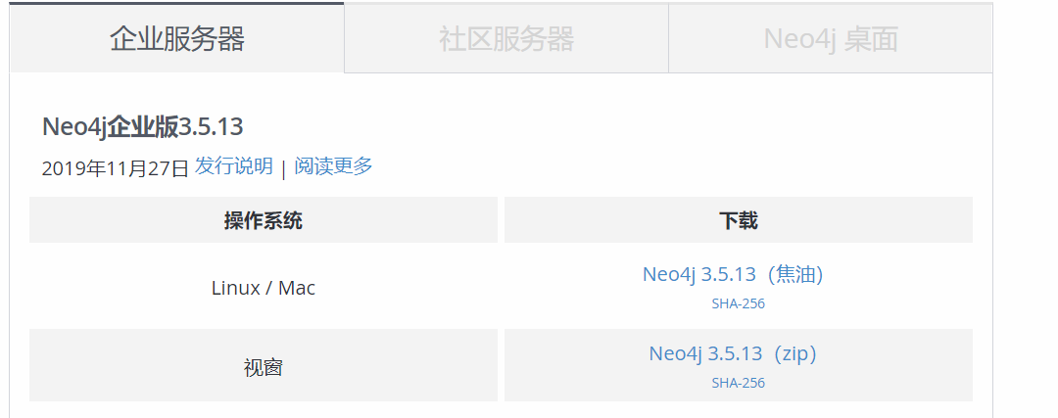

1. 访问微云数据主页：[http://we-yun.com/index.php/blog/releases-56.html](https://links.jianshu.com/go?to=http%3A%2F%2Fwe-yun.com%2Findex.php%2Fblog%2Freleases-56.html" \t "_blank)，提供国内ftp下载地址：[ftp://neo4j.55555.io/neo4j/3.5.6/](https://links.jianshu.com/go?to=ftp%3A%2F%2Fneo4j.55555.io%2Fneo4j%2F3.5.6%2F" \t "_blank)

## 安装

tar zxvf neo4j-community-3.5.6-unix.tar.gz -C ../servers/

cd /export/servers/neo4j-community-3.5.6/

vim conf/neo4j.conf

dbms.connectors.default\_listen\_address=0.0.0.0

dbms.connectors.default\_advertised\_address=0.0.0.0

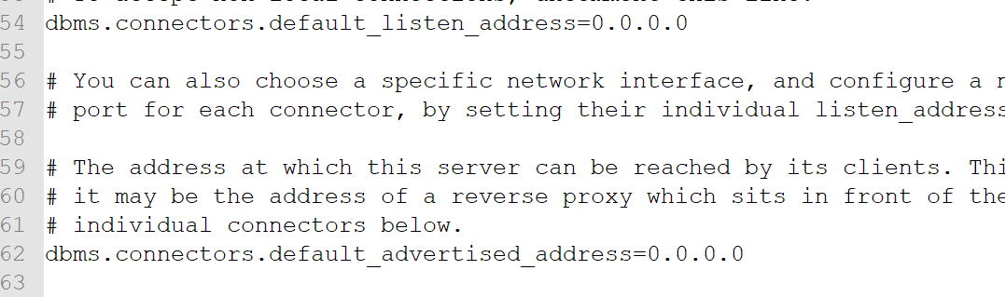

vi /etc/profile

export NEO4J\_HOME=/export/servers/neo4j-community-3.5.6

export PATH=:$NEO4J\_HOME/bin:$PATH

source /etc/profile

## 启动neo4j服务

neo4j start

## 访问web

<http://192.168.52.129:7474/browser/>

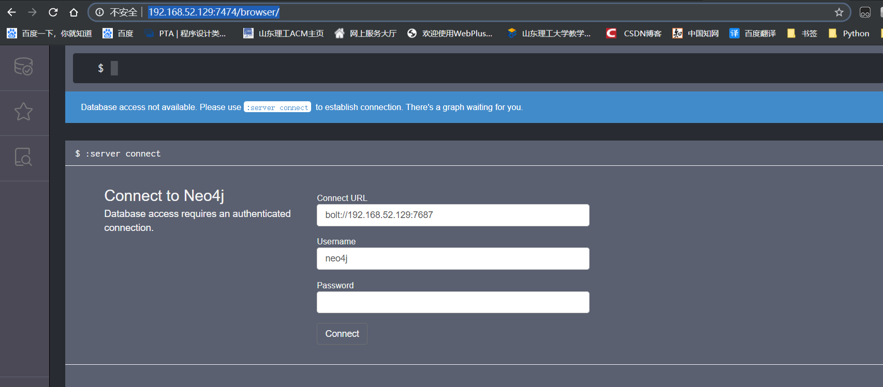

登录界面默认填充了用户名neo4j。

输入默认密码neo4j后，修改密码123456，进入neo4j

# Python访问Neo4j

安装驱动

pip install neo4j-driver

导包

from neo4j import GraphDatabase

建立连接

driver=GraphDatabase.driver("bolt://192.168.52.129",auth=("neo4j", "123456"))

session = driver.session()

传递Cypher语句

session.run("CREATE (a:Persion {name:'alice'})")  
result=session.run("MATCH (a:Persion) RETURN a.name")  
for i in result:  
 print(i['a.name'])  
  
result = session.run("MATCH (a:Persion) RETURN a")  
for i in result:  
 print(i['a'])

关闭连接

session.close()

