Unit 7 – Summary Measures and Hypothesis Testing
Summary Measures Interpretation (Exa 7.1B)
The summary statistics for Diets A and B provide a straightforward comparison of how effective each programme appears before applying more advanced tests. Diet A shows a higher mean weight loss (5.341 kg) than Diet B (3.710 kg), suggesting it produces better results on average. Both diets display similar variability, meaning the outcomes within each group are relatively consistent. These descriptive measures help highlight initial performance differences and show how summary statistics can give quick insight into patterns worth exploring further through hypothesis testing.
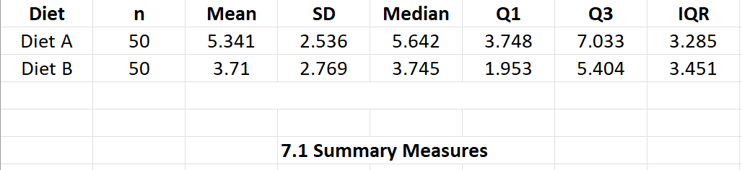
Quartiles and Interquartile Range (Exa 7.2B)
Looking at the quartiles adds further detail to the comparison between the diets. Diet A has a higher median weight loss (5.642 kg), while its IQR (3.285 kg) shows that participants’ results varied more widely. Diet B has a lower median (3.745 kg) and a slightly wider IQR (3.451 kg), reflecting lower but more evenly distributed outcomes. This additional breakdown reinforces that Diet A generally delivers stronger weight-loss results, whereas Diet B’s outcomes are more tightly clustered. Quartile analysis therefore supports the earlier conclusion from the summary measures.
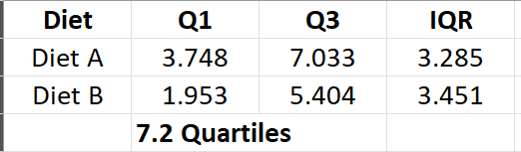
Brand Preferences Across Two Areas (Exa 7.3D)
The comparison of brand preferences across the two areas highlights clear patterns in the categorical data. In Area 1, 'Other' brands account for more than half of all choices, and the same is true in Area 2. Brand B is slightly more popular in Area 2, while Brand A remains the least preferred. These differences illustrate how frequencies and percentages can quickly show regional variation in consumer behaviour.
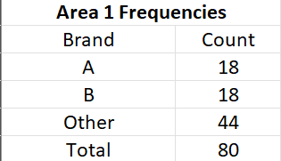
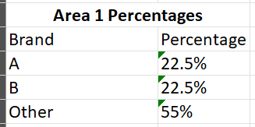
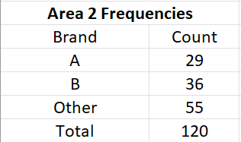
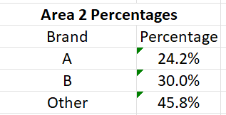
Paired Comparison: Con1 vs Con2 (Ex 7.4F)
The paired comparison between Con1 and Con2 measurements shows that Con1 is generally higher than Con2. The mean difference of 13.2 indicates that, across the stores, Con1 consistently produced larger values. Although there is some variation in the differences, the overall pattern suggests a meaningful difference between the two measures. This type of paired analysis helps determine whether observed differences are systematic rather than random.
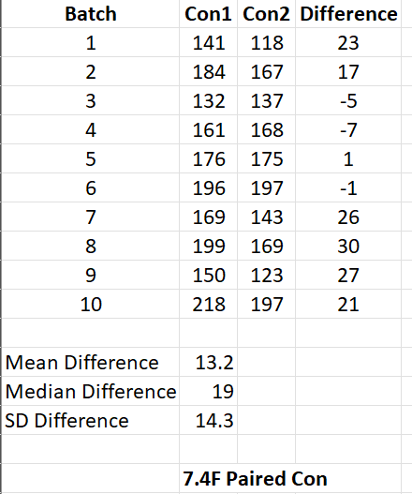
Paired Comparison: Agent1 vs Agent2 (Ex 7.4G)
The analysis of the two agents shows that Agent 2 typically records higher values than Agent 1. The average difference (-0.433) indicates that Agent 1 tends to produce slightly lower measurements across the batches. The differences are small and relatively consistent, demonstrated by the modest standard deviation. This suggests a minor but noticeable bias between the two agents.
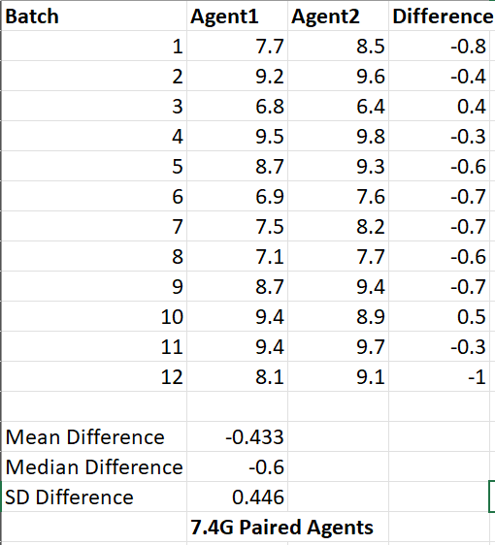
Independent Samples t-Test: Diet A vs Diet B (Exa 7.6B)
The independent samples test shows a clear difference in effectiveness between the diets. Diet A produced a higher mean weight loss than Diet B, and this difference was statistically significant (t = 3.07, p = 0.003). The confidence interval for the mean difference (0.58 to 2.69) confirms that Diet A consistently leads to greater weight loss. These results provide strong evidence that Diet A is more effective, supporting the patterns seen in the descriptive statistics and demonstrating the value of inferential testing in confirming initial observations.
