Unit 8 – Charts and Analysis Report
1. Introduction
This report presents a statistical analysis of several datasets using graphical and tabular methods. The aim is to interpret patterns, compare distributions, and evaluate how different visualisation techniques support data understanding. Tables and charts created in Excel have been imported to illustrate findings relating to brand preferences, species prevalence, and weight-loss outcomes.
2. Brand Preferences Analysis
Figure 1. Brand Preferences – Area 1 and Area 2 (Table)
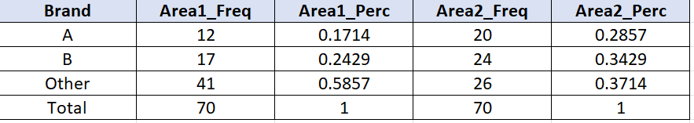
Figure 1 displays the frequency and percentage distribution of brand preferences for Areas 1 and 2. Area 1 shows that most respondents preferred 'Other' brands, with Brand B more popular than Brand A. In Area 2, the distribution is more evenly spread between the named brands and 'Other', indicating differences in brand awareness or availability between locations.
Figure 2. Brand Preferences – Area 1 and Area 2 (Chart)
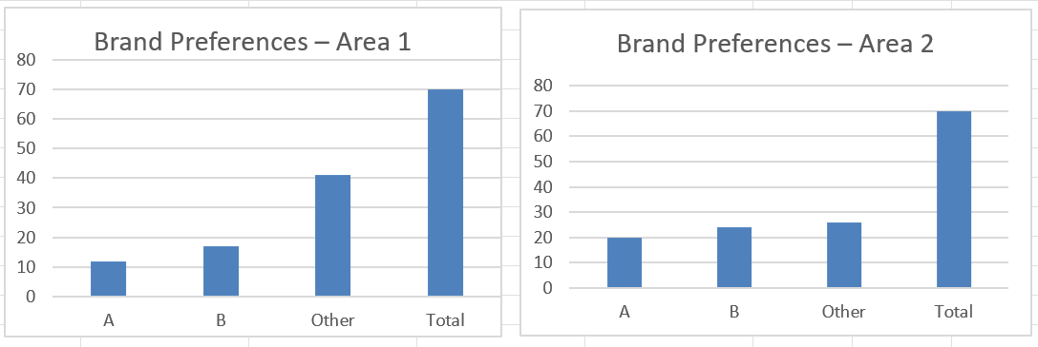
The bar chart provides a visual comparison of the two areas, making it easier to see that Area 2 has relatively higher counts for Brands A and B, while Area 1 has a stronger skew towards 'Other'. This type of grouped bar chart is appropriate for comparing categorical frequencies across two groups.

3. Heather Prevalence Analysis
Figure 3. Heather Prevalence by Location (Table)
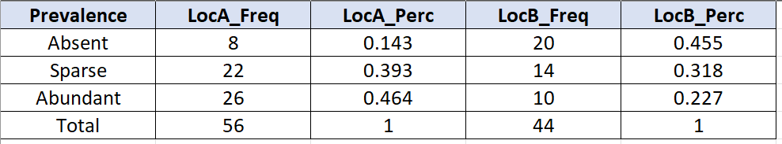
Figure 3 shows the frequencies and percentages of heather prevalence (Absent, Sparse, Abundant) at two locations. Location A has more transects in the Abundant and Sparse categories, while Location B has a higher proportion of Absent transects. This suggests that Heather is more established at Location A.
Figure 4. Heather Prevalence by Location (Chart)
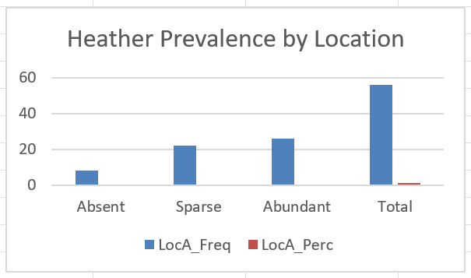
The clustered column chart reinforces these differences by visualising the relative heights of the bars for each prevalence category. The chart quickly communicates that Abundant Heather is more common at Location A, whereas Location B has a higher count of Absent transects.
4. Weight-Loss Analysis: Diet A and Diet B
Figure 5. Diet A – Grouped Frequency Table
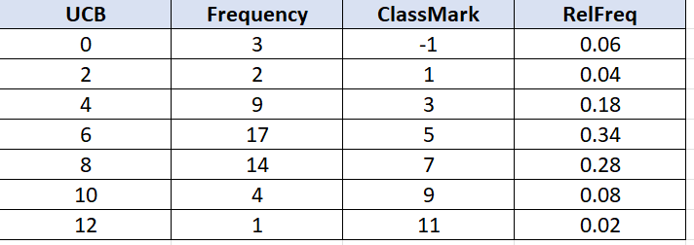
Figure 5 summarises the grouped weight-loss data for Diet A using class boundaries, class marks and relative frequencies. Most observations fall into the mid-range classes, indicating typical weight loss around the central values, with fewer participants showing very low or very high changes.
Figure 6. Diet A Weight-Loss Distribution (Chart)
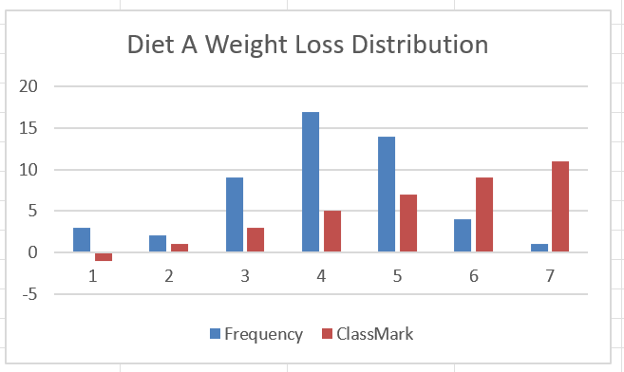
The Diet A chart presents the same information in visual form. The tallest bars occur in the middle classes, and the distribution tails off towards the extremes. This suggests a unimodal distribution centred on moderate weight loss.
Figure 7. Diet B – Grouped Frequency Table
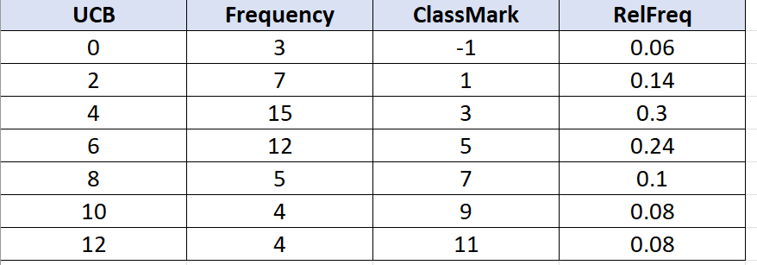
Figure 7 shows the grouped weight-loss data for Diet B. Frequencies are again highest in the mid-range classes, but the relative frequencies of the upper classes are slightly larger than for Diet A. This indicates that a higher proportion of participants on Diet B achieved greater weight loss.
Figure 8. Diet B Weight-Loss Distribution (Chart)
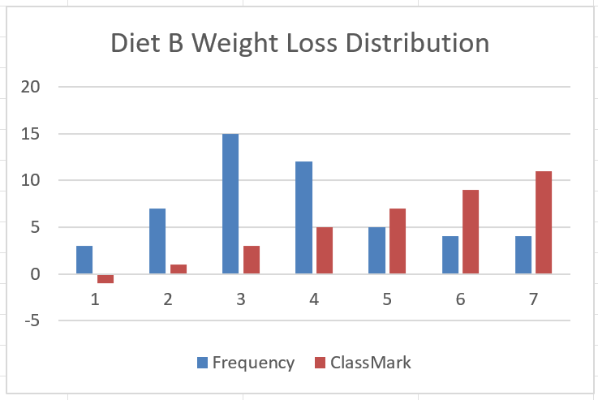
The Diet B chart highlights the heavier tail at higher class marks when compared with Diet A. This suggests that Diet B may be slightly more effective for achieving larger weight reductions, though a formal hypothesis test would be needed to confirm statistical significance.
5. Discussion and Evaluation
Across the datasets, the combination of tables and charts enhances interpretation. Frequency and percentage tables provide precise numerical summaries, while bar charts and histograms allow rapid visual comparison of patterns. For the brand preference and Heather datasets, bar charts are appropriate because the variables are categorical. For the diet data, grouped frequency tables and histograms are suitable for continuous weight-loss measures. Using both representations supports more robust conclusions about differences between groups and the spread of values within each dataset.
6. Conclusion
This report demonstrates how descriptive statistics and graphical displays can be used together to summarise and interpret data from different applied contexts. The analysis highlights contrasts in consumer behaviour, ecological conditions and dietary outcomes. Presenting both tables and charts meets the requirements of the unit by showing a clear understanding of data analysis processes and effective communication of statistical findings.

