FUTURE-READY CLOUD STRATEGY FOR MEDLIFE DIAGNOSTICS

# 

**Table of Contents**

1) Company & Problem Context 3

2) Executive Summary 3

3) Cloud Solution Design with IaC 4

3.1 Design principles 4

3.2 Target architecture 4

3.3 Environments & release path 5

3.4 Infrastructure as Code plan 6

3.5 Cost management 7

4) Integrating AI, Automation & Hybrid Cloud 8

5) Risk & Compliance 9

6) Future Recommendations 11

References 13

# 1) Company & Problem Context

The sector selected is healthcare, which is based on MedLife Diagnostics, a mid-sized medical diagnostics company with 15 branches in India. MedLife works with patient data that is highly sensitive, including electronic health records (EHRs), laboratory reports, and images information, therefore, there should be a high level of compliance with the data protection requirements. These are the key business catalysts: cost-saving, faster delivery of test results, adherence to the regulations, AI-based diagnostics, and increased resiliency of the system to deliver continuous services. The company, however, is not without its share of limitations: it does not have an IT budget, trained cloud specialists, and old systems, and healthcare regulations restrict the data residency and latency of the systems. These problems demand a secure, scalable, and automated cloud infrastructure strategy to modernise the operations and offer a better workflow in patient care.

# 2) Executive Summary

The challenge that has been faced by MedLife Diagnostics has been slow data processing, high costs in infrastructure and low scalability due to the reliance on the on-premises servers and the broken legacy. The issues linked with compliance to the healthcare data rules and the need to access the records related to the patients in different branches; furthermore, the access must be secured and in real-time. The vision of digital transformation is to assist the firm to provide quicker services, cost-effective and develop improved data-driven insights.

The proposed cloud would be to migrate to the hybrid cloud platform of the Microsoft Azure that will integrate the on-premises data centres with the secure cloud services to create the balance between control and flexibility. With the solution, automated provisioning, configuration, and scaling will be a possibility using Terraform as an Infrastructure as Code (IaC) solution. The architecture will include microservices delivered as containerised, which is deployed using the Azure Kubernetes Service (AKS), serverless data pipeline, which is deployed using the Azure Functions, and CI/CD whereby it will be integrated with the help of the Azure DevOps as a tool of continuous deployment and testing.

The expected outcomes will be the reduction of the lead time of the service by 60 percent, decrease of the cost of infrastructure by 30 percent, triple the number of deployment frequency, less than 30 minutes RTO, and 99.95 percent uptime of the critical services. Those measurable KPIs will ensure a better level of operational efficiency, legal requirements, and faster delivery of healthcare insight and ultimately patient experience and corporate strength.

# 3) Cloud Solution Design with IaC

## 3.1 Design principles

The cloud solution is built upon the principles of the Well-Architected Framework, which focuses on security, reliability, performance efficiency, cost optimisation, and operational excellence. Encrypted data storage, IAM controls, and constant monitoring are the priorities of security and compliance. Scalable performance, automated management of infrastructure, and sustainable use of resources are other concerns of the architecture to reduce waste and enable prolonged business expansion.

## 3.2 Target architecture

The architecture to be proposed to MedLife Diagnostics follows a hybrid cloud model, based on the use of Azure to interconnect on-premise systems with cloud-based services to achieve security in scaling. Azure Kubernetes Service (AKS) is used to support compute and runtime operations associated with containerised applications (e.g., patient portal, scheduling system) that need uptime to ensure reliability, whereas Azure Functions (serverless) is used to support event-driven workloads such as notifying patients about their test results (Ramakrishnan *et al.,* 2025). Autoscaling is a performance and cost-efficient method of scaling the compute resources according to demand in a dynamic fashion.

The data layer consists of an Azure SQL Database is used to support transactional workloads, an Azure Data Lake is used to support analytics and AI-driven diagnostics, and geo-redundant backups with cross-region replication are used to support disaster recovery. Networking will use a hub-and-spoke topology, which includes a Web Application Firewall (WAF) and Zero Trust principles to provide a safe data flow between branches and cloud services.

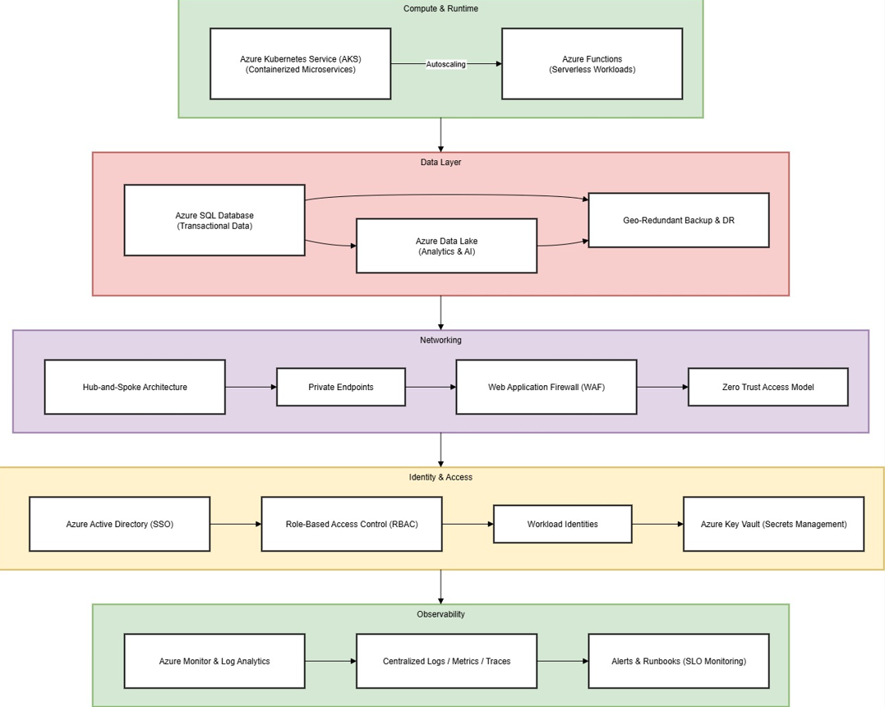

**Figure 1: Target Cloud Architecture for MedLife Diagnostics**

(Source: Self-Created)

Azure Active Directory (AAD) is used by identity and access management as Single Sign-On (SSO) and role-based access control (RBAC), and the secrets are stored in the Azure Key Vault. To enable observation, centralised logging, metrics, and tracing are managed through Azure Monitor and Log Analytics, with the assistance of Service Level Objectives (SLOs) and automatic alerts and runbooks to manage issues and respond to incidents proactively.

## 3.3 Environments & release path

The suggested cloud solution is based on a systematic Dev-Test-Prod environment design to provide stability and reliability in deployment levels. The Development environment also encourages continuous integration and experimentation, in which the feature branches and feature flags are used by the developers to allow or disable functionality to be done without impacting production (Vellela *et al.,* 2023). Test environment replicates production in order to test performance, security, and compliance using automated CI/CD pipelines in the Azure DevOps. After being validated, there are policy checks and automated approval gates that promote changes to production.

Within the Production environment, deployment is done with the help of a blue/green strategy in order to reduce downtime and risk. New versions are deployed in a parallel environment and switched upon validation. In the case of high-impact updates, they are released as canary releases, which are gradually introduced to a small number of users to check stability before being released to all users. This is a controlled release path that is used to guarantee consistency in delivery, fast rollback, and high availability without jeopardising compliance and user trust.

## 3.4 Infrastructure as Code plan

The selected IaC tool is Terraform, which was chosen due to its ability to be multi-cloud compatible, modular, and powerful in state management, which would be a perfect fit in the hybrid deployment of Azure in MedLife. Terraform allows the infrastructure to be consistently and repeatably provided and can also be integrated with the Azure DevOps pipeline to be automated. The repository structure is modular: it consists of a root directory where reusable modules (network, compute, and storage) are stored, distinct environment directories (dev, test, and prod), and Git-managed versions of a configuration. This enhances reusability, traceability, and effective cooperation.

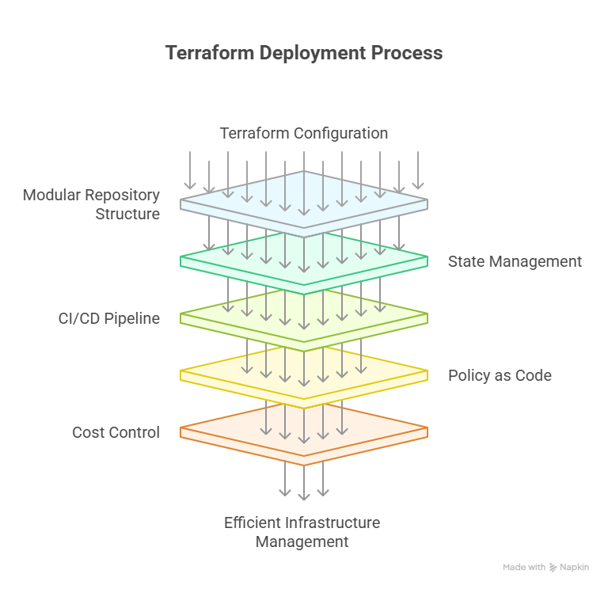

**Figure 2: Terraform Deployment Process**

(Source: Self-Created)

The state is stored in an Azure Storage backend, which is locked to ensure that only one person can change the remote state at a time. CI/CD pipelines implement a pull request (PR)-driven process, where a change is automatically checked and reviewed by a colleague, then the following stages of the plan are gated by checks, plan, and apply (Dhanalakshmi and George, 2022). The implementation of Policy as Code is based on Terraform Cloud and Azure Policy and touches on the compulsory resource tagging, encryption-by-default, and networking guardrails alongside the allowance of drift detection to ensure configuration integrity. In cost control, Terraform templates have optimised instance size, autoscaling policy, non-production resource shutdown timetable, and tiered storage lifetime, which guarantee predictable costs and sustainable resource expenditure without affecting the system performance and normativity.

## 3.5 Cost management

MedLife uses FinOps in order to be financially accountable and cost-efficient in the clouds. The project, environment, and owner tags are applied to all the cloud resources to allow tracking and reporting on a granular basis. Azure Cost Management has budgets and spending alerts, which are set to alert teams when there is a threshold violation. Usage dashboards give an insight into resource use, allowing the use of data to make decisions to optimise it (Chang *et al.,* 2021). A monthly regular rightsizing cadence is enacted monthly reviews assessing underutilised or idle resources to either adjust or deallocate them. All these combined help to maintain cost governance, transparency in operations, and effective usage of cloud assets in every environment.

# 4) Integrating AI, Automation & Hybrid Cloud

In the case of MedLife Diagnostics, AI and automation play a key role in improving the accuracy of diagnosis, the efficiency of operations, and compliance. The identification of two critical AI/ML applications is made, namely, AI-assisted diagnostics and anomaly detection in lab equipment data. The processing of the data starts with the ingestion of structured (EHR, lab results) and unstructured (imaging data) data into Azure Data Lake (Cresswell *et al.,* 2022). Purified and converted data is input to the Azure Machine Learning (AML) to train and deploy a model. Versioning, containerisation, and deployment of models via MLOps pipelines provide continuous retraining and monitoring of models. Regulatory compliance is implemented through lineage tracking, fairness checks, as well as audit trails in order to impose model governance. Drift monitoring guarantees the consistency and dependability of models in diagnostics in reality.

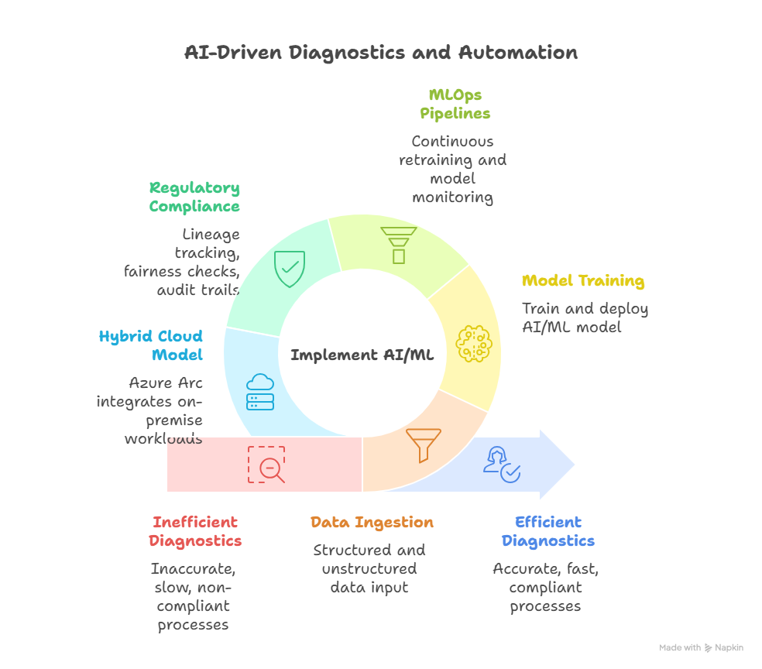

**Figure 3: AI-Driven Diagnostics and Automation**

(Source: Self-Created)

The hybrid cloud model is critical because regulatory data residency laws must be fulfilled, and access to local lab systems must have low latency. Azure integrates on-premise workloads using Azure Arc, which expands policy, inventory, and security management to hybrid environments (Lakshmi *et al.,* 2021). A single system of monitoring and compliance policies ensures their security posture is consistent, with safeguarded patient information, and takes advantage of the scalability of the cloud to provide analytics and AI workloads. With this approach, phased migration, regulatory compliance, and intelligent automation are possible, as well as the enhancement of patient service delivery and operational resilience.

# 5) Risk & Compliance

MedLife Diagnostics' risk and compliance framework will be aimed at being proactive in dealing with operational, security, and regulatory risks concerning the adoption of the cloud in healthcare. Among the main risks, one may single out misconfiguration, which may result in either security vulnerabilities or downtime, and is addressed by standardised IaC modules, peer code reviews, Policy as Code enforcement, and continuous conformance monitoring. The least privilege principles, Multi-Factor Authentication (MFA), Azure Key Vault, secret-less authentication, and frequent key rotation are used as means of managing identity and credential risks, which may be unauthorised access or misuse of privileges (Al-Araji *et al.,* 2025). Encryption in transit and at rest, sensitive information tokenisation, irrevocable backups, and geo-redundant storage discourage the risks of data leakage, regulatory breaches, and other information risks. Multi-AZ/ multi-region deployment, autoscaling, capacity test, chaos/game day exercise are used to mitigate the risks of availability and resilience. Containers, open-source IaC, portable data formats, and a hybrid cloud strategy minimise vendor lock-in, and regulatory compliance is ensured through data classification, retention policy, audit logging, and access review (Sun *et al.,* 2021). This is a systematic way of securing, being reliable, and, in addition, compliant cloud operations.

|  |  |  |  |
| --- | --- | --- | --- |
| **Risk** | **Impact** | **Likelihood** | **Mitigation Strategy** |
| Misconfiguration | Security vulnerabilities or downtime due to incorrect setup. | Medium | Use standardised IaC modules, enforce peer code reviews, implement Policy as Code via Azure Policy, and apply continuous compliance monitoring to detect drift. |
| Identity & Credentials | Unauthorised access leading to data breaches or privilege misuse. | High | Apply least privilege access, enforce Multi-Factor Authentication (MFA), store secrets in Azure Key Vault, enable secret less authentication, and schedule key rotation regularly. |
| Data Protection | Data loss, leakage, or regulatory non-compliance. | High | Ensure encryption at rest and in transit, use tokenisation for sensitive data, maintain immutable backups, and enable geo-redundant storage for disaster recovery. |
| Availability & Resilience | Service disruption affecting critical healthcare operations. | Medium | Deploy across multiple availability zones and regions, use autoscaling, perform capacity testing, and conduct chaos engineering/game days to validate recovery. |
| Vendor Lock-in | Limited flexibility or high migration cost. | Low | Use containers, open-source IaC (Terraform), portable data formats, and maintain a hybrid landing zone as an exit path. |
| Regulatory Compliance | Legal penalties or trust loss due to non-compliance. | High | Implement data classification, retention policies, audit logging, and access reviews, and ensure all processing has a lawful basis under healthcare data regulations. |

# 6) Future Recommendations

In the case of MedLife Diagnostics, the recommendations for the future are based on the new technologies, organisational efficiencies, and readiness of the organisation to make the cloud environment resilient, secure, and sustainable. Edge computing is recommended in the case of low-latency needed processing, e.g., IoT-enabled lab equipment, real-time patient monitoring, or scanners (Nancy *et al.,* 2022). The edge nodes are capable of processing data at the edge and integrating with the central control plane, which has a centralised analytics hub, security policy, and orchestration, to ensure there is a uniform governance of the hybrid environments. Cryptographic standards are also changing with quantum-readiness and crypto-agility becoming more critical. MedLife needs to catalogue the existing cryptographic tools, design and maintain algorithm agility, and track new quantum-safe standards, so that they can be flexible without necessarily obsoleting systems that are currently safe. The notion of sustainability can be instituted in cloud operations through rightsizing the compute power, scheduling scale-down on non-production workloads, setting up the tiered storage lifecycle, and using carbon-aware placement of regions, consequently minimising the costs and the environmental impact. The success of adoption is dependent on skills development and change in an organisation (Ijaz *et al.,* 2021). An IT training plan should help the employees to understand cloud-native solutions, AI/ML processes, and optimal security practices. The formation of a platform engineering team and internal service catalogue will make teams resourceful, add standards, and reduce operational friction. MedLife can proactively address these areas to enable it to future-proof its cloud strategy, to be regulatorily compliant, to be more resilient, and bring about an improvement in its patient outcomes without affecting its agility, security, and sustainability.

# 

# References

Al-Araji, Z.J., AlKhaldee, M.S., Mutlag, A.A., Abdulkadhim, Z.A., Farhood, H.M., Ahmad, S.S.S., Hikmat, N.N., Yassen, A., Al-Dulaimi, A.A.I., Al-Sheikh, N.N.H. and Ali, A.H., 2025. Healthcare Security in Edge-Fog-Cloud Environment using Blockchain: A Systematic Review. Mesopotamian Journal of CyberSecurity, 5(2), pp.606-635.

Chang, S.C., Lu, M.T., Pan, T.H. and Chen, C.S., 2021. Evaluating the E-health cloud computing systems adoption in Taiwan’s healthcare industry. Life, 11(4), p.310.

Cresswell, K., Domínguez Hernández, A., Williams, R. and Sheikh, A., 2022. Key challenges and opportunities for cloud technology in health care: Semistructured interview study. JMIR human factors, 9(1), p.e31246.

Dhanalakshmi, G. and George, V.S., 2022. Security threats and approaches in E-Health cloud architecture system with big data strategy using cryptographic algorithms. Materials Today: Proceedings, 62, pp.4752-4757.

Ijaz, M., Li, G., Lin, L., Cheikhrouhou, O., Hamam, H. and Noor, A., 2021. Integration and applications of fog computing and cloud computing based on the internet of things for provision of healthcare services at home. Electronics, 10(9), p.1077.

Lakshmi, G.J., Ghonge, M. and Obaid, A.J., 2021. Cloud based IoT Smart Healthcare System for Remote Patient Monitoring. EAI Endorsed Transactions on Pervasive Health & Technology, 7(28).

Nancy, A.A., Ravindran, D., Raj Vincent, P.D., Srinivasan, K. and Gutierrez Reina, D., 2022. Iot-cloud-based smart healthcare monitoring system for heart disease prediction via deep learning. Electronics, 11(15), p.2292.

Ramakrishnan, P., Jalaludeen, A.M., Gnanasekaran, L., Sundaram, T., Chopra, S. and Chopra, H., 2025. IoT-Enabled Smart Implants Surgery: Revolutionising Precision, Monitoring and Patient Safety. Scripta Medica, 56(3), pp.599-602.

Sun, J., Yuan, Y., Tang, M., Cheng, X., Nie, X. and Aftab, M.U., 2021. Privacy-preserving bilateral fine-grained access control for cloud-enabled industrial IoT healthcare. IEEE Transactions on Industrial Informatics, 18(9), pp.6483-6493.

Vellela, S.S., Reddy, B.V., Chaitanya, K.K. and Rao, M.V., 2023, January. An integrated approach to improve e-healthcare system using dynamic cloud computing platform. In 2023 5th International Conference on Smart Systems and Inventive Technology (ICSSIT) (pp. 776-782). IEEE.