**Microsoft Azure Resource Manager**

**A Framework for Modern Cloud Operations**

Mustafa Hussein, Farhad Karimov, Matteo Marchi and Tobias Zeier, the 8th of September 2025

University of Essex Online

# Introduction

This report critically evaluates Microsoft Azure Resource Manager (ARM) as a framework for modern cloud operations. It examines ARM’s features, service models, deployment approaches, and its role in enterprise governance. The analysis also considers limitations such as multi-cloud interoperability, comparing ARM with AWS CloudFormation and Terraform.

# Understanding ARM's Core Features and Hierarchy

Azure Resource Manager (ARM) is the control plane for all Azure resources, providing consistent request processing across interfaces such as the Portal, CLI, PowerShell, REST API, and SDKs (Gupta, 2023). Its functionality can be categorised into four main areas:

* **Authentication and Authorisation**: Azure Active Directory (AD) with Role-Based Access Control (RBAC).
* **Validation and Dependency Handling**: Ensures resources are provisioned in the correct sequence.
* **Routing Requests**: Directs commands to the relevant resource provider.
* **Governance and Organisation**: Implements policies, locks, tags, and cost visibility (Gao, 2025a).

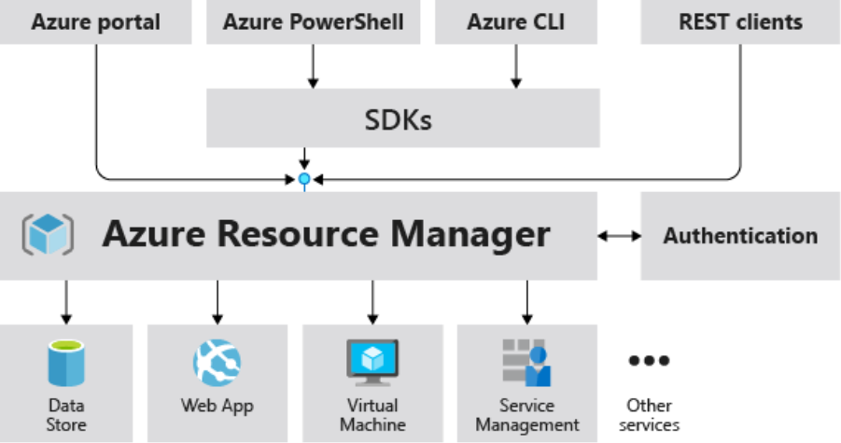

Figure : How Azure Resource Manager Serves as a Control Plane (Gao, 2025a)

ARM’s scope hierarchy – Management Groups, Subscriptions, Resource Groups, and Resources – enables governance cascading from high-level organisational controls down to individual services (Gao, 2025a). This layered structure facilitates enterprise-wide compliance while retaining flexibility for specific workloads. Additional core capabilities include Infrastructure-as-Code (IaC) via Bicep or JSON templates, automation through idempotent deployments, what-if previews for evaluating deployment impacts, deployment stacks, and CI/CD tool integration (Gao, 2025b).

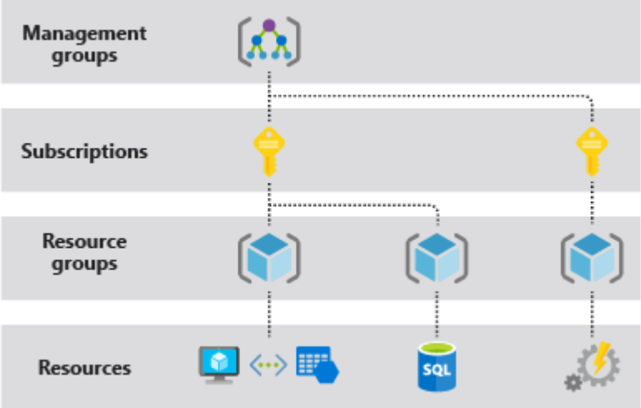

Figure : ARM’s Hierarchical Governance Structure (Gao, 2025a)

## Comparing ARM, AWS CloudFormation, and Terraform

Both ARM and AWS CloudFormation deliver declarative IaC, but their focus and execution differ:

* **Template Language**: ARM supports JSON and Bicep, whereas CloudFormation supports YAML and JSON (AWS, 2025).
* **Change Previews**: ARM provides *what-if* analysis; AWS uses Change Sets.
* **Governance**: ARM integrates with Azure AD and Policies; AWS relies on IAM and Config.
* **Hierarchy**: ARM applies management group, subscription, and resource group governance; AWS applies account and stack-based governance.

ARM’s direct integration into Microsoft’s ecosystem provides stronger compliance and policy enforcement, particularly in highly regulated industries. However, this comes at the cost of vendor lock-in, where organisations become heavily dependent on Azure-native services. In contrast, AWS benefits from ecosystem maturity and a wider user base, while Terraform adds flexibility through multi-cloud abstraction (Koneru, 2025). For enterprises prioritising resilience and interoperability, reliance on ARM alone may prove restrictive.

# Service Model Analysis

ARM operates across Azure’s service models, unifying governance and orchestration.

## IaaS Support

ARM automates the provisioning of VMs, virtual networks, and storage accounts. Declarative IaC ensures repeatability and security, with RBAC and Policy reducing misconfiguration risks (Morris, 2021; Gao, 2023). These features enhance operational resilience by embedding governance directly into infrastructure.

## PaaS Support

ARM provisions Azure App Services, SQL Databases, and Azure Kubernetes Service (AKS) via templates. This supports full application stack automation, enabling DevOps integration with CI/CD pipelines and reducing time-to-market (Gupta, 2024).

## SaaS Support

ARM indirectly supports SaaS by managing compliance for Microsoft 365 and Dynamics 365. Azure AD policies restrict access to compliant devices, strengthening enterprise security (Mell and Grance, 2011; Gao, 2023). However, ARM’s limited interoperability with third-party SaaS platforms constrains organisations that adopt diverse vendor ecosystems.

## Strengths and Limitations

The primary advantages of ARM include its unified governance system together with its scalability features and its ability to integrate with various ecosystems (Gupta, 2024). The platform delivers one of the most seamless IaaS, PaaS and SaaS combinations. The main difficulties with ARM stem from its complex JSON templates which Bicep helps address and its restricted ability to work across multiple clouds when compared to Terraform (Morris, 2021). The platform provides robust SaaS support for Microsoft solutions but its support for third-party platforms remains limited.

# Deployment Types

ARM facilitates governance and automation across public, private, and hybrid cloud environments.

## Public cloud (Azure).

ARM serves as Azure’s native control plane, enabling elasticity, automation, and global reach. Policies and RBAC enforce compliance and least-privilege access (Gao, 2025a). However, enterprises must manage egress costs and plan for resilience under the shared responsibility model.

## Private cloud (Azure Stack Hub).

For data sovereignty or low-latency requirements, ARM operates on-premises via Azure Stack Hub. While this preserves governance consistency, capacity remains hardware-bound and less elastic than public deployments (Rahman, Mahdavi-Hezaveh and Williams, 2019).

## Hybrid (Azure Arc + ARM).

Hybrid approaches project non-Azure resources into ARM’s control plane, reducing configuration drift but raising compliance challenges, particularly for GDPR Article 17 obligations (Kelly, Furey and Curran, 2021). Hybrid deployments balance governance centralisation with flexibility across environments.

## Balancing Compliance and Flexibility in ARM Deployments

Public Azure offers agility and broad policy coverage, private Azure ensures sovereignty and locality, while hybrid models centralise governance yet accommodate latency and placement needs. Organisations must balance compliance through auditable erasure (Kelly, Furey and Curran, 2021), the requirement for repeatable IaC pipelines (Rahman, Mahdavi-Hezaveh and Williams, 2019), and the trade-off between elastic scalability and hardware-bound capacity (Gao, 2025a).

# Designing Cloud Infrastructure with ARM

Designing infrastructure with ARM typically involves:

1. **Defining Governance**: Establish resource groups, policies, and RBAC (Artiom, 2025).
2. **Networking**: Configure VNets, subnets, and firewalls (Gao, 2023).
3. **Compute**: Provision VMs with monitoring and security extensions (Patni, Banerjee and Tiwari, 2020).
4. **Storage**: Attach accounts with redundancy and encryption options (Patni, Banerjee and Tiwari, 2020).
5. **Automation**: Employ templates for repeatability and auditability (Patni, Banerjee and Tiwari, 2020).

## Case Study: ASOS

ASOS, an online retailer, adopted ARM templates to automate deployments and enforce governance. This approach reduced manual error and generated savings of 15–20%, increasing to 25–40% after optimisation (Margetts, 2021). Provisioning times fell from weeks to hours, boosting agility (FitzMacken, 2025; Gao, 2025). The case illustrates broader trends: enterprises seek automation not only to reduce costs but also to embed compliance and governance in operations (Lane, 2025).

# ARM's Strengths, Limitations, and Multi-Cloud Role

ARM delivers strong governance and automation, but its effectiveness is most pronounced for organisations committed to Microsoft’s ecosystem. Multi-cloud strategies expose its weaknesses: limited SaaS integration and reduced interoperability. Terraform, in contrast, offers greater portability and vendor neutrality. Thus, ARM’s role may be complementary rather than comprehensive in multi-cloud strategies.

Nevertheless, ARM provides deep integration benefits. Its governance and compliance mechanisms are unmatched within Azure, making it particularly attractive to enterprises in regulated industries. The trade-off lies in balancing agility and compliance against interoperability and vendor lock-in. For many organisations, a hybrid orchestration strategy combining ARM with Terraform may represent the most pragmatic solution.

# Conclusion

Microsoft Azure Resource Manager (ARM) provides a robust governance and deployment framework that integrates IaaS, PaaS, and SaaS services within Azure. Its main advantages include unified automation, strong compliance features, and scalability. However, its limitations – template complexity, lack of multi-cloud support, and restricted SaaS integration – reduce its appeal for organisations seeking vendor neutrality. ARM is therefore best positioned for enterprises deeply embedded in the Microsoft ecosystem, while those prioritising multi-cloud flexibility should complement it with tools such as Terraform.

**Word Count:** 1,137

**References:**

Artiom, K. (2025). ‘Cloud Migration Framework: Transitioning from On-Premises to Azure Cloud for Improved System Reliability and Scalability’. *The American Journal of Applied Sciences*, 7(2), pp. 5-11. Available at: <https://doi.org/10.37547/tajas/volume07issue02-02>

AWS (2025) *Update CloudFormation stacks using change sets*. Available at: <https://docs.aws.amazon.com/AWSCloudFormation/latest/UserGuide/using-cfn-updating-stacks-changesets.html> (Accessed: 21 August 2025).

FitzMacken, T. (2025) *What are ARM templates?*. Available at: <https://learn.microsoft.com/en-us/azure/azure-resource-manager/templates/overview> (Accessed: 23 August 2025).

Gao, J. (2023) *Azure Resource Manager overview. Microsoft Docs*. Available at: <https://learn.microsoft.com/en-us/azure/azure-resource-manager/> (Accessed: 19 August 2025).

Gao, J. (2025) *Deploy resources with ARM templates and Azure portal*. Available at: <https://learn.microsoft.com/en-us/azure/azure-resource-manager/templates/deploy-portal> (Accessed: 23 August 2025).

Gao, J. (2025a) *What is Azure Resource Manager?*. Available at: <https://learn.microsoft.com/en-us/azure/azure-resource-manager/management/overview> (Accessed: 21 August 2025).

Gao, J. (2025b) *What is Bicep?*. Available at: <https://learn.microsoft.com/en-us/azure/azure-resource-manager/bicep/overview> (Accessed: 21 August 2025).

Gupta, D. (2024). *The Cloud Computing Journey: Design and Deploy Resilient and Secure Multi-Cloud Systems with Practical Guidance*. 1st edn. Birmingham: Packt Publishing, Limited.

Kelly, M., Furey, E. and Curran, K. (2021) ‘How to achieve compliance with GDPR Article 17 in a hybrid cloud environment’, *Sci*, 3(1), p. 3. Available at: <https://doi.org/10.3390/sci3010003>

Koneru, K. (2025) ‘Infrastructure as Code (IaC) for Enterprise Applications: A Comparative Study of Terraform and CloudFormation’, *American Journal of Technology* , 4(1), pp. 1–29. Available at: <https://doi.org/10.58425/ajt.v4i1.351>

Lane, J. (2025) *Case Study: Data Driven DevOps with ADO*. Available at: <https://techcommunity.microsoft.com/blog/appsonazureblog/case-study-data-driven-devops-with-ado/4128814> (Accessed: 21 August 2025).

Margetts, I. (2021) *ASOS implements cost optimization to fashion innovation for the future*. Available at: <https://www.microsoft.com/en/customers/story/1375958406314056214-asos-retailers-azure> (Accessed: 23 August 2025).

Mell, P. and Grance, T. (2011) *The NIST Definition of Cloud Computing Recommendations of the National Institute of Standards and Technology (Special Publication 800-145)*. National Institute of Standards and Technology. Available at: <https://nvlpubs.nist.gov/nistpubs/Legacy/SP/nistspecialpublication800-145.pdf>. (Accessed 19 August 2025).

‌

Morris, K. (2021) *Infrastructure as code: dynamic systems for the cloud age*. 2nd edn. Sebastopol, California: O’Reilly Media, Incorporated.

Patni, J.C., Banerjee, S. and Tiwari, D. (2020) ‘Infrastructure as a Code (IaC) to Software Defined Infrastructure using Azure Resource Manager (ARM)’, *2020 International Conference on Computational Performance Evaluation (ComPE)*, Shillong, India, 2-4 July. IEEE. Pp. 575-578. Available at: <https://doi.org/10.1109/ComPE49325.2020.9200030>

Rahman, A., Mahdavi-Hezaveh, R. and Williams, L. (2019) ‘A systematic mapping study of infrastructure as code research’, *Information and Software Technology*, 108, pp. 65-77. Available at: <https://doi.org/10.1016/j.infsof.2018.12.004>