Problem Statement:

Design a system that allows its users to utilize the facilities of a hospital lab through a website.

Scope:

The online lab management database project encompasses the following functionalities: patient registration, test selection, lab-test history viewing, discounts display, home sample collection requests, online payment, test status updates, lab report delivery to patients, test result sharing with designated doctors/hospitals, and offering future test discounts to registered patients.

Stakeholders:

Patient

Manager   
  
Requirements:   
  
1) The system shall allow patients to register themselves.   
  
2) The system shall allow patients to select the tests based on the doctors’s recommendation.   
  
3) The system shall allow patients to see their lab-test history.   
  
4) The system shall allow patients to see the discounts available on different tests.  
  
5) The system shall allow patients to initiate a request for sample collection from their homes.  
  
6) The system shall allow patients to pay for their lab-reports through online transactions.  
  
7) The system shall allow the manager to update the test status of the patient.  
  
8) The system shall allow the manager to send lab-reports to the patient’s email.  
  
9) The system shall allow the manager to send the lab-reports to the designated doctor’s email.  
  
10) The system shall allow the manager to give discounts to the registered patients for any future tests.

11) The System shall allow the manager to update the registered patients details.

12)The System shall allow the manager to update the doctors details.

***Lab Management System Schema:***

**Test-Report:**

| Id | Test-Status |
| --- | --- |

**Patient:**

| Id | Gender | Name | Age | Address | Email | Phone | Password |
| --- | --- | --- | --- | --- | --- | --- | --- |

**Bill:**

| Id | Date |
| --- | --- |

**Lab-Test:**

| Id | Name | Price | Test-Type | Discount | Description |
| --- | --- | --- | --- | --- | --- |

**Doctor:**

| Id | Name | Hospital-name | Specialization | Email | Hospital Address |
| --- | --- | --- | --- | --- | --- |

**Manager:**

| Id | Email | Name | Password |
| --- | --- | --- | --- |

ERD:

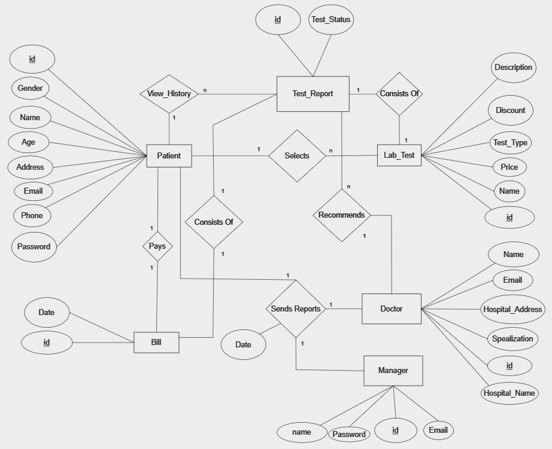

Mapping To Relational Tables:

