

Title of the Thesis

Name
neptun code

University Consultant’name, position

2025

Table of Content
Introduction 7
1. How to use this sample file, the recommended forms to be used in the thesis 8
1.1. The Structure of the Thesis 8
1.2. How to Form the Core Text, How to Apply Listing 8
1.3. Figures, Tables, Formulas 9
1.3.1. Forming the Figures 9
1.3.2. Forming the Tables 10
1.3.3. Forming the Formulas 10
1.3.4. How to implement and Position the Source-code into the Thesis 10
2. Further requriements for the thesis/diploma 11
2.1. The Structure and the Idioms of the Thesis 11
2.2. The Formal Structure of the Thesis 11
2.3. The Length of the Thesis 12
2.4. How to Refer to Literature and Idicate References in the Thesis 12
2.5. The Guide-lines for Technological Documewntation 13
2.6. Softvwares 13
2.7. How to Upload the Thesis and the Related Documents into the Electronic System 13
Summary (conclusions) 15
Summary/Zusammenfassung (just for those who write the thesis in hungarian) 16
list of figures 17
references 18
attachments 19

After typing and formatting the text, the table of contents must be updated. To update, please use right-click on any element in the table of contents and select Update Fields. In the dialog box that appears, select Update Entire Table of Contents.

Introduction
The thesis must be edited in a format that suggesred in this the template, using the thesis styles included in it (all of the styles to be used have the prefix szd_)
This thesis/diploma plan template has been created with the formatting described below, so it can be used to write your thesis.
The page setting of the thesis should be as follows: page size: A/4, all margins should be 2.5 cm, and the binding margin should be 5 mm. (For single-sided printing, the binding margin should be on the left, and for double-sided printing, it should alternate accordingly.)
The body of the thesis is in Normal style, size 12, Times New Roman font. There is no space before paragraphs, 6 pt after them, the body of the text is justified. The indentation of the first line is 0.7 cm. The line spacing of the text is 1.5. It is recommended to use automatic hyphenation and spell checking.
The format of the main chapter titles is szd_címsor1 (size 14, bold, left aligned), with 18 points of space before and 6 points after them. They should always start on a separate page (preferably on an odd numbered page if printed on both sides), but efforts should also be made to avoid creating almost empty pages (containing 3-4 lines) as a result.
The sub-chapters should follow consecutively; their style (according to their level) is szd_címsor2 or 3. There should be no more levels than this, further division is possible with Sub-headings (with the same style name). Their font is the same as the main chapter headings, their size decreases according to their level. Their spacing is: 18 points before, 6 points after.
The chapters should be numbered decimally (up to level 3), for this it is advisable to set the headings as a multi-level list, so that the numbering is automatic. A period should be added at the end of the numbers (this can be set in the number format). The page number should be placed in the footer, centered, counting from the Table of Contents, which is numbered 3 (for the first 2 pages, see chapter 2.2.), and will not be displayed. The provisions of the Hungarian standard apply to technical terms, units of measurement, physical and mathematical notation, and the drawing of figures [1] [2].
- How to Use this Sample File, the Recommended Forms to be used in the Thesis
While typing text, the style library contains formats that help you format your thesis/diploma project. You can access the style library by using the drop-down dialog box in the Styles block of the Home menu (see the icon marked with an arrow in Figure 1).
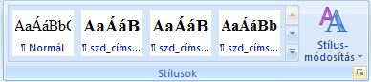
Figure 1.: The Style Library
The template has preset styles for use in theses/diploma projects. You can apply these styles after typing by going to the appropriate paragraph and selecting the appropriate style from the list shown in Figure 2. The formatting will be done automatically.
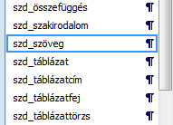
Figure 2.: Selecting the Style
  - The Structure of the Thesis
Use the style szd_címsor1 for formatting main chapters, szd_tímsor2 for formatting second-level titles, and szd_címsor3 for formatting third-level titles! Main (first-level) chapters start on a new page.
Use the style szd_címsor_tartalomjegyzék for formatting the title of the References, and use the style szd_címsor_számozatlan for formatting the title of the References!
  - How to Form the Core Text, How to Apply Listing
Use the szd_szöveg style to format the body text! The style is justified, uses one and a half line spacing, and the first line is indented. Do not use spaces between paragraphs of the body text!
You can use bullet points in your text by using any of these listed options:
- mark with bullets, like this list (you can use the szd_felsorolás style for this),
- mark with a letter (based on the szd_felsorolás_betű style),
- use numbers (based on the szd_felsorlás_szám style).
  - Figures, Tables, Formulas
    - Forming the Figures
The thesis may contain self-created figures and – in justified cases – figures taken from the literature. Figures can be placed:
- in the text part, in an organic unit with the text about them (usually immediately after the figure is referred to in the text);
- at the end of the text section, but in conjunction with it, if:
  - not larger than half of an A/4 page, and
  - due to their complex logical connections, they would disrupt the basic train of thought or are not necessarily following the text;
- c) in the appendix, if they cannot be bound together with A4 sheets due to their size.
Figures must always be numbered and titled, below the figure, centered in relation to the figure (as shown in Figure 1, for example). Use the style szd_ábra for the figure, and szd_ábracím for the figure title. The numbering can be done with continuously increasing serial numbers. The figure must always be referenced from the text. Smaller figures presenting a topic can also be presented in the following image. (Figure 3)
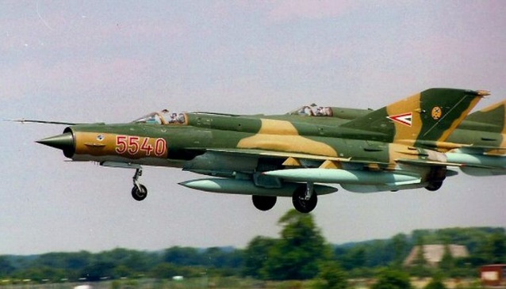 | 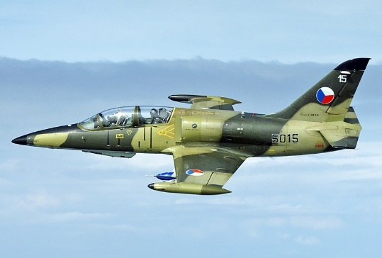
a | b
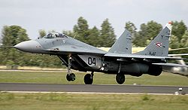 | 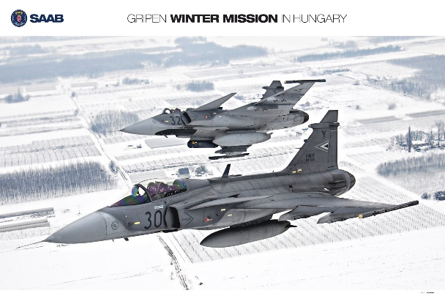
c | d
Figure 3.: Aircrafts operated at the Kecskemét military air base [number of the source from the reference list]
a – MiG-21; b – L-39, c – MiG-29; d – Gripen
The source of the figure should be written in square brackets after the figure title, with the corresponding serial number. In case of your own editing, it is not necessary to display the source separately. Figures may be surrounded by a thin frame, which may not exceed ½ point thickness. The resolution of the images should be a minimum of 150 dpi and a maximum of 250 dpi.
    - Forming the Tables
Place tables after the text it refers to, the table must always be referenced from the text. Tables are given a number and title, above the table, aligned to the right (for example, according to Table 1). To format the table title, use the szd_táblázattörzs style. The szd_táblázatfej and szd_táblázattörzs styles can be used in the table.
Table 1.: Example how to insert a Table [number of the source from the reference list]
Head cell
Body cell

    - Forming the Formulas
Place the relationships in the center, and then mark them on the same line with an Arabic number in parentheses on the right side. The formulas can be referenced in the text with this number. For formatting, use the szd_összefüggés style, and center or right align them using the tabs set in the style. For example:
The loss factor of a straight pipe can be calculated using the following equation:
$ξ= λ\frac{l}{d}$ (1)
where $λ$ is the pipe friction coefficient, l is the pipe length, and d is the internal diameter. Substituting these values into equation (1) gives the desired loss factor.
    - How to Implement and Position the Source-code into the Thesis
Source-code blocks of no more than 15 lines can be placed in the text if their display is necessary for understanding the applied algorithm. In such cases, they must be referenced in the surrounding text. They should be formatted with the szd_forráskód style.
var G = from x in dsAdatok.dtSzerzők
join y in dsAdatok.dtCikkek
on x equals y.dtSzerzőkRow
select
new
{ Szerző=x.Név,SzületésiÉv=x.SzületésiÉv,
Cím=y.Cím,URL=y.URL,Ár=y.Ár
};
There should be single line spacing between lines of source code and grammar checking should be disabled for the source-code.
- Further Requriements for the Thesis/Diploma
  - The Structure and the Idioms of the Thesis
In the thesis/diploma work, the student should elaborate on each task point of the thesis/diploma work in sufficient detail and depth, as this will be checked by the reviewer and the final examination committee. Avoid describing general theoretical knowledge in full detail, and instead focus on its application to the task. The thesis/diploma work is prepared for experts in the field, therefore concepts and relationships known to specialists should not be explained, but their application should be demonstrated.
The text should avoid informative stylistic devices and instead be written in a professional, scientific style. The text should be written in a clear, understandable style in accordance with the rules of the language used in the thesis (Hungarian, English). Words, sentence structures and grammatical forms deliberately borrowed from other languages ​​should be avoided.
The rules for using content or verbatim quotations from other authors are contained in Chapter 3.4 of this document.
  - The Formal Structure of the Thesis
- Inner title page – as shown in theThesis template.
- A copy of the thesis/diploma assignment sheet marked by the head of department and certified by the Office for Study and Education Affairs: can be downloaded from the NEPTUN system.
- Declaration of the preparation of one's own work: The student must tick this (does not have to include it in the thesis) in the NEPTUN system. Without this, the student cannot submit the work.
- The Thesis/Diploma Work Data Sheet form is not part of the thesis documentation, it is only registered in the NEPTUN system, which is administered by the departments and consultants.
- Table of Content
- Introudction (NO numberring)
- The substantive part of the thesis in a format corresponding to the Thesis Template.doc template
- Conclusions (NO numberring)
- List of Figures (NO numberring)
- references (see Chapter 3.4.)
- Attachments
  - Length of the Thesis
The length of the thesis, without appendices and annexes, should be 40-55 pages for undergraduate programs (BSc, BProf), 28-35 pages for continuing education programs and higher education vocational training (FSZ, FOSzK) programs, and 55-70 pages for master's programs (MSc).
  - References
The thesis/diploma work is the student's work, and its preparation requires the study of specialized literature, which makes up at least 1/3 of the thesis (this includes general literary research, description of the problem, company presentation, etc.). When preparing the thesis/diploma work, the student must indicate at least 15-20 literary sources, which include the most relevant elements of both domestic and international literature. In the thesis, the student should indicate those parts, statements, and data that were prepared based on the specialized literature (not independent results). A content or verbatim quotation used without indication is considered plagiarism. Content and verbatim quotations must be displayed with a serial number in square brackets. For example:
„A Föld alakját az szabja meg, hogy a felszínének mindenütt merőlegesnek kell lennie a gravitációs és a centrifugális erő eredőjének irányára, vagyis g irányára.” [6]
The figures taken are considered verbatim quotes, the reference should be placed after the title of the figure. When mentioning software, a reference to the literature is not required, instead a link to the software website should be placed in the bibliography. The thesis cannot be submitted without precise references and a bibliography. The bibliography should be prepared in alphabetical order according to the authors' names. The works used as sources should be listed with the following bibliographic data.
In the case of professional books:
- the name of the author(s), the title of the work,
- in the case of an edited volume, the name of the editor(s) followed by the designation (ed.)
- in the case of works with more than three authors, instead of listing the authors, the designation et al. is used after the name of the first author,
- the publisher, place of publication, year.
For articles taken from journals:
- the name of the author(s) as described for books, the title of the article,
- the title of the journal, volume number, year, location of the article (page number from what to what).
For Internet references:
- name of the author(s) as described for books, title of the article,
- web address (URL); date of viewing.

Some Examples:
- Budó Á.: Kísérleti fizika I. Tankönyvkiadó, Budapest, 1978.
- Çengel, J. A. – Boles, M. A.: Thermodynamics. McGraw-Hill, London, 1989.
- Hewlett-Packard Optoelectronics Division: Optoelectronics, Fiber-Optics Applications Manual. McGraw-Hill, London, 1981.
- Gambrell, L. B. – Morrow, L. M. – Pressley, M. (szerk.): Best practices in literacy instruction. Guliford Press, New York, 2007.
Elektronikus forrás:
http://books.google.hu/books?id=BmoiWNfWayoC. Megtekintés dátuma: 2015.01.13.
- Jang, J. S. R.: Anfis: adaptive network-based fuzzy inference systems. IEEE Transactions on System, Man and Cybernetics 23 (3) 1993. pp. 665-685.
  - The Guide-lines for Technological Documewntation
The student obtains the forms of technological documentation related to the task. They can be used by those employed at the workplace, which helps the thesis to be useful for the workplace. The content and form of technological documentation is prepared according to the aspects and principles learned during the processing of specialized subjects. Regardless of whether the relevant section of the operation plan must be filled in, it is advisable to present accurate and detailed calculations of technological data only for the most important operations.
  - Softwares
The procedures used during design, development and testing, as well as the implementation of the development documentation, are carried out according to the aspects and principles learned during the processing of the specialized subjects. The user documentation must be placed in the appendix of the thesis or, in the case of a web application, integrated into the appropriate parts of the website.
  - How to Upload the Thesis and the Related Documwents into the Electronic System
The thesis/diploma work and the attachments edited in the joint document must be uploaded to the NEPTUN system in text PDF format. The PDF file must contain the pages downloaded from NEPTUN and must not exceed the allowed storage size. Additional documents (technological documentation, blueprints, attachments that cannot be bound, in the case of software development, the source codes with explanations) must be uploaded in a ZIP file.

Conclusions

1 Pager Summary in a Foreign Langueage (Summary/Zusammenfassung) (compulsory only for thesis/diploma work written in Hungarian)

In BSc Pprogrammes
– the thesis must include the use of at least 5 foreign-language sources,
– the thesis must contain a 1-page summary in English or German.
Evaluation
- the evaluation of the thesis covers foreign-language literature and the summary in the literature review.

In MSc programmes
- the diploma work must include the use of at least 5 foreign-language sources,
- the diploma work must contain a 1-page summary in English or German,
- during the defense, members of the final examination committee may also ask questions in the foreign language specified in the summary.
Evaluation
- the evaluation of the diploma work includes the assessment of the use of foreign-language literature and the summary,
- during the defense, if a question is asked in a foreign language (English or German), the use of technical language is also evaluated as part of the defense grade.

List of Figures
1. ábra: A stílustár megjelenítése 7
2. ábra: A stílus kiválasztása 7
3. ábra: A kecskeméti katonai repülőbázison üzemeltetett repülőgépek [forrás száma] a – MiG-21; b – L-39, c – MiG-29; d – Gripen 8

References
You can format the References entries using the szd_szakirodalom style. Each reference should be displayed in alphabetical order. The last name of the author(s) of the source should be displayed in uppercase.
- Csengeri P. P.: Mennyiségek Mértékegységek Számok SI. Műszaki Könyvkiadó, Budapest, 1981.
- Énekes F.: A kiadványszerkesztés. Novella Könyvkiadó, Budapest, 2004.

Melléklet

