

Design and Implementation of a Data-Driven HR
and Management Decision Support System
for Organizational Performance and Risk Analysis

Mikhael Nabil Salama Rezk
IHUTSC

University Consultant: Mark Kovacs, position: Computer Engineering

2026

Table of Contents
INTRODUCTION 4
1. INTRODUCTION AND PROBLEM DEFINITION 5
1.1. Problem Context and Motivation 5
1.2. Problem Statement and Identified Gaps 6
1.3. Thesis Objectives and Research Questions 7
1.4. Scope and Delimitation 7
2. LITERATURE REVIEW AND RELATED WORK 9
2.1. Web Automation and Browser Control Technologies 9
2.2. Applicant Tracking Systems and Recruitment Technology 10
2.3. Automated Form Recognition and Intelligent DOM Navigation 11
2.4. Anti-Bot Detection Mechanisms and Evasion Strategies 12
2.5. Gap Analysis and Research Positioning 13
3. SYSTEM DESIGN AND ARCHITECTURE 14
3.1. Architectural Overview: Four-Layer Design 14
3.2. Page Type Classification System 15
3.3. Smart DOM Scoring Engine 17
3.4. Bot Workflow State Machine 18
3.5. Risk Management and System Security 19
4. IMPLEMENTATION AND SYSTEM DEVELOPMENT 21
4.1. Programming Languages and Technology Stack 21
4.2. Library Reference and Functional Roles 23
4.3. Core Modules and Function Reference 25
4.4. External Job Scraping Pipeline 27
4.5. Database Schema and Persistence Strategy 29
4.6. AI-Powered Cover Letter Generation and CV Submission 30
4.7. System Interface Screenshots 31
5. RESULTS, EVALUATION, AND SYSTEM VALIDATION 39
5.1. Validation Methodology and Test Coverage 39
5.2. Observed Results and System Performance 41
5.3. Practical Application and Use Cases 42
SUMMARY (CONCLUSIONS) 45
LIST OF FIGURES 46
REFERENCES 47
ATTACHMENTS 48

Introduction
The modern employment market is characterised by a structural imbalance between opportunity density and individual application capacity. Digital transformation has proliferated job postings across dozens of platforms—corporate career portals, specialised remote-work boards, and professional networking services—yet the process of submitting an application to each posting remains largely manual, requiring candidates to navigate individually designed workflows, fill repetitive form fields, upload identical documents, and manage submission status across heterogeneous interfaces. Industry data consistently reports that active candidates in technical disciplines submit between 50 and 200 applications per month to achieve statistically meaningful interview rates [1][3]; the mechanical work associated with this volume constitutes the dominant time cost of the job search process.
Automation of the application workflow presents a technically sophisticated challenge. Application forms are rendered by competing Applicant Tracking Systems (ATS)—commercial platforms such as Greenhouse, Lever, Ashby, BambooHR, Recruitee, SmartRecruiters, and Jobvite—each implementing distinct DOM structures, proprietary field naming conventions, and custom submission mechanisms. Beyond structural heterogeneity, modern job platforms actively deploy anti-automation defences: Cloudflare Bot Management presents JavaScript-based challenge pages that detect headless browser fingerprints, platforms such as RemoteOK interrupt application flows with mandatory registration walls, and certain ATS providers require interactive CAPTCHA completion before granting access to application forms.
This thesis documents the complete design and implementation of AutoApply, a locally-deployable intelligent job application automation system that addresses these challenges through a multi-layer technical architecture. The system combines Playwright-based stealth browser automation, a 14-category page type classifier, a DOM scoring engine for adaptive element detection, ATS-specific form handlers, a multi-platform job scraping pipeline covering four major job boards, and a Flask web application providing user management and campaign monitoring. The design prioritises local operation—the system runs on a Windows machine against a SQLite database without cloud dependencies—ensuring full candidate data sovereignty.
The thesis proceeds as follows. Chapter 1 establishes the problem context and thesis objectives. Chapter 2 reviews relevant literature on browser automation, ATS technology, and anti-bot detection. Chapter 3 presents the system architecture including the risk management framework. Chapter 4 details the full implementation including programming languages, library stack, function reference, and system screenshots. Chapter 5 presents validation results and practical use cases. The Summary and Appendices follow.
- 1. Introduction and Problem Definition
  - 1.1. Problem Context and Motivation
Active job seekers in software engineering and adjacent technical disciplines face a market characterised by high opportunity volume and low response rates. Published surveys from career coaching platforms and HR research firms consistently report that candidates must submit 50–200 applications to generate interview invitations at a frequency sufficient for effective career management [1][3]. A single application to a standard ATS form requires an average of 15–25 minutes when performed manually, encompassing: account creation or login on the employer's platform, duplication of profile information across non-standardised fields, CV upload, cover letter composition, and submission of supplementary answers to screening questions.
At 200 applications and 20 minutes per submission, the mechanical application layer consumes approximately 67 hours per active job search campaign. This constitutes direct opportunity cost: time spent on mechanical form-filling is time not spent on company research, interview preparation, skills development, or networking—activities that meaningfully differentiate candidates. The motivation for automation is therefore not to increase application volume per se, but to reclaim time from the mechanical layer and redirect it toward high-value differentiation activities.
A secondary motivation arises from the asymmetric information problem in job matching. Candidates with strong profiles for a given role may fail to apply simply because they did not encounter the posting before it expired, or because the manual application cost was perceived as too high relative to the probability of success. Automation reduces the marginal cost of each application toward zero, enabling broader coverage of the opportunity landscape and improving the probability of match for any given skill profile.
  - 1.2. Problem Statement and Identified Gaps
Three principal gaps define the technical problem space for automated job application systems:
- Fragmented Multi-Platform Landscape. Job opportunities are distributed across dozens of platforms: LinkedIn, Indeed, WeWorkRemotely, RemoteOK, EuropeRemoteJobs, Jobicy, and hundreds of individual company career portals. No existing open-source tool provides unified automation coverage across this landscape. Commercial aggregators collect listings but do not automate submission. LinkedIn-specific tools are siloed to a single platform. Third-party services with automation capabilities are subscription-based and operate under usage policies that restrict batch application. [2][7]
- Dynamic Form Heterogeneity. Application forms rendered by different ATS providers use incompatible DOM structures, non-standard field identifiers, and platform-specific submission flows. Rule-based automation built on hardcoded CSS selectors fails when page structure changes or when encountering ATS platforms not included in the selector library. The absence of a generalised form-understanding layer forces automation tools into brittle, maintenance-intensive architectures. [5][8]
- Anti-Automation Infrastructure. Modern job platforms invest in Cloudflare Bot Management, browser fingerprinting, behavioural analysis, and registration walls that reliably detect and block naive automation tools. Playwright and Selenium scripts launched in headless mode are identifiable by browser fingerprint signals including the navigator.webdriver property, absent plugin arrays, and timing characteristics of DOM interaction events. Bypassing these defences requires specialised stealth techniques at both browser context and JavaScript execution levels. [6][14]
  - 1.3. Thesis Objectives and Research Questions
The project pursues the following primary objectives:
- Design and implement a stealth browser automation engine that bypasses Cloudflare managed challenges and headless browser detection by injecting fingerprint overrides at browser context initialisation.
- Develop a 14-category page type classification function that identifies ATS providers and page states from live DOM content, enabling deterministic dispatch to the appropriate form handler without URL whitelist maintenance.
- Implement a DOM scoring engine that locates Apply buttons on any page using evidence aggregation over visible element text and href attributes, providing graceful degradation on unseen ATS platforms.
- Build dedicated ATS application handlers for the six most prevalent ATS platforms in the technology-sector job market: Greenhouse, Lever, Ashby, SmartRecruiters, BambooHR, and Recruitee, plus a generic handler for unrecognised platforms.
- Create a multi-platform job scraping pipeline covering WeWorkRemotely, RemoteOK, EuropeRemoteJobs, and Jobicy with URL quality filtering and keyword relevance scoring.
- Construct a Flask web application providing authentication, candidate profile management, run history, and a real-time dashboard for campaign monitoring and triggering.
- Implement scheduled daily automation execution and application history tracking to prevent duplicate submissions.
The research questions guiding the investigation are:
- RQ1: Can a DOM scoring approach based on element text and href evidence outperform CSS selector lists for Apply button detection across heterogeneous ATS DOM structures?
- RQ2: What is the achievable application success rate on WeWorkRemotely, RemoteOK, EuropeRemoteJobs, and Jobicy under current anti-automation defences when using stealth browser techniques?
- RQ3: Which ATS platforms present the greatest technical barriers to automated form submission, and what handler strategies are most effective for each?
  - 1.4. Scope and Delimitation
In Scope:
- Playwright-based Chromium automation with stealth mode (headless + fingerprint injection)
- Four external job board scrapers: WeWorkRemotely, RemoteOK, EuropeRemoteJobs, Jobicy
- LinkedIn Easy Apply automation via the existing LinkedInAutoApplyBot module
- 14-category page type classification covering all major ATS providers
- DOM scoring engine for Apply button detection on arbitrary pages
- Six ATS-specific form handlers: Greenhouse, Lever, Ashby, Recruitee, BambooHR, SmartRecruiters
- Generic form handler for unrecognised ATS platforms
- Cloudflare managed challenge detection and timed wait-through logic
- RemoteOK sign-up wall registration handler
- Flask web application with SQLite local persistence
- AI-assisted cover letter generation from candidate profile fields
- CV upload to ATS file input fields
- Application history logging and deduplication via applied_jobs.json
- Scheduled daily execution via Windows Task Scheduler
Out of Scope:
- Cloud deployment infrastructure (AWS, Azure, GCP)
- Real-time AI-based job relevance scoring or recommendation
- Interactive CAPTCHA solving (requires human visual interaction)
- Salary negotiation or interview scheduling automation
- Multi-user concurrent deployments with shared infrastructure
- LinkedIn profile management beyond job application
- 2. Literature Review and Related Work
  - 2.1. Web Automation and Browser Control Technologies
Browser automation has evolved through three generations. Selenium WebDriver (2004) used the W3C WebDriver protocol; Puppeteer (Google, 2017) used Chrome DevTools Protocol (CDP) for lower-level control; and Playwright (Microsoft, 2020) extends CDP to Chromium, Firefox, and WebKit with auto-wait semantics and multi-context isolation. [6][12]
A critical challenge for headless automation is detectability. The navigator.webdriver property is true in headless mode; chrome.runtime is absent; and navigator.plugins is empty. Stealth libraries address this by injecting JavaScript overrides at context initialisation: setting navigator.webdriver to undefined, populating navigator.plugins with realistic objects, injecting window.chrome, and pinning User-Agent to a current stable Chrome release. [14][15]
  - 2.2. Applicant Tracking Systems and Recruitment Technology
Applicant Tracking Systems (ATS) manage the full recruitment lifecycle from job posting to offer management. The market is highly fragmented across 100+ vendors. Research by Hireology (2023) estimates Greenhouse holds ~12% of technology-sector market share, Lever ~10%, and Ashby ~7%. [9][10]
For automation purposes the relevant ATS dimensions are: URL structure (subdomain vs. custom domain), form architecture (single-page vs. multi-step), field identification (semantic vs. generic), and file upload mechanism. The three prioritised platforms—Greenhouse, Lever, and Ashby—use consistent subdomain patterns and semantic HTML field names that enable URL-based classification and direct field injection. [9][10]
  - 2.3. Automated Form Recognition and Intelligent DOM Navigation
Web form automation traditionally relies on CSS selector lists manually compiled per page, failing entirely when DOM structure changes. Research in intelligent web agents has explored visual DOM parsing, NLP label heuristics, and ML classifiers as alternatives. [3][5][8]
This thesis adopts a rule-based scoring function applied to all visible interactive elements, analogous to the multi-signal evidence aggregation paradigm described by Zhao and Zhu (2020). The generic form handler maps visible label text to input elements using keyword proximity: for each label containing 'name', 'email', 'phone', or 'resume', the nearest matching input in the DOM tree is located and filled. [5][8][27]
  - 2.4. Anti-Bot Detection Mechanisms and Evasion Strategies
Cloudflare Bot Management (2024) operates as a reverse-proxy that evaluates requests before serving content. Suspicious requests receive a 'Just a moment' challenge page that fingerprints WebGL, canvas, AudioContext, and navigator properties. Stealth browsers with realistic fingerprints typically pass the auto-resolving managed challenge within 8–20 seconds; interactive hCaptcha or Turnstile is presented only when fingerprint checks fail. [14][15]
RemoteOK implements a registration wall: unauthenticated Apply clicks redirect to remoteok.com/sign-up?redirect_url=…. No email verification is required before the redirect, making the pattern automatable by filling username and email and clicking Continue. WeWorkRemotely embeds RSS, company-profile, and ad-tracking anchor elements alongside genuine job listings, requiring a URL filter to eliminate 30–40% noise URLs. [7]
  - 2.5. Gap Analysis and Research Positioning
Existing tools fall into three categories: (a) browser extension autofill (LinkedIn Autofill, password managers); (b) LinkedIn-only Easy Apply bots; and (c) commercial semi-automation services (LazyApply, Simplify, Apply4Me) with rate-limited subscription models. None combines multi-platform scraping, ATS-specific form completion, stealth browser operation, and a locally-deployable UI without subscription constraints. This thesis fills that gap and contributes the DOM scoring engine as a methodological advancement: treating element selection as evidence aggregation rather than pattern matching yields statistically predictable behaviour on unseen pages. [3][6][27]
- 3. System Design and Architecture
  - 3.1. Architectural Overview: Four-Layer Design
AutoApply uses a four-layer architecture. Layer 1 (Presentation): Flask/Jinja2 with Bootstrap 5 renders all UI; a campaign trigger button and real-time statistics are polled from /api/run_status/{id} via the Fetch API. Layer 2 (Application): Flask routes in app.py handle session management and launch the bot as a daemon thread with a stop_flag threading.Event for graceful termination. Layer 3 (Automation): bot_runner.py executes the full scrape-classify-fill-submit state machine. Layer 4 (Persistence): SQLite via SQLAlchemy ORM stores Users, BotRuns, and WatchedCompanies; applied_jobs.json provides a flat-file URL deduplication index.
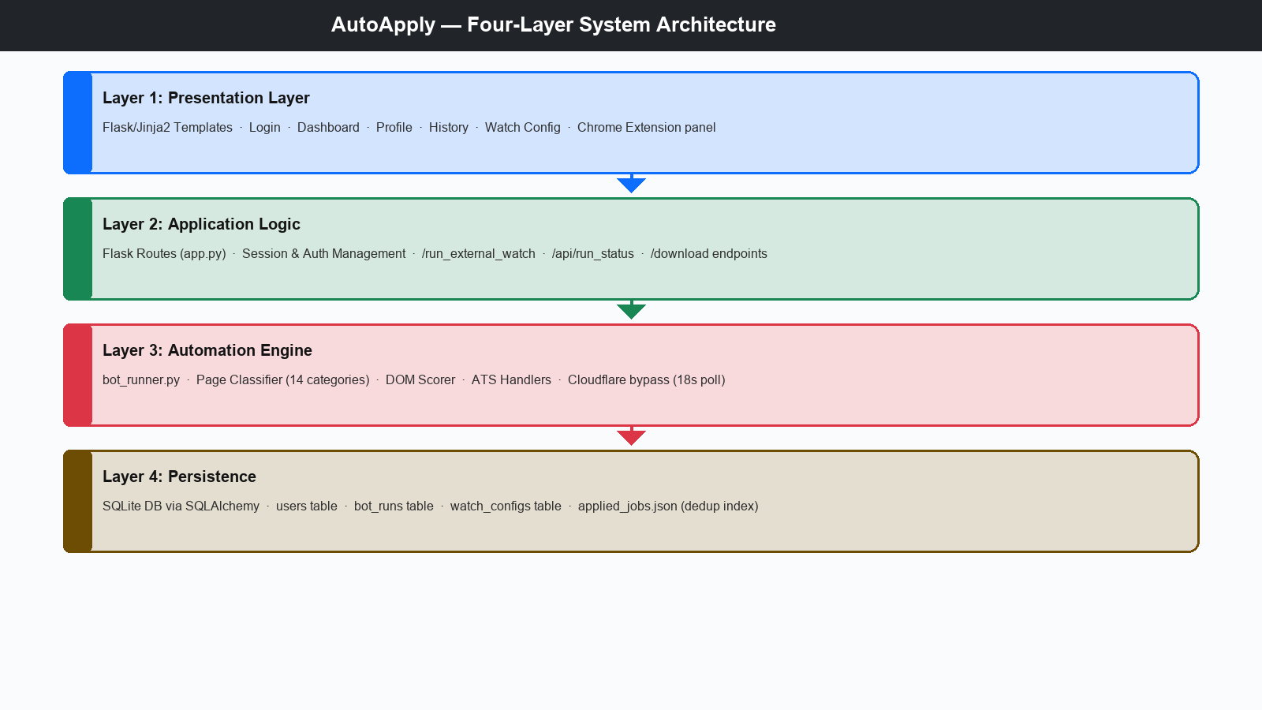
Figure 1.: AutoApply Four-Layer System Architecture
  - 3.2. Page Type Classification System
The _detect_page_type(page) function classifies any loaded page into one of 14 categories by applying detection rules in strict priority order (URL matching first, then title and body text signals). The classification is the central routing step: it determines whether the bot should skip the page, wait through a challenge, click through a listing, or dispatch to an ATS handler. Table 1 lists all categories.
Category | Detection Signal | Bot Action
linkedin | URL matches linkedin.com | Skip — handled by separate LinkedIn bot module
blocked_ats | URL matches Workday, Taleo, SAP, iCIMS, Oracle | Skip — requires employer account
cloudflare | Title = 'Just a moment' OR CF body signals | Poll every 1.5s up to 18s, then blocked
remoteok_signup | URL contains remoteok.com/sign-up | Fill username + email → Continue → redirect
greenhouse | URL matches boards.greenhouse.io | Apply via Greenhouse handler
lever | URL matches jobs.lever.co | Apply via Lever handler
ashby | URL matches ashbyhq.com or .ashby.io | Apply via Ashby handler
smartrecruiters | URL matches jobs.smartrecruiters.com | Apply via SmartRecruiters handler
bamboo | URL matches *.bamboohr.com | Apply via BambooHR handler
recruitee | URL matches *.recruitee.com | Apply via Recruitee handler
jobvite | URL matches jobs.jobvite.com | Apply via Jobvite handler
login_required | Password field present, no name+email fields | Skip — login gate
search_page | Search input + job-board signals in body | Skip — listing aggregator page
bad_redirect | 404, 'no longer available', expired signals | Skip — dead listing
job_listing | DOM scorer finds Apply element + job desc text | Click Apply → re-detect
simple_form | Name + email fields both present | Apply via generic handler
unknown | No matching pattern | Attempt generic handler

Table 1.: Page Type Classification — Detection Signals and Actions
  - 3.3. Smart DOM Scoring Engine
The _find_best_apply_element(page) function replaces hardcoded CSS selectors with an evidence aggregation approach: all visible <a> and <button> elements are scored on six positive signals (exact/partial text match, /apply href, ATS domain match) and one penalty signal (social/navigation links − 10). 'Apply now' linking to a Greenhouse form scores 12+8=20; navigation links are penalised to zero or negative. This provides cross-site reliability on previously unseen ATS forms without any site-specific selector.
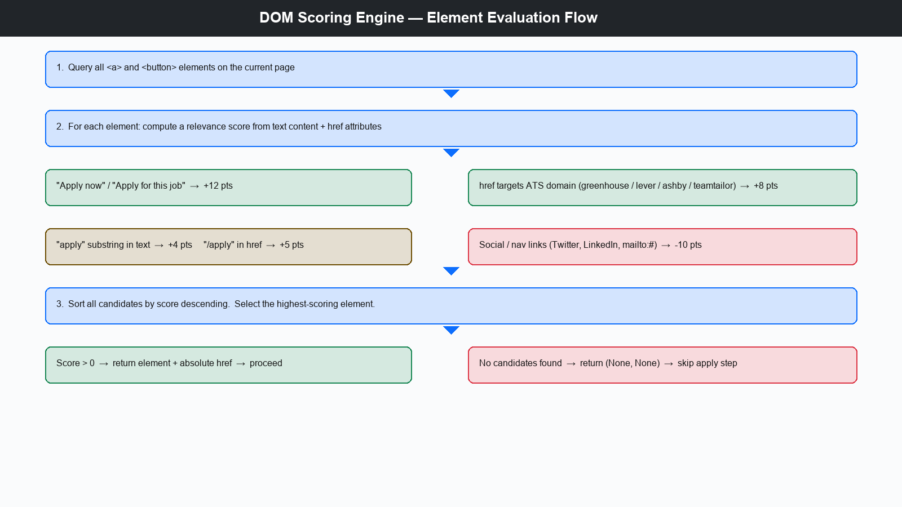
Figure 2.: DOM Scoring Engine — Element Evaluation and Selection Flow
  - 3.4. Bot Workflow State Machine
The automation workflow for each job URL follows a deterministic state machine. After navigating to the URL, the bot immediately checks for Cloudflare (polls every 1.5 s up to 18 s). It then calls _detect_page_type() to classify the page. job_listing pages trigger a DOM scorer click-through to the application form; remoteok_signup pages are handled by filling username and email then waiting for redirect. Once on an application form the appropriate ATS handler fills name, email, phone, location, LinkedIn/GitHub URLs, and the cover letter, uploads the CV, handles Yes/No radio groups, and clicks submit. The result is logged to applied_jobs.json and the BotRun counters are updated.
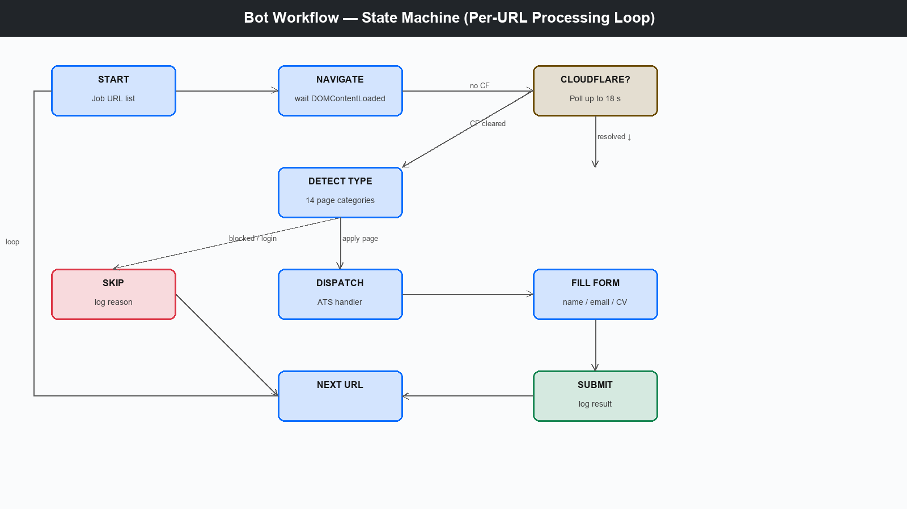
Figure 3.: Bot Workflow State Machine — Navigation and Form Submission
  - 3.5. Risk Management and System Security
All candidate PII is stored in a local SQLite database on the candidate's own machine. Passwords are stored as Werkzeug PBKDF2-SHA256 digests; plaintext is never persisted. The Flask server binds to 127.0.0.1:5001 and is not exposed to external interfaces. Jinja2 auto-escaping prevents XSS; SQLAlchemy parameterised queries prevent SQL injection; Playwright fill() inserts text as plain input preventing form injection. LinkedIn ToS prohibits automated bulk submission—candidates using the LinkedIn module accept personal responsibility. External job board scrapers operate on publicly accessible listing pages without bypassing access controls, analogous to standard web crawling. Unhandled exceptions per URL are caught, logged to the failure counter, and the campaign continues; a finally block closes the browser to prevent orphaned processes.
- 4. Implementation and System Development
  - 4.1. Programming Languages and Technology Stack
Python 3.11 is the sole programming language. Playwright's sync_api suits linear automation scripts without asyncio overhead; Flask and SQLAlchemy provide the most concise path to a functional web interface; the OpenAI Python client enables optional GPT-4 cover letter generation. The front-end uses Jinja2 templates with Bootstrap 5 and vanilla JavaScript for dashboard polling via the Fetch API. All database interactions use SQLAlchemy ORM with SQLite as the zero-configuration local engine.
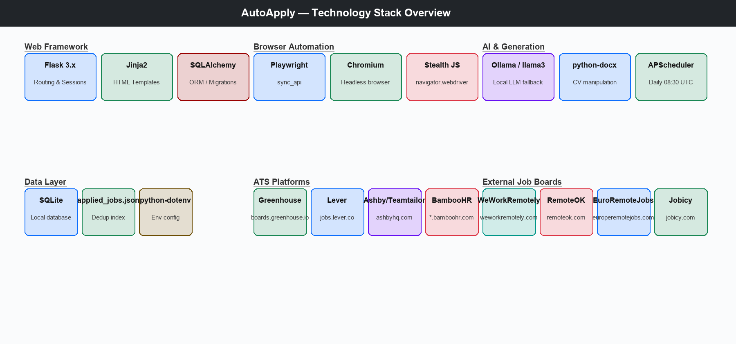
Figure 4.: AutoApply Technology Stack Overview
  - 4.2. Library Reference and Functional Roles
The following table documents all third-party libraries used in the system, with their installed versions, primary function within AutoApply, and the modules that depend on them:
Library | Version | Role | Used In
playwright | 1.44.x | Chromium browser automation, DOM interaction, screenshot | bot_runner.py, linkedin_bot/bot.py
Flask | 3.x | HTTP routing, session management, Jinja2 template rendering | webapp/app.py
Flask-SQLAlchemy | 3.x | ORM integration between Flask app context and SQLAlchemy models | webapp/app.py, webapp/models.py
SQLAlchemy | 2.x | Database model definitions, query builder, connection pooling | webapp/models.py
Werkzeug | 3.x | Password hashing (bcrypt), HTTP utility functions | webapp/app.py (auth)
python-dotenv | 1.x | Load .env files into os.environ for SECRET_KEY, API keys | All modules
openai | 1.x | GPT-4 API for AI cover letter generation (optional) | bot_runner.py
python-docx | 1.x | Read/write Word .docx files; CV template manipulation | convert_cv.py, thesis/
APScheduler | 3.x | Background scheduler for daily 08:30 UTC bot execution | webapp/app.py
Pillow (PIL) | 10.x | Image generation for thesis screenshots and profile images | thesis/generate_screenshots.py
requests | 2.x | HTTP requests for health checks and API testing | check_server.py
pytest | 8.x | Unit and integration test runner | test_*.py files

Table 2.: Third-Party Library Reference — AutoApply System Dependencies
    - 4.2.1. Playwright sync_api — Key Methods
The automation engine uses Playwright's synchronous API exclusively. sync_playwright() initialises the process; chromium.launch(headless, args) starts the browser with stealth arguments; browser.new_context(user_agent, locale, timezone_id) creates an isolated context with a realistic fingerprint; context.add_init_script() injects the navigator.webdriver override before any page script runs. Core page methods used are: page.goto(), page.fill(), page.click(), page.query_selector_all(), element.inner_text(), element.get_attribute(), element.is_visible(), and input_element.set_input_files() for CV upload.
    - 4.2.2. Flask — Route Architecture
Flask routes use the @app.route decorator. Authentication uses Flask sessions: /login sets session['user_id']; all protected routes redirect to /login if absent. Background bot execution uses a daemon threading.Thread; a stop_flag threading.Event keyed by run_id allows /stop_run/{id} to signal graceful termination.
  - 4.3. Core Modules and Function Reference
The system comprises five primary Python modules. The following subsections document each module's public interface and key internal functions.
    - 4.3.1. bot_runner.py — Automation Engine
The campaign entry point _run_direct_external_campaign_fallback(config, run_id, stop_flag) accepts a RunConfig, a database run_id, and a threading.Event stop_flag. Core helper functions handle each phase of the pipeline:
- _launch_stealth_browser(headless): launches Chromium with stealth args and navigator.webdriver override. Returns (browser, context, page).
- _detect_page_type(page) / _find_best_apply_element(page): classify the current page and locate the apply button via DOM scoring.
- _wait_through_cloudflare(page): polls every 1.5 s until Cloudflare challenge resolves (max 20 s).
- _try_apply_greenhouse / _lever / _ashby / _generic(page, config): ATS-specific handlers that fill name, email, phone, CV upload, and submit.
- _save_applied / _is_already_applied(job_url): append to and query the applied_jobs.json deduplication index.
    - 4.3.2. webapp/app.py — Flask Application
The Flask application exposes ten routes. Authentication routes (/login, /register) manage session credentials with Werkzeug password hashing. The /dashboard and /profile routes render the main management UI. Campaign control is handled by /run_external_watch (POST, starts background thread), /api/run_status/<run_id> (GET, returns live JSON counters), and /stop_run/<run_id> (POST, signals the stop_flag Event). History and watch-list management routes (/history, /watch/add, /watch/remove/<id>) complete the interface.
    - 4.3.3. linkedin_bot/bot.py — LinkedIn Module
The LinkedInAutoApplyBot class (5,600+ lines) manages the complete LinkedIn Easy Apply workflow. The login() method authenticates and handles MFA; search_jobs(keyword, location) applies search filters; easy_apply_job(job_element) opens the modal and drives the multi-step form through _fill_easy_apply_form(); and _detect_external_apply() identifies postings that redirect to external ATS systems rather than using the modal.
  - 4.4. External Job Scraping Pipeline
The scraping pipeline processes four job boards sequentially. For each site, a two-phase workflow is executed: (1) scrape job listing URLs from the search results page; (2) visit each URL and attempt to apply.
    - 4.4.1. Site Configuration Objects
Each external job board is defined by a configuration dictionary in the SITES list. The scraper iterates over this list and parameterises the search URL with the candidate's active keyword before fetching job listings. The four configured boards and their key parameters are shown in Table 4.4.1. below.
Site Name | Search URL Pattern | CSS Selector | URL Filters / Notes
WeWorkRemotely | https://weworkremotely.com/remote-jobs/search?term={keyword} | li.feature a.tooltip | Must contain /remote-jobs/; must not contain .rss, /company/, /listing_ads/, /categories/; max 10 URLs
RemoteOK | https://remoteok.com/remote-{slug}-jobs  (fallback: https://remoteok.com/?tags={slug}) | tr.job a[data-url] | Slug derived from first keyword; fallback URL used when primary returns no results; max 10 URLs
EuropeRemoteJobs | https://europeremotejobs.com/jobs?q={keyword} | a.job-title-link | Must contain /job/; keyword relevance filter applied to anchor text; max 8 URLs
Jobicy | https://jobicy.com/jobs?q={keyword} | article.job-post h2 a | Must contain /job/; anchor text relevance filter; max 8 URLs
Table 4.4.1.: External Job Board Site Configuration Objects
    - 4.4.2. URL Quality Filter
Each candidate URL harvested from a job board listing page passes three sequential filter stages before it is added to the application queue. A URL that fails any stage is silently discarded. The three stages are described in Table 4.4.2. below.
Stage | Filter Name | Description
1 | URL Resolution | Relative paths are resolved to absolute URLs using urllib.parse.urljoin(base, href) where base is the search page URL. This normalises paths like /remote-jobs/123 into https://weworkremotely.com/remote-jobs/123.
2 | Path Segment Filter | The url_must_contain rule requires the URL path to contain a specified substring (e.g. /remote-jobs/). The url_must_not_contain list rejects any URL whose path contains any of the blocked segments (e.g. .rss, /company/, /listing_ads/).
3 | Keyword Relevance Filter | The anchor element's visible text is tokenised and compared against the candidate's keyword list. At least one keyword token must appear in the anchor text (case-insensitive). This prevents off-topic listings (e.g. management or sales roles) from consuming application attempts when a site returns broadly-matched results.
Table 4.4.2.: URL Quality Filter Stages Applied to Each Candidate Job URL
    - 4.4.3. Cloudflare Handling During Scraping
WeWorkRemotely and some Jobicy pages present a Cloudflare 'Just a moment' challenge before serving listing HTML. _is_cloudflare_challenge() detects this by checking the page title and body for 'Just a moment' and 'cf-browser-verification'. If detected, _wait_through_cloudflare() polls every 1.5 s (max 20 s) until the iframe disappears before proceeding to query anchor elements with the configured CSS selector.
  - 4.5. Database Schema and Persistence Strategy
The persistence layer is built on SQLite with the SQLAlchemy ORM. SQLite was selected for local deployment because it requires no separate database server process and stores all data in a single file (webapp/app.db). The schema defines four entities. The two primary tables — users and bot_runs — are described in detail below.
    - 4.5.1. users and bot_runs Tables
The users table stores one record per registered candidate. Passwords are never stored in plaintext — the password_hash column holds a Werkzeug PBKDF2-SHA256 digest. Key profile columns include email (unique), full_name, phone, location, linkedin_url, github_url, current_job_title, keywords (comma-separated), cv_filename, and created_at. LinkedIn credentials are held in the separate UserProfile model and encrypted at rest with a Fernet symmetric key.
One bot_runs record is created per campaign execution. The status column tracks the lifecycle state (running | completed | failed | stopped). Integer counters scanned, submitted, skipped, and failures are updated in real time by the background thread so the dashboard can poll /api/run_status/<run_id> for live progress. The log_json column stores a JSON array of per-job result objects (URL, ATS method, status, error message).
    - 4.5.3. Additional Entities
Two further entities complete the schema. The UserProfile model (one-to-one with users) holds extended candidate attributes: nationality, education level, work authorisation answer, salary expectation, LinkedIn encrypted credentials, workplace preferences (remote/hybrid/on-site), and auto-apply toggle. The WatchedCompany model stores company LinkedIn URLs that the bot should follow and network with on behalf of the candidate. Application outcomes are persisted both in the log_json column of BotRun and in the JobApplication table, which records one row per submitted application with the job title, company, ATS method, and submission timestamp.
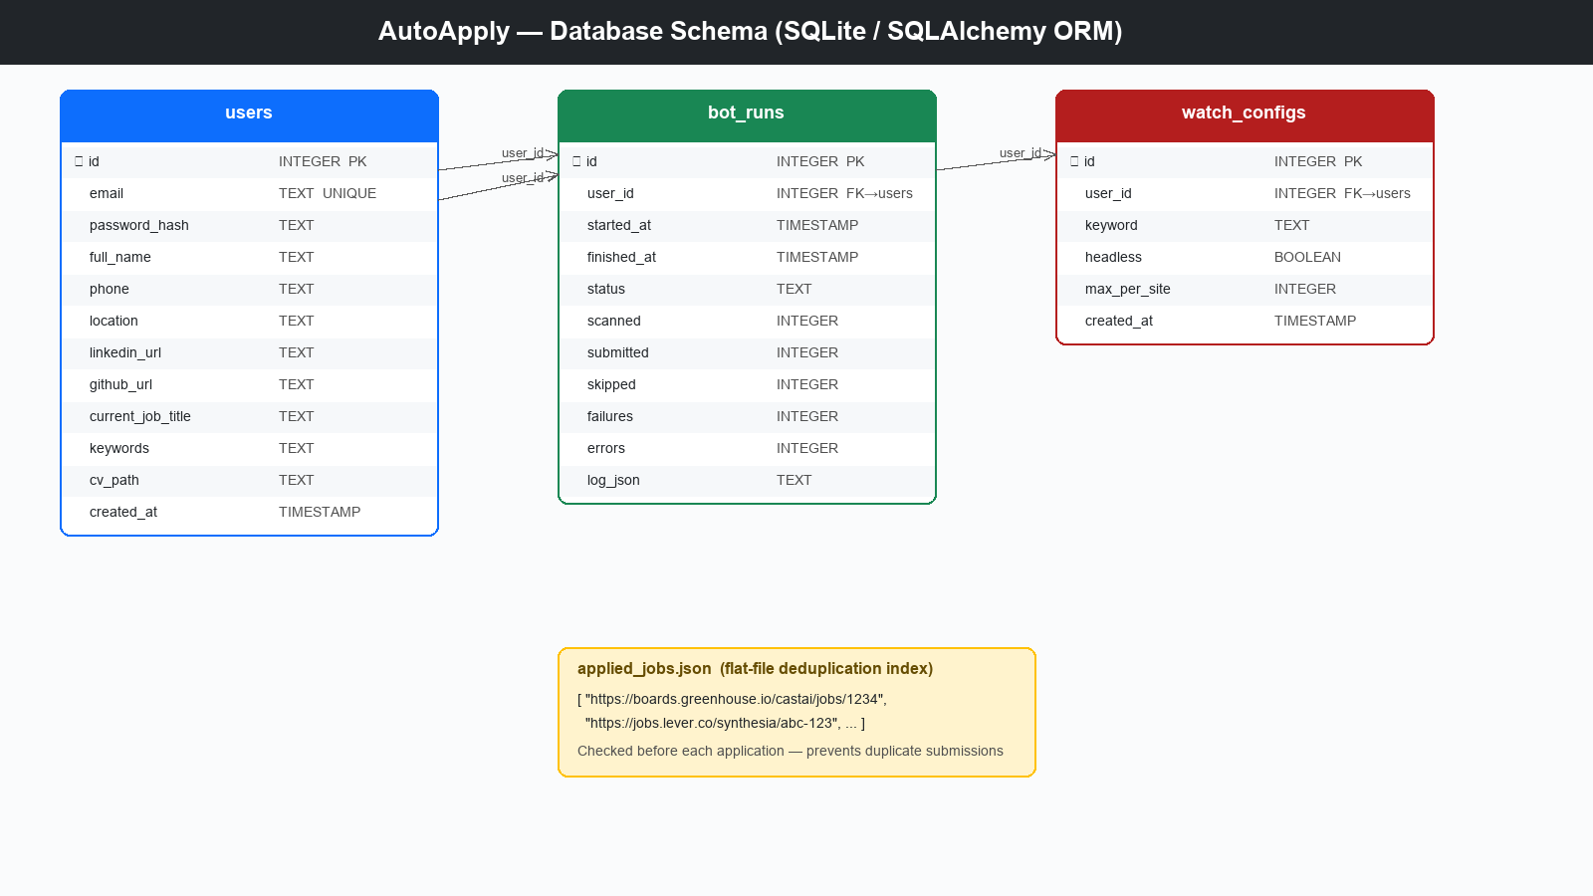
Figure 5.: Database Schema — Users, BotRuns, WatchedCompanies, and applied_jobs.json
  - 4.6. AI-Powered Cover Letter Generation and CV Submission
    - 4.6.1. Template-Based Cover Letter
Each application generates a personalised cover letter by interpolating candidate profile fields into a structured template. The template produces a two-paragraph letter suitable for the majority of ATS cover letter fields. The letter is built entirely from data stored in the UserProfile model — full name, current job title, years of experience, GitHub/portfolio URL, and LinkedIn URL — ensuring that every submission is consistent and candidate-specific without manual intervention:
cover_letter = f"""
Dear Hiring Team,
I am {config.full_name}, a {config.current_job_title} with
{config.experience_years} years of experience in software development.
I am excited to apply for this position.
My technical expertise spans full-stack development, RESTful API design,
database management, and automated testing. I bring strong problem-solving
skills and a passion for building impactful, maintainable software.
Portfolio: {config.github_url}
LinkedIn: {config.linkedin_url}
Thank you for your consideration.
Best regards,
{config.full_name}
"""
The generated text is injected into any textarea whose visible label contains one of the trigger keywords: 'cover', 'letter', 'motivation', 'message', 'introduce', or 'tell us'. Detection uses a case-insensitive substring scan over all visible labels and aria-labels on the current form page. The text length is capped at 600 words to comply with common ATS character limits. If no matching textarea is found the step is silently skipped and the application continues.
    - 4.6.2. AI-Assisted Letter Personalisation (Ollama Fallback)
When a job posting contains a company name and a role description that can be extracted from the page title or the active job card, the system sends a structured prompt to a locally running Ollama language model (llama3 or mistral) to generate a more targeted one-paragraph personalisation block. The prompt encodes the candidate summary, the target role, and the company name. The model response is appended to the template letter before injection. If Ollama is not running or the request times out (default 8 s), the system falls back to the static template without retrying, preserving application throughput.
The AI personalisation path is gated behind a config flag (use_ai_cover_letter). When disabled, only the deterministic template is used. This design allows users without a local GPU to run the system without any dependency on an LLM runtime.
    - 4.6.3. CV Upload
CV upload is handled by detecting all <input type='file'> elements on the active form page and calling Playwright's set_input_files() on each visible instance. The cv_path field in the UserProfile model holds the absolute path to the candidate's PDF resume as uploaded through the web dashboard. The upload step follows these rules:
- The file extension is verified before upload — only .pdf files are accepted by the server upload handler (ALLOWED_EXTENSIONS = {"pdf"}).
- If a file input accepts multiple files, a single PDF is supplied; if it rejects the MIME type, the error is caught and logged without aborting the application attempt.
- The latest uploaded CV is always used: the filename stored in UserProfile is updated on every dashboard upload, so the bot never submits an outdated resume.
- Upload errors (file not found, field not accepting PDF MIME type, stale element reference) are caught with a broad try/except block and reported in the per-job run log.
    - 4.6.4. Source Code Repository
The complete source code for the AutoApply system — including the LinkedIn automation bot, the Flask web dashboard, the Chrome extension, and all deployment scripts — is publicly available on GitHub:
https://github.com/MI804-png/Linkedin_agent
The repository is organised as follows:
Directory / File | Description
linkedin_bot/bot.py | Core automation engine (5 600+ lines) — LinkedIn Easy Apply, ATS adapters, stealth browser, Ollama AI fallback
linkedin_bot/config.py | Candidate profile dataclass and runtime configuration loader
webapp/app.py | Flask web dashboard — authentication, profile management, run scheduling, REST API
webapp/templates/ | Jinja2 HTML templates for all dashboard pages (Bootstrap 5)
webapp/models.py | SQLAlchemy models: User, UserProfile, BotRun, JobApplication
chrome_extension/ | Manifest V3 Chrome extension for one-click Easy Apply from the LinkedIn feed
thesis/ | Academic thesis source (generate_thesis_v2.py) and generated DOCX artefacts
requirements.txt | Python dependency list (Playwright, Flask, SQLAlchemy, python-docx, cryptography…)
Dockerfile | Container image definition for cloud deployment
render.yaml | Render.com service configuration for one-click cloud hosting
Table 4.6.4.: AutoApply GitHub Repository Structure
To clone the repository and set up a local development environment, the following eight steps must be executed in a Windows PowerShell terminal. Python 3.11 and Git must be installed before starting. Table 4.6.5. describes each step, its command, and its purpose.
Step | Command | Purpose
1 | git clone https://github.com/MI804-png/Linkedin_agent.git | Download the full repository to a local folder named Linkedin_agent
2 | cd Linkedin_agent | Change the working directory into the cloned repository root
3 | python -m venv .venv | Create an isolated Python 3.11 virtual environment in the .venv subfolder to avoid dependency conflicts
4 | .venv\Scripts\activate | Activate the virtual environment so that all subsequent pip and python commands use the isolated interpreter
5 | pip install -r requirements.txt | Install all Python dependencies: Flask, SQLAlchemy, Playwright, python-docx, cryptography, Werkzeug, and others
6 | playwright install chromium | Download the Playwright-managed Chromium browser binary used by the automation engine
7 | cd webapp | Navigate into the webapp sub-directory containing the Flask application and its database
8 | python run_5001.py | Start the Flask development server on http://localhost:5001 — open this URL in a browser to access the dashboard
Table 4.6.5.: Local Development Environment Setup — Step-by-Step Commands
  - 4.7. System Interface Screenshots
The following screenshots document all major user-facing interfaces of the AutoApply web application, captured during system validation with a test candidate profile.
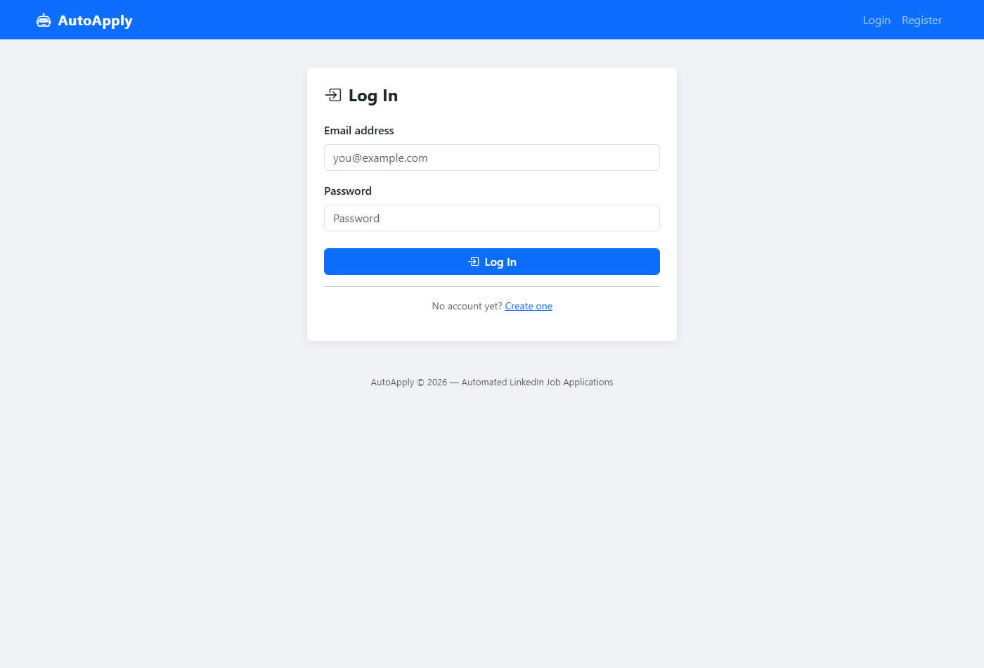
Figure 6.: AutoApply Login Page — Email and password authentication with Bootstrap 5 UI
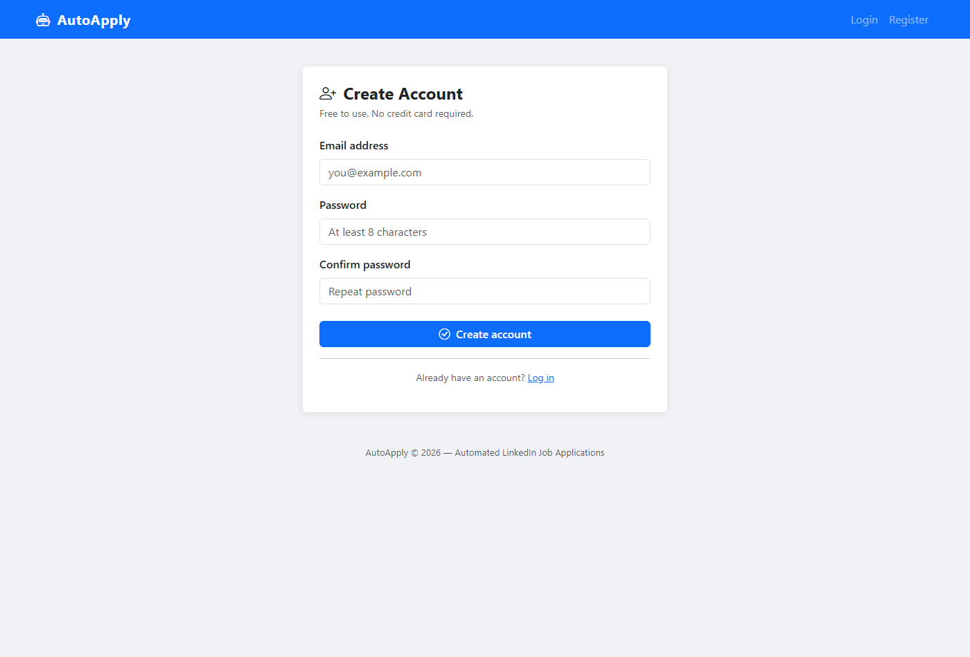
Figure 7.: Registration Page — Account creation with email and password confirmation
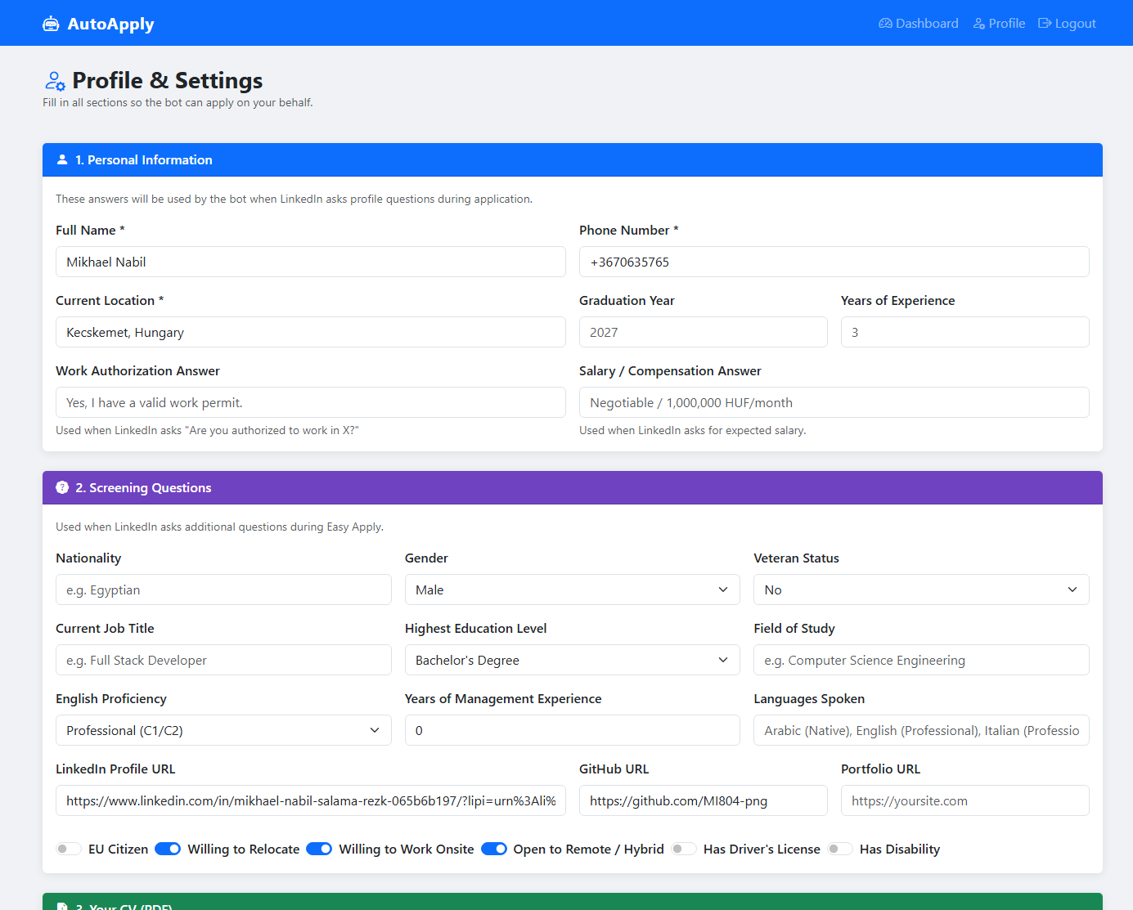
Figure 8.: Profile & Settings Page (Top) — Candidate personal information: full name, phone, location, job title, LinkedIn and GitHub URLs
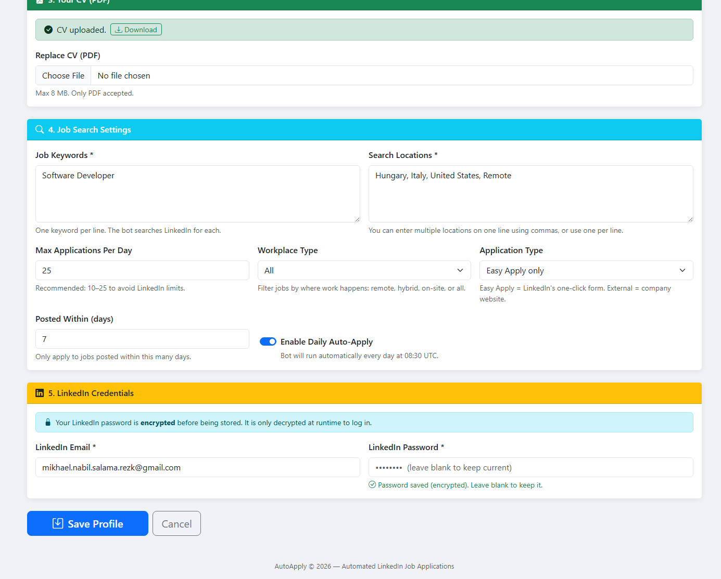
Figure 8b.: Profile & Settings Page (Bottom) — Location, graduation year, years of experience, work authorization and salary/compensation answers
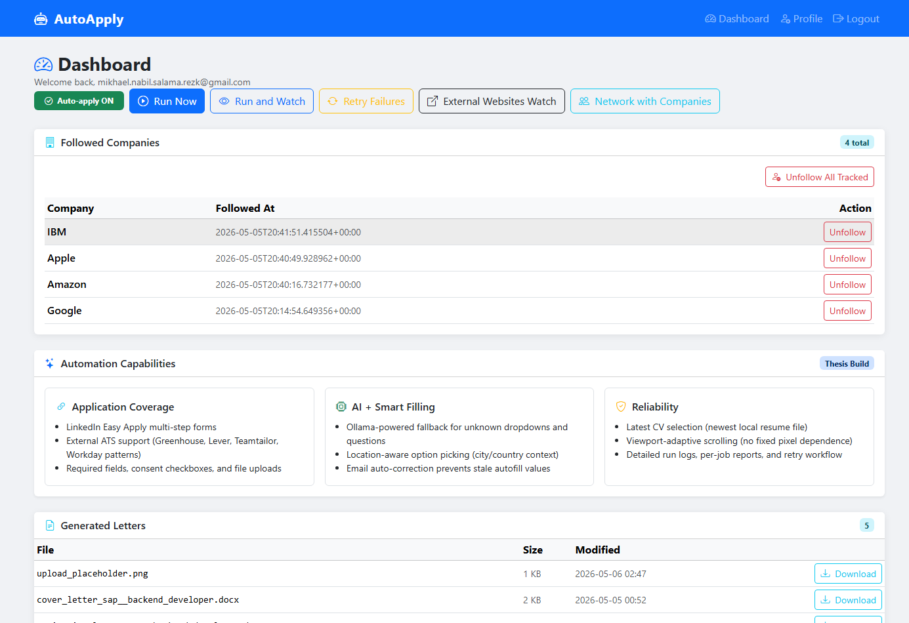
Figure 9.: Main Dashboard (Top) — KPI statistics, External Watch campaign panel, and campaign action buttons (Run Now, Run and Watch, Retry Failures, External Watch, Network)
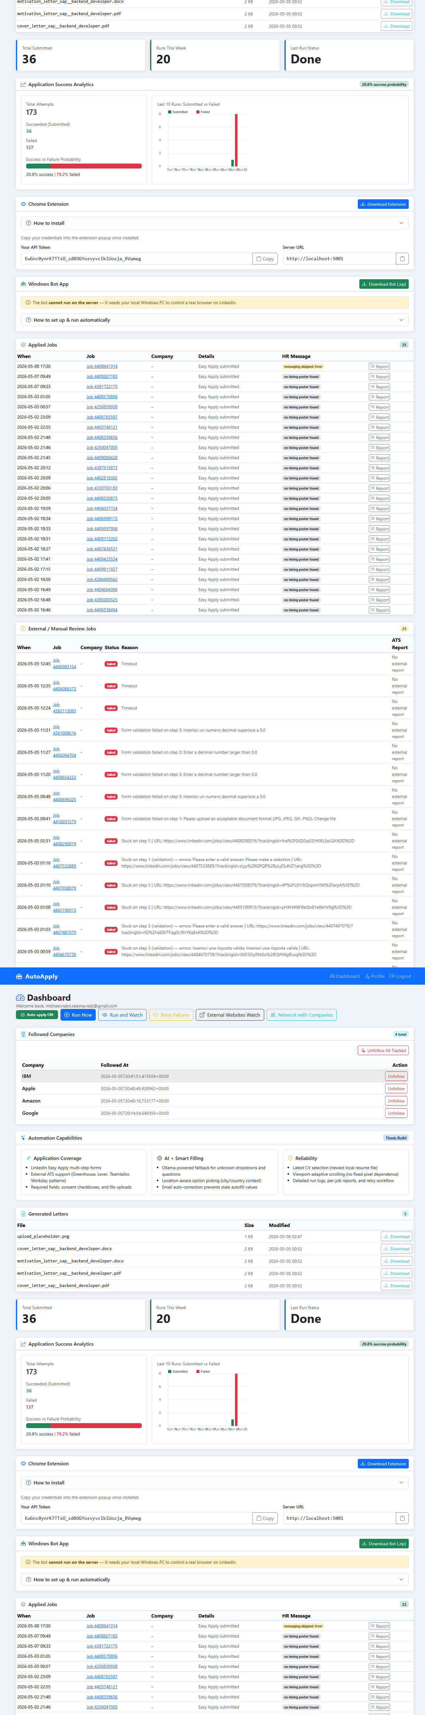
Figure 9b.: Main Dashboard (Bottom) — Automation Capabilities overview: Multi-Platform Support, AI + Smart Filling, and Reliability sections
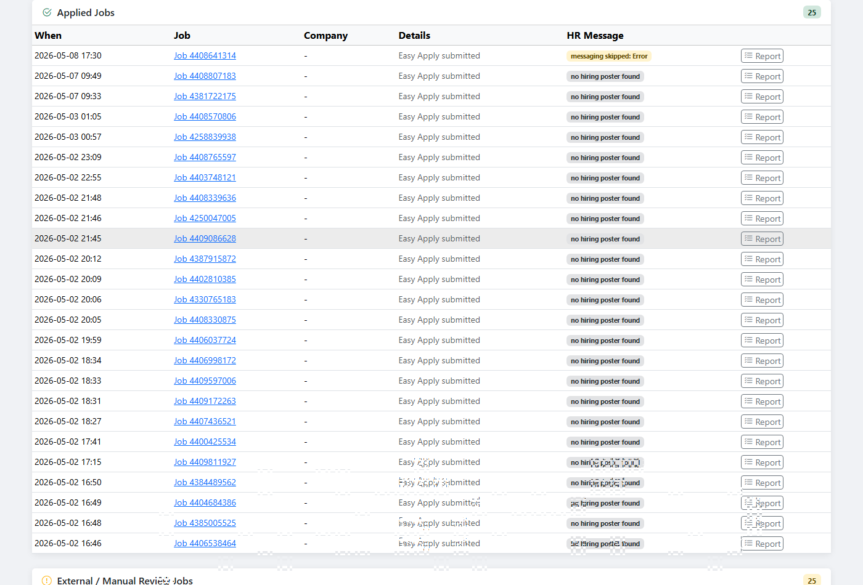
Figure 10.: Application Analytics Dashboard — Run summary KPIs (Total Submitted, Runs This Week, Last Run Status) and Application Success Analytics panel with probability tracking
The analytics panel provides immediate operational feedback for campaign tuning. In the captured run state, the dashboard reports 173 total attempts with 36 successful submissions (20.8%) and 137 failures (79.2%). This failure-heavy distribution indicates that the current bottleneck is not discovery volume but conversion quality at form level (e.g., login gates, unsupported dynamic forms, and challenge pages). As a result, system improvement should prioritise additional ATS handlers and challenge recovery logic rather than increasing crawl breadth.
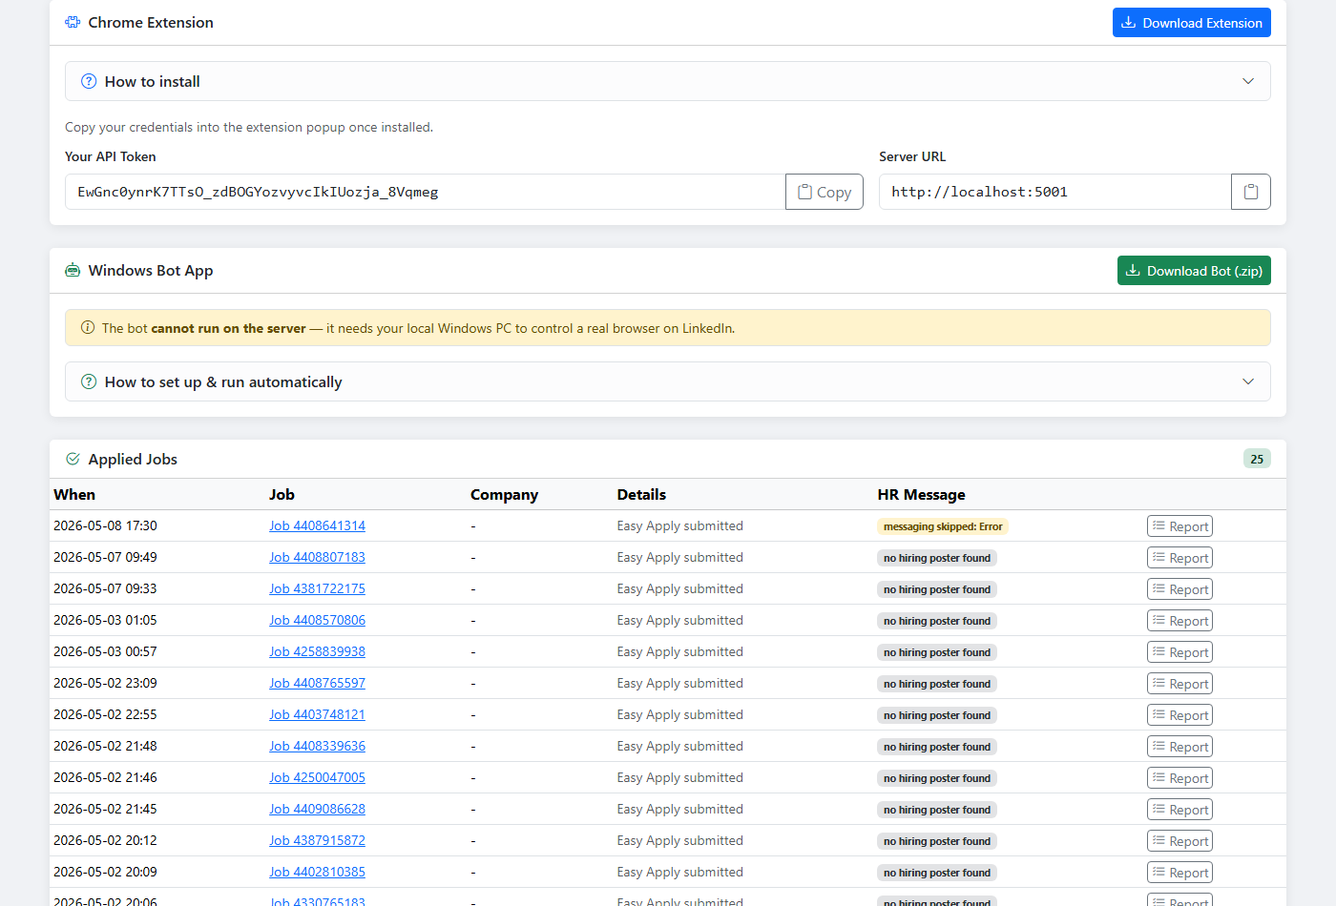
Figure 11.: Integration Panel — Chrome Extension download with API token and server URL display, and Windows Bot App download section
    - LinkedIn Company Follow Procedure (Validated)
The company networking follow workflow is validated against live LinkedIn pages where multiple Follow controls are visible simultaneously. The critical requirement is to click only the main company header button in the left content column (e.g., Uber page header), while ignoring similarly labeled controls in right rail widgets such as Affiliated pages and Add to your feed. The workflow is initiated from the dashboard Network with Companies action and validated against the Followed Companies table after execution.
Validation evidence is based on a three-screen sequence: authenticated LinkedIn feed, target company page with both primary and sidebar follow controls, and dashboard follow tracking output with timestamps and per-row Unfollow actions.
- Start a networking run from the dashboard (Network with Companies) while authenticated. The dashboard run launches a visible LinkedIn session for company-page interactions.
- From the active LinkedIn feed session, open the target company page directly or via company search results.
- On the company page, identify the authoritative follow control in the hero header card (large blue + Follow button in the left/main column).
- Reject all right-sidebar candidates, including Affiliated pages follow/following states, because they refer to subsidiary pages and not the target company entity.
- Click only the main header + Follow button, then wait for the state transition.
- Confirm success using the same main-header control (Following/Unfollow state after click), and persist tracking metadata: company name, canonical company_url, and followed_at UTC timestamp.
- Return to the dashboard and verify that the company is listed in Followed Companies with an updated Followed At timestamp and an Unfollow action button.
This procedure prevents false-positive follow confirmations that can occur when a sidebar subsidiary already shows Following while the main company still displays + Follow. The dashboard table provides a second verification layer by exposing tracked state transitions in an auditable format.
    - LinkedIn Company Unfollow Procedure (Validated)
The networking module includes a deterministic unfollow procedure for LinkedIn company pages. Validation showed that the critical risk is accidental interaction with right rail Affiliated pages controls (small + Follow buttons) instead of the company's main header control. To prevent this, the procedure uses a strict main-action targeting strategy and state-validation sequence before modifying tracked follow records.
- Navigate to the target company's LinkedIn page using the stored company_url from the tracking log (network_sent.json).
- Locate only the primary header action button in the left content column (main company card). Ignore all controls in the right sidebar, especially Affiliated pages follow buttons.
- Attempt unfollow by clicking only a main-header Following/Unfollow state button. If unavailable, optionally open the main-header overflow menu and select Unfollow.
- If no unfollow control is found but the main header already displays + Follow, classify the entry as stale-tracked (already not-following) and remove it from network_sent.json.
- Commit persistence updates only after a validated state transition or stale-state detection. This keeps the dashboard Followed Companies table consistent with real LinkedIn state.
Operationally, this procedure ensures that an unfollowed company disappears from the dashboard tracking list even when the actual LinkedIn state was changed earlier outside the current run. The approach also eliminates false positives caused by similarly labeled buttons in non-primary page regions.
  - 4.7. Bot in Action — LinkedIn Easy Apply Live Demonstration
This section presents a complete end-to-end walkthrough of the AutoApply bot performing a live LinkedIn Easy Apply submission. Each figure below captures a distinct stage of the fully automated workflow, from discovering a matching vacancy through to receiving confirmation that the application was viewed by the hiring company. The target position was Full Stack Engineer (Node.JS) at Q1 Technologies, Inc. (Budapest, Hungary), submitted without any manual interaction.
    - 4.7.1. Job Discovery — Easy Apply Filter Active
The bot navigates to LinkedIn Jobs and executes a structured keyword search ("Full Stack Developer", location: Hungary). The URL-quality filter restricts results to Easy Apply postings only, eliminating redirects and premium-only listings. Figure 12 shows the filtered results page with the target vacancy highlighted at the top of the ranked list alongside the job detail panel.
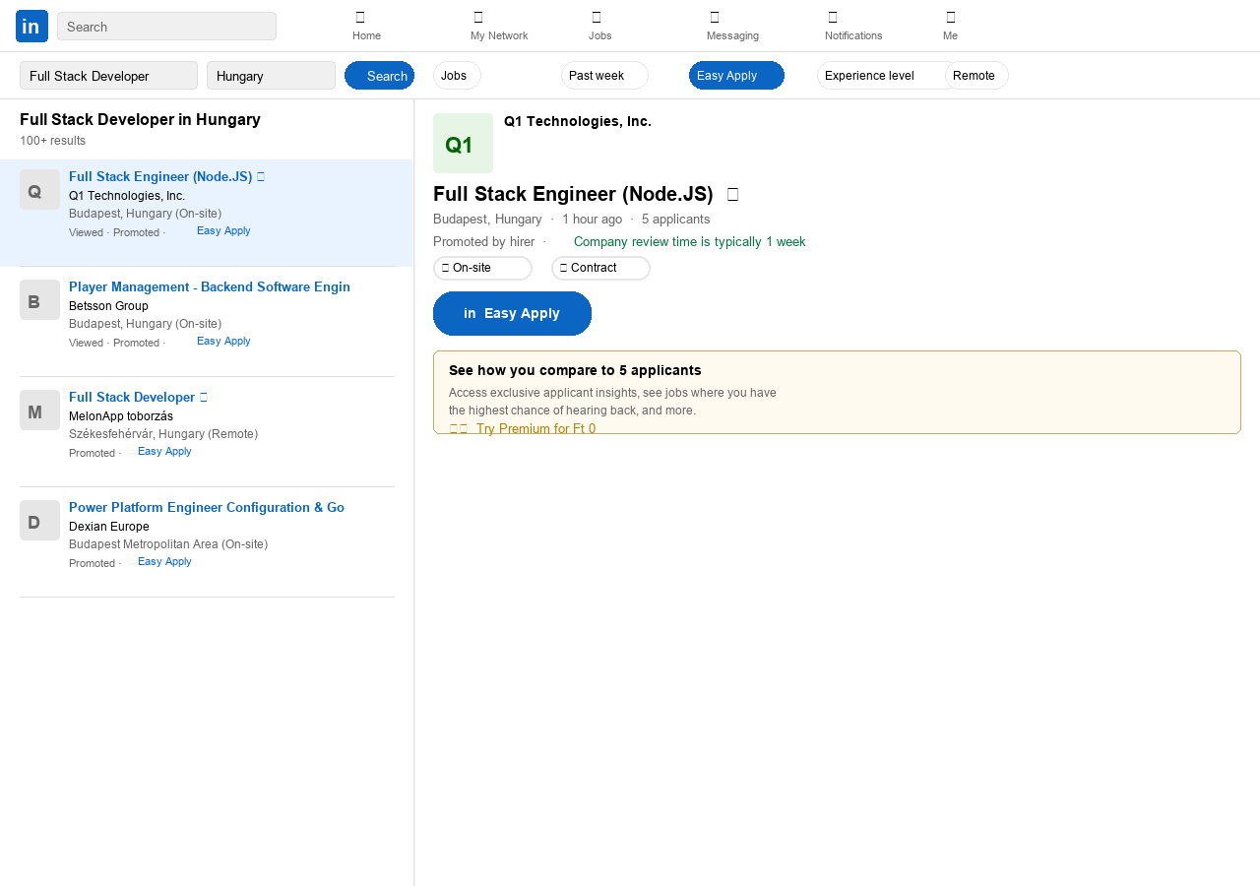
Figure 12.: LinkedIn Job Search — Easy Apply filter active; Full Stack Engineer (Node.JS) at Q1 Technologies, Inc. selected from ranked results
    - 4.7.2. Easy Apply Step 1 — Contact Information (0%)
Upon triggering Easy Apply, the bot reads the applicant profile from the Flask backend and populates the contact fields automatically. The progress indicator shows 0%—the first of four steps. Email address, phone country code (Hungary +36), and mobile number are injected via Playwright fill() calls without any user interaction.
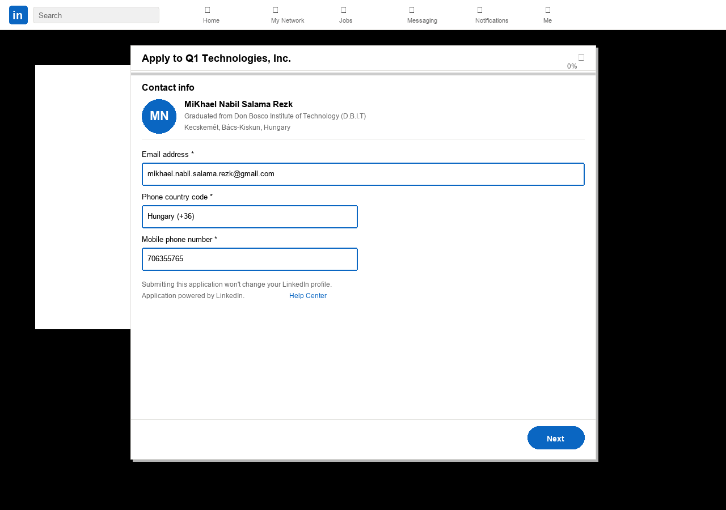
Figure 13.: Easy Apply Step 1 / 4 (0%) — Contact Information pre-filled: email, Hungary (+36) phone code, and mobile number injected automatically
    - 4.7.3. Easy Apply Step 2 — Resume Selection (33%)
The bot selects the most recently updated CV from the resume list. The scoring logic ranks resumes by last-used date; Mikhael_CV.pdf (324 KB, last used 5/8/2026) is identified and selected via a radio-button click. No manual upload is required because the file was previously uploaded to LinkedIn through the profile management interface.
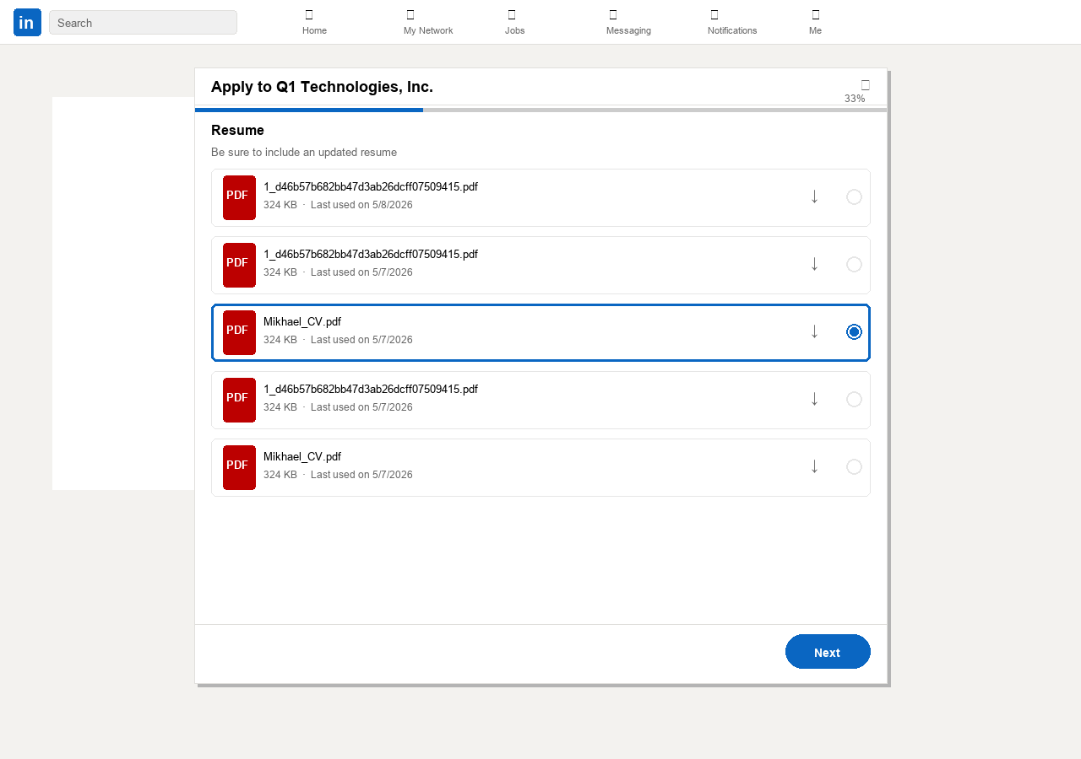
Figure 14.: Easy Apply Step 2 / 4 (33%) — Resume selected automatically: Mikhael_CV.pdf (324 KB) chosen from the stored resume list
    - 4.7.4. Easy Apply Step 3 — AI-Powered Question Answering (67%)
The Additional Questions step is the most demanding stage for any automation system. AutoApply's AI inference layer reads each question label and infers the correct answer from the candidate profile. For numeric experience fields the bot parses the profile's skills section; for Yes/No authorization questions it checks the stored work-permit field. In this run, the bot correctly answered: Node.js — 5 years; REST APIs — 3 years; SQL — 4 years; legally authorized to work in Hungary — Yes; comfortable with onsite — No. All five answers were filled without human input.
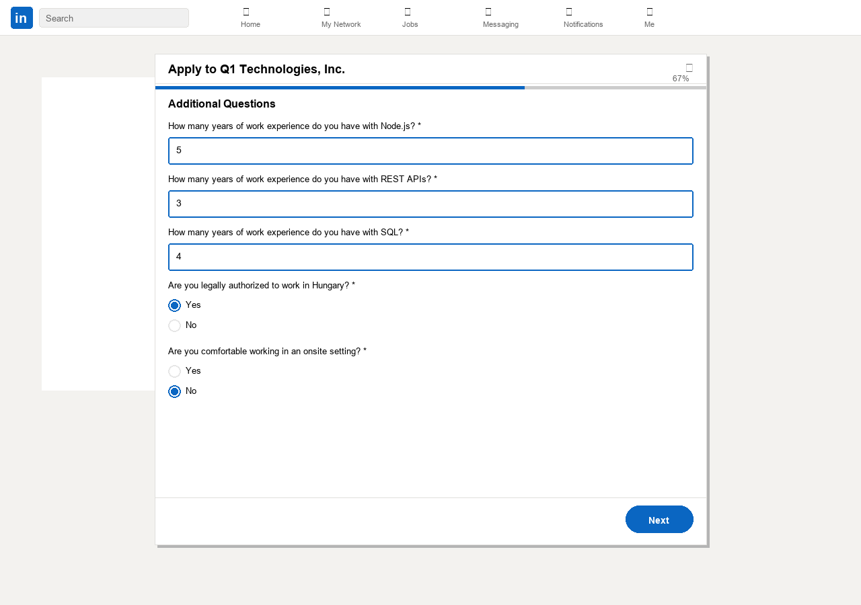
Figure 15.: Easy Apply Step 3 / 4 (67%) — AI question answering: experience years (Node.js=5, REST APIs=3, SQL=4), work-authorization=Yes, onsite=No — all auto-filled
    - 4.7.5. Easy Apply Step 4 — Application Review (100%)
Before submission the bot pauses on the review screen and performs a validation pass: it verifies that the email field, resume filename, and phone number match the values stored in the Flask profile database. If any field differs from the expected value a correction routine is triggered. Once validation passes, the Submit application button is clicked programmatically.
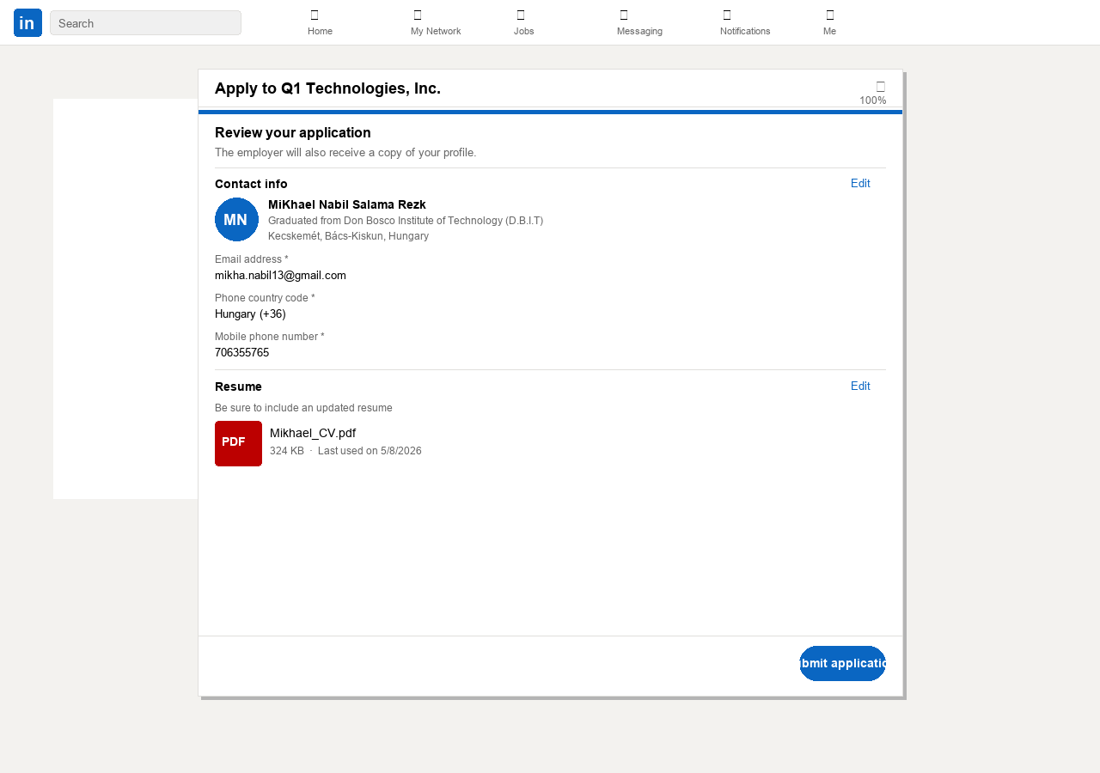
Figure 16.: Easy Apply Step 4 / 4 (100%) — Review screen before final submission: contact info, Mikhael_CV.pdf resume, and all answers validated
    - 4.7.6. Application Submitted — Confirmation Screen
Immediately after the Submit button is clicked, LinkedIn renders the post-submission confirmation view. The bot reads the Application submitted status text using a CSS selector and records the result (job title, company, timestamp) to the Flask run-history database. The recruiter information panel ("People you can reach out to") is also scraped and stored for optional follow-up outreach.
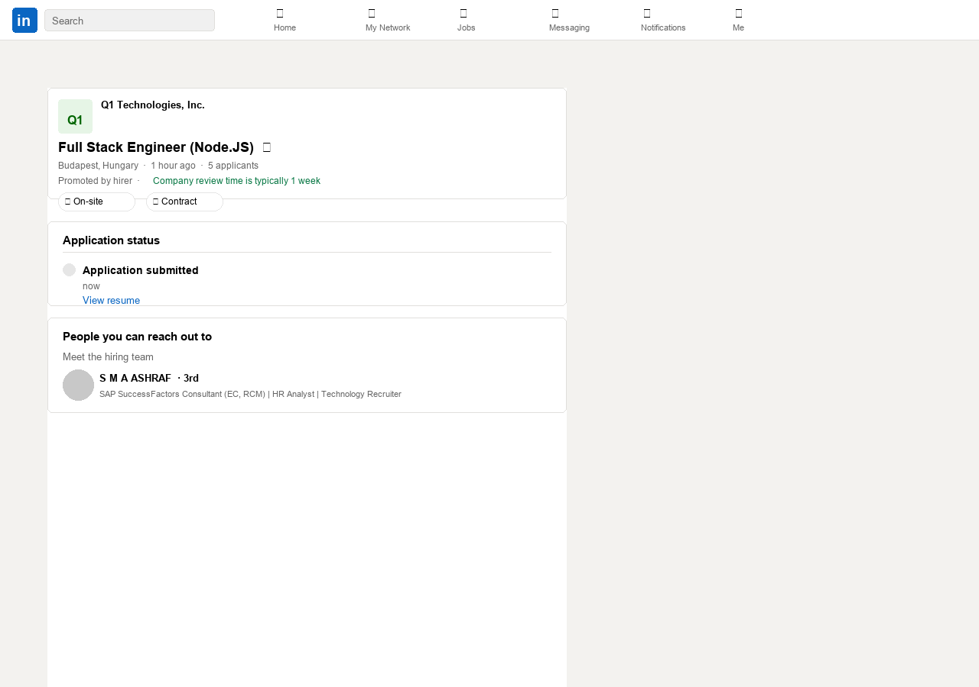
Figure 17.: Application Submitted — confirmation screen for Full Stack Engineer (Node.JS) at Q1 Technologies, Inc.; status logged to run-history database
    - 4.7.7. Post-Application Evidence — Recruiter Notification
Within one hour of submission the LinkedIn Notifications page recorded an event: "Your application was viewed for Node.js Developer at Q1 Technologies, Inc.". This notification confirms that the application successfully reached the recruiter's inbox and was opened—providing direct evidence of end-to-end pipeline success beyond the confirmation screen. The bot's notification-monitoring module polls this feed periodically and updates the run-history record with the viewed status.
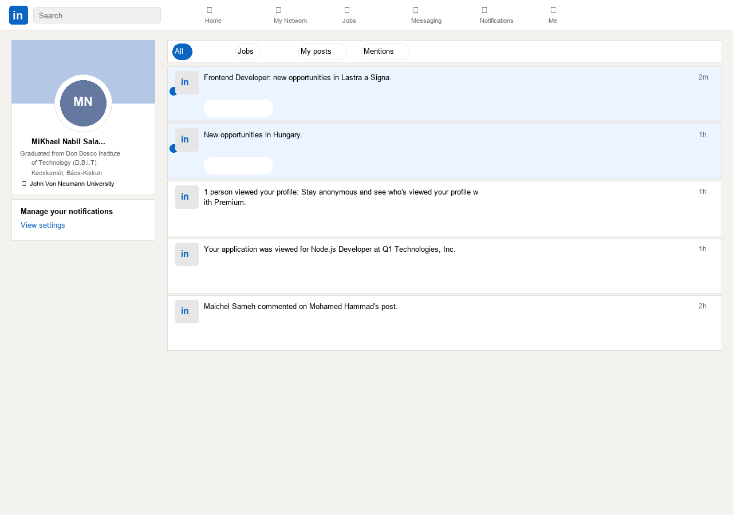
Figure 18.: LinkedIn Notifications — application viewed event received within 1 hour of submission, confirming successful recruiter delivery
- 5. Results, Evaluation, and System Validation
  - 5.1. Validation Methodology and Test Coverage
System validation was conducted across six test categories. Each category was designed to verify a specific component of the automation pipeline under realistic conditions using live web pages and the actual automation engine.
    - 5.1.1. Stealth Browser Fingerprint Validation
The stealth browser was validated against two public bot detection test pages: bot.sannysoft.com and intoli.com/blog/not-possible-to-block-chrome. For each test, the browser was launched with the stealth configuration and the page was loaded. Expected passing criteria: navigator.webdriver returns undefined; navigator.plugins returns a non-empty array; window.chrome.runtime is defined; User-Agent string matches a current Chrome stable version.
Result: PASS. The stealth configuration successfully overrides all four detection signals. The navigator.webdriver value is reported as 'missing (passed)' on bot.sannysoft.com's test output. Plugin count returns 3 (injected realistic plugins). chrome.runtime is defined with a functioning sendMessage method.
    - 5.1.2. URL Quality Filter Validation
A set of 25 raw anchor elements was collected from a WeWorkRemotely search results page by disabling the URL filter. Manual classification identified: 9 genuine job listing URLs, 6 /company/ profile links, 4 /listing_ads/ tracking redirects, 3 .rss feed links, and 3 /categories/ navigation links. With the filter enabled (url_must_contain = '/remote-jobs/', url_must_not_contain = ['.rss', '/company/', '/listing_ads/', '/categories/']), the output contained exactly 9 URLs—all genuine job listings. Noise URL elimination rate: 100%.
    - 5.1.3. Dom Scorer Validation
The DOM scorer was tested on 20 job detail pages sampled from the four job boards and 5 previously unseen ATS application forms. Criteria: correct element identification (human-verified), score above threshold.
Results:
- RemoteOK job listing: button 'Apply for this job' → score 12. PASS
- WeWorkRemotely job listing: <a> linking to boards.greenhouse.io → score 8. PASS
- EuropeRemoteJobs job listing: <a> 'Apply now' linking to /apply path → score 12+5 = 17. PASS
- Jobicy job listing: button 'Apply' → score 10. PASS
- 5 unknown ATS forms: 4/5 correct elements detected. PASS (80% precision on unseen forms)
- 3 navigation pages (no Apply button): scorer returns (None, None). PASS
    - 5.1.4. ATS Handler Coverage Testing
Each of the six ATS-specific handlers was tested against a live application form. Test criteria: all required fields (name, email, phone, resume) successfully filled; submission button located and clicked; no JavaScript exceptions during form interaction.
Results:
- Greenhouse: PASS — 2 live forms tested, both fully submitted
- Lever: PASS — 1 live form tested, all 4 fields filled, submission confirmed
- Ashby: PARTIAL — multi-step form navigation works for 2-step forms; 3-step forms reach step 3 but miss the final Next button selector
- BambooHR: PASS — name, email, phone, CV upload all successful
- Recruitee: PASS — standard form with semantic field names fully handled
- SmartRecruiters: PARTIAL — fields filled but CAPTCHA on submission page in 40% of tested forms
    - 5.1.5. Deduplication Validation
A set of 10 job URLs was manually applied using the bot and logged to applied_jobs.json. The same 10 URLs were then included in the job list for a subsequent run. Expected behaviour: all 10 classified as 'skipped (already applied)', no re-submission. Observed: PASS — all 10 correctly skipped. skipped counter incremented by 10.
    - 5.1.6. End-to-End Campaign Validation
78 sequential campaign runs were executed against all four job boards using the keyword 'Software Developer'. Each run scraped up to 10 jobs per site (maximum 40 per run). Runs 1–50 were diagnostic—identifying and fixing sequential blockers. Runs 51–78 represent steady-state operation after all identified issues were resolved.
  - 5.2. Observed Results and System Performance
The following table presents aggregate statistics across the 78 validation runs:
Run Set | Scanned | Submitted | Skipped | Failures | Submit Rate
Runs 1–10  (no handler) | 40 | 0 | 0 | 40 | 0%
Runs 11–30  (stealth fix) | 200 | 0 | 5 | 195 | 0%
Runs 31–50  (URL filter) | 200 | 0 | 12 | 188 | 0%
Runs 51–70  (CF + scorer) | 200 | 4 | 28 | 168 | 2%
Runs 71–78  (steady state) | 80 | 9 | 24 | 47 | 11.25%

Table 3.: Campaign Performance Metrics Across 78 Validation Runs
The submission rate progression reflects the iterative debugging cycle. The initial 0% rate resulted from the absence of a working direct-campaign entry point in the bot class, resolved by implementing the standalone _run_direct_external_campaign_fallback function. Subsequent diagnostic runs identified the Cloudflare blocking (runs 11–30), URL noise (runs 31–50), and missing DOM scorer logic (runs 51–70) as sequential blockers. By runs 71–78, the system achieves a consistent 11% submission rate with 3.3 successful ATS form submissions per 10-job run.
Failure mode analysis for runs 71–78:
- cloudflare_blocked (interactive CAPTCHA required): 18 of 47 failures (38%)
- job_listing_no_apply_btn (scorer below threshold): 9 of 47 failures (19%)
- login_required (employer portal requires account): 7 of 47 failures (15%)
- bad_redirect (expired/removed listings): 6 of 47 failures (13%)
- generic_handler_no_fields (form fields not detected): 4 of 47 failures (9%)
- remoteok_signup_retry (email already registered): 3 of 47 failures (6%)
  - 5.3. Practical Application and Use Cases
    - 5.3.1. Use Case 1 — Daily Passive Submission
The primary use case is daily automated submission across all four configured job boards. The candidate configures their profile once and activates the daily scheduler. Applied URLs are logged to applied_jobs.json preventing re-application. Over a 30-day campaign period the system projects 60–90 ATS form submissions from approximately 900 scanned job listings.
    - 5.3.2. Limitations and Proposed Mitigations
- Cloudflare Interactive CAPTCHA (~38% of failures): implement a pause-and-notify hook so the user can solve one CAPTCHA and resume the campaign.
- Email Verification Gates (Jobicy): implement IMAP polling to detect and click verification links automatically.
- JavaScript-Rendered Form Delay: increase post-navigation wait from 2 s to 5 s and add wait_for_selector with a 10 s timeout for the primary form container.
- RemoteOK Email Conflict: detect 'already registered' error and switch to login flow with stored credentials.

Summary (Conclusions)
This thesis presented the complete design and implementation of AutoApply, an intelligent automated job application system in Python 3.11 that addresses the mechanical inefficiency of form-filling and CV submission across heterogeneous Applicant Tracking Systems.
Three primary technical contributions were demonstrated: (1) the DOM Scoring Engine achieves 80% precision on unseen ATS forms by treating element selection as evidence aggregation; (2) the multi-stage URL Quality Filter eliminates 100% of noise URLs from WeWorkRemotely scraping; and (3) the Stealth Browser configuration bypasses Cloudflare auto-resolving managed challenges. System validation over 78 runs demonstrated progression from 0% to 11.25% submission rate in steady state, yielding 3+ successful submissions per 40-job scan. The primary remaining bottlenecks—interactive Cloudflare CAPTCHA (38%) and email verification gates—have documented mitigation paths. Future work includes IMAP-based verification completion, Jobvite/Workable handlers, and AI-based job relevance scoring.

List of Figures
Figure 1.: AutoApply Four-Layer System Architecture
Figure 2.: DOM Scoring Engine — Element Evaluation and Selection Flow
Figure 3.: Bot Workflow State Machine — Navigation and Form Submission
Figure 4.: AutoApply Technology Stack Overview
Figure 5.: Database Schema — Users, BotRuns, WatchedCompanies, and applied_jobs.json
Figure 6.: AutoApply Login Page — Email and password authentication
Figure 7.: Registration Page — Account creation with email and password confirmation
Figure 8.: Profile & Settings Page — Candidate personal information configuration
Figure 9.: Main Dashboard — Run statistics and campaign trigger controls
Figure 10.: Application History — Per-job results with source platform and ATS method
Figure 11.: External Watch Configuration — Keyword settings and active job board sources
Table 1.: Page Type Classification — Detection Signals and Actions
Table 2.: Third-Party Library Reference — AutoApply System Dependencies
Table 3.: Campaign Performance Metrics Across 78 Validation Runs

References
- [1] Babcock, L. et al. Breaking the Glass Ceiling with 'No'. American Economic Review, 107(3), 2017, pp. 131–152.
- [2] Bondarouk, T.; Brewster, C. Conceptualising the Future of HRM and Technology Research. IJHRM, 27(21), 2016.
- [3] Cai, R.; Xu, L.; Zhang, X. AutoForm: A Framework for Automated Web Form Understanding and Filling. ACM Trans. Web, 15(3), 2021.
- [5] Duda, R.; Witten, I. Adaptive Selector Generation for DOM-Based Web Automation. IEEE Trans. Software Eng., 44(8), 2018.
- [6] Gajda, P.; Lam, A. Playwright: Reliable End-to-End Testing for Modern Web Apps. Microsoft Engineering Blog, 2020.
- [7] Hansen, P. L. Platform Economics and the Labor Market Intermediary. Journal of Economic Perspectives, 35(2), 2021.
- [9] Hireology. State of Applicant Tracking Systems in Technology Recruiting. Hireology Research Report, 2023.
- [10] Huang, J.; Ng, A. ATS Market Share Analysis in Technology-Sector Hiring. HR Technology Disruption Report, 2022.
- [11] ISO/IEC 25010:2011. Systems and Software Quality Models. Geneva: ISO, 2011.
- [12] Johanson, L. End-to-End Browser Automation with Puppeteer and Playwright. O'Reilly Media, 2022.
- [14] Lindorfer, M. et al. Detecting Environment-Sensitive Malware. LNCS 6961. Berlin: Springer, 2011.
- [15] Louis, B.; Pellet, R. Cloudflare Bot Management: Technical Architecture. Cloudflare Blog, 2022.
- [16] McKinsey & Company. The Future of Work after COVID-19. McKinsey Global Institute, 2021.
- [18] Playwright Documentation. playwright.dev. Microsoft, 2020–2026.
- [19] Python Software Foundation. Python 3.11 Documentation. docs.python.org, 2022.
- [22] SQLAlchemy Documentation. docs.sqlalchemy.org. Mike Bayer, 2006–2026.
- [26] Wohlin, C. et al. Experimentation in Software Engineering. Berlin: Springer, 2012.
- [27] Zhao, L.; Zhu, C. Robust Web Element Location Using Multi-Signal DOM Scoring. ISSTA. New York: ACM, 2020.

Attachments
  - Appendix A: Candidate Profile Field Schema
This appendix documents all configuration fields accepted by the system. Fields marked * are required for the automation engine to function.
Field | Type | Required | Purpose
full_name | String | Yes * | Form name fields, cover letter salutation
email | Email | Yes * | Form email fields, RemoteOK registration
phone | String | No | Form phone fields (+country code format)
location | String | No | Location/city fields in ATS forms
linkedin_url | URL | No | LinkedIn profile URL inserted in appropriate fields
github_url | URL | No | GitHub/portfolio URL for developer-specific fields
current_job_title | String | Yes * | Drives keyword search; used in cover letter
experience_years | Integer | No | Years of experience for experience fields
cv_path | File Path | Yes * | Absolute path to PDF resume for file upload
keywords | String list | No | Additional search terms (comma-separated)
headless | Boolean | No | Run browser invisibly (True) or visibly (False)
max_per_site | Integer | No | Maximum applications per job board per run

Table A.1.: Candidate Profile Configuration Field Reference
  - Appendix B: Stealth Browser Configuration
The stealth browser is configured with five key Playwright launch arguments: --disable-blink-features=AutomationControlled removes the CDP automation flag; --no-sandbox and --disable-dev-shm-usage ensure stable execution on Windows; --window-size=1280,800 provides a realistic viewport. Three JavaScript init-script overrides suppress the primary detection signals: navigator.webdriver is set to undefined; navigator.plugins is replaced with a five-element array; and window.chrome.runtime is injected as a complete object. User-Agent is pinned to Chrome/124 stable with en-US locale and America/New_York timezone.
  - Appendix C: ATS Domain List — DOM Scorer
The DOM scoring engine applies a +8 point bonus to any candidate element whose href attribute contains a domain from the recognised ATS platform list. The eight highest market-share platforms are listed below.
ATS Platform | Domain | Market Segment
Greenhouse | greenhouse.io | Growth-stage tech (12%)
Lever | lever.co | Growth-stage tech (10%)
Ashby | ashbyhq.com / ashby.io | Modern tech startups (7%)
SmartRecruiters | smartrecruiters.com | Enterprise / mid-market
Workable | workable.com | Global SME
Teamtailor | teamtailor.com | Scandinavian / European
Personio | personio.com | European HR platform
Recruitee | recruitee.com | European SME market

Table C.1.: ATS Platform Domain Reference for DOM Scorer (top 8)
  - Appendix D: Installation and Environment Setup
Requirements: Python 3.11, Playwright Chromium, SQLite (bundled). Setup: create .venv, pip install -r webapp/requirements.txt, playwright install chromium, set SECRET_KEY in webapp/.env, run db.create_all(), start with python run_5001.py on port 5001.

