Sahara Restaurant - Website QR

Scan this QR code to open the website on mobile.
https://YOUR-RENDER-SERVICE.onrender.com

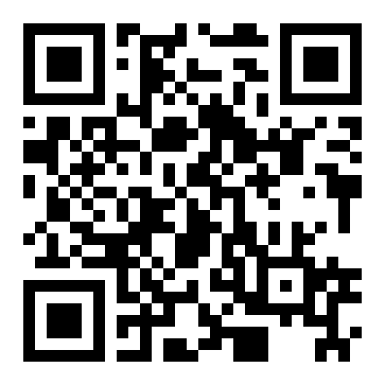

Owner copy - ready to print

