Project Documentation
WebProgramming 2 – Lecture Homework
Prepared by:
- Mikhael Nabil Salama Rezk (IHUTSC)
- Szabó Lilla (BDCRL0)

Table of Contents
Project Overview 1
Responsive theme 2
Authentication Implementation 2
Main Page Menu 3
Admin Dashboard 4
Database Menu 5
Contact Menu 6
Messages Menu 7
Graph Menu 8
CRUD Menu 8
Admin Menu 12
Profile Settings 14
Hosting and Deployment 15
GitHub and Version Control 16

Project Overview
This documentation covers the Laravel-based web application submitted for the Web Programming 2 course. The project integrates Laravel (backend) with an Inertia + React frontend. It implements user authentication, role-based access control, CRUD operations for articles, a contact form, administrative features, and data visualizations. The document describes system requirements, architecture, implementation details, database schema, testing results, and future improvements.

Responsive theme
The project uses a modern, responsive theme built with Inertia.js, React, and Tailwind CSS. It was partially applied from https://themewagon.com/theme-tag/html5-css3/
The theme features a left-side navigation bar, a central content area, and a footer, creating a clear and consistent structure across all pages.
Styling is managed through Tailwind CSS, which provides a simple color palette, responsive typography, and flexible layouts that adapt to various screen sizes.
Overall, the theme follows a clean, minimalist design focused on readability, responsiveness, and ease of navigation, giving the website a professional and modern appearance.
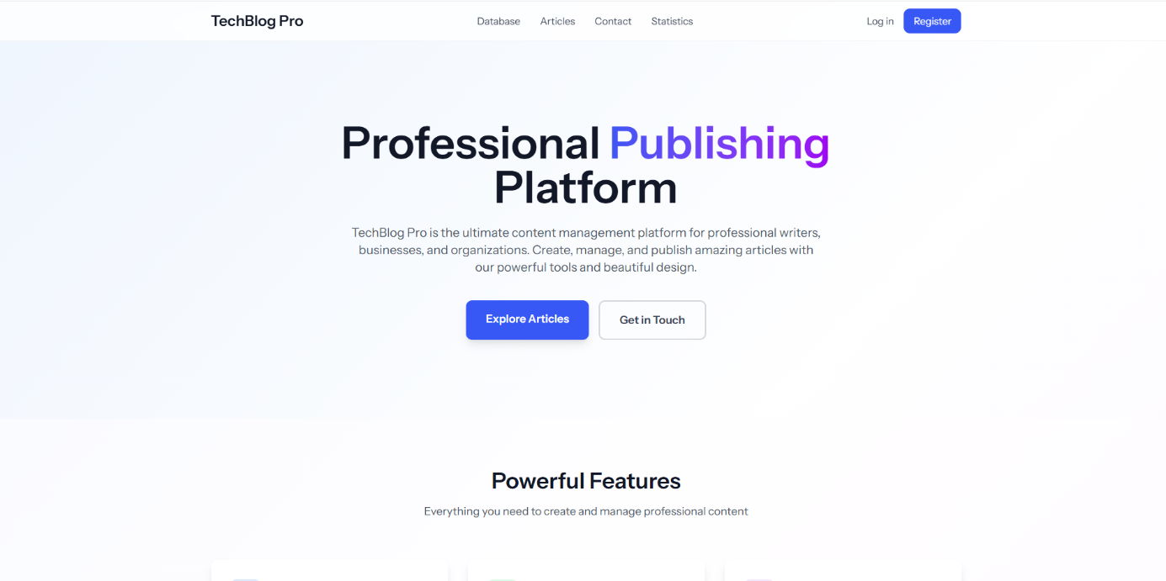

Authentication Implementation
Authentication in the project was implemented using Laravel’s built-in authentication system with role-based access control. Three user roles are defined:
- Visitor
- Registered User,
- Admin.
Menu visibility depends on user roles:
- Visitor – can access the Main and Contact pages.
- Registered User – gains access to the Messages and Database menus.
- Admin – can access all menus, including the Admin dashboard and user management section.
Users can register, log in, and log out securely, with passwords automatically hashed before storage. After registration, users receive the “registered” role by default, while administrative rights can be assigned through the Admin interface.
Access to specific pages is protected using middleware — auth for logged-in users and a custom admin middleware for administrative pages.
The User model includes helper methods (isAdmin(), isRegistered(), isVisitor()) to check roles easily.
This setup ensures secure access control and clearly separates permissions between different user types.
Admin:
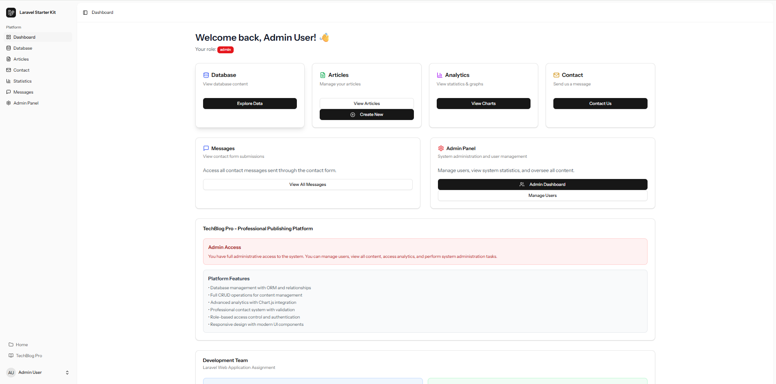
Registered User:
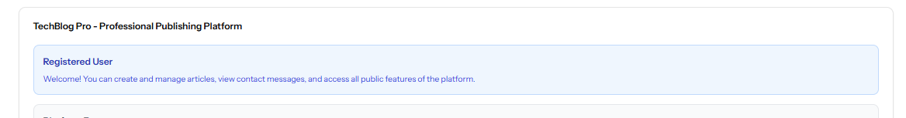

Main Page Menu
The Main Page serves as the introduction to the Laravel web application. At the top, a large heading displays the website title, welcoming users and presenting the purpose of the site.
Below the title, the page features a 2×3 grid layout that displays six interactive menu cards:
- Database Management – opens the section displaying data retrieved from the database.
- Full CRUD Operations – directs to the interface where users can create, modify, and delete records.
- Advanced Analytics – presents dynamic data visualizations generated using Chart.js.
- Role-Based Access – demonstrates user permissions (visitor, registered user, admin).
- Contact Management – provides access to the contact form for sending messages.
- Admin Dashboard – available only for administrators, showing system statistics and user management tools.
Each menu item is displayed as a responsive, card-style button with hover effects, ensuring a modern and user-friendly design consistent with the site’s overall theme.
At the bottom of the page, a custom footer is included, containing additional navigation links and copyright information, maintaining consistency across all pages of the application.
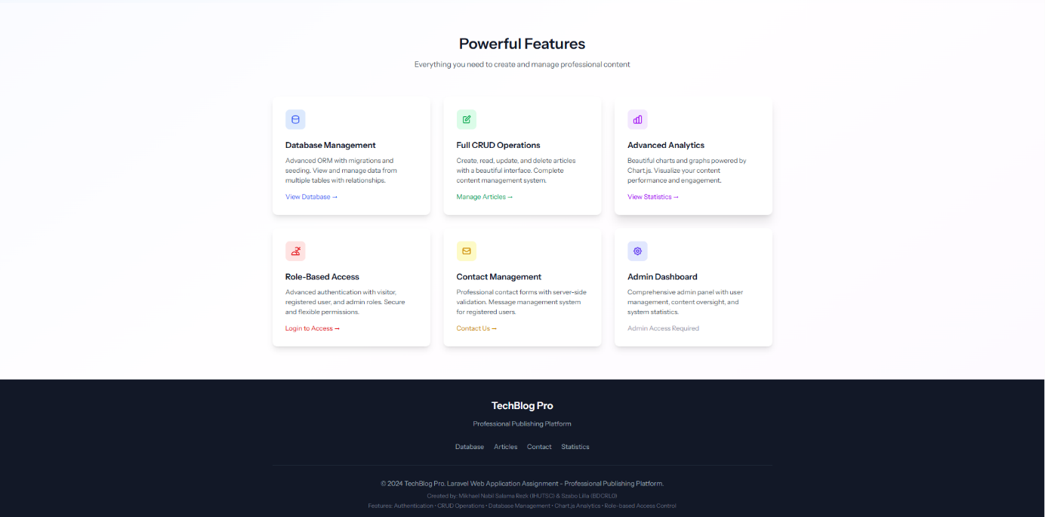

Admin Dashboard
After logging in as an Admin user, the application opens the Dashboard, which provides an overview of all main management areas.
The top section displays six interactive cards:
- Database
- Articles
- Analytics
- Contact
- Messages
- Admin Panel
Beneath the cards, a highlighted note reads:
“Admin Access – You have full administrative access to the system.”
A short list below it summarizes all platform features available to administrators.
On the left side, a vertical navigation menu includes links to Dashboard, Database, Articles, Contact, Statistics, Messages, and Admin Panel (available only for admin), with Dashboard highlighted to indicate the current view. At the bottom of the sidebar, a “Home” button allows returning to the main site, under that the current user is also shown.
This page acts as the central hub for administrators, combining clear navigation with a concise overview of system statistics and management tools.

Database Menu
The Database Menu presents an overview of the application’s stored data in a clear, structured layout divided into three sections: Articles, Categories, and Users.
At the top, the Articles section displays the total number of articles and a short description.
Below it, a responsive table lists all articles with columns for ID, Title, Category, Author, Status, and Publish Date.
This table demonstrates the use of Eloquent relationships, linking each article to its author and category.
The next section, Categories, shows the number of categories in the system, along with a list that includes Technology, Business, Lifestyle, Education, and Science.
Each category has a short description and shows how many articles belong to it, allowing users to understand content distribution.
Finally, the Users section provides a summary of registered users.
A table displays each user’s ID, Name, Email, and Role (Admin, Registered, or Visitor), illustrating the role-based structure of the application.
This page demonstrates the integration of multiple related database tables through Laravel’s Eloquent ORM, presenting the data in a user-friendly, organized manner.
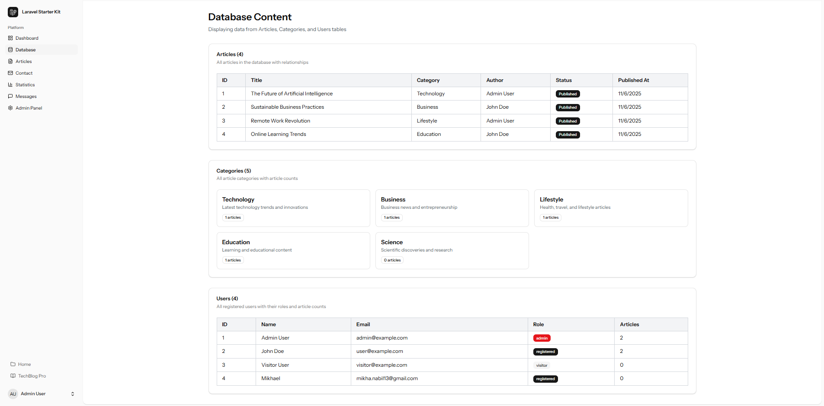

Contact Menu
The Contact Menu allows registered users to send messages to the site owner through a simple and responsive form.
At the top of the form, a large title:“Contact Us” introduces the section, followed by a short descriptive text inviting users to reach out.
The form includes input fields for:
- Name
- Email
- Subject
- Message.
Each field is validated both on the client side and the server side. Validation rules require all fields to be filled, and the message must contain at least 10 characters. If any rule is violated, the respective input field is outlined in red, and a clear error message appears below it, for example, “The message must be at least 10 characters.”
When the “Send Message” button is clicked, the form data is submitted to the server via the ContactController@store method. After successful validation, the message is saved to the Contacts database table using the Eloquent model Contact.
A confirmation message (“Thank you for your message! We will get back to you soon.”) is then displayed to inform the user that their submission was successful.
This feature demonstrates server-side validation, secure data handling, and proper use of Laravel’s Form Request and Eloquent ORM.
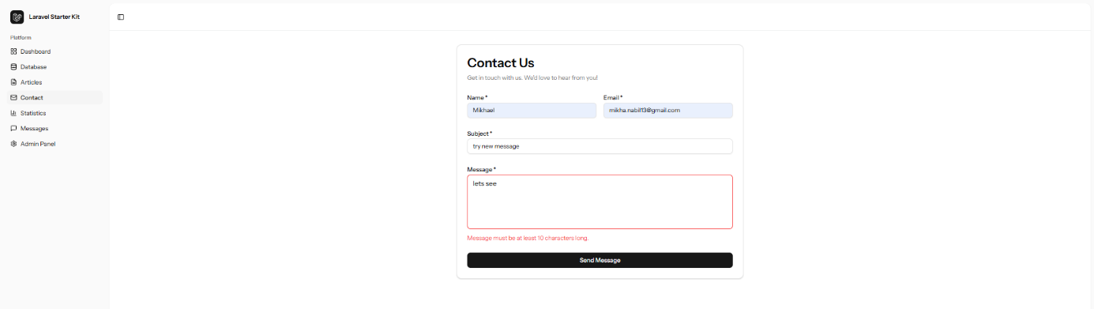

Messages Menu
Displays all messages sent through the Contact form, available only to authenticated users.
This page retrieves the records from the Contacts database table using the MessageController, which orders them in descending order so that the most recent messages appear at the top.
Each message is presented in an individual, bordered section.
At the top of each message block, the subject is displayed in bold text, followed by the sender’s name and email address. Below this, the actual message content is shown clearly and formatted for readability. On the right side of each section, the timestamp indicates when the message was submitted.
This layout provides an organized and chronological overview of all incoming messages, enabling administrators and registered users to review recent communications efficiently.
Technically, this feature demonstrates the use of Eloquent ORM for data retrieval and Inertia.js for dynamic page rendering, ensuring real-time updates when new messages are added
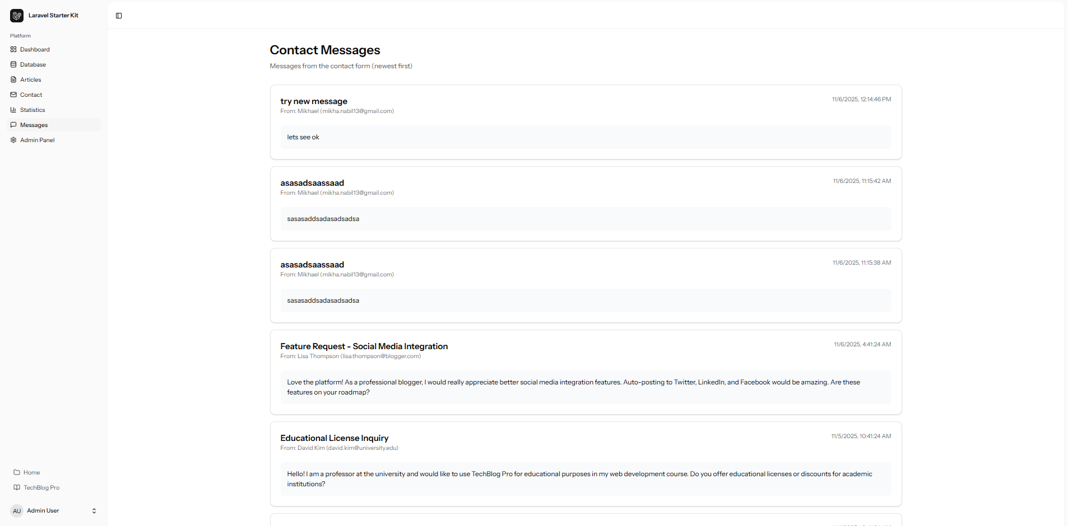

Graph Menu
The Graph Menu provides analytical insights generated dynamically from the application’s database.
This functionality is implemented in the GraphController, which retrieves and aggregates data from multiple tables using Eloquent ORM queries.
The controller prepares three distinct datasets:
- The number of articles per category,
- The number of articles published over time, and
- The number of contact messages received over time
Each dataset is passed to the frontend through Inertia.js, which transfers the data as reactive properties to the React component responsible for rendering charts.
On the client side, Chart.js is used to visualize the datasets — displaying them as pie, line, or bar charts.
This implementation demonstrates the integration of server-side data aggregation in Laravel with client-side rendering using a JavaScript charting library. It also ensures real-time accuracy, as the charts reflect the current database state each time the page is loaded.
The Graph Menu thus showcases the combination of Eloquent queries, Inertia-based data passing, and Chart.js rendering for dynamic analytics within a Laravel application.
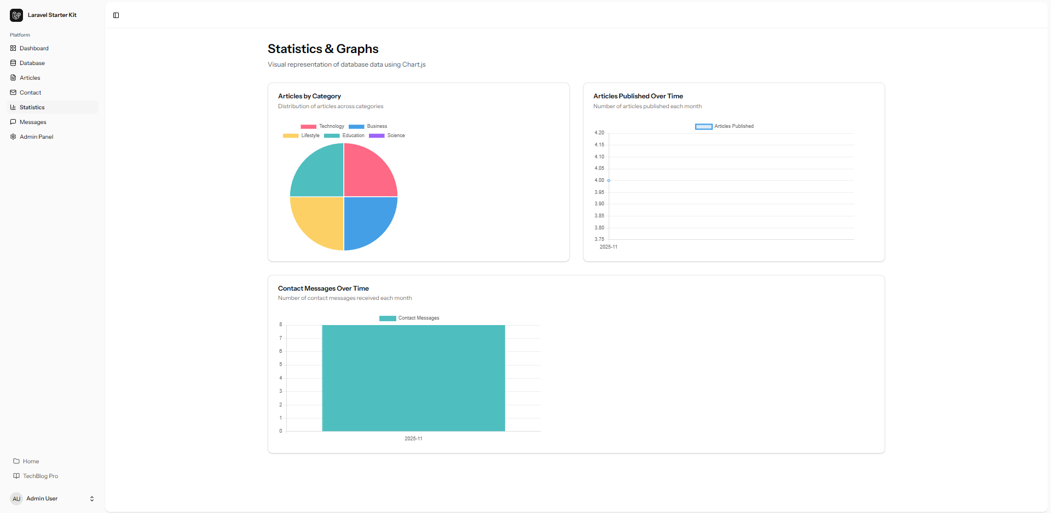

CRUD Menu
The CRUD Menu implements the full Create, Read, Update, and Delete functionality for managing articles within the system.
It is handled by the ArticleController, which uses Laravel’s resourceful routing and Eloquent ORM for all database operations, while the frontend interface is rendered through Inertia.js and React components for a seamless single-page experience.
The index() method retrieves all articles using Eloquent relationships — Article::with(['user', 'category'])->get() — and displays them in structured sections. Each section shows the article title, short description, category, and publication status, along with three control buttons on the right side: View, Edit, and Delete.
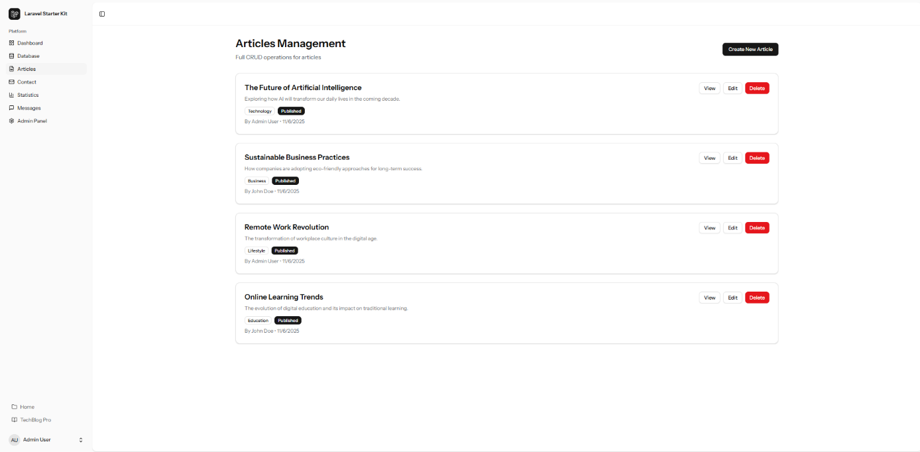
The Delete button triggers a backend call to the destroy() method, which removes the record and returns a success message through Inertia flash notifications.
Article Deletion:
At the top of the page, a “Create New Article” button opens the article creation form. The form includes fields for Title, Category (from a dropdown list), Excerpt, and Content, plus a checkbox to mark the article as published immediately.
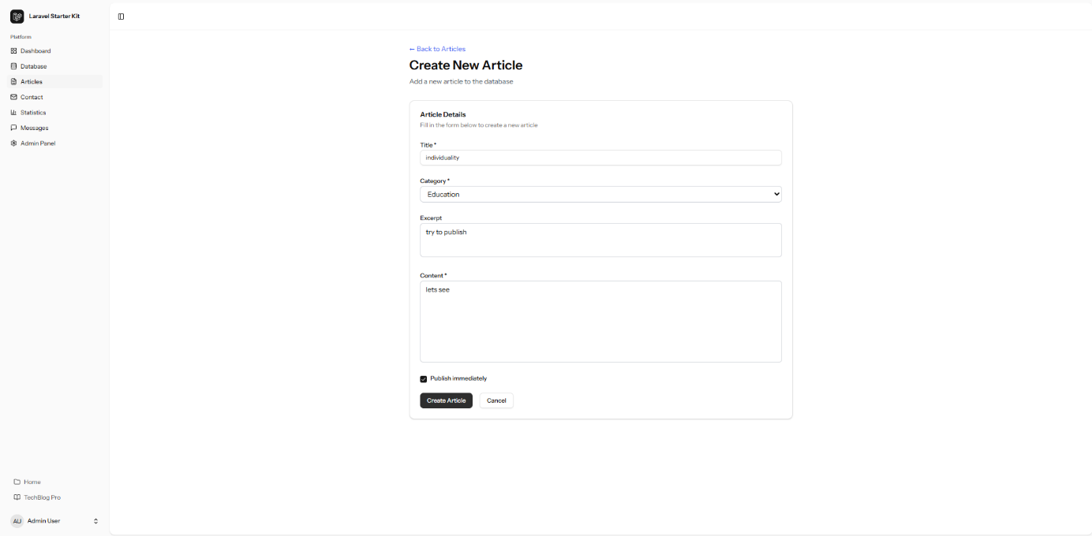
Showinng the article is created:
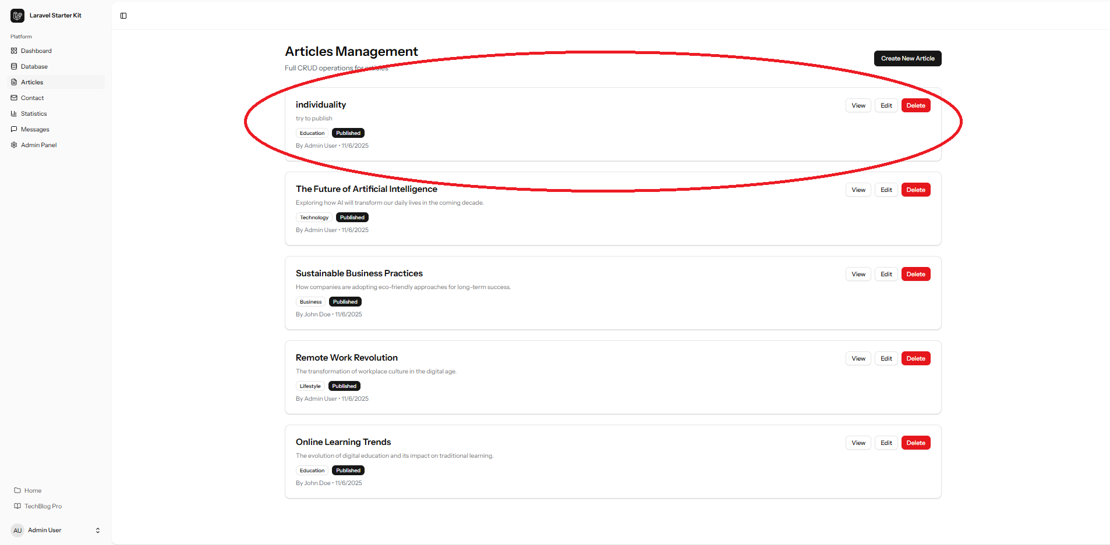
When the Create button is pressed, the store() method validates the input using Laravel’s validation rules and saves the record in the database, linking it to the authenticated user.
The Edit and Update methods follow the same validation logic to modify existing entries securely.
All operations are validated both on the frontend and backend, ensuring that only complete and correct data is stored.
Inertia automatically updates the interface after each action, eliminating the need for page reloads and maintaining a smooth, modern user experience.
This component demonstrates the effective use of Laravel’s MVC architecture, Eloquent ORM, form validation, and Inertia-based reactive rendering, combining them into a cohesive CRUD system that is both secure and user-friendly.
View the ”Individuality” article:
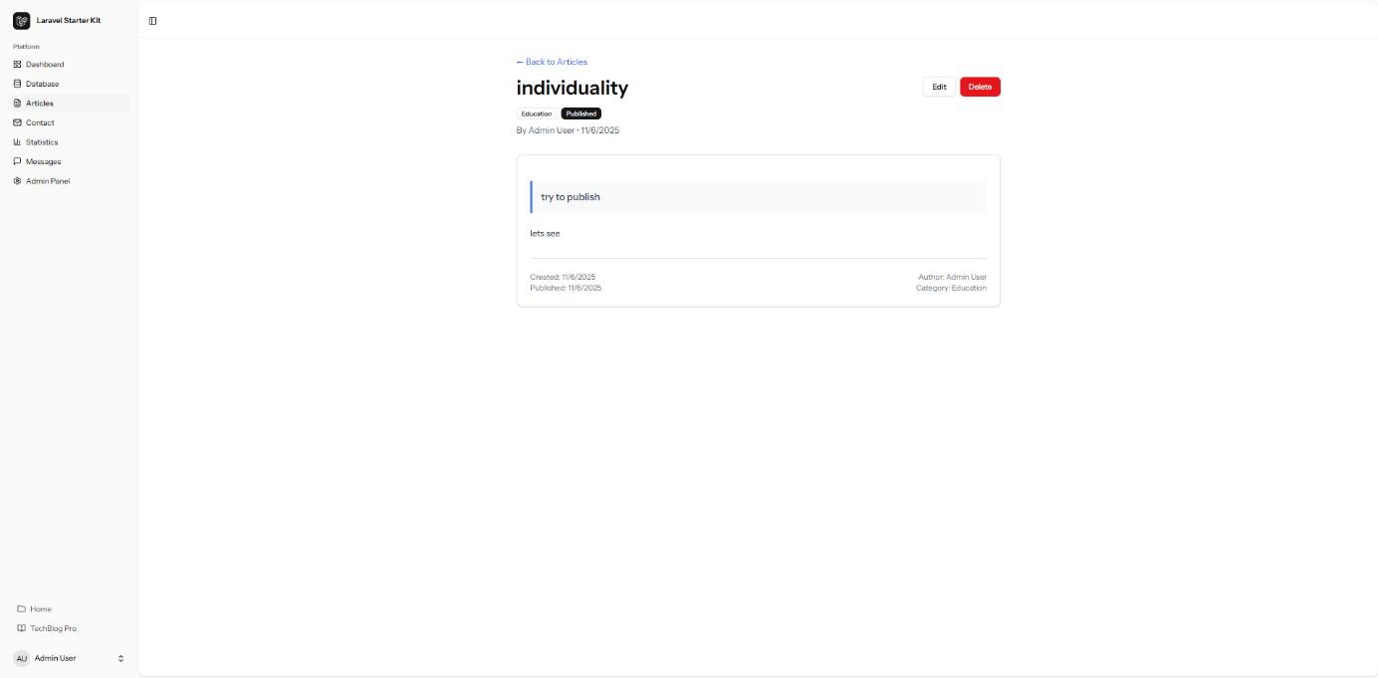
Edit the ”Individuality” article:
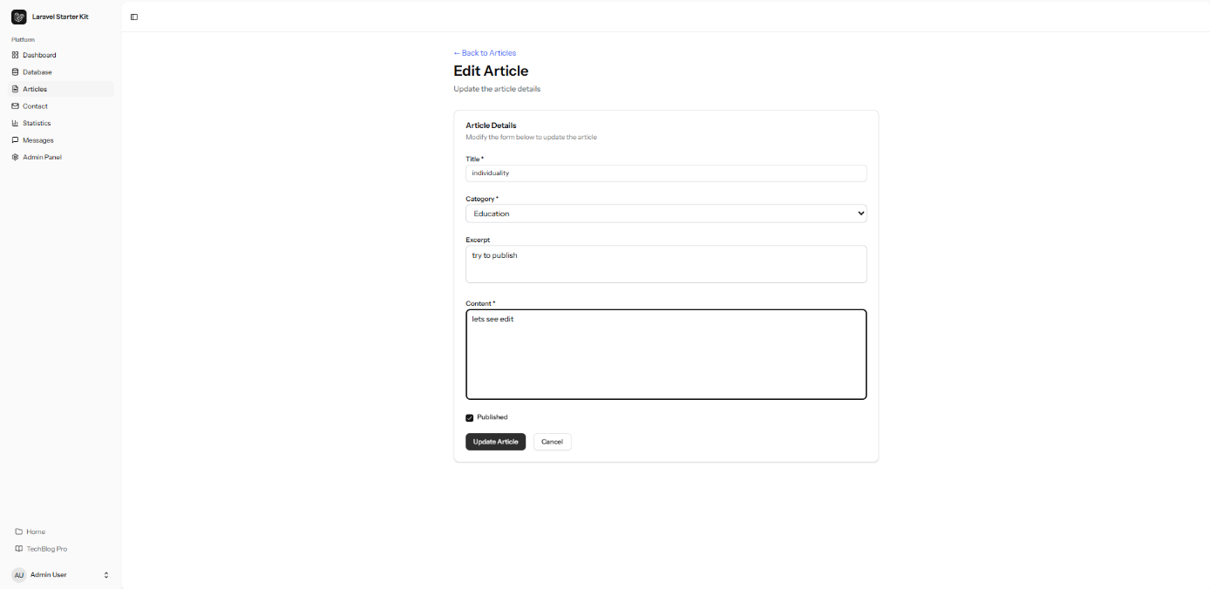
Deletion of the ”Individuality” article:
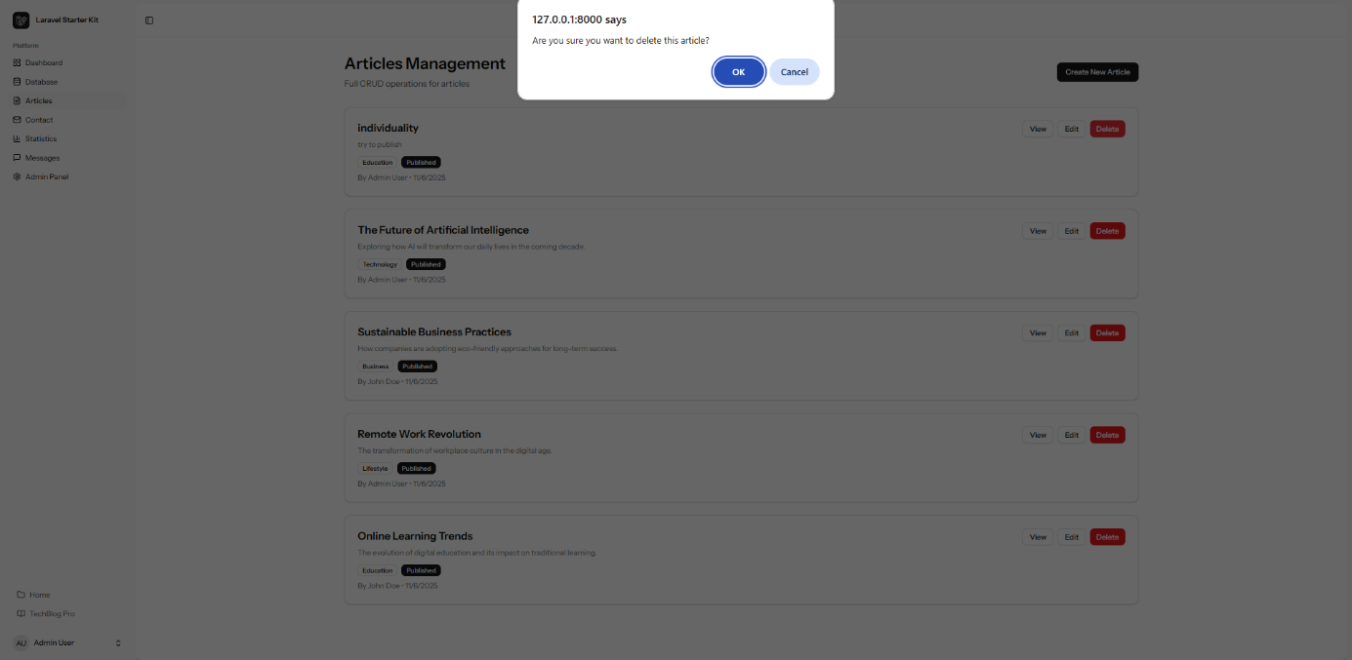
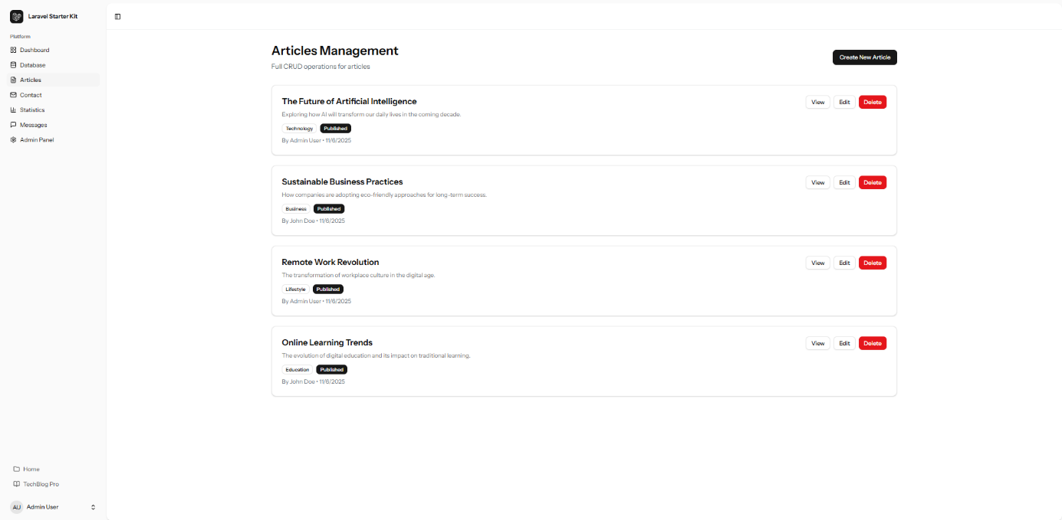

Admin Menu
The Admin Menu provides an overview of system activity and management functions available only to users with administrator privileges. It is implemented through the AdminController, which aggregates data from multiple models:
- User
- Article
- Category
- Contact
and renders it via Inertia.js into a React-based dashboard.
At the top of the page, under the “Admin Dashboard” heading, a brief description introduces the page, followed by five summary cards showing key metrics: Total Users, Total Articles, Published Articles, Categories, and Messages. Each card displays a live count retrieved from the database using Eloquent ORM queries.
Below the summary, three sections display the latest records from different tables:
- Recent Users – shows the username, email, and role (Admin, Registered, or Visitor).
- Recent Articles – lists article titles, author names, categories, publication dates, and statuses.
- Recent Messages – presents the message subject, sender’s name, email, and date received.
This page provides administrators with a clear overview of the platform’s activity and content. All data is dynamically loaded through Inertia, ensuring that updates in the database are reflected instantly without reloading the page.
Access to this entire section is restricted by a dedicated admin middleware, ensuring that only authenticated administrators can view or modify sensitive system data.
This design highlights the project’s secure role-based access control, combining Laravel’s authentication system, middleware protection, and Inertia’s reactive data rendering to maintain a robust administrative interface.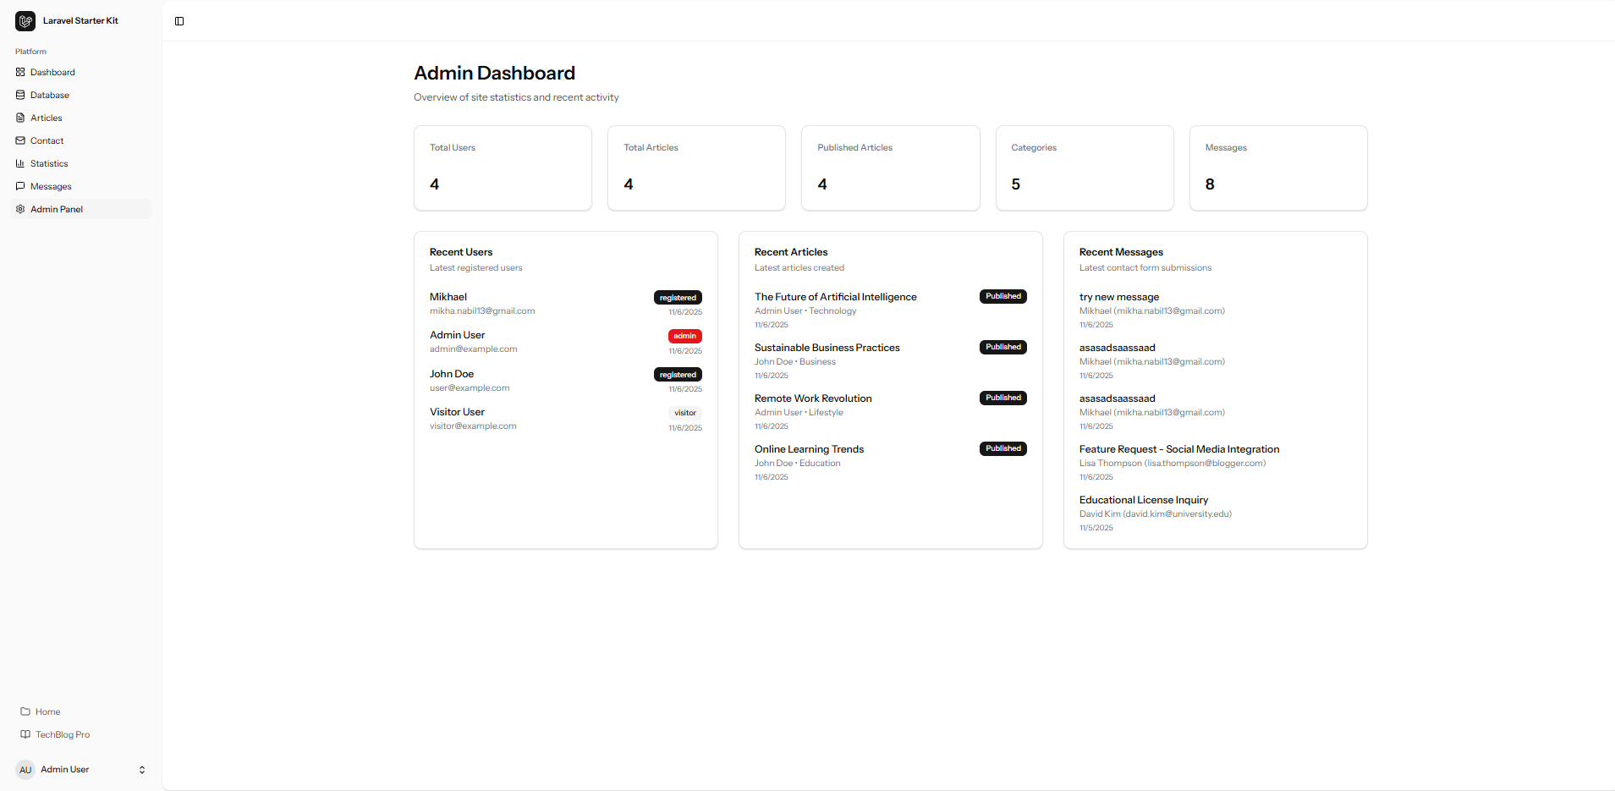
Log in with a registered user to check the admin panel:
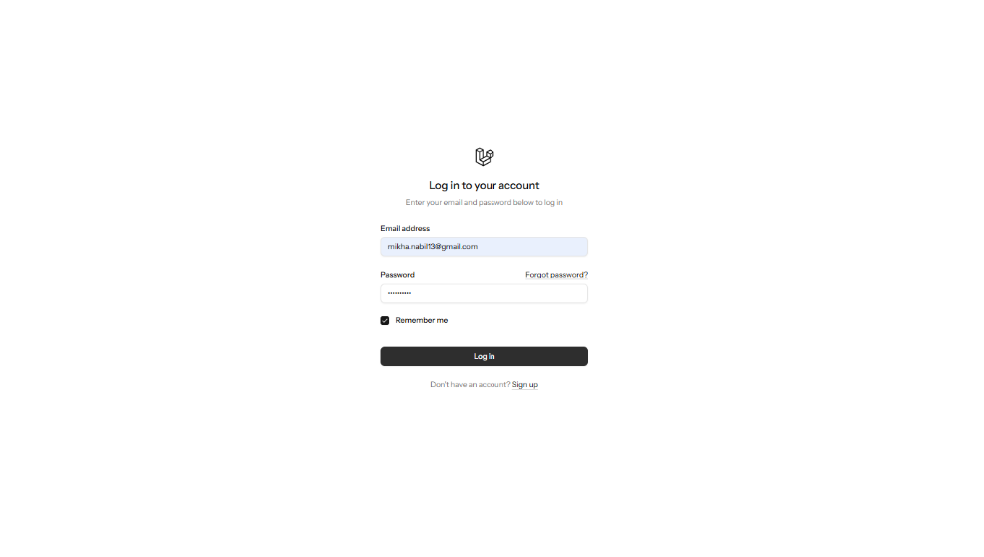
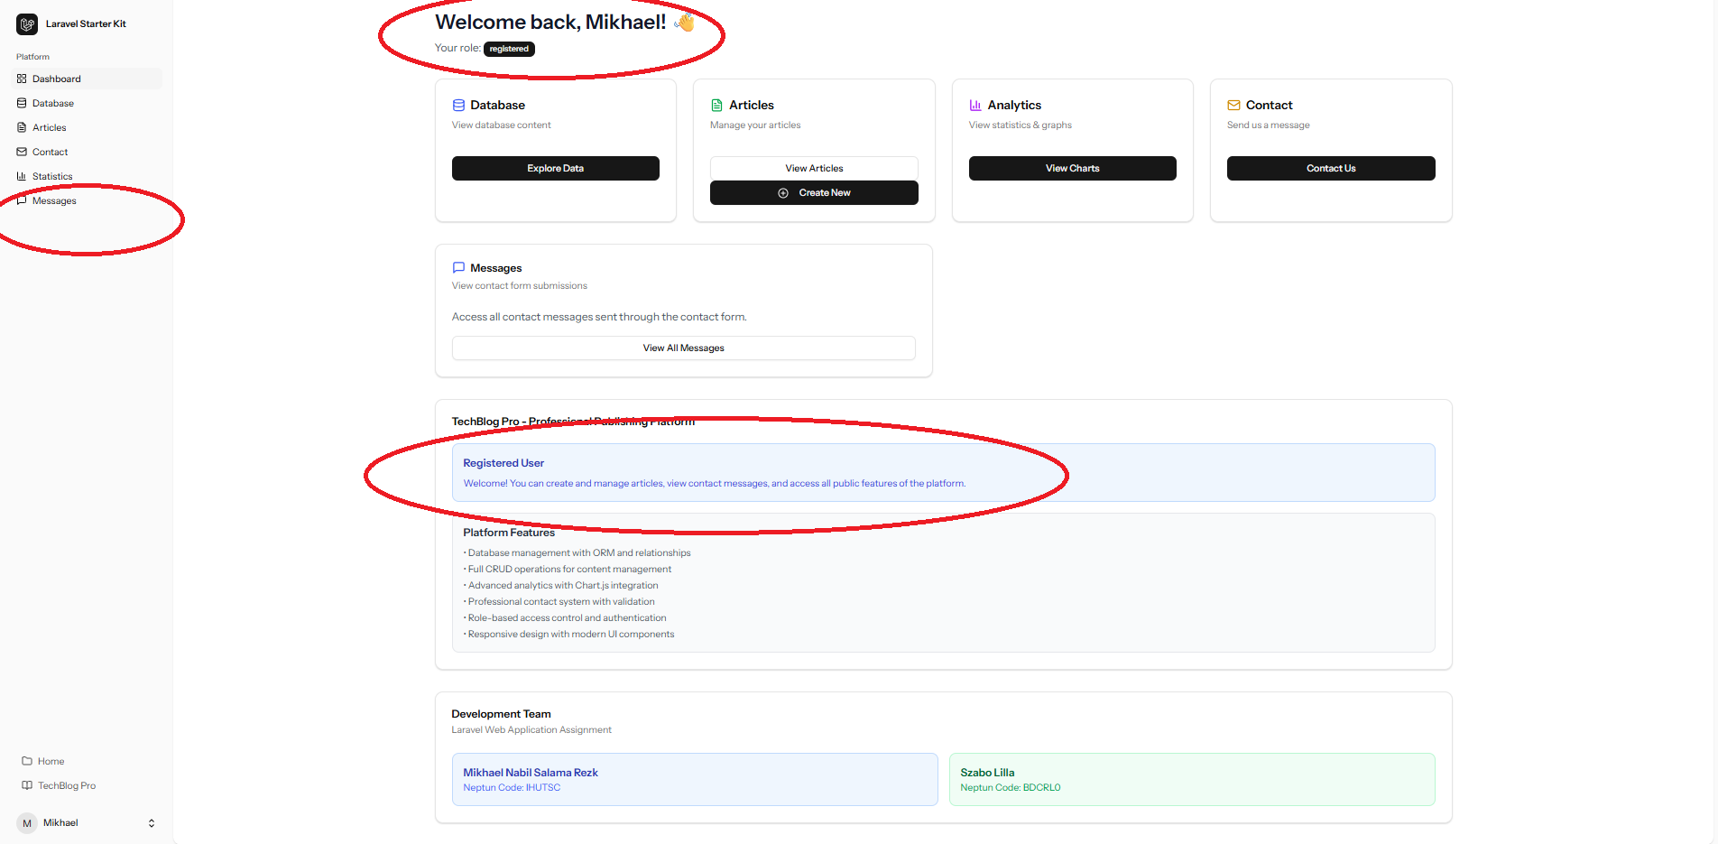

Profile Settings
The Profile Settings module enables authenticated users to manage their account data securely. It is implemented in the ProfileController, which defines the edit(), update(), and destroy() methods for retrieving, modifying, and deleting user information from the users table.
All profile routes are protected by the auth middleware, ensuring only logged-in users can access them.
The active user’s name and role are displayed at the bottom of the sidebar. Clicking on this area opens a dropdown with Settings and Logout options.
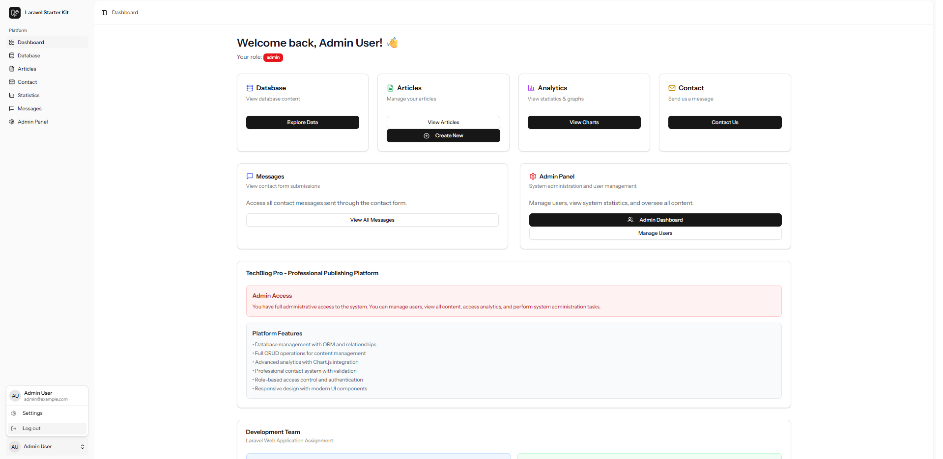
The Settings view is rendered through Inertia.js and contains three subcomponents:
- Profile
- Password
- Appearance
The Profile form allows users to edit their name and email, validated via Laravel Form Requests before being updated in the database through Eloquent ORM.
It also includes a Delete Account section, which calls the destroy() method to securely remove the user record after confirmation.
The Password tab handles credential updates. The controller verifies the current password, validates the new one, and securely stores it using Laravel’s Hash facade.
The Appearance tab manages theme preferences such as light or dark mode, stored per user and dynamically applied via Tailwind CSS classes.
This module showcases the integration of Laravel authentication, Eloquent ORM, Form Request validation, and Inertia reactivity to deliver a secure, interactive account management system.
Profile settings:
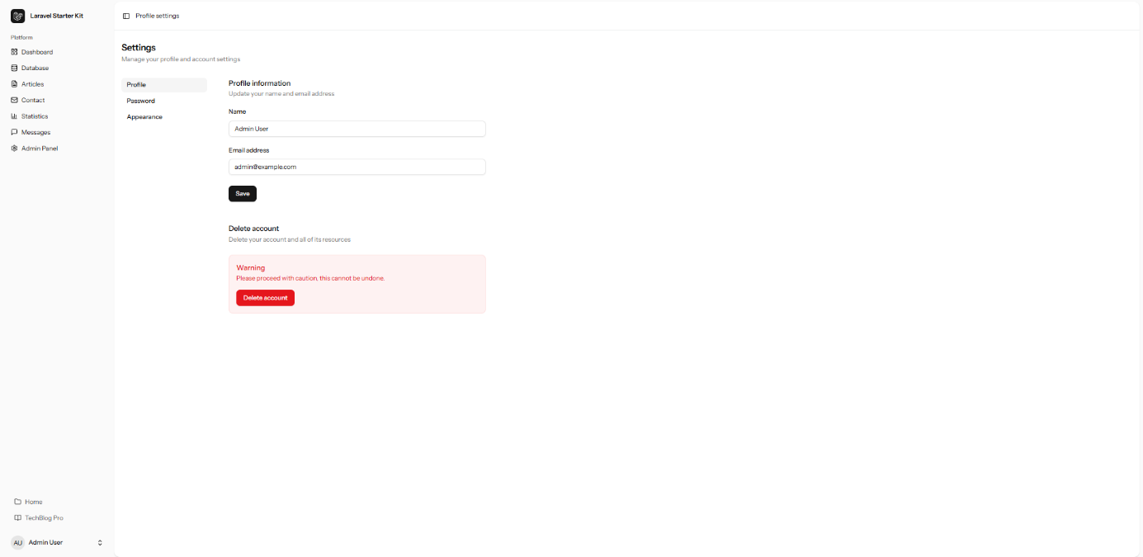

Hosting and Deployment
The project was deployed to a public PHP hosting provider to make the Laravel application accessible online.
Before deployment, the frontend was built in production mode using Vite, which compiled all React and CSS assets into the /public directory. The project files were then uploaded to the hosting server via FTP, and the public folder was set as the web root.
A MySQL database was created on the hosting platform, using one of the provided sample databases from the course materials.
Connection details (host, database name, username, and password) were configured in the .env file, and migrations and seeders were executed to initialize the structure.
After deployment, the application was tested to verify correct operation of authentication, CRUD functions, and form submissions.
This process demonstrates proper setup of Laravel’s environment configuration, database connectivity, and frontend asset optimization on a live hosting environment.

GitHub and Version Control
The project used Git for version control and was hosted on a public GitHub repository, ensuring transparency and traceability.
Although commits appear under one contributor, both team members collaborated on the same computer, jointly handling coding, debugging, and testing.
Git was used to manage versions, track features, and document milestones like authentication, CRUD, and database integration—demonstrating effective use of version control and GitHub for collaborative development.
