Register

1 – 1 - 1



5



10



20



50



100



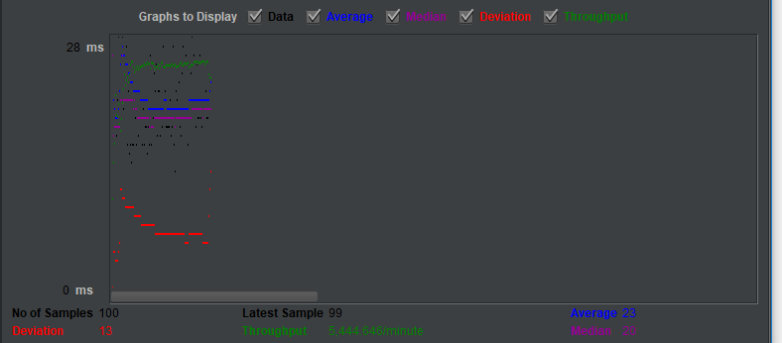

200 – 1 – 1



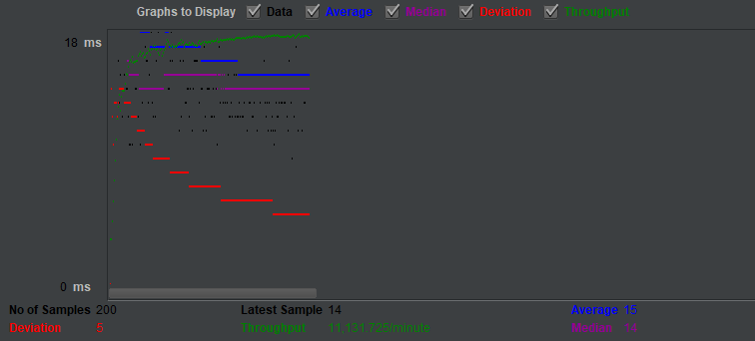

Login

1 -1 -1



5 -1 -1s



10



20



50



100



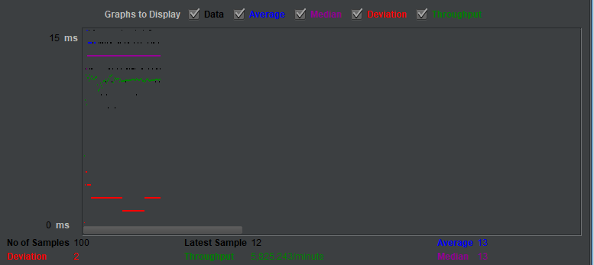

200



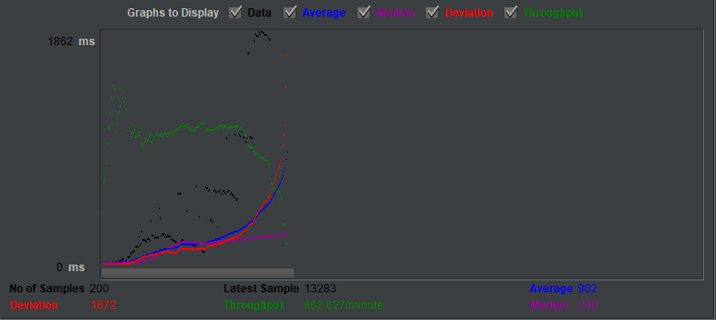

View Page

1 - 2



5 - 2



10 - 2



20 - 2



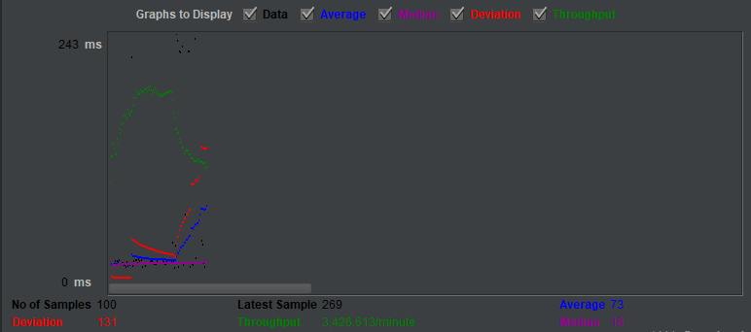

50



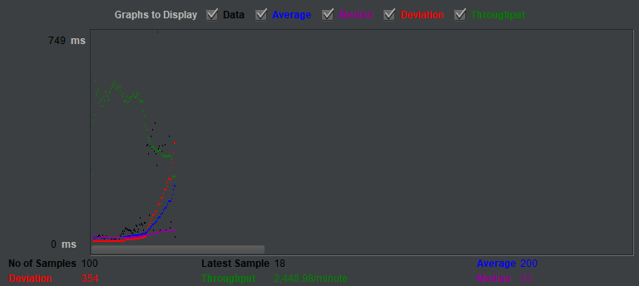

100 -2-3s



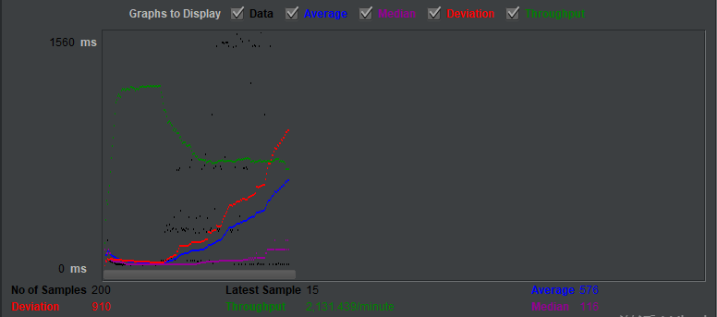

100-2-1s



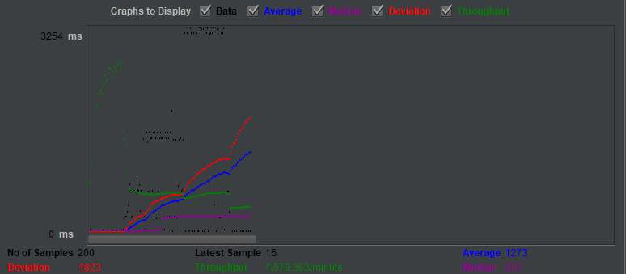

200-2-1s



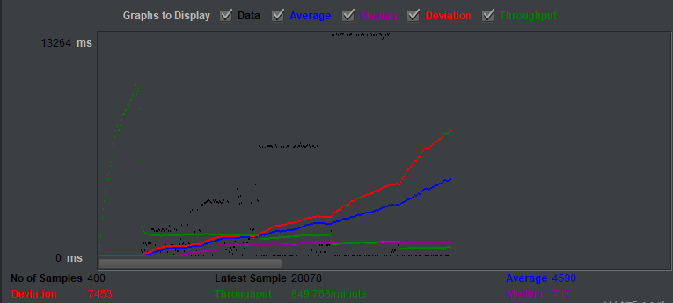

Create

1 – 2 - 1



5 – 2 - 1



10 – 2 - 1



20 – 2 - 1



50 – 2 - 1



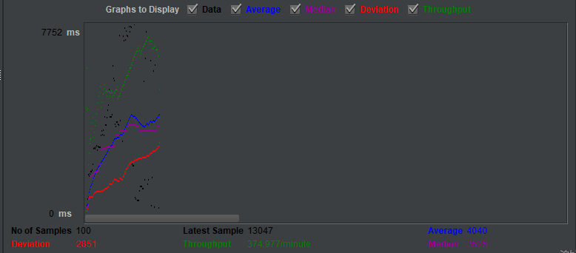

100 -2 -1



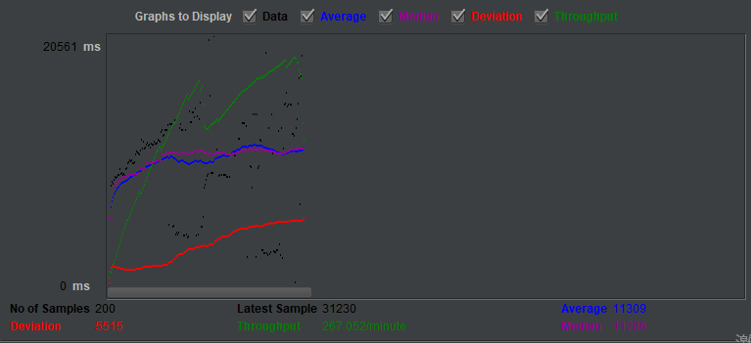

Chrome开发者工具

