**安裝 Node.js**Node.Js (<https://nodejs.org/en/>)

**建制工作Work Folder**Ex. D:\Development\webpack-tutorial-sample

**開啟 Command Prompt**開啟 Command Prompt 指到 work folder

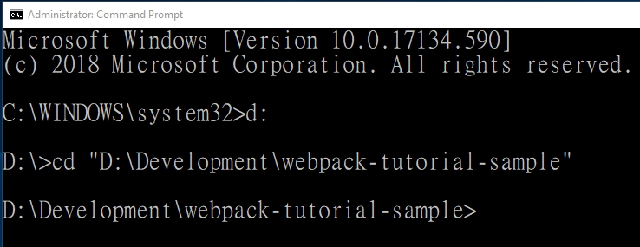

**NPM 初始化**

npm init –y



**安裝 webpack & webpack-cli**

npm i webpack webpack-cli --save-dev



**Edit package.json**

在 package.json 的 scripts section 補上

"dev": "webpack --mode development",

"build": "webpack --mode production",

**建置 webpack.config.js**

建立一個 webpack.config.js 的檔案 在workfolder

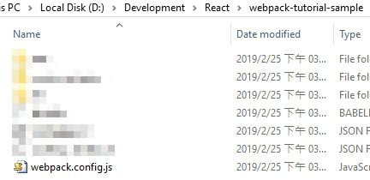

**Edit webpack.config.js**

建立entry point 跟 output point

module.exports = {

entry: './src/index.js',

output: {

path: __dirname + '/dist',

publicPath: '/',

filename: 'bundle.js'

}

};

**建立 enter file**建立 src folder 跟 index.js  
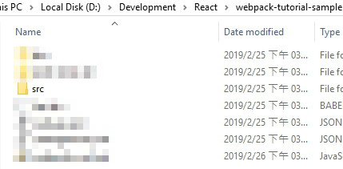

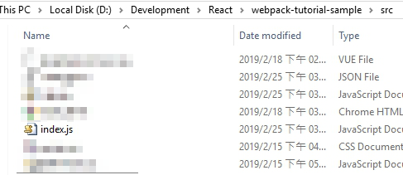

**安裝webpack-dev-server**

npm install --save-dev webpack-dev-server



**Edit package.json**

在 package.json 的 scripts section 補上

"start": "webpack-dev-server --open --mode development"

**安裝html-webpack-plugin**npm install html-webpack-plugin –save-dev



**Edit webpack.config.js**

const HtmlWebPackPlugin = require("html-webpack-plugin");

const htmlPlugin = new HtmlWebPackPlugin({

template: "./src/index.html",

filename: "./index.html"

});

plugins: [

htmlPlugin

]

如下圖

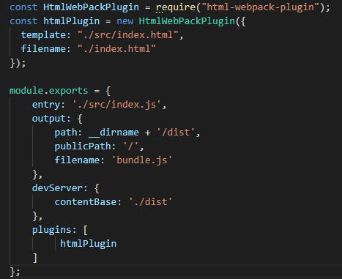

**設定Hot Module Replacement**

在 Webpack.config.js 補上

const webpack = require('webpack');

devServer: {

hot: true

}

plugins: [

new webpack.HotModuleReplacementPlugin(),

]

如下圖

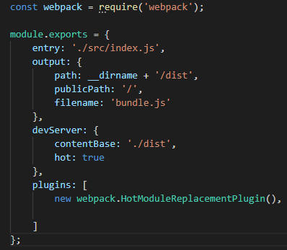

**安裝 JQuery**

npm install jquery --save-dev



**安裝 style-loader & css-loader**

npm install --save-dev style-loader css-loader

**Edit webpack.config.js**

補上

module: {

rules: [

{

test: /\.css$/,

use: [

{

loader: "style-loader"

},

{

loader: "css-loader"

}

]

}

]

}

如下圖  
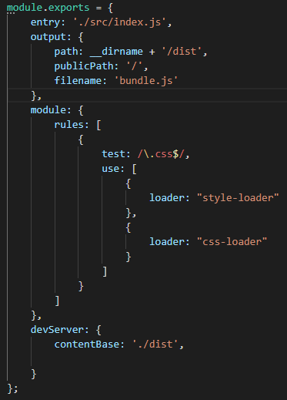

**安裝 babel, babel-loader & preset-env**

npm i @babel/core babel-loader @babel/preset-env --save-dev



**建置 .babelrc**

建立一個 .babelrc

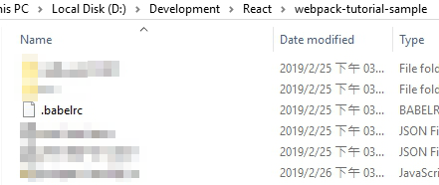

**Edit .babelrc**

補上

{

"presets": [ "@babel/preset-env"]

}

如下圖

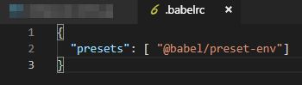

**Edit webpack.config.js**

補上

module: {

rules: [

{

test: /\.(js)$/,

exclude: /(node_modules)/,

use: {

loader: 'babel-loader'

}

}

]

}

如下圖

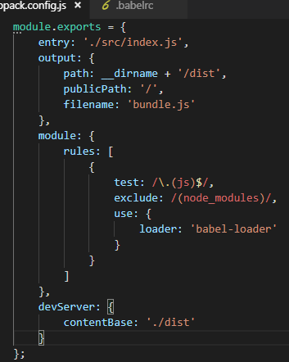

**安裝 react, react-dom & preset-react**

npm i react reac-dom @babel/perset-react –-save-dev



**Edit .babelrc**

補上

{

"presets": [ "@babel/preset-react"]

}

如下圖

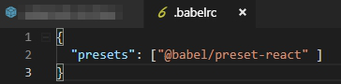

**安裝 vue, vue-loader, vue-template-compiler**

npm install vue vue-loader vue-template-compiler --save-dev

**Edit webpack.config.js**

補上

const { VueLoaderPlugin } = require("vue-loader");

module: {

rules: [

{

test: /\.vue$/,

loader: 'vue-loader'

}

]

}

plugins: [

new VueLoaderPlugin()

]

resolve: {

alias: {

'vue$': 'vue/dist/vue.esm.js'

},

extensions: ['*', '.js', '.vue', '.json']

}

如下圖

