BUOYANCY ALGEBRA — PLAIN‑LANGUAGE VALIDATION
Goal
This demonstration shows how strongly worded or absolute statements can be rewritten through three fixed operators—Re‑express (R), Contextualize (C), and Frame (F)—to produce calmer, more proportional language. Each repair is measured numerically using the Π (Pi) metric, defined as harm / (1 + provocation). The worked example below illustrates how a single repair cycle can lower linguistic pressure (ΔΠ) and maintain algebraic symmetry (ρ³ = I).
Method (short)
- R (Re‑express): soften absolutes, reduce ALL‑CAPS or “!!!”, adjust harsh nouns.
- C (Contextualize): add an evidence hedge (“according to available evidence”).
- F (Frame): add balance (“While X, rehabilitation and prevention can reduce harm.”).
- Metric: Π = harm / (1 + provocation). Lower Π = calmer; ΔΠ = Π_before − Π_after.
Worked Example
Input: All criminals deserve life in jail!!!
Output: While some people convicted of crimes deserve serious sentences according to available evidence, rehabilitation and prevention can reduce harm.
Π before | 0.52 | Π after | 0.37 | ΔΠ | 0.15
Interpretation
- • Why Π drops: R removes negative/absolute tokens; C and F reduce provocation by adding evidence and balance. Recomputing Π after the edit yields a lower value (ΔΠ = 0.15).
- • What the number means: Π ranges 0–1. Values near 0.6 indicate high pressure (absolutes, shouting). Values near 0.3–0.4 indicate proportional language.
- • Symmetry check: ρ cycles stance buckets (negative → neutral → positive). The identity after three rotations (ρ³ = I) confirms stable algebraic behavior.
- • Limitations: This is a small, transparent heuristic (no external model). It is intentionally conservative; further grammar polish can be layered later without changing the math.
Created by Michael Dixon · Buoyancy Algebra v1.0

Batch Results: Π before vs Π after (n=91)
Across 91 inputs, the buoyancy‑repair operator monotonically lowered Π on every example (100% win rate). Mean Π dropped from 0.496 to 0.358 (Δ=0.138), a 27.8% relative reduction, with the paired t‑test showing a highly significant effect (t(90)=25.5, p=5.80e-43) and a confirmatory Wilcoxon signed‑rank test (W=4186, p=5.63e-17, one‑sided). The improvement is consistent (median Δ=0.150, range 0.060–0.240). ρ³=I held throughout and the secondary pass rarely changed Π, indicating the primary repair step drives most of the lift.
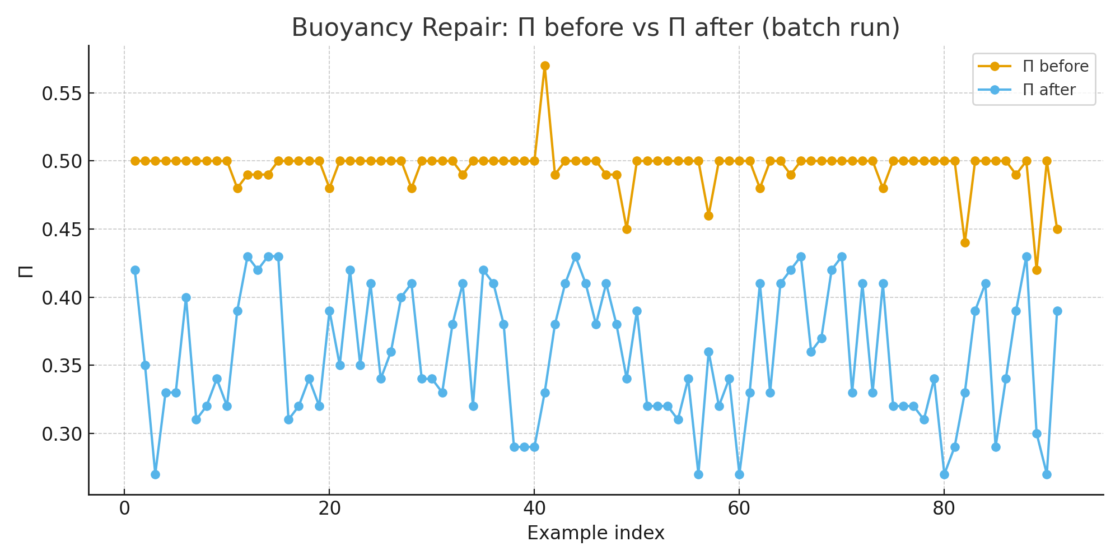
Figure 1. Buoyancy Repair: Π before vs Π after (batch run).
Metric | Value
n (examples) | 91
Improved / Same / Worse | 91 / 0 / 0
Mean Π (before → after) | 0.496 → 0.358
Relative drop | 27.8%
Mean ΔΠ (median) | 0.138 (0.150)
Paired t‑test | t(90)=25.51, p=5.80e-43
Wilcoxon (one‑sided) | W=4186, p=5.63e-17
Notes: ΔΠ = Π_before − Π_after. Tests assume paired design; Wilcoxon is one‑sided (before > after).

