Tochukwu Chukwudolue
Sandwell College

All visual designs
Greenfield Local Hub

Contents
Algorithm Design 3
Register Flowchart 3
Log-In Flow chart 4
Entity Framework Diagram 5
Data Dictionary 5
Site map 5
Test Strategy 5

Algorithm Design

Register Flowchart
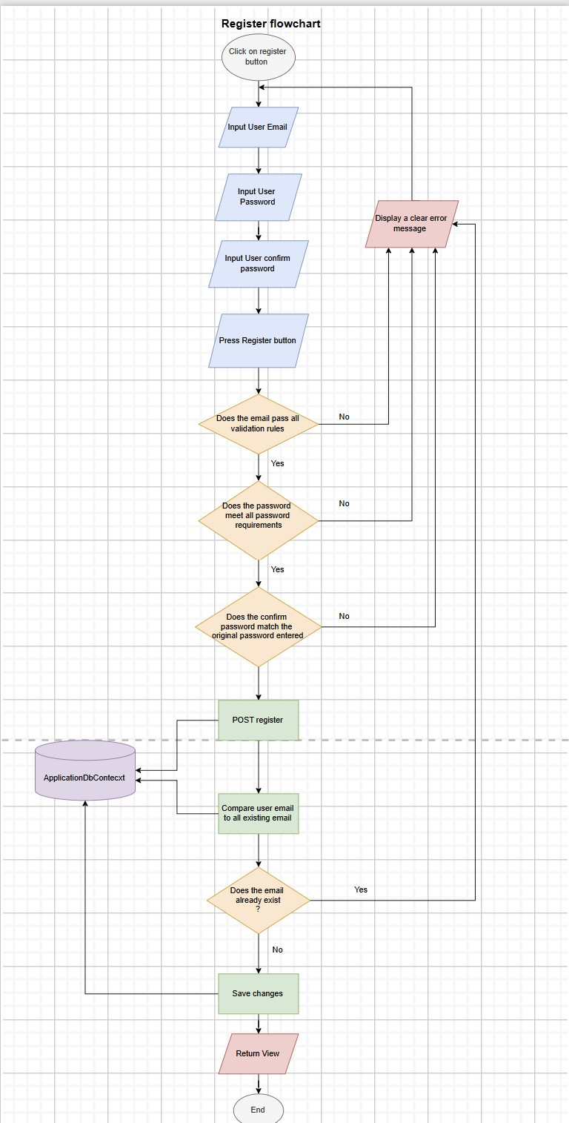
The User will be prompted to enter their email and desired password which they will use to set up their account. The system validates whether all inputs are valid. If it is valid, the system displays an error message and prompts the user to change or edit the log in credential which they have entered. Once the system confirms that all entries are valid, the user’s info is stored in the database and the user is directed to the home page.

Log-In Flow chart
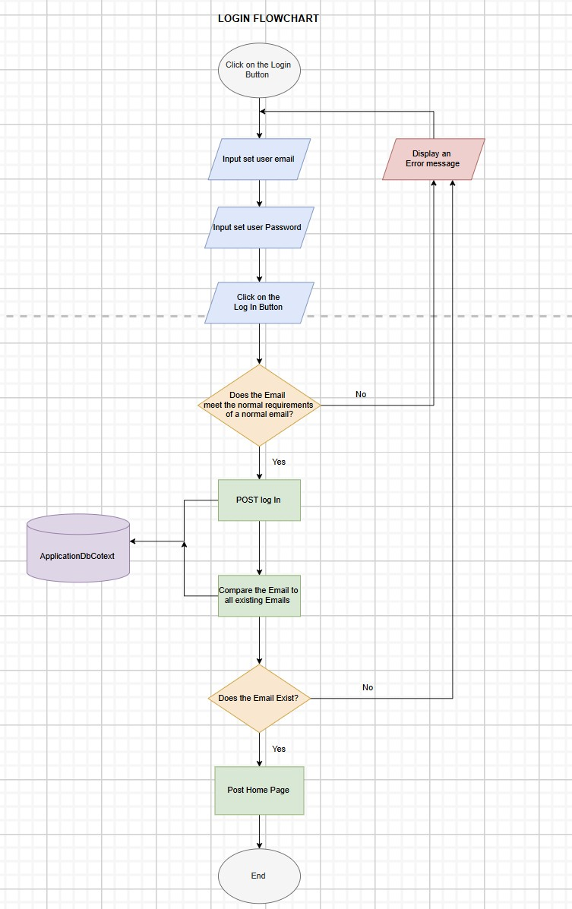
The User will be prompted to input their user email and password. The system checks whether all inputs are valid. If it’s not, the system displays an error message telling the user they have entered invalid credentials and they should re-enter their details. The system then checks the database to validate whether the email and password used is already registered. If not, a message is displayed telling the user there is no such account with the credentials entered. It is either an incorrect password if the email exists but the password does not match, or the account does not exist if the email is not found. If the email exists and the password matches, the user is taken to the homepage.

Entity Framework Diagram
ASP USERS
ORDERS
BASKET
PURCHASE
ORDER BASKET
ORDER PURCHASE

Data Dictionary

Site map

Test Strategy

