Development Diary
Greenfield Local Hub

Tochukwu Chukwudolue

Contents
Version 1.0 2
Day 1 3
Creating and setting up the project 3
Models 3
Version 1.1 2
Day 2 2
Seeding Roles 2
Seeding Producers 3
Seeding Products 4
Basket Functionality 5
Version 1.2 7
Day 3 7
Basket Page creation and editing 7
Orders page 8
Orders Authorisation 9
Producer Dashboard 9
Version 2.0 11
Day 4 11
Gmail Login system 11
CSS Integration 11
Extra Functionality 11
Loyalty Program 11
Accessibility Settings 11

Version 1.0

Day 1

Creating and setting up the project

The project was created using ASP.NET Core-Web App
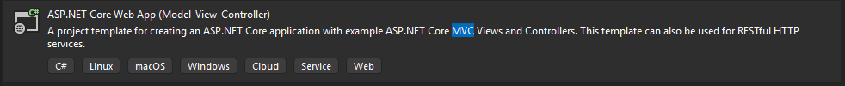
This template allows us to take use of Models, Views and Controllers which are utilised when creating both the front end and back end of a web application.
We name the project E-commerce which would be a place holder for the folder name. We selected the .NET 9.0 Framework since it allows for better performance, new features, scalability and better optimisation.
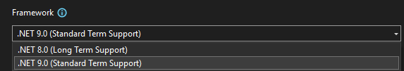
We select Individual accounts as this creates a Register and Log-In template which we can utilise for our web application. It creates the user database for us and all the functionality, being able to edit it and customise it to our needs.
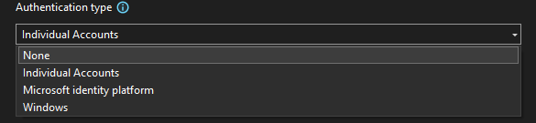

We then tap on create. This builds the template for us to work on. Everything appears as expected but three additional packages were installed which allowed for some extra functionality. They were;
- Microsoft.VisualStudio. Web.CodeGeneration. Design
- Microsoft.EntityFrameworkCore. Design
- Microsoft. Entity. FrameworkCore.SqlServer
The solution comes with pre-installed folders which would house the Models, Views and Controllers which would be built for the solution.
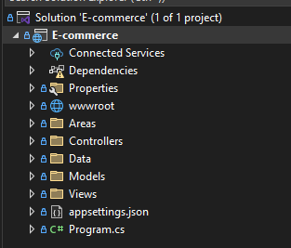
Before we click on the run button, we change the format from HTTPS to HTTP. After which, we can check whether there are any build errors in the project
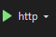
The Website appears to be functional with four buttons (Home and Privacy), alongside the Register and Log-In.

Models
In my initial Entity Relationship diagram, I created models which I deemed appropriate and assigned attributes to each, However, upon creating the models I noticed redundancy in my initial design and made edits to most. I added “MaxUses” and “UsedCount” to the discount model so as to prevent multiple usage of the same discount code, added “Delivery Type” to Order as it was a design requirement I had overseen, added price Attributes (Unit Price and Total Price) to Order Products and Basket Products. I have also added “Status” in Basket as well as removed “Last Update” due to Irrelevance and finally, removed “Is Available” in Product due to redundancy.
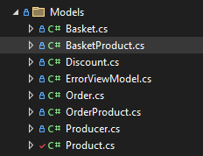
After Creating the models, I added my first Migration and Updated Database
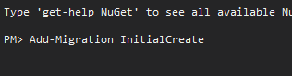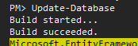

I did edit the Producer model as well, removing the “LastName” attribute and renaming the “FirstName” attribute to “ProducerName”. Next, I scaffolded my models which ended up creating views and controllers for each respective model.
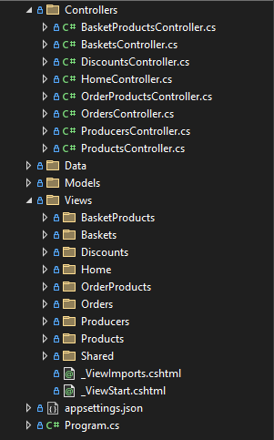
I then added navigation Links to each of these for ease the development process as well as a added a placeholder Logo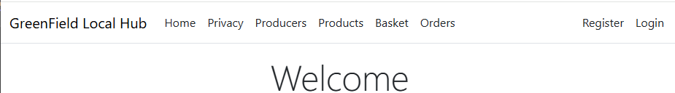
I then created a new file called seed data. This would essentially hold pre placed data which would be visible across the website.
I created a seed roles function for an admin i.e created an admin account
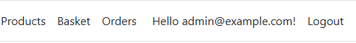
Today
I have been able to;
- Created the web project using ASP.NET core MVC.
- Created the models for the project which are essentially the same in the entity relationship diagram
- Scaffolded those models which created their views and controllers
- Added appropriate migration and updated databases
- Added Navigation Links so as to allow me navigate through the different webpages
- Create seed data file and seeded Roles for an admin.

Tomorrow
I wish to;
- Finish seeding all Roles
- Seed users i.e., producers
- Seed products
- Test for successful seeding process
- Create basic functionality
- Work on controller Logic

Version 1.1

Day 2

Seeding Roles
I resume from where I left off yesterday by seeding roles into the system. There are 3 essential things which I plan on seeding, Roles for Authentication, Products and Producers which would be visible data seen on the website.
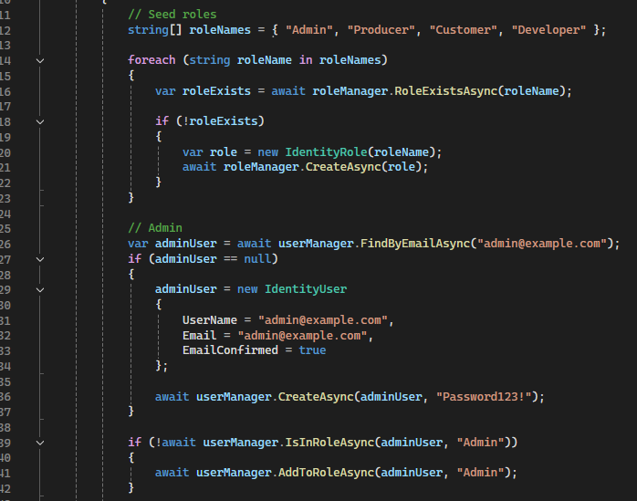 These users were created as temporary users so as to develop the website. Each of them would be able to access features which are only authorised to them. The Producer and Customer are the main users of the system hence would be seen the most throughout development.
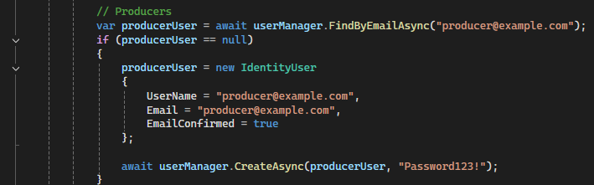This is one of the producer’s Login Info, 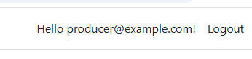
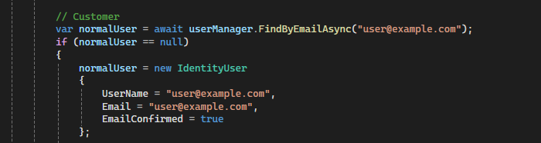
And this is a Customer Login Info.
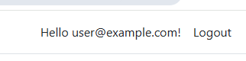

Seeding Producers
There will not be only one singular producer since an Industry standard farm website should typically have a variety of producers who offer a wide range of products. I encountered errors in the code which were quickly solved and averted. All I had to do was drop the database and re-update so as for Information on the website to update. I equally seeded producer Information which would be visible on the html page. 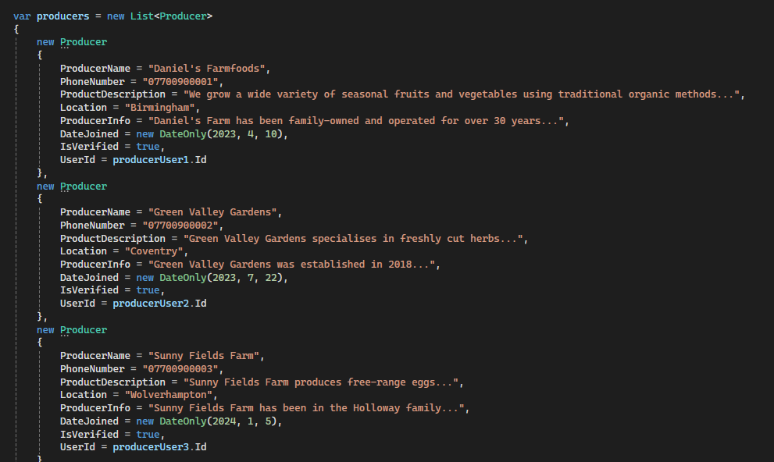
This stage took some trial and error due to a typo error in one of the models. This was solved by editing the model, adding migration, dropping the previous database and updating the database so as for the system to have correct and data which is correct.
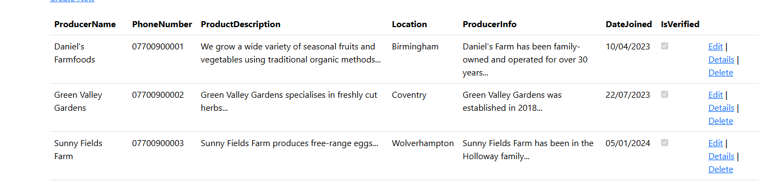
These are the producers that are going to be visible in the website.

Seeding Products
Next thing that I’ll be seeding is Products. These are going to be what customers purchase with when they interact with the website.
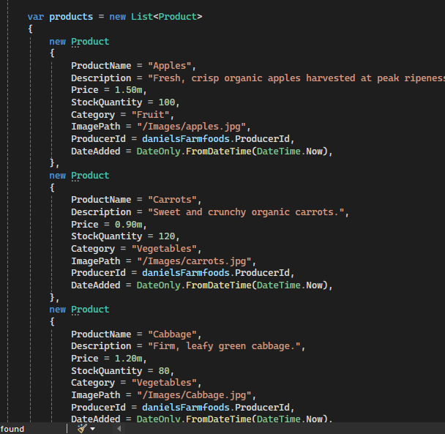 Before I completed this, I had to make a separate folder for the product Images in the website.
These are the few products which would be visible in the prototype. More may be added in future if the need arises.
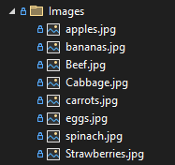After seeding all these, I edited the program.cs file so that the system calls the data which was planted in the backend.
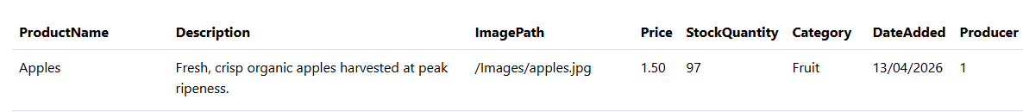
The images are note visible as of now simply because they have not been coded. This will be done at later times

Basket Functionality
Next is controller Logic and basic functionality. Firstly, I’d want to find a way to add products to my basket. I’d need to add an “Add to Basket” button which essentially would add products to my basket.
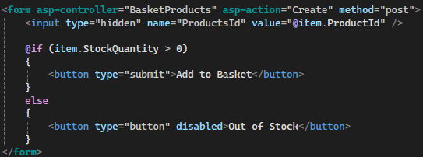
This was the form which would create a temporary Add to basket button 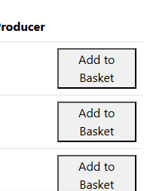They ended up looking something like this. The controller was then editted so as to redirect the user to the basket page whenever they add a product to their basket as long as the user is logged in. If the user is not logged in, they can not access the basket.

Today
I have been able to;
- Finish seeding all Roles
- Seed users i.e., producers
- Seed products
- Test for successful seeding process
- Work on basket functionality partially by creating an add to basket button
- Edit the controller logic in redirecting a user to the basket page.

Tomorrow
I wish to;
- Create and edit the basket page
- Create a checkout system
- Create a place order button which shows the user their orders on the orders page.
- Work on the orders page
- Work on Authorisation
- Create a producer dashboard.

Version 1.2

Day 3

Basket Page creation and editing
Resuming from where I had left off on the previous day, I first temporary improve the look of the basket with basic html. Alongside that, I edit the controller. The system scans the basket of the logged in user, if it is empty, a message is displayed and a navigation link to products page is present. Otherwise, the quantity and price of a product is displayed. 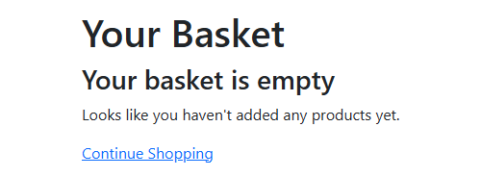
This is what the basket page looks like when there is nothing inside the basket.
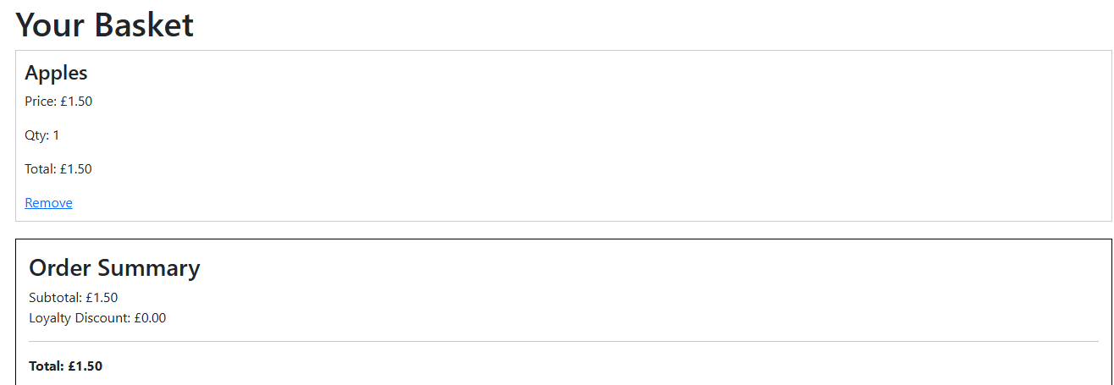
And this is what it looks like with an item in the basket

Checkout system
Next thing that I’ll be working on is the proceed the check out button. 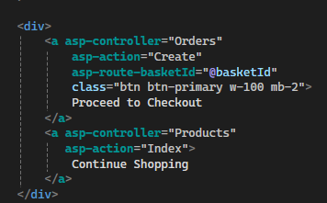 Equally, I edited the create basket form hence when the proceed to checkout button is tapped, the user is redirected to a checkout page. 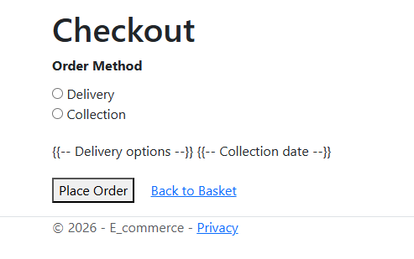

Orders page
Next is to get the place order button working. Inside the controller, the system would find the currently logged in user and assign values for the order of that specific user. The system then sets the tracking status to pending by default. Additonally worked on the subtotal as well as discount calculator. The system would also have two different delivery options, which would be “Delivery” or “Collection”. With every order made, the stick of that Item is updated
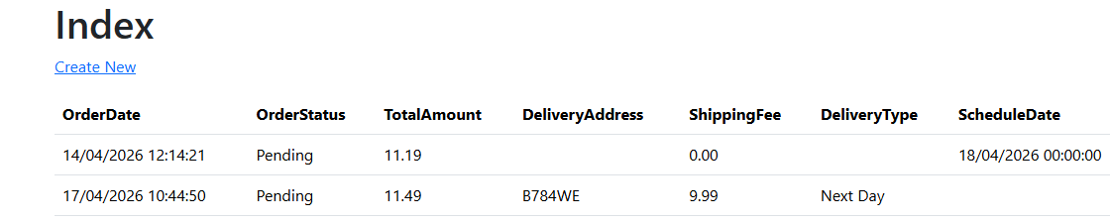

After designing the controller Logic, next thing to so was to edit the order Index so that details of the order made is fully displayed. All products in that order, Total, Status, Date and time of when the order was made etc. Additionally, a navigation link was placed which would take the user back to the orders page.
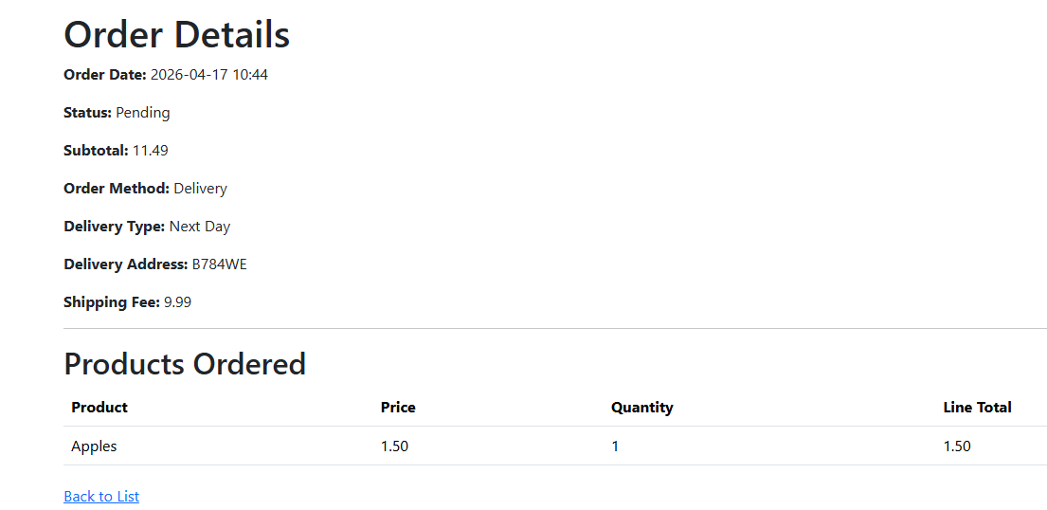

Orders Authorisation
Next is Authorisation. Users should only be allowed to see their own order history and no one else’s. 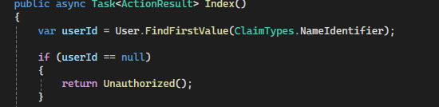 Producers and Admins however should have full access to the orders. The controller was edited to allow users of higher authority to access all orders. Producers would view these orders and start creating them. Admins would oversee all that happens.

Producer Dashboard
I created a new .cshtml file as well as a new controller dashboard. I added authorisation to allow only the producer, admin and dev to access the dashboard. Regular customers would have no way of accessing the page unless they have the log in credentials of a higher authority.
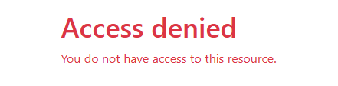.
The dashboard was edited to display basic stock information, Orders, and update products, and also made it so that producers can only edit their own products and not the products of any other producer.
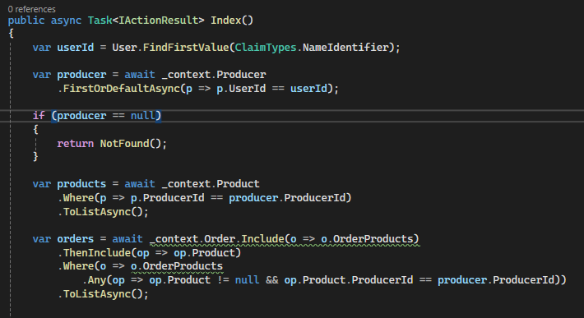
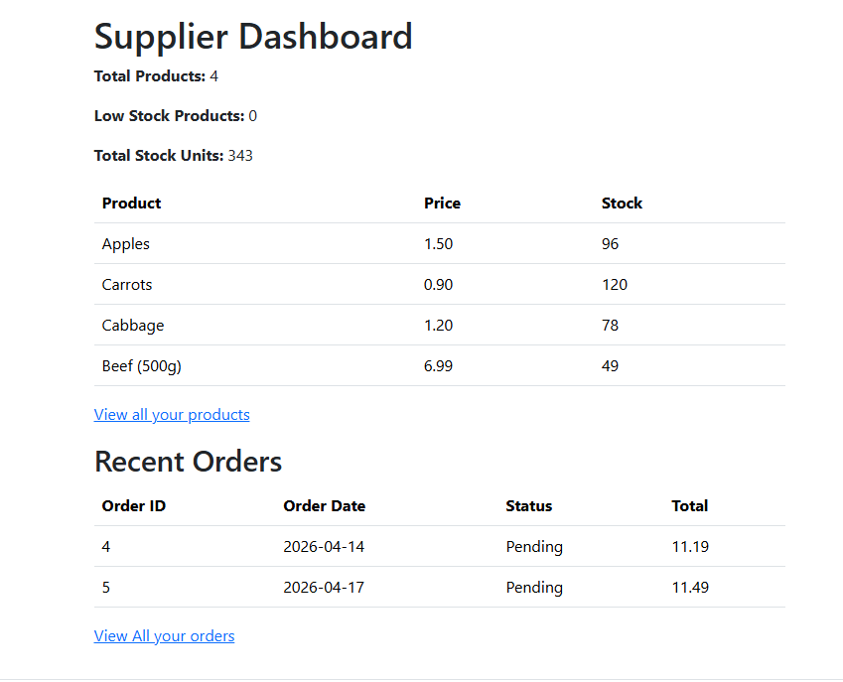
Today
I have been able to;
- Create and edit the basket page
- Create a checkout system
- Create a place order button which shows the user their orders on the orders page.
- Work on the orders page
- Work on Authorisation
- Create a producer dashboard.

Tommorrow
I want to;
- Integrate a GMAIL Login system
- Begin adding css and javascript to the website
- Add other little bits of extra functionality
- Work on Accessibility settings
- Design the Loyalty program

Version 2.0

Day 4

Gmail Login system
To Integrate the system, we need to head over to Google Developer Console and Login with my Google Account and create a new project. After which I would add a new credential which is inside the APIs and Services menu. From this I would select my client and complete the form which essentially requires me to fill in information about the project. After which my client Id and secret are generated. I would then go back to visual studio and install an authorisation package.
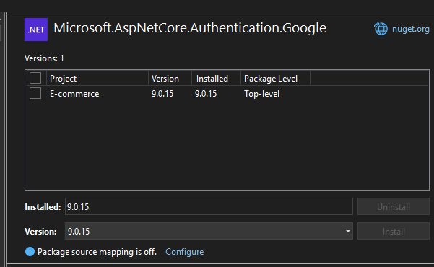
I then go to my appsettings.json file and import my client Id and secret. 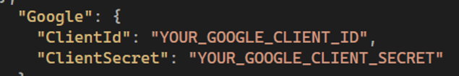When we run the application we can see that we can Log in with a google account. 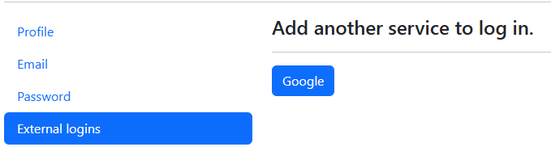

Page creation and CSS Integration
Home Page
Navigation Bar
Footer
Orders
Producers
Producer Dashboard

Extra Functionality
Products
Basket

Loyalty Program
Loyalty Page

Accessibility Settings

