Lab 2

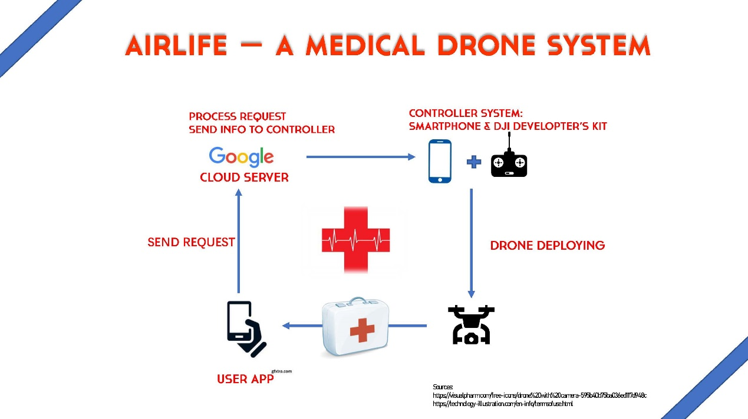

Project Description

Advisor:

Zhou.Li. <http://engineering.uci.edu/users/zhou-li>

1. Our Project aims to build a medical drone system, which allows its users to acquire medical support delivered by an AI-Controlled drone under emergencies.
2. Users can send request through mobile Network to our server, and the server will appoint a self-navigated drone to the user`s location, which is controlled by an Android device through stable connection between Drone controller and drone, so that it will enable multi task to be processed simultaneously.

The project can be divided in 4 parts:

1. Develop a user app that allows the user to send request according to his/her need.
2. Build a server that can answer the request and communicate with the drone control device
3. Develop an App for the controlling Android device to communicate with server and control the drone.
4. Use Computer Vision to help identifying and locating the user.

Advantage:

1. Whoever is facing a medical emergency requires an immediate Medical Support, and the drone can travel as fast as 4m/s, without encountering any possible traffic jam.
2. In comparison to ambulance, the drone is far more flexible, so that it can satisfy more kinds of emergent situation.
3. Comparing to ambulance, calling a drone cost much less.

Test:

We will test our system in central park.

1. Basic: we will let the drone take off from central park and locate the user on another part of the central park.
2. Advanced: we will let the drone take off from outside the campus and locate the user in the central park.

Constraint:

**DJI Mobile SDK**

**Connection Between Smart Phone and Controller:**

**Provided By**

**DJI**

1. We can`t test our system at some crowd location, in case of safety
2. We can`t let the drone carry some heavy equipment.

**Connection Between Smart Phone and Server:**

**Bluetooth**

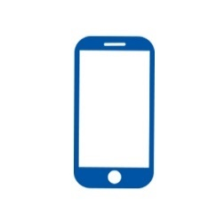

Server

**USB**

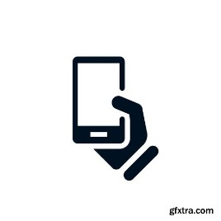

**Process Request**

**Send User GPS to Controlling Smartphone**

**Drone Deploying**

**Drone Controlling Android App**

**Computer Vision**

**User APP**

**Send Request**