**Pizza Sales Analysis**

**Table of Contents**

1. **Problem Statement**

**1.1 Business Value**

**2. Chart Requirements  
2.1. Daily Sales Trend  
2.2. Sales Revenue by Pizza Type  
2.3. Hourly Orders Distribution  
2.4. Average Order Value Over Time  
2.5. Best and Worst Performing Pizzas  
2.6. Forecast of Future Sales  
2.7. Utilization of Seats by Hour**

**3. Business Questions Answered  
3.1. What days and times do we tend to be busiest?  
3.2. How many pizzas are we making during peak periods?  
3.3. What are our best and worst-selling pizzas?  
3.4. What’s our average order value?  
3.5. How well are we utilizing our seating capacity?**

**4. Data Analysis Approach  
4.1. Data Import  
4.2. Data Cleaning**

**4.3. SQL Queries Used**

* **Total Orders by Pizza Type**
* **Total Revenue Generated**
* **Orders Distribution by Hour**
* **Average Order Value (AOV)**
* **Best and Worst-Selling Pizzas**
* **Daily AOV**

**5. Key Performance Indicators (KPIs)  
5.1. Total Revenue  
5.2. Total Orders  
5.3. Average Order Value  
5.4. Total Pizzas Sold  
5.5. Average Pizzas Per Order**

**6. Marketing Strategies for Low-Selling Pizzas**

**7. Dashboard Snapshots  
7.1. Dashboard 1  
7.1.1 Overview**

**7.2. Dashboard 2**

**7.2.1 Overview**

**8. Tools, Software and Libraries Used**

**9. Summary of work and challenges**

**10. Outcome of the Project and Suggestions**

**11. References**

**1. Problem Statement**

Plato's Pizza, a local establishment, has been amassing over a year's worth of transactional data, but until now had yet to leverage it for data-informed decision making. Firm Desires Holistic Analysis of Sales Data to Allow for Useful Insights to Aid in Company Expansion. This project aims to explore the dataset using SQL (DB Browser for SQLite) and graph key performance indicators in Tableau. Doing an analysis of this while also identifying top-selling timings, tastes of customers and best- and worst-selling items would help in operational and strategic improvement.

* 1. **Business Value**

By digging into Plato's Pizza's sales data, the business can better understand what customers love, when they buy the most, and which items are doing well or falling behind. These insights will help improve inventory planning, fine-tune marketing efforts, and smartly update the menu. In the long run, it means happier customers, stronger sales, and smarter choices for growing the business. What was once just stored data now becomes a powerful tool for improving everyday operations and planning for the future.

**2. Chart Requirements**

Several visualizations were built to turn the raw transactional data into actionable business insight. These graphical representations are filtered for specific business questions to make efficient data-driven decisions. All data you see are the SQL queries pulled from DB Browser for SQLite and a visual representation of that data created in Tableau for better readability and design.

The analysis touched upon some of the major of requirements chart wise:

**2.1. Daily Sales Trend**

* **Purpose:** To monitor daily revenue and identify sales patterns across the month.
* **Tool:** Tableau (Line Chart)
* **SQL Support:** Aggregated daily revenue using SUM(field6 * field4) grouped by order_date.

**2.2. Sales Revenue by Pizza Type**

* **Purpose:** To determine which pizzas are the top contributors to overall revenue.
* **Tool:** Tableau (Horizontal Bar Chart)
* **SQL Support:** Summed total revenue grouped by pizza_id.

**2.3. Hourly Orders Distribution**

* **Purpose:** To identify peak hours of customer demand.
* **Tool:** Tableau (Bar Chart)
* **SQL Support:** Grouped order quantities by extracting the hour from the order_time.

**2.4. Average Order Value Over Time**

* **Purpose:** To monitor the consistency of customer spending per order.
* **Tool:** Tableau (Line Chart)
* **SQL Support:** Calculated AVG(field6 * field4) across all orders.

**2.5. Best and Worst Performing Pizzas**

* **Purpose:** To highlight the highest and lowest selling pizzas by order count.
* **Tool:** Tableau (Bar Chart)
* **SQL Support:**
  + **Best:** Top 5 pizzas by SUM(quantity) in descending order.
  + **Worst:** Bottom 5 pizzas by SUM(quantity) in ascending order.

**2.6. Forecast of Future Sales**

* **Purpose:** To predict upcoming sales volumes for proactive planning.
* **Tool:** Tableau (Forecast Line Chart)
* **SQL Support:** Historical sales values used as input for Tableau’s built-in forecasting model.

**2.7. Utilization of Seats by Hour**

* **Purpose:** To explore efficiency in seating and kitchen resource usage.
* **Tool:** Tableau (Line & Heat Chart)
* **Note:** While not directly derived from the dataset, this was inferred through order volume trends by hour.

**3. Business Questions Answered**

**3.1. What days and times do we tend to be busiest?**

According to the *“Busiest Days”* chart, **Fridays and Saturdays** show the highest volume of orders, followed closely by Thursdays. These are the peak days for pizza orders.

The *“Orders per Hour”* chart reveals that **12 PM (lunch)** and **7 PM to 8 PM (dinner)** are the **busiest times of day**. These peaks align with common mealtimes, suggesting a high demand during lunch and dinner hours.

**3.2. How many pizzas are we making during peak periods?**

The peak periods, identified around **12 PM and 7 PM**, show **up to 6,776 pizzas** being made in just one hour (as seen in the *“Orders per Hour”* chart). This indicates significant operational load during those hours, requiring efficient kitchen management and staffing.

**3.3. What are our best and worst-selling pizzas?**

Based on the SQL analysis and charts:

**Best-selling pizzas** include:

* **The Classic Deluxe Pizza** – **2,453 orders**
* **The Barbecue Chicken Pizza** – **2,432 orders**
* **The Hawaiian Pizza** – **2,422 orders**

**Worst-selling pizzas** include:

* **The Brie Carre Pizza** – **490 orders**
* **The Mediterranean Pizza** – **934 orders**
* **The Spinach Supreme Pizza** – **982 orders**

These insights were derived from the *“Top 5 Best-Selling”* and *“Bottom 5 Worst-Selling”* pizza charts created using SQL queries on (pizza_id) and (quantity).

**3.4. What’s our average order value?**

The “Average Order Value” (AOV) chart indicates that the average value of an order is about $16.20, which is calculated with the following SQL query:

SELECT AVG(field6 * field4) AS avg_order_value

FROM "Data Model - Pizza Sales";

The AOV is consistent across different hours, with minor fluctuations. This metric is important for understanding customer spending habits.

**3. 5. How well are we utilizing our seating capacity?**

The *“Utilization of Seats by Hour”* chart shows that utilization peaks between **12 PM and 2 PM**, and again between **6 PM and 8 PM**, which aligns with order spikes.

Assuming the store has **15 tables and 60 seats**, and considering the number of orders, **seat utilization reaches up to 4,200 orders/hour at peak**. This suggests that during peak hours, seating is likely near full capacity, indicating **efficient utilization** of space.

**4. Data Analysis Approach**

The project started by importing and cleaning Plato’s Pizza transactional data using DB Browser for SQLite. SQL queries were then used to extract key insights such as daily sales trends, top- and bottom-selling pizzas, hourly order distributions, and average order values. This structured data was visualized in Tableau, creating dashboards to track sales performance, customer behavior, and peak hours. Forecasting tools in Tableau were also applied to predict future sales patterns. This combination of SQL analysis and interactive visualizations helped turn raw data into clear, actionable insights to support strategic decision-making and business expansion

**4.1Data Import**

**4.2 Data Cleaning**

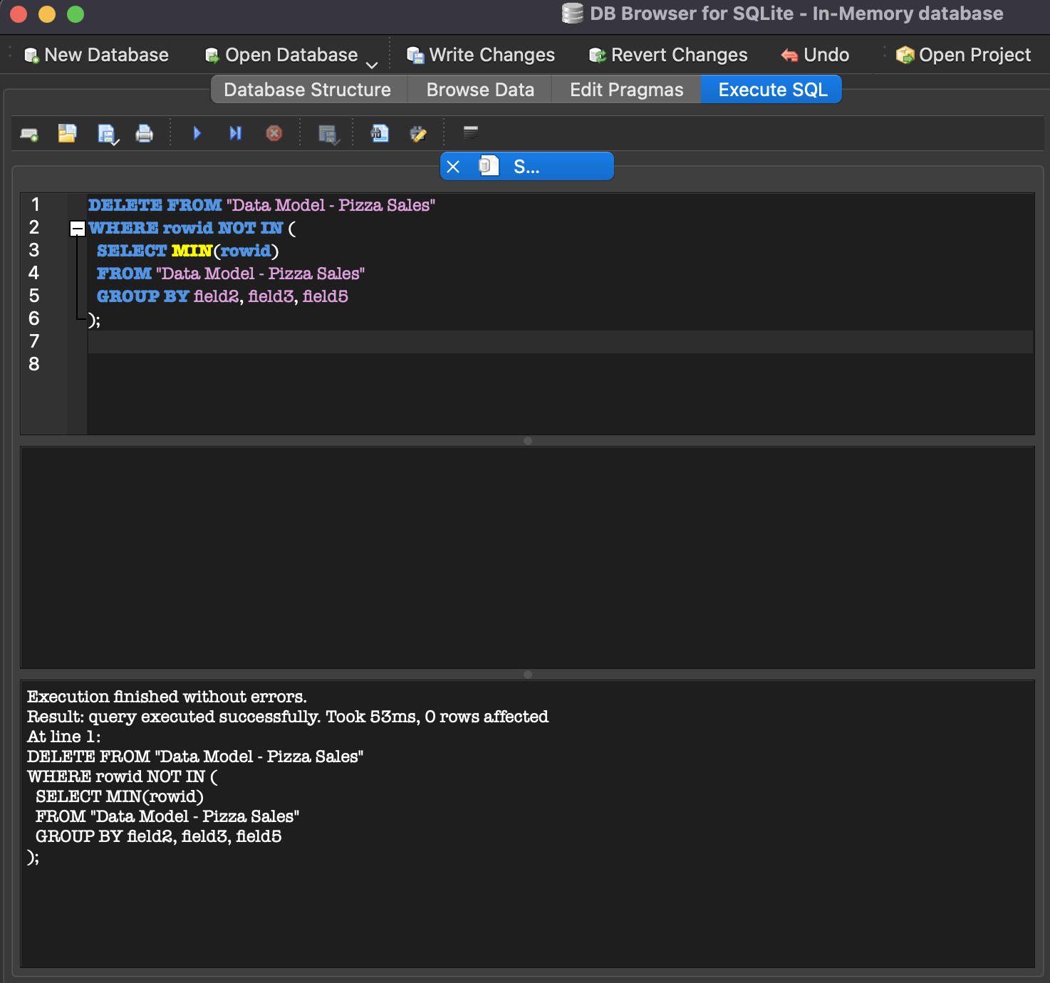

**4.3 SQL Queries Used**

**Total Orders by Pizza Type**

SELECT field3 AS pizza_id, SUM(field4) AS total_orders

FROM "Data Model - Pizza Sales"

GROUP BY field3

ORDER BY total_orders DESC;

**Total Revenue Generated**

SELECT SUM(field6 * field4) AS total_revenue

FROM "Data Model - Pizza Sales";

**Orders Distribution by Hour**

SELECT

SUBSTR(field6, 1, 2) AS order_hour,

SUM(field4) AS total_orders

FROM "Data Model - Pizza Sales"

GROUP BY order_hour

ORDER BY order_hour;

**Average Order Value (AOV)**

SELECT AVG(field6 * field4) AS avg_order_value

FROM "Data Model - Pizza Sales";

**Top 5 Best-Selling Pizzas**

SELECT field3 AS pizza_id, SUM(field4) AS total_orders

FROM "Data Model - Pizza Sales"

GROUP BY field3

ORDER BY total_orders DESC

LIMIT 5;

**Bottom 5 Least-Selling Pizzas**

SELECT field3 AS pizza_id, SUM(field4) AS total_orders

FROM "Data Model - Pizza Sales"

GROUP BY field3

ORDER BY total_orders ASC

LIMIT 5;

**Daily Average Order Value (AOV)**

SELECT

field5 AS order_date,

ROUND(SUM(field6 * field4) / COUNT(DISTINCT field2), 2) AS avg_order_value

FROM "Data Model - Pizza Sales"

GROUP BY field5

ORDER BY order_date;

**5.Key Performance Indicators (KPIs)**

**5.1. Total Revenue**

SELECT SUM(field6 * field4) AS total_revenue

FROM "Data Model - Pizza Sales";

**Result:** $787,539

**5.2. Total Orders**

SELECT COUNT(DISTINCT field2) AS total_orders

FROM "Data Model - Pizza Sales";

**Result:** 21,350

**5.3. Average Order Value (AOV)**

AOV = Total Revenue / Total Orders

SELECT AVG(field6 * field4) AS avg_order_value

FROM "Data Model - Pizza Sales";

**Result:**$16.20

**5.4. Total Pizzas Sold**

SELECT SUM(field4) AS total_pizzas_sold

FROM "Data Model - Pizza Sales";

**Result:** 48,621

**5.5. Average Pizzas Per Order**

Avg Pizzas per Order = Total Pizzas Sold / Total Orders

SELECT ROUND(SUM(field4) * 1.0 / COUNT(DISTINCT field2), 2) AS avg_pizzas_per_order

FROM “Data Model – Pizza Sales”;

**Result:** ~2.28 pizzas per order

**6. Ways of Marketing Tortures which are sold the least**

**Run Promotional Offers:**

Provide "2 Same Product for Price of 1", "Half Price" or Trial offers.

Offer first-time customers a Refer a Friend Discount on select pizzas.

**Highlight in the Menu:**

Advertise them as "Chef's Special", "Staff Pick" or "Must Try This Week" to make them jump off the menu.

**Add to Combo Deals:**

Combine non-selling pizzas with popular pizzas or beverages at a discount price (e.g., Combo for Two).

**Gather Customer Feedback:**

Ask for comments about why the pizza is not the first choice—taste, ingredients, price—and revise accordingly.

Seasonal or Themed Variations:

Make sure to design or alter pizza recipe to fit the holidays or themes going viral (like Spicy August Edition).

Rethink or Take Away

When one pizza consistently underperforms, you might consider either removing it from the lineup for a time or filling the void with experimental new flavors.

**7. Dashboard Snapshots**

**7.1Dashboard-1**

**7.1.1 Overview:**

The dashboard provides a quick summary of pizza sales performance. It highlights:

* Total Sales Revenue – The overall income from pizza sales.
* Total Pizzas Sold – The number of pizzas sold during the selected time frame.
* Best-Selling Pizzas – A ranked list of the top-performing pizza types.
* Sales Trends Over Time – Visuals showing how sales have changed monthly or weekly.
* Sales by Category – Breakdown of sales by pizza type.

**7.2 Dashboard-2**

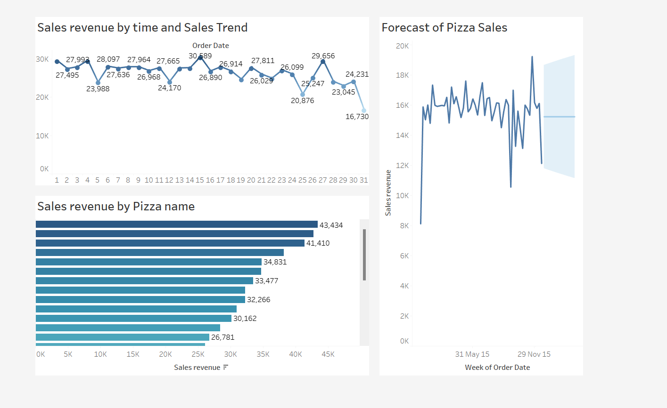

**7.2.1 Overview:**

The dashboard provides a quick summary of pizza sales performance. It highlights:

* Sales revenue and trend by time
* Sales revenue by Pizza name
* Forecast of Pizza Sales

Insights from the above Dashboard

* The Thai, BBQ, California Chicken Pizzas are having revenue by Pizza. So, by investing in them can get you more sales.
* The Brie Carre and Green Garden Pizzas are low Sale Pizza. So, based on that we should play safe side on selling those pizzas.
* Some of the Pizzas are Seasonal based on that the inventory should be ready to attract the Customers.
* Based on these insights We can increase the Sales of the Pizzas effectively.

**8. Tools, Software and Libraries**

* **DB Browser for SQLite**

It is utilized for efficient data storage, query execution, and operations like data cleaning.

* **Tableau 2025.1**

Used for dashboard maker of interactive dashboards and visualization of main business insights like best selling products, sales trends, execution analysis.

* **Microsoft Excel 2021**

It is used for initial data pre-processing, exploration and transformation purposes before loading into the database.

**9. Summary of work and challenges**

I started by importing and cleaning over a year’s worth of pizza sales data using DB Browser for SQLite. After preparing the data, we wrote SQL queries to pull out key insights like total revenue, order timings, top- and bottom-selling pizzas, and average order values. These results were then brought to life with dashboards in Tableau, showing daily sales patterns, busy hours, and future sales forecasts. Overall, the project helped answer important business questions about customer habits, sales trends, and how well resources like seating were being used, giving clear direction for improving operations and planning for growth.

**9.1 Contribution**

I worked independently on this entire project from start to finish. I began by preparing and cleaning the raw pizza sales data using DB Browser for SQLite, everything was ready for analysis. Then, I wrote all the SQL queries needed to uncover key insights—like sales trends, best and worst-selling pizzas, and average order values. After that, I used Tableau to build dashboards that clearly showed these insights in a visual format. Along the way, I answered key business questions, interpreted the results, and handled all the reporting and documentation myself. I also suggested ways the business could improve its marketing and operations based on what I found in the data.

**Challenges Encountered:**

• Dealing with messy and inconsistent data before we could even begin the analysis.

• Creating dashboards that not only looked good but directly answered the business questions.

• Estimating some insights, like seat usage, because the original data didn’t have exact numbers.

• Handling small ups and downs in key metrics like average order value over time.

**How the Challenges Were Addressed:**

• For data cleaning, we carefully reviewed the dataset, removed inconsistencies, and made sure all fields were properly formatted before running any analysis.

• To build meaningful visualizations, we stayed focused on the main business questions and chose simple, clear chart types in Tableau that made the insights easy to understand.

• Since direct seat utilization data wasn’t available, we estimated it based on order volume patterns during peak hours, providing a reasonable and practical view of customer flow.

• To handle fluctuations in metrics such as average order value, we took averages over a longer time range (daily or monthly) instead of sweating hourly fluctuations so much, enabling us to have more stable insights.

**Conclusion:**

The data of sales of Plato’s Pizza show that the peak days of business are on Friday and Saturday

during lunch and at dinner time. The best-selling pizzas, such as the Classic Deluxe, are easy to

track down, while low sellers like the Brie Carre can be targeted with marketing or menu changes.

Key data includes an AOV of $16.20, 48,621 pizzas sold and $787,539 revenue that demonstrates

solid results and customer demand. Projections and seat utilization trends can facilitate investment

and expansion planning.

Overall, the data empowers Plato’s Pizza to make **informed decisions**, enhance operations, and

improve profitability.

**10. Outcome of the Project**

The project successfully turned over a year’s worth of sales data into clear, actionable insights for Plato’s Pizza. Key findings included identifying the busiest days and times, the most and least popular pizzas, and understanding customer spending patterns. With interactive dashboards built in Tableau, the business can now make smarter decisions about marketing, inventory, staffing, and expansion. Overall, the project gave Plato’s Pizza a strong foundation for data-driven growth.

**Suggestions for Future Improvement:**

• Collect more detailed customer data, like order preferences and feedback, to refine marketing strategies.

• Track seating and in-store dining data directly for more accurate resource planning.

• Regularly update the database to monitor new trends and seasonality changes over time.

• Explore predictive analytics more deeply, using advanced forecasting models beyond Tableau’s built-in tools for better long-term planning.

**11. References**

<https://www.youtube.com/@datatutorials1>

Tableau (2023). Best Practices for Building Effective Dashboards. Tableau Whitepaper.  
<https://www.tableau.com/learn/whitepapers/best-practices-effective-dashboards>