A

PROJECT-IV Synopsis Report

on

AccessPath AI
Evidence Driven Accessibility Journey Evaluation

Submitted by:
Aniket Mishra - 230648
Krish Bajaj - 230665
Daksh Choudhary - 230876

under mentorship of

Dr. Anusha Chhabra

Assistant Professor-III


Department of Computer Science Engineering

School of Engineering and Technology

BML MUNJAL UNIVERSITY, GURUGRAM (INDIA)

October 2026

Synopsis Overview
AccessPath AI tests whether a person who relies on a keyboard can complete a defined web task. The current prototype runs an appointment-booking journey on two controlled sites: one accessible and one intentionally blocked. An AI model may suggest the next key press, but fixed rules decide what is safe to execute and whether the task has completed or failed. Every step is stored for review.

Abstract
Page scanners can find many accessibility problems, but they do not show whether a user can finish a task that spans several pages and changing interface states. AccessPath AI evaluates that full journey for a keyboard-only user. At each step, the system records a limited view of the page, asks a selected planner for one keyboard action, checks the action against fixed safety rules, and executes it with Playwright only if approved. It then stores focus changes, action results, screenshots, and the final outcome. The study uses two controlled appointment-booking sites with known expected results: an accessible version and a version with an unreachable time-slot control. The prototype includes a Django dashboard, a background worker, persistent run records, a fixed test planner, and optional live AI planners. The project evaluates task completion, barrier detection, safety, and repeatability. It does not claim full WCAG conformance.
Keywords web accessibility, keyboard access, WCAG, AI planning, browser automation, task completion, test evidence

Contents
1 Introduction and Problem Definition
2 Literature Review
3 Research Gap
4 Aim Objectives and Research Questions
5 Proposed Methodology
6 Expected Outcomes and Evaluation
7 Conclusion
8 References

1 Introduction and Problem Definition
Web accessibility allows people with different abilities to use digital services. WCAG 2.2 defines widely used accessibility requirements, and WCAG-EM explains how to scope, evaluate, and report an accessibility review [1][2]. For a person who cannot use a mouse, keyboard access is essential. If focus cannot reach or activate one control, an appointment, form, payment, or account task may become impossible.
Most automated tools inspect the current page and report rule failures. That is useful, but a multi-step task changes after every action. Focus can move incorrectly, validation can appear, and a later control can become unreachable. The project therefore studies task completion across the whole journey, not only problems on one page.
Problem definition: Current rule-based and AI-assisted tools do not consistently produce safe, repeatable evidence that a keyboard-only user can complete a multi-step task. A useful system must limit what the AI can request, check each action before execution, use observable rules for the final result, and keep evidence that another person can review.

1.1 Project Scope
- User profile: motor accessibility through keyboard-only interaction.
- Main task: a multi-step appointment-booking journey.
- Test targets: controlled accessible and deliberately broken sites.
- Permitted input: Tab, Shift+Tab, Enter, Space, arrow keys, and approved synthetic text entry.
- Possible results: completed, blocked, inconclusive, safety stopped, provider error, or environment error.

2 Literature Review

2.1 Standards and Automated Checks
WCAG 2.2 groups accessibility under four principles: perceivable, operable, understandable, and robust [1]. The criteria most relevant here cover keyboard operation, keyboard traps, focus order, focus visibility, and focus that is not hidden. WCAG-EM also requires clear scope, representative states, suitable tools, expert review, and reporting [2]. AccessPath AI addresses only a narrow keyboard profile and cannot certify full conformance.
Rule-based tools such as axe-core are fast and useful during development, but Deque reports that axe-core automatically detects an average of 57 percent of WCAG issues [3]. Playwright also recommends combining automated checks with manual assessment and user testing [4]. Comparisons of accessibility tools show that each tool finds issues that others miss [5][6][7].

2.2 Keyboard Journeys and AI
Manual keyboard testing can reveal unreachable controls, poor focus order, traps, and failed recovery. It is valuable but slow to repeat. Fixed end-to-end scripts are repeatable, yet a person must define every step in advance. This project tests whether a planner can choose the next step while fixed rules continue to control safety and results.
Recent studies use artificial intelligence for accessibility checks, text alternatives, code suggestions, and interface interaction. Reviews report growing use but uneven evaluation and limited participation by people with disabilities [8][10]. Lopez-Gil and Pereira reported 87.18 percent detection on selected WCAG checks that usually need manual judgment [9]. Yepes-Parra and Escobar-Velasquez also explored agents that interact through keyboard and screen-reader modes [11]. These studies support the direction of this work, but they do not settle how to produce safe, reviewable evidence for a complete journey.

2.3 Literature Comparison
Source | Useful finding | Limit for this project
WCAG 2.2 and WCAG-EM | Define accessibility requirements and a review process | Do not execute a complete user task
Vigo et al. 2013 | Shows the risk of relying on automated tools alone | Compares scanners rather than full journeys
Ara et al. 2024 | Reviews 92 accessibility evaluation studies | Finds broad methods and continuing gaps
Pool 2023 | Shows that nine tools found different issues | No tool provided complete coverage
Lopez-Gil and Pereira 2025 | Uses an AI model for selected manual checks | Covers three criteria, not task completion
Aljedaani and Mollik 2026 | Reviews 38 studies of AI models and accessibility | Finds varied methods and limited user involvement
Yepes-Parra and Escobar-Velasquez 2025 | Explores agents using accessible interaction modes | Early work with limited common benchmarks

3 Research Gap
AI has already been used in accessibility research, so this project does not claim otherwise. The narrower gap is the limited evidence on systems where an AI planner attempts a complete task through a declared accessibility method while fixed components control safety, execution, result classification, and evidence.
- Page checks report isolated issues, while users succeed or fail across a sequence of states.
- Many tools inspect code or text without discovering and following a task path.
- AI can interpret intent, but it can also repeat, invent, or request unsafe actions.
- A useful barrier report needs the page state, focused element, attempted action, result, and screenshot.
- Controlled accessible and broken versions with known expected results remain uncommon.
Research gap statement: AccessPath AI studies a controlled framework in which an AI planner can select only from approved keyboard actions, while browser observation, safety checks, completion rules, and stored evidence remain under fixed program control.

4 Aim Objectives and Research Questions

4.1 Aim
To design and evaluate a safe, repeatable system that determines whether a multi-step web task can be completed by a keyboard-only user, using AI to suggest actions and fixed rules to control execution and results.

4.2 Objectives
- Build accessible and deliberately broken versions of the same task with known expected results.
- Use clear data structures for page observations, keyboard actions, safety decisions, and evidence.
- Support both a fixed test planner and selected live AI planners.
- Check every proposed action before it reaches the browser.
- Decide results from visible completion or barrier conditions, not from AI opinion.
- Store enough evidence to reproduce and review each result.
- Measure completion, correct blocking, false results, fallback use, and agreement across repeated runs.

4.3 Research Questions
Research question
Can a limited AI planner complete a multi-step task using only permitted keyboard actions?
Can a full journey reveal keyboard barriers that a single-page scan does not explain well?
Do fixed safety checks stop invalid or unsafe AI actions before browser execution?
How reliably can the system separate completion, blocking, inconclusive results, and technical failure?
Does step-by-step evidence make reported barriers easier to reproduce and review?

5 Proposed Methodology

5.1 Research Design
The study follows a build-and-evaluate method. The team first creates a controlled system and test environment. It then runs the same declared task on accessible and broken versions, compares the result with the known expected result, and checks the stored evidence. AI selects a possible next action but does not decide safety or success.

5.2 Test Environment
Phase 1 uses versioned appointment-booking test sites. The accessible version supports keyboard completion. The broken version contains one declared barrier: the time-slot control cannot be reached or used through the permitted keyboard path. All input values are synthetic, so the study does not require patient or personal data. Using controlled sites makes the expected result known and repeated runs comparable.

5.3 System Architecture
The dashboard creates a run and sends it to a background worker. During the evaluation, the worker observes the page, obtains one proposed action, checks it, executes only an approved keyboard action, and applies fixed rules to the observed result. Run data and screenshots are saved for the reviewer.
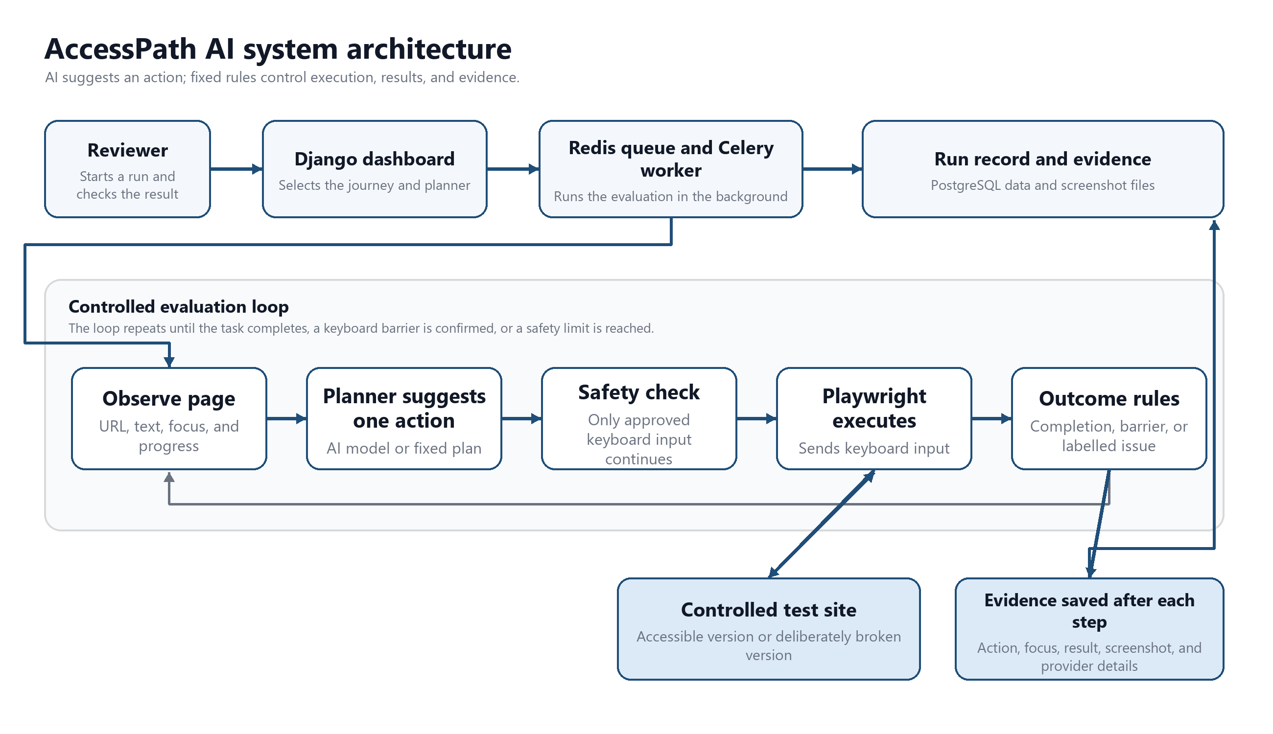
Figure 1 AccessPath AI system architecture and evidence flow

5.4 Evaluation Cycle
Step | What happens
1 Observe | Capture the approved URL, visible text, focused element, progress, and remaining limits.
2 Propose | The selected planner suggests one permitted keyboard action.
3 Check | Fixed rules verify the action, target, focus state, typing permission, and remaining limits.
4 Execute | Playwright performs only the approved keyboard action.
5 Record | Store the before and after states, result, screenshots, and planner details.
6 Decide | Fixed rules confirm completion, a keyboard barrier, or a clearly labelled issue.

5.5 Tools and Technologies
Technology | Purpose
Python and Django | Dashboard, run workflow, validation, and result pages
PostgreSQL | Journeys, runs, steps, provider details, and evidence records
Redis and Celery | Background run queue and worker
Playwright | Keyboard input, browser observation, navigation, and screenshots
Pydantic | Checks that observations, actions, and evidence match the required structure
Gemini and OpenRouter | Optional live proposals; each provider is recorded separately
Fixed test planner | Repeatable controlled runs and visible contingency
Docker Compose | Reproducible local web, worker, database, queue, and test-site services
pytest Ruff and Pyright | Tests, code checks, and type checks

5.6 Safety Controls
- Only approved test-site addresses are allowed.
- The planner can request only a small set of keyboard actions; scripts and mouse clicks are not accepted.
- Fixed policy checks every proposal before execution.
- Text entry uses synthetic values only.
- Calls, steps, time, retries, and rejected actions all have limits.
- The report shows the provider and any fallback; fixed-plan evidence is never presented as live-AI evidence.
- Requests to the same provider are spaced out in the worker process.

6 Expected Outcomes and Evaluation

6.1 Outcome Classes
- Completed: the declared confirmation state is visible.
- Blocked: evidence shows that a keyboard barrier prevents progress.
- Inconclusive: the run ends without enough evidence for completion or a confirmed barrier.
- Safety stopped: an action or navigation request breaks a safety rule.
- Provider or environment error: an external model or local service prevents evaluation.

6.2 Evaluation Measures
Measure | Meaning
Task completion rate | Share of accessible runs that reach the declared completion state
Correct block rate | Share of broken runs correctly reported as blocked
False completion rate | Broken runs incorrectly reported as completed; target is zero
False block rate | Accessible runs incorrectly reported as blocked
Fallback rate | Runs that switch from a live planner to the fixed contingency
Repeated-run agreement | Consistency of the result across repeated runs
Evidence completeness | Presence of action, focus, result, screenshot, reason, and provider details
Efficiency | Planner calls, executed steps, elapsed time, and provider failures

7 Conclusion
AccessPath AI addresses the gap between finding accessibility issues on one page and showing whether a keyboard-only user can finish a complete task. AI can suggest the next action, but fixed rules control what reaches the browser, what counts as completion, and what evidence is stored. The current prototype demonstrates this approach on accessible and deliberately broken appointment-booking sites. Its contribution is a practical and reviewable way to study keyboard journey completion and barriers, not a claim that AI can certify accessibility.

References
[1] World Wide Web Consortium. (2024). Web Content Accessibility Guidelines (WCAG) 2.2. https://www.w3.org/TR/WCAG22/
[2] World Wide Web Consortium. (2026). WCAG Evaluation Methodology (WCAG-EM) 2.0. https://www.w3.org/TR/WCAG-EM/
[3] Deque Systems. (2026). axe-core: Accessibility engine for automated Web UI testing. https://github.com/dequelabs/axe-core
[4] Microsoft. (2026). Accessibility testing with Playwright. https://playwright.dev/docs/accessibility-testing
[5] Vigo, M., Brown, J., and Conway, V. (2013). Benchmarking web accessibility evaluation tools: Measuring the harm of sole reliance on automated tests. W4A 2013. https://doi.org/10.1145/2461121.2461124
[6] Ara, J., Sik-Lanyi, C., and Kelemen, A. (2024). Accessibility engineering in web evaluation process: A systematic literature review. Universal Access in the Information Society, 23, 653-686. https://doi.org/10.1007/s10209-023-00967-2
[7] Pool, J. R. (2023). Accessibility Metatesting: Comparing Nine Testing Tools. W4A 2023. https://doi.org/10.1145/3587281.3587282
[8] Vera-Amaro, G., and Rojano-Caceres, J. R. (2025). Towards accessible website design through artificial intelligence: A systematic literature review. Information and Software Technology, 186, 107821. https://doi.org/10.1016/j.infsof.2025.107821
[9] Lopez-Gil, J. M., and Pereira, J. (2025). Turning manual web accessibility success criteria into automatic: An LLM-based approach. Universal Access in the Information Society, 24, 837-852. https://doi.org/10.1007/s10209-024-01108-z
[10] Aljedaani, W., and Mollik, R. H. (2026). Large Language Models for Web Accessibility: A Systematic Literature Review. W4A 2026. https://doi.org/10.1145/3800424.3800452
[11] Yepes-Parra, J. D., and Escobar-Velasquez, C. (2025). Autonomous Agents for Accessibility: Simulating Visual Impairments in Web Interfaces. ASE 2025, 3953-3957. https://doi.org/10.1109/ASE63991.2025.00349
[12] Microsoft. (2026). Keyboard API. Playwright documentation. https://playwright.dev/docs/api/class-keyboard

