Agentic AI Project Synopsis
Autonomous ML Engineer Crew
Revised 19 October 2026

1 Project Title
Autonomous ML Engineer Crew

2 Team Members
Name | Roll Number
Punya Mahajan | 230611
Aniket Mishra | 230648
Radhika Singh | 230833

3 Problem Definition
Problem addressed Developing a usable machine-learning prediction service from raw data requires data validation and cleaning, feature preparation, model selection and tuning, held-out evaluation, and deployment. People who have a structured dataset but limited ML expertise or time often cannot complete this workflow. The Autonomous ML Engineer Crew automates these steps through coordinated agents. The user supplies a CSV dataset, names the target column, and describes the prediction goal. The system performs a supported supervised classification or regression workflow. If a trained model does not meet the selected quality threshold, the Evaluation Agent returns structured feedback for another bounded tuning attempt.
Intended users Intended users include data analysts, small startup teams, and students who have a structured tabular dataset and need a working predictive model without manually building the complete ML pipeline.

4 Objectives and Expected Outcomes
The objective and end-user outcome remain unchanged.
- Automate data preparation, model selection and tuning, evaluation, and deployment through a coordinated multi-agent pipeline that uses CrewAI and Google ADK.
- Implement a self-reflection loop in which the Evaluation Agent applies a task-appropriate metric and justified threshold, then returns actionable feedback to the Model-Selection and Tuning Agent when the model fails.
- Deliver a live prediction service with a trained model, a /predict API, a model report card, basic usage and error monitoring, and a reusable pipeline for another compatible dataset.
After the user provides a raw CSV dataset, target column, and prediction goal, the system produces a trained model, a live /predict endpoint, a short model report card, usage and error monitoring, and a reusable pipeline. The final workflow result is validated with Pydantic and delivered as JSON plus a human-readable Markdown report card.

5 Proposed Methodology

Agents and Responsibilities
Agent | Framework | Unchanged responsibility
Data-Prep Agent | CrewAI | Validate the CSV and target, profile and clean data, engineer features, and produce a data-quality report.
Model-Selection and Tuning Agent | Google ADK | Train candidate models, run bounded hyperparameter search, log runs, and return model artifacts and metadata.
Evaluation Agent | CrewAI | Run held-out validation, apply task-appropriate metrics, and produce a report card with pass or fail feedback.
Deployment and Observability Agent | CrewAI | Package the accepted model, expose the FastAPI service, and configure runtime monitoring.
Orchestrator | CrewAI Flow | Sequence agents, maintain shared state, validate handoffs, and enforce the bounded evaluation-to-tuning loop.

CrewAI and Google ADK are the only agentic frameworks. Pydantic, MCP, A2A, MLflow, Langfuse, OpenTelemetry, FastAPI, Docker, and Google Cloud Run support contracts, tools, interoperability, tracing, serving, and deployment; they do not add agents or change agent responsibilities.

Framework Boundary and A2A Communication
CrewAI Flow remains the top-level orchestrator. The existing ADK-based Model-Selection and Tuning Agent is exposed as an A2A service with an Agent Card. The CrewAI Orchestrator calls that service through an A2A client and exchanges typed task messages and artifacts. Each message carries the pipeline run ID, input artifact references, the requested task, the validated result, and any protocol error or timeout. This creates an explicit CrewAI-to-ADK interoperability boundary without adding or renaming agents.

Shared State and Pydantic Contracts
A typed PipelineState is the single source of workflow context. Agents pass artifact references and validated summaries rather than raw dataframe contents. Every handoff uses a Pydantic model, and the orchestrator rejects invalid state transitions before the next agent runs.
Contract | Key content | Producer and consumer
PipelineState | run ID, task type, target, status, retry count, artifact references, trace ID | Orchestrator and all agents
DataPrepResult | dataset hash, schema, quality findings, train and test artifact URIs | Data-Prep to Model-Selection
ModelSelectionResult | candidate runs, best model URI, parameters, training metrics | ADK Model-Selection to Evaluation
EvaluationResult | held-out metrics, threshold rationale, pass or fail, retry feedback | Evaluation to Orchestrator and Model-Selection
DeploymentResult | image digest, service URL, health status, deployment revision | Deployment to Orchestrator
PipelineResult | final status, model card, endpoint, lineage, trace URL, cost and runtime | Orchestrator to user

MCP Tool Integration
MCP is mandatory in the implementation. A custom MCP server exposes two tools with JSON schemas and Pydantic-validated returns.
MCP tool | Purpose | Required evidence
profile_dataset | Wrap pandas-based schema, missing-value, target, leakage, and dataset-hash checks. | Successful call, malformed-file failure, validated DatasetProfile response
log_and_query_experiment | Wrap MLflow run creation, metric and parameter logging, artifact registration, and best-run lookup. | Create and query calls, unavailable-service failure, validated ExperimentRecord response

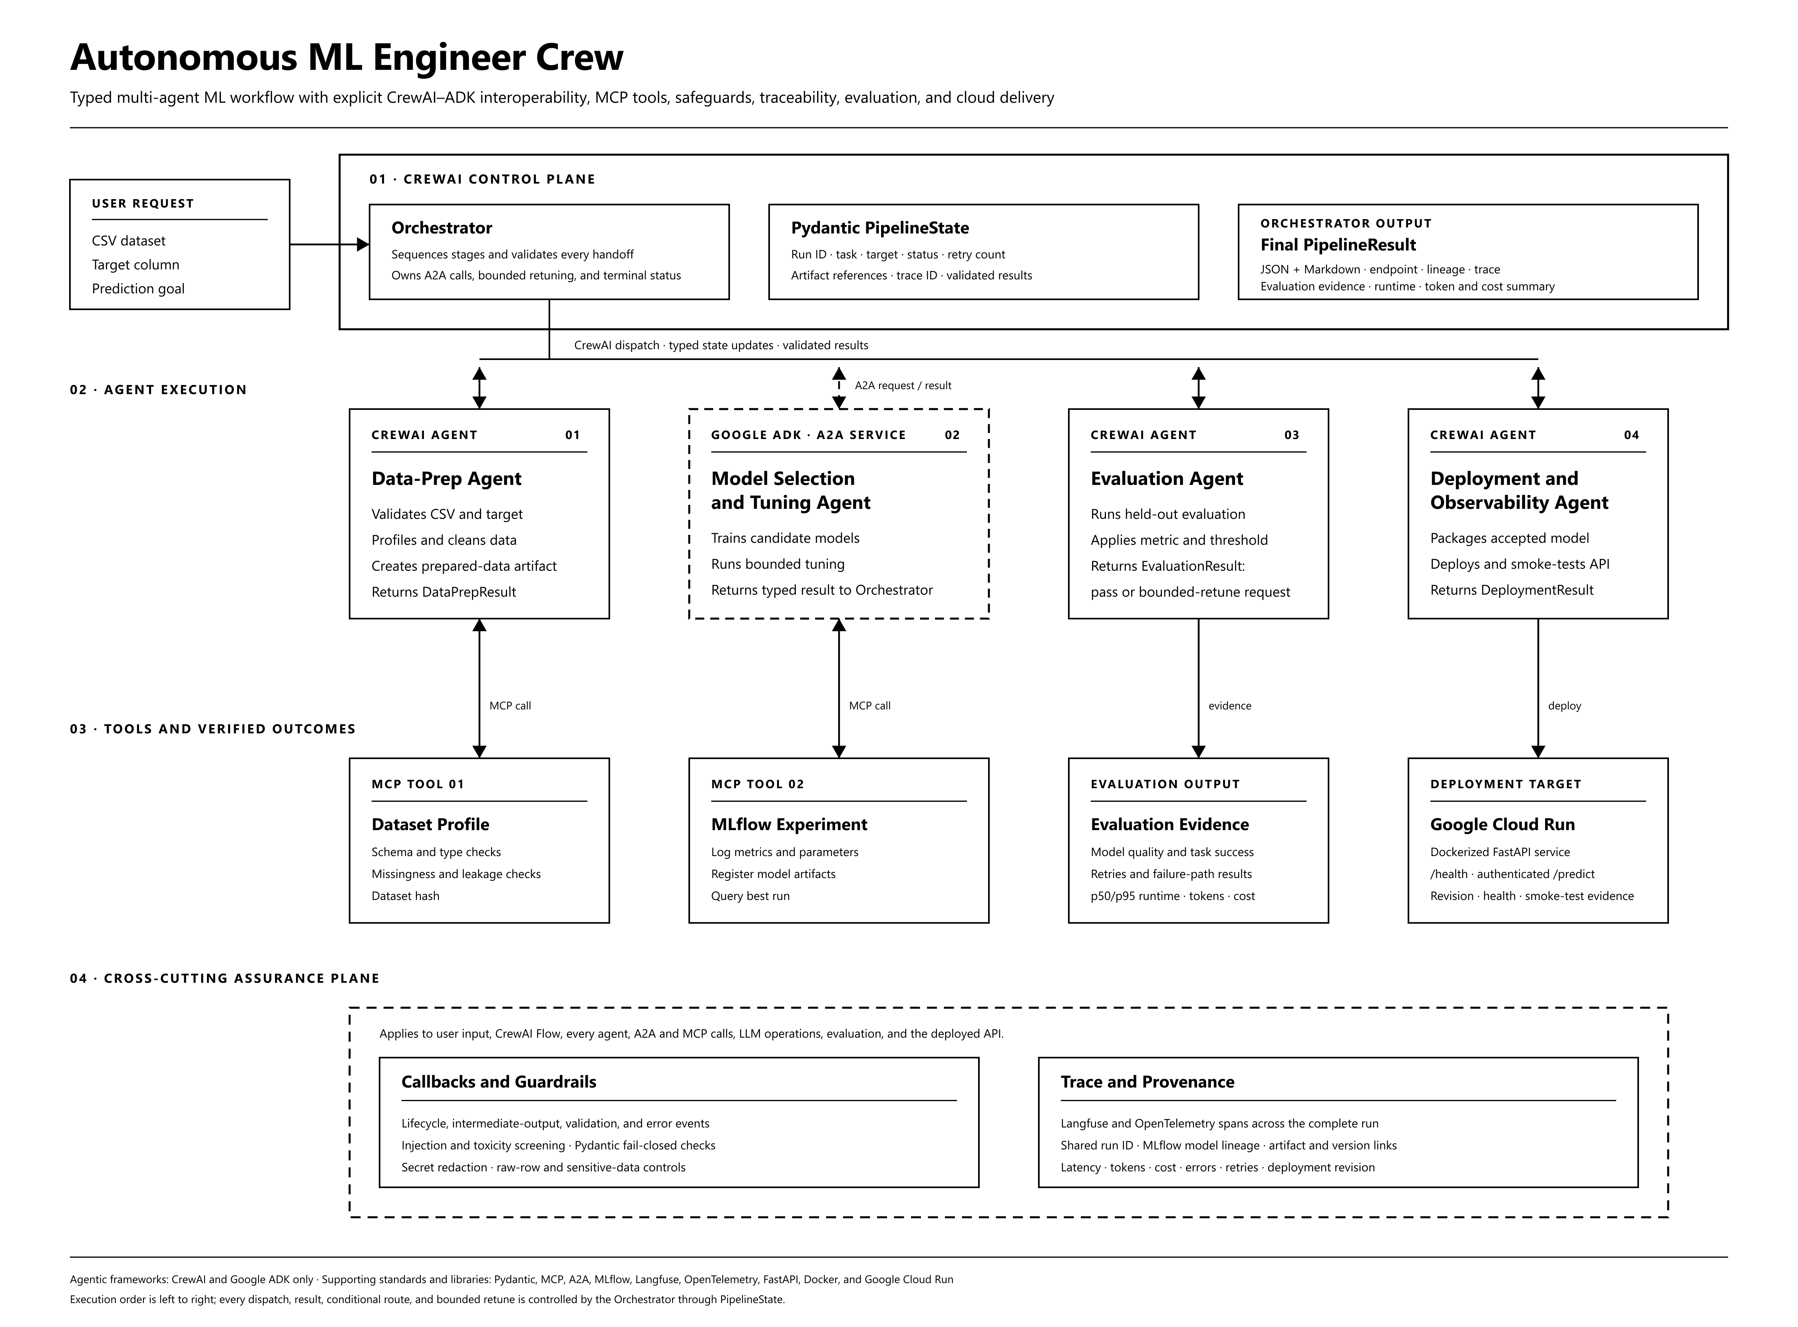
Figure 1 Final aligned implementation architecture

Agentic Workflow and Design Patterns
- The Orchestrator validates the request and initializes PipelineState.
- The Data-Prep Agent calls the Dataset Profile MCP tool and writes a DataPrepResult.
- The Orchestrator sends the prepared-data artifact to the ADK Model-Selection Agent through A2A. The agent trains candidates and calls the MLflow MCP tool.
- The Evaluation Agent validates held-out metrics and emits an EvaluationResult.
- A passing result routes to deployment. A failing result returns structured feedback for another tuning attempt until the configured retry limit is reached.
- The Deployment and Observability Agent deploys the accepted model to Google Cloud Run, runs a health check, and returns a DeploymentResult.
- The Orchestrator validates and serializes PipelineResult as JSON and Markdown.
The workflow uses sequential orchestration, tool use, conditional routing, an evaluator-optimizer reflection loop, bounded retries, typed state, and explicit terminal success and failure states.

Callbacks Monitoring and Error Handling
The orchestration wrapper defines on-stage-start, on-stage-complete, on-stage-error, retry, and validation-failure callbacks. The ADK agent registers before-agent, after-agent, before-tool, and after-tool callbacks. Every event records the run ID, agent, operation, state transition, duration, result type, retry count, and sanitized error. Callback tests verify normal execution, invalid tool returns, timeouts, and exceptions.

Security and Guardrails
- Accept only CSV files within configured size and row limits; reject path traversal, missing targets, unsupported task types, and suspicious leakage indicators.
- Parse the prediction goal as untrusted input. Detect prompt-injection patterns and abusive or toxic content before it reaches an agent or model.
- Validate every A2A message, MCP response, agent handoff, and final output with Pydantic. Invalid data fails closed and creates an audit event.
- Keep raw dataset rows inside Python data tools. Send only schema summaries, quality findings, metrics, and artifact references to the LLM.
- Use tool allowlists, least-privilege service identities, Secret Manager, log redaction, authenticated endpoints, request limits, and container resource limits.

Observability and Provenance
Langfuse receives OpenTelemetry traces for the CrewAI Flow, agents, A2A calls, MCP calls, LLM requests, routing decisions, retries, and deployment actions. MLflow remains the system of record for model parameters, metrics, and artifacts. A single run ID links the dataset hash, prepared-data artifact, model run, evaluation, container image digest, deployment revision, and final response. Traces redact raw rows and secrets while retaining timing, token, cost, error, and version metadata.

Evaluation Cost and Runtime Plan
End-to-end evaluation will run on one public regression dataset and one public classification dataset. Repeated runs will cover the success path, one evaluation retry, invalid input, MCP failure, A2A timeout, invalid tool output, exhausted retries, and deployment smoke testing.
Area | Measure | Evidence
Model quality | MAE or RMSE for regression; F1 and ROC-AUC for classification; justified pass threshold | Versioned model report cards and MLflow runs
Agent reliability | task success, schema-valid handoffs, tool failure rate, retry rate, terminal-state correctness | Automated end-to-end and failure-path tests
Runtime | per-stage duration plus end-to-end p50 and p95 over repeated runs | Trace export and evaluation table
Cost | LLM input and output tokens, provider price, Cloud Run CPU and memory time, storage and tracing assumptions | Per-run estimate and monthly scenario
Reproducibility | dataset hash, dependency lock, random seed, model artifact, image digest, deployment revision | Provenance manifest linked by run ID

Cloud Deployment
The accepted model is packaged with Docker and served by FastAPI on Google Cloud Run. The service exposes /health and authenticated /predict endpoints. Deployment uses a least-privilege service account and Secret Manager. The final evidence set includes the container image digest, Cloud Run revision, endpoint, health-check result, prediction smoke test, rollback command, and sanitized runtime logs.

6 Feasibility and Resources
The prototype remains limited to small-to-medium structured CSV datasets for supervised classification or regression. Public house-price and customer-churn datasets support repeatable testing, while the demo can accept a compatible user dataset. Candidate models, hyperparameter trials, dataset size, retries, and Cloud Run resources are capped. A standard laptop supports local development, and a modest Cloud Run service supports the final demonstration.
Category | Selected resources
Agentic frameworks | CrewAI and Google ADK only
Contracts and protocols | Pydantic, MCP, A2A
ML and tracking | pandas, scikit-learn, MLflow
Security and tracing | Callbacks, guardrails, OpenTelemetry, Langfuse
Serving and deployment | FastAPI, Docker, Google Cloud Run, Secret Manager

7 Team Members and Individual Understanding
Member | Role and responsibility | Individual understanding
Punya Mahajan 230611 | Model-Selection and Tuning Agent; Orchestrator integration | Candidate-model selection, bounded tuning, ADK agent and tool logic, CrewAI Flow state, routing, and A2A integration.
Aniket Mishra 230648 | Data-Prep Agent; Deployment and Observability Agent | Input validation, data preparation, MCP tool integration, Docker and Cloud Run deployment, API safeguards, and runtime monitoring.
Radhika Singh 230833 | Evaluation Agent; documentation | Held-out evaluation, acceptance thresholds, report cards, callback evidence, end-to-end evaluation, and cost and runtime reporting.

These remain the original ownership areas. All members will test the shared contracts, A2A and MCP integration, guardrails, traces, and final demonstration so that each member can explain and modify the full system.

8 Project Timeline
Activity | Week | Revised deliverable without changing scope
Problem and Design | September Week 3 | Project charter, fixed agent architecture, typed contracts, A2A and MCP boundaries, threat model
Development and Coding | Late September to October Week 2 | CrewAI Flow, ADK model agent, Pydantic state, two MCP tools, bounded retry
Integration and Testing | October Weeks 3 to 4 | End-to-end workflow, A2A and MCP tests, callbacks, structured logs, failure paths
Evaluation and Refinement | October Week 4 to November Week 1 | Guardrail tests, trace validation, model metrics, latency and cost evaluation
Presentation and Interface | November Weeks 1 to 2 | Minimal upload and query interface, trace walkthrough, demo script
Deployment | November Week 2 | Docker image, Cloud Run service, authenticated /predict, health check, monitoring
Final Demo | Final course week | Public repository, live pipeline, final report, benchmark evidence, contribution matrix

9 Team Responsibility Matrix
Activity | Punya Mahajan | Aniket Mishra | Radhika Singh
Agent Design | Model selection and orchestration design | Data preparation and deployment design | Evaluation and test design
Agent and Tool Development | ADK tools and CrewAI integration | Data preparation and deployment tools | Evaluation and report-card tools
Integration and Testing | Workflow and retry integration | Data pipeline and API integration | Evaluation tests and sample runs
Evaluation and Documentation | Model and tuning evidence | Deployment and monitoring evidence | Metrics, report card, and progress write-up
Presentation and Interface | Architecture and orchestration | Interface and API demonstration | Evaluation results and demo data
Deployment | Integration support | Docker and FastAPI deployment | Acceptance testing

10 Minimum Requirements Verification Plan
The following evidence must exist before the project is presented as compliant. Planning language alone will not count as completion.
Requirement | Implementation commitment | Completion evidence
1 State sharing | Typed PipelineState and validated per-agent updates | State-transition integration test and trace
2 MCP tools | Dataset Profile and MLflow Experiment tools | Two successful calls plus failure tests
3 Pydantic output | Typed handoffs and PipelineResult JSON and Markdown | Schema tests and sample serialized output
4 Design patterns | Sequential routing, tools, evaluator-optimizer loop, bounded retry | Pass, retry, and exhausted-retry traces
5 Callbacks | Stage and ADK agent, model, and tool callbacks | Correlated lifecycle and error events
6 A2A | CrewAI Orchestrator calls ADK Model-Selection service | Agent Card, protocol transcript, interoperability test
7 Frameworks | CrewAI and Google ADK only | Pinned dependencies, imports, and integration run
8 Security | Input, prompt, tool, output, secret, and authorization guardrails | Adversarial and malformed-response tests
9 Observability | Langfuse and OpenTelemetry plus MLflow lineage | Trace export and provenance manifest
10 Evaluation | Quality, reliability, runtime, token, and cost evaluation | Reproducible benchmark and estimate report
11 Cloud | Dockerized FastAPI on Google Cloud Run | Live endpoint, revision, health check, logs, smoke test

