## MICS Lab

# X-Mas 2022

## Enigmas Race!

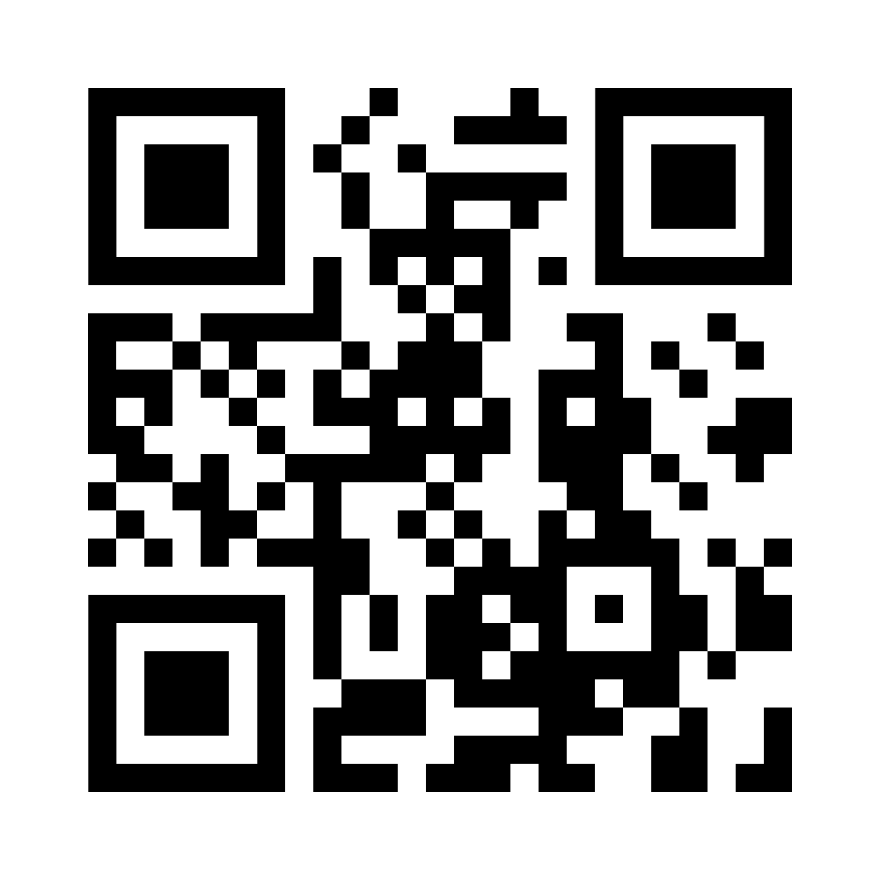<https://mics-lab.github.io/Enigmas-Xmas2022/>

## MICS Lab

# X-Mas 2022

## QR code to websiteEnigmas Race!

<https://mics-lab.github.io/Enigmas-Xmas2022/>

## MICS Lab

# X-Mas 2022

## QR code to websiteEnigmas Race!

<https://mics-lab.github.io/Enigmas-Xmas2022/>

## MICS Lab

# X-Mas 2022

## QR code to websiteEnigmas Race!

<https://mics-lab.github.io/Enigmas-Xmas2022/>