mzML: Mass Spectrometry Markup Language

Status of This Document

This document presents the specification for the mzML (Mass Spectrometry Markup Language) data format developed by the HUPO Proteomics Standards Initiative. After all comments and suggested changes submitted by the community review are addressed, the format will be released as version 1.0.0, expected in January 2008. Distribution is unlimited.

Version: Draft of Version 1.0.0; Release Candidate tag: 0.99.1; November 8, 2007.

Abstract

The Human Proteome Organisation (HUPO) Proteomics Standards Initiative (PSI) defines community standards for data representation in proteomics to facilitate data comparison, exchange and verification. The Mass Spectrometry Working Group (PSI-MS WG) develops standards for describing the results of a mass spectrometric analysis. This document presents information to the mass spectrometry community about the modelling in XML of the experimental results obtained by mass spectrometric analysis of biomolecular compounds. This XML format is based on the previous two formats mzData (Julian, Binz et al. 2005) and mzXML (Pedrioli, Eng et al. 2004), and when it is completed and accepted, obsoletes the two previous formats, and should be used in place of them. This document should be read in conjunction with a kit of auxiliary files, including the example instance documents, controlled vocabulary file, and xsd files. All files related to this proposal are available for download at http://psidev.info/index.php?q=node/257.

Contents

Abstract 1
1. Introduction 2
1.1 Background 2
1.2 Previous formats 4
1.3 Design Philosophy 4
2. Implementation of the Format 5
2.1 Concepts and Terminology 5
2.2 Relationship to Other Specifications 5
2.2.1 The PSI Mass Spectrometry Controlled Vocabulary (CV) 6
2.3 Resolved Design Issues 7
2.3.1 Count attributes 7
2.4 Other supporting materials 7
2.5 Open Issues 8
2.5.1 The new CV term problem 8
3. Model in XML Schema 10
3.1 Element <mzML> 11
3.2 Element <cvList> 14
3.3 Element <fileDescription> 14
3.4 Element <referenceableParamGroupList> 16
3.5 Element <sampleList> 16
3.6 Element <instrumentList> 17
3.7 Element <softwareList> 18
3.8 Element <dataProcessingList> 19
3.9 Element <run> 20
3.10 Element <cv> 21
3.11 Element <fileContent> 22
3.12 Element <sourceFileList> 23
3.13 Element <contact> 23
3.14 Element <referenceableParamGroup> 24
3.15 Element <sample> 25
3.16 Element <instrument> 26
3.17 Element <software> 27
3.18 Element <dataProcessing> 28
3.19 Element <paramGroupRef> 28
3.20 Element <cvParam> 29
3.21 Element <userParam> 29
3.22 Element <sourceFileRefList> 30
3.23 Element <spectrumList> 31
3.24 Element <sourceFile> 32
3.25 Element <componentList> 33
3.26 Element <instrumentSoftwareRef> 33
3.27 Element <softwareParam> 34
3.28 Element <processingMethod> 34
3.29 Element <sourceFileRef> 35
3.30 Element <spectrum> 35
3.31 Element <source> 38
3.32 Element <analyzer> 39
3.33 Element <detector> 40
3.34 Element <spectrumDescription> 41
3.35 Element <binaryDataArray> 42
3.36 Element <acquisitionList> 44
3.37 Element <precursorList> 45
3.38 Element <scan> 46
3.39 Element <binary> 48
3.40 Element <acquisition> 48
3.41 Element <precursor> 49
3.42 Element <selectionWindowList> 49
3.43 Element <ionSelection> 50
3.44 Element <activation> 51
3.45 Element <selectionWindow> 51
4. Conclusions 52
5. Authors and Contributors 52
6. References 54
7. Intellectual Property Statement 54
Copyright Notice 54

Introduction

Background

Mass spectrometry is a popular method to analyse bio-molecules by measuring the intact mass-to-charge ratios of their in-situ generated ionised forms or the mass-to-charge ratios of in-situ-generated fragments of these ions. The resulting mass spectra are used for a variety of purposes, among which is the identification, characterization, and absolute or relative quantification of the analysed molecules. The processing steps to achieve these goals typically involve semi-automatic computational analysis of the recorded mass spectra and sometimes also of the associated metadata (e.g., elution characteristics if the instrument is coupled to a chromatography system). The result of the processing can be assigned a score, rank or confidence measure.

Differences inherent in the use of a variety of instruments, different experimental conditions under which analyses are performed, and potential automatic data preprocessing steps by the instrument software can influence the actual measurements and therefore the results after processing. Additionally, most instruments output their acquired data in a very specific and often proprietary format. These proprietary formats are then typically transformed into so-called peak lists to be analysed by identification and characterisation software. Data reduction such as peak centroiding and deisotoping is often performed during this transformation from proprietary formats to peak lists. In addition, these peak list file formats lack information about the precursor MS signals and about the associated metadata (i.e., instrument settings and description, acquisition mode, etc) compared to the files they were derived from. The peak lists are then used as inputs for subsequent analysis. The many different and often proprietary formats make integration or comparison of mass spectrometer output data difficult or impossible, and the use of the heavily processed and data-poor peak lists is often suboptimal.

This document addresses this problem with the presentation of the mzML XML format, which is designed to hold the data output of a mass spectrometer as well as a systematic description of the conditions under which this data was acquired and transformed. The following target objectives can be defined for the format:

- The discovery of relevant results, so that, for example, data sets in a database or public repository that use a particular technique or combination of techniques can be identified and studied by experimentalists during experiment design or data analysis.
- The sharing of best practice, whereby, for example, approaches that have been successful at analysing low abundance analytes can be captured alongside the results produced.
- The evaluation of results, whereby, for example, the number and quality of the spectra recorded from a sample can be assessed in the light of the experimental conditions.
- The sharing of data sets, so that, for example, public repositories can import or export data, multi-site projects can share results to support integrated analysis, or meta-analyses can be performed by third parties from previously published data.
- The most comprehensive support of the instruments output, so that data can be captured in profile mode, centroid mode, and other relevant forms of biomolecular mass spectrometry data representation

The primary focus of the model is to support long-term archiving and sharing, rather than day-to-day laboratory management, although the model is extensible to support context-specific details.

The description of mass spectrometry data output and its experimental context requires that models include: (i) the actual data acquired, to a sufficient precision, as well as its associated metadata; and (ii) an adequate description of the instrument characteristics, its configuration and possible preprocessing steps applied. This document details both these parts, as they are required to support the tasks T1 to T5 above.

This document defines a specification and is not a tutorial. As such, the presentation of technical details is deliberately direct. The role of the text is to describe the schema model and justify design decisions made. This document does not provide comprehensive examples of the schema in use. Example documents are provided separately and should be examined in conjunction with this document. It is anticipated that tutorial material will be developed in the future to aid implementation. Although the present specification document describes constraints and guidelines related to the content of an mzML document as well as the availability of tools helping to read and write mzML, it does not describe any implementation constraints or specifications such as coding language or operating system for software that will generate and/or read mzML data.

Previous formats

During 2003 – 2005, two data formats to store mass spectrometer output in an open, vendor-neutral, XML format were developed. The mzData format [mzData] was developed by the PSI, primarily as a data exchange and archive format. The mzXML format [mzXML] was developed at the Institute for Systems Biology (ISB), primarily in order to streamline data processing software. Both formats are used extensively but it has been noted that having two formats for essentially the same information causes unnecessary confusion in the community and adds complexity to software developers as often both formats must be supported. Therefore the designers of mzData and mzXML, including representatives of instrument vendors, analysis software developers and end users, have joined under the auspices of the PSI and jointly developed a single format intended to replace the previous two. This new format is named mzML and is described in this document.

The main difference between the two original formats, aside from the primary intent described above, is the design philosophy of flexibility. The mzData format was designed to be quite flexible via the extensive use of a controlled vocabulary. It was hoped that the actual xsd schema could remain stable for many years while the accompanying controlled vocabulary could be frequently updated to support new technologies, instruments, and methods of acquiring data.

On the other hand, mzXML was designed with a very strict schema with most auxiliary information described in enumerated attributes. This simplified software implementations as there was only one way to present various attributes and the validity of the documents could be easily checked with industry-standard XML validators.

The main challenge in uniting these two formats was therefore resolving the opposing philosophies rather than fundamental technical issues. The result is a format that contains the best aspects of the two original formats so that it may be widely adopted and will resolve the current problem of two formats.

Design Philosophy

Since the development of mzML brought together many different philosophies, the primary mzML designers agreed on the following design principles that would guide its development:

- Keep the format simple. Many elaborate extensions were proposed but most were rejected in favour of a simple implementation.
- Minimize alternate ways of encoding the same information. Such flexibility, while sometimes touted as a benefit for some products, is bad for data formats.
- Build in some flexibility for encoding new important information but keep the format stable. There is a strong desire from companies that develop software for their customers to keep the data format stable over long periods of time with updates to an auxiliary file.
- Support the features of mzData and mzXML but not a lot more in version 1.0. Only support for SRM data was added (which is also supported in the latest mzXML 3.1 and thus not really new).
- Finish version 1.0 of the format soon with the resources available. It was felt that the greatest community benefit would be to resolve the mzData/mzXML duality rather than expend limited resources on new features.

There was great temptation to add support for many new kinds of data and representation possibilities. There are many enhancements that have been suggested, but the small group of volunteers that have actively developed this format have opted to focus on the primary goal set before us: develop a single format that the vendors and current software can easily support and thereby obsolete mzData and mzXML. The enhancements not considered compatible with this goal will be entertained for mzML 2.0

One of the aspects of mzXML that enabled its very swift adoption was a ready set of open source tools that implemented the format. With these tools many users were able to begin using the format immediately without coding their own software. Therefore, to insure that mzML is a format that will be adopted quickly and implemented uniformly, the format is presented with several tools that write, read, and validate the format. At submission to the PSI document process, the following software will implement mzML:

- Two or more converters that convert from vendor formats to mzML.
- The popular RAMP parser library that currently supports mzData and mzXML.
- An mzML semantic validator that checks for correct implementation of files.

The mzData format was a far more flexible format than mzXML. The support of new technologies could be added to mzData files by adding new controlled vocabulary terms, while mzXML often required a full schema revision. This is evidenced by mzData still being at version 1.05 while mzXML is currently at version 3.1. However, mzData did suffer from a problem of inconsistently used vocabulary terms and there appeared several different dialects of mzData, encoding the same information in subtly different ways. This was not usually a problem for human inspection of the file, but caused difficulty writing and maintaining reader software.

This problem was been solved (it is hoped) for mzML by releasing a semantic validator with the data format. This semantic validator enforces many rules as to how controlled vocabulary terms are used, not only making sure that the terms are in the CV, but also that the correct terms are used in the correct location in the document and the required terms are present the correct number of times. This allows greater flexibility in the schema, but enforces order in how the CV terms are used. This will require the discipline of using the semantic validator, not just an XML validator. The result is that new technologies or information can be accommodated with adjustments to the controlled vocabulary and validator, not to the schema. Opinions differ on whether this is a benefit or a curse.

The remainder of this document is structured as follows. Section 2.1 describes a number of concepts and information about the implementation of mzML, including aspects of terminology, design issues, the controlled vocabulary, etc. The schema model itself is presented in XML schema (XSD) notation in Section 3; some conclusions are presented in Section 5.

Implementation of the Format

Concepts and Terminology

This document assumes familiarity with one data modelling notation, namely XML Schema (www.w3.org/XML/Schema). Models are described using XML schema.

The keywords “MUST,” “MUST NOT,” “REQUIRED,” “SHALL,” “SHALL NOT,” “SHOULD,” “SHOULD NOT,” “RECOMMENDED,” “MAY,” and “OPTIONAL” are to be interpreted as described in RFC-2119 (Bradner 1997).

Relationship to Other Specifications

The specification described in this document is not being developed in isolation; indeed, it is designed to be complementary to, and thus used in conjunction with, several existing and emerging models. Related specifications include the following:

- MIAPE MS (http://www.psidev.info/index.php?q=node/91) The “Minimum Information About a Proteomics Experiment: Mass Spectrometry” document identifies the minimum information required to report the use of a mass spectrometer in a proteomics experiment. It is expected that mzML will be used to capture the requirements specified in MIAPE MS. However, mzML does not enforce MIAPE compliance itself; mzML documents may be valid and useful without being fully MIAPE compliant.
- sepCV (http://obo.sourceforge.net/cgi-bin/detail.cgi?sep). At various defined positions within GelML, terms must be provided from a controlled vocabulary or ontology. sepCV is a controlled vocabulary designed specifically by PSI and the Metabolomics Standards Initiative to provide a lexicon for protein separation techniques. sepCV will support the annotation of GelML with an agreed standard terminology.
- spML (http://www.psidev.info/index.php?q=node/90). spML (sample processing Markup Language) is the proposed PSI standard for describing general protein separation and sample processing other than gel electrophoresis. GelML is being developed separately from spML because there is a well defined community associated with gel electrophoresis. As both GelML and spML build on FuGE (Functional Genomics Experiment) (Jones, Miller et al. 2007) and use FuGE to describe the relationships between steps in a proteomics workflow, they will be designed to be straightforward to use together where appropriate. This document does not assume familiarity with spML.
- GelInfoML (http://www.psidev.info/index.php?q=node/38). The GelInfoML specification is being developed by PSI as a model for analysis of images resulting from gel electrophoresis. There are a number of software packages, both commercial and freely available, that analyse gel images to quantify the abundance of protein within a particular gel spot or to compare the abundance of a protein spot between different images. The GelInfoML format is being developed separately from GelML because the kind of information represented in the two formats is different and the images resulting from gel electrophoresis can be analysed multiple times without repeating the experiment.
- analysisXML (http://www.psidev.info/index.php?q=node/85). The analysisXML specification is being developed by PSI as a standard to capture the output of search engines that assign mass spectra to protein or peptide sequences. It is FuGE-based and will provide a UML model as well as an XML schema. It is anticipated that mzML will serve as an important ‘input’ to the model defined by analysisXML. This document does not assume familiarity with analysisXML or FuGE.

The PSI Mass Spectrometry Controlled Vocabulary (CV)

A comprehensive collection of terms have been defined (mostly extracted from vocabulary and definitions in chapter 12 of the IUPAC nomenclature book) and structured in an mzML-friendly way, hopefully facilitating the browsing of the terms. Almost all first-level branch terms (the direct children of the root term) have a homonymous XML element in mzML. Their children, the second-level terms, are relevant topics or categories which need CV support for their description. The leaf nodes under their respective parent categories should be used in a CvParam under the appropriate XML element in mzML schema. Some terms describe attributes that must be coupled with a numerical value attribute in the CvParam element (e.g. dwell time MS:1000039) and optionally a unit for that value (e.g. second MS:1000502). These attributes are all also children of the term ‘object attribute’ (MS:1000547) and they also have a second parent term related to the appropriate schema section it belongs. Note that all the terms that are not children of ‘object attribute’ should never contain a value as they are concepts stand by themselves (e.g. positive scan MS:1000130).

Although the structure of the CV and the mzML schema are related, the details of which terms are allowed/recommended in a given schema section is reported in the mapping file. The mapping file is a list of associations between a CvParam element in a specific schema location (described with an Xpath) and the branches of the CV terms expected in that location. Such file is read and interpreted by the validator checking that the data annotation is consistent. The mapping file needs to be checked and eventually updated when the CV terms or structure are changed.

As recommended by the PSI CV guidelines, psi-ms.obo should be dynamically maintained via the psidev-ms-dev mailing lists that allow any user to request new terms in agreement with the community involved. Once a consensus is reached among the community the new terms are added within few days. If there is no obvious consensus, a CV committee should vote and make a decision. A new psi-ms.obo should then be released by updating the file on the CVS server without changing the name of the file (this would alter the propagation of the file to the OBO website and to other ontology services that rely on file stable URI). For this reason an internal version number with two decimals (x.y.z) should be increased:
- x should be increased when the first level term are renamed added deleted or rearranged in the structure, such rearrangement is suppose to be rare and is very likely to have repercussion on the mapping.
- y should be increased when any other term except the first level one are altered.
- z should be increased when there is no term addition or deletion but just editing on the definitions or other minor changes.

The following ontologies or controlled vocabularies specified below may also be suitable or required in certain instances:

- ChEBI (http://www.ebi.ac.uk/chebi/)
- OBI (Ontology of Biological Investigations, formerly called FuGO http://obi.sourceforge.net/).

Resolved Design Issues

There were several issues regarding the design of the format that were not clear cut, and a design choice was made that was not completely agreeable to everyone. So that these issues o not keep coming up, we document here the issues and why the decision that is implemented was made.

Count attributes

It was decided that all list elements would have a count attribute. The reason is that parsers implemented in languages where memory allocation or array sizing is important, it is a nice performance enhancement to have a count attribute indicating how many elements there are in the list. Although it was felt that this is an easy target for creating inconsistent files (i.e. writing out a count=”5” attribute followed by 6 items in the list), this was deemed to be rare and in the vast majority of cases the value can be relied on. The code would need to adapt to cases where the count was incorrect, but this is no more difficult than not knowing the value ahead of time. Validators of mzML should check that the counts are correct when validating file.

Other supporting materials

This document cannot be fully judged on its own. It is important to study the accompanying sample instance documents, controlled vocabulary, schema files, and the software that implements this pre-release version of mzML.

All these files and programs are available at:
http://psidev.info/index.php?q=node/257

They are:

Filename | Description
README.txt | Summary file for the mzML evaluation kit
TODO.txt | Information on items that still need to be resolved before release
mzML0.99.0.html | HTML documentation of the model
mzML0.99.0.xsd | Main mzML XML schema definition file
mzML0.99.9_idx.xsd | Wrapper schema for indexing an mzML file for random access
psi-ms.obo | PSI-MS controlled vocabulary in OBO format
specialNotes.txt | A set of special notes associated with individual elements
ms-mapping.txt | XML-encoded rules for where certain cvParams MAY/MUST appear in the document.
tiny1.mzML0.99.0.xml | Tiny hand-crafted two spectrum MS1 + MS2 LCQ example
tiny2_SRM.mzML0.99.0.xml | Tiny hand-crafted example of SRM data
tiny4_LTQ-FT.mzML0.99.0.xml | Tiny hand-crafted example of describing hybrid instrument
1min.mzML | Example output of ReAdW Thermo -> mzML converter
2min.mzML | Example output of wolf Waters -> mzML converter
validateMzML.pl | Small Perl program to use Xerces to perform crude (not semantic) validation of an mzML file
mzMLContentHandler.pm | Reader class used by validateMzML.pl
mzML_0.99_validator.zip | Java implementation of a full semantic validator for mzML

Additional material is referenced with hyperlinks at the same URL.

Open Issues

Most issues were resolved within the group and/or discussed on the discussion lists or at telephone conferences and resolved. This section is devoted to any issues that appeared too thorny to resolve, and we throw it out to the community to guide us on how to proceed.

Note: Each of the following items should be resolved during this comment period and the decision implemented in version 1.0.0, so that the following subsections can be removed. Please send your feedback to the discussion list.

The new CV term problem

It was decided that all annotations on the data that should come from a list of allowed values using the <cvParam> element. All information encoded as element attributes are never controlled vocabulary terms. Thus, as an example to describe spectrum type, the cvParam element must be provided to specify a term below MS:1000559 “spectrum type”, such as:

<cvParam cvLabel="MS" accession="MS:1000580" name="MSn spectrum" value=""/>

Note that both accession and the term name are provided. Parsers should focus on the accession number as this should never change, even if the term name is adjusted in the controlled vocabulary later. Note that there is no value. The mere presence of the term is the annotation.

The problem comes when there is a new term to be added. Let’s assume that it becomes necessary to add a new spectrum type “SRM spectrum”. Vendor X would like to start writing mzML with this spectrum type. What should happen and what could also happen?

In an ideal world, Vendor X would contact the PSI-MS WG controlled vocabulary coordinator and request a new child term of “spectrum type”. The CV coordinator would verify that this is a new concept, not simply a synonym of an existing concept, add the term to the CV and release a new version of the psi-ms.obo file at the same location. Vendor X would obtain the accession number and could begin writing out valid mzML. The semantic validator would (and already does) automatically download the new .obo file and validate that the new mzML is semantically valid using the new term.

If the file is then distributed to arbitrary site Y, local software will suddenly encounter this new term:

<cvParam cvLabel="MS" accession="MS:1000583" name="SRM spectrum" value=""/>

and there is a possibility of failure. The first problem that may occur is that reader software may try to understand what the spectrum type is, but it will not find a spectrum type that it understands. Therefore it can only conclude that either no spectrum type was provided, or one of the terms it doesn’t recognize is a spectrum type but it won’t know which one. If the software could connect to the Internet, and could automatically download the latest .obo file, and look to see if this term was in the file, and then determine what parent the above term had, and understand that the parent is “spectrum type”, then the software could conclude that the above cv term is a spectrum type, but a new one that it doesn’t not know how to handle yet. Such a string of logic is not terribly difficult but it is not trivial and is objectionable to some.

Worse yet, Vendor X could have been lazy and not even contacted the PSI-WG CV coordinator and just started publishing mzML with:

<cvParam cvLabel="MS" accession="MS:9999999" name="SRM spectrum" value=""/>

There is no way to resolve this. No reader could possibly know how to handle this. It should be avoided at all cost. Although it should be noted that until the proper accession number is furnished, such an approach will at least initially be used. In any case, processing software may still not know how to properly handle SRM spectra, but it should already be able to confidently understand what the spectrum type is and admit it cannot handle it.

In order to make it easier for software developers, two possible solutions are offered: B)

<cvParam cvLabel="MS" accession="MS:1000035" name="spectrum type" value="SRM spectrum"/>

In this case, the accession of parent/category term and its name are provided and the child/leaf term is given as a value. Or C)

<cvParam cvLabel="MS" categoryAccession=”MS:1000035” categoryName=”spectrum type” accession="MS:1000583" name="SRM spectrum" value=""/>

In this case, both the accession and name of both the parent/category and the child/leaf term is explicitly provided.

In both cases, reader software can now know exactly that the spectrum type is “SRM spectrum” without complex logic and proceed with processing based on that. However, case B provides no accession number of the leaf, and thus the software code will be written to the name which could suffer from capitalization/spelling issues, which is to be avoided.

For case C, both the category and the leaf terms are explicitly provided. Reader software can easily determine what the spectrum type is without complex logic even in the face of a MS:9999999 accession shown above. The downside of option C is that files are more verbose than otherwise and that there is the possibility of conflicting, incorrect stated category and left nodes. A final argument against this is that such a scheme was tried with MAGE-ML (MicroArray Gene Expression Markup Language) version 1, and it caused massive confusion. An alternate contention is that the massive confusion resulted from nesting of terms rather than the flat attribute structure proposed here.

So in summary, the three proposed options are:

A) <cvParam cvLabel="MS" accession="MS:1000583" name="SRM spectrum" value=""/>

B) <cvParam cvLabel="MS" accession="MS:1000035" name="spectrum type" value="SRM spectrum"/>

C) <cvParam cvLabel="MS" categoryAccession=”MS:1000035” categoryName=”spectrum type” accession="MS:1000583" name="SRM spectrum" value=""/>

Option A is currently used in this proposal and accompanying files. It relies on (and perhaps even forces) participation in the active maintenance of the controlled vocabulary, as well as more complex reader logic to handle well.

Option B has some historical precedents but lack of an accession number for the leaf term is a serious strike against it.

Option C seems most complete but is verbose and might promote laziness in the participation in the setting of new CV terms.

It has been noted by repository curators that option B or C may provide the flexibility that promotes optimal annotation of data. It allows submitters to make up terms that fit their data best and then curators could update the CV (and the submitted documents) to conform to a consistent state.

It would seem that option C is the easiest for implementers of readers, and may promote the best use of the controlled vocabulary, but you be the judge. Please study the issue (*especially* if you anticipate coding software to read mzML) and give us your feedback.

Model in XML Schema

The mzML model is described in XML schema below.

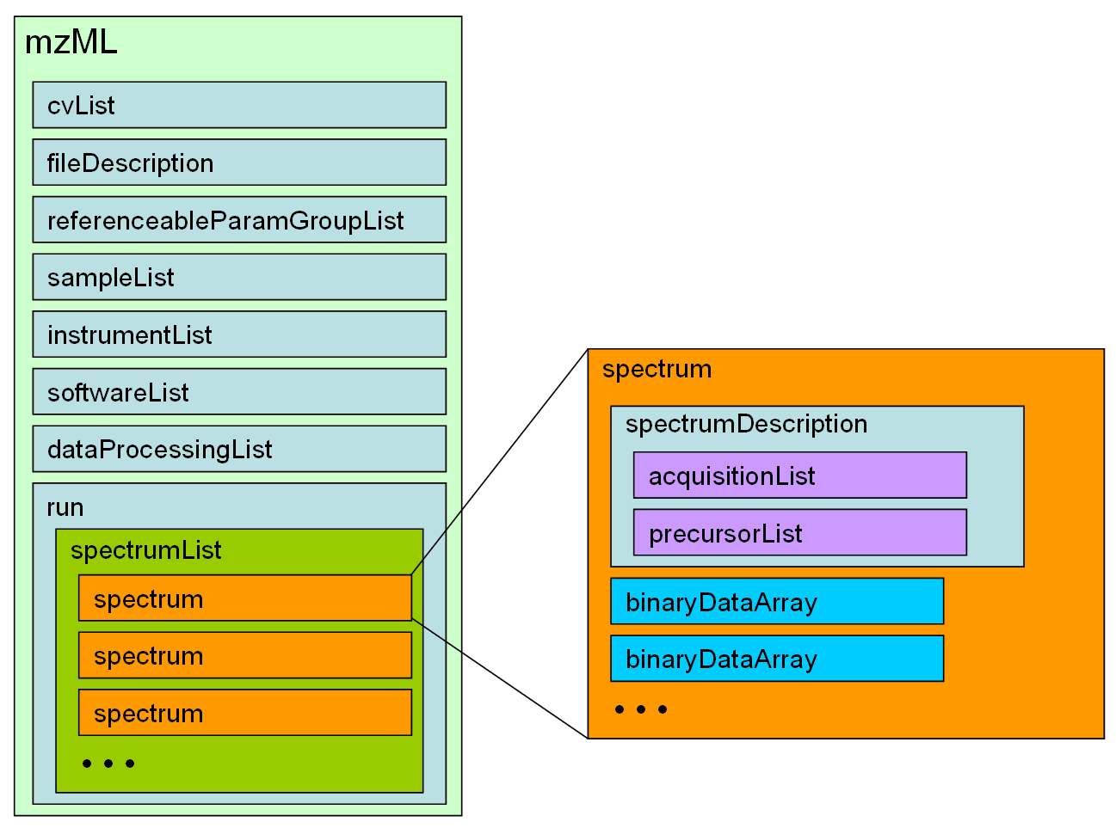
Figure 1: High level overview of the XML elements for mzML. Each box represents an XML element, nested within other elements as shown.

Element <mzML>
Definition:
This is the root element for the Proteomics Standards Initiative (PSI) mzML schema, which is intended to capture the use of a mass spectrometer, the data generated, and the initial processing of that data (to the level of the peak list).
Attributes:
Attribute Name | Data Type | Use | Definition
accession | xs:string | optional | An optional accession number for the mzML document.
id | xs:anyURI | required | An id for the mzML document.
version | xs:string | required | The version of this mzML document.
Subelements:
Subelement Name | minOccurs | maxOccurs | Definition
cvList | 1 | 1 | Container for one or more controlled vocabulary definitions.
fileDescription | 1 | 1 | Information pertaining to the entire mzML file (i.e. not specific to any part of the data set) is stored here.
referenceableParamGroupList | 0 | 1 | Container for a list of referenceableParamGroups
sampleList | 0 | 1 | List and descriptions of samples.
instrumentList | 1 | 1 | List and descriptions of instruments.
softwareList | 1 | 1 | List and descriptions of software used to acquire and/or process the data in this mzML file.
dataProcessingList | 1 | 1 | List and descriptions of data processing applied to this data.
run | 1 | 1 | The definition and specification of a mass spectrometry run.
Graphical Context:
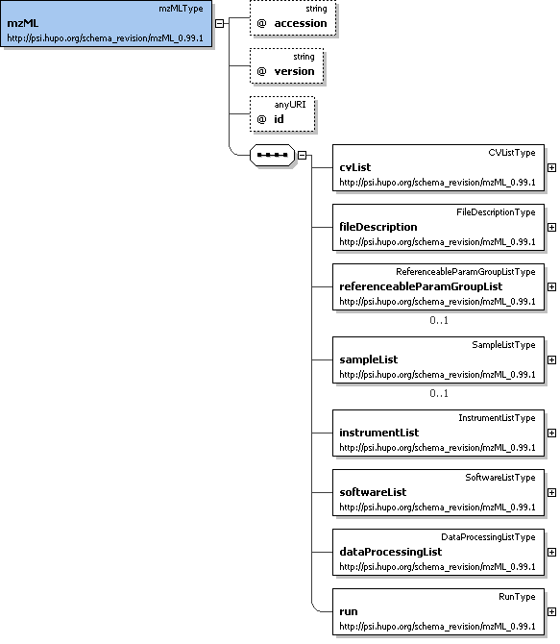
Example Context:
<mzML xmlns="http://psi.hupo.org/schema_revision/mzML_0.99.1" xmlns:xsi="http://www.w3.org/2001/XMLSchema-instance" xsi:schemaLocation="http://psi.hupo.org/schema_revision/mzML_0.99.1 mzML0.99.1.xsd" accession="" id="urn:lsid:psidev.info:mzML.instanceDocuments.tiny1" version="0.99.1">
<cvList count="1">
<cv cvLabel="MS" fullName="Proteomics Standards Initiative Mass Spectrometry Ontology" version="2.0.2" URI="http://psidev.sourceforge.net/ms/xml/mzdata/psi-ms.2.0.2.obo"/>
</cvList>
<fileDescription>
...
</mzML>
Notes and Constraints:
The <mzML> element and all content below may occur by itself in an XML document, but is also designed to be wrapped in the mzML indexing schema in order to facilitate random access within the file with appropriate reader software.

Element <cvList>
Definition:
Container for one or more controlled vocabulary definitions.
Attributes:
Attribute Name | Data Type | Use | Definition
count | xs:nonNegativeInteger | required | The number of CV definitionsin this mzML file.
Subelements:
Subelement Name | minOccurs | maxOccurs | Definition
cv | 1 | unbounded | Information about an ontology or CV source and a short 'lookup' tag to refer to.
Graphical Context:
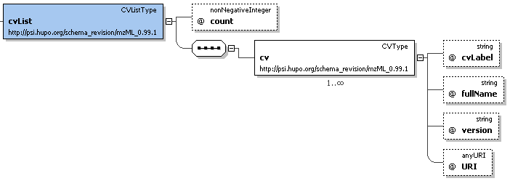
Example Context:
<cvList count="1">
<cv cvLabel="MS" fullName="Proteomics Standards Initiative Mass Spectrometry Ontology" version="2.0.2" URI="http://psidev.sourceforge.net/ms/xml/mzdata/psi-ms.2.0.2.obo"/>
</cvList>
Notes and Constraints:
One of the <cv> elements in this list MUST be the PSI MS controlled vocabulary. All <cvParam> elements in the document MUST refer to one of the <cv> elements in this list.

Element <fileDescription>
Definition:
Information pertaining to the entire mzML file (i.e. not specific to any part of the data set) is stored here.
Attributes:
none
Subelements:
Subelement Name | minOccurs | maxOccurs | Definition
fileContent | 1 | 1 | This summarizes the different types of spectra that can be expected in the file. This is expected to aid processing software in skipping files that do not contain appropriate spectrum types for it.
sourceFileList | 0 | 1 | List and descriptions of the source files this mzML document was generated or derived from
contact | 0 | unbounded | Structure allowing the use of a controlled (cvParam) or uncontrolled vocabulary (userParam), or a reference to a predefined set of these in this mzML file (paramGroupRef).
Graphical Context:
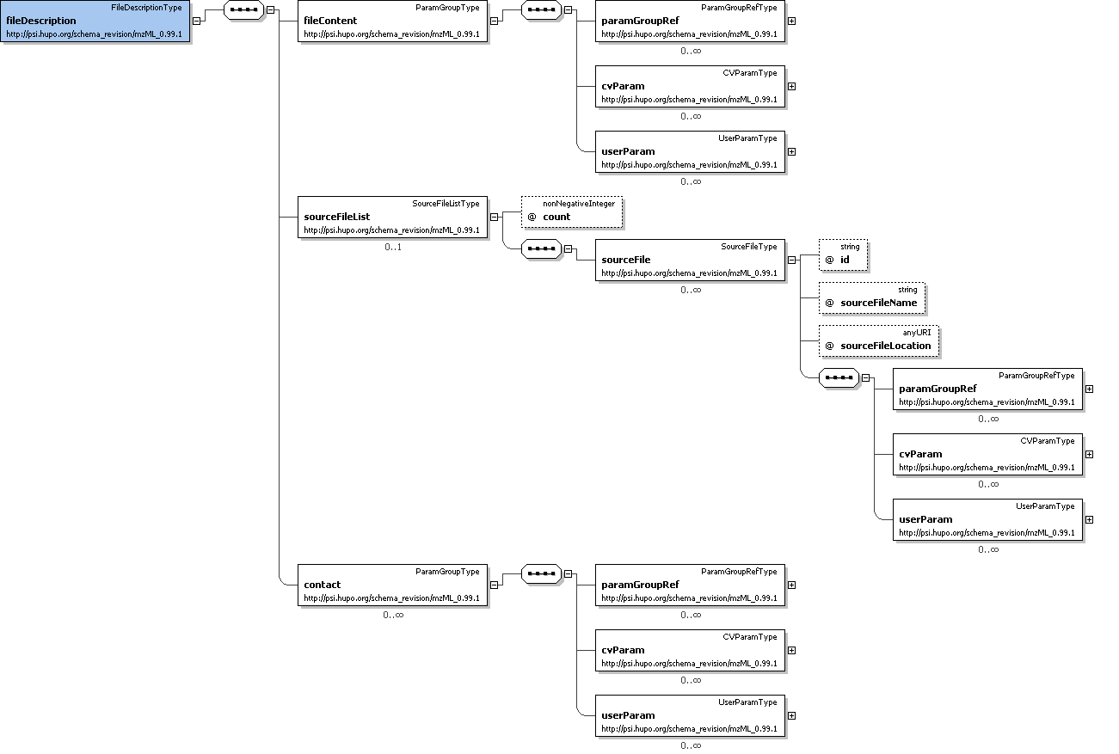
Example Context:
<fileDescription>
<fileContent>
<cvParam cvLabel="MS" accession="MS:1000580" name="MSn spectrum" value=""/>
</fileContent>
<sourceFileList count="1">
...
</fileDescription>

Element <referenceableParamGroupList>
Definition:
Container for a list of referenceableParamGroups
Attributes:
Attribute Name | Data Type | Use | Definition
count | xs:nonNegativeInteger | required | The number of ParamGroups defined in this mzML file.
Subelements:
Subelement Name | minOccurs | maxOccurs | Definition
referenceableParamGroup | 1 | unbounded | ParamGroup that can be referenced from elsewhere in this mzML document by using the 'paramGroupRef' element in that location to reference the 'id' attribute value of this element.
Graphical Context:
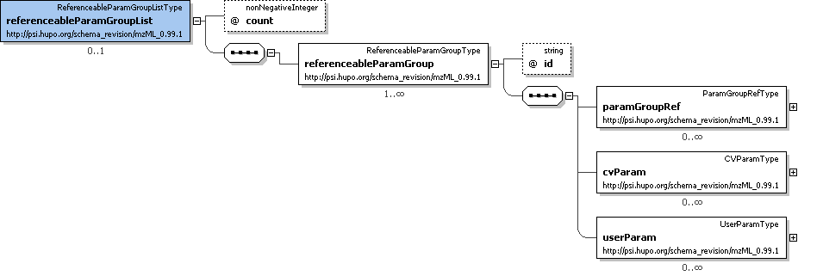
Example Context:
<referenceableParamGroupList count="2">
<referenceableParamGroup id="CommonMS1SpectrumParams">
<cvParam cvLabel="MS" accession="MS:1000130" name="positive scan" value=""/>
<cvParam cvLabel="MS" accession="MS:1000498" name="full scan" value=""/>
</referenceableParamGroup>
...
</referenceableParamGroupList>

Element <sampleList>
Definition:
List and descriptions of samples.
Attributes:
Attribute Name | Data Type | Use | Definition
count | xs:nonNegativeInteger | required | The number of Samples defined in this mzML file.
Subelements:
Subelement Name | minOccurs | maxOccurs | Definition
sample | 1 | unbounded | Expansible description of the sample used to generate the dataset, named in sampleName.
Graphical Context:
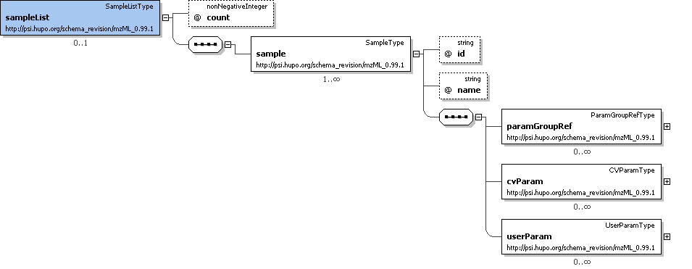
Example Context:
<sampleList count="1">
<sample id="1" name="Sample1"/>
</sampleList>

Element <instrumentList>
Definition:
List and descriptions of instruments.
Attributes:
Attribute Name | Data Type | Use | Definition
count | xs:nonNegativeInteger | required | The number of instruments present in this list.
Subelements:
Subelement Name | minOccurs | maxOccurs | Definition
instrument | 1 | unbounded | Description of the components of the mass spectrometer used
Graphical Context:
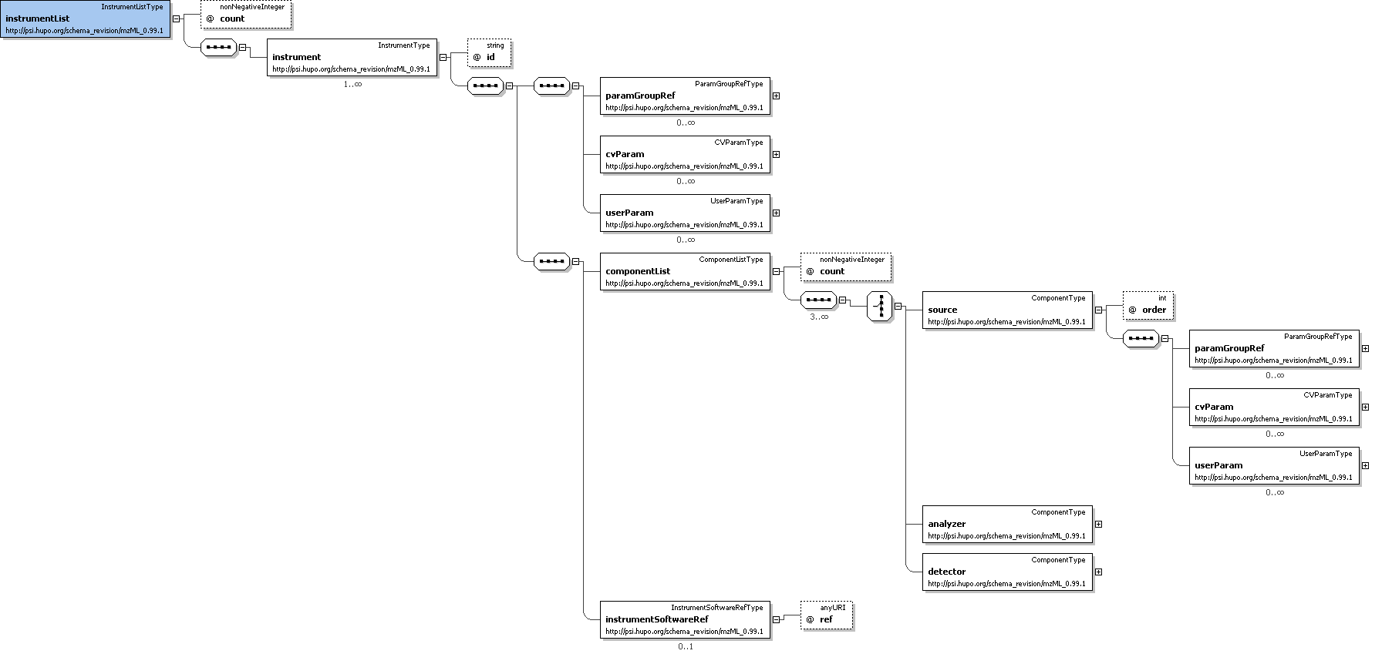
Example Context:
<instrumentList count="1">
<instrument id="LCQ Deca">
<cvParam cvLabel="MS" accession="MS:1000554" name="LCQ Deca" value=""/>
<cvParam cvLabel="MS" accession="MS:1000529" name="instrument serial number" value="23433"/>
<componentList count="3">
...
</instrumentList>

Element <softwareList>
Definition:
List and descriptions of software used to acquire and/or process the data in this mzML file.
Attributes:
Attribute Name | Data Type | Use | Definition
count | xs:nonNegativeInteger | required | The number of softwares defined in this mzML file.
Subelements:
Subelement Name | minOccurs | maxOccurs | Definition
software | 1 | unbounded | A piece of software.
Graphical Context:
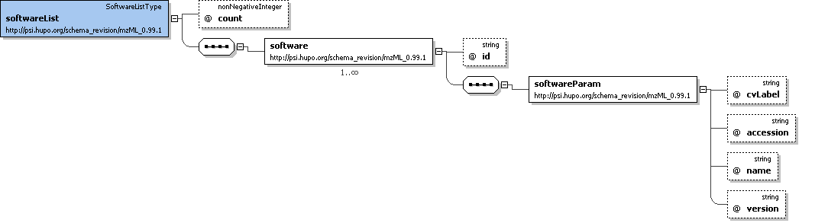
Example Context:
<softwareList count="3">
<software id="Bioworks">
<softwareParam cvLabel="MS" accession="MS:1000533" name="Bioworks" version="3.3.1 sp1"/>
</software>
<software id="ReAdW">
...
</softwareList>

Element <dataProcessingList>
Definition:
List and descriptions of data processing applied to this data.
Attributes:
Attribute Name | Data Type | Use | Definition
count | xs:nonNegativeInteger | required | The number of DataProcessingTypes in this mzML file.
Subelements:
Subelement Name | minOccurs | maxOccurs | Definition
dataProcessing | 1 | unbounded | Description of the way in which a particular software was used.
Graphical Context:
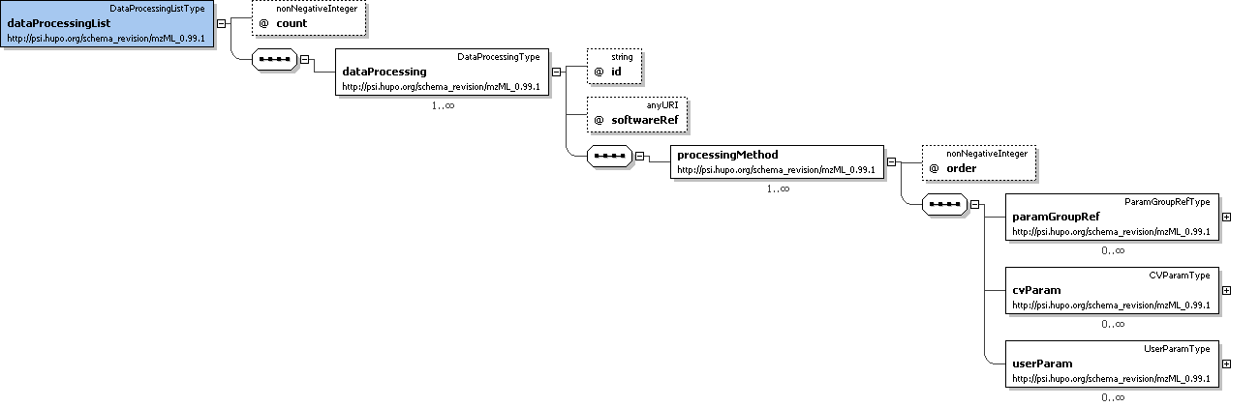
Example Context:
<dataProcessingList count="2">
<dataProcessing id="Xcalibur Processing" softwareRef="Xcalibur">
<processingMethod order="1">
<cvParam cvLabel="MS" accession="MS:1000033" name="deisotoping" value="false"/>
<cvParam cvLabel="MS" accession="MS:1000034" name="charge deconvolution" value="false"/>
...
</dataProcessingList>

Element <run>
Definition:
The definition and specification of a mass spectrometry run.
Attributes:
Attribute Name | Data Type | Use | Definition
id | xs:string | required | A unique identifier for this run.
instrumentRef | xs:string | required | This attribute MUST reference the 'id' of the appropriate InstrumentType.
sampleRef | xs:anyURI | optional | This attribute MUST reference the 'id' of the appropriate SampleType.
startTimeStamp | xs:dateTime | optional | The optional start timestamp of the run, in UT.
Subelements:
Subelement Name | minOccurs | maxOccurs | Definition
paramGroupRef | 0 | unbounded | A reference to a previously defined ParamGroup, which is a reusable container of one or more cvParams.
cvParam | 0 | unbounded | This element holds additional data or annotation. Only controlled values are allowed here.
userParam | 0 | unbounded | Uncontrolled user parameters (essentially allowing free text). Before using these, one should verify whether there is an appropriate CV term available, and if so, use the CV term instead
sourceFileRefList | 0 | 1 | Container for a list of source file references.
spectrumList | 1 | 1 | All mass spectra and the acquisitions underlying them are described and attached here. Subsidiary data arrays are also both described and attached here.
Graphical Context:
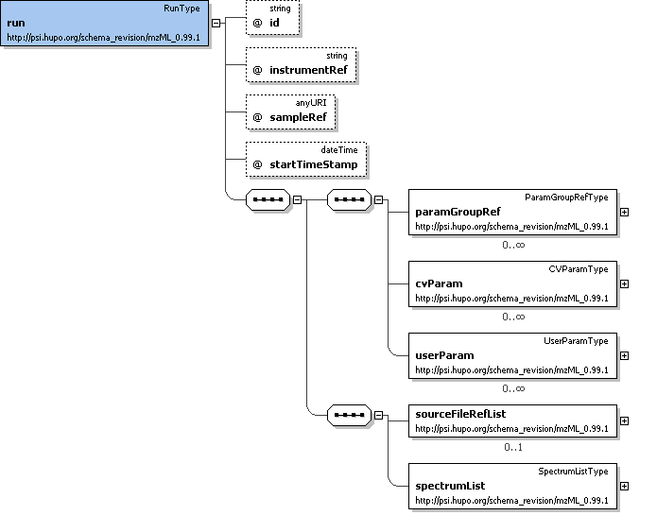
Example Context:
<run id="Exp01" instrumentRef="LCQ Deca" sampleRef="1" startTimeStamp="2007-06-27T15:23:45.00035">
<sourceFileRefList count="1">
<sourceFileRef ref="1"/>
</sourceFileRefList>
<spectrumList count="2">
...
</run>

Element <cv>
Definition:
Information about an ontology or CV source and a short 'lookup' tag to refer to.
Attributes:
Attribute Name | Data Type | Use | Definition
URI | xs:anyURI | required | The URI for the resource.
cvLabel | xs:string | required | The short label to be used as a reference tag with which to refer to this particular Controlled Vocabulary source description (e.g., from the cvLabel attribute, in CVParamType elements).
fullName | xs:string | required | The usual name for the resource (e.g. The PSI-MS Controlled Vocabulary).
version | xs:string | optional | The version of the CV from which the referred-to terms are drawn.
Subelements:
none
Example Context:
<cv cvLabel="MS" fullName="Proteomics Standards Initiative Mass Spectrometry Ontology" version="2.0.2" URI="http://psidev.sourceforge.net/ms/xml/mzdata/psi-ms.2.0.2.obo"/>

Element <fileContent>
Definition:
This summarizes the different types of spectra that can be expected in the file. This is expected to aid processing software in skipping files that do not contain appropriate spectrum types for it.
Attributes:
none
Subelements:
Subelement Name | minOccurs | maxOccurs | Definition
paramGroupRef | 0 | unbounded | A reference to a previously defined ParamGroup, which is a reusable container of one or more cvParams.
cvParam | 0 | unbounded | This element holds additional data or annotation. Only controlled values are allowed here.
userParam | 0 | unbounded | Uncontrolled user parameters (essentially allowing free text). Before using these, one should verify whether there is an appropriate CV term available, and if so, use the CV term instead
Example Context:
<fileContent>
<cvParam cvLabel="MS" accession="MS:1000580" name="MSn spectrum" value=""/>
</fileContent>
cvParam Mapping Rules:
MUST supply a *child* term of MS:1000524 (data file content) one or more times
e.g.: MS:1000579 (MS1 spectrum)
e.g.: MS:1000580 (MSn spectrum)
e.g.: MS:1000581 (CRM spectrum)
e.g.: MS:1000582 (SIM spectrum)
e.g.: MS:1000583 (SRM spectrum)
Example cvParams:
<cvParam cvLabel="MS" accession="MS:1000580" name="MSn spectrum" value=""/>

Element <sourceFileList>
Definition:
List and descriptions of the source files this mzML document was generated or derived from
Attributes:
Attribute Name | Data Type | Use | Definition
count | xs:nonNegativeInteger | required | Number of source files used in generating the instance document.
Subelements:
Subelement Name | minOccurs | maxOccurs | Definition
sourceFile | 0 | unbounded | Description of the source file, including location and type.
Example Context:
<sourceFileList count="1">
<sourceFile id="1" sourceFileName="tiny1.RAW" sourceFileLocation="file://F:/data/Exp01" >
<cvParam cvLabel="MS" accession="MS:1000563" name="Xcalibur RAW file" value=""/>
<cvParam cvLabel="MS" accession="MS:1000569" name="SHA-1" value="71be39fb2700ab2f3c8b2234b91274968b6899b1"/>
</sourceFile>
...
</sourceFileList>

Element <contact>
Definition:
Structure allowing the use of a controlled (cvParam) or uncontrolled vocabulary (userParam), or a reference to a predefined set of these in this mzML file (paramGroupRef).
Attributes:
none
Subelements:
Subelement Name | minOccurs | maxOccurs | Definition
paramGroupRef | 0 | unbounded | A reference to a previously defined ParamGroup, which is a reusable container of one or more cvParams.
cvParam | 0 | unbounded | This element holds additional data or annotation. Only controlled values are allowed here.
userParam | 0 | unbounded | Uncontrolled user parameters (essentially allowing free text). Before using these, one should verify whether there is an appropriate CV term available, and if so, use the CV term instead
Example Context:
<contact>
<cvParam cvLabel="MS" accession="MS:1000586" name="contact name" value="William Pennington"/>
<cvParam cvLabel="MS" accession="MS:1000587" name="contact address" value="Higglesworth University, 12 Higglesworth Avenue, 12045, HI, USA"/>
<cvParam cvLabel="MS" accession="MS:1000588" name="contact URL" value="http://www.higglesworth.edu/"/>
<cvParam cvLabel="MS" accession="MS:1000589" name="contact email" value="wpennington@higglesworth.edu"/>
...
</contact>
cvParam Mapping Rules:
MUST supply a *child* term of MS:1000585 (contact person attribute) one or more times
e.g.: MS:1000586 (contact name)
e.g.: MS:1000587 (contact address)
e.g.: MS:1000588 (contact URL)
e.g.: MS:1000589 (contact email)
e.g.: MS:1000590 (contact organization)
Example cvParams:
<cvParam cvLabel="MS" accession="MS:1000586" name="contact name" value="William Pennington"/>
<cvParam cvLabel="MS" accession="MS:1000587" name="contact address" value="Higglesworth University, 12 Higglesworth Avenue, 12045, HI, USA"/>
<cvParam cvLabel="MS" accession="MS:1000588" name="contact URL" value="http://www.higglesworth.edu/"/>
<cvParam cvLabel="MS" accession="MS:1000589" name="contact email" value="wpennington@higglesworth.edu"/>

Element <referenceableParamGroup>
Definition:
ParamGroup that can be referenced from elsewhere in this mzML document by using the 'paramGroupRef' element in that location to reference the 'id' attribute value of this element.
Attributes:
Attribute Name | Data Type | Use | Definition
id | xs:string | required | The identifier with which to reference this ReferenceableParamGroup.
Subelements:
Subelement Name | minOccurs | maxOccurs | Definition
paramGroupRef | 0 | unbounded | A reference to a previously defined ParamGroup, which is a reusable container of one or more cvParams.
cvParam | 0 | unbounded | This element holds additional data or annotation. Only controlled values are allowed here.
userParam | 0 | unbounded | Uncontrolled user parameters (essentially allowing free text). Before using these, one should verify whether there is an appropriate CV term available, and if so, use the CV term instead
Example Context:
<referenceableParamGroup id="CommonMS1SpectrumParams">
<cvParam cvLabel="MS" accession="MS:1000130" name="positive scan" value=""/>
<cvParam cvLabel="MS" accession="MS:1000498" name="full scan" value=""/>
</referenceableParamGroup>
Example cvParams:
<cvParam cvLabel="MS" accession="MS:1000130" name="positive scan" value=""/>
<cvParam cvLabel="MS" accession="MS:1000498" name="full scan" value=""/>

Element <sample>
Definition:
Expansible description of the sample used to generate the dataset, named in sampleName.
Attributes:
Attribute Name | Data Type | Use | Definition
id | xs:string | required | A unique identifier across the samples with which to reference this sample description.
name | xs:string | optional | An optional name for the sample description, mostly intended as a quick mnemonic.
Subelements:
Subelement Name | minOccurs | maxOccurs | Definition
paramGroupRef | 0 | unbounded | A reference to a previously defined ParamGroup, which is a reusable container of one or more cvParams.
cvParam | 0 | unbounded | This element holds additional data or annotation. Only controlled values are allowed here.
userParam | 0 | unbounded | Uncontrolled user parameters (essentially allowing free text). Before using these, one should verify whether there is an appropriate CV term available, and if so, use the CV term instead
Example Context:
<sample id="1" name="Sample1"/>
cvParam Mapping Rules:
MAY supply a *child* term of GO:0005575 (cellular_component) one or more times
MAY supply a *child* term of BTO:0000000 (brenda source tissue ontology) one or more times
MAY supply a *child* term of PATO:0001241 (quality of an object) one or more times
MAY supply a *child* term of MS:1000548 (sample attribute) one or more times
e.g.: MS:1000001 (sample number)
e.g.: MS:1000004 (sample mass)
e.g.: MS:1000005 (sample volume)
e.g.: MS:1000006 (sample concentration)
e.g.: MS:1000053 (sample batch)

Element <instrument>
Definition:
Description of the components of the mass spectrometer used
Attributes:
Attribute Name | Data Type | Use | Definition
id | xs:string | required | An identifier for this instrument that is unique across all instruments.
Subelements:
Subelement Name | minOccurs | maxOccurs | Definition
paramGroupRef | 0 | unbounded | A reference to a previously defined ParamGroup, which is a reusable container of one or more cvParams.
cvParam | 0 | unbounded | This element holds additional data or annotation. Only controlled values are allowed here.
userParam | 0 | unbounded | Uncontrolled user parameters (essentially allowing free text). Before using these, one should verify whether there is an appropriate CV term available, and if so, use the CV term instead
componentList | 1 | 1 | List with the different components used in the mass spectrometer. At least one source, one mass analyzer and one detector need to be specified.
instrumentSoftwareRef | 0 | 1 | Reference to a previously defined software element
Example Context:
<instrument id="LCQ Deca">
<cvParam cvLabel="MS" accession="MS:1000554" name="LCQ Deca" value=""/>
<cvParam cvLabel="MS" accession="MS:1000529" name="instrument serial number" value="23433"/>
<componentList count="3">
<source order="1">
...
</instrument>
cvParam Mapping Rules:
MUST supply a *child* term of MS:1000462 (ion optics) only once
e.g.: MS:1000216 (field-free region)
e.g.: MS:1000221 (magnetic deflection)
e.g.: MS:1000246 (delayed extraction)
e.g.: MS:1000275 (collision quadrupole)
e.g.: MS:1000281 (selected ion flow tube)
e.g.: MS:1000286 (time lag focusing)
e.g.: MS:1000300 (reflectron)
e.g.: MS:1000304 (accelerating voltage)
e.g.: MS:1000307 (einzel lens)
e.g.: MS:1000308 (electric field strength)
et al.
MUST supply a *child* term of MS:1000496 (instrument attribute) only once
e.g.: MS:1000032 (customization)
e.g.: MS:1000236 (transmission)
e.g.: MS:1000529 (instrument serial number)
MUST supply a *child* term of MS:1000031 (instrument model) only once
e.g.: MS:1000124 (Shimadzu instrument model)
e.g.: MS:1000139 (4000 Q TRAP)
e.g.: MS:1000140 (4700 Proteomic Analyzer)
e.g.: MS:1000141 (APEX IV)
e.g.: MS:1000142 (APEX-Q)
e.g.: MS:1000143 (API 150EX)
e.g.: MS:1000144 (API 150EX Prep)
e.g.: MS:1000145 (API 2000)
e.g.: MS:1000146 (API 3000)
e.g.: MS:1000147 (API 4000)
et al.
Example cvParams:
<cvParam cvLabel="MS" accession="MS:1000554" name="LCQ Deca" value=""/>
<cvParam cvLabel="MS" accession="MS:1000529" name="instrument serial number" value="23433"/>

Element <software>
Definition:
A piece of software.
Attributes:
Attribute Name | Data Type | Use | Definition
id | xs:string | required | An identifier for this software that is unique across all SoftwareTypes.
Subelements:
Subelement Name | minOccurs | maxOccurs | Definition
softwareParam | 1 | 1 | A description of the software, based on CV information and a software version.
Example Context:
<software id="Bioworks">
<softwareParam cvLabel="MS" accession="MS:1000533" name="Bioworks" version="3.3.1 sp1"/>
</software>

Element <dataProcessing>
Definition:
Description of the way in which a particular software was used.
Attributes:
Attribute Name | Data Type | Use | Definition
id | xs:string | required | A unique identifier for this data processing that is unique across all DataProcessingTypes.
softwareRef | xs:anyURI | required | This attribute MUST reference the 'id' of the appropriate SoftwareType.
Subelements:
Subelement Name | minOccurs | maxOccurs | Definition
processingMethod | 1 | unbounded | Description of the default peak processing method. This element describes the base method used in the generation of a particular mzML file. Variable methods should be described in the appropriate acquisition section - if no acquisition-specific details are found, then this information serves as the default.
Example Context:
<dataProcessing id="Xcalibur Processing" softwareRef="Xcalibur">
<processingMethod order="1">
<cvParam cvLabel="MS" accession="MS:1000033" name="deisotoping" value="false"/>
<cvParam cvLabel="MS" accession="MS:1000034" name="charge deconvolution" value="false"/>
<cvParam cvLabel="MS" accession="MS:1000035" name="peak picking" value="true"/>
...
</dataProcessing>

Element <paramGroupRef>
Definition:
A reference to a previously defined ParamGroup, which is a reusable container of one or more cvParams.
Attributes:
Attribute Name | Data Type | Use | Definition
ref | xs:anyURI | required | Reference to the id attribute in a previously defined ParamGroup.
Subelements:
none
Example Context:
<paramGroupRef ref="CommonMS1SpectrumParams"/>

Element <cvParam>
Definition:
This element holds additional data or annotation. Only controlled values are allowed here.
Attributes:
Attribute Name | Data Type | Use | Definition
accession | xs:string | required | The accession number of the referred-to term in the named resource (e.g.: MS:000012).
cvLabel | xs:string | required | The short tag for the resource as defined in the cvList in this mzML file.
name | xs:string | required | The actual name for the parameter, from the referred-to controlled vocabulary. This should be the preferred name associated with the specified accession number.
unitAccession | xs:string | optional | An optional CV accession number for the unit term associated with the value, if any (e.g., 'MS:1000137' for 'electron volt').
unitName | xs:string | optional | An optional CV name for the unit accession number, if any (e.g., 'electron volt' for 'MS:1000137' ).
value | xs:string | optional | The value for the parameter; may be absent if not appropriate, or a numeric or symbolic value, or may itself be CV (legal values for a parameter should be enumerated and defined in the ontology).
Subelements:
none
Example Context:
<cvParam cvLabel="MS" accession="MS:1000580" name="MSn spectrum" value=""/>

Element <userParam>
Definition:
Uncontrolled user parameters (essentially allowing free text). Before using these, one should verify whether there is an appropriate CV term available, and if so, use the CV term instead
Attributes:
Attribute Name | Data Type | Use | Definition
name | xs:string | required | The name for the parameter.
type | xs:string | required | The type of the parameter, where appropriate.
value | xs:string | required | The value for the parameter, where appropriate.
Subelements:
none
Example Context:

Element <sourceFileRefList>
Definition:
Container for a list of source file references.
Attributes:
Attribute Name | Data Type | Use | Definition
count | xs:nonNegativeInteger | required | This number of source files referenced in this list.
Subelements:
Subelement Name | minOccurs | maxOccurs | Definition
sourceFileRef | 0 | unbounded | Reference to a previously defined sourceFile.
Graphical Context:
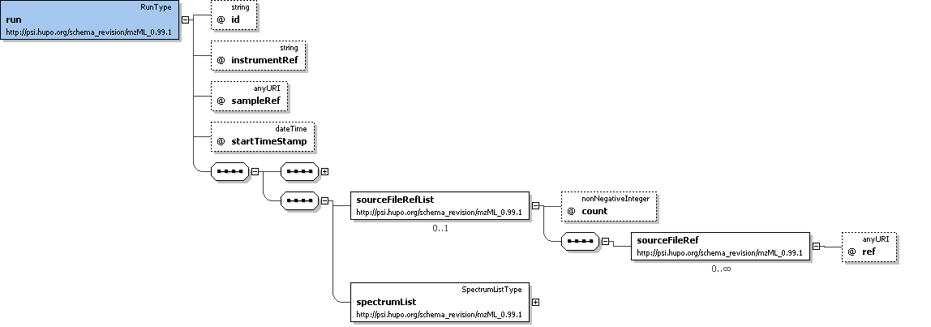
Example Context:
<sourceFileRefList count="1">
<sourceFileRef ref="1"/>
</sourceFileRefList>

Element <spectrumList>
Definition:
All mass spectra and the acquisitions underlying them are described and attached here. Subsidiary data arrays are also both described and attached here.
Attributes:
Attribute Name | Data Type | Use | Definition
count | xs:nonNegativeInteger | required | The number of spectra defined in this mzML file.
Subelements:
Subelement Name | minOccurs | maxOccurs | Definition
spectrum | 0 | unbounded | The structure that captures the generation of a peak list (including the underlying acquisitions)
Graphical Context:
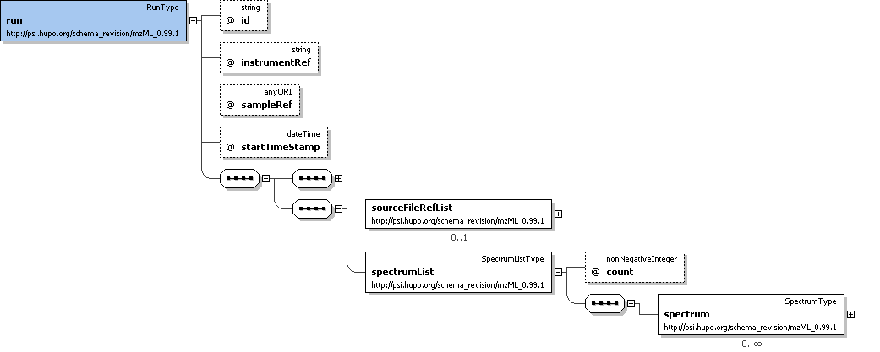
Example Context:
<spectrumList count="2">
<spectrum id="S19" scanNumber="19" msLevel="1">
<cvParam cvLabel="MS" accession="MS:1000580" name="MSn spectrum" value=""/>
<spectrumDescription>
<cvParam cvLabel="MS" accession="MS:1000127" name="centroid mass spectrum" value=""/>
...
</spectrumList>

Element <sourceFile>
Definition:
Description of the source file, including location and type.
Attributes:
Attribute Name | Data Type | Use | Definition
id | xs:string | required | An identifier for this file.
sourceFileLocation | xs:anyURI | required | URI-formatted full path to file, without actual file name appended.
sourceFileName | xs:string | required | Name of the source file, without reference to location (either URI or local path).
Subelements:
Subelement Name | minOccurs | maxOccurs | Definition
paramGroupRef | 0 | unbounded | A reference to a previously defined ParamGroup, which is a reusable container of one or more cvParams.
cvParam | 0 | unbounded | This element holds additional data or annotation. Only controlled values are allowed here.
userParam | 0 | unbounded | Uncontrolled user parameters (essentially allowing free text). Before using these, one should verify whether there is an appropriate CV term available, and if so, use the CV term instead
Example Context:
<sourceFile id="1" sourceFileName="tiny1.RAW" sourceFileLocation="file://F:/data/Exp01" >
<cvParam cvLabel="MS" accession="MS:1000563" name="Xcalibur RAW file" value=""/>
<cvParam cvLabel="MS" accession="MS:1000569" name="SHA-1" value="71be39fb2700ab2f3c8b2234b91274968b6899b1"/>
</sourceFile>
cvParam Mapping Rules:
MUST supply a *child* term of MS:1000561 (data file checksum type) one or more times
e.g.: MS:1000568 (MD5)
e.g.: MS:1000569 (SHA-1)
MUST supply a *child* term of MS:1000560 (source file type) one or more times
e.g.: MS:1000526 (MassLynx raw format)
e.g.: MS:1000562 (wiff file)
e.g.: MS:1000563 (Xcalibur RAW file)
e.g.: MS:1000564 (mzData file)
e.g.: MS:1000565 (pkl file)
e.g.: MS:1000566 (mzXML file)
e.g.: MS:1000567 (yep file)
e.g.: MS:1000584 (mzML file)
Example cvParams:
<cvParam cvLabel="MS" accession="MS:1000563" name="Xcalibur RAW file" value=""/>
<cvParam cvLabel="MS" accession="MS:1000569" name="SHA-1" value="71be39fb2700ab2f3c8b2234b91274968b6899b1"/>

Element <componentList>
Definition:
List with the different components used in the mass spectrometer. At least one source, one mass analyzer and one detector need to be specified.
Attributes:
Attribute Name | Data Type | Use | Definition
count | xs:nonNegativeInteger | required | The number of components in this list.
Subelements:
Subelement Name | minOccurs | maxOccurs | Definition
source | 1 | 1 | A source component.
analyzer | 1 | 1 | A mass analyzer (or mass filter) component.
detector | 1 | 1 | A detector component.
Example Context:
<componentList count="3">
<source order="1">
<cvParam cvLabel="MS" accession="MS:1000398" name="nanoelectrospray" value=""/>
</source>
<analyzer order="2">
...
</componentList>

Element <instrumentSoftwareRef>
Definition:
Reference to a previously defined software element
Attributes:
Attribute Name | Data Type | Use | Definition
ref | xs:anyURI | required | This attribute MUST be used to reference the 'id' attribute of a software element.
Subelements:
none
Example Context:
<instrumentSoftwareRef ref="Xcalibur"/>

Element <softwareParam>
Definition:
A description of the software, based on CV information and a software version.
Attributes:
Attribute Name | Data Type | Use | Definition
accession | xs:string | required | The accession number for this CV term.
cvLabel | xs:string | required | The CV label for this CV term.
name | xs:string | required | The preferred name in the CV for the accession number of this CV term.
version | xs:string | required | The software version.
Subelements:
none
Example Context:
<softwareParam cvLabel="MS" accession="MS:1000533" name="Bioworks" version="3.3.1 sp1"/>

Element <processingMethod>
Definition:
Description of the default peak processing method. This element describes the base method used in the generation of a particular mzML file. Variable methods should be described in the appropriate acquisition section - if no acquisition-specific details are found, then this information serves as the default.
Attributes:
Attribute Name | Data Type | Use | Definition
order | xs:nonNegativeInteger | required | This attributes allows a series of consecutive steps to be placed in the correct order.
Subelements:
Subelement Name | minOccurs | maxOccurs | Definition
paramGroupRef | 0 | unbounded | A reference to a previously defined ParamGroup, which is a reusable container of one or more cvParams.
cvParam | 0 | unbounded | This element holds additional data or annotation. Only controlled values are allowed here.
userParam | 0 | unbounded | Uncontrolled user parameters (essentially allowing free text). Before using these, one should verify whether there is an appropriate CV term available, and if so, use the CV term instead
Example Context:
<processingMethod order="1">
<cvParam cvLabel="MS" accession="MS:1000033" name="deisotoping" value="false"/>
<cvParam cvLabel="MS" accession="MS:1000034" name="charge deconvolution" value="false"/>
<cvParam cvLabel="MS" accession="MS:1000035" name="peak picking" value="true"/>
</processingMethod>
...
</processingMethod>
cvParam Mapping Rules:
MUST supply a *child* term of MS:1000543 (data processing action) one or more times
e.g.: MS:1000033 (deisotoping)
e.g.: MS:1000034 (charge deconvolution)
e.g.: MS:1000035 (peak picking)
e.g.: MS:1000592 (smoothing)
e.g.: MS:1000593 (baseline reduction)
e.g.: MS:1000594 (low intensity data point removal)
MUST supply a *child* term of MS:1000530 (file format conversion) one or more times
e.g.: MS:1000544 (Conversion to mzML)
e.g.: MS:1000545 (Conversion to mzXML)
e.g.: MS:1000546 (Conversion to mzData)
Example cvParams:
<cvParam cvLabel="MS" accession="MS:1000033" name="deisotoping" value="false"/>
<cvParam cvLabel="MS" accession="MS:1000034" name="charge deconvolution" value="false"/>
<cvParam cvLabel="MS" accession="MS:1000035" name="peak picking" value="true"/>
<cvParam cvLabel="MS" accession="MS:1000544" name="Conversion to mzML" value=""/>

Element <sourceFileRef>
Definition:
Reference to a previously defined sourceFile.
Attributes:
Attribute Name | Data Type | Use | Definition
ref | xs:anyURI | required | This attribute MUST reference the 'id' of the appropriate sourceFile.
Subelements:
none
Example Context:
<sourceFileRef ref="1"/>

Element <spectrum>
Definition:
The structure that captures the generation of a peak list (including the underlying acquisitions)
Attributes:
Attribute Name | Data Type | Use | Definition
dataProcessingRef | xs:anyURI | optional | This attribute can optionally reference the 'id' of the appropriate DataProcessingType.
id | xs:string | required | A unique identifier for this spectrum. It should be expected that external files may use this identifier together with the mzML filename or accession to reference a particular spectrum.
msLevel | xs:int | required | This attribute MUST give the MS level as an integer (e.g., '1' for MS, '2' for MS/MS, etc.).
scanNumber | xs:int | required | The scan number for this spectrum.
sourceFileRef | xs:anyURI | optional | This attribute can optionally reference the 'id' of the appropriate SourceFileType.
Subelements:
Subelement Name | minOccurs | maxOccurs | Definition
paramGroupRef | 0 | unbounded | A reference to a previously defined ParamGroup, which is a reusable container of one or more cvParams.
cvParam | 0 | unbounded | This element holds additional data or annotation. Only controlled values are allowed here.
userParam | 0 | unbounded | Uncontrolled user parameters (essentially allowing free text). Before using these, one should verify whether there is an appropriate CV term available, and if so, use the CV term instead
spectrumDescription | 1 | 1 | Description of the parameters for the mass spectrometer for a given acquisition (or list of acquisitions).
binaryDataArray | 0 | unbounded | The structure into which encoded binary data goes. Byte ordering is always little endian (Intel style). Computers using a different endian style MUST convert to/from little endian when writing/reading mzML
Graphical Context:
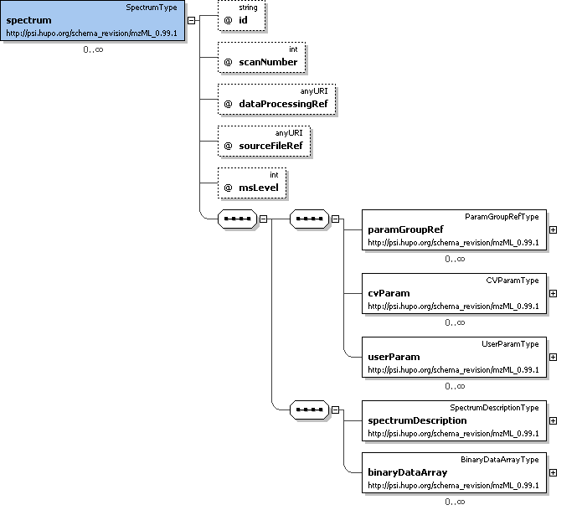
Example Context:
<spectrum id="S19" scanNumber="19" msLevel="1">
<cvParam cvLabel="MS" accession="MS:1000580" name="MSn spectrum" value=""/>
<spectrumDescription>
<cvParam cvLabel="MS" accession="MS:1000127" name="centroid mass spectrum" value=""/>
<cvParam cvLabel="MS" accession="MS:1000528" name="lowest m/z value" value="400.39"/>
...
</spectrum>
cvParam Mapping Rules:
MUST supply a *child* term of MS:1000559 (spectrum type) only once
e.g.: MS:1000579 (MS1 spectrum)
e.g.: MS:1000580 (MSn spectrum)
e.g.: MS:1000581 (CRM spectrum)
e.g.: MS:1000582 (SIM spectrum)
e.g.: MS:1000583 (SRM spectrum)
Example cvParams:
<cvParam cvLabel="MS" accession="MS:1000580" name="MSn spectrum" value=""/>
Notes and Constraints:
id's MUST be unique within a file. They may be LSIDs or simply the scan number. scanNumbers MUST be unique within a file and MUST be monotonically increasing throughout the file, although not necessarily sequentially.

Element <source>
Definition:
A source component.
Attributes:
Attribute Name | Data Type | Use | Definition
order | xs:int | required | This attribute MUST be used to indicate the order in which the components are encountered from source to detector (e.g., in a Q-TOF, the quadrupole would have the lower order number, and the TOF the higher number of the two).
Subelements:
Subelement Name | minOccurs | maxOccurs | Definition
paramGroupRef | 0 | unbounded | A reference to a previously defined ParamGroup, which is a reusable container of one or more cvParams.
cvParam | 0 | unbounded | This element holds additional data or annotation. Only controlled values are allowed here.
userParam | 0 | unbounded | Uncontrolled user parameters (essentially allowing free text). Before using these, one should verify whether there is an appropriate CV term available, and if so, use the CV term instead
Example Context:
<source order="1">
<cvParam cvLabel="MS" accession="MS:1000398" name="nanoelectrospray" value=""/>
</source>
cvParam Mapping Rules:
MUST supply a *child* term of MS:1000482 (source attribute) one or more times
e.g.: MS:1000392 (ionization efficiency)
e.g.: MS:1000486 (source potential)
e.g.: MS:1000552 (maldi spot identifier)
MUST supply a *child* term of MS:1000008 (ionization type) one or more times
e.g.: MS:1000070 (atmospheric pressure chemical ionization)
e.g.: MS:1000071 (chemical ionization)
e.g.: MS:1000074 (fast atom bombardment ionization)
e.g.: MS:1000075 (matrix-assisted laser desorption ionization)
e.g.: MS:1000227 (multiphoton ionization)
e.g.: MS:1000239 (atmospheric pressure matrix-assisted laser desorption ionization)
e.g.: MS:1000255 (flowing afterglow)
e.g.: MS:1000257 (field desorption)
e.g.: MS:1000258 (field ionization)
e.g.: MS:1000259 (glow discharge ionization)
et al.
MUST supply a *child* term of MS:1000007 (inlet type) one or more times
e.g.: MS:1000055 (continuous flow fast atom bombardment)
e.g.: MS:1000056 (direct inlet)
e.g.: MS:1000058 (flow injection analysis)
e.g.: MS:1000059 (inductively coupled plasma)
e.g.: MS:1000060 (infusion)
e.g.: MS:1000061 (jet separator)
e.g.: MS:1000062 (membrane separator)
e.g.: MS:1000063 (moving belt)
e.g.: MS:1000064 (moving wire)
e.g.: MS:1000065 (open split)
et al.
Example cvParams:
<cvParam cvLabel="MS" accession="MS:1000398" name="nanoelectrospray" value=""/>

Element <analyzer>
Definition:
A mass analyzer (or mass filter) component.
Attributes:
Attribute Name | Data Type | Use | Definition
order | xs:int | required | This attribute MUST be used to indicate the order in which the components are encountered from source to detector (e.g., in a Q-TOF, the quadrupole would have the lower order number, and the TOF the higher number of the two).
Subelements:
Subelement Name | minOccurs | maxOccurs | Definition
paramGroupRef | 0 | unbounded | A reference to a previously defined ParamGroup, which is a reusable container of one or more cvParams.
cvParam | 0 | unbounded | This element holds additional data or annotation. Only controlled values are allowed here.
userParam | 0 | unbounded | Uncontrolled user parameters (essentially allowing free text). Before using these, one should verify whether there is an appropriate CV term available, and if so, use the CV term instead
Example Context:
<analyzer order="2">
<cvParam cvLabel="MS" accession="MS:1000082" name="quadrupole ion trap" value=""/>
</analyzer>
cvParam Mapping Rules:
MUST supply a *child* term of MS:1000012 (resolution measurement method) one or more times
e.g.: MS:1000085 (baseline)
e.g.: MS:1000086 (full width at half-maximum)
e.g.: MS:1000087 (ten percent valley)
MUST supply a *child* term of MS:1000480 (mass analyzer attribute) one or more times
e.g.: MS:1000014 (accuracy)
e.g.: MS:1000022 (TOF Total Path Length)
e.g.: MS:1000024 (final MS exponent)
e.g.: MS:1000025 (magnetic field strength)
e.g.: MS:1000105 (reflectron off)
e.g.: MS:1000106 (reflectron on)
MUST supply a *child* term of MS:1000443 (mass analyzer type) one or more times
e.g.: MS:1000078 (axial ejection linear ion trap)
e.g.: MS:1000079 (fourier transform ion cyclotron resonance mass spectrometer)
e.g.: MS:1000080 (magnetic sector)
e.g.: MS:1000081 (quadrupole)
e.g.: MS:1000082 (quadrupole ion trap)
e.g.: MS:1000083 (radial ejection linear ion trap)
e.g.: MS:1000084 (time-of-flight)
e.g.: MS:1000254 (electrostatic energy analyzer)
e.g.: MS:1000284 (stored waveform inverse fourier transform)
e.g.: MS:1000288 (cyclotron)
et al.
Example cvParams:
<cvParam cvLabel="MS" accession="MS:1000082" name="quadrupole ion trap" value=""/>

Element <detector>
Definition:
A detector component.
Attributes:
Attribute Name | Data Type | Use | Definition
order | xs:int | required | This attribute MUST be used to indicate the order in which the components are encountered from source to detector (e.g., in a Q-TOF, the quadrupole would have the lower order number, and the TOF the higher number of the two).
Subelements:
Subelement Name | minOccurs | maxOccurs | Definition
paramGroupRef | 0 | unbounded | A reference to a previously defined ParamGroup, which is a reusable container of one or more cvParams.
cvParam | 0 | unbounded | This element holds additional data or annotation. Only controlled values are allowed here.
userParam | 0 | unbounded | Uncontrolled user parameters (essentially allowing free text). Before using these, one should verify whether there is an appropriate CV term available, and if so, use the CV term instead
Example Context:
<detector order="3">
<cvParam cvLabel="MS" accession="MS:1000253" name="electron multiplier" value=""/>
</detector>
cvParam Mapping Rules:
MUST supply a *child* term of MS:1000026 (detector type) only once
e.g.: MS:1000107 (channeltron)
e.g.: MS:1000108 (conversion dynode electron multiplier)
e.g.: MS:1000109 (conversion dynode photomultiplier)
e.g.: MS:1000110 (daly detector)
e.g.: MS:1000111 (electron multiplier tube)
e.g.: MS:1000112 (faraday cup)
e.g.: MS:1000113 (focal plane array)
e.g.: MS:1000114 (microchannel plate detector)
e.g.: MS:1000115 (multi-collector)
e.g.: MS:1000116 (photomultiplier)
et al.
MUST supply a *child* term of MS:1000481 (detector attribute) only once
e.g.: MS:1000028 (detector resolution)
e.g.: MS:1000029 (sampling frequency)
MUST supply a *child* term of MS:1000027 (detector acquisition mode) only once
e.g.: MS:1000117 (analog-digital converter)
e.g.: MS:1000118 (pulse counting)
e.g.: MS:1000119 (time-digital converter)
e.g.: MS:1000120 (transient recorder)
Example cvParams:
<cvParam cvLabel="MS" accession="MS:1000253" name="electron multiplier" value=""/>

Element <spectrumDescription>
Definition:
Description of the parameters for the mass spectrometer for a given acquisition (or list of acquisitions).
Attributes:
none
Subelements:
Subelement Name | minOccurs | maxOccurs | Definition
paramGroupRef | 0 | unbounded | A reference to a previously defined ParamGroup, which is a reusable container of one or more cvParams.
cvParam | 0 | unbounded | This element holds additional data or annotation. Only controlled values are allowed here.
userParam | 0 | unbounded | Uncontrolled user parameters (essentially allowing free text). Before using these, one should verify whether there is an appropriate CV term available, and if so, use the CV term instead
acquisitionList | 0 | 1 | List and descriptions of acquisitions .
precursorList | 0 | 1 | List and descriptions of precursors to the spectrum currently being described.
scan | 0 | 1 | -
Graphical Context:
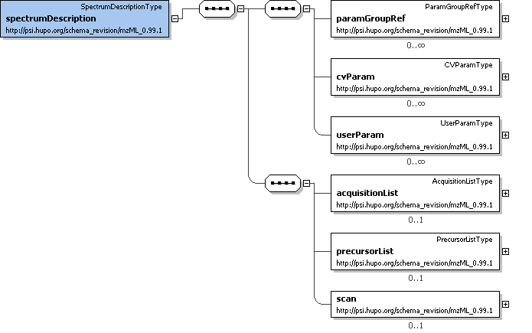
Example Context:
<spectrumDescription>
<cvParam cvLabel="MS" accession="MS:1000127" name="centroid mass spectrum" value=""/>
<cvParam cvLabel="MS" accession="MS:1000528" name="lowest m/z value" value="400.39"/>
<cvParam cvLabel="MS" accession="MS:1000527" name="highest m/z value" value="1795.56"/>
<cvParam cvLabel="MS" accession="MS:1000504" name="base peak m/z" value="445.347"/>
...
</spectrumDescription>
cvParam Mapping Rules:
MUST supply a *child* term of MS:1000525 (spectrum representation) only once
e.g.: MS:1000127 (centroid mass spectrum)
e.g.: MS:1000128 (profile mass spectrum)
MUST supply a *child* term of MS:1000499 (spectrum attribute) one or more times
e.g.: MS:1000285 (total ion current)
e.g.: MS:1000504 (base peak m/z)
e.g.: MS:1000505 (base peak intensity)
e.g.: MS:1000527 (highest m/z value)
e.g.: MS:1000528 (lowest m/z value)
Example cvParams:
<cvParam cvLabel="MS" accession="MS:1000127" name="centroid mass spectrum" value=""/>
<cvParam cvLabel="MS" accession="MS:1000528" name="lowest m/z value" value="400.39"/>
<cvParam cvLabel="MS" accession="MS:1000527" name="highest m/z value" value="1795.56"/>
<cvParam cvLabel="MS" accession="MS:1000504" name="base peak m/z" value="445.347"/>
<cvParam cvLabel="MS" accession="MS:1000505" name="base peak intensity" value="120053"/>
<cvParam cvLabel="MS" accession="MS:1000285" name="total ion current" value="1.66755e+007"/>

Element <binaryDataArray>
Definition:
The structure into which encoded binary data goes. Byte ordering is always little endian (Intel style). Computers using a different endian style MUST convert to/from little endian when writing/reading mzML
Attributes:
Attribute Name | Data Type | Use | Definition
arrayLength | xs:nonNegativeInteger | required | The original length of the data array.
dataProcessingRef | xs:string | optional | This optional attribute may reference the 'id' attribute of the appropriate DataProcessingType.
encodedLength | xs:nonNegativeInteger | required | The encoded length of the binary data array.
Subelements:
Subelement Name | minOccurs | maxOccurs | Definition
paramGroupRef | 0 | unbounded | A reference to a previously defined ParamGroup, which is a reusable container of one or more cvParams.
cvParam | 0 | unbounded | This element holds additional data or annotation. Only controlled values are allowed here.
userParam | 0 | unbounded | Uncontrolled user parameters (essentially allowing free text). Before using these, one should verify whether there is an appropriate CV term available, and if so, use the CV term instead
binary | 1 | 1 | The actual encoded binary data.
Graphical Context:
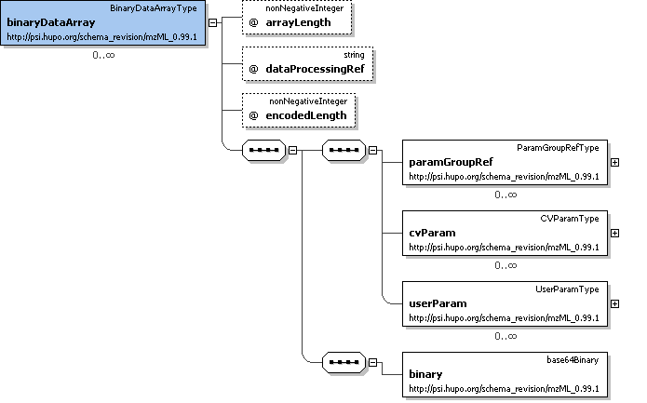
Example Context:
<binaryDataArray arrayLength="1313" encodedLength="5000" dataProcessingRef="Xcalibur Processing">
<cvParam cvLabel="MS" accession="MS:1000521" name="32-bit float" value=""/>
<cvParam cvLabel="MS" accession="MS:1000576" name="no compression" value=""/>
<cvParam cvLabel="MS" accession="MS:1000514" name="m/z array" value=""/>
<binary>AAAAwDsGeUAAAADAkBB5QAAAAACTIHlAAAAAgHgzeUAAAABAkj...</binary>
...
</binaryDataArray>
cvParam Mapping Rules:
MUST supply a *child* term of MS:1000572 (binary data compression type) only once
e.g.: MS:1000574 (zlib compression)
e.g.: MS:1000576 (no compression)
MUST supply a *child* term of MS:1000513 (binary data array) only once
e.g.: MS:1000514 (m/z array)
e.g.: MS:1000515 (intensity array)
e.g.: MS:1000516 (charge array)
e.g.: MS:1000517 (signal to noise array)
e.g.: MS:1000595 (time array)
MUST supply a *child* term of MS:1000518 (binary data type) only once
e.g.: MS:1000519 (32-bit integer)
e.g.: MS:1000520 (16-bit float)
e.g.: MS:1000521 (32-bit float)
e.g.: MS:1000522 (64-bit integer)
e.g.: MS:1000523 (64-bit float)
Example cvParams:
<cvParam cvLabel="MS" accession="MS:1000521" name="32-bit float" value=""/>
<cvParam cvLabel="MS" accession="MS:1000576" name="no compression" value=""/>
<cvParam cvLabel="MS" accession="MS:1000514" name="m/z array" value=""/>
<cvParam cvLabel="MS" accession="MS:1000515" name="intensity array" value=""/>
<cvParam cvLabel="MS" accession="MS:1000523" name="64-bit float" value=""/>

Element <acquisitionList>
Definition:
List and descriptions of acquisitions .
Attributes:
Attribute Name | Data Type | Use | Definition
count | xs:nonNegativeInteger | required | the number of acquisitions defined in this mzML file.
Subelements:
Subelement Name | minOccurs | maxOccurs | Definition
paramGroupRef | 0 | unbounded | A reference to a previously defined ParamGroup, which is a reusable container of one or more cvParams.
cvParam | 0 | unbounded | This element holds additional data or annotation. Only controlled values are allowed here.
userParam | 0 | unbounded | Uncontrolled user parameters (essentially allowing free text). Before using these, one should verify whether there is an appropriate CV term available, and if so, use the CV term instead
acquisition | 1 | unbounded | Scan or acquisition from original raw file used to create this peak list, as specified in sourceFile.
Graphical Context:
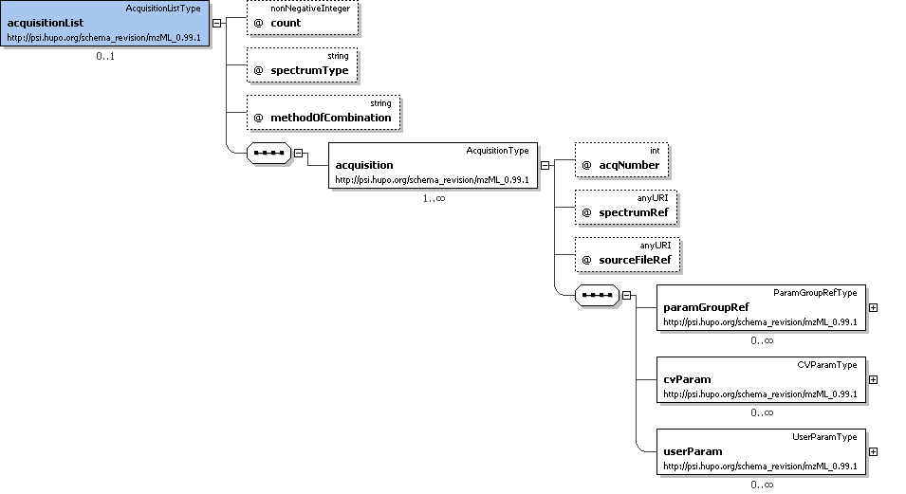
Example Context:

Element <precursorList>
Definition:
List and descriptions of precursors to the spectrum currently being described.
Attributes:
Attribute Name | Data Type | Use | Definition
count | xs:nonNegativeInteger | required | The number of precursors in this list.
Subelements:
Subelement Name | minOccurs | maxOccurs | Definition
precursor | 1 | unbounded | The method of precursor ion selection and activation
Graphical Context:
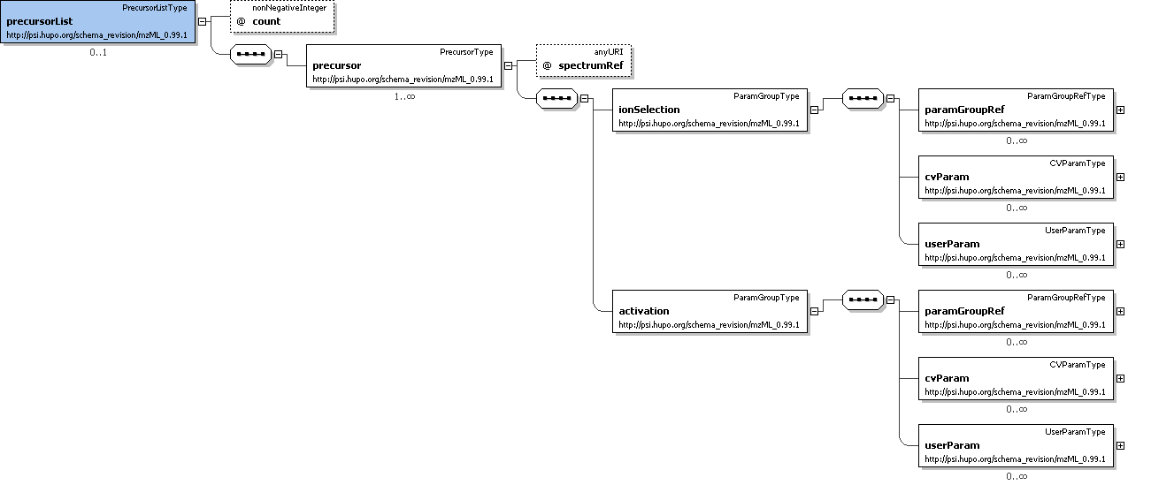
Example Context:
<precursorList count="1">
<precursor spectrumRef="19">
<ionSelection>
<cvParam cvLabel="MS" accession="MS:1000040" name="m/z" value="445.34"/>
<cvParam cvLabel="MS" accession="MS:1000041" name="charge state" value="2"/>
...
</precursorList>

Element <scan>
Definition:
The instrument's 'run time' parameters; common to the whole of this spectrum.
Attributes:
Attribute Name | Data Type | Use | Definition
instrumentRef | xs:string | required | This attribute MUST reference the 'id' attribute of the appropriate InstrumentType.
Subelements:
Subelement Name | minOccurs | maxOccurs | Definition
paramGroupRef | 0 | unbounded | A reference to a previously defined ParamGroup, which is a reusable container of one or more cvParams.
cvParam | 0 | unbounded | This element holds additional data or annotation. Only controlled values are allowed here.
userParam | 0 | unbounded | Uncontrolled user parameters (essentially allowing free text). Before using these, one should verify whether there is an appropriate CV term available, and if so, use the CV term instead
selectionWindowList | 1 | 1 | Container for a list of select windows.
Graphical Context:
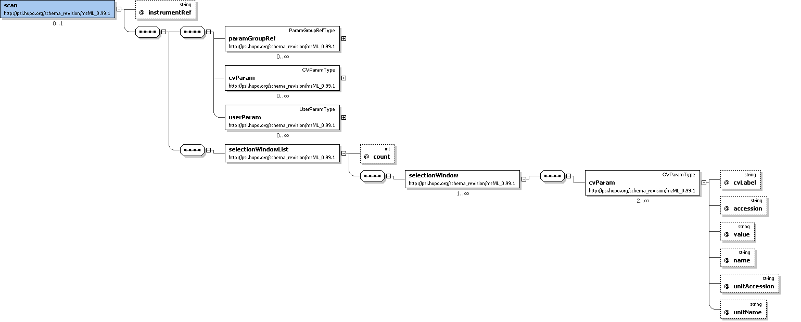
Example Context:
<scan instrumentRef="LCQ Deca">
<paramGroupRef ref="CommonMS1SpectrumParams"/>
<cvParam cvLabel="MS" accession="MS:1000016" name="scan time" value="5.890500" unitAccession="MS:1000038" unitName="minute"/>
<cvParam cvLabel="MS" accession="MS:1000512" name="filter string" value="+ c NSI Full ms [ 400.00-1800.00]"/>
<selectionWindowList count="1">
...
</scan>
cvParam Mapping Rules:
MUST supply a *child* term of MS:1000465 (scan polarity) only once
e.g.: MS:1000129 (negative scan)
e.g.: MS:1000130 (positive scan)
MUST supply a *child* term of MS:1000503 (scan attribute) one or more times
e.g.: MS:1000011 (mass resolution)
e.g.: MS:1000015 (scan rate)
e.g.: MS:1000016 (scan time)
e.g.: MS:1000023 (isolation width)
e.g.: MS:1000511 (ms level)
e.g.: MS:1000512 (filter string)
MUST supply a *child* term of MS:1000018 (scan direction) only once
e.g.: MS:1000092 (decreasing m/z scan)
e.g.: MS:1000093 (increasing m/z scan)
MUST supply a *child* term of MS:1000019 (scan law) only once
e.g.: MS:1000094 (exponential)
e.g.: MS:1000095 (linear)
e.g.: MS:1000096 (quadratic)
MUST supply a *child* term of MS:1000020 (scanning method) only once
e.g.: MS:1000100 (precursor ion scan)
e.g.: MS:1000101 (product ion scan)
e.g.: MS:1000205 (selected ion monitoring)
e.g.: MS:1000206 (selected reaction monitoring)
e.g.: MS:1000244 (consecutive reaction monitoring)
e.g.: MS:1000323 (constant neutral loss scan)
e.g.: MS:1000324 (constant neutral gain scan)
e.g.: MS:1000497 (zoom scan)
e.g.: MS:1000498 (full scan)
Example cvParams:
<cvParam cvLabel="MS" accession="MS:1000016" name="scan time" value="5.890500" unitAccession="MS:1000038" unitName="minute"/>
<cvParam cvLabel="MS" accession="MS:1000512" name="filter string" value="+ c NSI Full ms [ 400.00-1800.00]"/>

Element <binary>
Definition:
The actual encoded binary data.
Attributes:
none
Subelements:
none
Example Context:

Element <acquisition>
Definition:
Scan or acquisition from original raw file used to create this peak list, as specified in sourceFile.
Attributes:
Attribute Name | Data Type | Use | Definition
acqNumber | xs:int | required | A number for this acquisition.
sourceFileRef | xs:anyURI | required | This attribute MUST reference the 'id' attribute of the appropriate SourceFileType.
spectrumRef | xs:anyURI | required | This attribute MUST reference the 'id' attribute of the appropriate SpectrumType.
Subelements:
Subelement Name | minOccurs | maxOccurs | Definition
paramGroupRef | 0 | unbounded | A reference to a previously defined ParamGroup, which is a reusable container of one or more cvParams.
cvParam | 0 | unbounded | This element holds additional data or annotation. Only controlled values are allowed here.
userParam | 0 | unbounded | Uncontrolled user parameters (essentially allowing free text). Before using these, one should verify whether there is an appropriate CV term available, and if so, use the CV term instead
Example Context:
cvParam Mapping Rules:
MUST supply a *child* term of MS:1000570 (spectra combination) one or more times
e.g.: MS:1000571 (sum of spectra)
e.g.: MS:1000573 (median of spectra)
e.g.: MS:1000575 (mean of spectra)

Element <precursor>
Definition:
The method of precursor ion selection and activation
Attributes:
Attribute Name | Data Type | Use | Definition
spectrumRef | xs:anyURI | optional | Reference to the id attribute of the spectrum from which the precursor was selected.
Subelements:
Subelement Name | minOccurs | maxOccurs | Definition
ionSelection | 1 | 1 | This captures the type of ion selection being performed, and trigger m/z (or m/z's), neutral loss criteria etc. for tandem-MS or data dependent scans.
activation | 1 | 1 | The type and energy level used for activation.
Example Context:
<precursor spectrumRef="19">
<ionSelection>
<cvParam cvLabel="MS" accession="MS:1000040" name="m/z" value="445.34"/>
<cvParam cvLabel="MS" accession="MS:1000041" name="charge state" value="2"/>
</ionSelection>
...
</precursor>

Element <selectionWindowList>
Definition:
Container for a list of select windows.
Attributes:
Attribute Name | Data Type | Use | Definition
count | xs:int | required | The number of selection windows defined in this list.
Subelements:
Subelement Name | minOccurs | maxOccurs | Definition
selectionWindow | 1 | unbounded | Definition of a selection window.
Example Context:
<selectionWindowList count="1">
<selectionWindow>
<cvParam cvLabel="MS" accession="MS:1000501" name="scan m/z lower limit" value="400.000000"/>
<cvParam cvLabel="MS" accession="MS:1000500" name="scan m/z upper limit" value="1800.000000"/>
</selectionWindow>
...
</selectionWindowList>

Element <ionSelection>
Definition:
This captures the type of ion selection being performed, and trigger m/z (or m/z's), neutral loss criteria etc. for tandem-MS or data dependent scans.
Attributes:
none
Subelements:
Subelement Name | minOccurs | maxOccurs | Definition
paramGroupRef | 0 | unbounded | A reference to a previously defined ParamGroup, which is a reusable container of one or more cvParams.
cvParam | 0 | unbounded | This element holds additional data or annotation. Only controlled values are allowed here.
userParam | 0 | unbounded | Uncontrolled user parameters (essentially allowing free text). Before using these, one should verify whether there is an appropriate CV term available, and if so, use the CV term instead
Example Context:
<ionSelection>
<cvParam cvLabel="MS" accession="MS:1000040" name="m/z" value="445.34"/>
<cvParam cvLabel="MS" accession="MS:1000041" name="charge state" value="2"/>
</ionSelection>
cvParam Mapping Rules:
MUST supply a *child* term of MS:1000455 (ion selection attribute) one or more times
e.g.: MS:1000040 (m/z)
e.g.: MS:1000041 (charge state)
e.g.: MS:1000042 (intensity)
Example cvParams:
<cvParam cvLabel="MS" accession="MS:1000040" name="m/z" value="445.34"/>
<cvParam cvLabel="MS" accession="MS:1000041" name="charge state" value="2"/>

Element <activation>
Definition:
The type and energy level used for activation.
Attributes:
none
Subelements:
Subelement Name | minOccurs | maxOccurs | Definition
paramGroupRef | 0 | unbounded | A reference to a previously defined ParamGroup, which is a reusable container of one or more cvParams.
cvParam | 0 | unbounded | This element holds additional data or annotation. Only controlled values are allowed here.
userParam | 0 | unbounded | Uncontrolled user parameters (essentially allowing free text). Before using these, one should verify whether there is an appropriate CV term available, and if so, use the CV term instead
Example Context:
<activation>
<cvParam cvLabel="MS" accession="MS:1000133" name="collision-induced dissociation" value=""/>
<cvParam cvLabel="MS" accession="MS:1000045" name="collision energy" value="35.00" unitAccession="MS:1000137" unitName="Electron Volt"/>
</activation>
cvParam Mapping Rules:
MUST supply a *child* term of MS:1000456 (precursor activation) one or more times
e.g.: MS:1000045 (collision energy)
e.g.: MS:1000133 (collision-induced dissociation)
e.g.: MS:1000134 (plasma desorption)
e.g.: MS:1000135 (post-source decay)
e.g.: MS:1000136 (surface-induced dissociation)
e.g.: MS:1000242 (blackbody infrared radiative dissociation)
e.g.: MS:1000245 (charge stripping)
e.g.: MS:1000246 (delayed extraction)
e.g.: MS:1000250 (electron capture dissociation)
e.g.: MS:1000262 (infrared multiphoton dissociation)
et al.
Example cvParams:
<cvParam cvLabel="MS" accession="MS:1000133" name="collision-induced dissociation" value=""/>
<cvParam cvLabel="MS" accession="MS:1000045" name="collision energy" value="35.00" unitAccession="MS:1000137" unitName="Electron Volt"/>

Element <selectionWindow>
Definition:
Definition of a selection window.
Attributes:
none
Subelements:
Subelement Name | minOccurs | maxOccurs | Definition
cvParam | 2 | unbounded | Two or more CV parameters defining the selection window.
Example Context:
<selectionWindow>
<cvParam cvLabel="MS" accession="MS:1000501" name="scan m/z lower limit" value="400.000000"/>
<cvParam cvLabel="MS" accession="MS:1000500" name="scan m/z upper limit" value="1800.000000"/>
</selectionWindow>
cvParam Mapping Rules:
MUST supply a *child* term of MS:1000549 (selection window attribute) one or more times
e.g.: MS:1000500 (scan m/z upper limit)
e.g.: MS:1000501 (scan m/z lower limit)
e.g.: MS:1000502 (dwell time)
Example cvParams:
<cvParam cvLabel="MS" accession="MS:1000501" name="scan m/z lower limit" value="400.000000"/>
<cvParam cvLabel="MS" accession="MS:1000500" name="scan m/z upper limit" value="1800.000000"/>

Conclusions

This document contains the specifications for using the mzML format to represent mass spectrometry results, metadata and associated context. This specification, in conjunction with the XML Schema and the Reference Manual constitute a proposal for a standard from the Proteomics Standards Initiative. These artefacts are currently undergoing the PSI document process standardization process, which will result in a standard officially sanctioned by PSI.

Authors and Contributors

Eric Deutsch
Institute for Systems Biology,
1441 N 34th St,
Seattle WA 98103-8904
United States of America
edeutsch@systemsbiology.org

Lennart Martens
EMBL Outstation,
The European Bioinformatics Institute,
Wellcome Trust Genome Campus,
Cambridge CB10 1SD
United Kingdom
lennart.martens@ebi.ac.uk

Pierre-Alain Binz
Swiss Institute of Bioinformatics
Proteome Informatics Group
1, Rue Michel Servet
CH-1211 Geneve 4
Switzerland
Pierre-Alain.Binz@isb-sib.ch

Puneet Souda
Pasarow Mass Spectrometry Laboratory
Box 42, NPI-Semel Institute
UCLA
760 Westwood Plaza
Los Angeles, California, 90024-1759
United States of America

Luisa Montecchi-Palazzi
EMBL Outstation,
The European Bioinformatics Institute,
Wellcome Trust Genome Campus,
Cambridge CB10 1SD
United Kingdom
luisa@ebi.ac.uk

The following people contributed to the model development, controlled vocabulary development, gave feedback or tested mzML:
- Matthew Chambers, Vanderbilt University
- Karl Clauser, Broad Institute
- Mike Coleman, Stowers Institute
- David Creasy, Matrix Science Ltd.
- Eva Duchoslav, MDS Sciex
- Jimmy Eng, University of Washington
- Jayson Falkner, University of Michigan
- David Horn, Agilent Technologies
- Phil Jones, European Bioinformatics Institute
- Randy Julian, Indigo Biosystems
- Kent Laursen, Indigo Biosystems
- Frederik Levander, Lund University
- Ruth McNally, ESRC CESAGen
- Luis Mendoza, Institute for Systems Biology
- Patrick Pedrioli, Swiss Institute of Technology
- Angel Pizarro, University of Pittsburgh
- Brian Pratt, Insilicos, LLC
- Sean Seymour, Applied Biosystems
- Jim Shofstahl, Thermo Electron
- David Shteynberg, Institute for Systems Biology
- Joshua Tasman, Institute for Systems Biology
- Chris Taylor, European Bioinformatics Institute
- Trish Whetzel, University of Pennsylvania

References

Intellectual Property Statement

The PSI takes no position regarding the validity or scope of any intellectual property or other rights that might be claimed to pertain to the implementation or use of the technology described in this document or the extent to which any license under such rights might or might not be available; neither does it represent that it has made any effort to identify any such rights. Copies of claims of rights made available for publication and any assurances of licenses to be made available, or the result of an attempt made to obtain a general license or permission for the use of such proprietary rights by implementers or users of this specification can be obtained from the PSI Chair.

The PSI invites any interested party to bring to its attention any copyrights, patents or patent applications, or other proprietary rights which may cover technology that may be required to practice this recommendation. Please address the information to the PSI Chair (see contacts information at PSI website).

Copyright Notice

Copyright (C) Proteomics Standards Initiative (2007). All Rights Reserved.

This document and translations of it may be copied and furnished to others, and derivative works that comment on or otherwise explain it or assist in its implementation may be prepared, copied, published and distributed, in whole or in part, without restriction of any kind, provided that the above copyright notice and this paragraph are included on all such copies and derivative works. However, this document itself may not be modified in any way, such as by removing the copyright notice or references to the PSI or other organizations, except as needed for the purpose of developing Proteomics Recommendations in which case the procedures for copyrights defined in the PSI Document process must be followed, or as required to translate it into languages other than English.

The limited permissions granted above are perpetual and will not be revoked by the PSI or its successors or assigns.

This document and the information contained herein is provided on an "AS IS" basis and THE PROTEOMICS STANDARDS INITIATIVE DISCLAIMS ALL WARRANTIES, EXPRESS OR IMPLIED, INCLUDING BUT NOT LIMITED TO ANY WARRANTY THAT THE USE OF THE INFORMATION HEREIN WILL NOT INFRINGE ANY RIGHTS OR ANY IMPLIED WARRANTIES OF MERCHANTABILITY OR FITNESS FOR A PARTICULAR PURPOSE."

