# Wireshark Lab Report

## 1. HTTP Traffic Analysis

Below are the screenshots of HTTP traffic captured and analyzed in Wireshark.

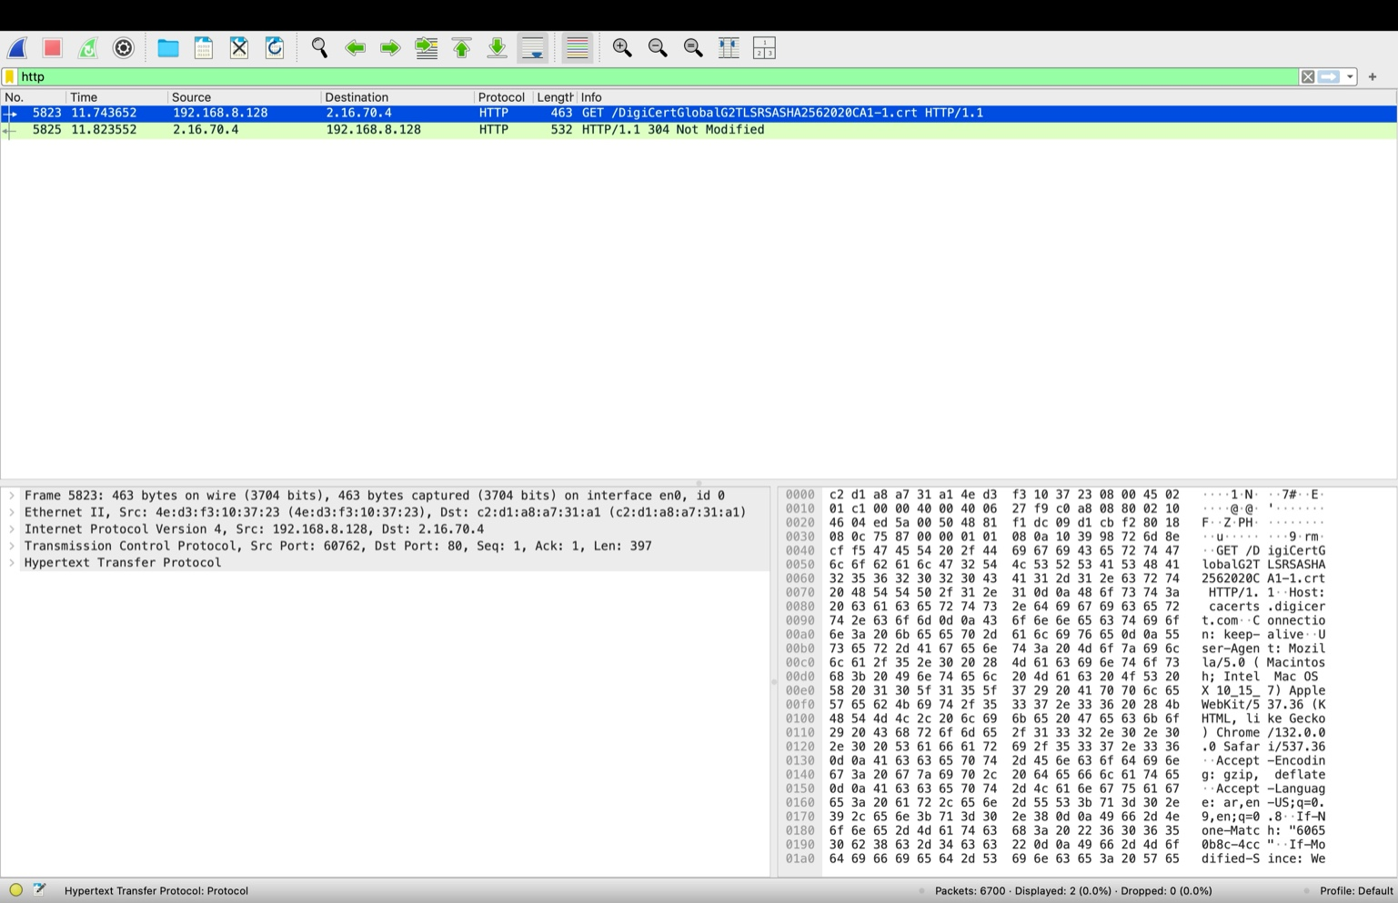

## 2. TCP Traffic Analysis

Below are the screenshots of TCP traffic captured and analyzed in Wireshark, including TCP Stream conversation.

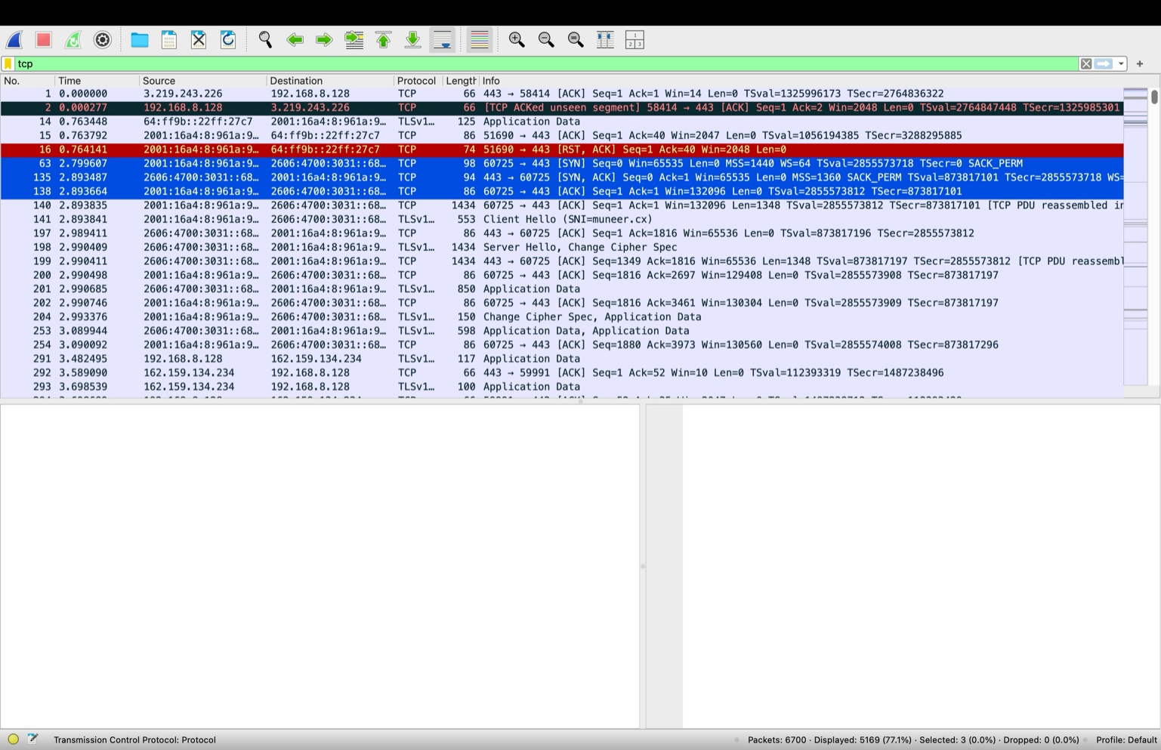

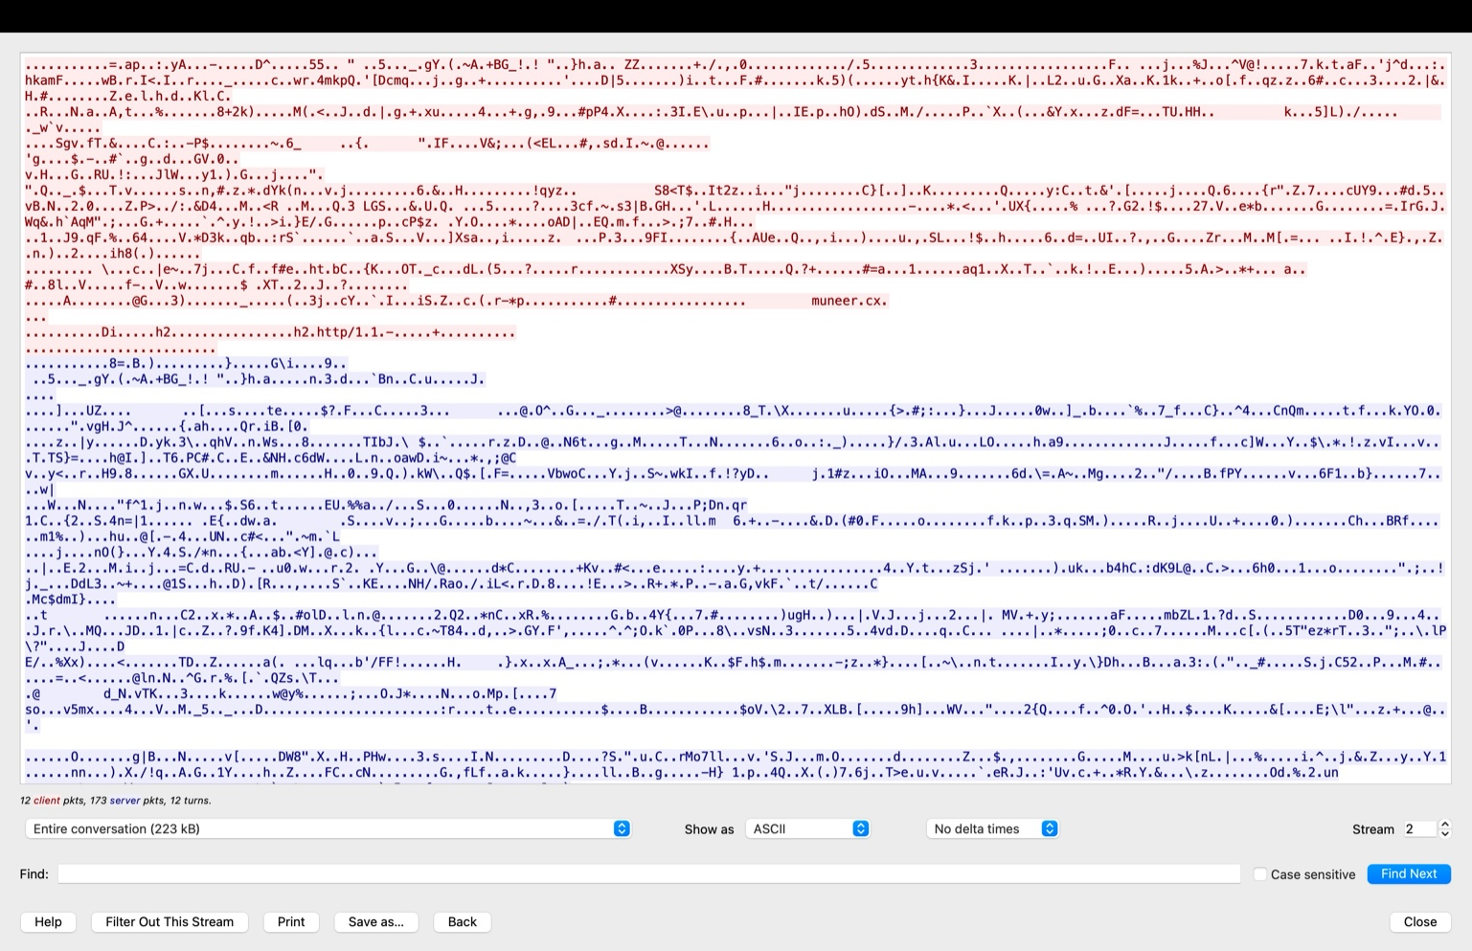

## 3. UDP Traffic Analysis

Below are the screenshots of UDP traffic captured and analyzed in Wireshark.

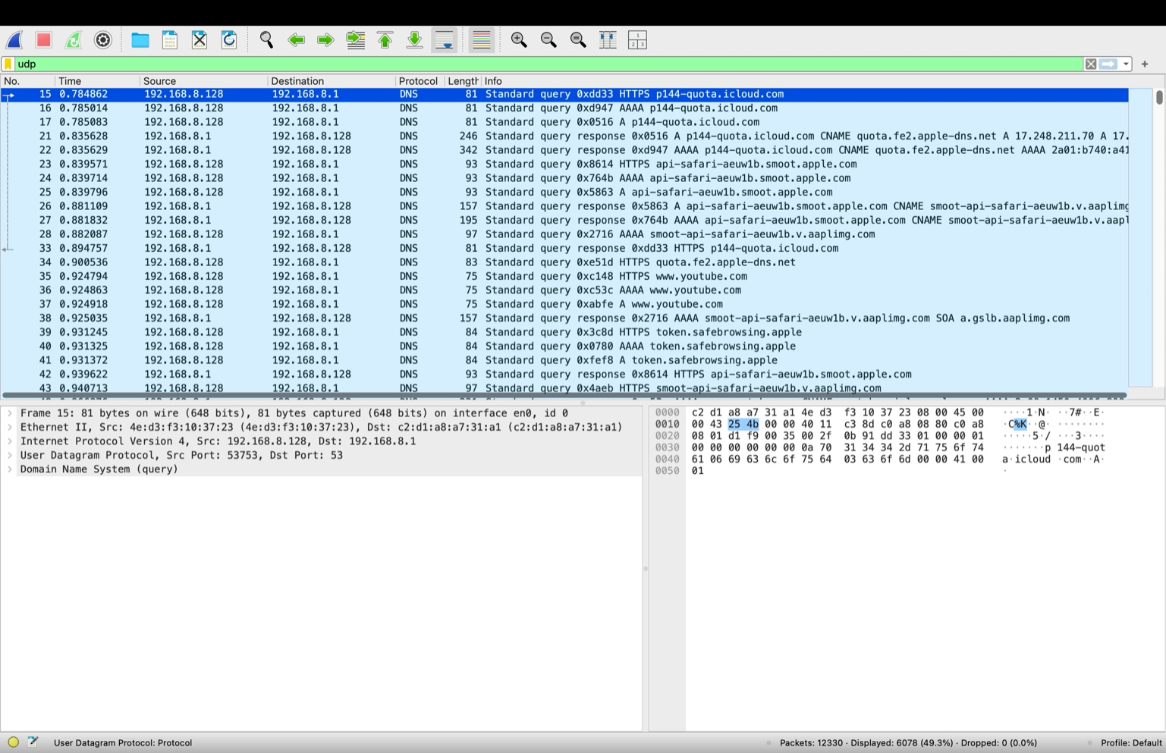

## 4. Comparison Between TCP and UDP

Table 1: Reliability and Connection Establishment

|  |  |
| --- | --- |
| Feature | Description |
| Reliability | TCP ensures reliability through acknowledgments and retransmission, whereas UDP does not. |
| Connection | TCP is connection-oriented (requires a handshake), while UDP is connectionless. |

Table 2: Use Cases and Performance

|  |  |  |
| --- | --- | --- |
| Feature | TCP | UDP |
| Use Cases | Web browsing, file transfer, emails | Streaming, gaming, VoIP |
| Performance | Reliable but slower due to acknowledgments | Faster but less reliable |