This manual gives an introduction of the usage of GBlender interface. For the technical details, please refer to the relevant papers.

GBlender is developed in NetBean 6.8 environment.
Required Softwares: GBlender Package, Java JDK 1.6, ZGRViewer and Graphviz (used to visual graph display).

To run the project from the command line, go to the “Sigmod11_Demo” folder and type the following:
java -jar -Xms1400m -Xmx1400m GBLENDER.jar
Or create a short cut for “run.bat” with “logo.ico” on your desktop, then double click it.
Usage of GBlender System
- Click ” Set Database” button to choose dataset and set relevant parameters.
The default setting for real life dataset is: Database Name: AIDS, Dataset Size 40, Support Threshold: 0.1, Frequent Size: 8, Max Missed Edge: 3
The default setting for synthetic dataset is: Database Name: Syn, Dataset Size 60, Support Threshold: 0.05, Frequent Size:4, Max Missed Edge:2
Please refer to the parameters settings in the papers for the other settings.
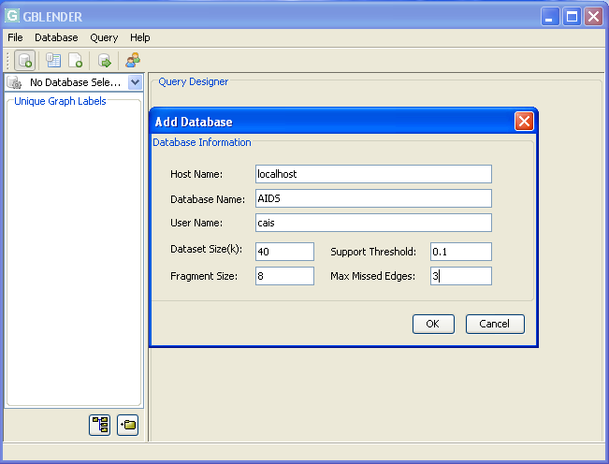

- Click “Build Index” button to build indexes for given parameters.
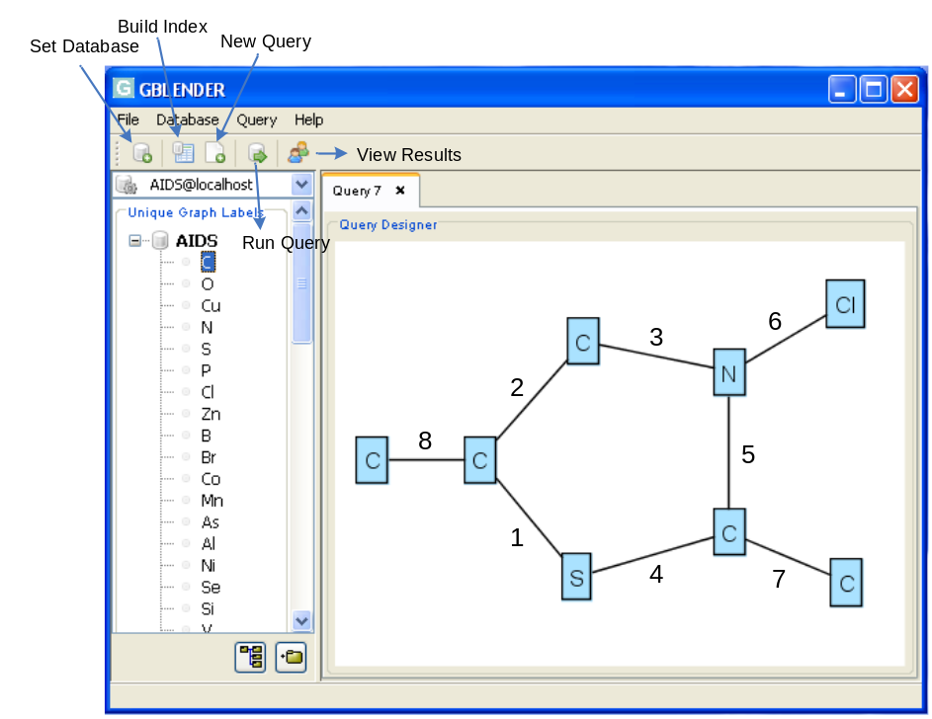

- Click “New Query” button to create a canvas for new query drawing.
- Drag one label from the left panel and drop it on the canvas once a time.
- Repeat step 4 to draw one more node, then connect two labels with an edge by left clicking the first label and right clicking the second label.
At this time, “Interaction Viewer” window will pop up and show the current query statuses, such as candidate size and response time.
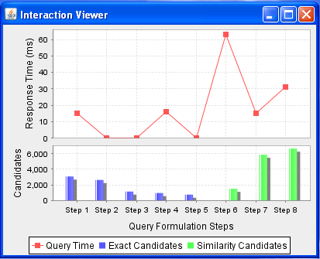

- When current query has no exact candidates, “Query Options” dialogue will pop up. Users may choose “Invoke Similarity Query”, or “Modify the query”. If “Modify the query” button is clicked, the system will recommend an edge to users for modification by highlighting it.
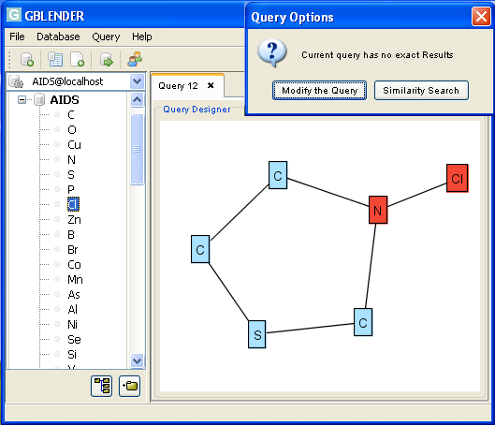
- Deleting an edge is exactly the reverse operation of adding an edge, by right clicking the first edge, then left clicking the second edge.
- When a query is formulated completely, click the “Run Query” button to obtain the results.
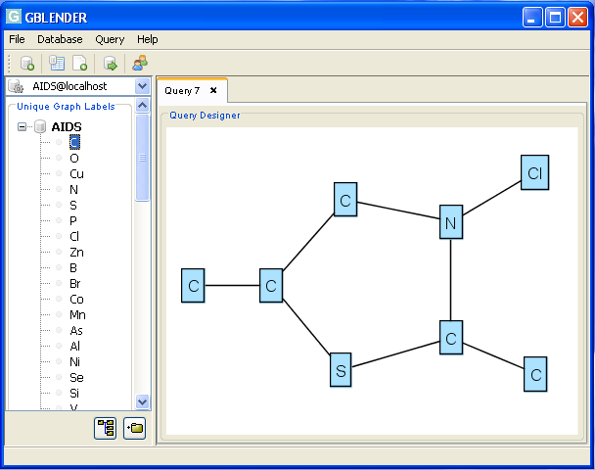
- Click “View Results” on the “Query Results” dialogue to check the visual dispalys
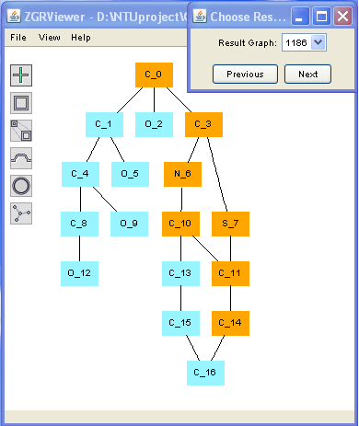

Authors: Changjiu Jin, Sourav S Bhowmick, Xiaokui Xiao, Byron Choi, Shuigeng Zhou

Relevant Papers:
1. C Jin, Sourav S Bhowmick, X Xiao, Byron Choi, S Zhou
GBLENDER: Visual Subgraph Query Formulation Meets Query Processing.
ACM SIGMOD 2011, (Demo paper)
2. C. JIN, ET AL. GBLENDER++: A Practical Framework for Blending Visual
Subgraph Query Formulation and Query Processing. In Technical Report,
http://www.cais.ntu.edu.sg/»assourav/TechReports/GBlender-TR.pdf, 2010.
3. C Jin, Sourav S Bhowmick, X Xiao, James Cheng, Byron Choi
GBLENDER: Towards Blending Visual Query Formulation and Query Processing in Graph Databases. ACM SIGMOD 2010

March, 2011

